Docker-03

Create a image from running container.

✅ Step 1: Check running containers
Run:
docker ps
already got:
653d74a3428d amazon-nginx ... nginx-container
So running container name is:
✅ nginx-container

✅ Step 2: Go inside the running container
If you want to make changes (example: create file, install package) then enter container:
docker exec -it nginx-container bash
Now you are inside container.
Example change:
echo "Hello from my custom container" > /usr/share/nginx/html/index.html
Then exit:
exit

✅ Step 3: Create IMAGE from running container
Now convert that running container into an image using commit:
docker commit nginx-container dhanu8688/amazon-nginx:v2
This will create a new image called:
✅ dhanu8688/amazon-nginx:v2

✅ Step 4: Verify image is created
Run:
docker images
will see something like:
dhanu8688/amazon-nginx v2 <new-image-id> ...

✅ Step 5: Run a new container using newly created image
Now test new image:
docker run -d --name new-nginx-test -p 83:80 dhanu8688/amazon-nginx:v2

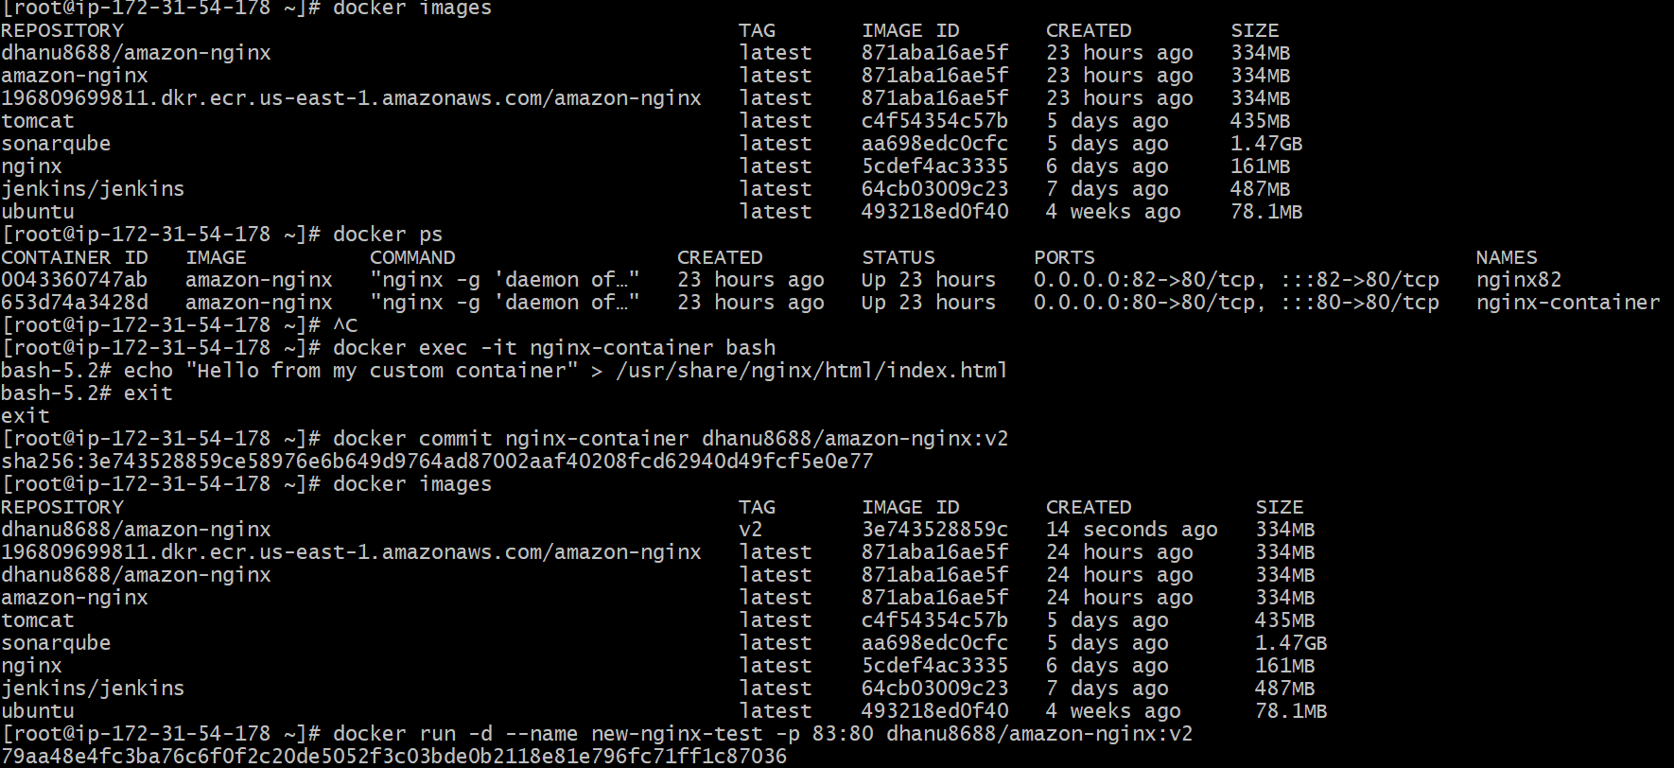

✅ Step 7: Open in browser
Now open:
http://<your-ec2-public-ip>:83
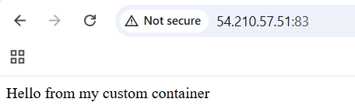

Copy image from local machine to docker server and load the image.

Open gitbash in desktop
Then pull image here (Make sure u have signed in desktop docker account )

And save the image “ docker save -o nginx.tar nginx:latest

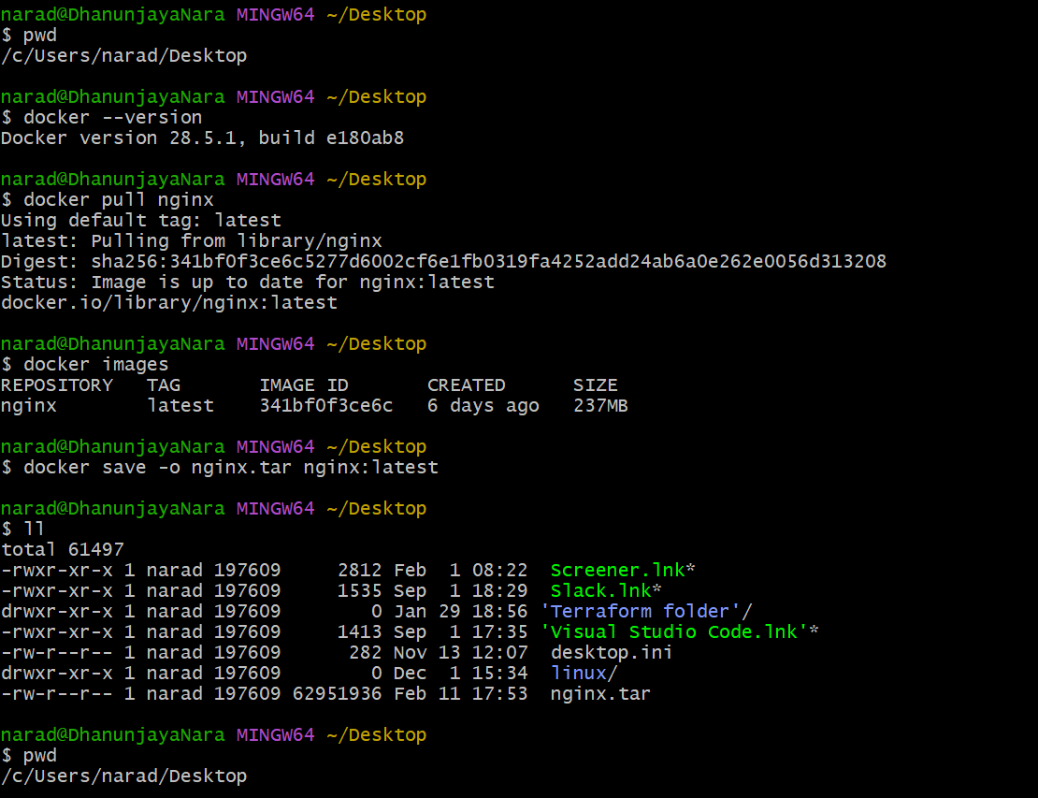

Copy image to Docker server
scp -i "/c/Users/narad/Downloads/maruthi.pem" "/c/Users/narad/Desktop/nginx.tar" ec2-user@54.210.57.51:/tmp

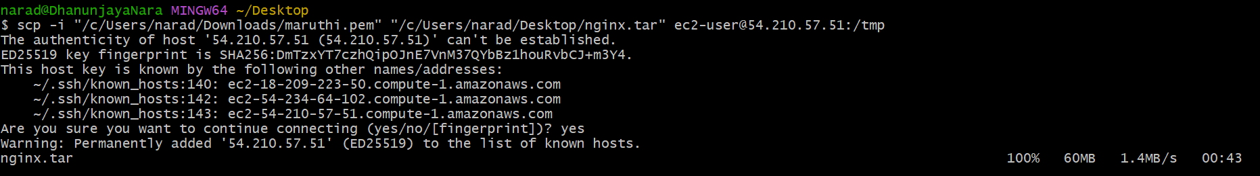

Login to Docker server:

Load image on docker server:

docker load -i /tmp/nginx.tar

Verify images:

docker images

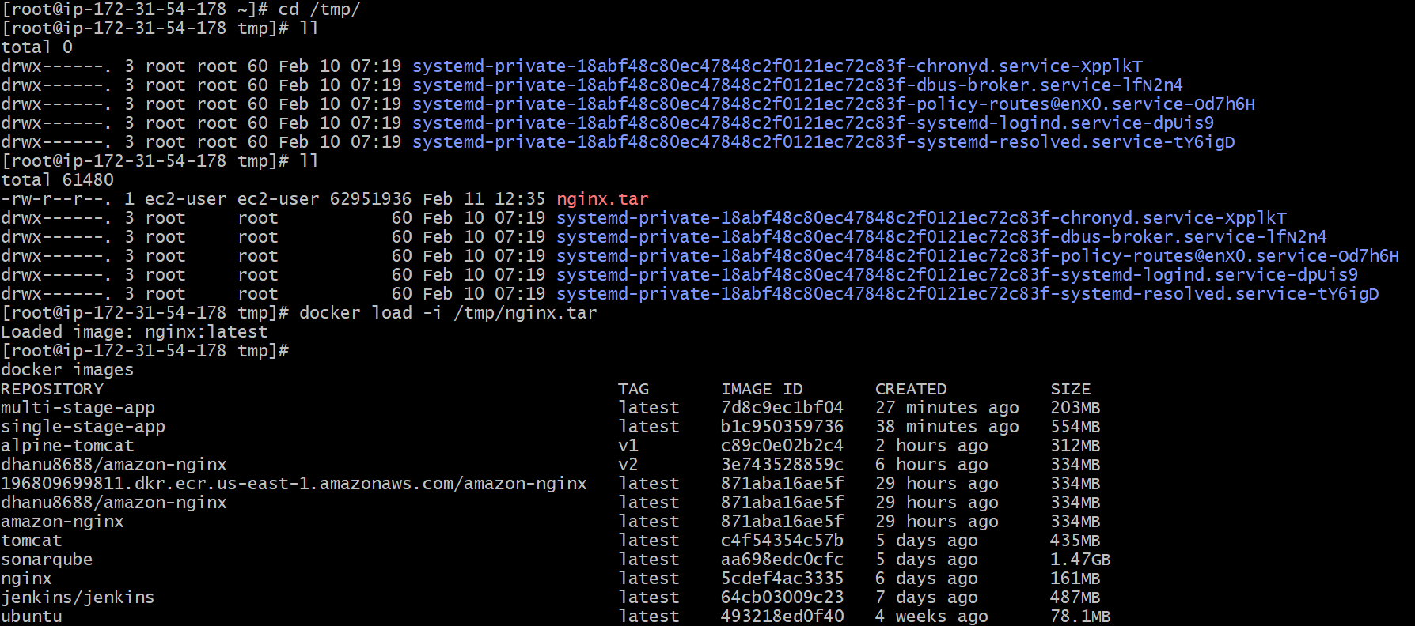

Create Docker image using alpine and customize with tomcat.

Step 1: Create a folder
On your Linux server (or local machine):
mkdir alpine-tomcat
cd alpine-tomcat

Step 2: Create Dockerfile
vi Dockerfile

FROM alpine:latest

# Install Java (required for Tomcat)
RUN apk update && apk add openjdk11 wget tar bash

# Create tomcat directory
RUN mkdir -p /opt/tomcat

# Download Tomcat
RUN wget https://downloads.apache.org/tomcat/tomcat-9/v9.0.96/bin/apache-tomcat-9.0.96.tar.gz -P /tmp

# Extract Tomcat
RUN tar -xvzf /tmp/apache-tomcat-9.0.96.tar.gz -C /opt/tomcat --strip-components=1

# Expose Tomcat port
EXPOSE 8080

# Start Tomcat
CMD ["/opt/tomcat/bin/catalina.sh", "run"]
Now save and exit:
Press:
ESC
:wq

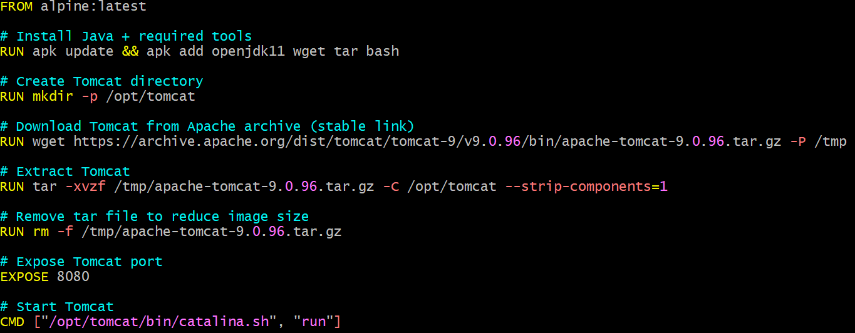

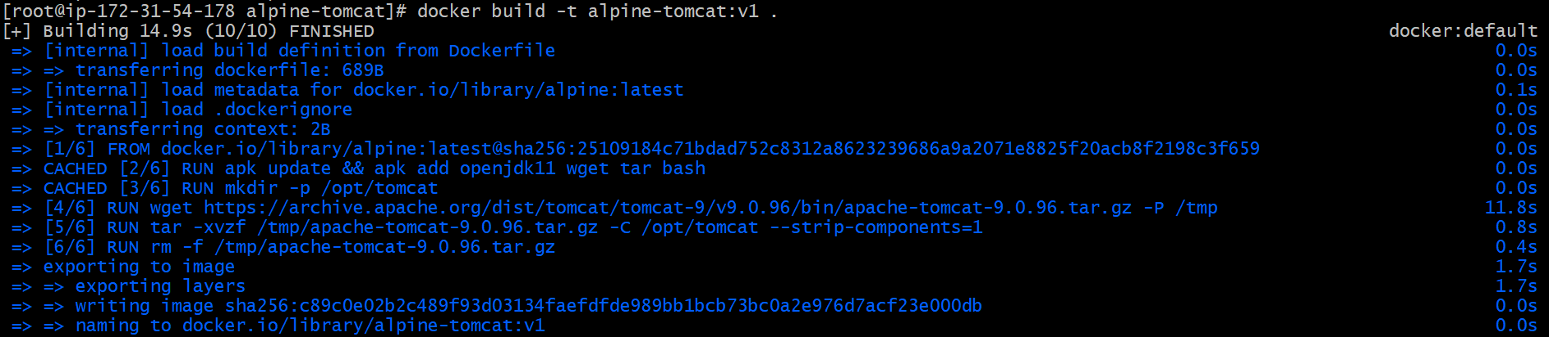

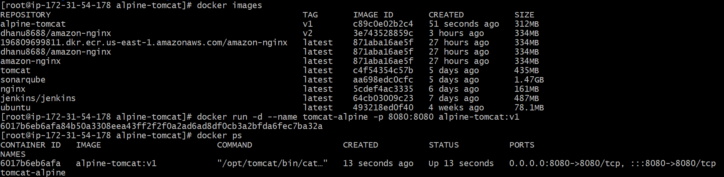

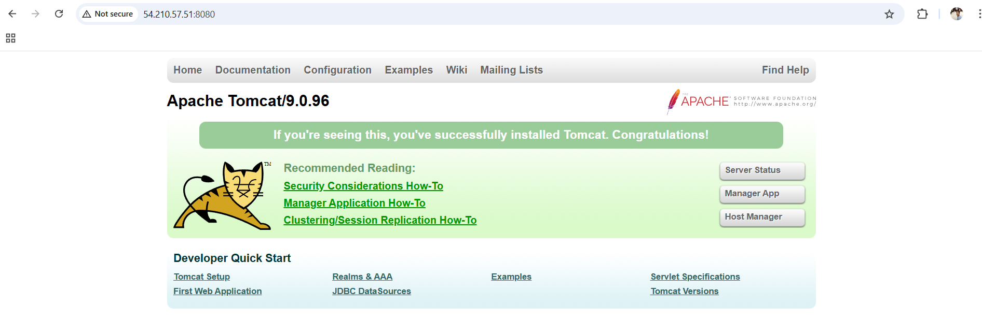

Create single stage and multi stage docker file using this source code: https://github.com/betawins/multi-stage-example.git.

Open Dockerfile-single
vi Dockerfile-single

Step 4: Build Docker image using Dockerfile-single
docker build -f Dockerfile-single -t single-stage-app .

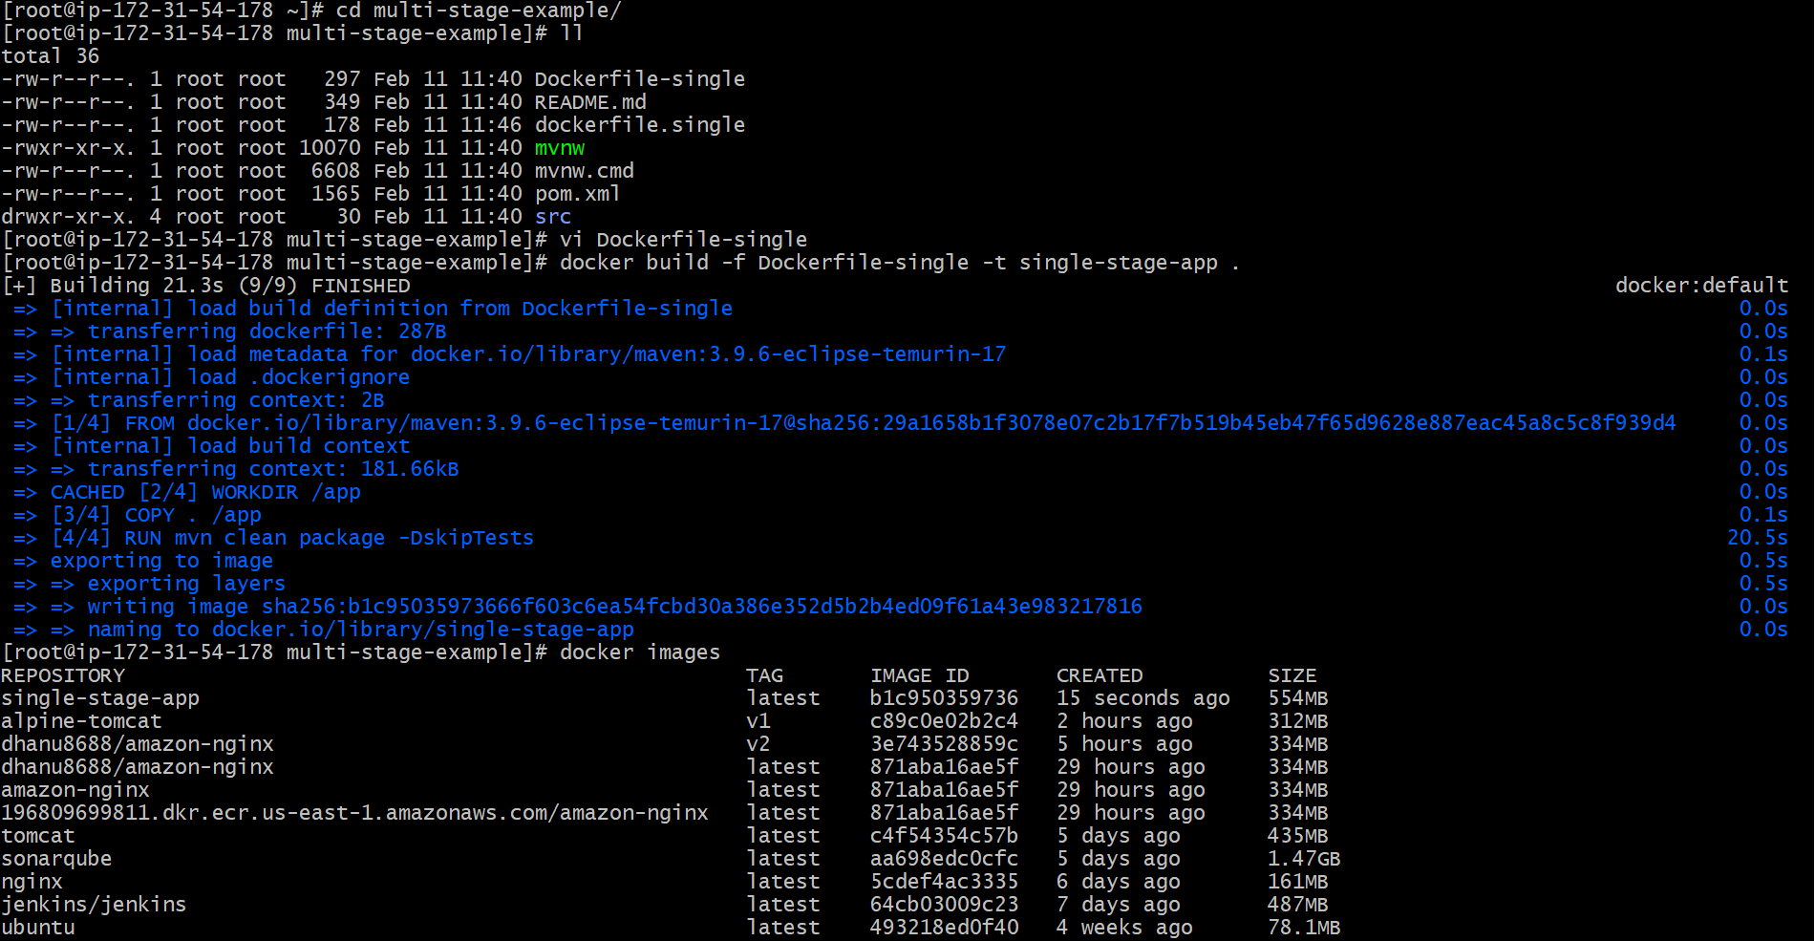
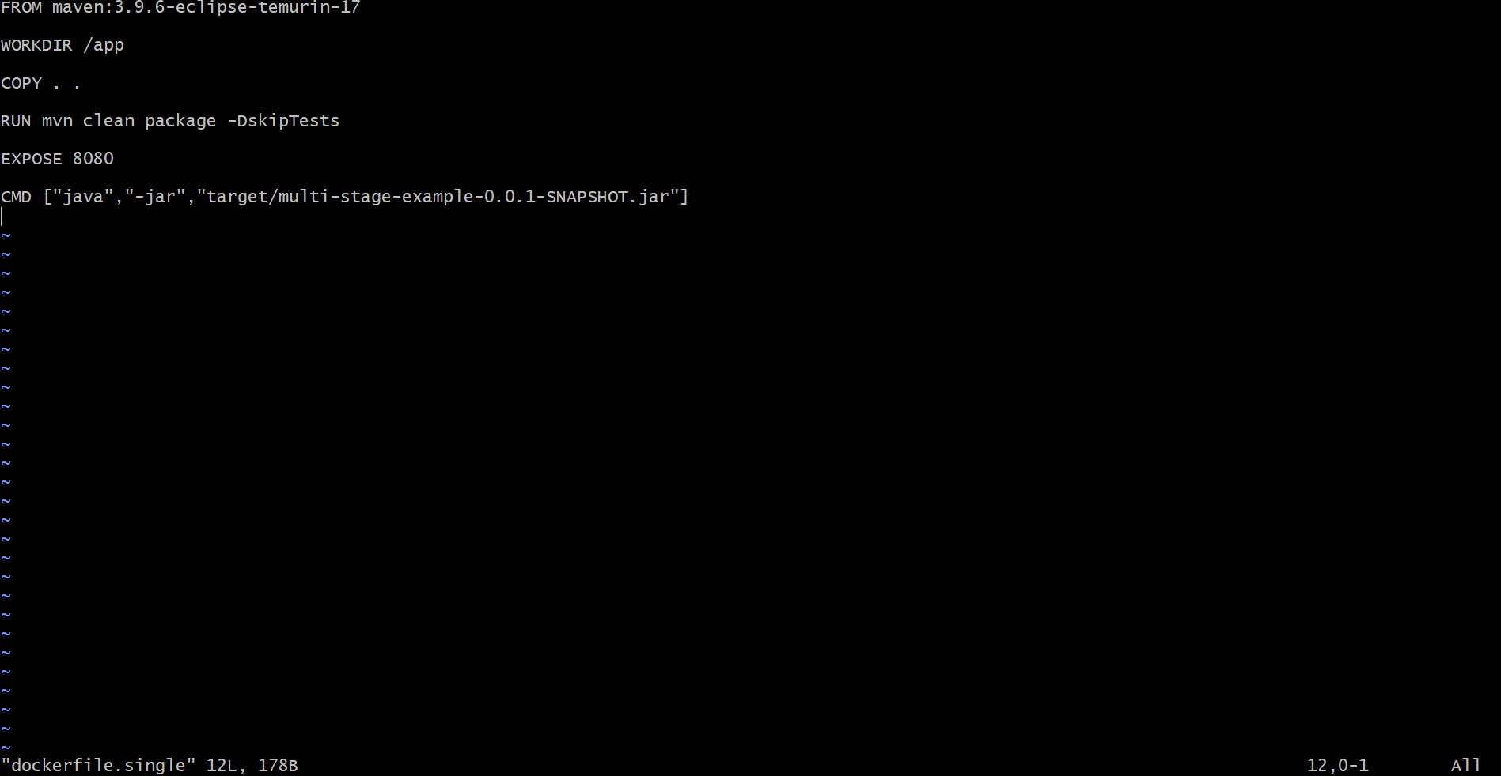
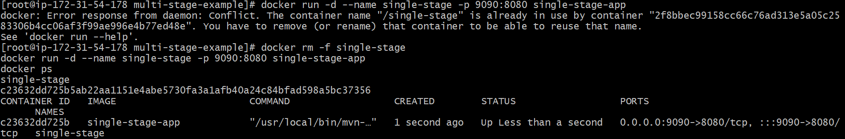
Now check the image in the browser.

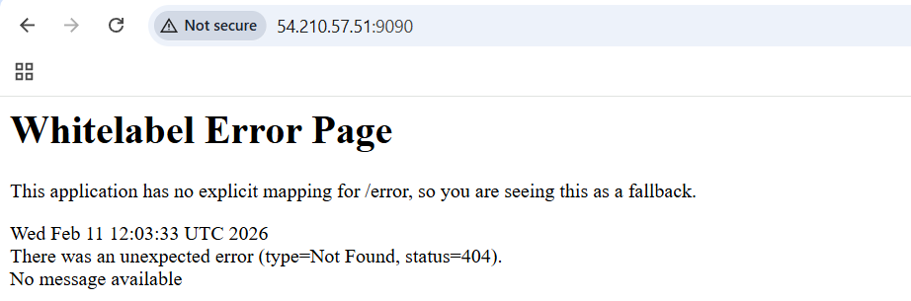
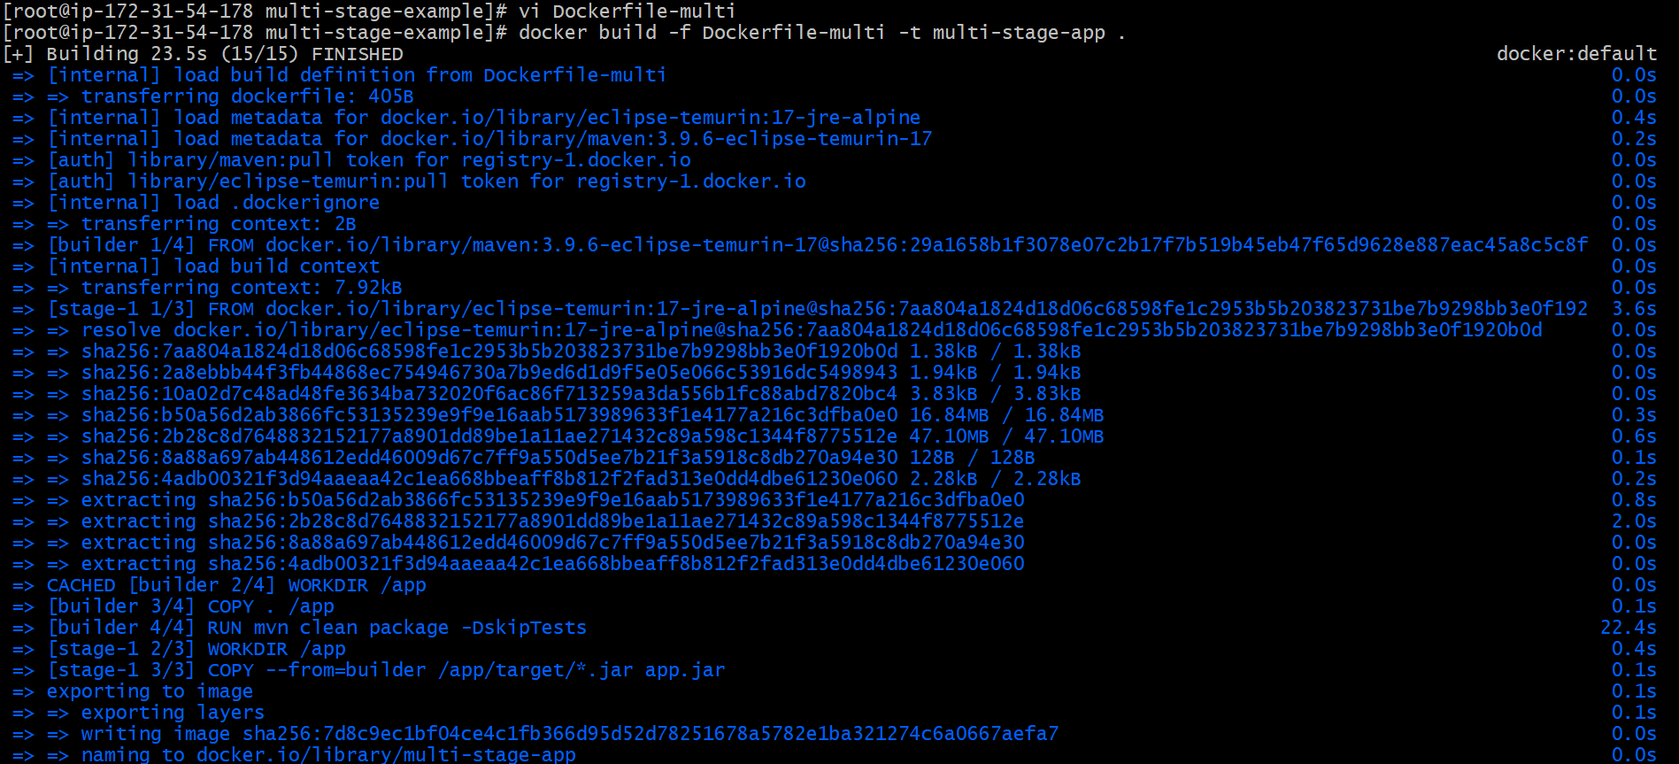
Now again multi-stage file :
Open the file and paste the Docker file and build and run the file.
Now check the image in the browser.
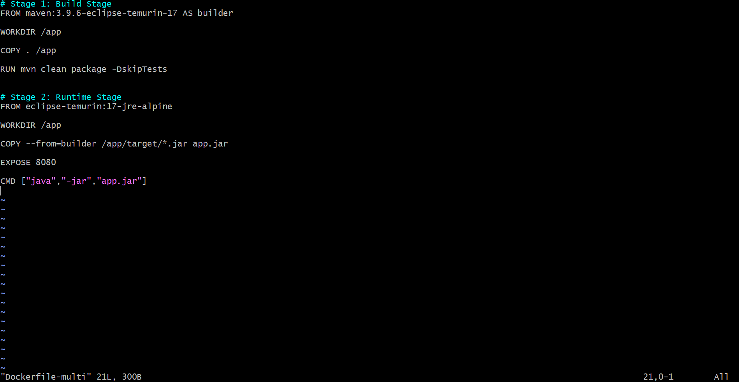
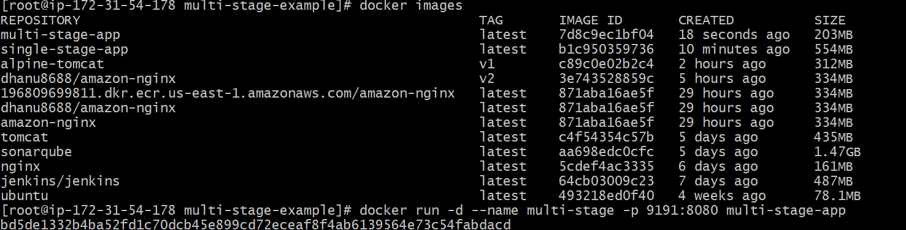
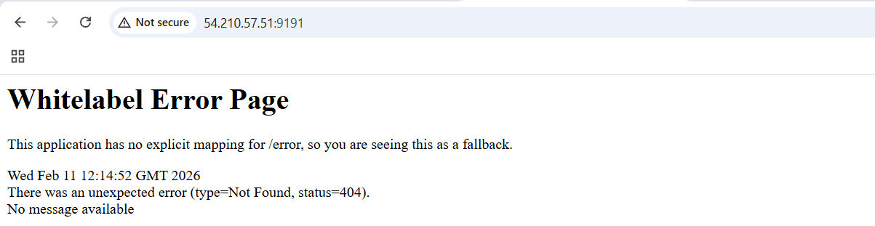

Install docker compose and execute sample application.
Download docker compose plugin:
sudo curl -L "https://github.com/docker/compose/releases/latest/download/docker-compose-linux-x86_64" -o /usr/local/bin/docker-compose
Give execute permission:
sudo chmod +x /usr/local/bin/docker-compose
Verify:
docker-compose --version

Run Sample Application using Docker Compose
Create a folder:
mkdir sample-app
cd sample-app
Create docker-compose file using vi:
vi docker-compose.yml
Paste this:
version: "3.8"

services:
web:
image: nginx
container_name: nginx_web
ports:
- "80:80"
Save and exit:
- Press ESC
- Type :wq
- Enter
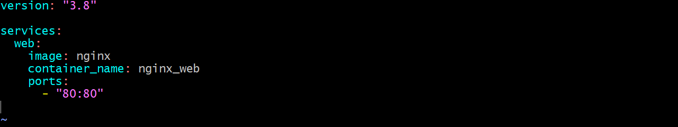
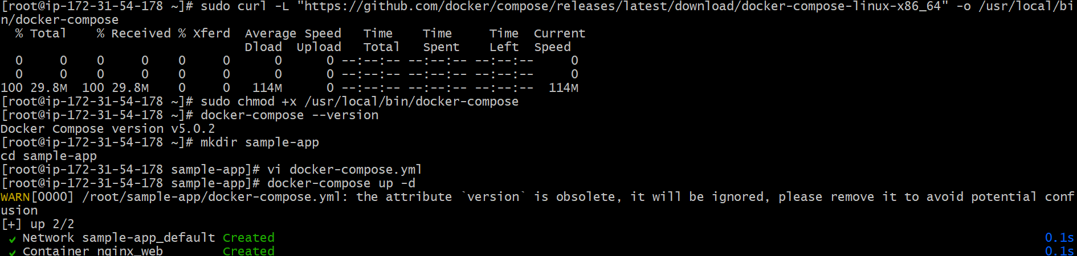

Start Application
docker-compose up -d
Check running containers:
docker ps

Test in Browser
Open:
http://<EC2_PUBLIC_IP>

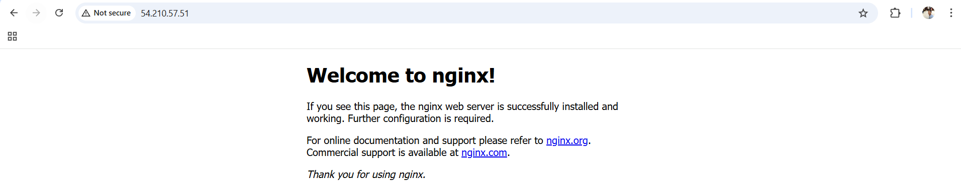

Implement solution to scan images when pushed to docker registry.

Enable Docker Scout in DockerHub
- Login to DockerHub
- Go to:
📌 Repositories → dhanu8688/amazon-nginx → Settings
- Under Image security insight settings
Select:
✅ Docker Scout image analysis
- Click:
✅ Save
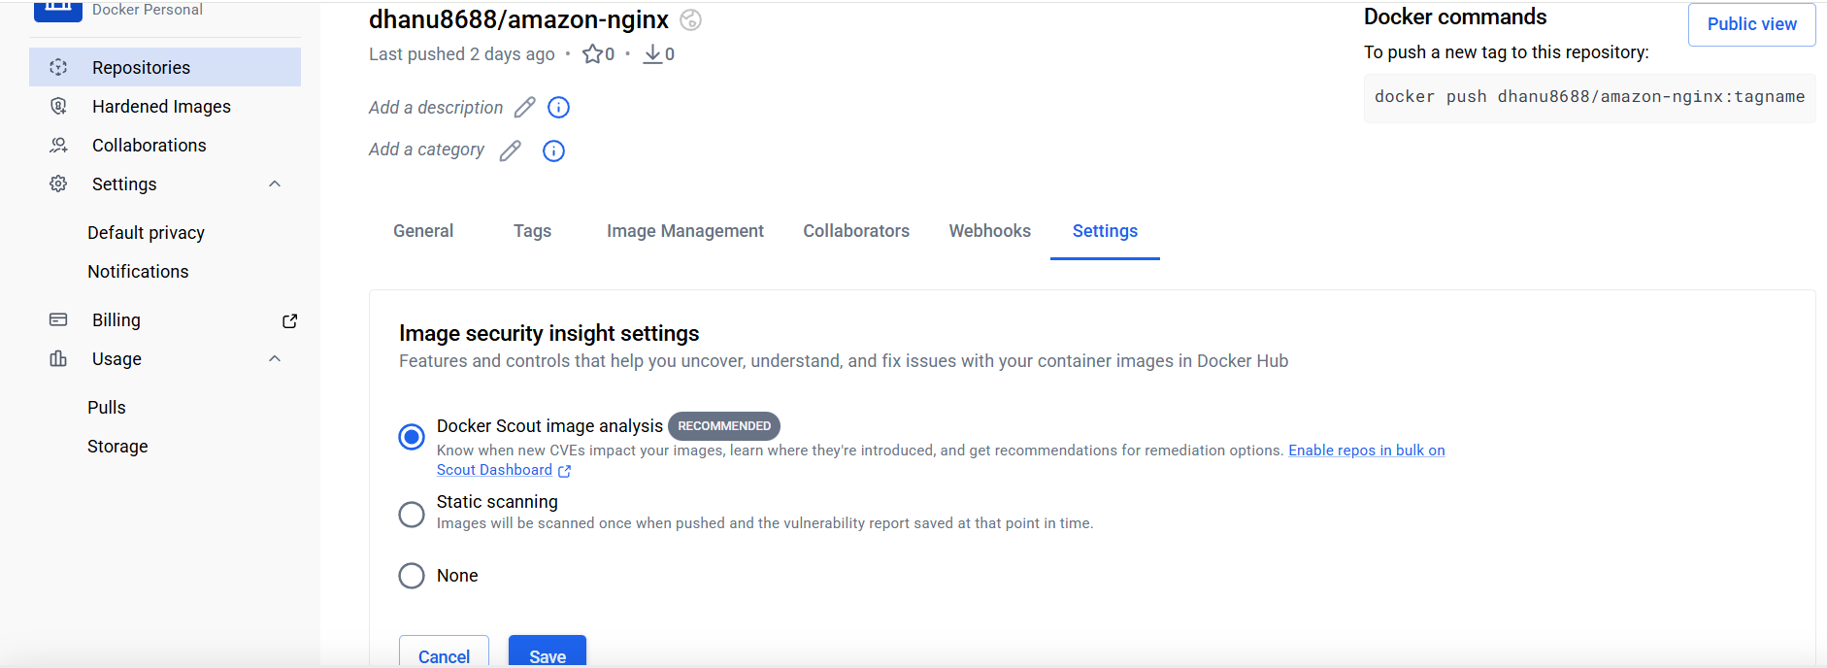

Go to Project Directory
cd multi-stage-example

Check Files
check the Dockerfiles:
ls -lh
Output
- Dockerfile-multi
- Dockerfile-single

Build Docker Image
docker build -f Dockerfile-multi -t dhanu8688/amazon-nginx:1.0 .

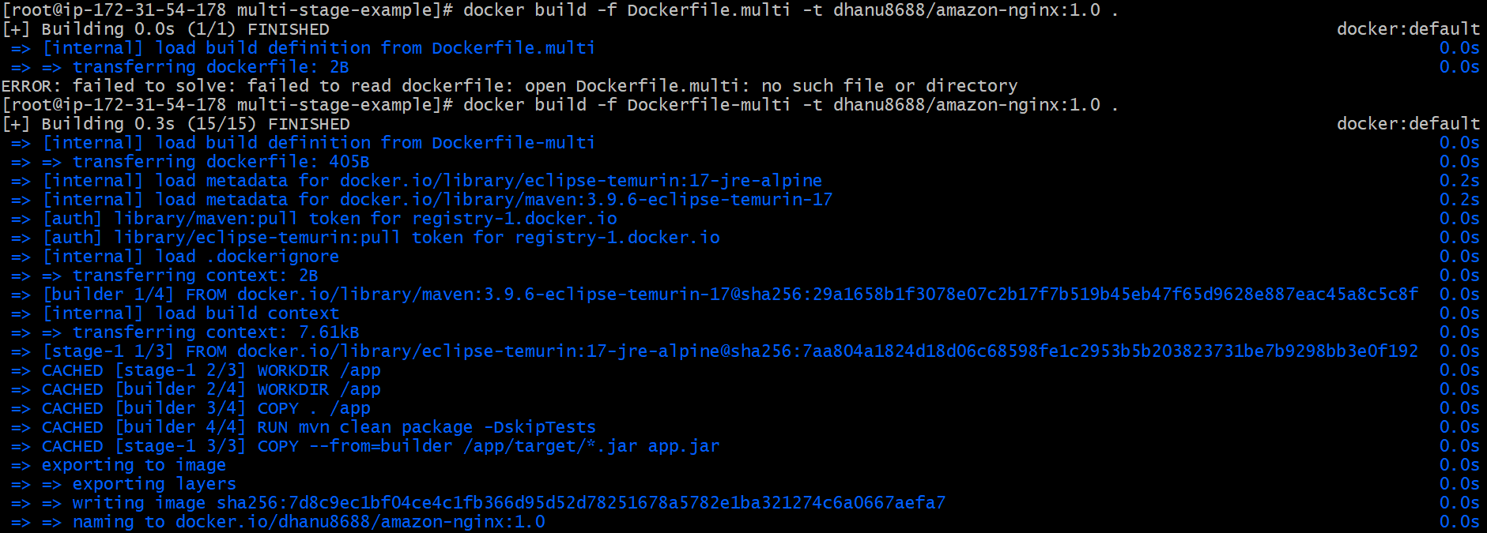
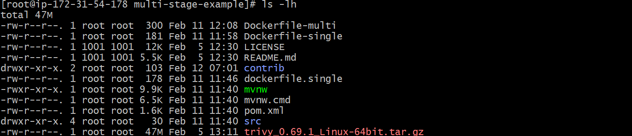

Step 6: Run Trivy Scan (Image Scanning Locally)
trivy image --severity HIGH,CRITICAL --exit-code 1 dhanu8688/amazon-nginx:1.0
This command checks vulnerabilities.
- It scanned Alpine OS
- It scanned Java jar dependencies
- It produced vulnerability summary

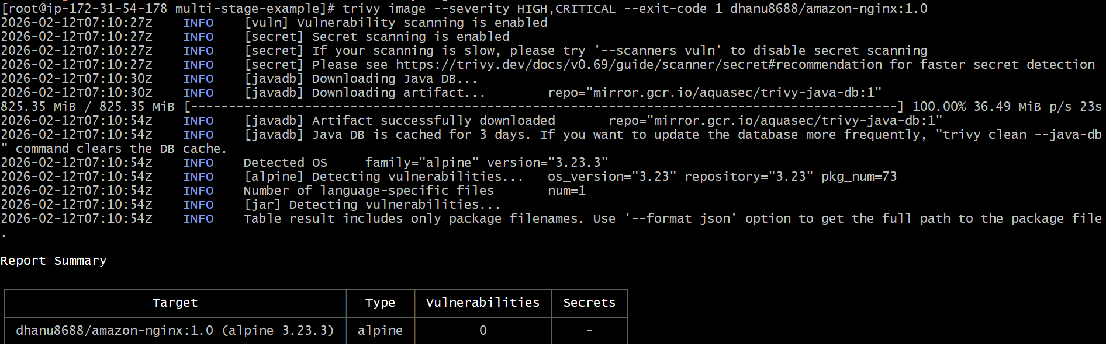

Push Image to DockerHub
docker push dhanu8688/amazon-nginx:1.0

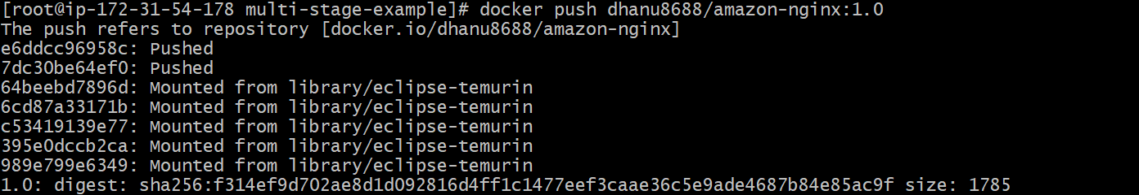

Verify Image in DockerHub Repository
📌 DockerHub → Repositories → amazon-nginx → Tags
You confirmed:
✅ Tag 1.0 is available
✅ Docker Scout analyzed vulnerabilities
✅ Vulnerability counts visible in UI

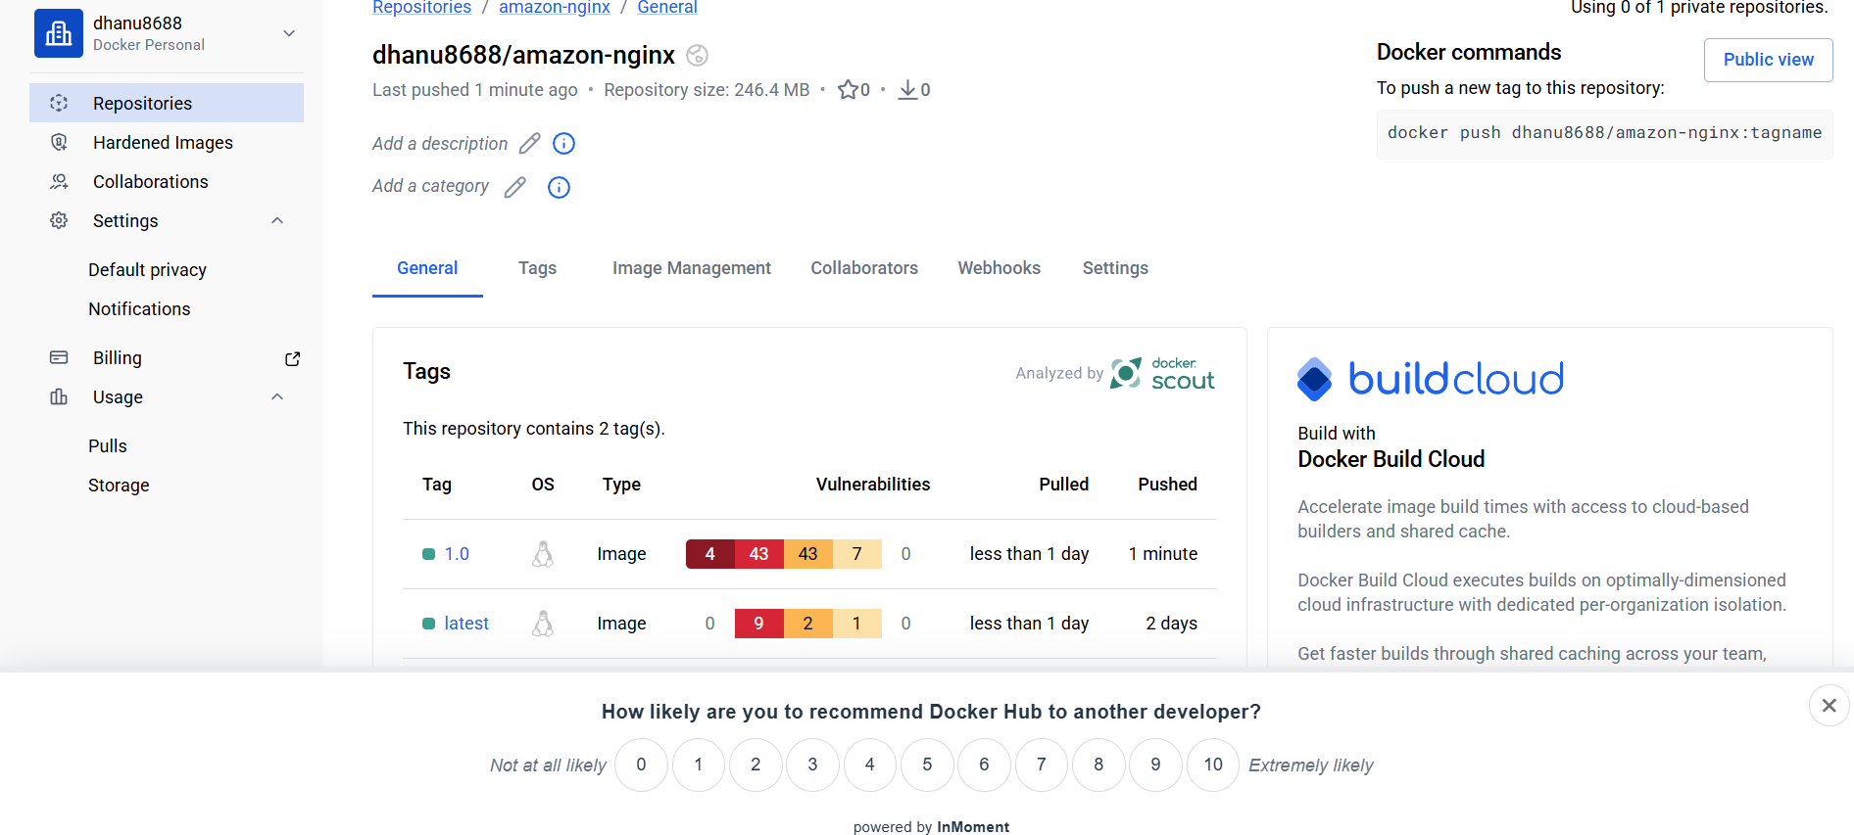

Implement solution to scan images when pushed to AWS ECR.

✅ Step 1: Create ECR Repository
aws ecr create-repository \
--repository-name devops \
--region us-east-1

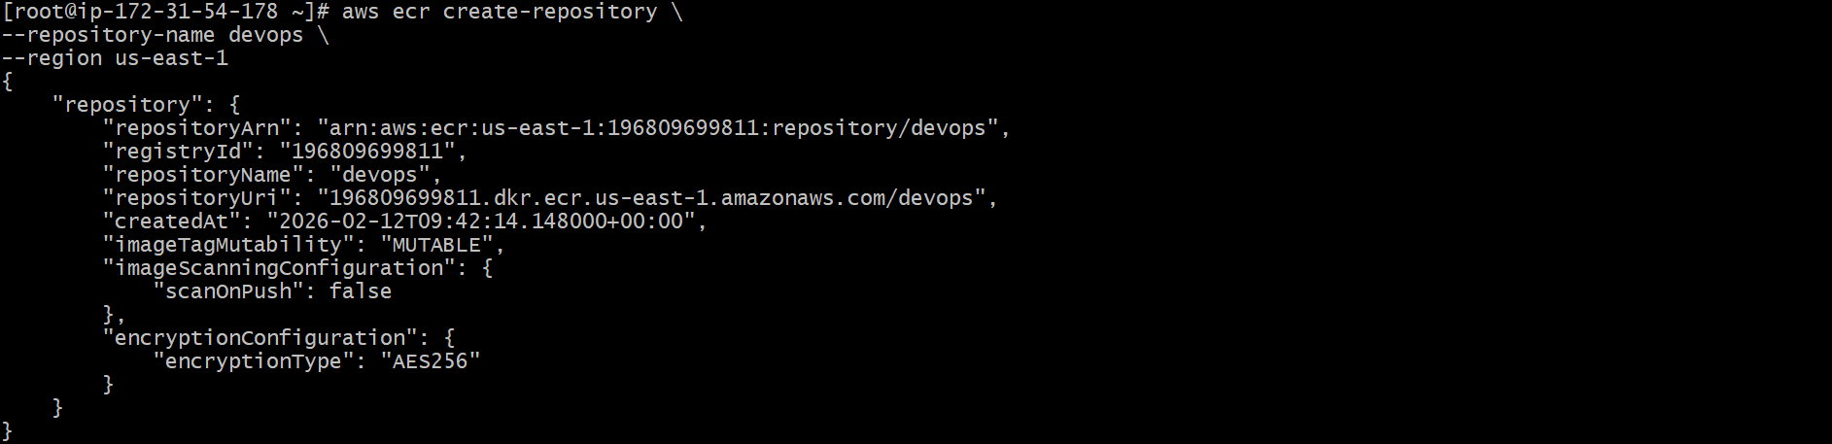

✅ Step 2: Enable Image Scanning on Push
aws ecr put-image-scanning-configuration \
--repository-name devops \
--image-scanning-configuration scanOnPush=true \
--region us-east-1

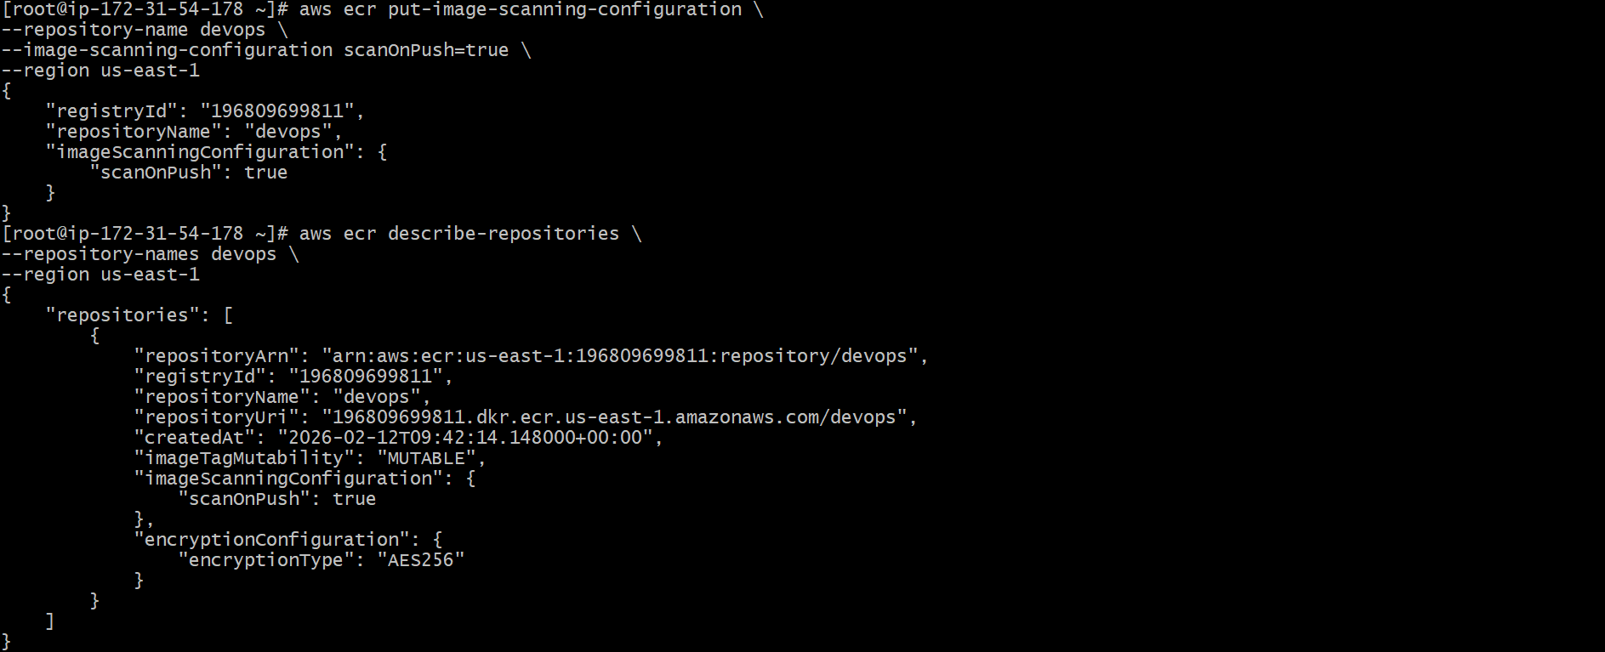

✅ Step 3: Verify Scanning Configuration
aws ecr describe-repositories \
--repository-names devops \
--region us-east-1
OR check registry scanning config:
aws ecr get-registry-scanning-configuration \
--region us-east-1

✅ Step 4: Get AWS Account ID
aws sts get-caller-identity --query Account --output text

✅ Step 5: Authenticate Docker to AWS ECR
Replace <account-id> with your account ID.
aws ecr get-login-password --region us-east-1 | docker login --username AWS --password-stdin <account-id>.dkr.ecr.us-east-1.amazonaws.com

✅ Step 6: Verify Docker Image Available Locally
docker images
Make sure you have image like:
dhanu8688/amazon-nginx 1.0

✅ Step 7: Tag the Docker Image for ECR
Replace <account-id>.
docker tag dhanu8688/amazon-nginx:1.0 <account-id>.dkr.ecr.us-east-1.amazonaws.com/devops 1.0

✅ Step 8: Verify Tagging
docker images
You should see:
123456789012.dkr.ecr.us-east-1.amazonaws.com/devops 1.0

✅ Step 9: Push Image to ECR (Triggers Scan Automatically)
docker push <account-id>.dkr.ecr.us-east-1.amazonaws.com/devops:1.0
Example:
docker push 123456789012.dkr.ecr.us-east-1.amazonaws.com/devops:1.0

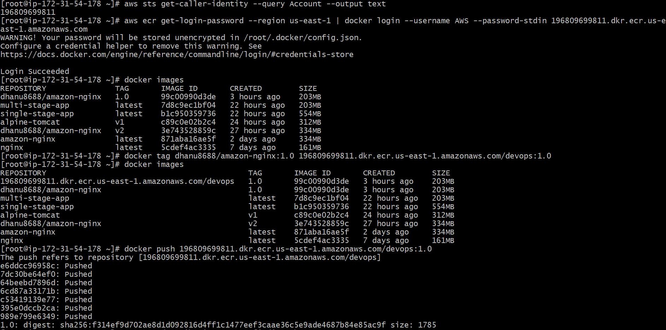

✅ Step 10: View Scan Results in AWS Console
Go to:
AWS Console → ECR → Repositories → devops → Images → Scan findings

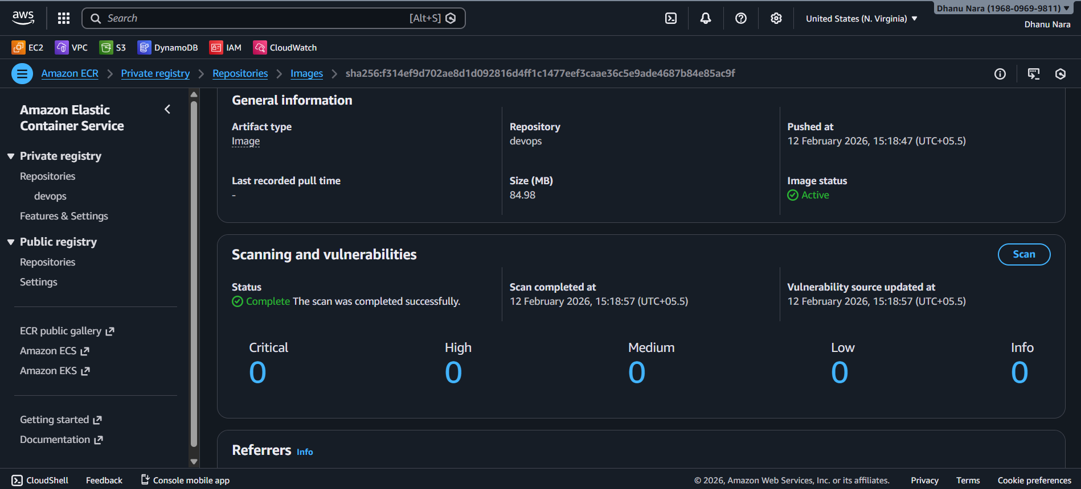

Create a Jenkins pipeline to create a docker image and push the image to Docker hub.

Step 1: Install Required Jenkins Plugins
Go to:
📌 Jenkins Dashboard → Manage Jenkins → Plugins → Available plugins
Search: docker
Select these plugins (same as your screenshot):
✅ Docker
✅ Docker Commons
✅ Docker Pipeline
✅ Docker API
Then click Install.

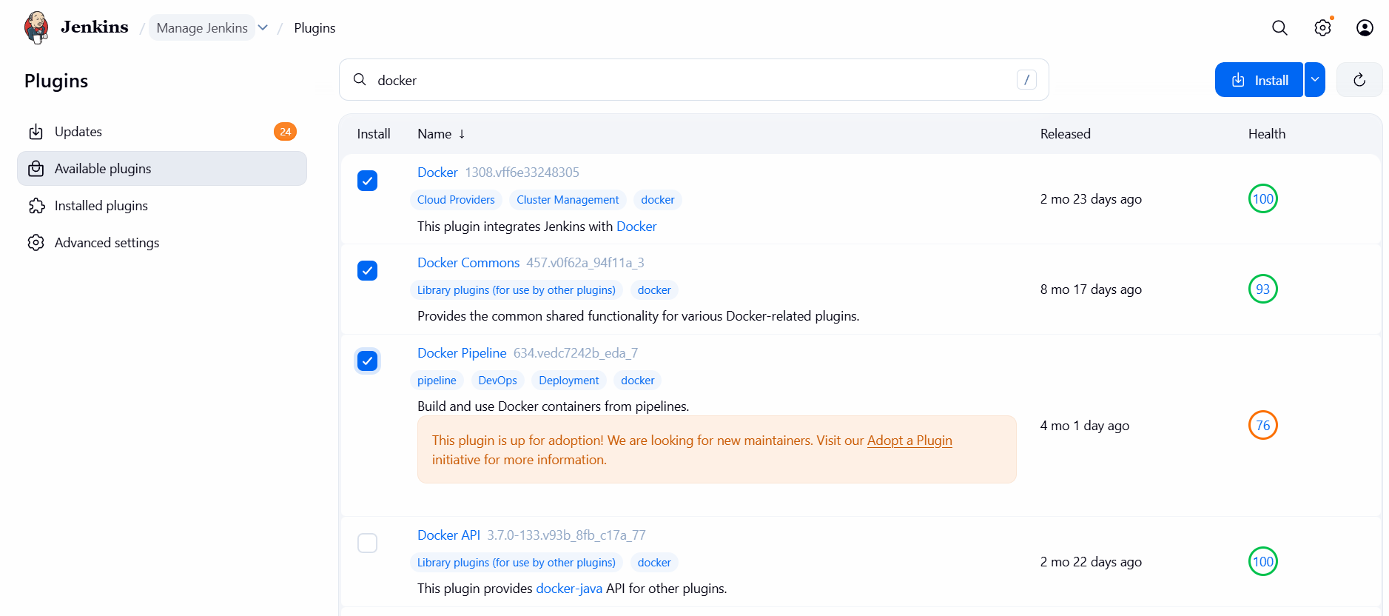
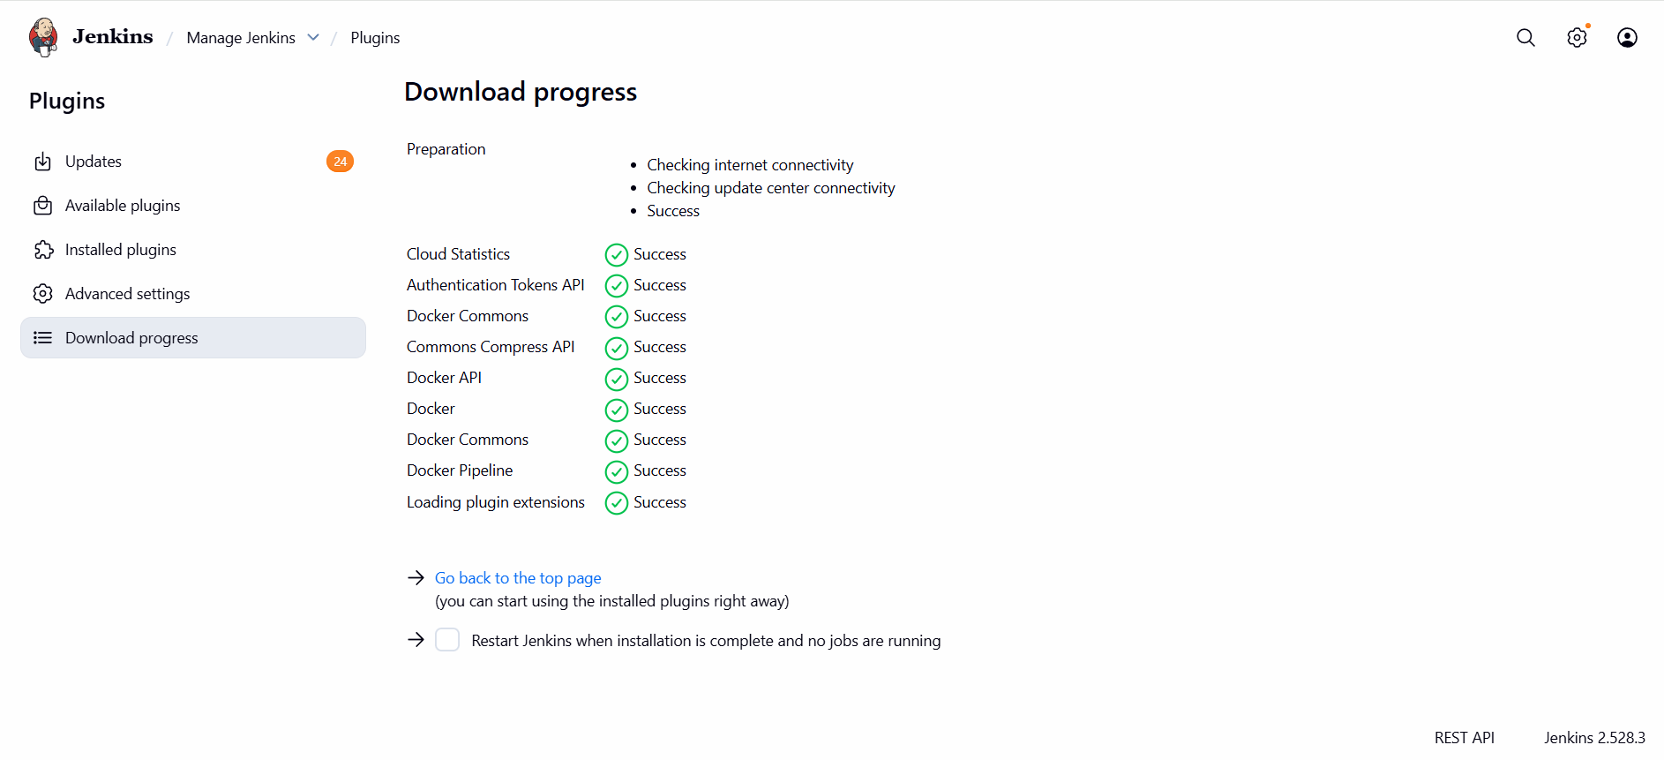

Step 2: Add DockerHub Credentials in Jenkins (Pic 3)
Go to:
📌 Manage Jenkins → Credentials → System → Global credentials (unrestricted)
Click:
➡️ Add Credentials
Choose:
- Kind: Username with password
- Username: dhanu8688
- Password: (your dockerhub password or token)
- ID: docker ✅ (Important)
- Description: dockerhub
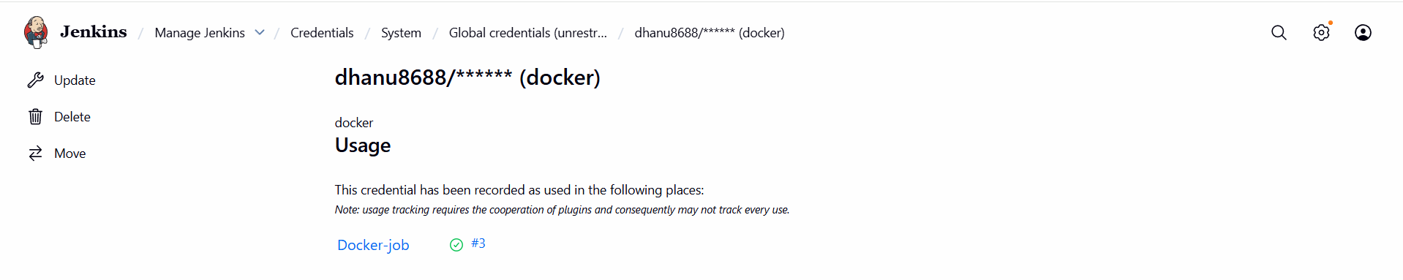

Step 3: Create New Jenkins Pipeline Job
Go to:
📌 Jenkins Dashboard → New Item
Enter job name:
Docker-job
Select:
✅ Pipeline
Click OK

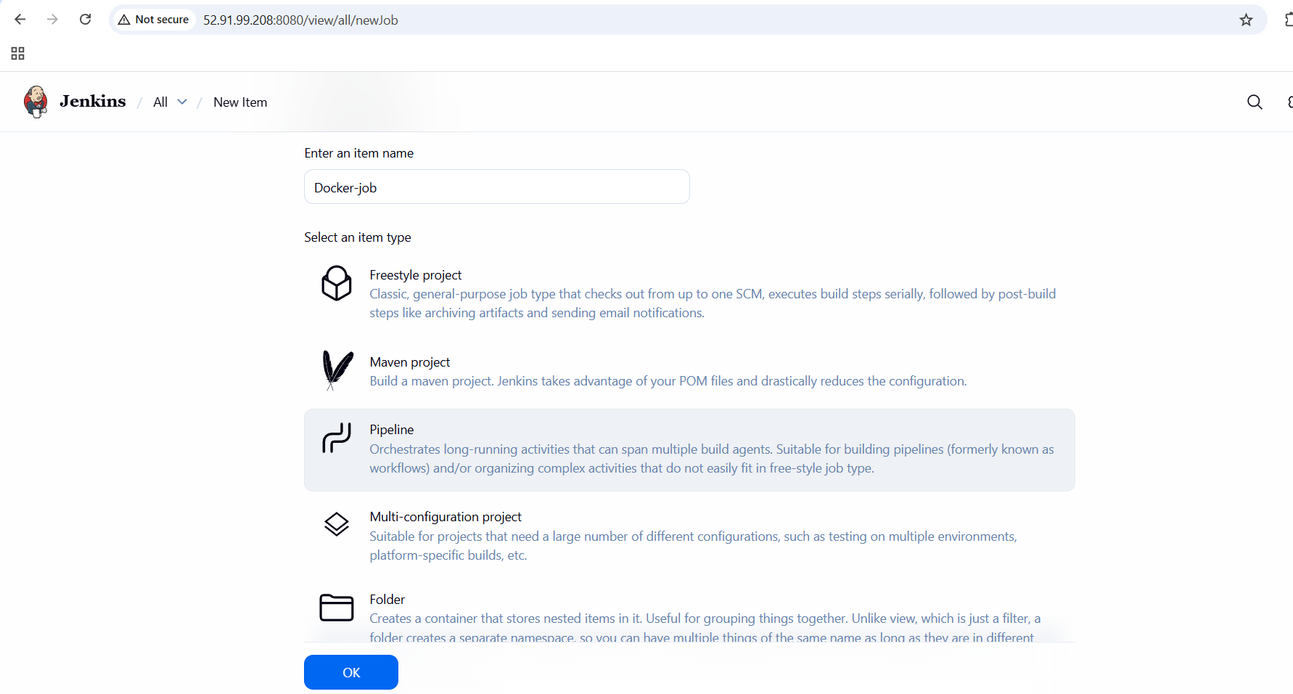

Step 4: Configure Pipeline from GitHub SCM
In pipeline configuration:

Under Pipeline section:
Definition:
✅ Pipeline script from SCM
SCM:
✅ Git
Repository URL:
https://github.com/Dhanunara/Docker-pipeline.git
Credentials:
Leave as none (because repo is public)
(as in your screenshot)
Branch:
*/main
Script Path:
Jenkinsfile
Enable:
✅ Lightweight checkout (optional)
Click Save

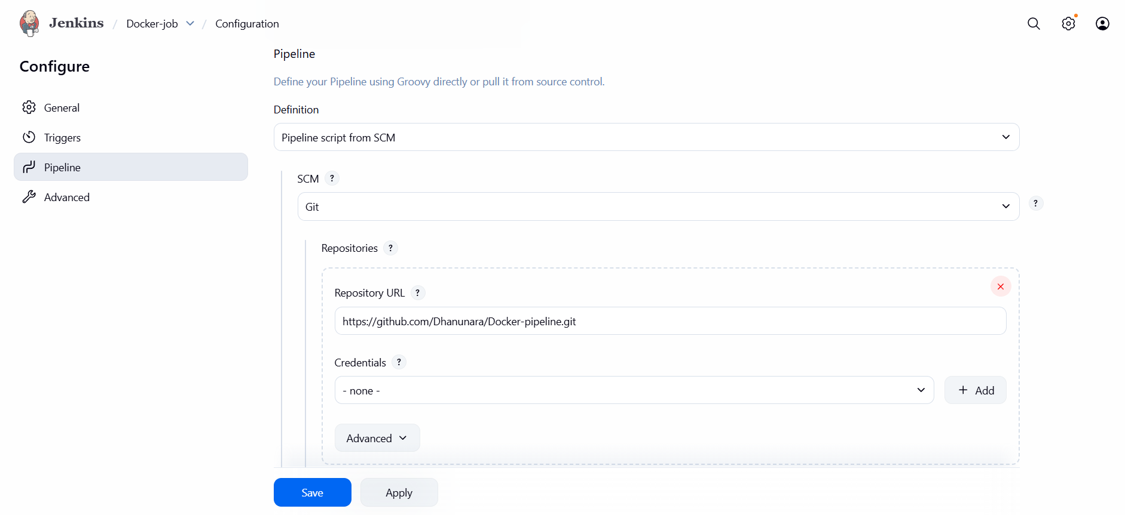
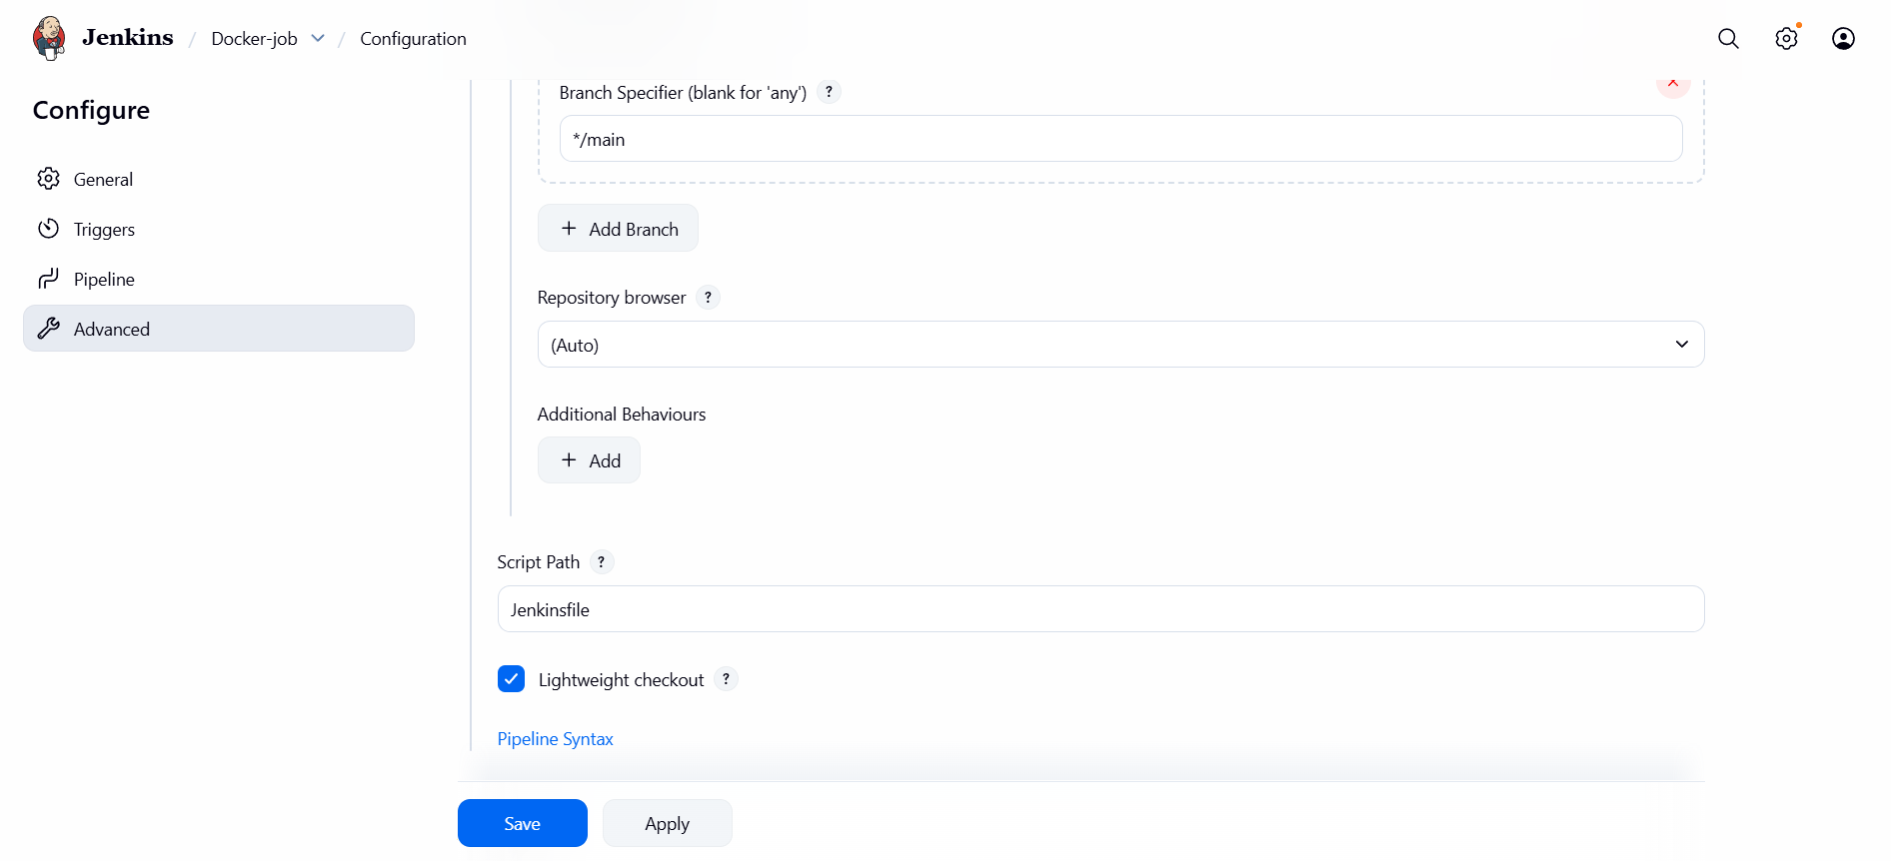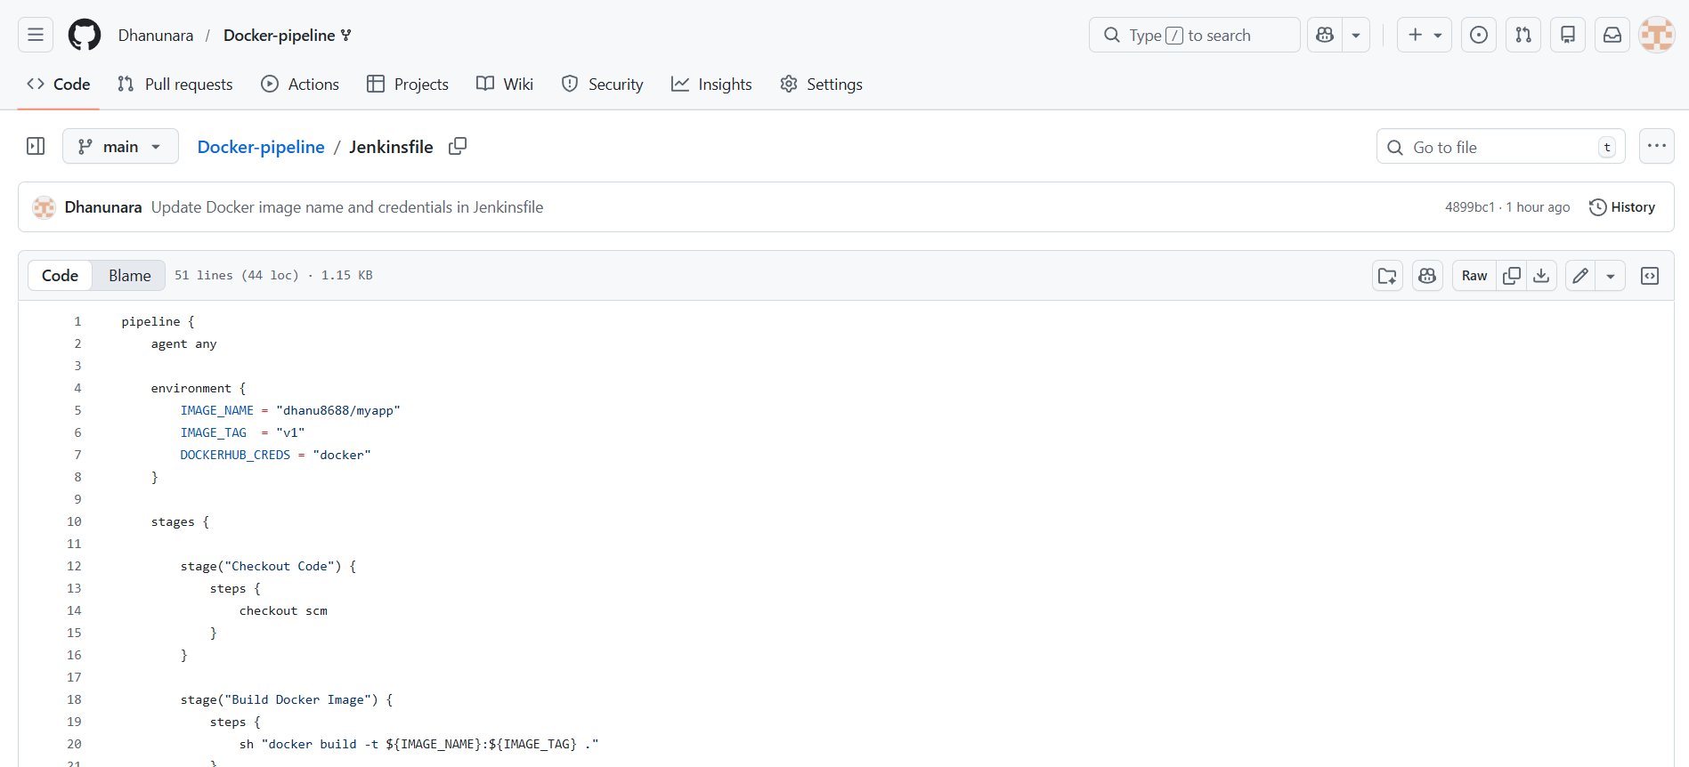

pipeline {
agent any

environment {
IMAGE_NAME = "dhanu8688/myapp"
IMAGE_TAG = "v1"
DOCKERHUB_CREDS = "docker"
}

stages {

stage("Checkout Code") {
steps {
checkout scm
}
}

stage("Build Docker Image") {
steps {
sh "docker build -t ${IMAGE_NAME}:${IMAGE_TAG} ."
}
}

stage("Docker Hub Login") {
steps {
withCredentials([usernamePassword(
credentialsId: DOCKERHUB_CREDS,
usernameVariable: 'DOCKER_USER',
passwordVariable: 'DOCKER_PASS'
)]) {
sh 'echo "$DOCKER_PASS" | docker login -u "$DOCKER_USER" --password-stdin'
}
}
}

stage("Push Image to Docker Hub") {
steps {
sh "docker push ${IMAGE_NAME}:${IMAGE_TAG}"
}
}
}

post {
success {
echo " Image successfully pushed to Docker Hub"
}
failure {
echo " Pipeline failed"
}
}
}
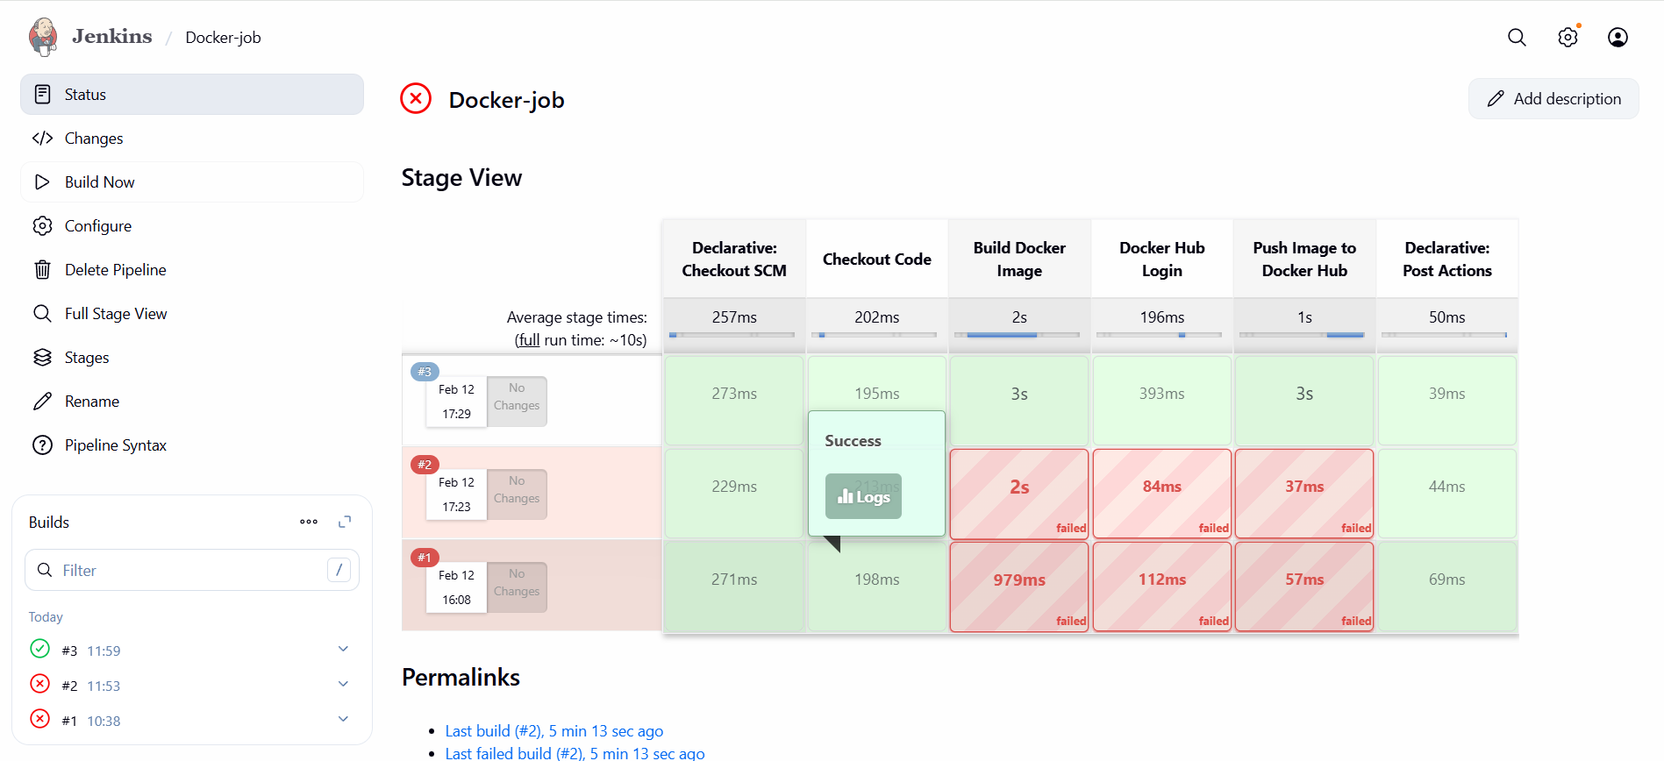
Image pushed to docker hub.
