Ansible-02

Install httpd using ansible playbook, use handlers,notifiers.

Title
Install httpd (Apache) Using Ansible Playbook with Handlers and Notifiers

Objective
The objective of this task is to automate the installation and configuration of the httpd (Apache) web server on multiple worker nodes using an Ansible playbook. The playbook is developed incrementally to install Apache, deploy a custom web page, and restart the Apache service efficiently using handlers and notifiers only when changes occur.

Prerequisites
- One Ansible Controller node (Ubuntu)
- Two Worker nodes (Ubuntu)
- Ansible installed on the controller
- Inventory file configured with worker node IPs
- Passwordless SSH or sudo access to worker nodes
- Apache package (apache2/httpd) available in repositories
- Basic understanding of YAML and Ansible modules

Step-by-Step Implementation

Create Initial Apache Playbook
A basic playbook was created to only install Apache on all worker nodes.
File: apache.yml

Command used:
ansible-playbook apache.yml --syntax-check
Purpose:
- Verify YAML syntax
- Ensure playbook structure is correct

Run Playbook in Check Mode
Before execution, the playbook was validated using dry-run mode.
ansible-playbook apache.yml –check

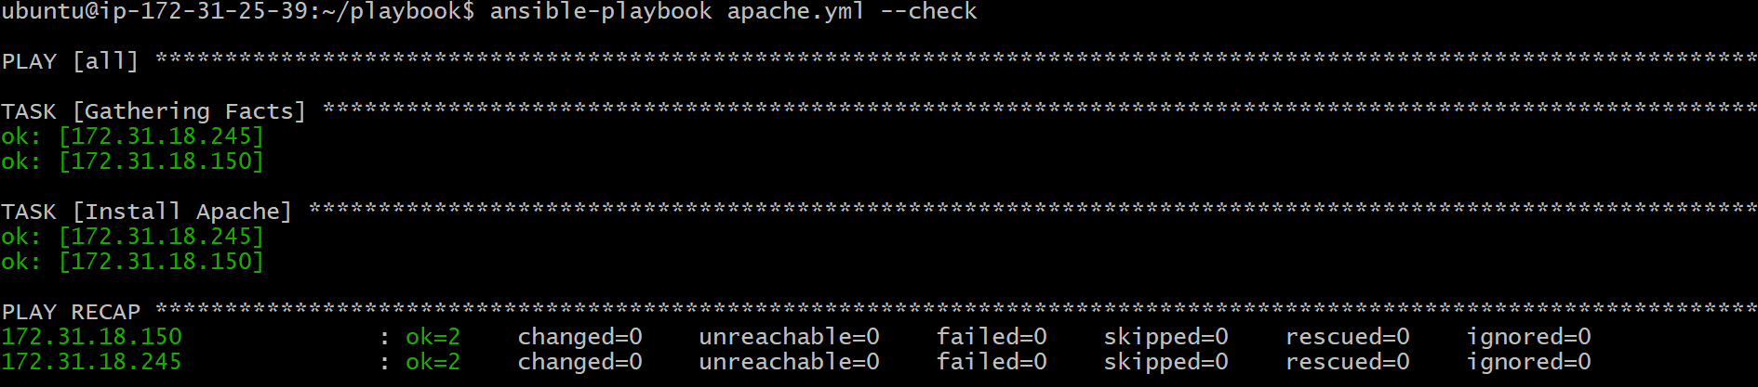

Create Custom index.html File
A custom web page was created on the Ansible controller.
vi index.html
Content added:
This is Ansible Controller
Purpose:
- Prepare a custom webpage to be deployed on Apache


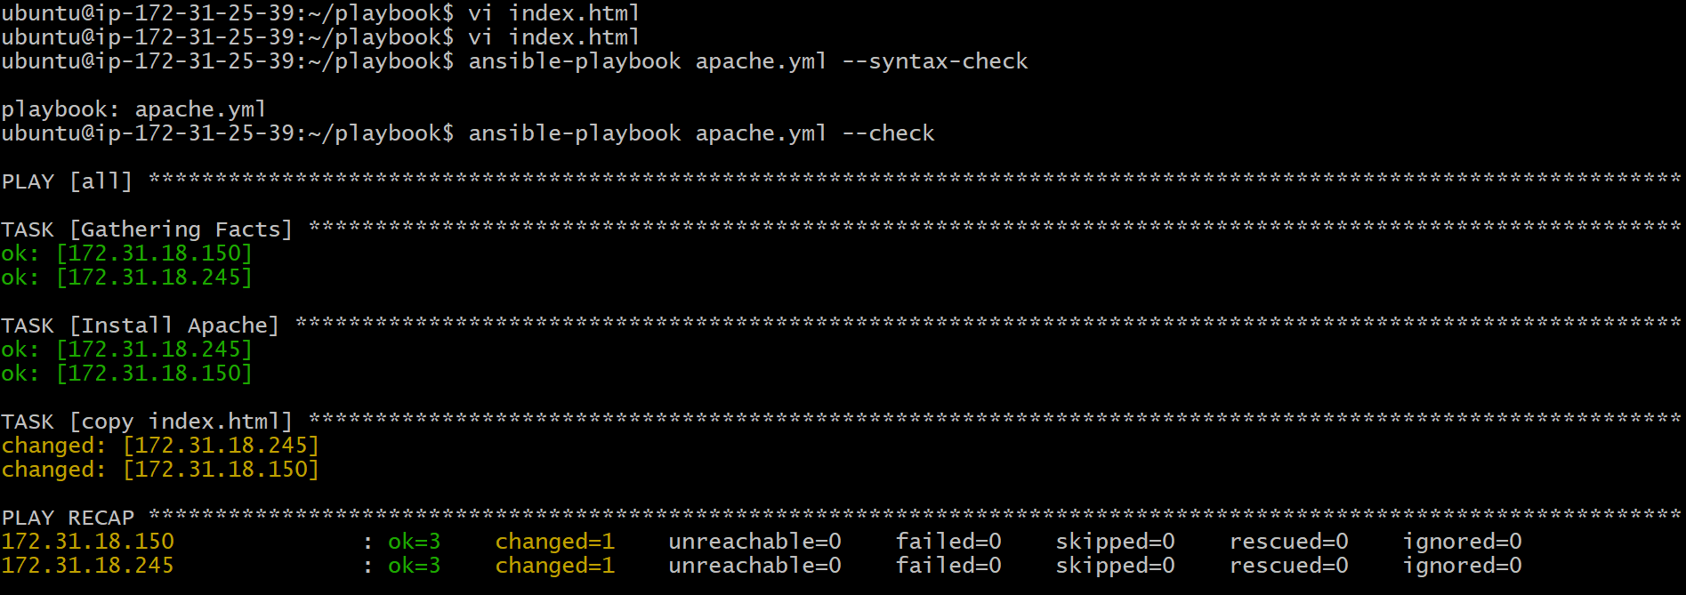

Execute Updated Playbook
The playbook was executed to apply the changes.
ansible-playbook apache.yml
Result:
- Apache installed successfully
- index.html copied to all worker nodes



Add Apache Restart Task
To reflect content changes immediately, a service restart task was added.

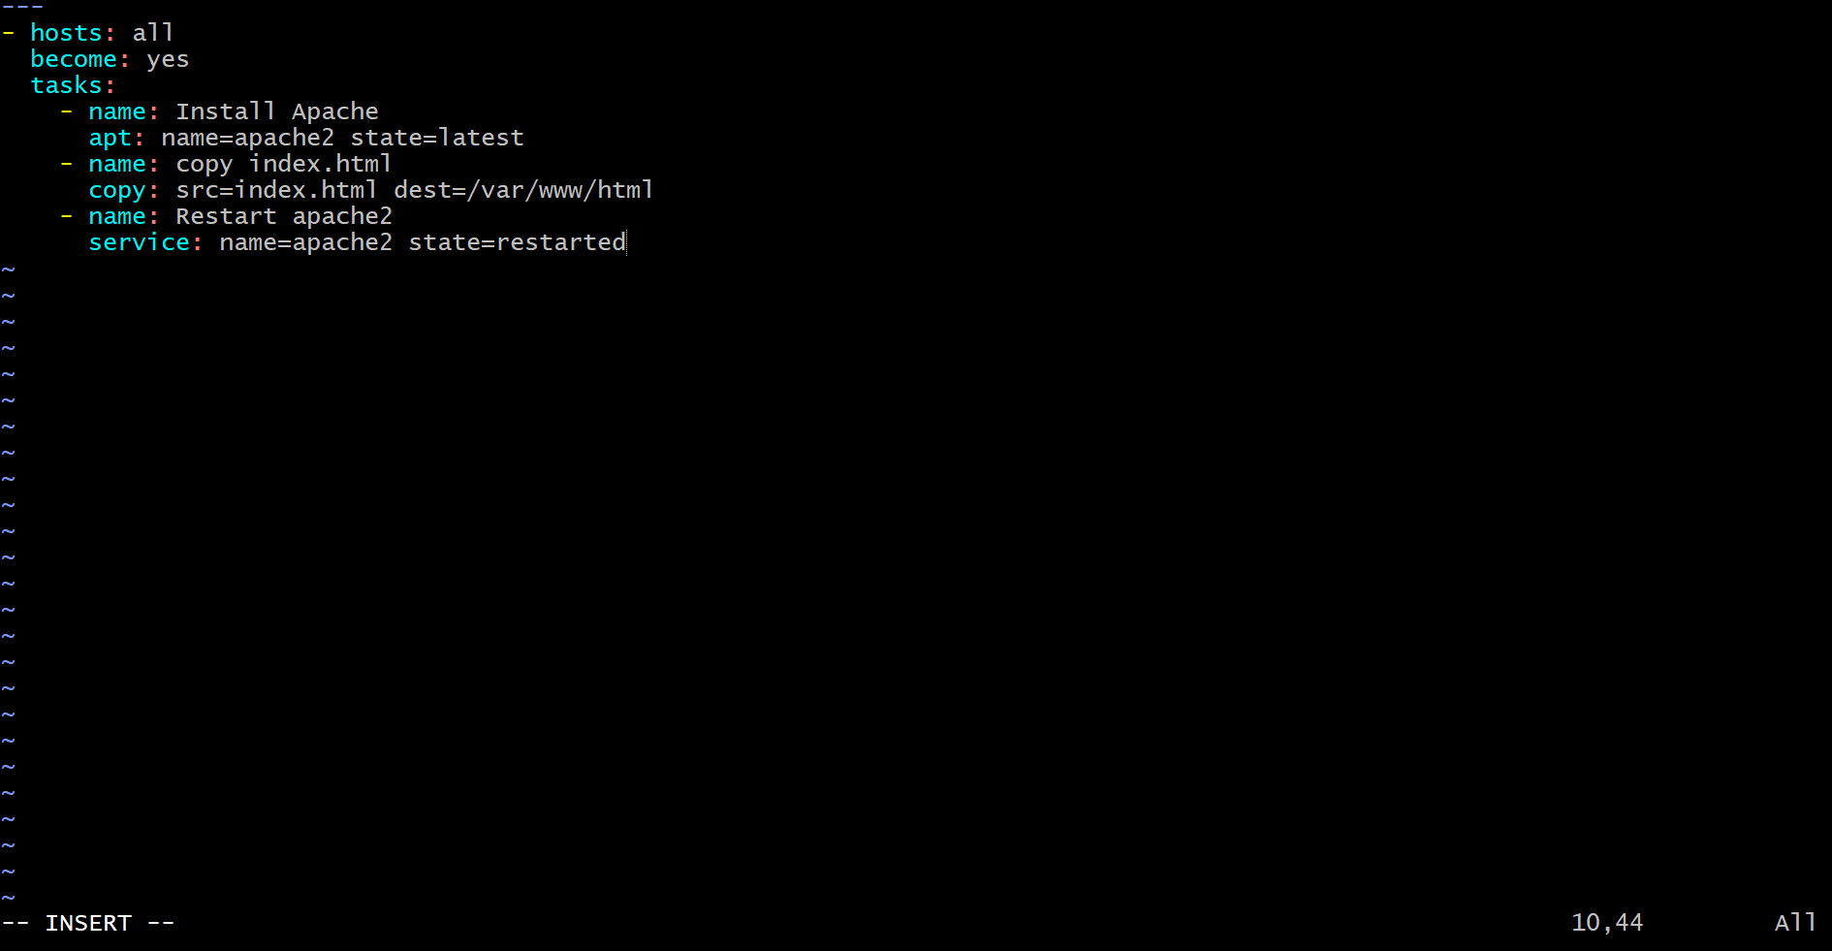
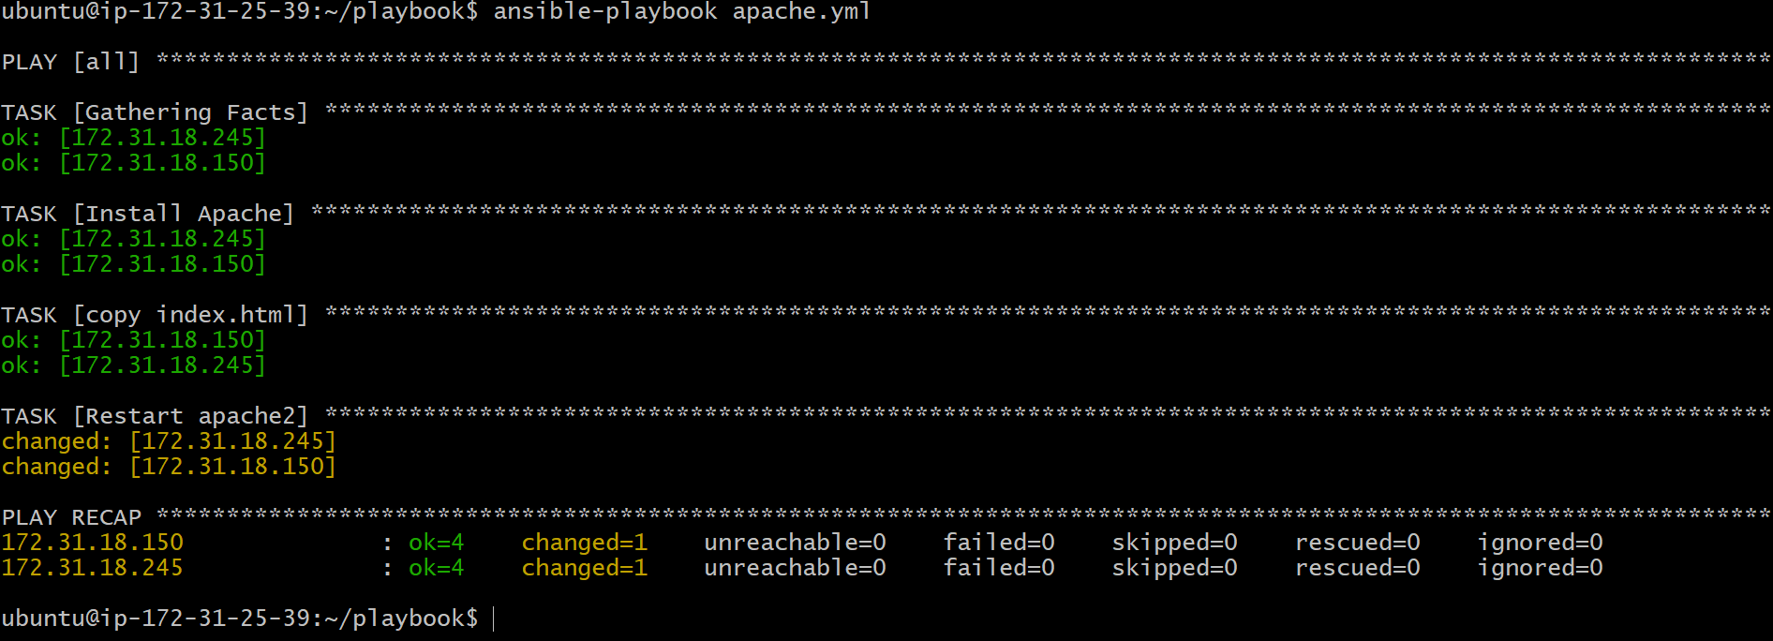


Optimize Using Handlers and Notifiers
To avoid unnecessary restarts, the restart task was moved into a handler and triggered using notify.


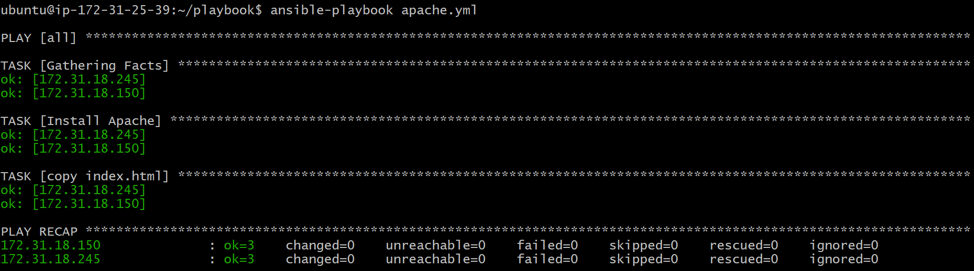

Result:
- Apache restarts only when index.html changes
- Improved efficiency and idempotency

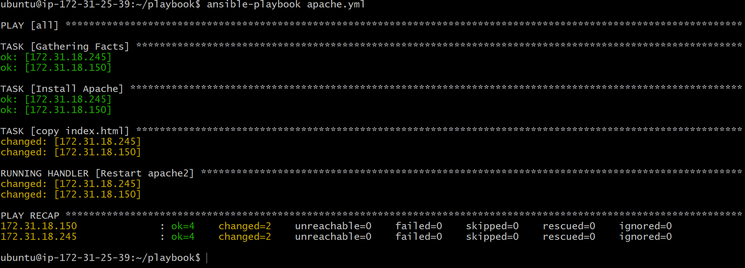

Conclusion
This task demonstrates how to install and manage the httpd (Apache) web server using an Ansible playbook built incrementally. By introducing handlers and notifiers, the Apache service restarts only when configuration changes occur, ensuring idempotency and efficient automation. This approach reflects real-world DevOps best practices for configuration management and service orchestration.

Write a ansible playbook to install apache tomcat.

Title
Install Apache Tomcat Using Ansible Playbook (Binary Installation)

Objective
The objective of this task is to install Apache Tomcat on multiple worker nodes using an Ansible playbook by downloading the Tomcat binary from the official Apache archive URL. Java is installed as a prerequisite, Tomcat is extracted to a custom directory, and post-installation permission and startup steps are performed on the worker nodes.

Prerequisites
- One Ansible Controller node (Ubuntu)
- Two Worker nodes (Ubuntu)
- Ansible installed on the controller
- Inventory file configured with worker node IPs
- SSH connectivity between controller and worker nodes
- Sudo privileges on worker nodes
- Internet access from worker nodes
- Basic knowledge of YAML and Ansible

Step-by-Step Implementation

Step 1: Create Tomcat Playbook
On the Ansible controller, navigate to the playbook directory:
cd ~/playbooks
vi tomcat.yml

Step 2: Add Tasks to Install Java and Tomcat
The playbook was written incrementally with the following tasks:

- hosts: all
become: yes

tasks:
- name: Install Java
apt:
name: openjdk-11-jdk
state: present
update_cache: yes

- name: Create tomcat directory
file:
path: /opt/tomcat
state: directory

- name: Download Tomcat
get_url:
url: https://archive.apache.org/dist/tomcat/tomcat-9/v9.0.85/bin/apache-tomcat-9.0.85.tar.gz
dest: /tmp/tomcat.tar.gz

- name: Extract Tomcat
unarchive:
src: /tmp/tomcat.tar.gz
dest: /opt/tomcat
remote_src: yes

Step 3: Validate the Playbook
Syntax validation was performed to ensure correctness:
ansible-playbook tomcat.yml --syntax-check

Step 4: Execute the Playbook
The playbook was executed from the controller:
ansible-playbook tomcat.yml
Result:
- Java installed successfully
- Tomcat downloaded and extracted under /opt/tomcat on all worker nodes

Step 5: Post-Installation Steps on Worker Nodes
Since Tomcat was installed using binaries, the following steps were performed manually on each worker node.

Permission Update:
sudo chmod +x /opt/tomcat/apache-tomcat-9.0.85/bin/*.sh

Start Tomcat:
sudo /opt/tomcat/apache-tomcat-9.0.85/bin/startup.sh

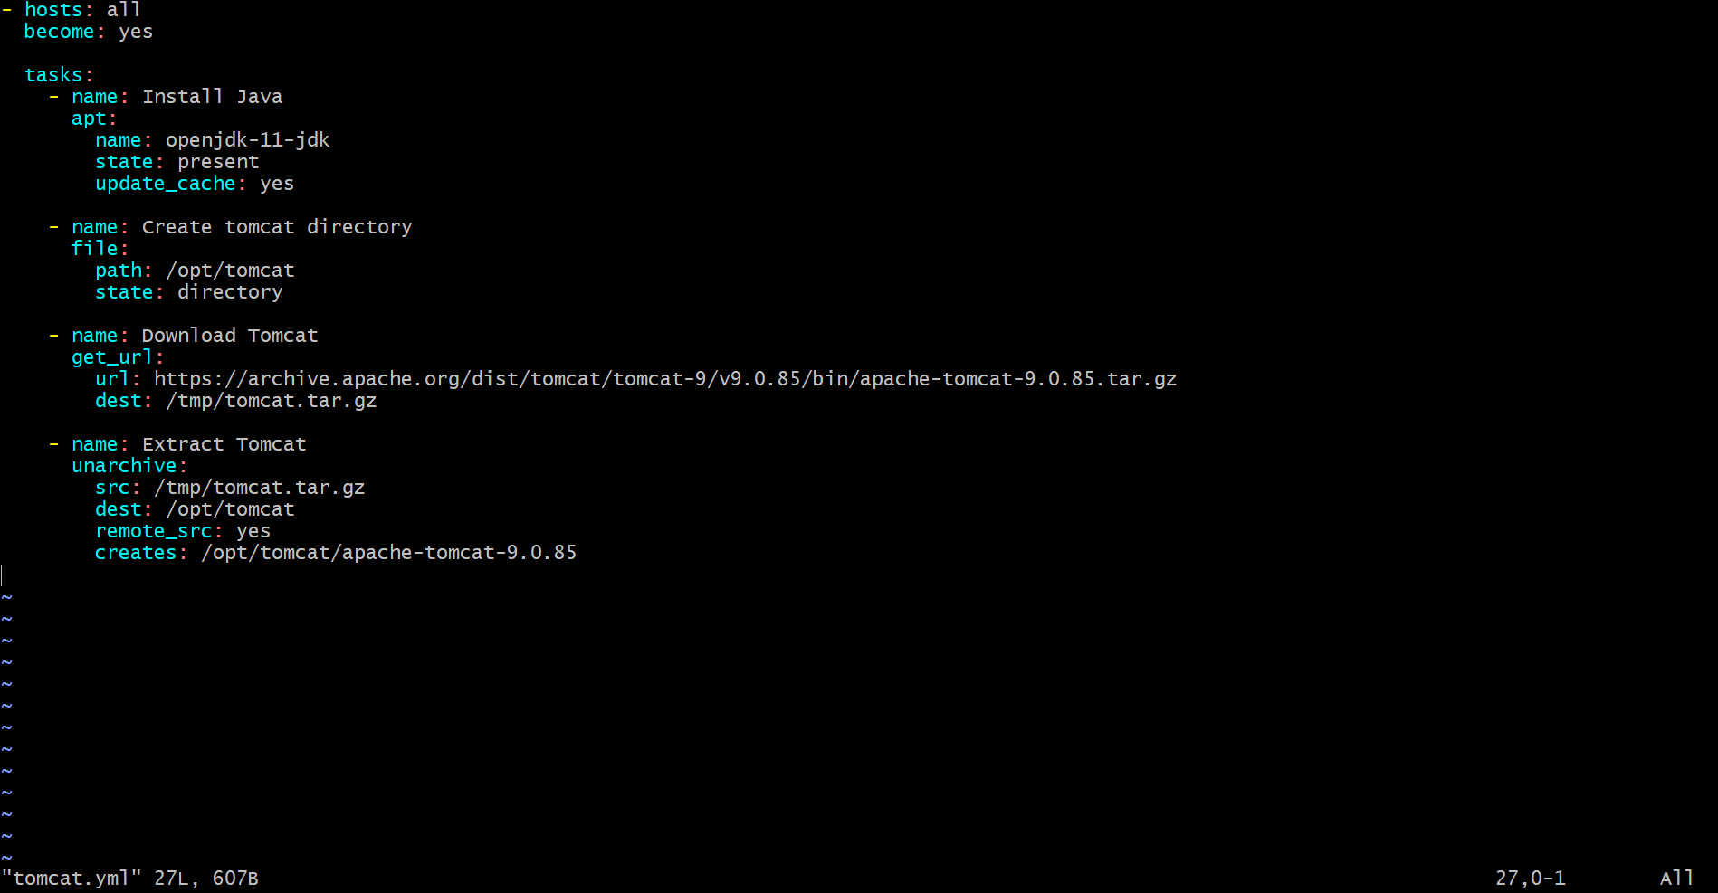
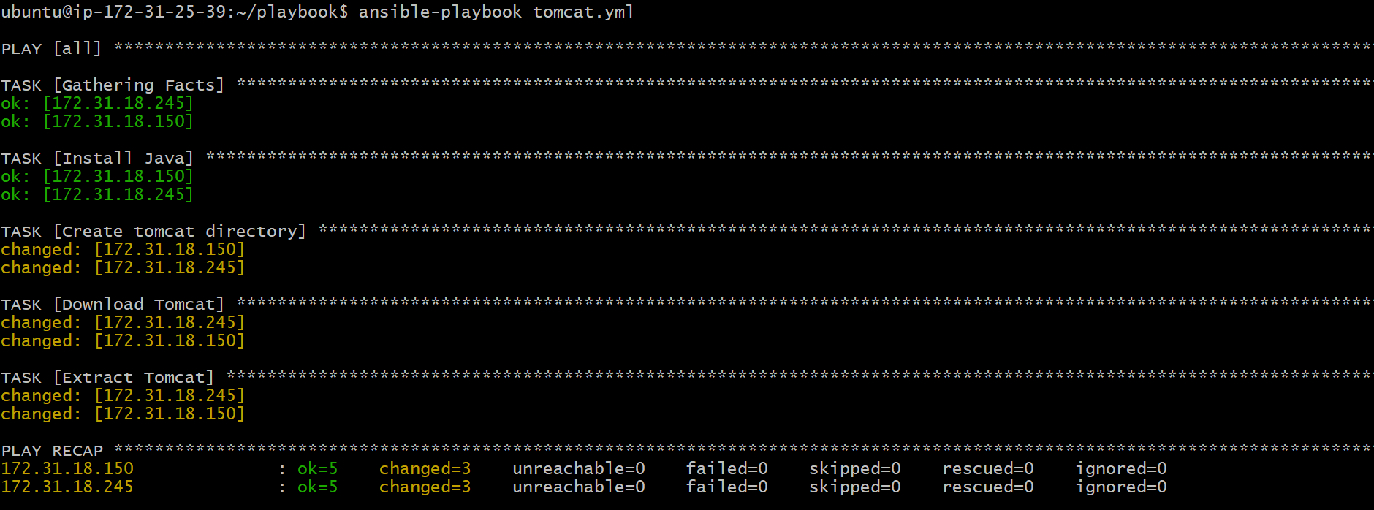

Validation Steps
- Verify Tomcat Process
ps -ef | grep tomcat
- Access Tomcat in Browser
Open:
http://<worker-node-public-ip>:8080
Expected output:
Apache Tomcat/9.0.85

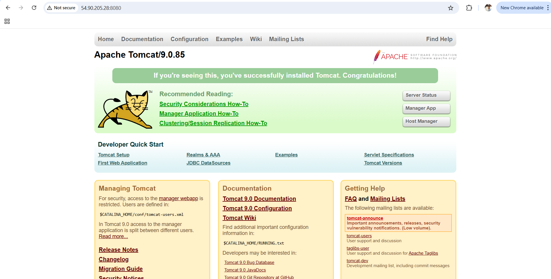
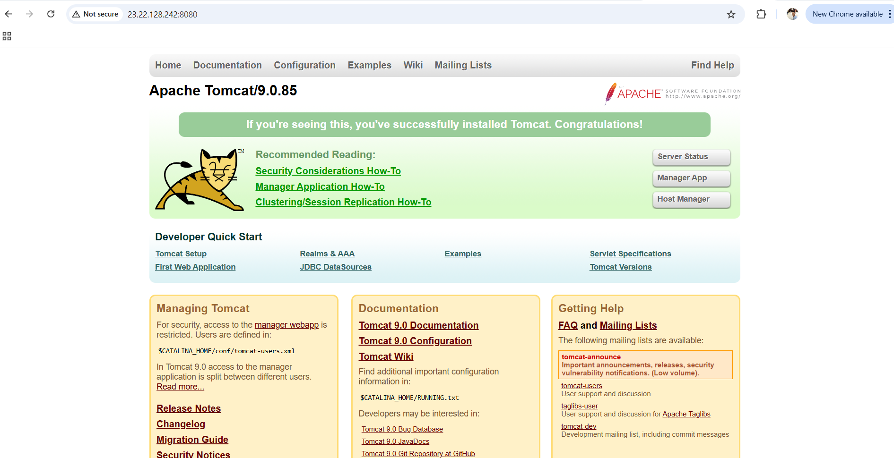

Conclusion
This task demonstrates how Apache Tomcat can be installed using an Ansible playbook without relying on OS package repositories. By downloading the Tomcat binary from the Apache archive, the installation becomes OS-independent. Java was installed as a prerequisite, and Tomcat was successfully extracted and started on multiple worker nodes, showcasing Ansible’s ability to automate multi-node software installation in a controlled and repeatable manner.

Write a ansible playbook to provision one ec2 on aws.

Title
Provision One EC2 Instance on AWS Using Ansible Playbook

Objective
To provision a single EC2 instance in AWS using an Ansible playbook by connecting to AWS through IAM credentials and launching the instance with the required configuration.

Prerequisites
- AWS account
- IAM user with EC2 permissions
- AWS CLI installed and configured
- Ansible installed on control node
- amazon.aws Ansible collection installed
- Existing AWS resources:
  - Key pair
  - VPC and Subnet
  - Security Group
- Valid AMI ID for the selected region

Step-by-Step Implementation

Step 1: Configure AWS Credentials
aws configure

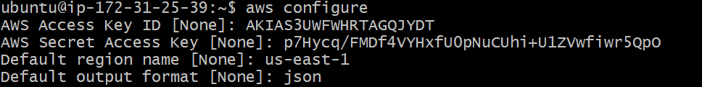
Sudo apt update
sudo apt install python3 python3-pip -y
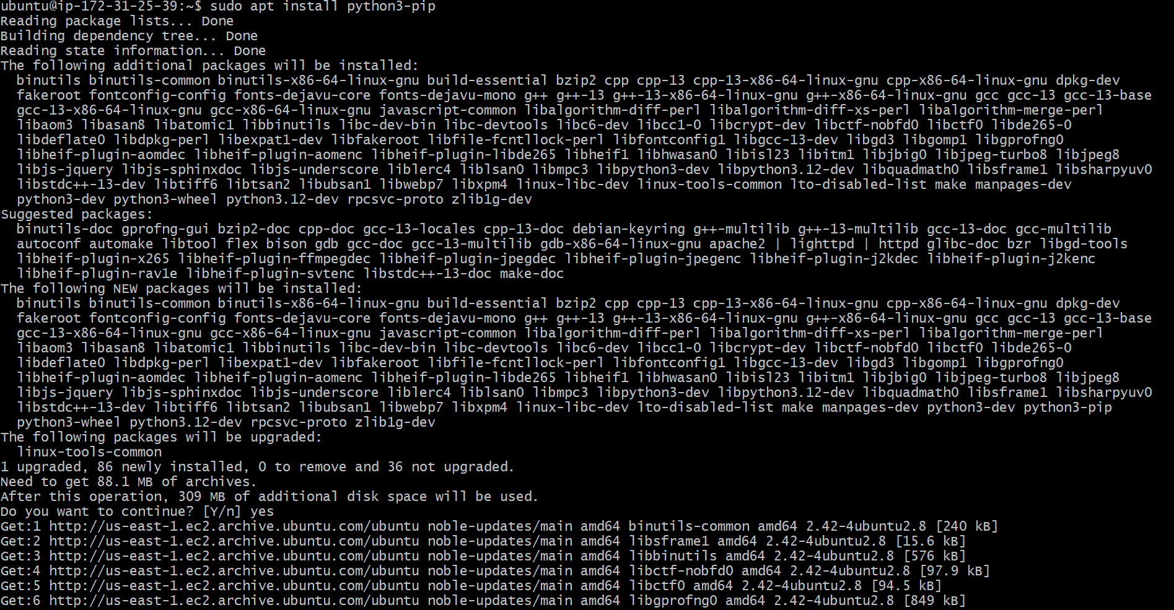

Step 2: Create Ansible Playbook
Create the playbook using vi editor:
vi ec2.yml
Add the following content:
- name: Provision one EC2 instance using Ansible
hosts: localhost
connection: local
gather_facts: no

tasks:
- name: Launch EC2 instance
amazon.aws.ec2_instance:
name: ansible-ec2
key_name: dhanu
instance_type: t3.micro
image_id: ami-04233b5aecce09244
region: eu-north-1
vpc_subnet_id: subnet-0a501b086b05a1ea7
security_groups:
- default
network:
assign_public_ip: true
count: 1
wait: yes
Save and exit:
:wq

Step 3: Run the Ansible Playbook
ansible-playbook ec2.yml


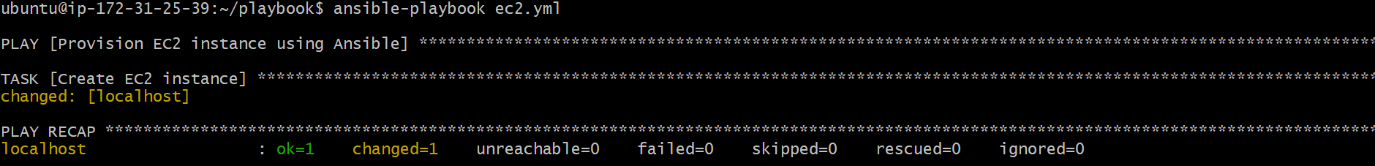
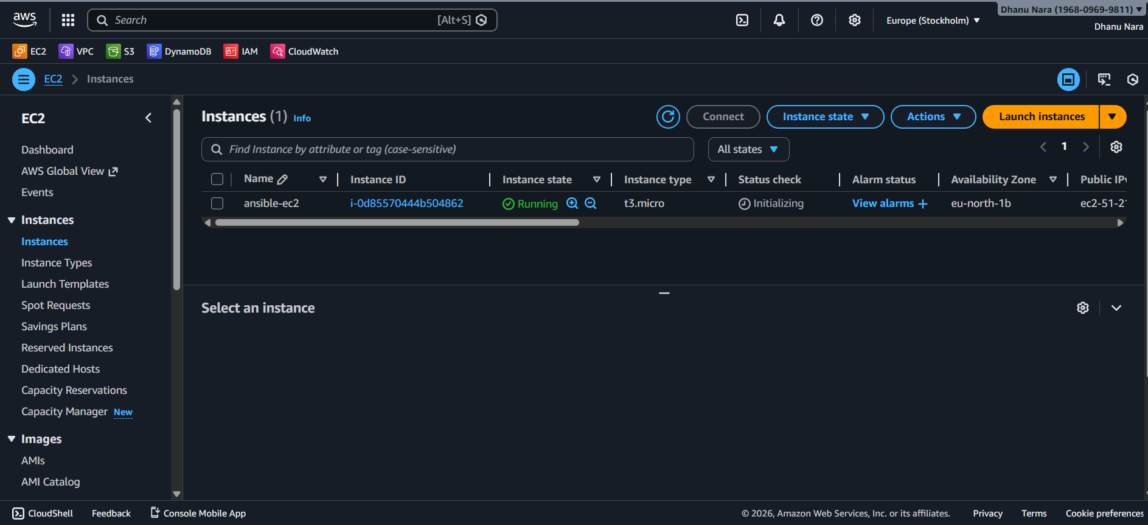

Conclusion
The EC2 instance was successfully provisioned on AWS using an Ansible playbook. This approach enables automated, repeatable, and consistent infrastructure provisioning without manual intervention through the AWS console.

Write a ansible playbook to copy one file from node-1 to node-2.

Title
Copy a File from One Node to Another Using Ansible Playbook

Objective
To copy a file from one managed node (Worker 1) to another managed node (Worker 2) using Ansible, with the control node acting as an intermediary.

Prerequisites
- Ansible installed on the control node
- SSH connectivity from control node to both worker nodes
- Inventory already configured and reachable
- Python installed on all nodes
- Source file available on Worker 1

Step-by-Step Implementation

Step 1: Verify Connectivity
Ensure Ansible can connect to all nodes:
ansible all -m ping
Expected output:
SUCCESS

Step 2: Verify Source File on Worker 1
Login to Worker 1:
ssh ubuntu@172.31.18.245
Check file existence:
ls /tmp/sample.txt
If the file does not exist, create it:
echo "Hello from worker 1" > /tmp/sample.txt
Exit:
exit

Step 3: Create Ansible Playbook
Create the playbook using vi editor:
vi copyfile.yml
Add the following content:
- name: Fetch file from worker 1 to control node
hosts: 172.31.18.245
gather_facts: no

tasks:
- name: Fetch file
fetch:
src: /tmp/sample.txt
dest: /tmp/sample.txt
flat: yes

- name: Copy file from control node to worker 2
hosts: 172.31.18.150
gather_facts: no

tasks:
- name: Copy file to worker2
copy:
src: /tmp/sample.txt
dest: /tmp/sample.txt
force: no
Save and exit:
:wq

Step 4: Run the Playbook
Execute the playbook:
ansible-playbook copyfile.yml

Validation Steps

Validation 1: Check on Worker 2
Login to Worker 2:
ssh ubuntu@172.31.18.150
Verify file:
ls -l /tmp/sample.txt
cat /tmp/sample.txt

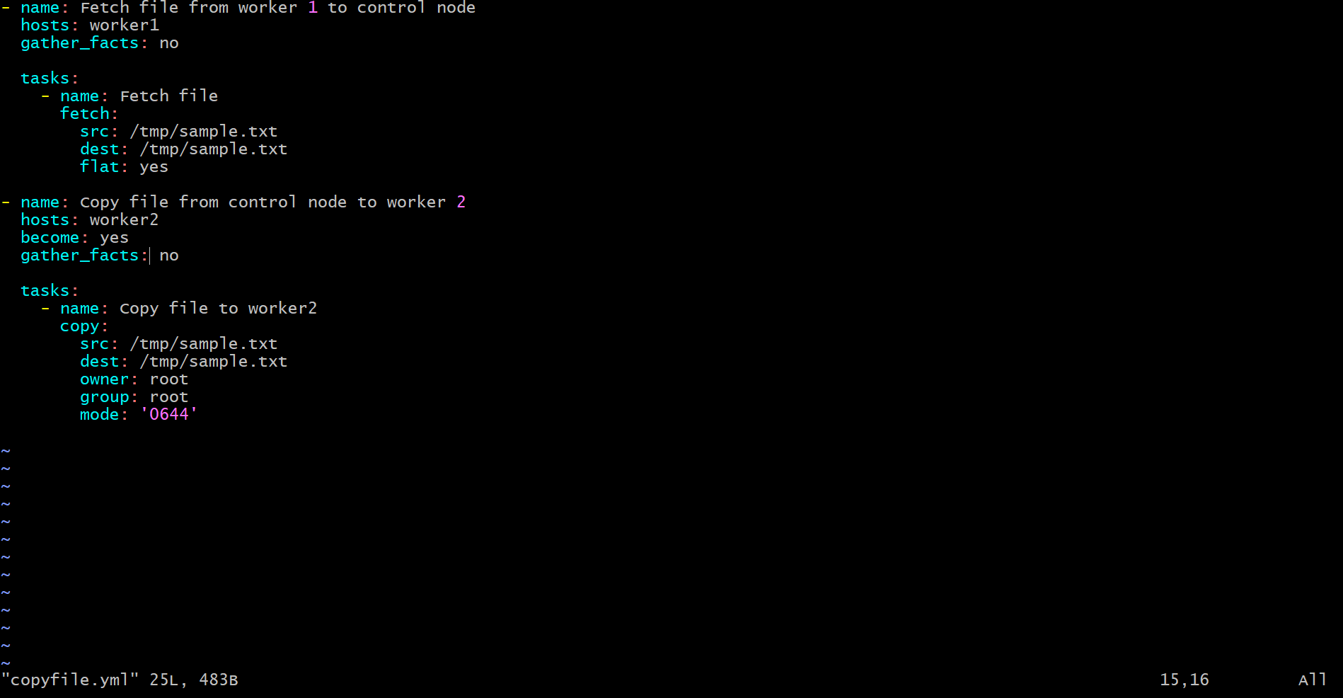
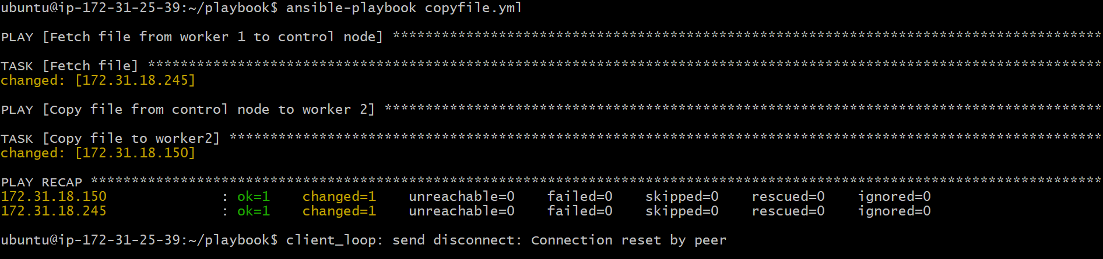
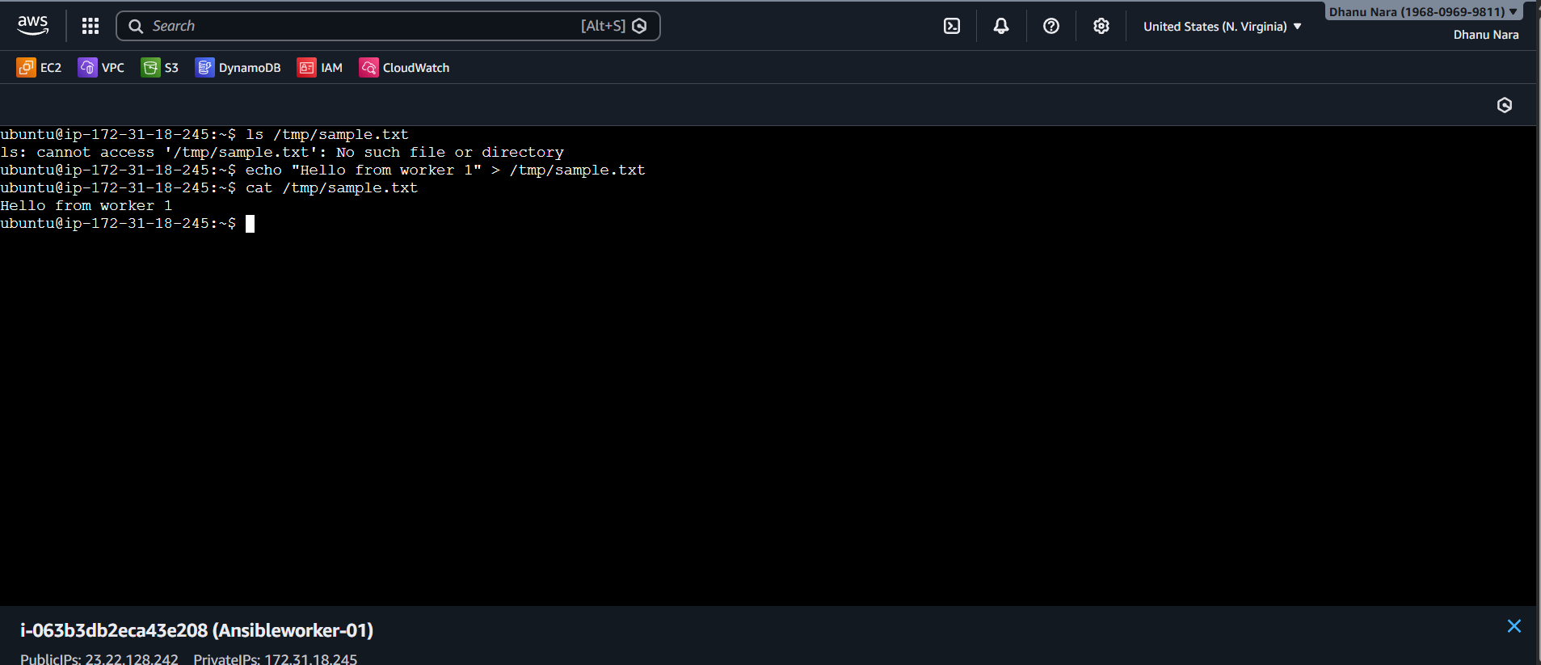
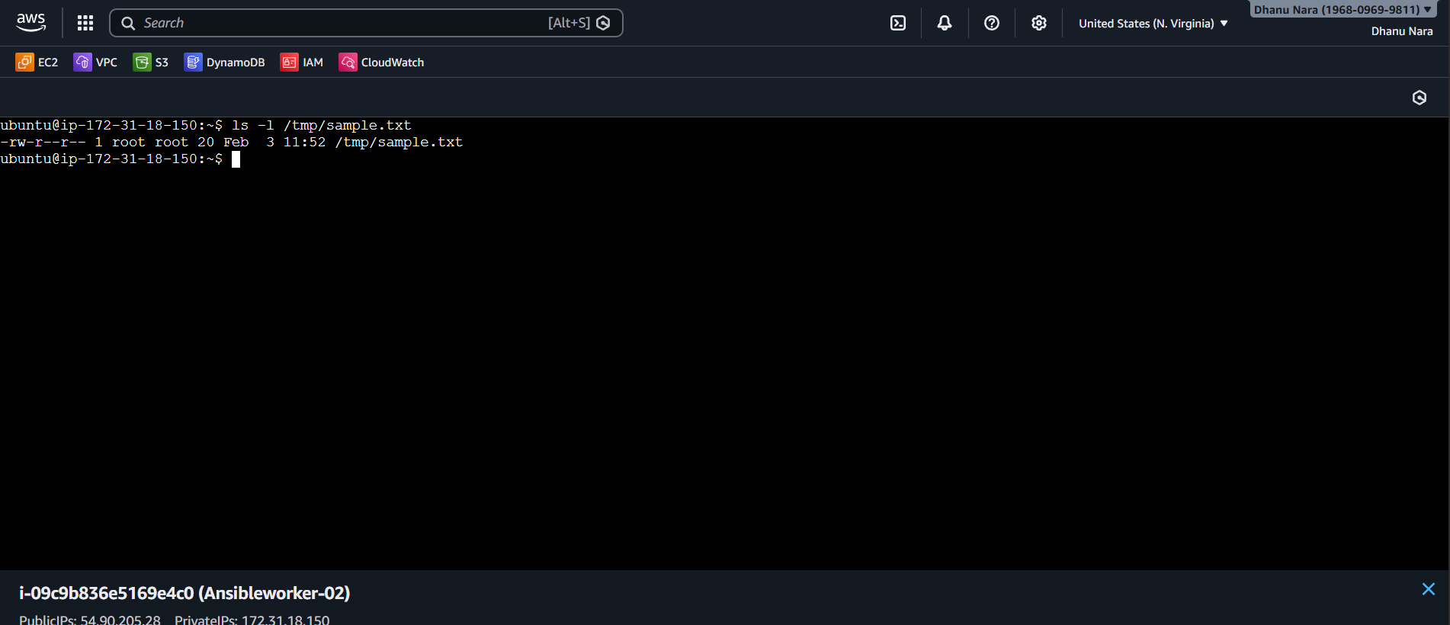

Conclusion
The file was successfully copied from Worker 1 to Worker 2 using Ansible. The task demonstrated Ansible’s fetch and copy modules, proper troubleshooting of common issues, and validation of idempotent behavior.

Write a ansible playbook to create different files with different names using single playbook.

Title
Create Multiple Files with Different Names Using a Single Ansible Playbook

Objective
To create multiple files with different names on managed nodes using a single Ansible playbook in an automated and idempotent way.

Prerequisites
- Ansible installed on control node
- SSH connectivity to target node(s)
- Inventory already configured
- Python installed on managed nodes

Step-by-Step Implementation

Step 1: Create Ansible Playbook
Create the playbook using vi editor:
vi create_files.yml
Add the following content:
- name: Create multiple files using one playbook
hosts: all
become: yes
gather_facts: no

vars:
file_list:
- /tmp/file1.txt
- /tmp/file2.log
- /tmp/file3.conf
- /tmp/file4.sh

tasks:
- name: Create files with different names
file:
path: "{{ item }}"
state: touch
mode: '0644'
loop: "{{ file_list }}"
Save and exit:
:wq

Step 2: Run the Playbook
ansible-playbook create_files.yml

Validation Steps
Login to any managed node and verify:
ls -l /tmp/file*
Expected:
file1.txt
file2.log
file3.conf
file4.sh


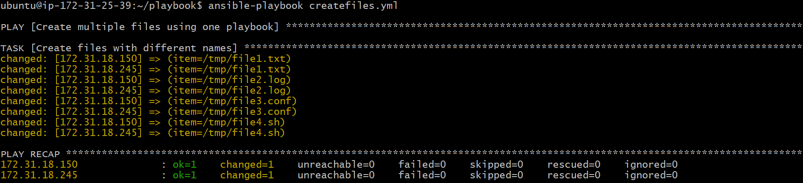
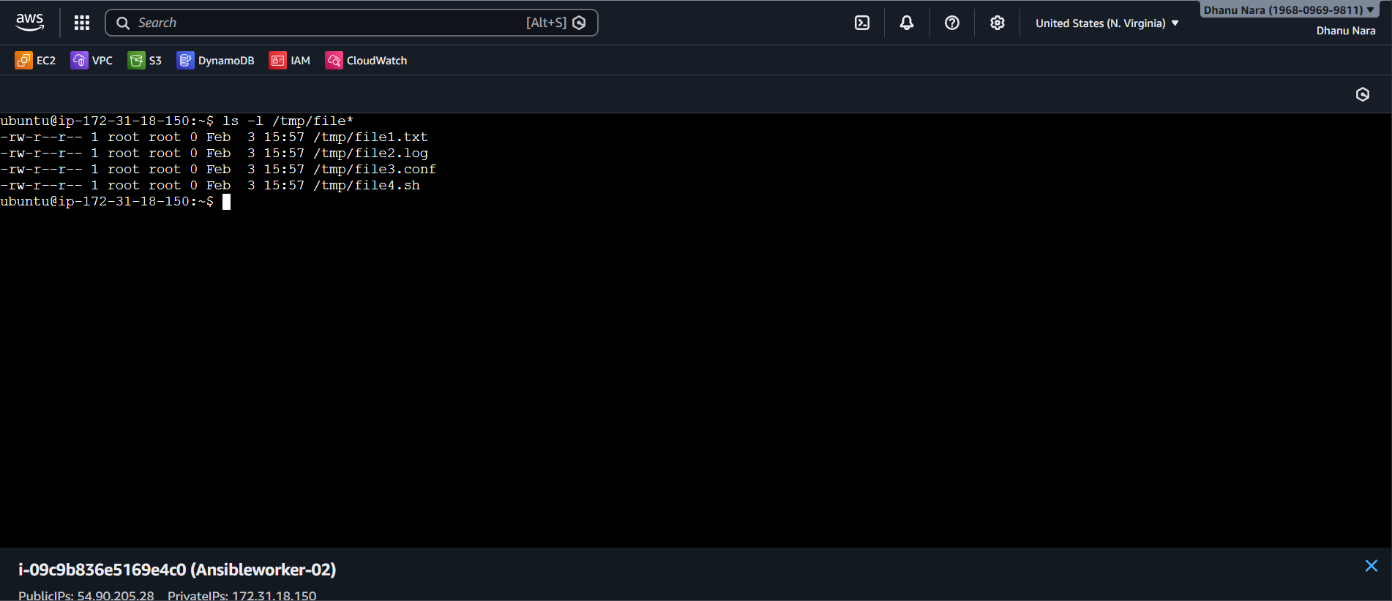
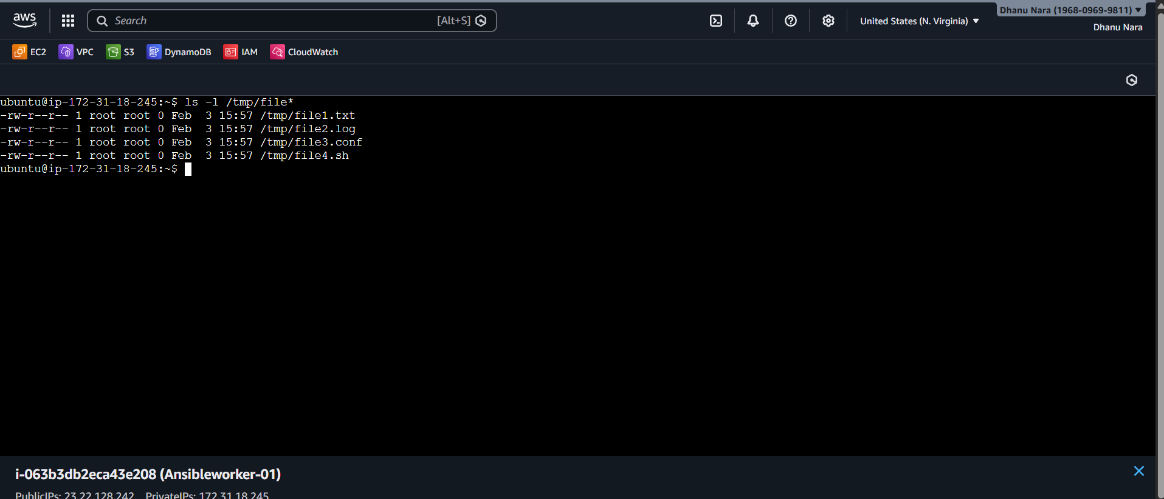

Conclusion
Using a single Ansible playbook with loops, multiple files with different names were successfully created. This method is efficient, scalable, and avoids writing multiple tasks for similar operations.

