Ansible-03

1.Write a single ansible playbook which will install apache and nginx. Note: Playbook should not be hardcoded and pass the variables from different file.

TITLE
Ansible Playbook to Install and Configure Apache and Nginx Using External Variables File

OBJECTIVE
To create a single Ansible playbook that installs and configures Apache (port 80) and Nginx (port 81) on multiple EC2 instances by passing all package/service/port details from an external variables file, avoiding hardcoding inside the playbook.

PREREQUISITES
- Ansible installed on control node (Master).
- Target servers (EC2 instances) must be reachable via SSH.
- Inventory file should contain the target server IPs under a group like [webservers].
- SSH key file should be configured properly.
- Python3 must be available on managed nodes.
- Ports must be allowed in Security Group:
  - 80 for Apache
  - 81 for Nginx
- Folder structure should contain:
  - playbook.yml
  - vars/webservers.yml
  - inventory

Step 1: Create Variables File
Create directory:
mkdir -p vars
Create vars file:
vi vars/webservers.yml
Add below content:
apache_package: apache2
apache_service: apache2
apache_port: 80

nginx_package: nginx
nginx_service: nginx
nginx_port: 81
Save and exit:
:wq



Step 2: Create Ansible Playbook
Create playbook file:
vi playbook.yml
Paste this playbook:
---
- name: Install and configure Apache and Nginx
hosts: webservers
become: yes

vars_files:
- vars/webservers.yml

tasks:
- name: Install Apache
apt:
name: "{{ apache_package }}"
state: present
update_cache: yes

- name: Configure Apache port
lineinfile:
path: /etc/apache2/ports.conf
regexp: '^Listen'
line: "Listen {{ apache_port }}"
notify: Restart Apache

- name: Start and enable Apache
service:
name: "{{ apache_service }}"
state: started
enabled: yes

- name: Install Nginx
apt:
name: "{{ nginx_package }}"
state: present

- name: Remove default Nginx site if exists
file:
path: /etc/nginx/sites-enabled/default
state: absent

- name: Create Nginx config for custom port
copy:
dest: /etc/nginx/conf.d/custom.conf
content: |
server {
listen {{ nginx_port }};
location / {
root /usr/share/nginx/html;
index index.html;
}
}
notify: Restart Nginx

- name: Start and enable Nginx
service:
name: "{{ nginx_service }}"
state: started
enabled: yes

handlers:
- name: Restart Apache
service:
name: "{{ apache_service }}"
state: restarted

- name: Restart Nginx
service:
name: "{{ nginx_service }}"
state: restarted
Save:
:wq

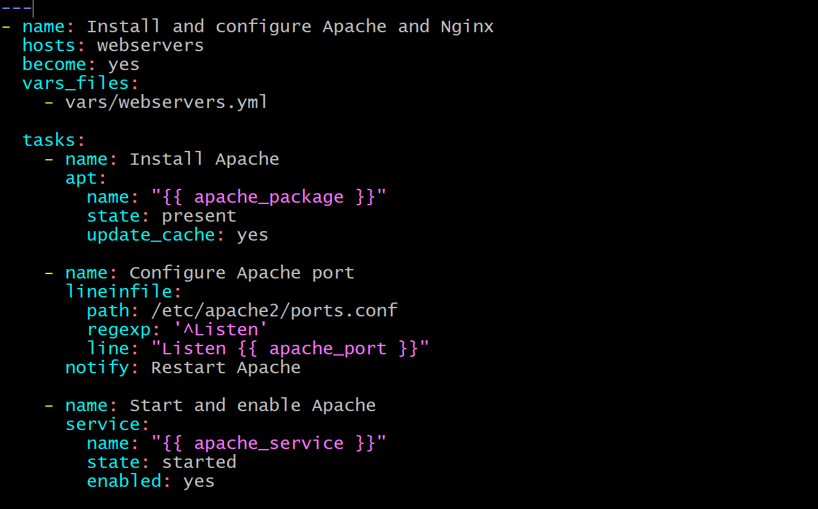
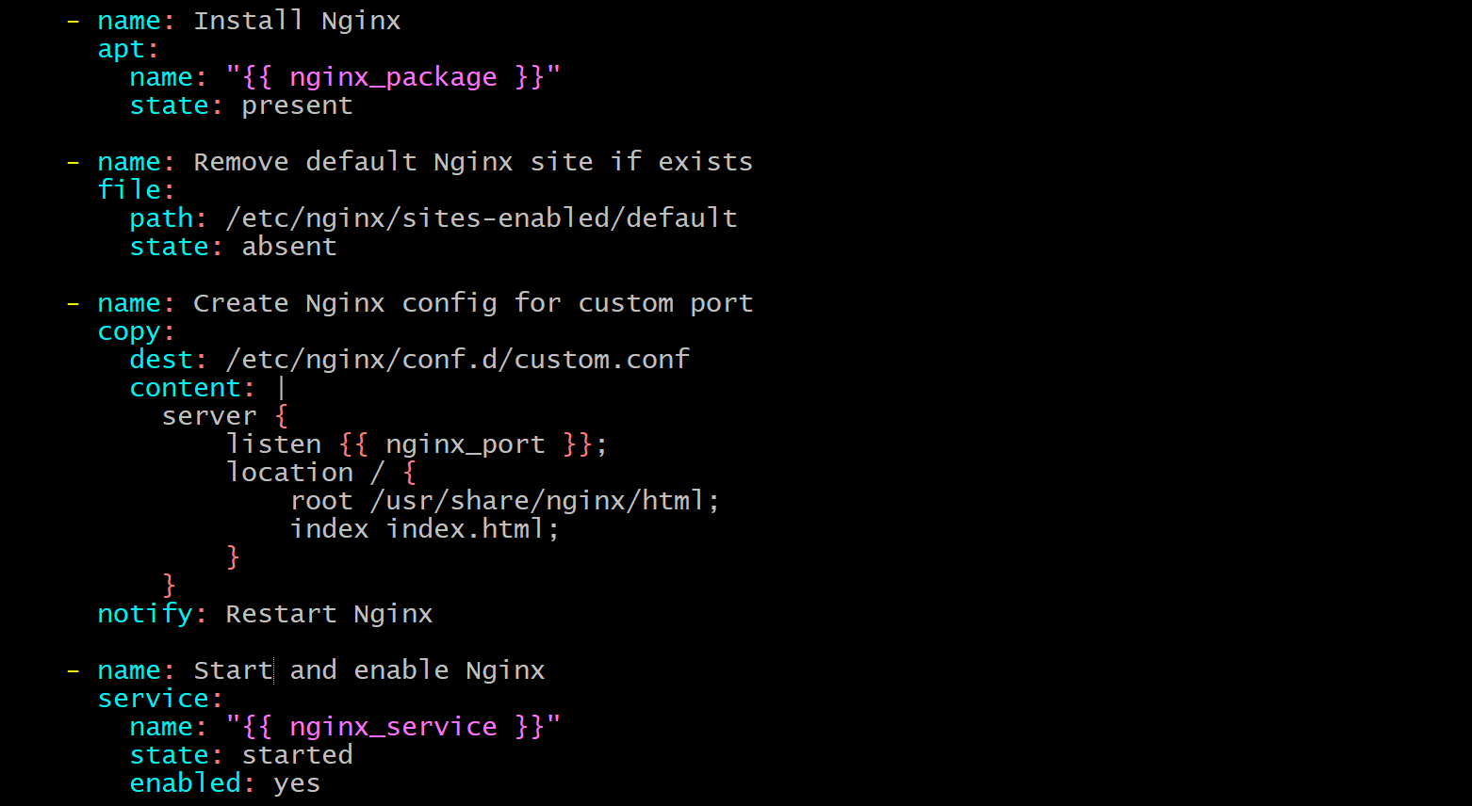


Step 3: Run the Playbook
Execute:
ansible-playbook -i inventory playbook.yml

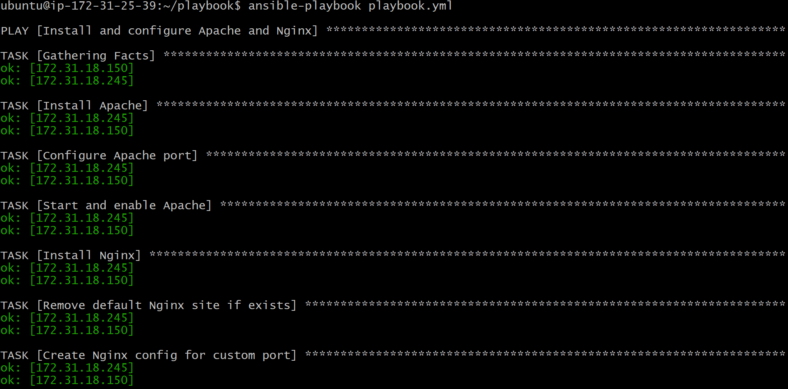
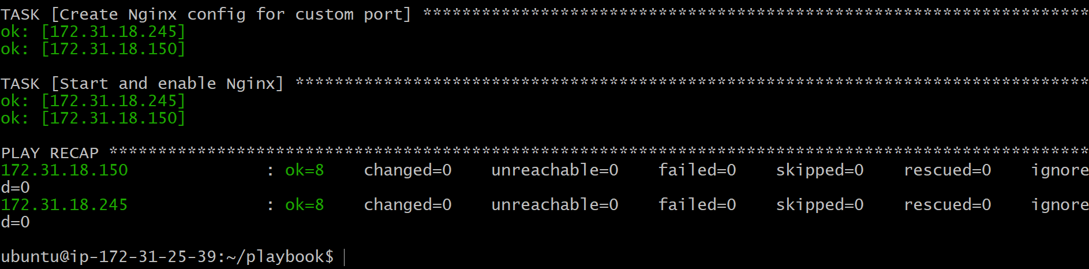
Security groups custom tcp 81 and http 80 has to configure.

Check the worker1 publicIP:80
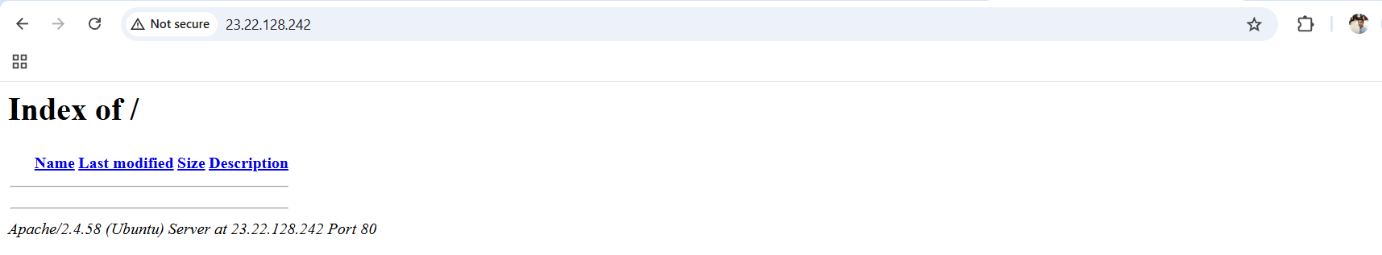

Public IP:81 of worker1

publicIP:80 of worker2
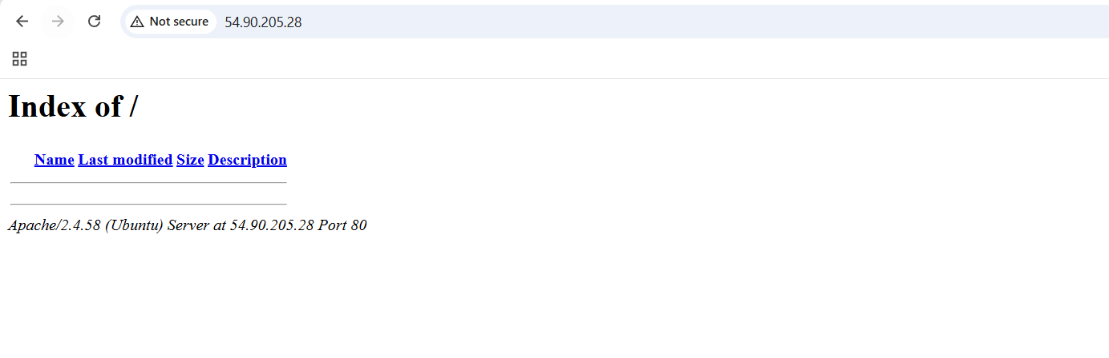
PublicIP:81 of worker2


CONCLUSION
This implementation successfully installs and configures Apache and Nginx on multiple servers using a single Ansible playbook while keeping all configuration values like package names, service names, and ports in an external variables file. This approach ensures the playbook is not hardcoded, reusable, easy to modify, and follows best automation practices.

2.Ansible playbook to create 10 different directories with minimal code and directory names should be passed as variables.

TITLE
Ansible Playbook to Create 10 Directories Using Variables File (Minimal Code)

OBJECTIVE
To create 10 different directories on multiple remote servers using a single Ansible playbook with minimal code, where all directory names/paths are stored in a separate variables file (no hardcoding inside playbook).

PREREQUISITES
- Ansible installed on control node.
- Inventory configured with target servers under group webservers.
- SSH connectivity working (ansible webservers -m ping should be SUCCESS).
- become: yes access enabled (sudo permission).
- Folder structure available:
  - create_dirs.yml
  - vars/dirs.yml
  - inventory

STEP-BY-STEP IMPLEMENTATION

Step 1: Create vars folder
mkdir -p vars

Step 2: Create variables file for directory list
vi vars/dirs.yml
Add:
dir_list:
- /opt/dir1
- /opt/dir2
- /opt/dir3
- /opt/dir4
- /opt/dir5
- /opt/dir6
- /opt/dir7
- /opt/dir8
- /opt/dir9
- /opt/dir10
Save:
:wq




Step 3: Create playbook file
vi create_dirs.yml
Paste:
---
- name: Create multiple directories
hosts: webservers
become: yes

vars_files:
- vars/dirs.yml

tasks:
- name: Create directories
file:
path: "{{ item }}"
state: directory
mode: "0755"
loop: "{{ dir_list }}"
Save:
:wq



Step 4: Run playbook
ansible-playbook -i inventory create_dirs.yml

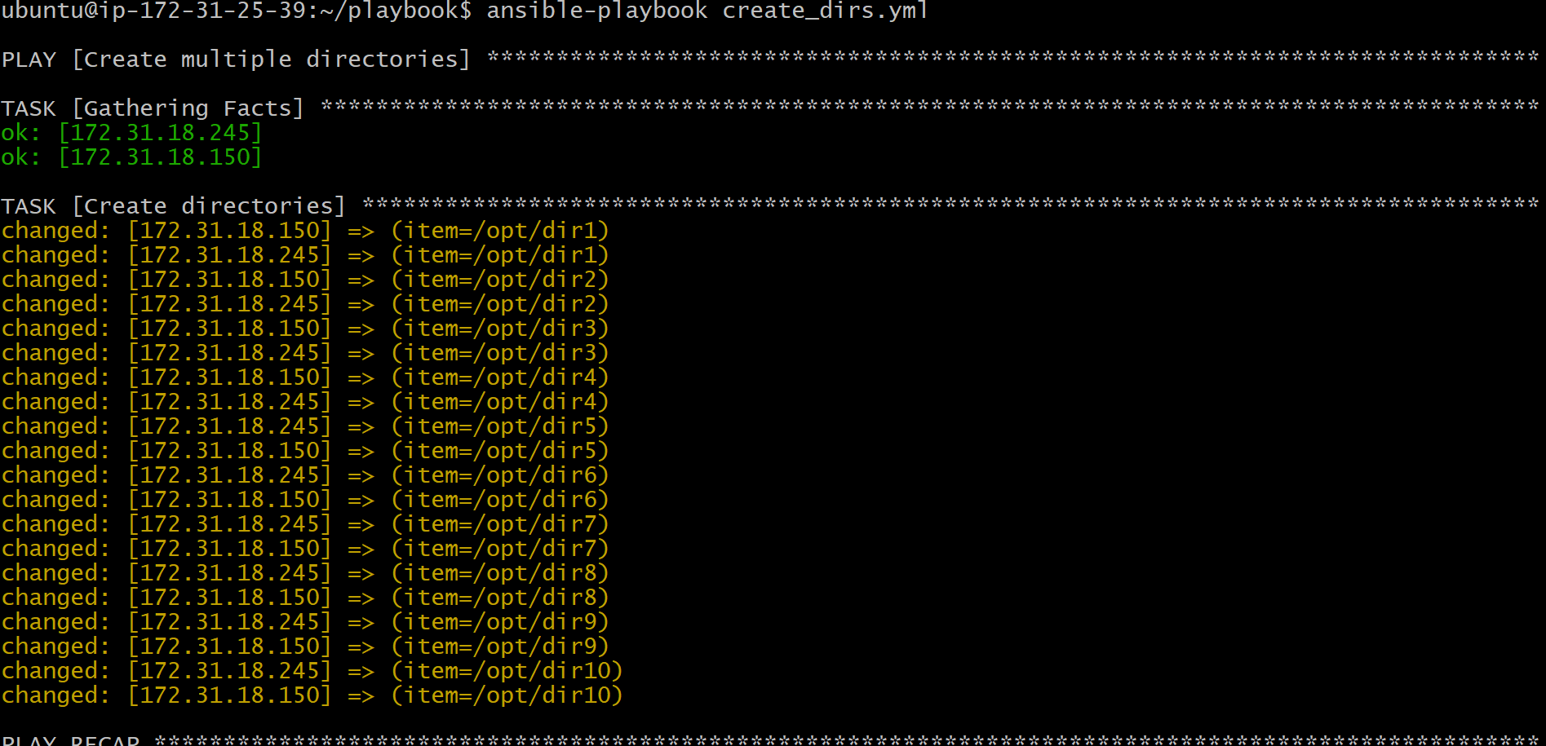

VALIDATION STEPS

Step 1: Check playbook output
You should see output like:
- changed: (item=/opt/dir1)
- changed: (item=/opt/dir2)
- ...
- changed: (item=/opt/dir10)

Step 2: Verify directories created on servers
Run:
ansible webservers -m shell -a "ls -ld /opt/dir*"
Expected:
All 10 directories should be listed.

Step 3: Verify manually (optional)
SSH into worker nodes and check:
ls -l /opt/
You should see:
dir1 to dir10

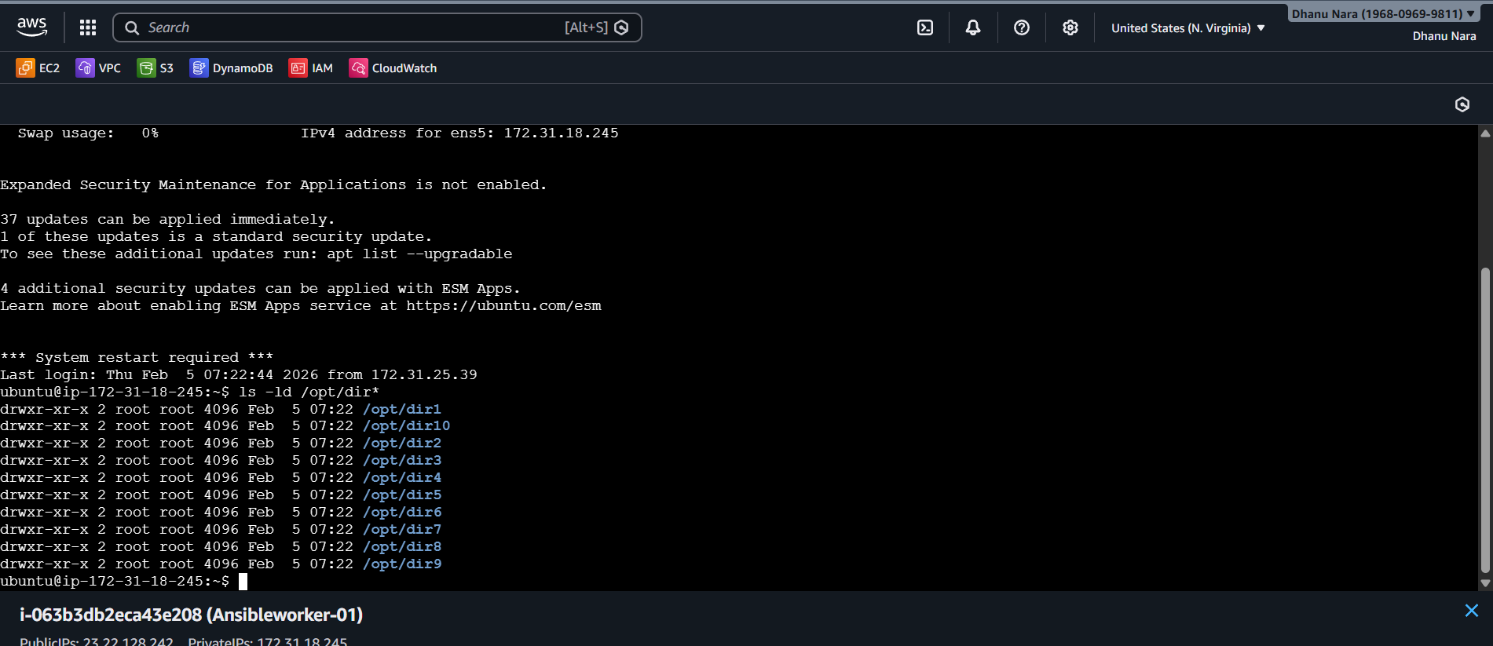
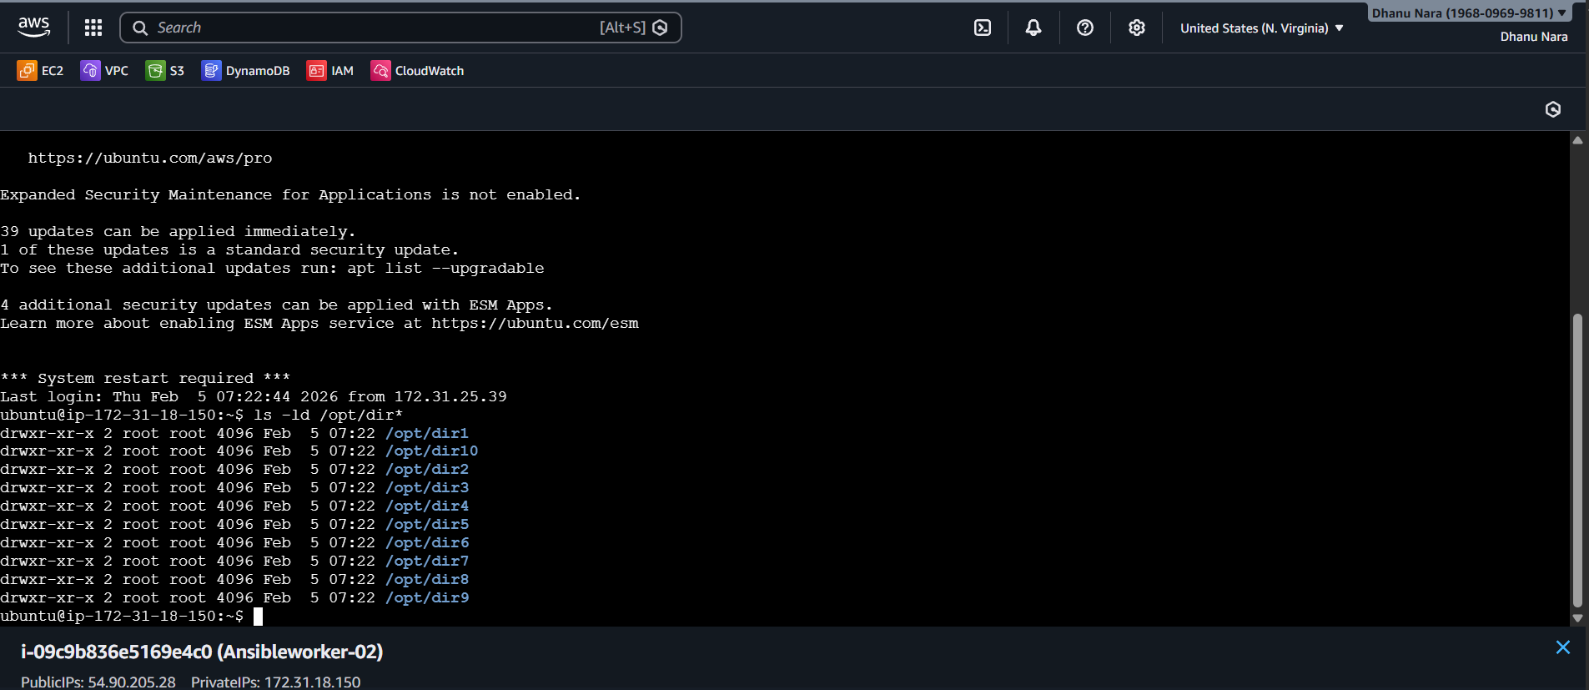

CONCLUSION
This playbook successfully creates 10 directories across multiple servers using minimal Ansible code by looping through a list of directory paths stored in an external variables file. This approach avoids hardcoding, improves reusability, and follows best automation practices.

3.Ansible playbook to copy ssh-keygen from master to worker nodes. Note: a)Provision new 3 ec2 machines, one master and two worker nodes.
b)Create common user called ansadm and provide sudo priviliges on 3 ec2 instances.
c)Create ssh-keygen in master and your playbook should copy the keygen making it password less authentication.

TITLE
Ansible Automation to Provision 3 EC2 Instances, Create Common User (ansadm) with Sudo, and Configure Passwordless SSH from Master to Workers

OBJECTIVE
To automate the complete infrastructure setup using Ansible by:
- Provisioning 3 EC2 instances (1 Master + 2 Workers).
- Creating a common user ansadm on all instances with passwordless sudo access.
- Generating SSH key pair on Master and copying the public key to Worker nodes to enable passwordless SSH authentication from Master → Workers.

PREREQUISITES

AWS Requirements
- AWS account configured.
- IAM user should have required permissions:
  - EC2 Full Access
  - VPC access (if needed)
- Keypair should exist in AWS Console (example: maruthi)
- AMI ID should be valid Ubuntu AMI (example used: ami-0b6c6ebed2801a5cb)
- Region should be correct (example: us-east-1)

STEP-BY-STEP IMPLEMENTATION

Step 1: Create ec2.yml
vi ec2.yml

Step 2: Add below playbook
---
- name: Provision Infrastructure
hosts: localhost
connection: local
gather_facts: no

tasks:
- name: Launch 3 EC2 Instances
amazon.aws.ec2_instance:
name: "{{ item.name }}"
key_name: "maruthi"
instance_type: t3.micro
image_id: ami-0b6c6ebed2801a5cb
region: us-east-1
wait: yes
tags:
Role: "{{ item.role }}"
loop:
- { name: "Ansible-Master", role: "master" }
- { name: "Worker-01", role: "worker" }
- { name: "Worker-02", role: "worker" }

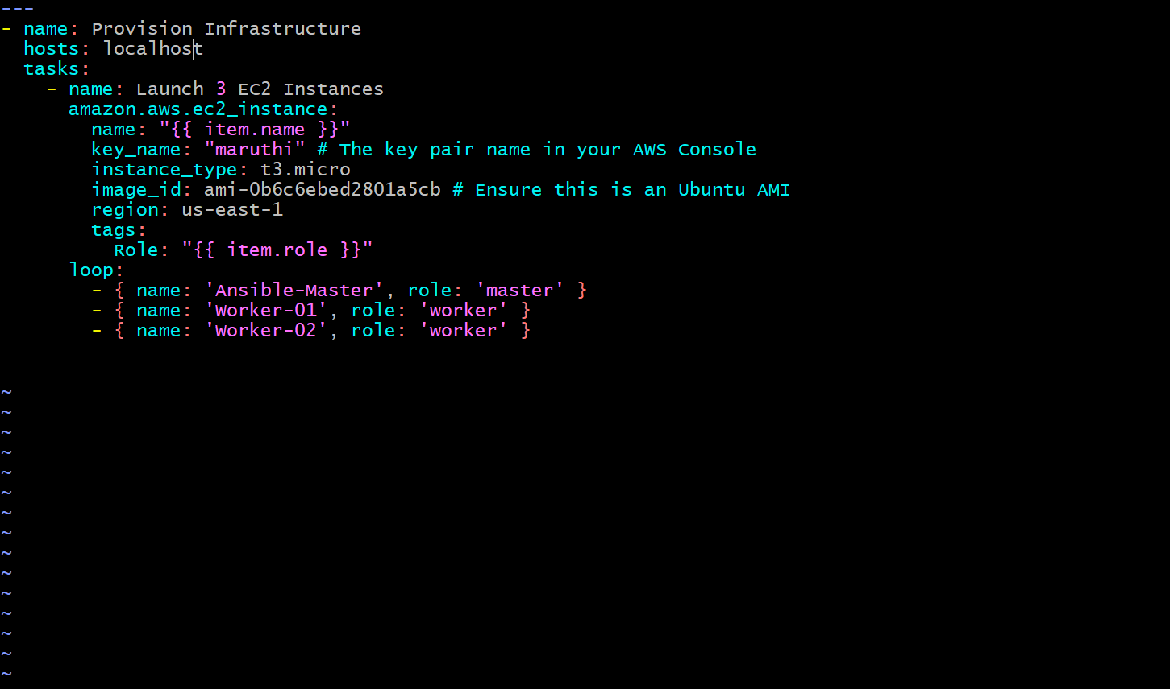

Step 3: Run playbook
ansible-playbook ec2.yml
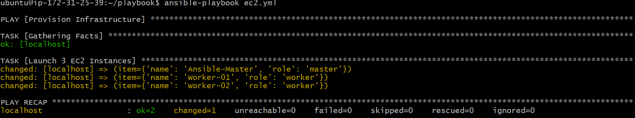

Step 4: Verify in AWS Console
EC2 → Instances → Check 3 instances are running:
- Ansible-Master
- Worker-01
- Worker-02
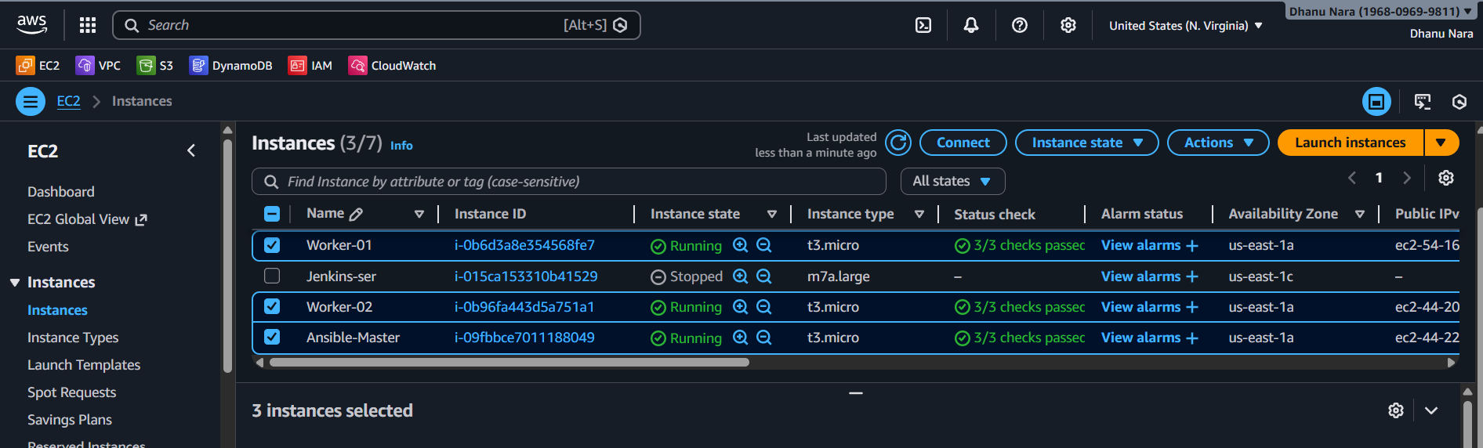

Go to inventory
cd /etc/ansible/
sudo vi hosts

Add Private IPs
[all]
172.31.1.83
172.31.10.199
172.31.0.101

[master]
172.31.1.83

[worker]
172.31.10.199
172.31.0.101
Save:
:wq



Create User ansadm and Provide Passwordless Sudo

Step 1: Create user.yml
cd ~/playbook
vi user.yml

Step 2: Add below playbook
---
- name: Phase A & B - Setup User and Sudo
hosts: all
become: yes

tasks:
- name: Install ACL for privilege escalation
ansible.builtin.apt:
name: acl
state: present
update_cache: yes

- name: Create ansadm user
ansible.builtin.user:
name: ansadm
shell: /bin/bash
groups: sudo
append: yes

- name: Grant passwordless sudo to ansadm
ansible.builtin.lineinfile:
path: /etc/sudoers.d/ansadm
line: "ansadm ALL=(ALL) NOPASSWD:ALL"
create: yes
mode: "0440"
validate: "/usr/sbin/visudo -cf %s"

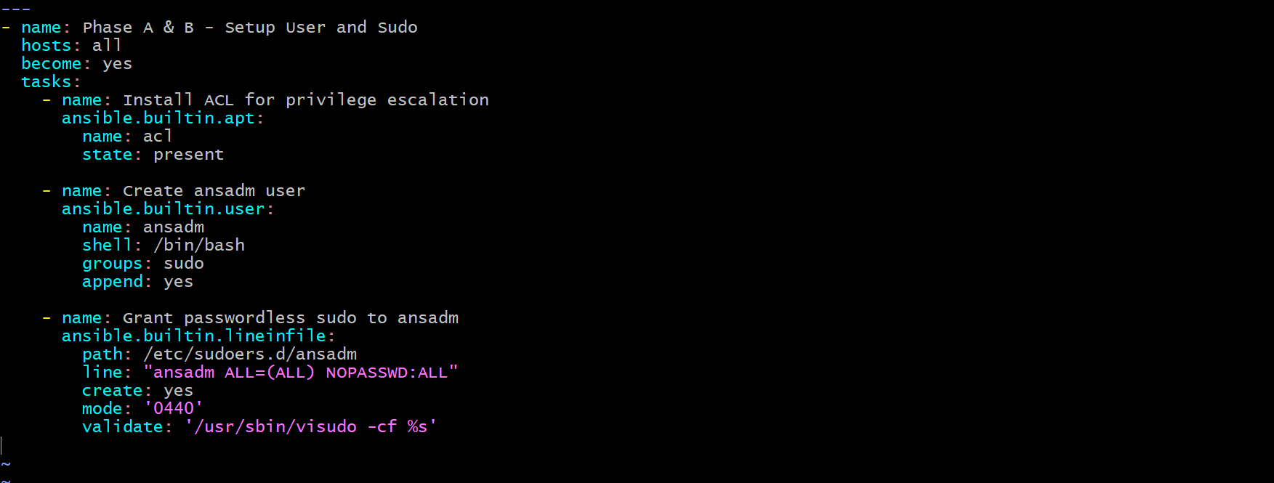
• SSH private key (ssh.pem) should be available and permission set:
chmod 400 ssh.pem



Run playbook
ansible-playbook -i /etc/ansible/hosts user.yml -u ubuntu --private-key=ssh.pem

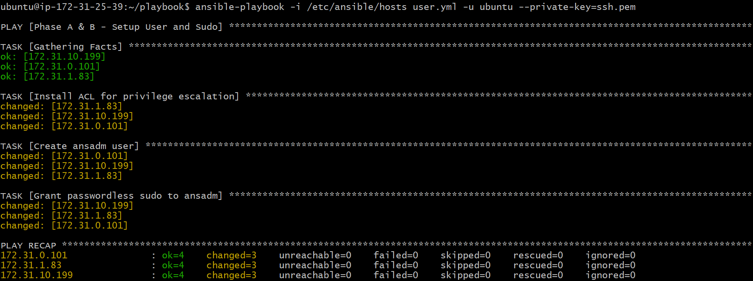

Generate SSH Key on Master and Copy to Workers

Create masterkey.yml
vi masterkey.yml

Add below playbook
---
- name: Generate Key on Master
hosts: master
become: yes

tasks:
- name: Ensure .ssh directory exists for ansadm
ansible.builtin.file:
path: /home/ansadm/.ssh
state: directory
owner: ansadm
group: ansadm
mode: "0700"

- name: Generate SSH Key for ansadm on Master
become_user: ansadm
ansible.builtin.openssh_keypair:
path: /home/ansadm/.ssh/id_rsa
type: rsa
size: 4096

- name: Read Master public key for distribution
ansible.builtin.slurp:
src: /home/ansadm/.ssh/id_rsa.pub
register: master_pub_key

- name: Distribute Key to workers
hosts: worker
become: yes

tasks:
- name: Add Master public key to worker authorized_keys
become_user: ansadm
ansible.posix.authorized_key:
user: ansadm
state: present
key: "{{ hostvars[groups['master'][0]]['master_pub_key']['content'] | b64decode }}"

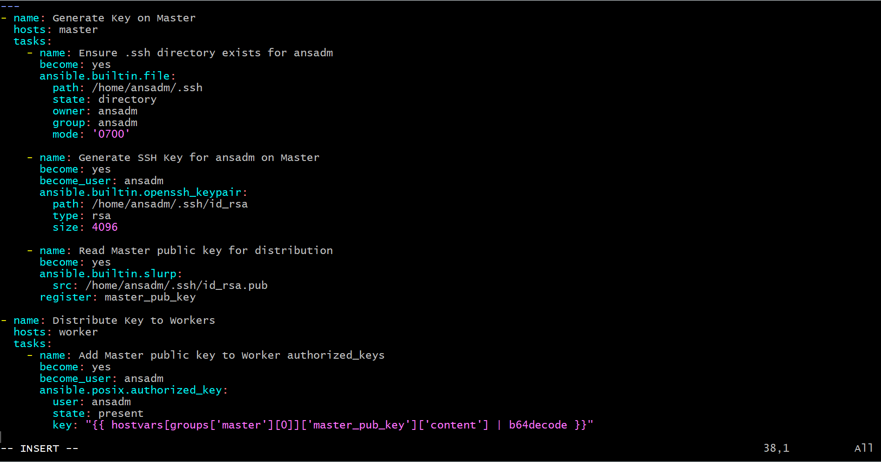

Run playbook
ansible-playbook -i /etc/ansible/hosts masterkey.yml -u ubuntu --private-key=ssh.pem

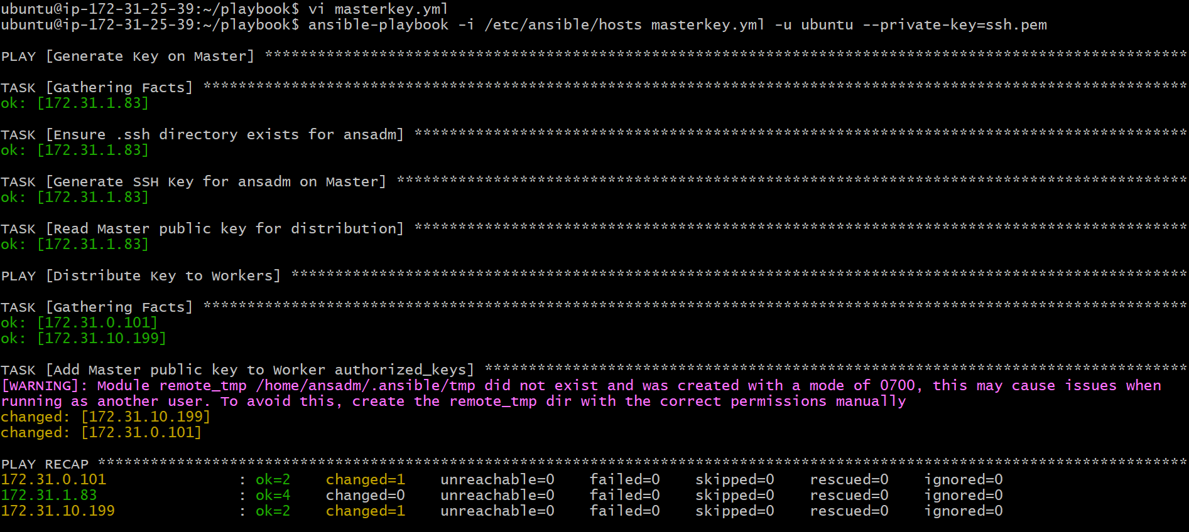

Verify Passwordless SSH

Step 1: SSH into Master
ssh -i ssh.pem ubuntu@172.31.1.83
Switch user:
sudo su - ansadm

Step 2: SSH into worker node
ssh 172.31.0.101
If login happens without password prompt → Passwordless SSH is working .
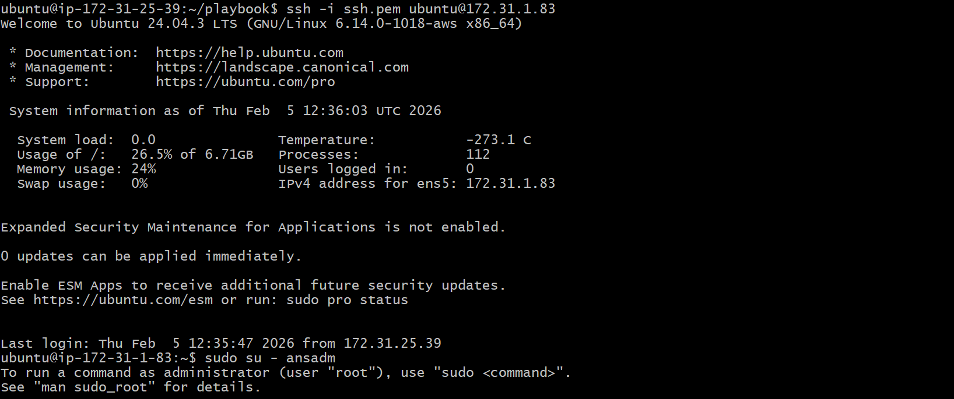
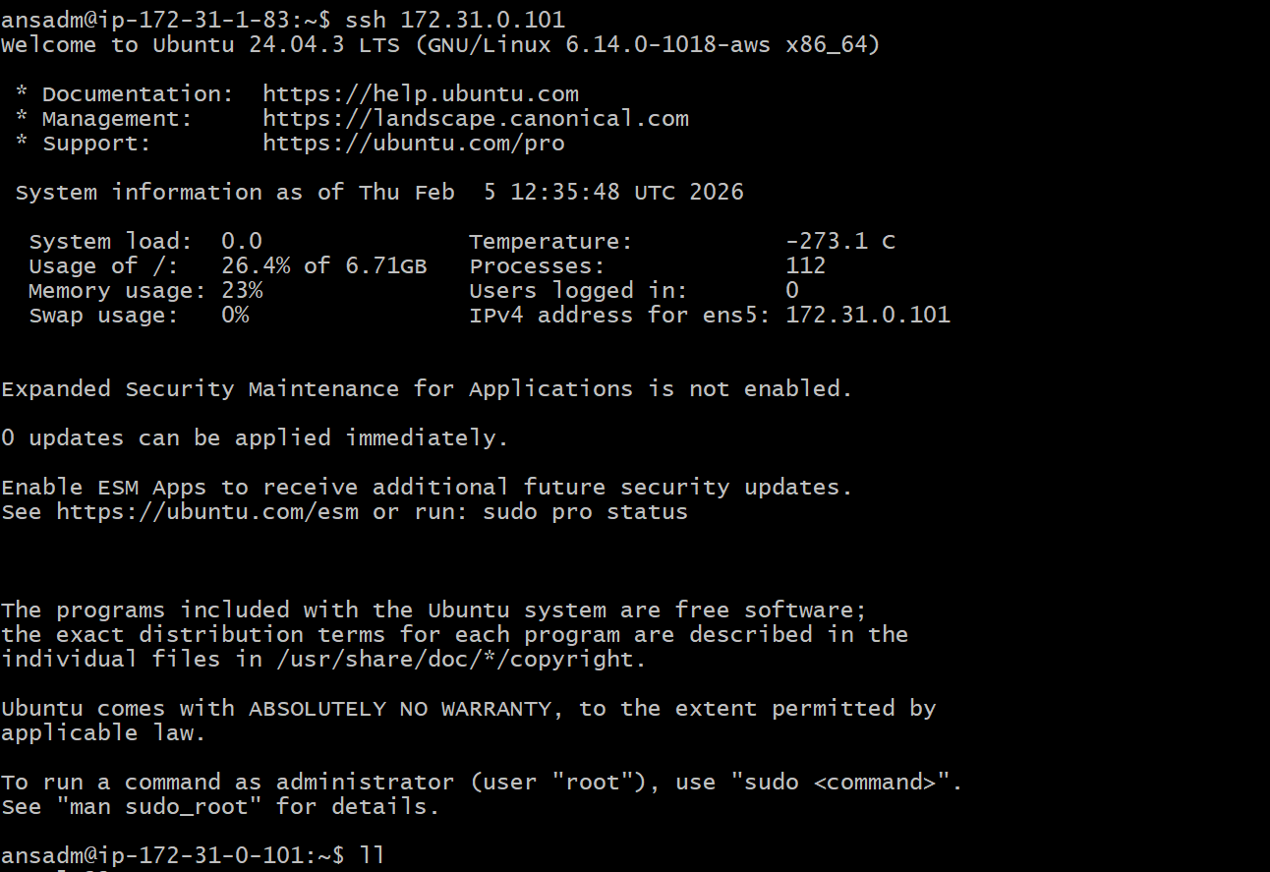

VALIDATION STEPS

1. Check EC2 Instances
AWS Console → EC2 → Instances → Ensure 3 instances are in running state.

2. Check inventory connectivity
ansible all -i /etc/ansible/hosts -m ping -u ubuntu --private-key=ssh.pem
Expected:
SUCCESS => pong

3. Check ansadm user created
ansible all -i /etc/ansible/hosts -m shell -a "id ansadm" -u ubuntu --private-key=ssh.pem
Expected output:
- user exists
- belongs to sudo group

4. Verify sudo access
ansible all -i /etc/ansible/hosts -m shell -a "sudo -l" -u ansadm --private-key=ssh.pem
Expected:
- NOPASSWD permission

5. Verify SSH key exists on master
ansible master -i /etc/ansible/hosts -m shell -a "ls -l /home/ansadm/.ssh/" -u ubuntu --private-key=ssh.pem
Expected:
- id_rsa
- id_rsa.pub

6. Verify authorized_keys on workers
ansible worker -i /etc/ansible/hosts -m shell -a "cat /home/ansadm/.ssh/authorized_keys" -u ubuntu --private-key=ssh.pem
Expected:
- master public key present

7. Confirm passwordless SSH
From master:
sudo su - ansadm
ssh 172.31.0.101
ssh 172.31.10.199
Expected:
- No password prompt

CONCLUSION
This Ansible automation successfully provisions three EC2 instances (one master and two workers), creates a common privileged user ansadm with passwordless sudo access, generates an SSH key pair on the master node, and distributes the master’s public key to worker nodes. This enables secure passwordless SSH authentication from master to workers, which is essential for cluster-based automation and DevOps infrastructure management.

4.Ansible playbook to inject ansible vault variables.

TITLE
Ansible Playbook to Inject Ansible Vault Variables into Playbook Execution

OBJECTIVE
To securely store sensitive variables like username and password using Ansible Vault, and then inject (use) those encrypted variables inside an Ansible playbook during execution without exposing them in plain text.

PREREQUISITES
- Ansible installed on Control Node (Master).
- Inventory file configured and working.
- Target nodes reachable (ansible all -m ping should work).
- Ansible Vault feature available (default with Ansible).
- Basic YAML knowledge.
- SSH access to all nodes.

STEP-BY-STEP IMPLEMENTATION

Step 1: Create Vault File
Run:
ansible-vault create vault.yml
It will ask:
- New vault password
- Confirm vault password
Then it opens in vi editor.

Step 2: Add Sensitive Variables
Inside vault.yml add:
db_user: admin
db_pass: MySecret123
Save and exit:
:wq

Step 3: Create Vault Playbook
Create playbook:
vi vaultbook.yml

Add this:
---
- name: Inject Vault Variables
hosts: all
become: yes

vars_files:
- vault.yml

tasks:
- name: Show vault variables
debug:
msg: "DB_USER={{ db_user }} DB_PASS={{ db_pass }}"
Save:
:wq
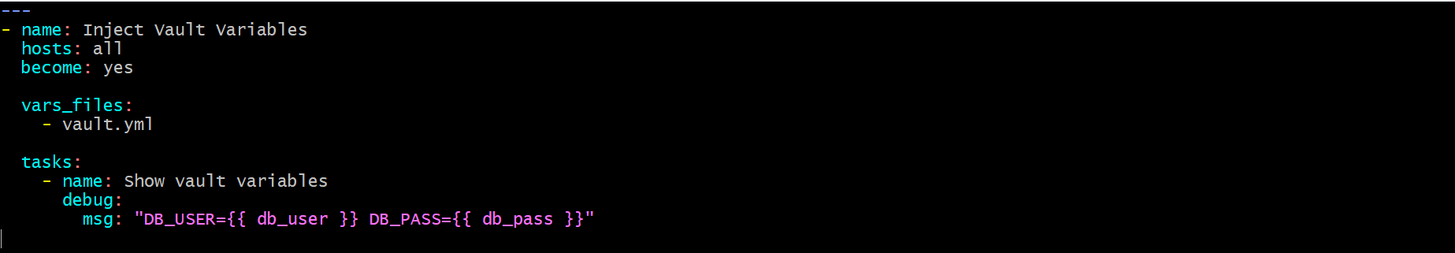

Step 4: Run the Playbook with Vault Password
Execute:
ansible-playbook -i /etc/ansible/inventory vaultbook.yml --ask-vault-pass
It will ask:
Vault password:
Enter your vault password.
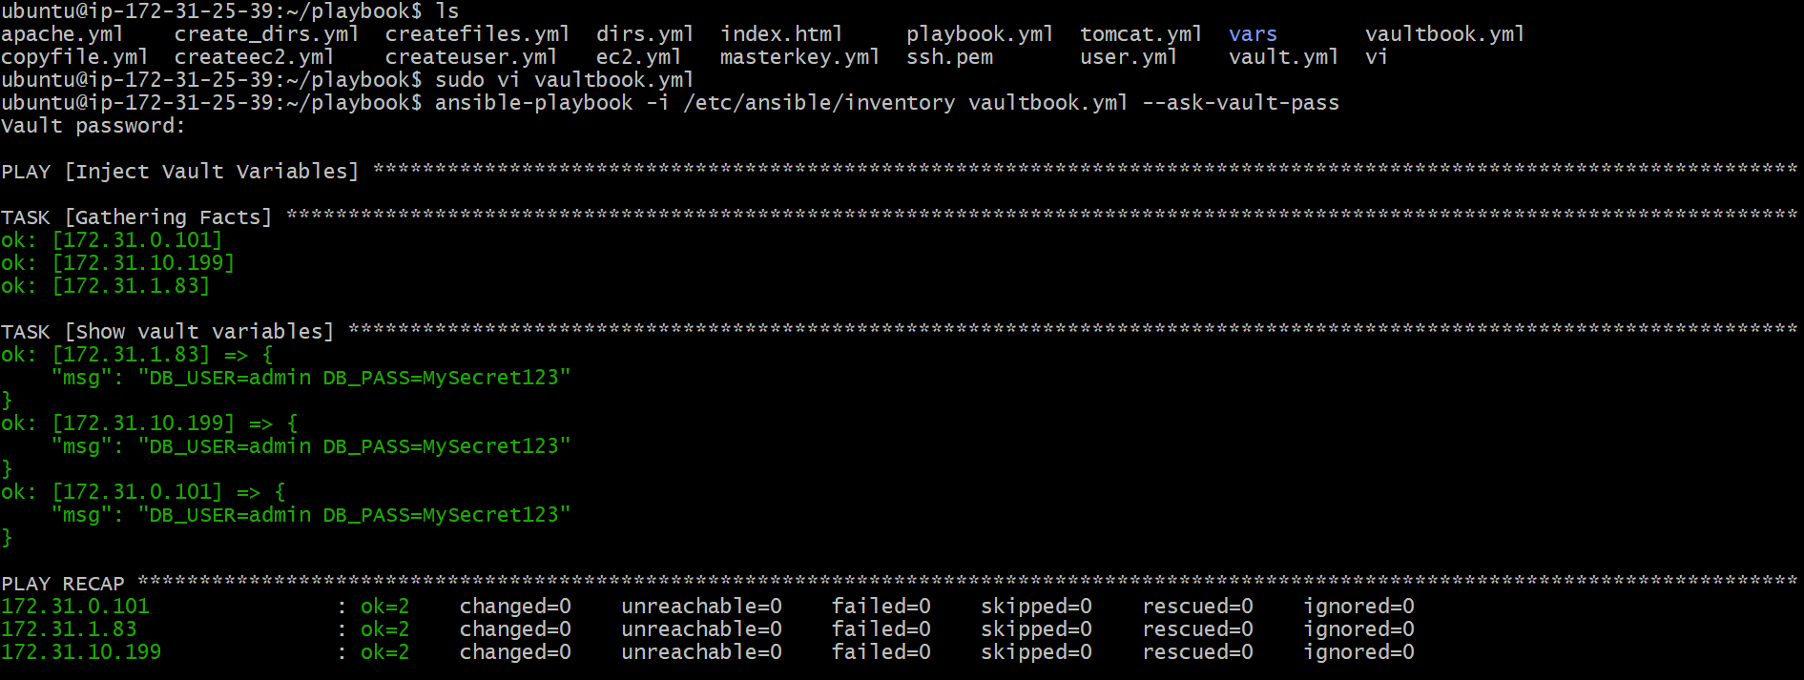

VALIDATION STEPS

Step 1: Verify Vault File is Encrypted
Run:
cat vault.yml
Expected: Encrypted content will display (not plain text).

Step 2: Verify Vault Variables Injection
Run:
ansible-playbook -i /etc/ansible/inventory vaultbook.yml --ask-vault-pass
Expected output:
msg: "DB_USER=admin DB_PASS=MySecret123"

Step 3: Verify Play Recap
At the end you should see:
- failed=0
- unreachable=0

CONCLUSION
This setup successfully encrypts sensitive information using Ansible Vault and injects the secured variables into an Ansible playbook using vars_files. This ensures passwords and secrets are not stored in plain text while still being usable during automation tasks across multiple servers.

