Ansible-04

1.Create ansible playbook to create ansible vault.

Title
Ansible Vault Creation and Secure Variable Injection using Vault Password File

Objective
To securely store sensitive credentials (like DB username/password) using Ansible Vault encryption, and then use those encrypted variables inside an Ansible playbook without exposing the secrets in plain text.

Prerequisites
Before starting this task, ensure the following:
- One Ansible Controller machine (Ubuntu/Linux)
- Managed nodes configured in Ansible inventory
- SSH connectivity working from controller to all target servers
Example:
- ansible all -m ping
- Ansible installed
- ansible --version
- Vault password file created and secured
- Basic knowledge of vi editor

Step-by-Step Implementation

Step 1: Go to playbook directory
On controller machine:
cd playbook/

Step 2: Create Vault password file
Create a file to store vault password:
vi .vault_pass.txt
Inside file:
Dhanu@8688
Save and exit :wq

Step 3: Give proper permission to vault password file
chmod 600 .vault_pass.txt
Check:
ls -l .vault_pass.txt



Step 4: Create variables file (plain text)
Create a file which contains secret values:
vi vault_vars.yml
Add:
db_user: admin
db_pass: MySecret123
Save and exit.

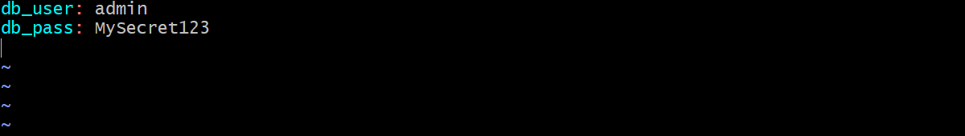

Step 5: Encrypt variables file using Ansible Vault
Encrypt the variables file and create encrypted output file:
ansible-vault encrypt vault_vars.yml --output vault.yml --vault-password-file .vault_pass.txt
Now vault.yml becomes encrypted.
Check:
cat vault.yml
You will see:
$ANSIBLE_VAULT;1.1;AES256

Step 6: Verify encrypted file content
To view the encrypted file safely:
ansible-vault view vault.yml --vault-password-file .vault_pass.txt
It should show:
db_user: admin
db_pass: MySecret123

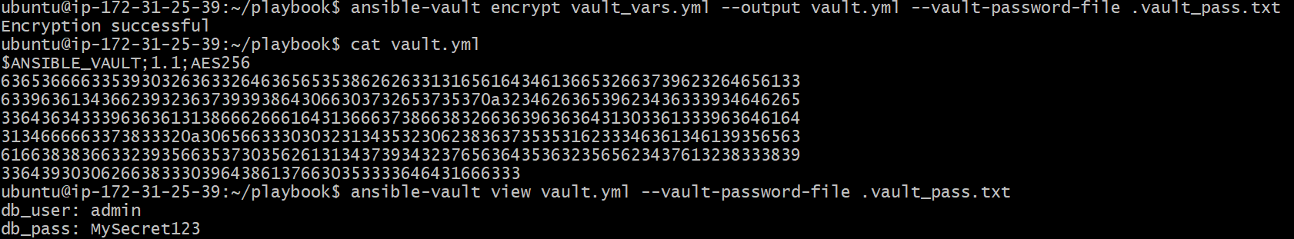

Step 7: Create Playbook to inject vault variables
Create playbook:
vi vaultbook.yml
Paste:
- name: Inject Vault Variables
hosts: all
become: yes

vars_files:
- vault.yml

tasks:
- name: Show vault variables
debug:
msg: "DB_USER={{ db_user }} DB_PASS={{ db_pass }}"
Save and exit.
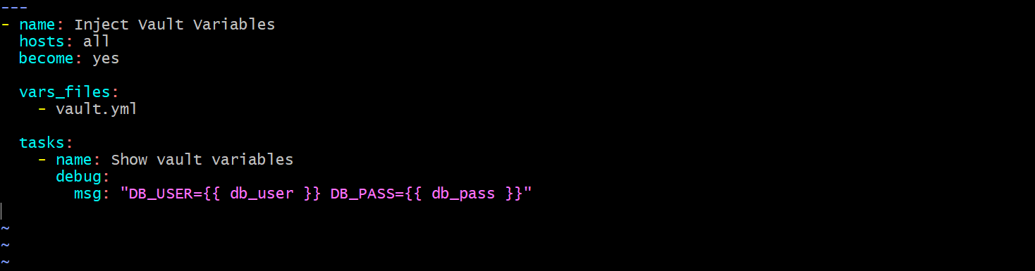

Step 8: Run the playbook using vault password file
Execute:
ansible-playbook -i /etc/ansible/hosts vaultbook.yml --vault-password-file .vault_pass.txt

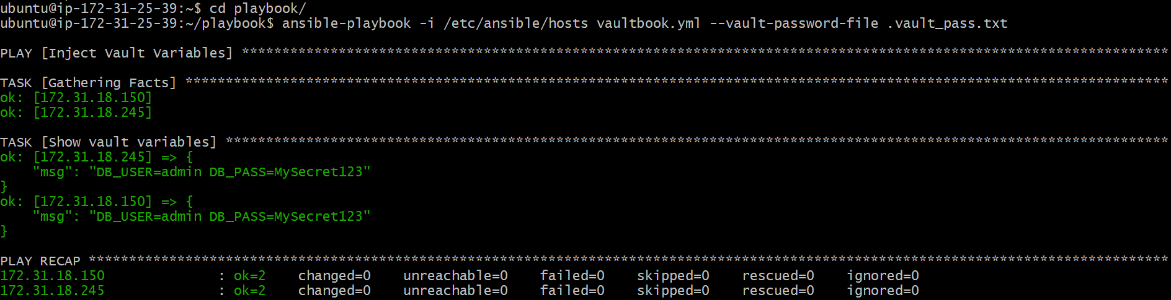

Validation Steps

Step 1: Validate vault file is encrypted
cat vault.yml
Expected output: should start with
$ANSIBLE_VAULT;1.1;AES256

Step 2: Validate vault file can be decrypted
ansible-vault view vault.yml --vault-password-file .vault_pass.txt
Expected output:
db_user: admin
db_pass: MySecret123

Step 3: Validate playbook execution
Run:
ansible-playbook -i /etc/ansible/hosts vaultbook.yml --vault-password-file .vault_pass.txt
Expected output should show:
ok: [server_ip] => {
"msg": "DB_USER=admin DB_PASS=MySecret123"
}
This confirms vault variables are injected successfully.

Conclusion
In this task, we successfully created an Ansible Vault encrypted file (vault.yml) containing sensitive DB credentials. We stored the vault password in a secured file (.vault_pass.txt) and executed the playbook without manual password entry. Finally, the playbook successfully decrypted and used the variables securely across all target nodes.

2.Write a ansible playbook to install apache in linux and ubuntu machine by using when condition.

Title
Install Apache on Ubuntu and RedHat Linux using Ansible when condition

Objective
To install and start Apache web server on Ubuntu and RedHat machines using a single Ansible playbook with when condition.

Prerequisites
- Two EC2 instances launched (Ubuntu + RedHat)
- Ansible installed in Controller machine
- Port 22 (SSH) enabled in Security Group
- Port 80 (HTTP) enabled in Security Group
- PEM key file available in controller machine with correct permission
- Inventory file configured with correct IPs and usernames

Step-by-Step Implementation

Step 1: Launch Instances
- Launch Ubuntu EC2 instance
- Launch RedHat EC2 instance

Step 2: Configure Security Group
- Add inbound rule SSH (22) → My IP
- Add inbound rule HTTP (80) → 0.0.0.0/0

Step 3: Copy PEM Key into Controller
- Copy maruthi.pem into controller machine
- Move it into playbook folder

Step 4: Give Permission to PEM Key
chmod 400 maruthi.pem

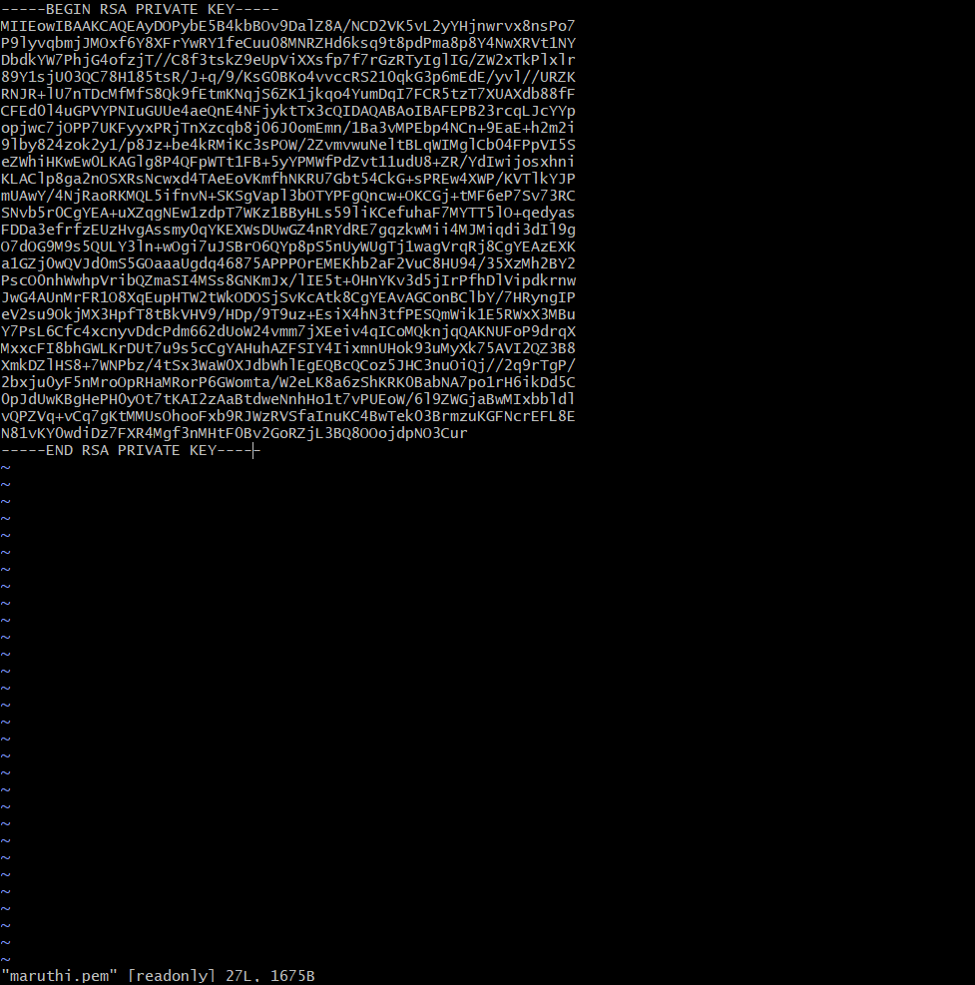

Step 5: Update Inventory File
sudo vi /etc/ansible/hosts
Paste this:
[webservers]
54.235.6.163 ansible_user=ubuntu
34.236.191.77 ansible_user=ec2-user

[webservers:vars]
ansible_ssh_private_key_file=/home/ubuntu/playbook/maruthi.pem
ansible_python_interpreter=/usr/bin/python3

Step 6: Test Connection
ansible webservers -m ping

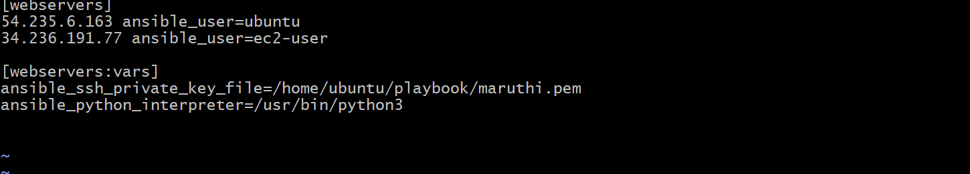

Step 7: Create Playbook
vi apache_when.yml
Paste:
- name: Install Apache on Ubuntu and RHEL using when condition
hosts: webservers
become: yes
gather_facts: yes

tasks:
- name: Install Apache on Ubuntu
apt:
name: apache2
state: present
update_cache: yes
when: ansible_os_family == "Debian"

- name: Start Apache on Ubuntu
service:
name: apache2
state: started
enabled: yes
when: ansible_os_family == "Debian"

- name: Install Apache on RHEL
yum:
name: httpd
state: present
when: ansible_os_family == "RedHat"

- name: Start Apache on RHEL
service:
name: httpd
state: started
enabled: yes
when: ansible_os_family == "RedHat"

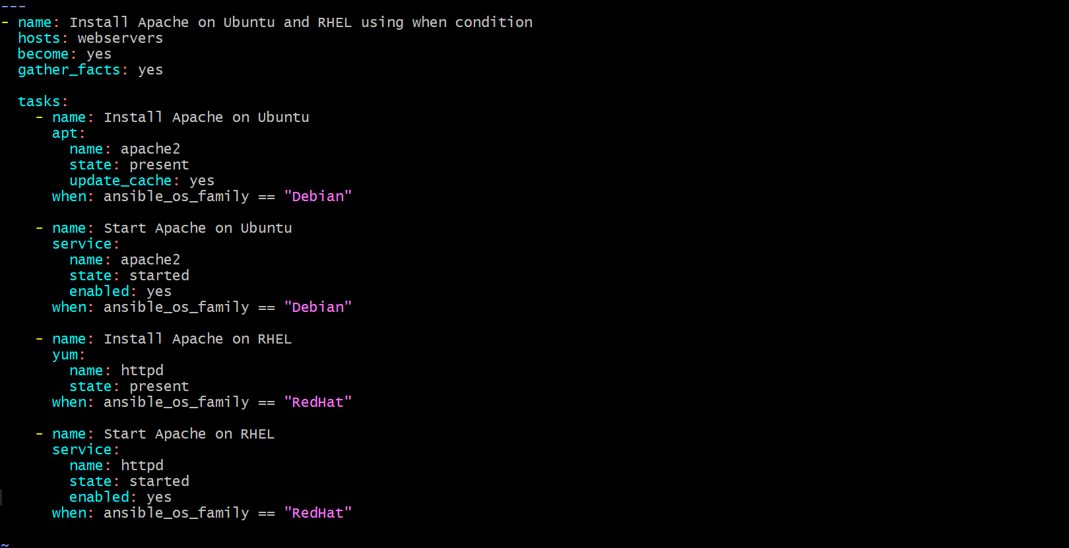

Step 8: Run Playbook
ansible-playbook apache_when.yml

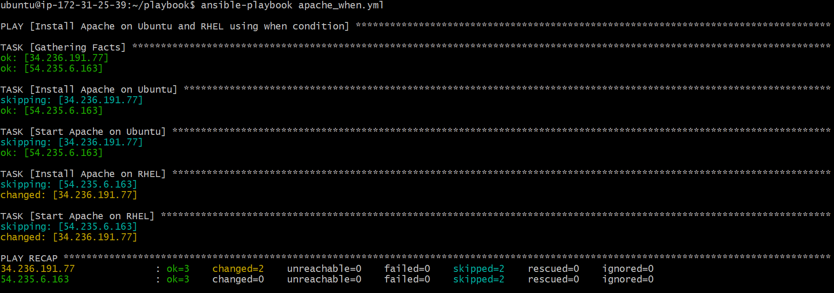

Validation Steps
- Check apache status:
ansible webservers -m shell -a "systemctl status apache2 || systemctl status httpd"

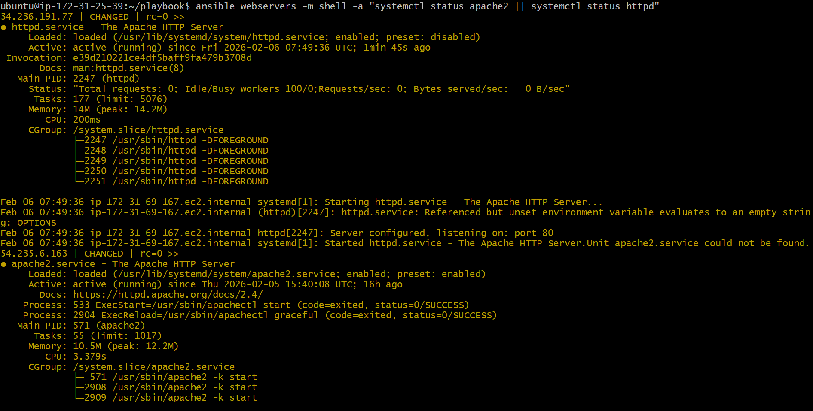
- Open Ubuntu Apache page:
http://54.235.6.163

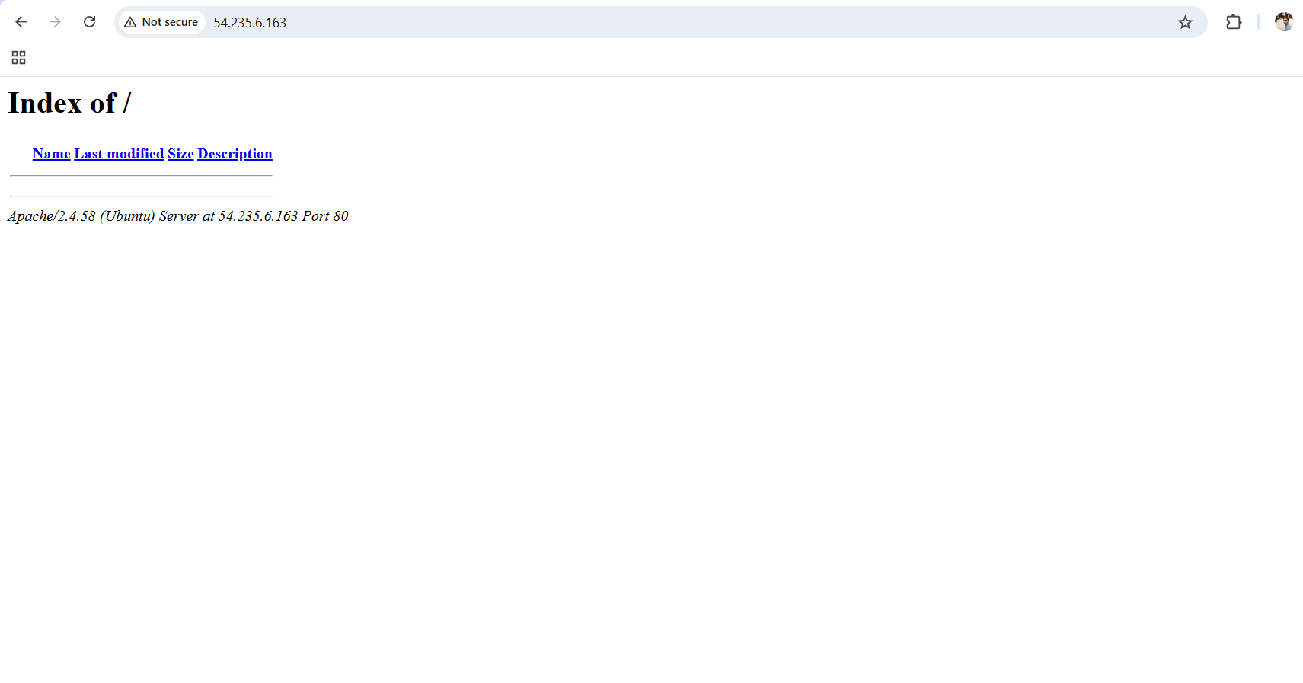

- Open RedHat Apache page:
http://34.236.191.77

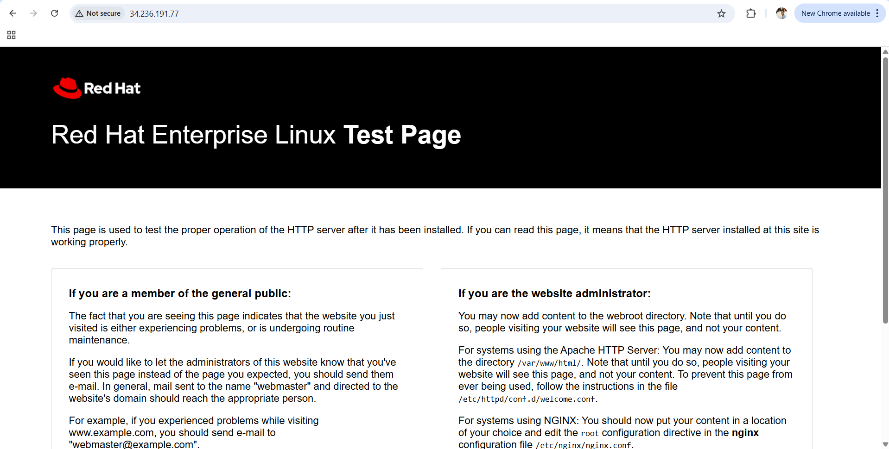

Conclusion
Successfully installed and configured Apache Web Server on both Ubuntu and RedHat Linux EC2 instances using a single Ansible playbook. The when condition ensured the correct package manager (apt for Ubuntu and yum for RedHat) and correct service (apache2 / httpd) were applied based on OS type. Finally, Apache service was enabled and started, and the web server was verified through browser access using the public IP addresses.

3.Create ansible playbook using roles to configure LAMP stack.

Title
Configure LAMP Stack using Ansible Roles (Ubuntu + RedHat)

Objective
To install and configure LAMP stack (Apache + MySQL/MariaDB + PHP) on Ubuntu and RedHat servers using Ansible roles with OS based when conditions and centralized variables.

Prerequisites
- Ansible Controller machine should be ready
- Ubuntu EC2 instance should be launched
- RedHat EC2 instance should be launched
- Security Group should allow port 22 (SSH)
- Security Group should allow port 80 (HTTP)
- PEM key should be available inside controller (maruthi.pem)
- Correct inventory file configuration
- Python3 should be installed in target nodes
- Ansible connectivity should work (ansible -m ping)

Step-by-Step Implementation

Step 1: Login into Ansible Controller
ssh -i maruthi.pem ubuntu@<controller-public-ip>

Step 2: Create and move to playbook directory
cd ~
mkdir -p playbook
cd playbook

Step 3: Create PEM file and give permissions
vi maruthi.pem
chmod 400 maruthi.pem

Step 4: Configure Inventory file
sudo vi /etc/ansible/hosts
Paste this:
[lamp]
54.235.6.163 ansible_user=ubuntu
34.236.191.77 ansible_user=ec2-user

[lamp:vars]
ansible_ssh_private_key_file=/home/ubuntu/playbook/maruthi.pem
ansible_python_interpreter=/usr/bin/python3
-

Step 5: Create role directory structure
mkdir -p roles/apache/tasks
mkdir -p roles/mysql/tasks
mkdir -p roles/php/tasks
mkdir -p group_vars

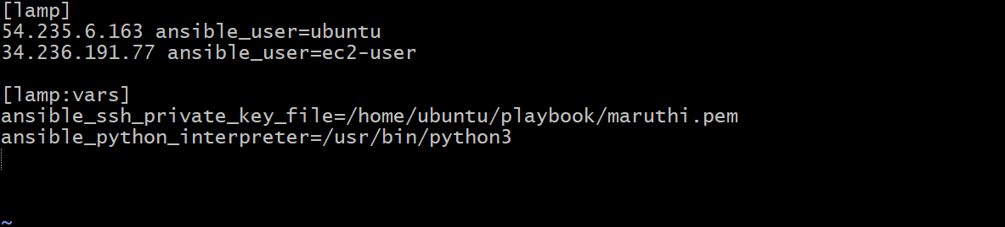

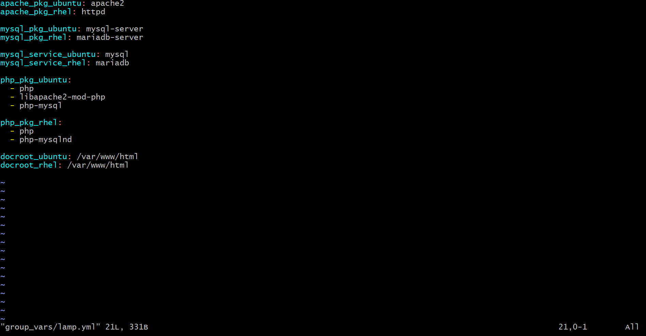
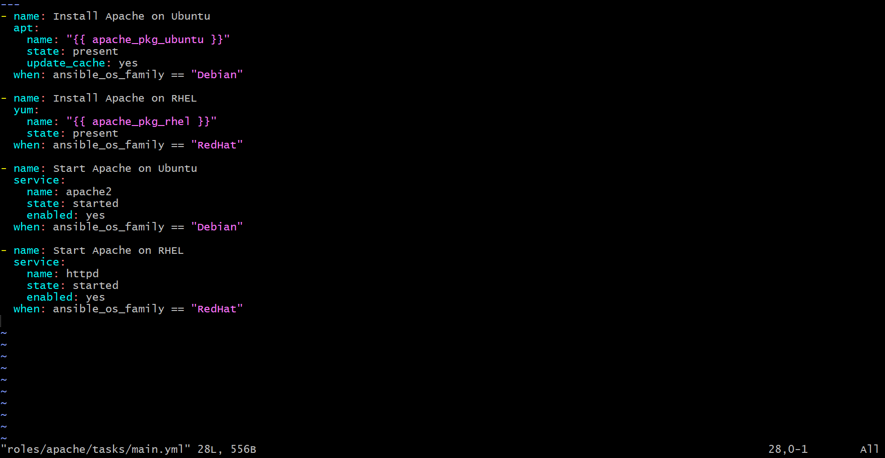
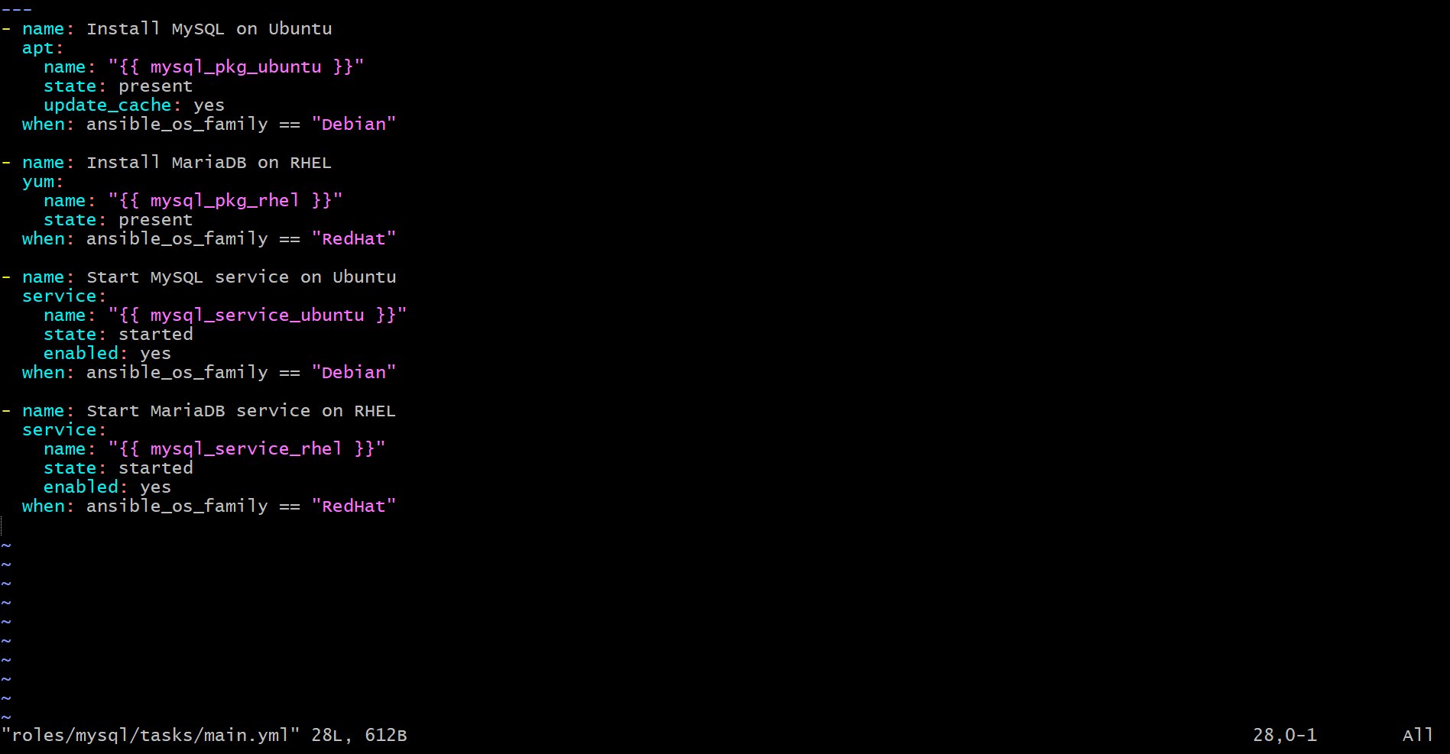
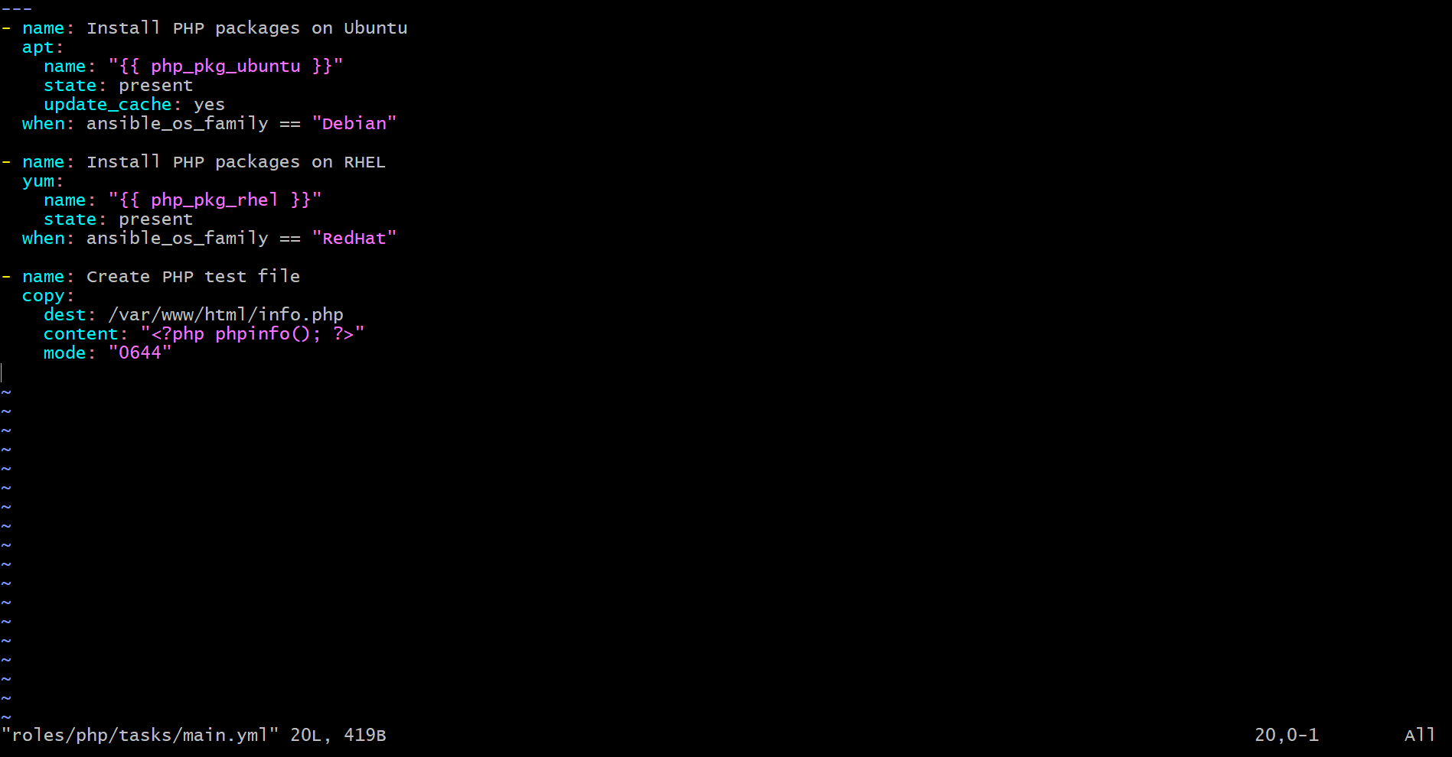
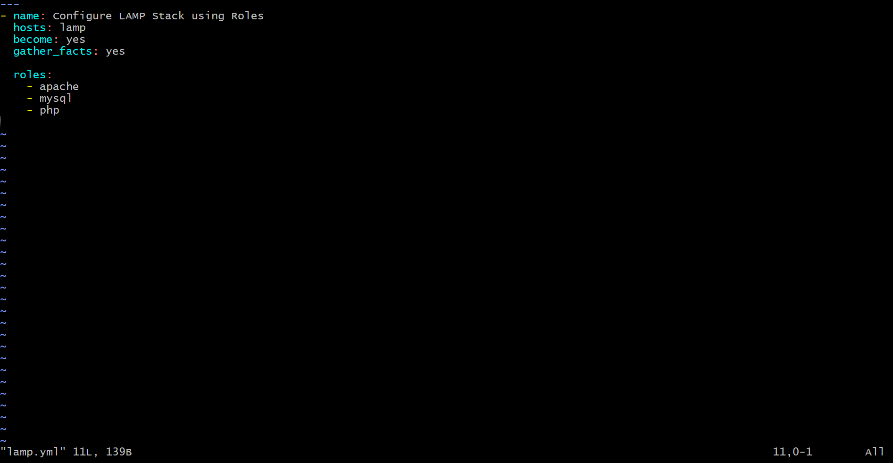

Step 6: Execute the playbook
ansible-playbook -i /etc/ansible/hosts lamp.yml

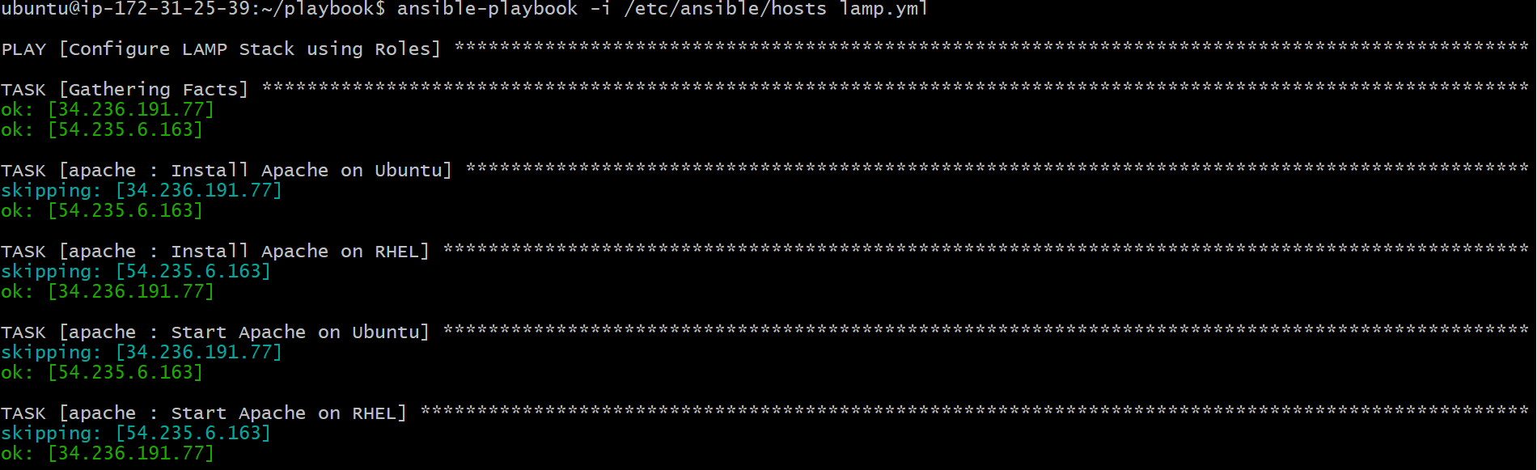
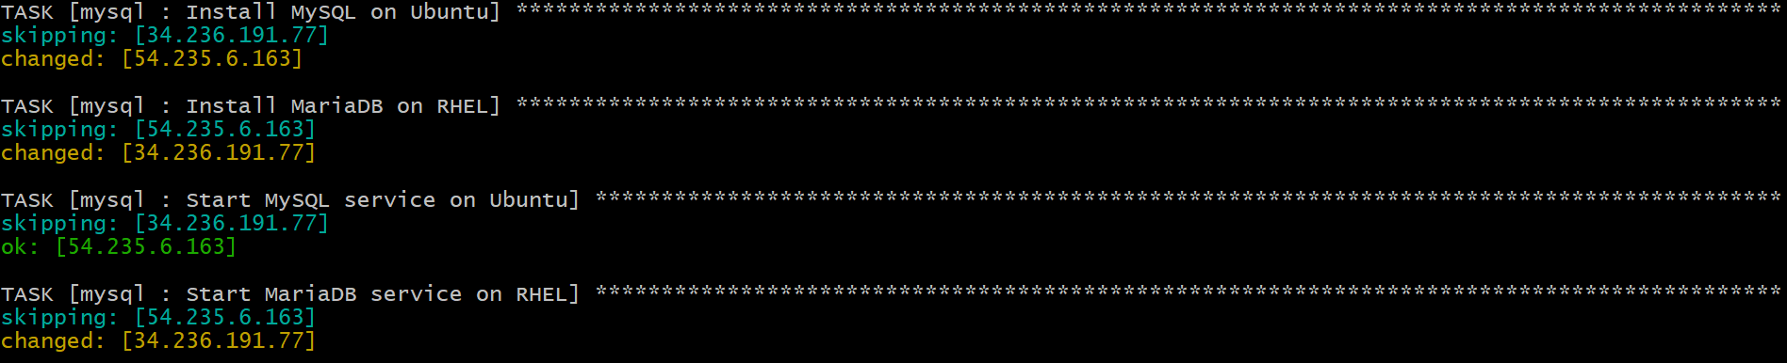
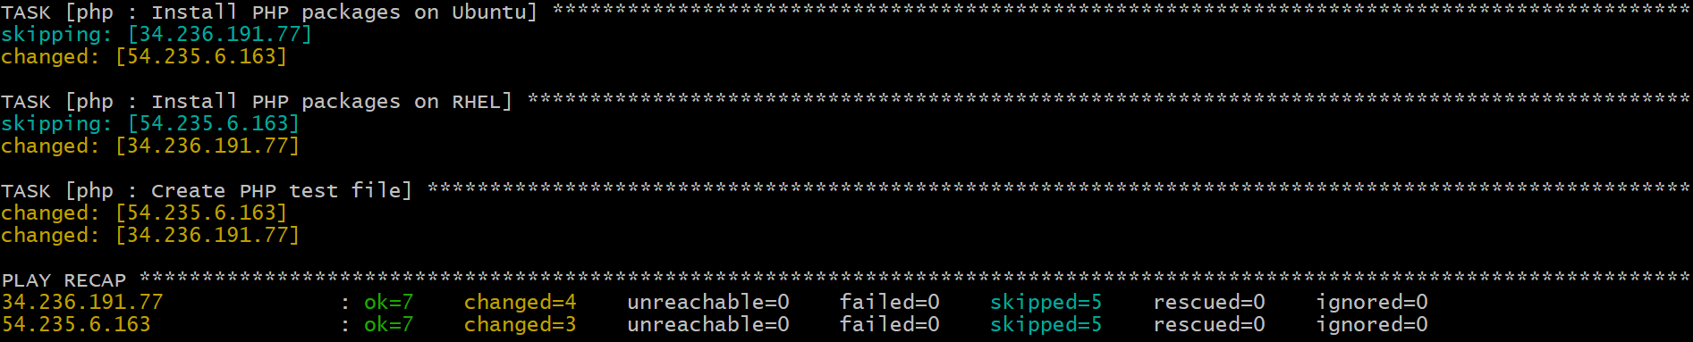

Validation Steps

Step 1: Check Apache service status
ansible lamp -m shell -a "systemctl status apache2 || systemctl status httpd"

Step 2: Check MySQL/MariaDB service status
ansible lamp -m shell -a "systemctl status mysql || systemctl status mariadb"

Step 3: Validate Apache homepage from browser
Ubuntu:
http://54.235.6.163
RedHat:
http://34.236.191.77

Step 4: Validate PHP page from browser
Ubuntu:
http://54.235.6.163/info.php
RedHat:
http://34.236.191.77/info.php

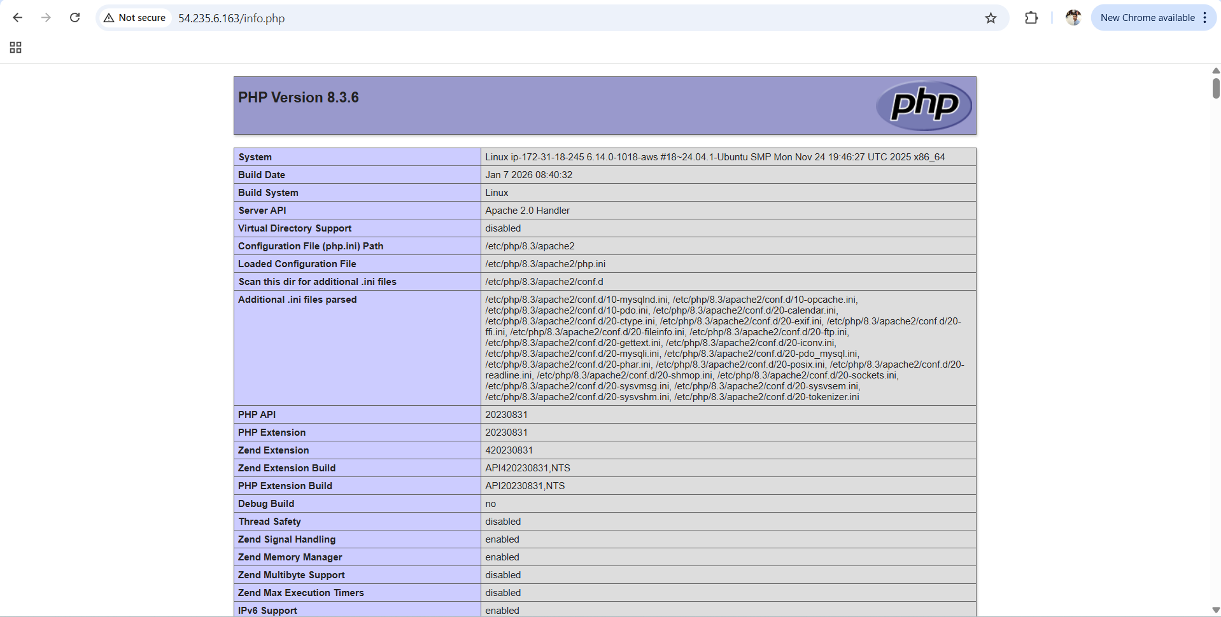

Login to redhat server and execute these commands.
sudo yum install -y httpd php php-cli php-common
sudo systemctl restart httpd
sudo systemctl enable httpd
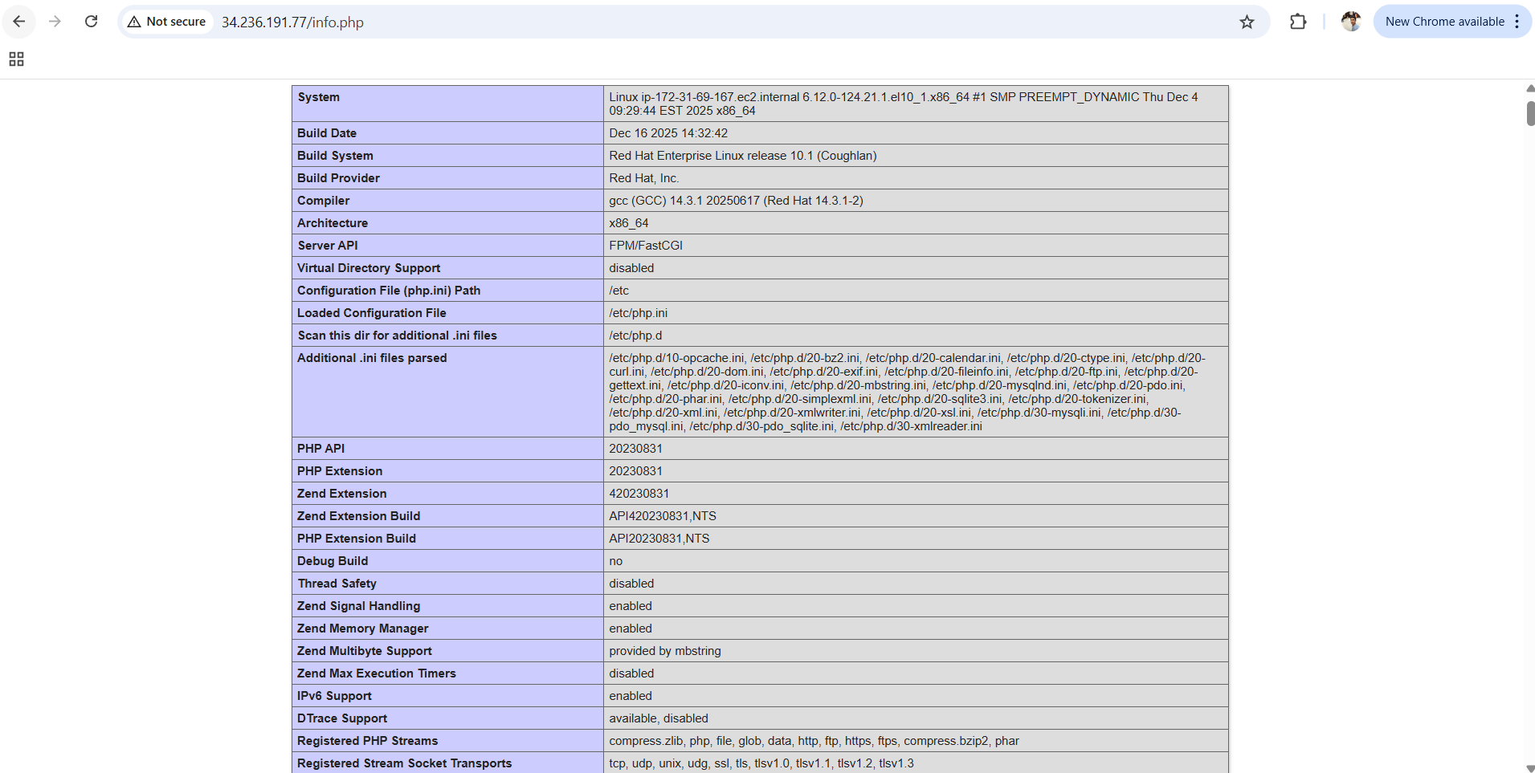

4.Setup ansible AWX and explore the options.

TITLE
Setup Ansible AWX on AWS EC2 and Explore AWX Options

OBJECTIVE
To install and configure Ansible AWX on an Ubuntu EC2 instance using Docker and Ansible installer, and explore AWX UI features like inventories, credentials, projects, templates, jobs, schedules, workflows, and RBAC.

PREREQUISITES

AWS Side
- AWS Account
- Ubuntu EC2 Instance (t2.large / t2.xlarge recommended)
- Key Pair (.pem file)
- Security Group with inbound rules:
  - SSH (22) → My IP
  - HTTP (80) → Anywhere (0.0.0.0/0)
- Public IP Address enabled

System Side (Inside EC2)
- Ubuntu OS (20.04 / 22.04 / 24.04)
- Root or sudo access
- Internet connectivity enabled
- Minimum 20 GB Storage
- Minimum 4 GB RAM (8 GB recommended)

Required Packages
- Git
- Ansible
- Docker
- Docker Compose

STEP-BY-STEP IMPLEMENTATION

Step 1: Launch Ubuntu EC2 Instance
- Go to AWS Console → EC2 → Launch Instance
- Select Ubuntu AMI
- Select instance type (t2.large / t2.xlarge)
- Select or create key pair
- Configure Security Group with SSH 22 and HTTP 80
- Launch instance

Step 2: Connect to EC2 Instance
ssh -i maruthi.pem ubuntu@<public-ip>
Switch to root:
sudo -i

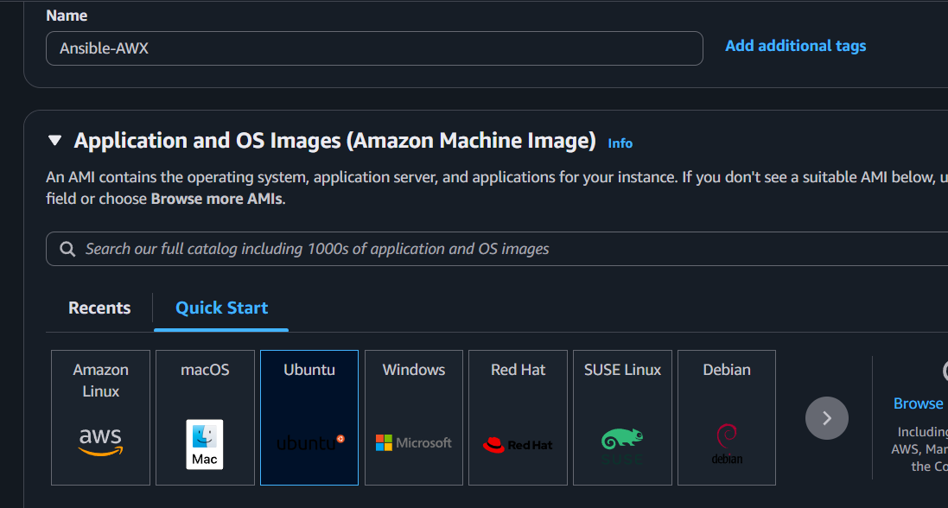
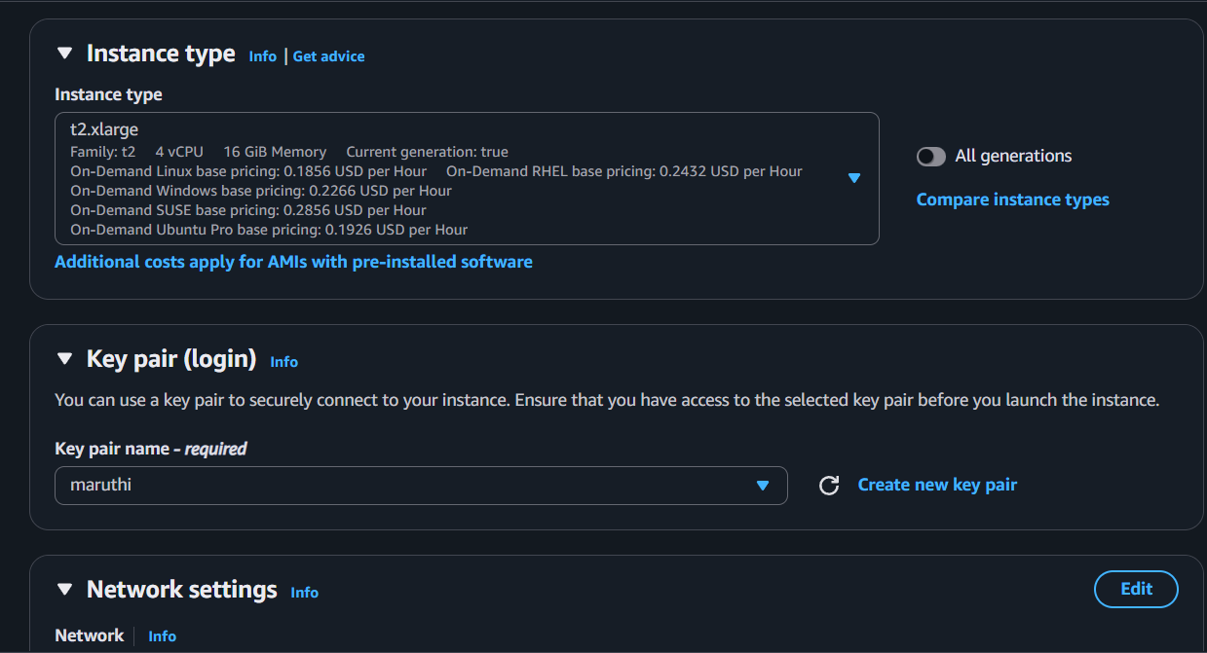
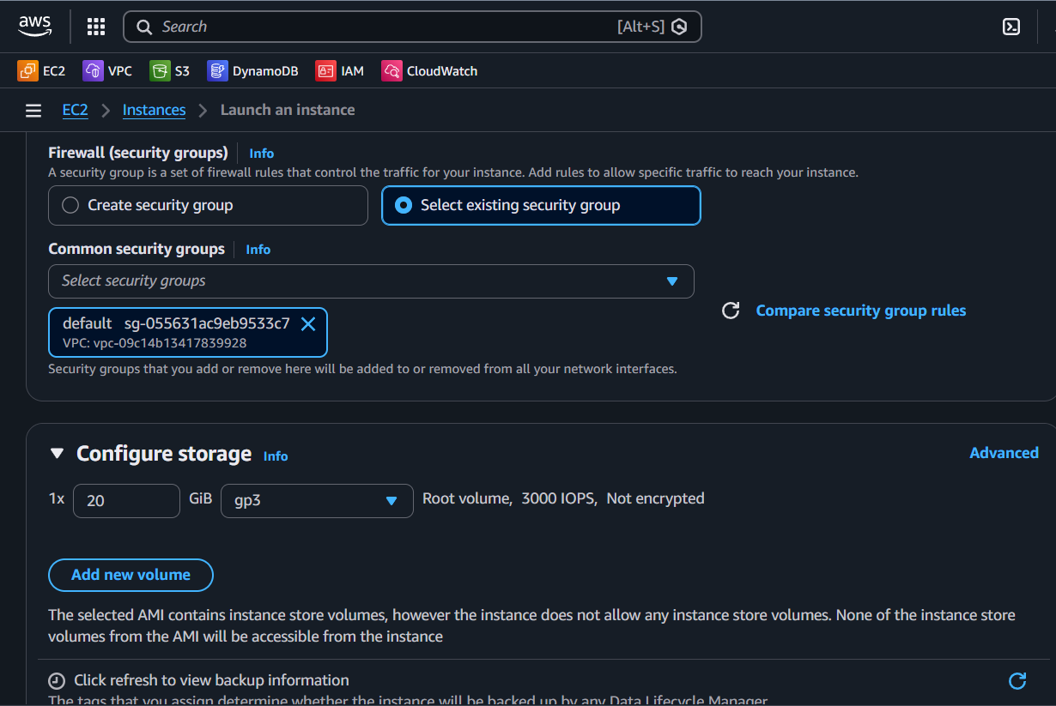

Step 3: Update the Server
apt update -y
apt upgrade -y

Step 4: Install Required Packages
apt install -y git ansible docker.io docker-compose
Enable docker:
systemctl enable docker
systemctl start docker
systemctl status docker

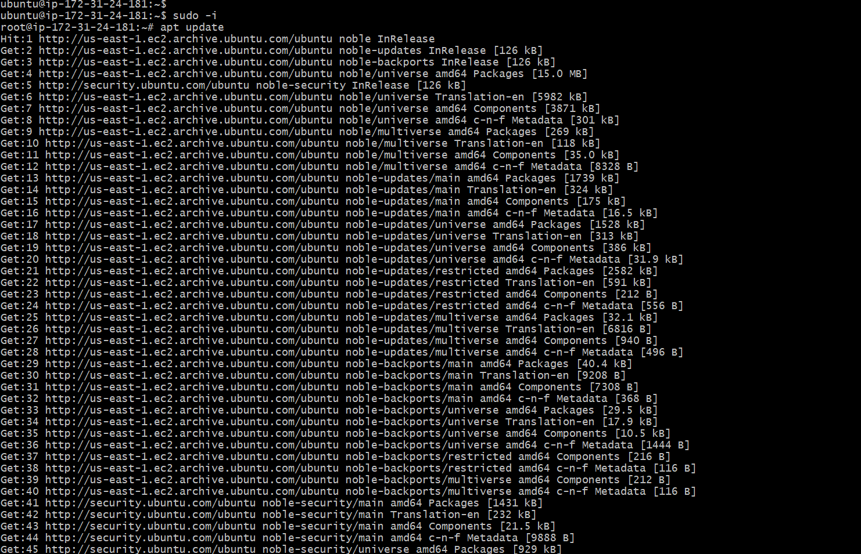

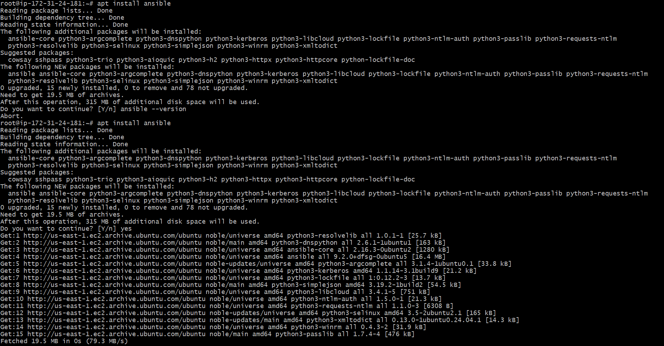
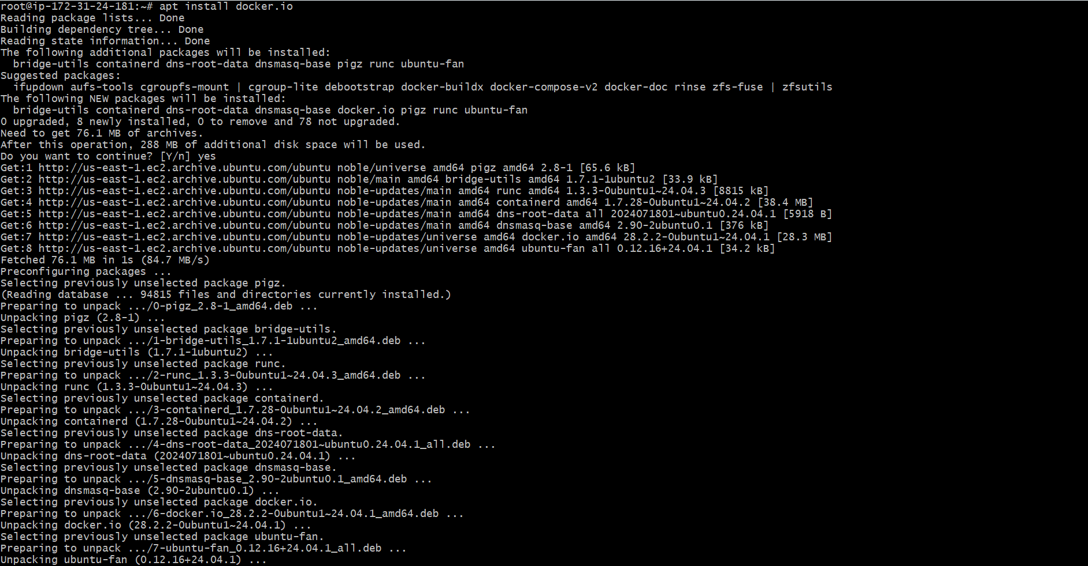
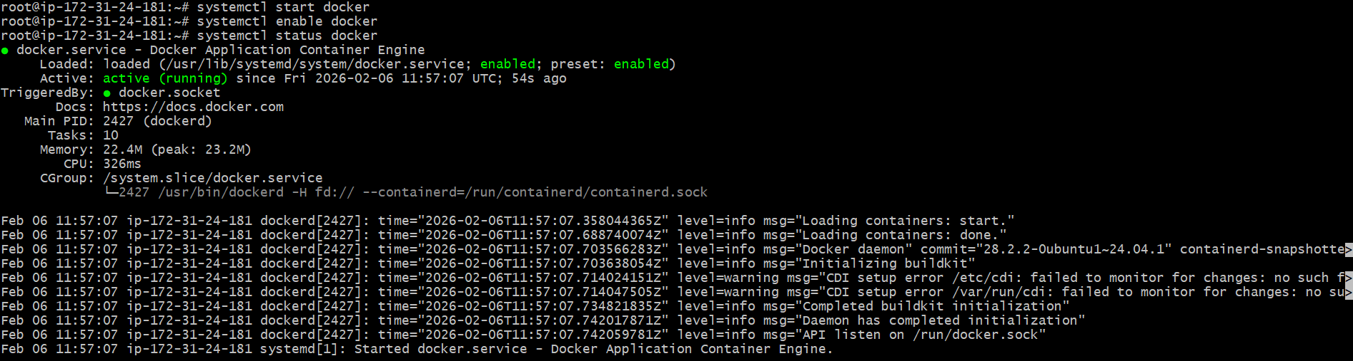
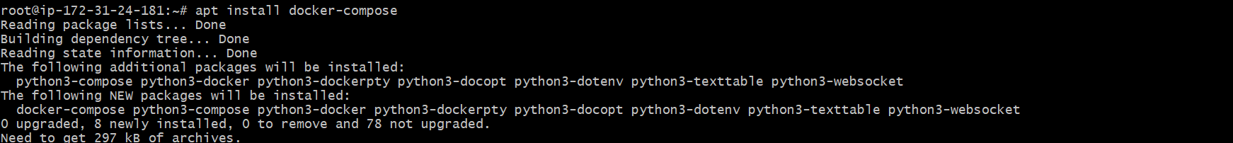

Step 5: Clone AWX Repository
git clone -b 17.1.0 https://github.com/ansible/awx.git
cd awx/installer

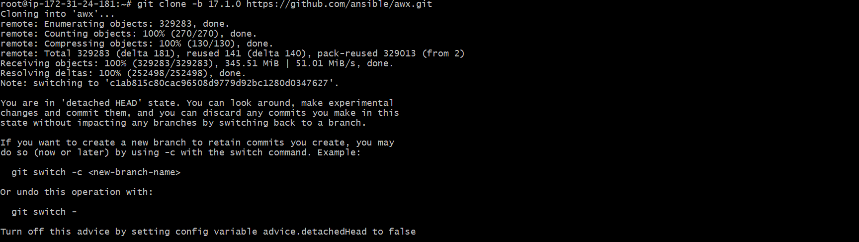
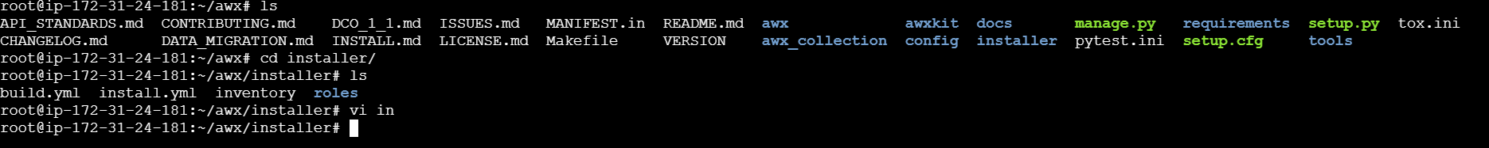

Step 6: Edit Inventory File
vi inventory
Update below values:
admin_user=admin
admin_password=Admin@123

pg_database=awx
pg_username=awx
pg_password=Admin@123

postgres_data_dir="/var/lib/awx/pgdocker"
Save and exit:
:wq

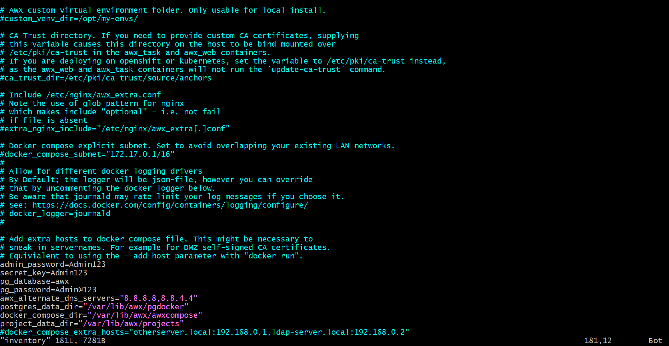

Step 7: Run AWX Installation Playbook
ansible-playbook -i inventory install.yml

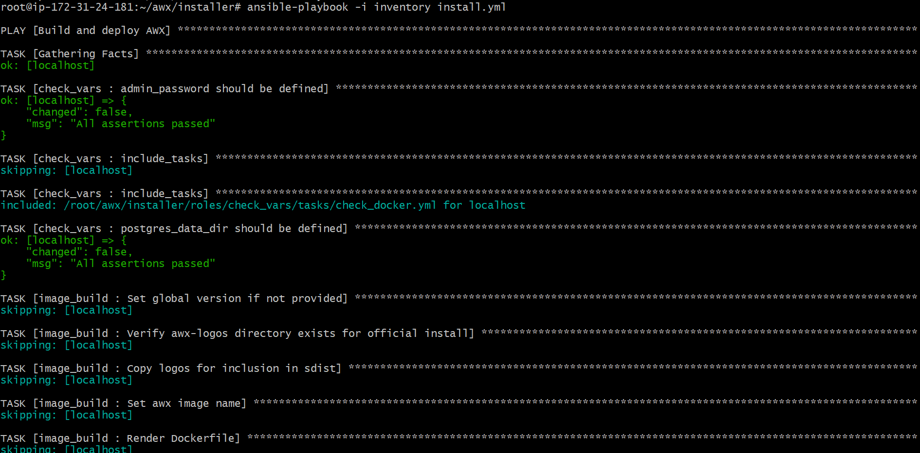

Step 8: Access AWX Web UI
Open browser:
http://<public-ip>
Login:
- Username: admin
- Password: Admin@123

