Ansible -01

What is Ansible
- Ansible is an open-source automation tool
- It is used to manage and configure multiple servers from one control machine
- It works without agents and uses SSH for communication
- Automation logic is written in simple YAML files called playbooks

What is Ansible used for
- Installing and managing software packages
- Configuring servers and maintaining desired state
- Deploying applications consistently
- Automating repetitive administrative tasks
- Managing large numbers of servers efficiently in DevOps environments

Setup one master and two worker nodes in ansible.

Title
Setting up One Ansible Master (Control Node) and Two Worker Nodes

Objective
To configure an Ansible master (control node) that can communicate with and manage two worker nodes using SSH, enabling centralized automation and configuration management.

Prerequisites
- AWS account
- 3 Ubuntu EC2 instances (same VPC recommended)
  - 1 Master (Ansible Control Node)
  - 2 Workers (Managed Nodes)
- Key pair (.pem) downloaded on your local system
- Security Group:
  - Allow SSH (22) from master → workers
- Ubuntu user: ubuntu
- Internet access on master EC2

Step-by-Step Implementation

Step 1: Launch Ubuntu EC2 Instances
- AMI: Ubuntu 22.04 LTS
- Instance type: t2.micro / t3.micro
- Same VPC & subnet
- Attach same key pair.
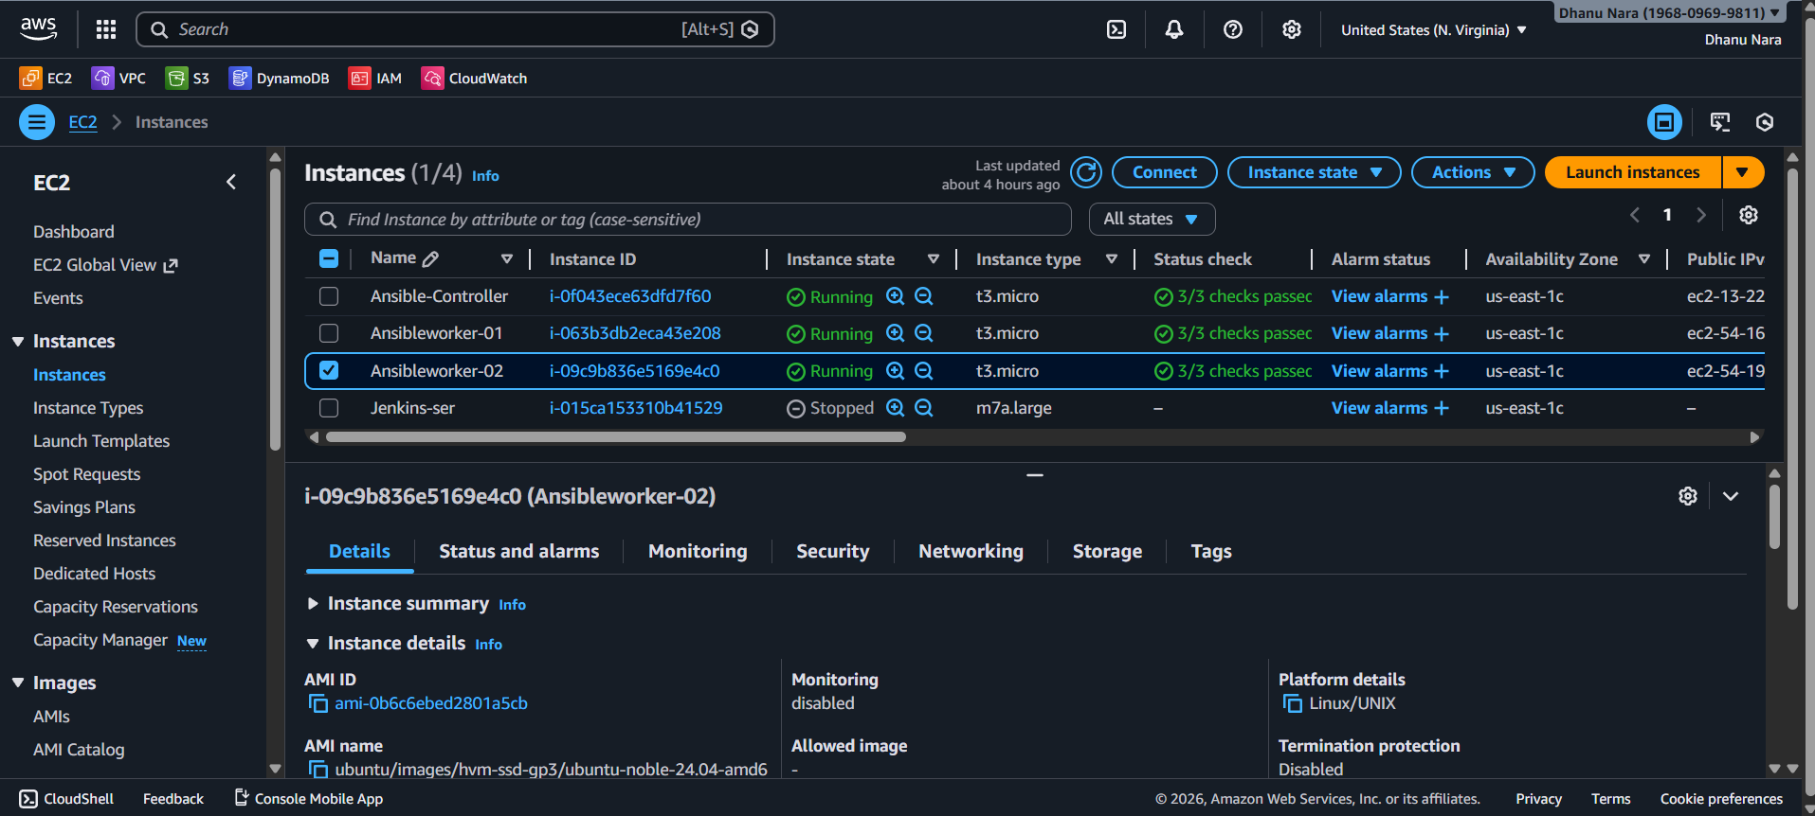

Step 2: Connect to Master EC2
From your local machine:
ssh -i key.pem ubuntu@<MASTER_PUBLIC_IP>

Step 3: Install Ansible on Master
sudo apt update
sudo apt install ansible -y
Verify:
ansible --version

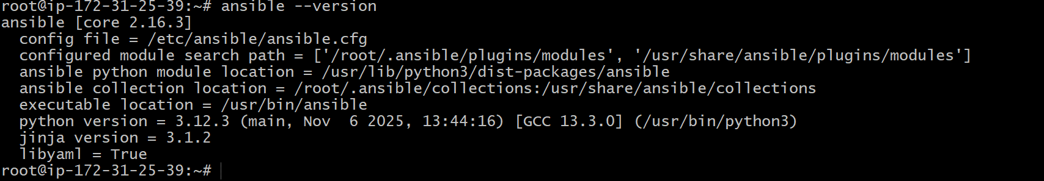

Step 4: Configure Ansible Inventory
Edit inventory using vi:
sudo vi /etc/ansible/hosts




Step 5: Create SSH Key on Master
ssh-keygen
Press Enter for all prompts.

Step 6: Copy SSH Public Key to Worker Nodes
From master:
In worker servers go to cd .ssh/ and vi authorized_keys paste the ssh-keygen created in the ansible-controller server.

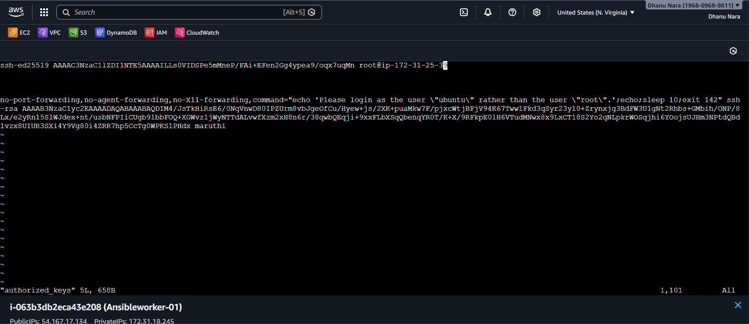

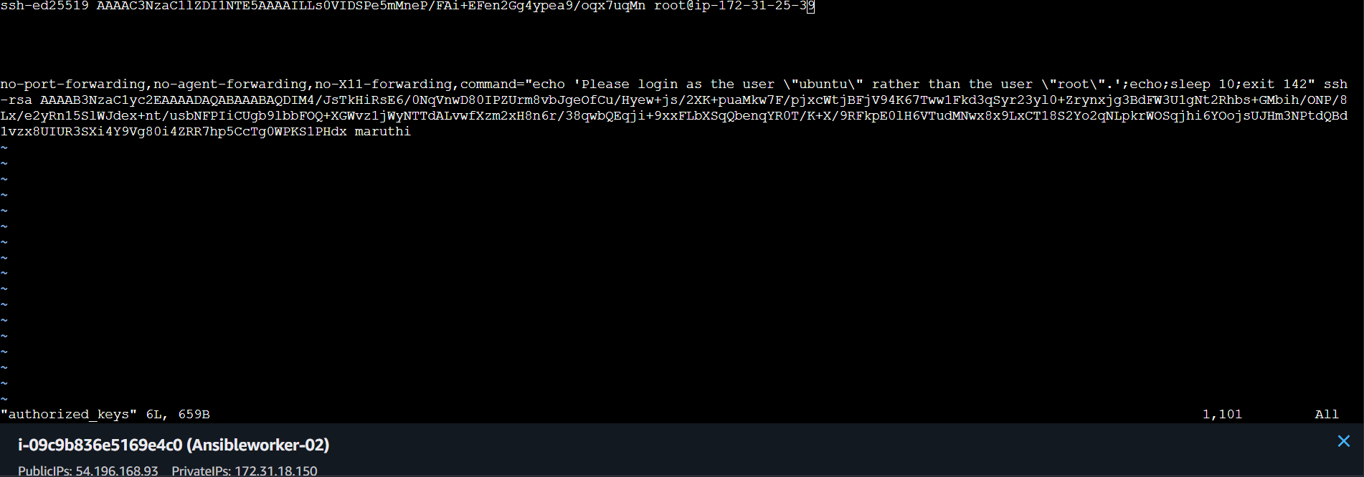

Step 7: Test Ansible Connectivity
ansible all -m ping

only to check the worker1 {ansible worker1 -m ping}.

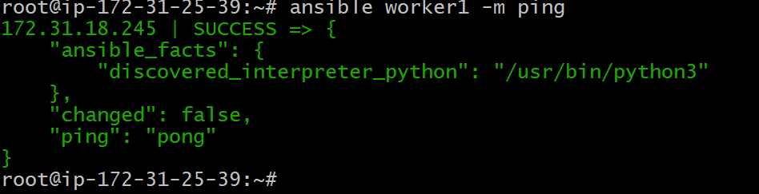

Validation Steps
Expected output:
172.31.20.11 | SUCCESS => {"ping": "pong"}
172.31.20.12 | SUCCESS => {"ping": "pong"}

Conclusion
we have successfully set up an Ansible master and two worker nodes on Ubuntu EC2 instances. The master can now securely communicate with the workers using SSH and automate configuration, deployment, and management tasks across multiple servers.

Created one custom inventory in root location named new_inventory.
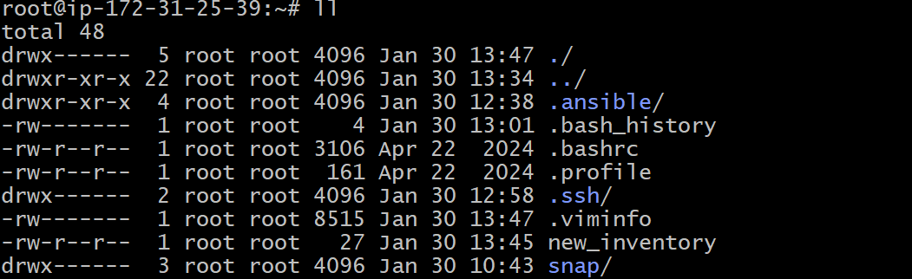
Given group name and private IP address of worker2 server.

So now to connect to the server with new_inventory we use.
We should add - i and location inventory name and group name and module.
{ansible -i /root/new_inventory/ newone -m ping}.
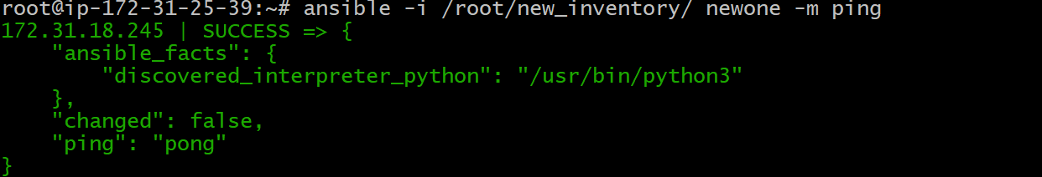

Installed Apache in Ansible Controller.
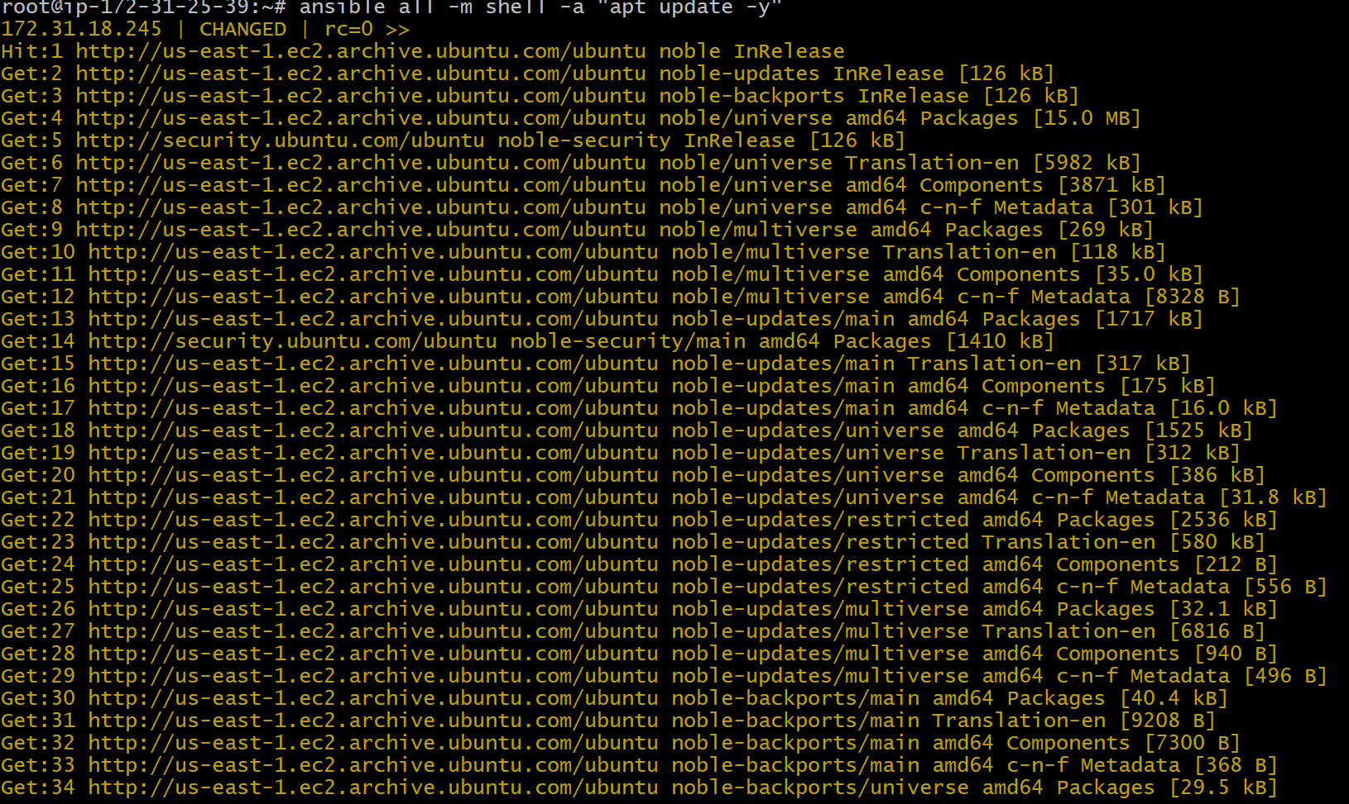
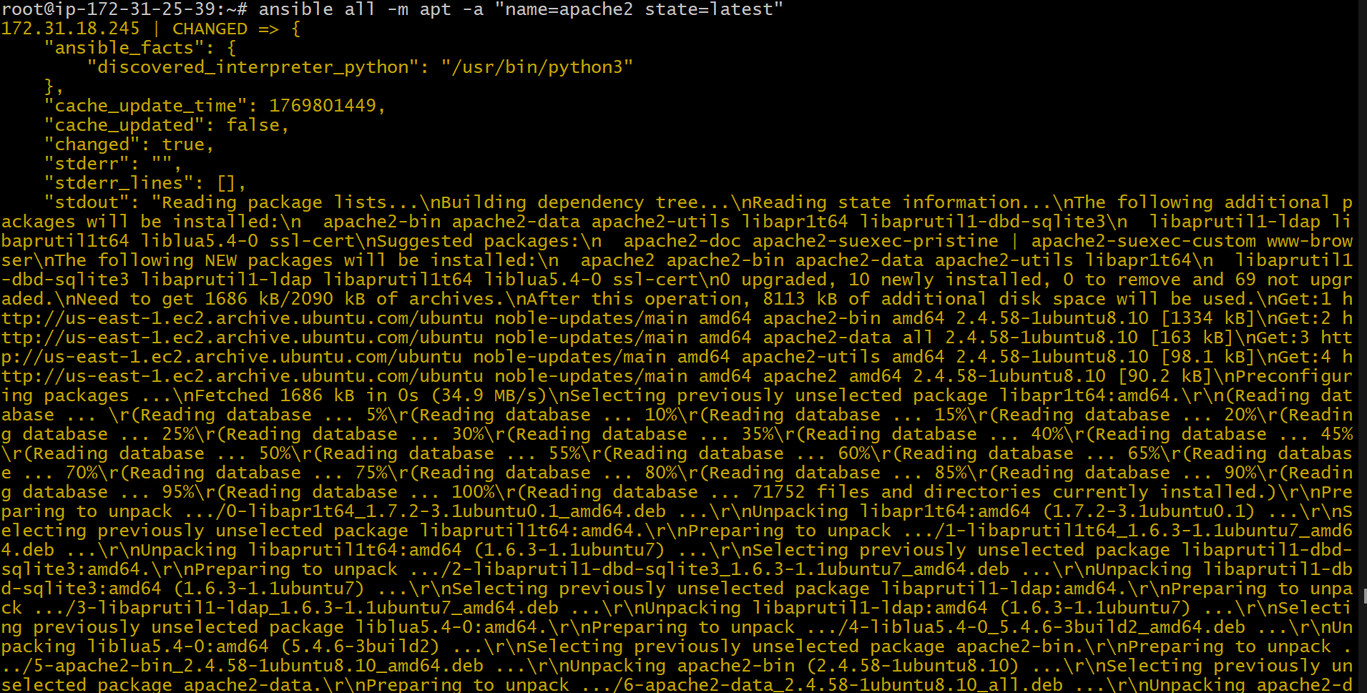

Checked Apache in worker 1 by pasting the IP in the browser.
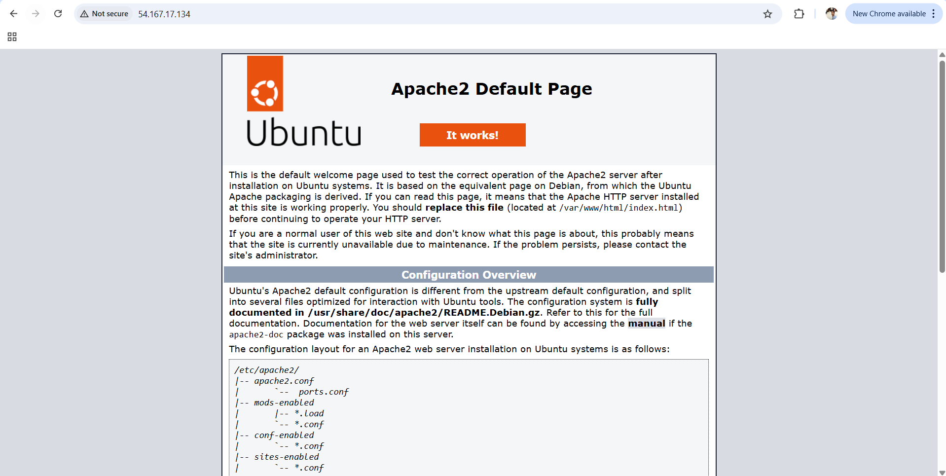

Checked Apache in worker 2 by pasting the IP in the browser.
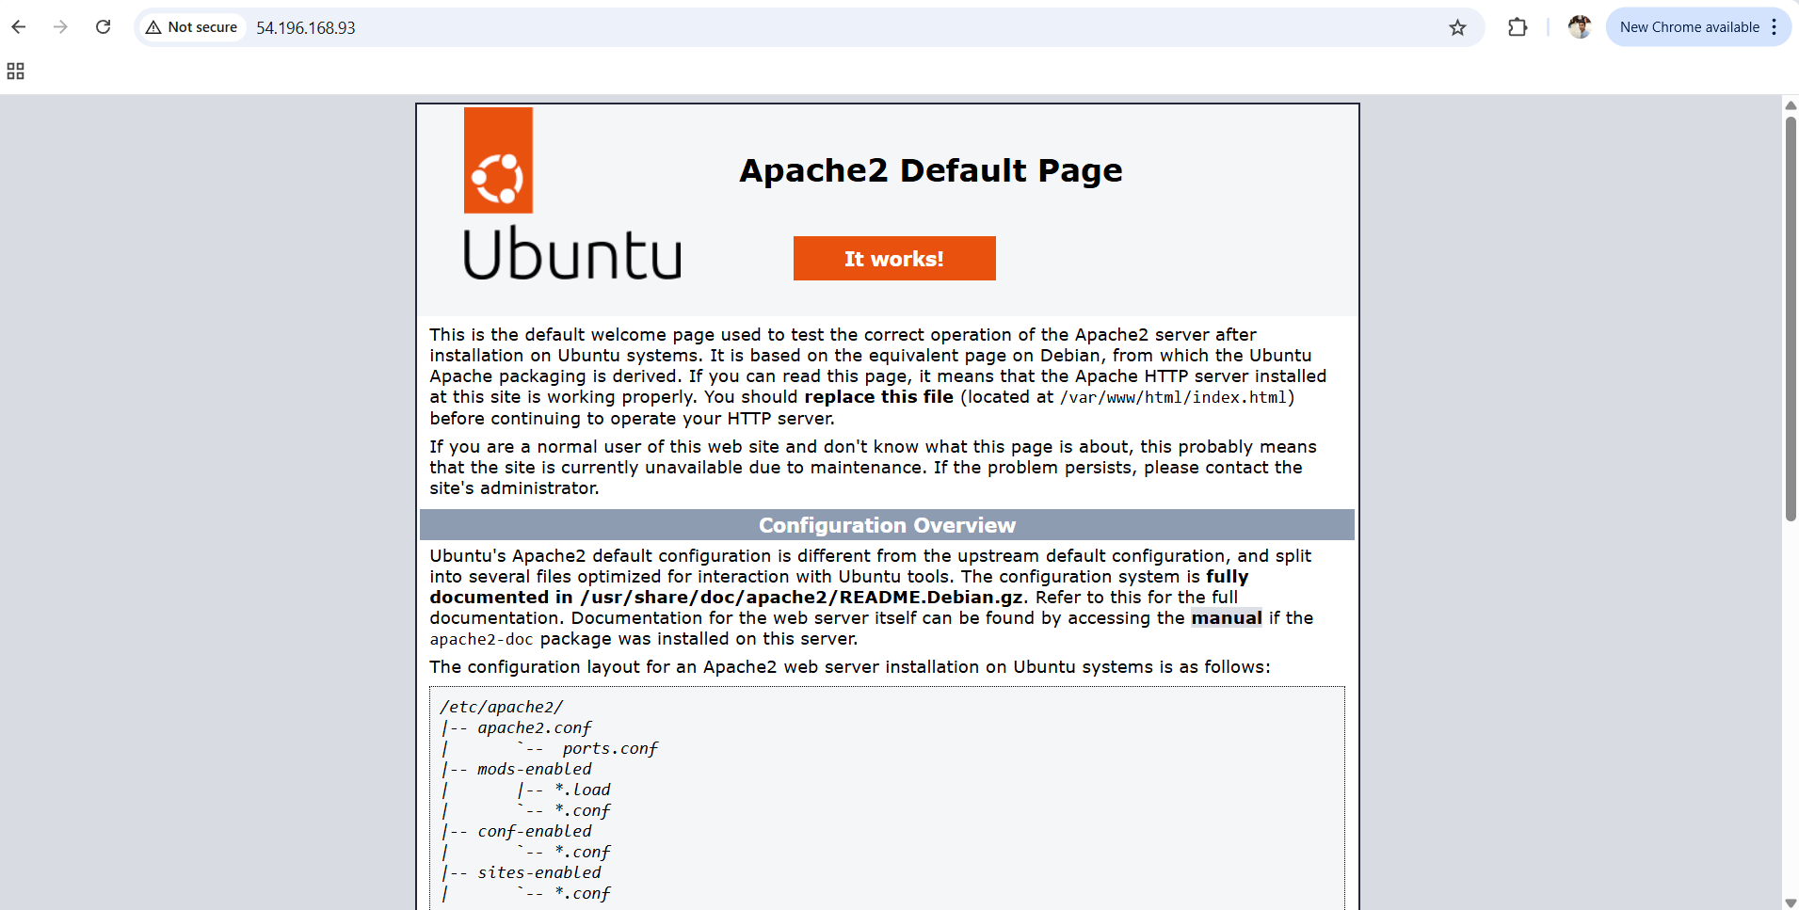

Stopped Apache in the Ansible controller.
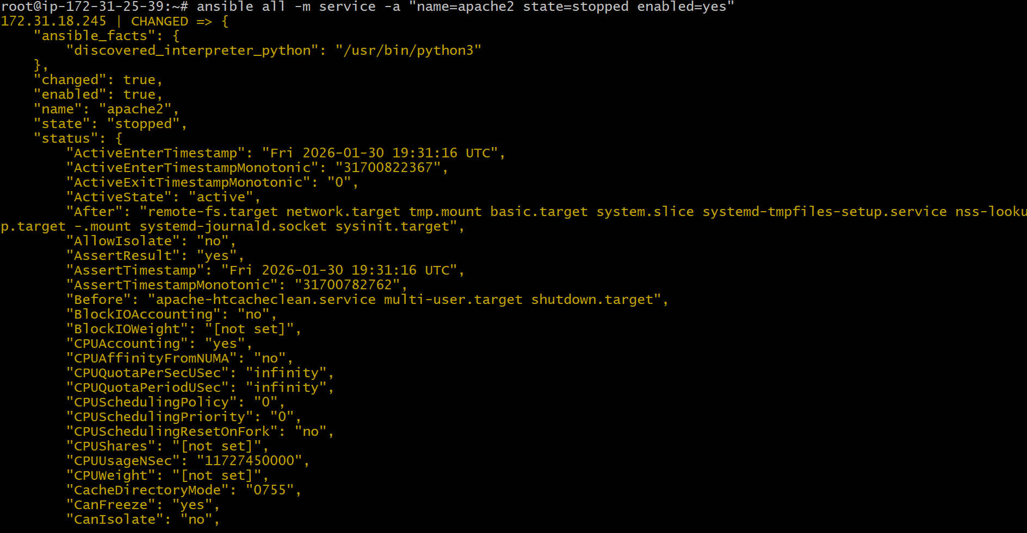
Checked status of Apache in worker1.
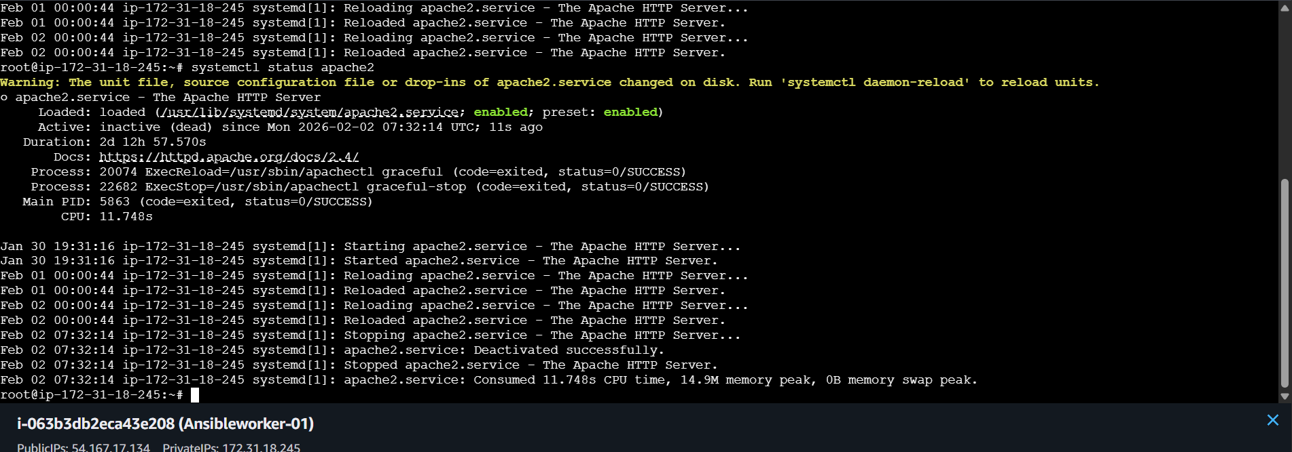
Checked the status of Apache in worker2.
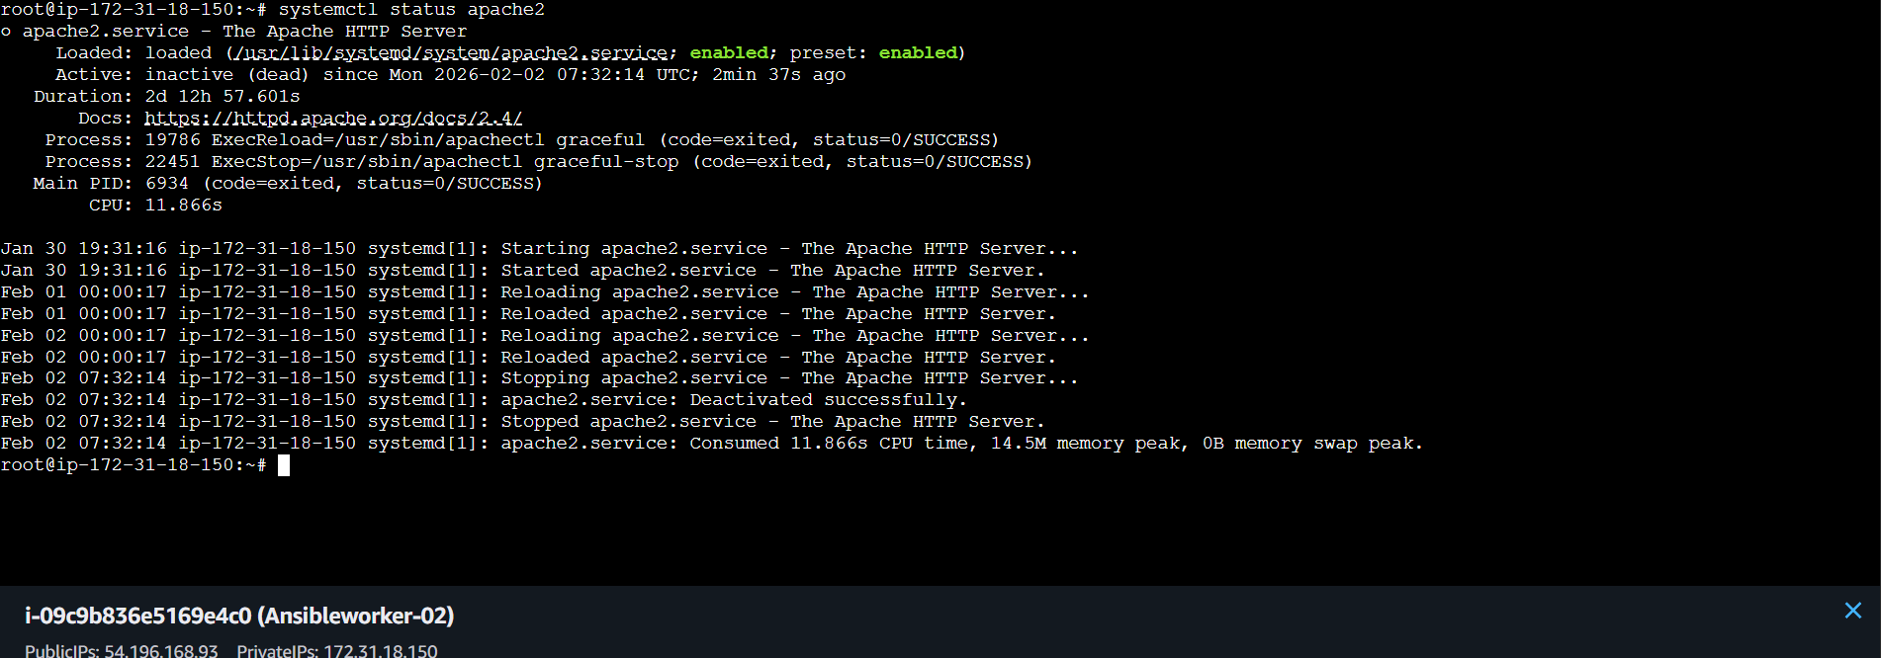

What are Ad-Hoc Commands
Ad-hoc commands are single-line Ansible commands executed directly from the terminal to perform quick, one-time tasks on remote servers without creating a playbook. They are mainly used for immediate actions and basic administration tasks.

Why Ad-Hoc Commands Are Used
Ad-hoc commands are used to:
- Perform quick checks
- Run one-time operations
- Troubleshoot issues instantly
- Avoid writing full playbooks for small tasks

When to Use Ad-Hoc Commands
Use ad-hoc commands when:
- The task is simple
- The task is not repetitive
- Immediate execution is required
Do not use ad-hoc commands when:
- The task is complex
- The task needs conditions, loops, or roles
- Automation must be reusable

Syntax of an Ad-Hoc Command

{ansible <host-pattern> -i <inventory> -m <module> -a "<arguments>"}

To check the uptime of slave machine.
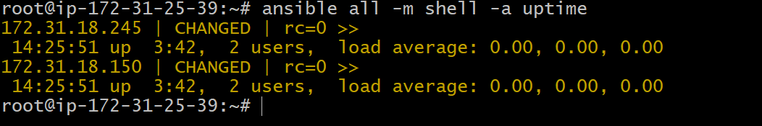

Created a folder
In worker1 it is visible

In worker2 it is visible


To gather the facts of slave machines.
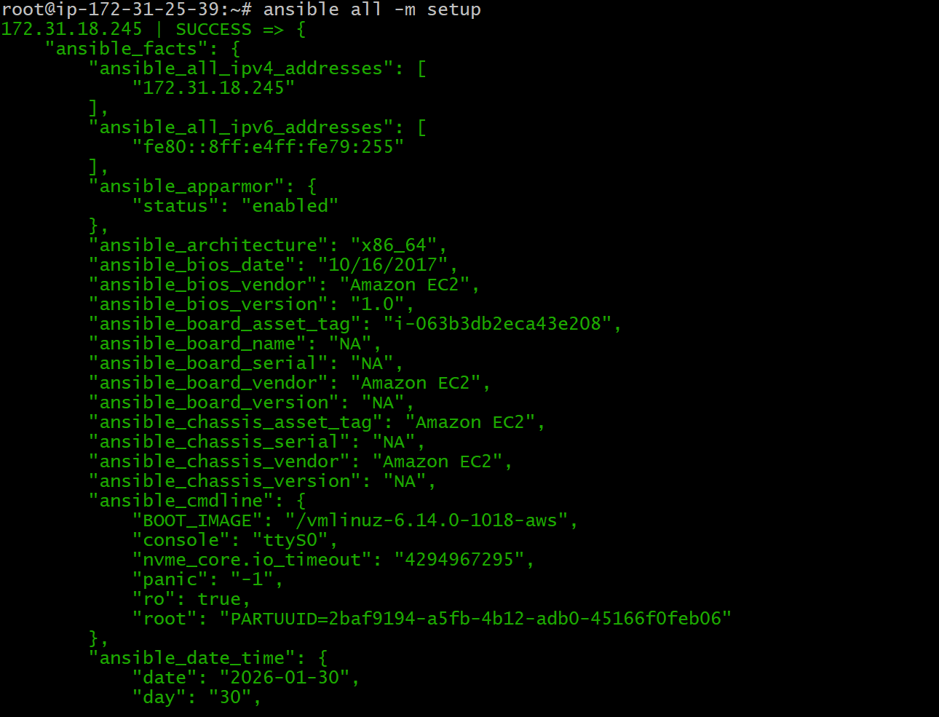

To check the free memory or memory usage.
