Jenkins-01

Install Jenkins and run Jenkins on port number 8081.
TITLE:
Jenkins Installation

OBJECTIVE:
Install Jenkins and configure it to run on port 8081.

PREREQUISITES:
EC2 instance running

STEP-BY-STEP-IMPLIMENTATION:
sudo wget -O /etc/yum.repos.d/jenkins.repo \
https://pkg.jenkins.io/redhat-stable/jenkins.repo
sudo yum upgrade
# Add required dependencies for the jenkins package
sudo yum install fontconfig java-21-openjdk
sudo yum install jenkins
sudo systemctl daemon-reload
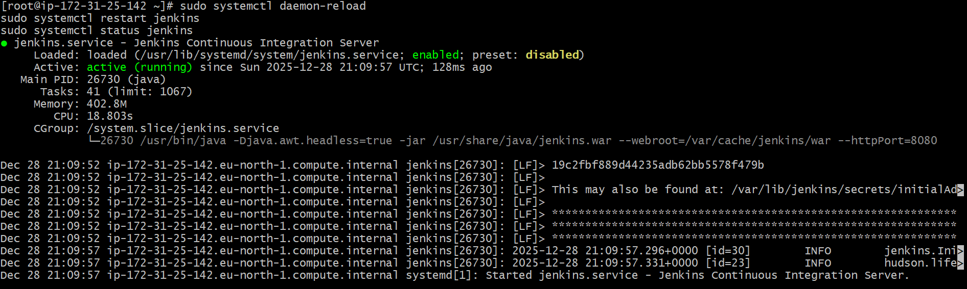
First check in the browser with public IP and 8080
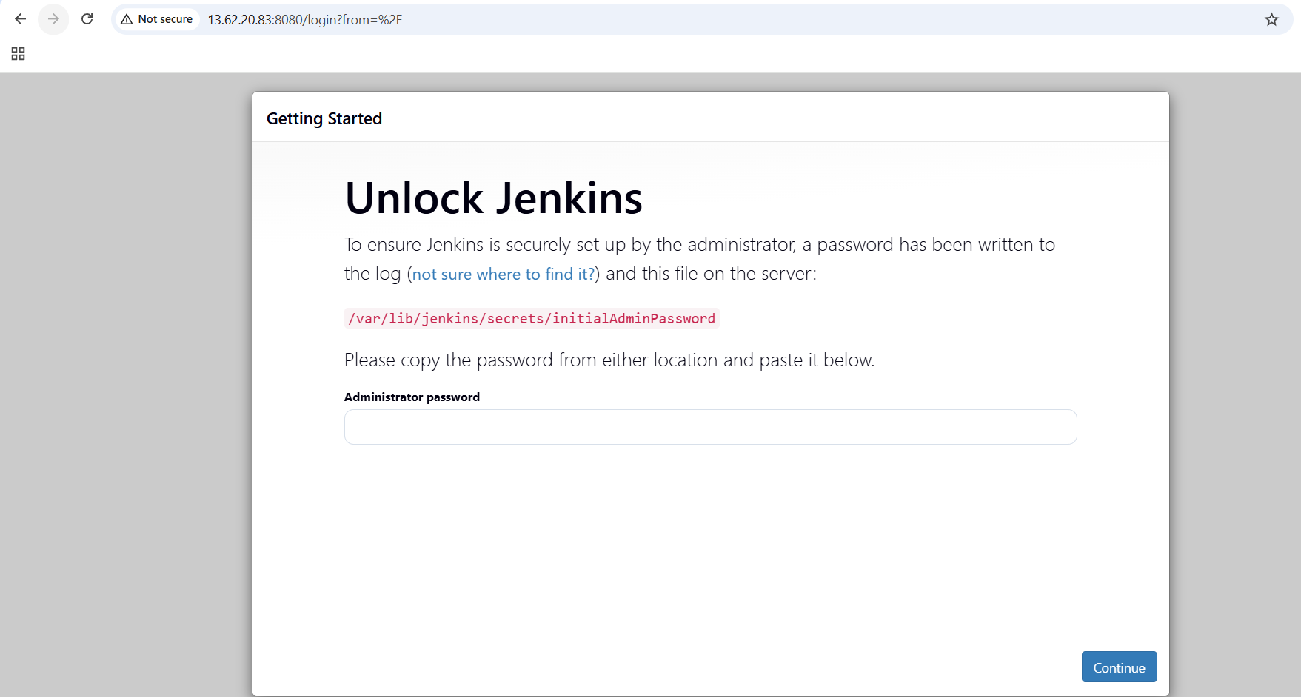
Change the port number in vi /lib/systemd/system/Jenkins.service.
Then systemctl restart Jenkins
Systemctl daemon-reload
Now check in browser with public IP and 8081.
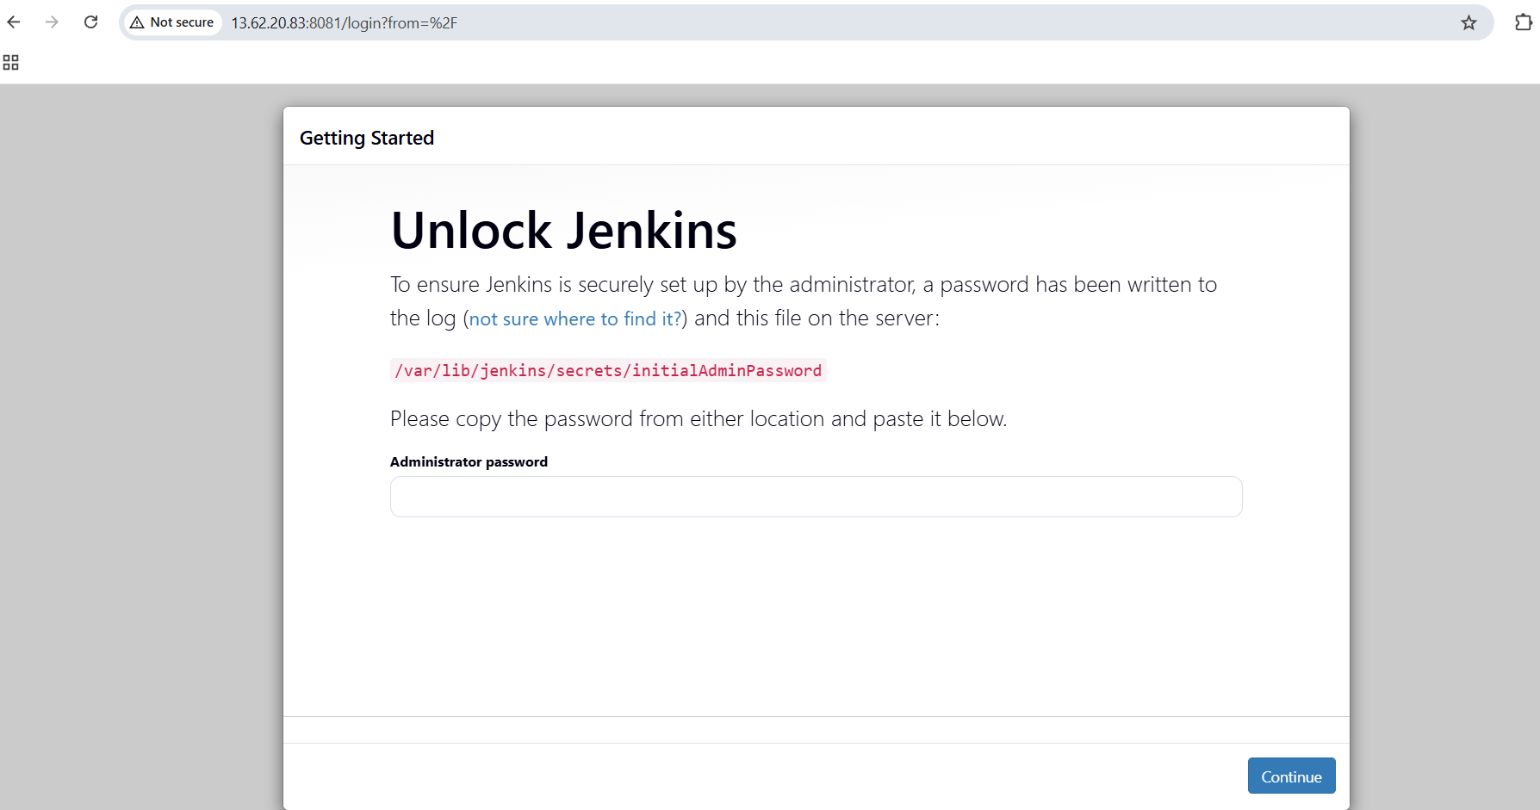

CONCLUSION:
Jenkins is successfully installed and configured to run on port 8081

Secure Jenkins server.
Jenkins server has to be secured so that others wont have the access. Go to admin and configure new credentials.
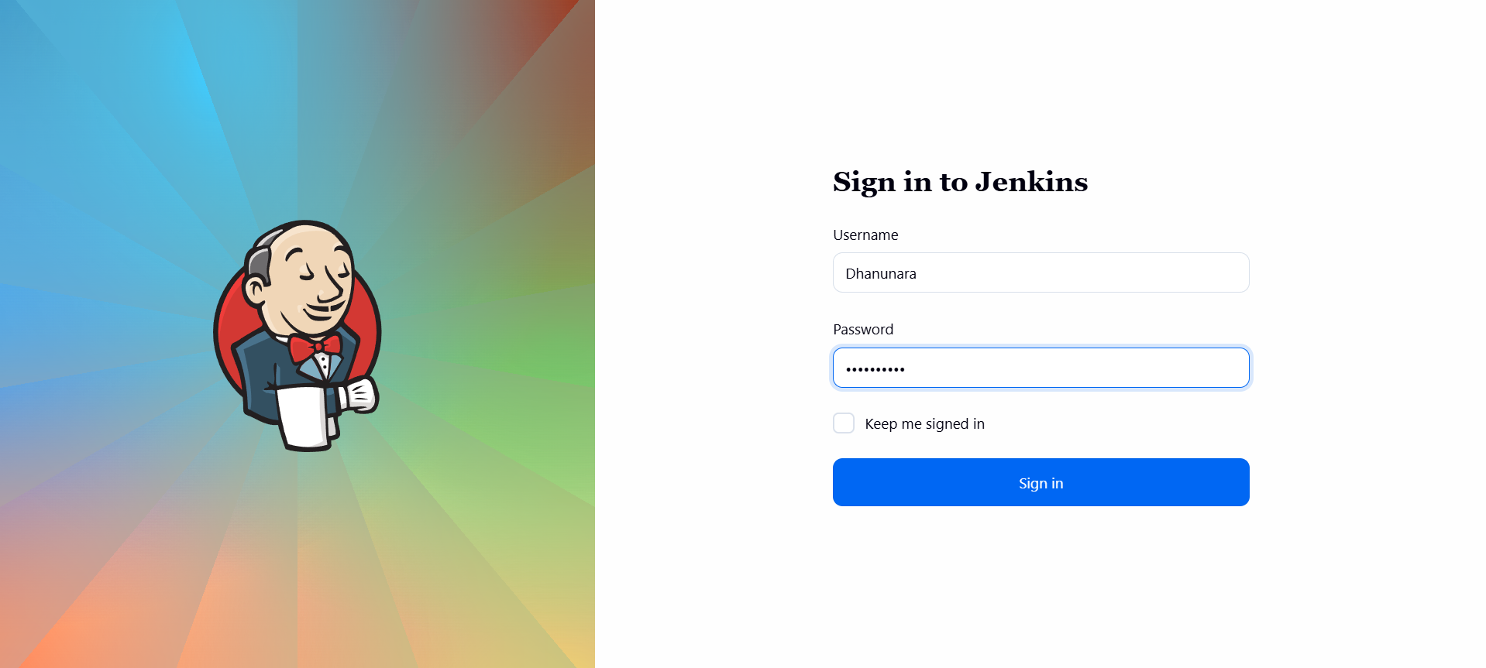

Create users called devops and testing with limited access.

TITLE:
Users with limited access

OBJECTIVE:
Create two users, devops and testing, with limited access permissions.

PREREQUISITES:
Jenkins has to be installed

STEP-BY-STEP-IMPLIMENTATION:
Created a user called “Devops”
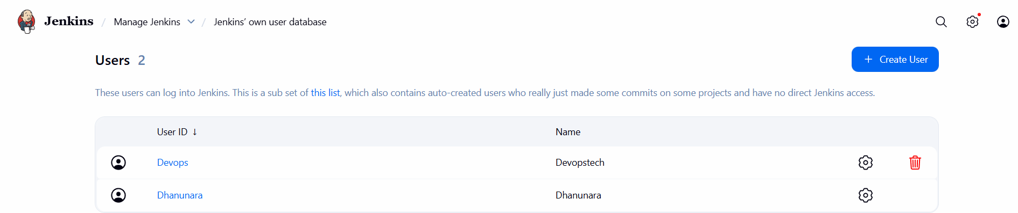
Read only access to the user
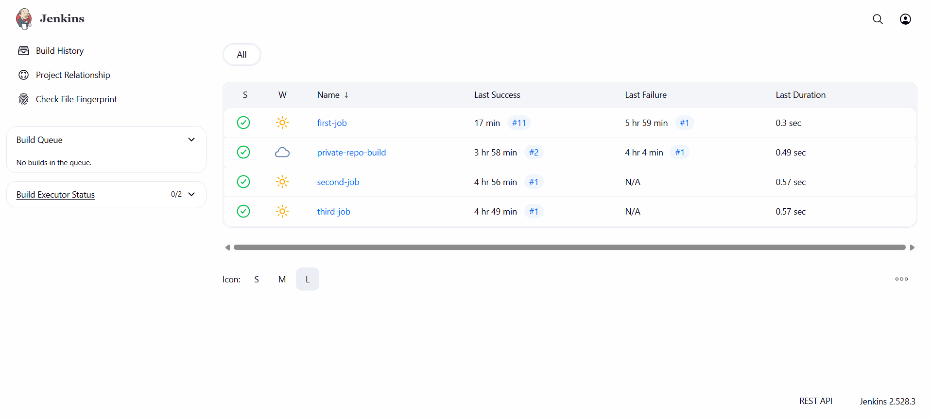
Created a user called “testing”
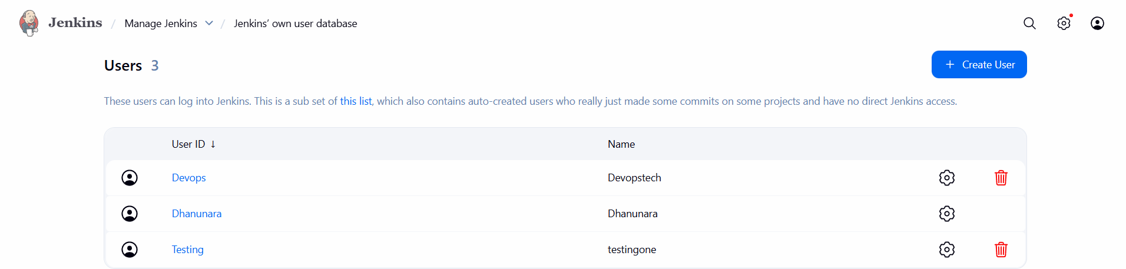

Read and build job access to the user

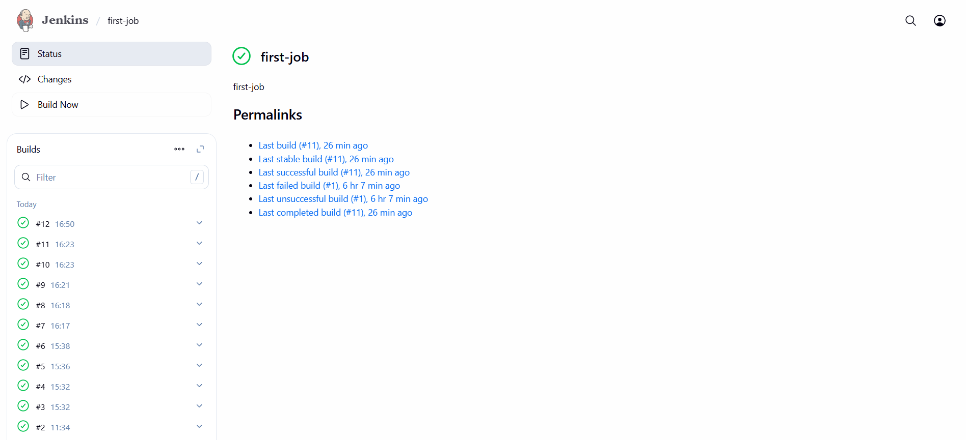

CONCLUSION:
Users devops and testing are successfully created with restricted access, ensuring controlled and secure usage on the system.

Configure labels and restrict the jobs to execute based on label only.

TITLE:
Configuring labels and restricting jobs.

OBJECTIVE:
Configure Jenkins agent labels and restrict specific jobs to run only on nodes matching that label.

PREREQUISITES:
Jenkins running and accessible
Atleast one Jenkins node is connected

STEP-BY-STEP-IMPLIMENTATION:
Created one node
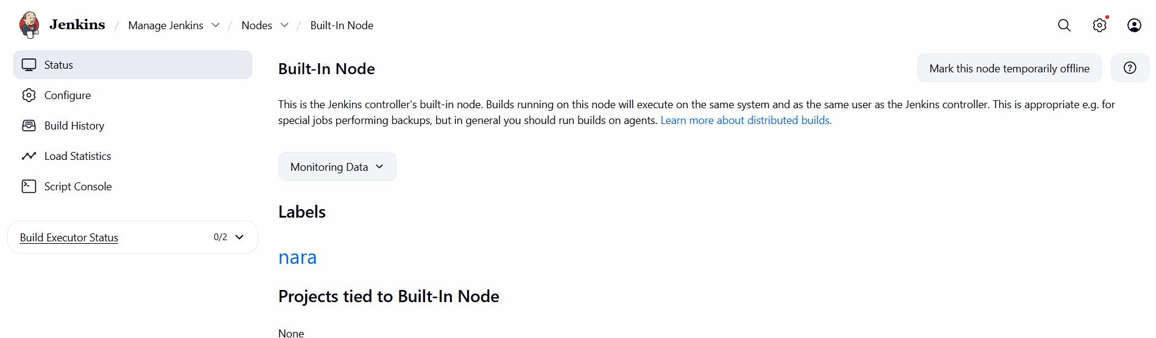
Build the job with the label
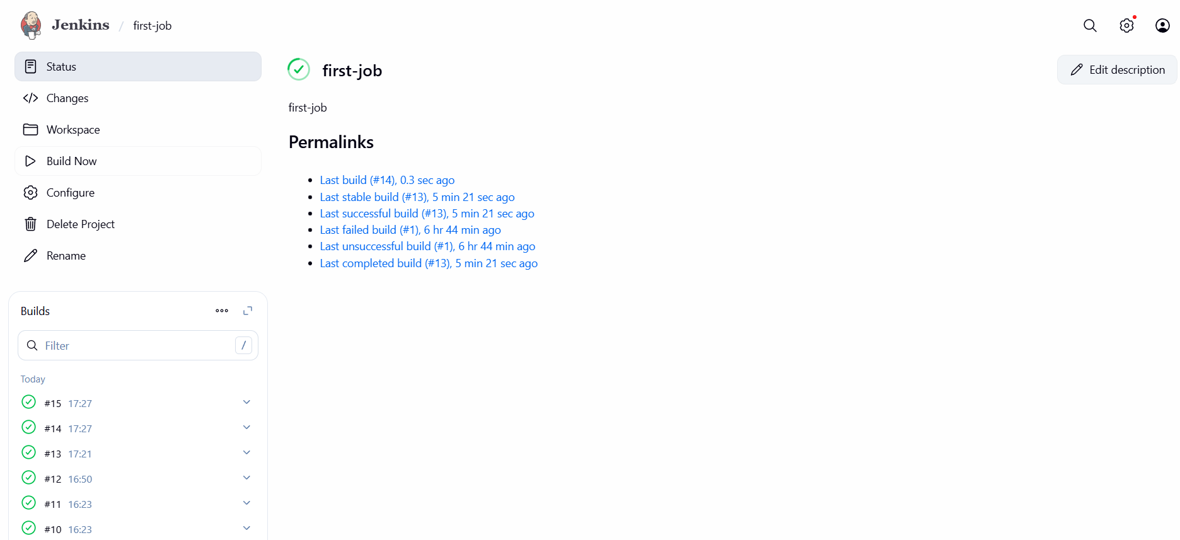
Used another label
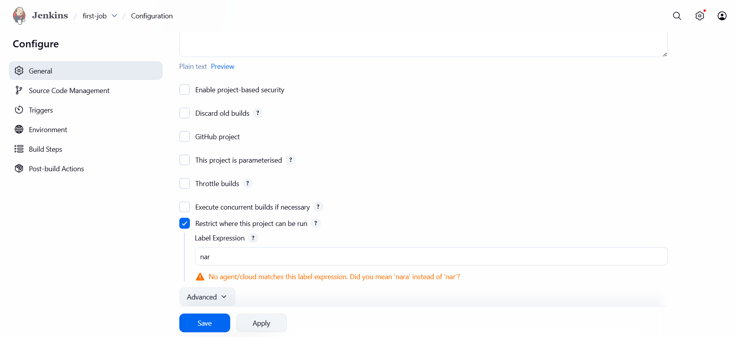
Not able to build
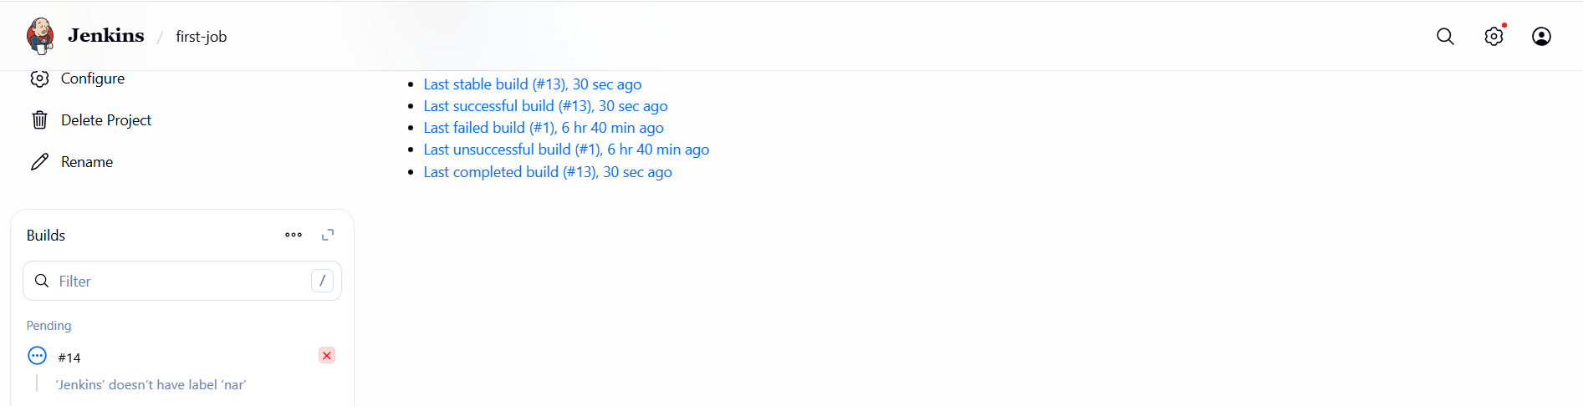

CONCLUSION:
Labels are configured successfully on Jenkins nodes, and jobs are restricted to run only on agents with the assigned label — ensuring controlled execution and resource management.

1.Create three sample jobs using the URL https://github.com/betawins/Techie_horizon_Login_app.git.

TITLE:
Sample jobs

OBJECTIVE:
Create three sample Jenkins jobs using a provided GitHub repository URL.

PREREQUISITES:
• Jenkins installed and running
• Git plugin installed in Jenkins
• Valid GitHub URL (public or private repo with token access if private)
• Jenkins machine having internet access to clone the repo
• Credentials added in Jenkins if using private URL
STEP-BY-STEP-IMPLIMENTATION:
Created three sample jobs.
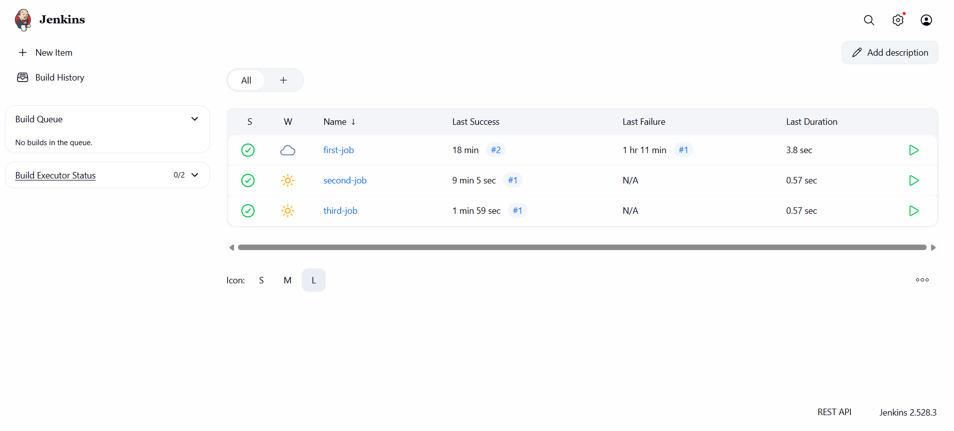
For Jenkins to see the files should go to /var/lib/jenlins.
In that workspace folder all the jobs will be available.
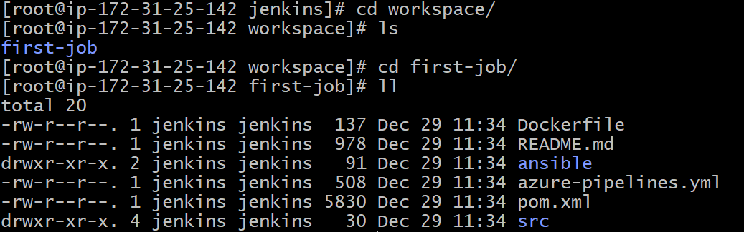
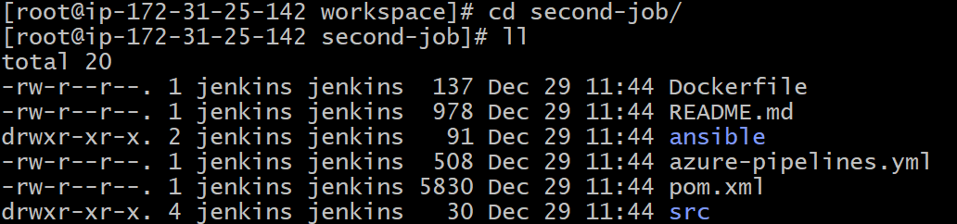
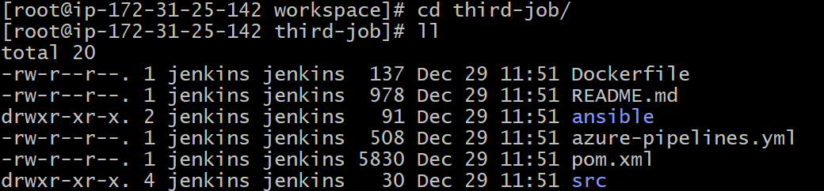
CONCLUSION:
Three sample Jenkins jobs were successfully created in Jenkins using the given repository URL, verifying that Jenkins can fetch code from the repo and trigger builds.

2.Create one Jenkins job using github private repository.

TITLE:
Jenkins job using github private repo

OBJECTIVE:
Create a Jenkins job that pulls code from a private GitHub repository and triggers a build

PREREQUISITES:
• Jenkins installed and running
• Git plugin installed
• A private GitHub repository created
• A Fine-grained personal access token (PAT) generated with repo access
• GitHub credentials added in Jenkins (Manage Jenkins → Credentials)
• Internet access between Jenkins server and GitHub

STEP-BY-STEP-IMPLIMENTATION:
First created a private repository in github.

Generate GitHub Personal Access Token
- Go to GitHub → Settings → Developer Settings → Personal Access Tokens
Copy the tocken created in the github
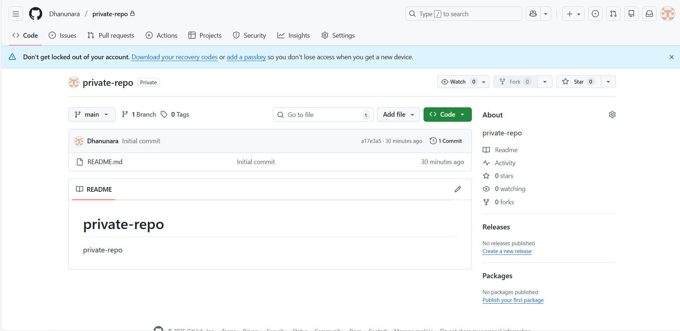

Add the credentials in the Jenkins
Now create a job using this git URL
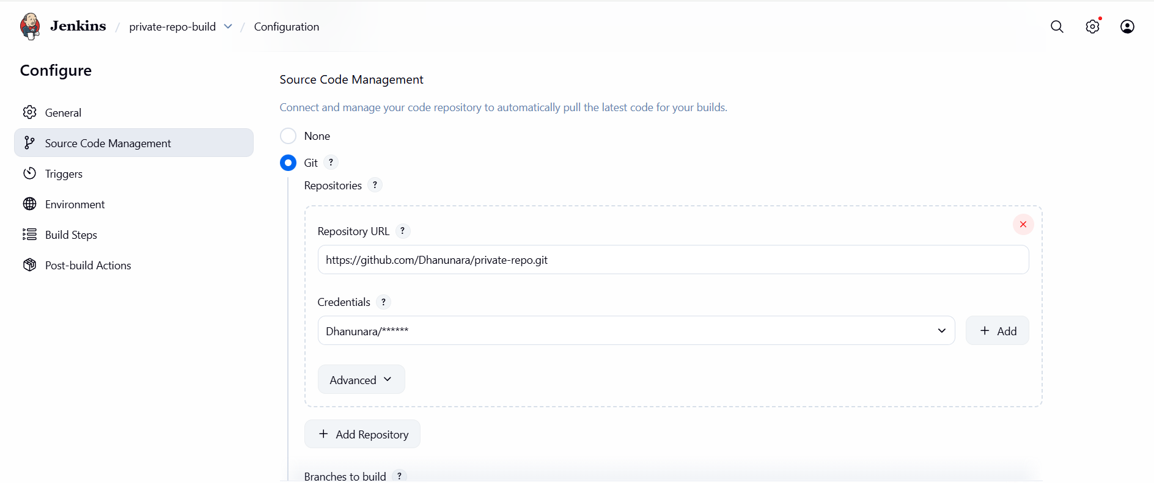
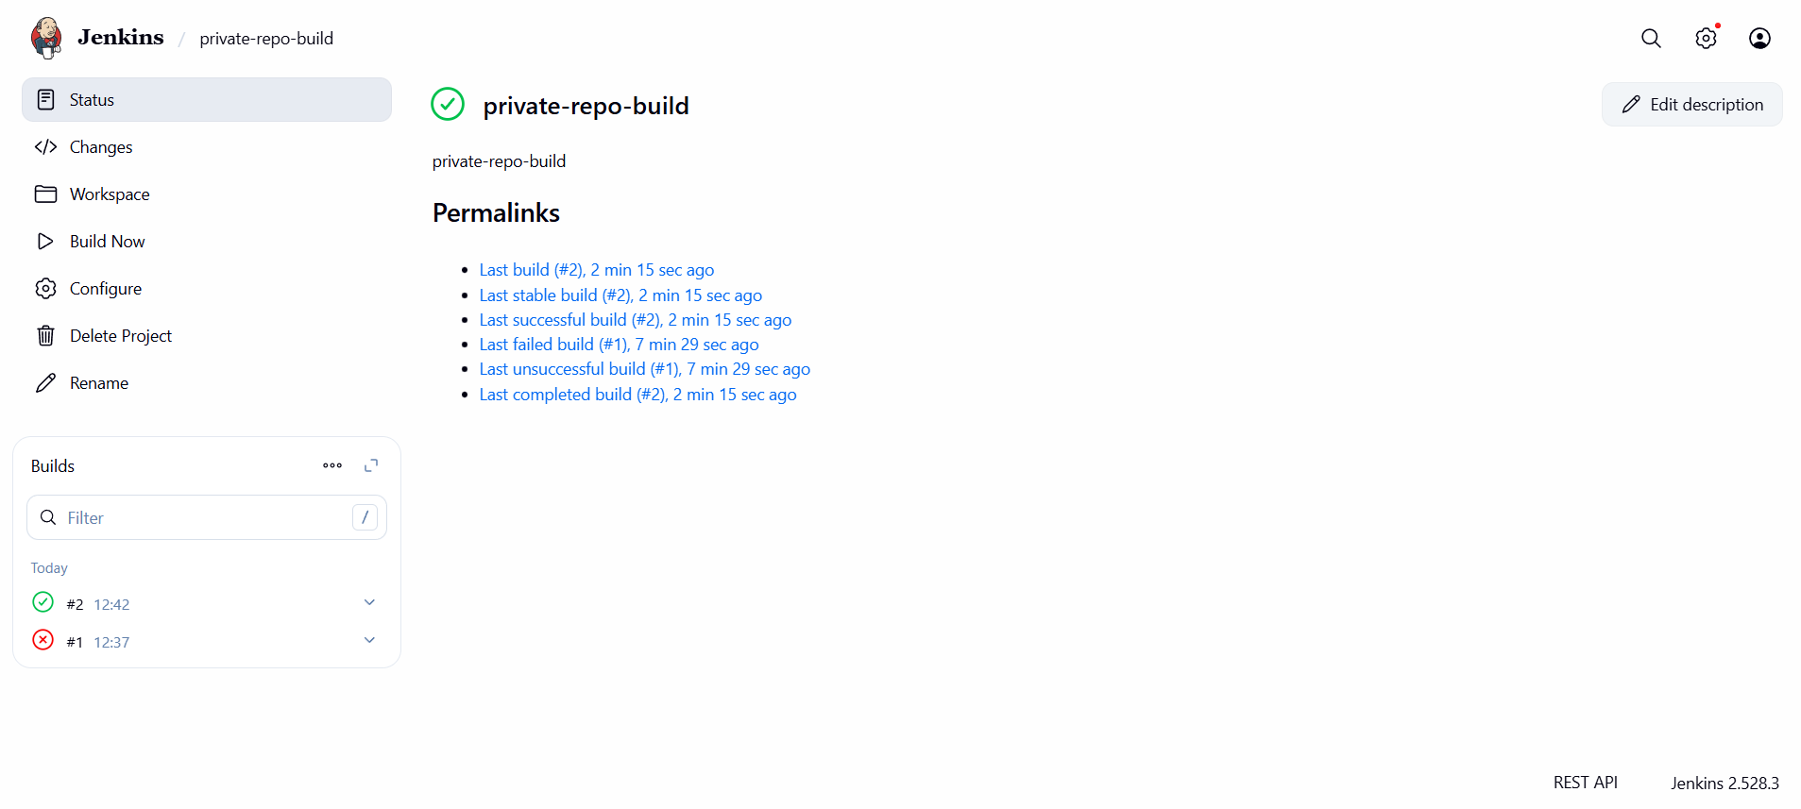

CONCLUSION:
A Jenkins job is successfully created and configured to fetch code from a private GitHub repository using an access token, enabling secure integration and build execution

