Jenkins-02

1.Configure two slave machines in Jenkins master.
TITLE:
Slave machine in Jenkins master.

OBJECTIVE:
To configure slave (agent) machines in Jenkins so that build and deployment jobs are executed on remote nodes, improving performance, scalability, and efficient resource utilization.

PREREQUISITES:
Jenkins master server must be installed and running.
Slave machine must be reachable from Jenkins master over the network.
Compatible Java version must be installed on the slave machine.
SSH service must be enabled and running on the slave machine.
Passwordless SSH (public–private key authentication) must be configured.
Jenkins user must have required permissions on the slave machine.
Required build tools (Git, Maven, Docker, etc.) must be installed on the slave

STEP-BY-STEP-IMPLIMENTATION:
Steps to be done on slave
===================
Login to slave machine..
switch to root user
install jdk 11 (amazon-linux-extras install java-openjdk11)
Create ssh-keygen
cat id_rsa.pub > authorized_keys
chmod 700 authorized_keys


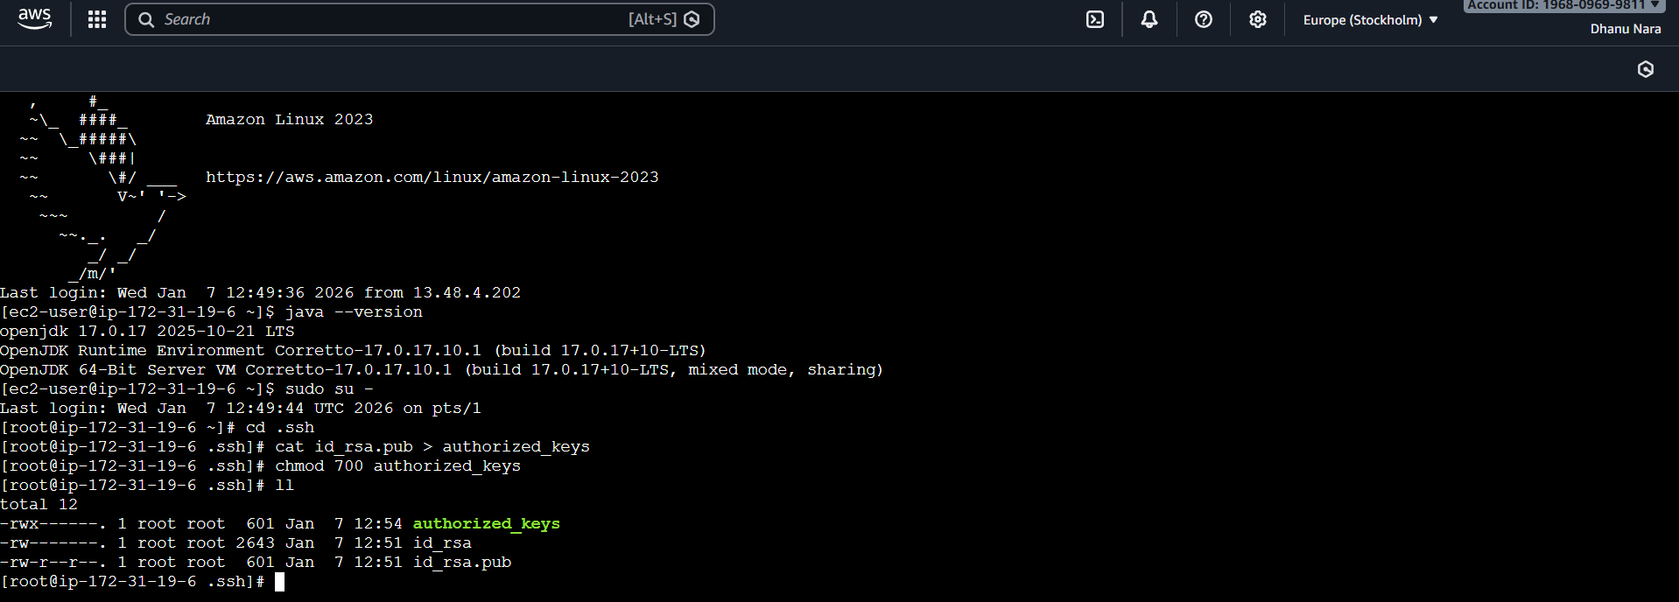
Steps to be done on master machine:
===========================
Login to master machine
switch to root user.
mkdir -p /var/lib/jenkins/.ssh
cd /var/lib/jenkins/.ssh
ssh-keyscan -H SLAVE-NODE-IP-OR-HOSTNAME >>/var/lib/jenkins/.ssh/known_hosts
# ssh-keyscan -H 172.31.38.42 >>/var/lib/jenkins/.ssh/known_hosts
chown jenkins:jenkins known_hosts
#we need to change the owner as we ran ssh-keyscan command using “root” user.
# default user of Jenkins will be “jenkins”
chmod 700 known_hosts.
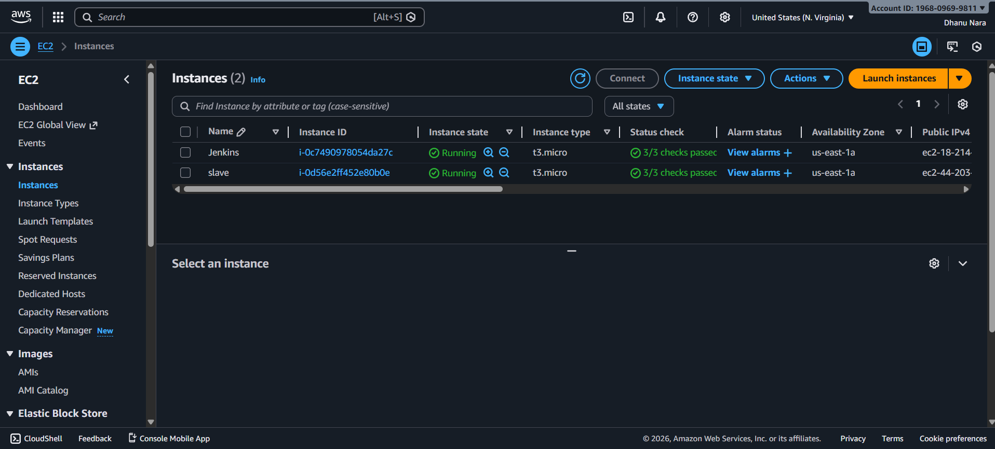
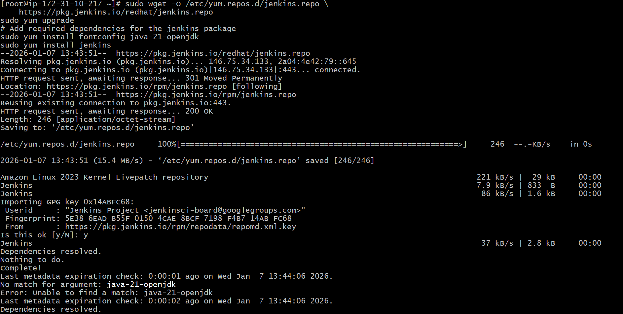
Go to manage jenkins
open manage node
under launch method select "Launch via SSh"
Host "public ip of slave"
creditals: select user with private key
enter ec2-user as name and paste the pem key.
host key verification startegy to be selected
save..
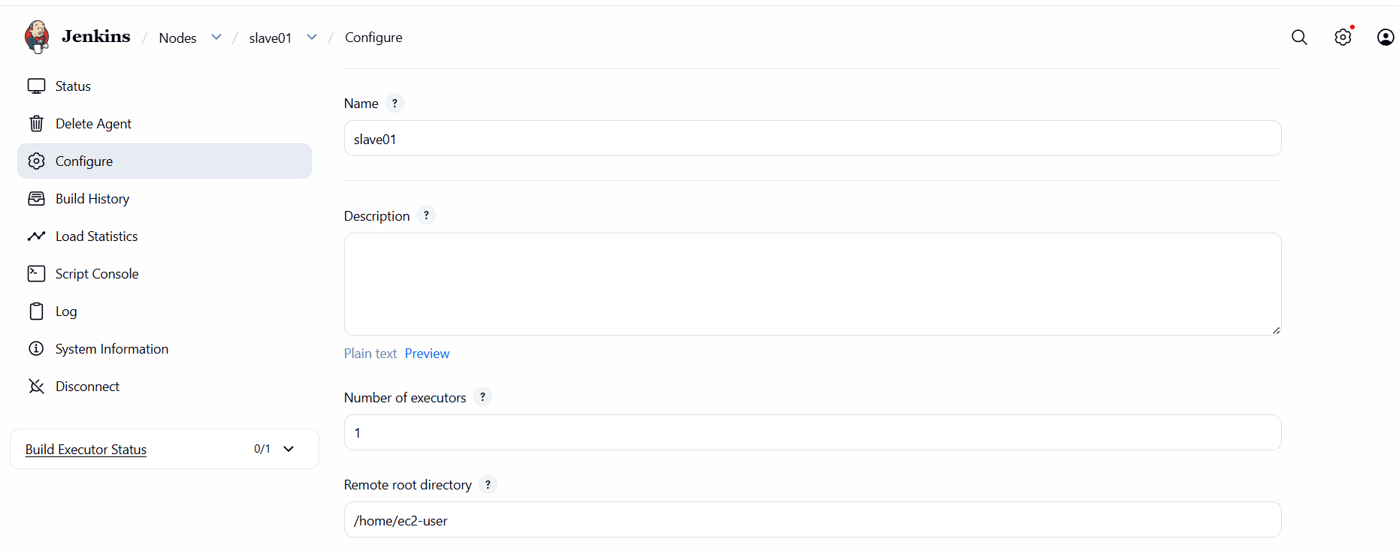
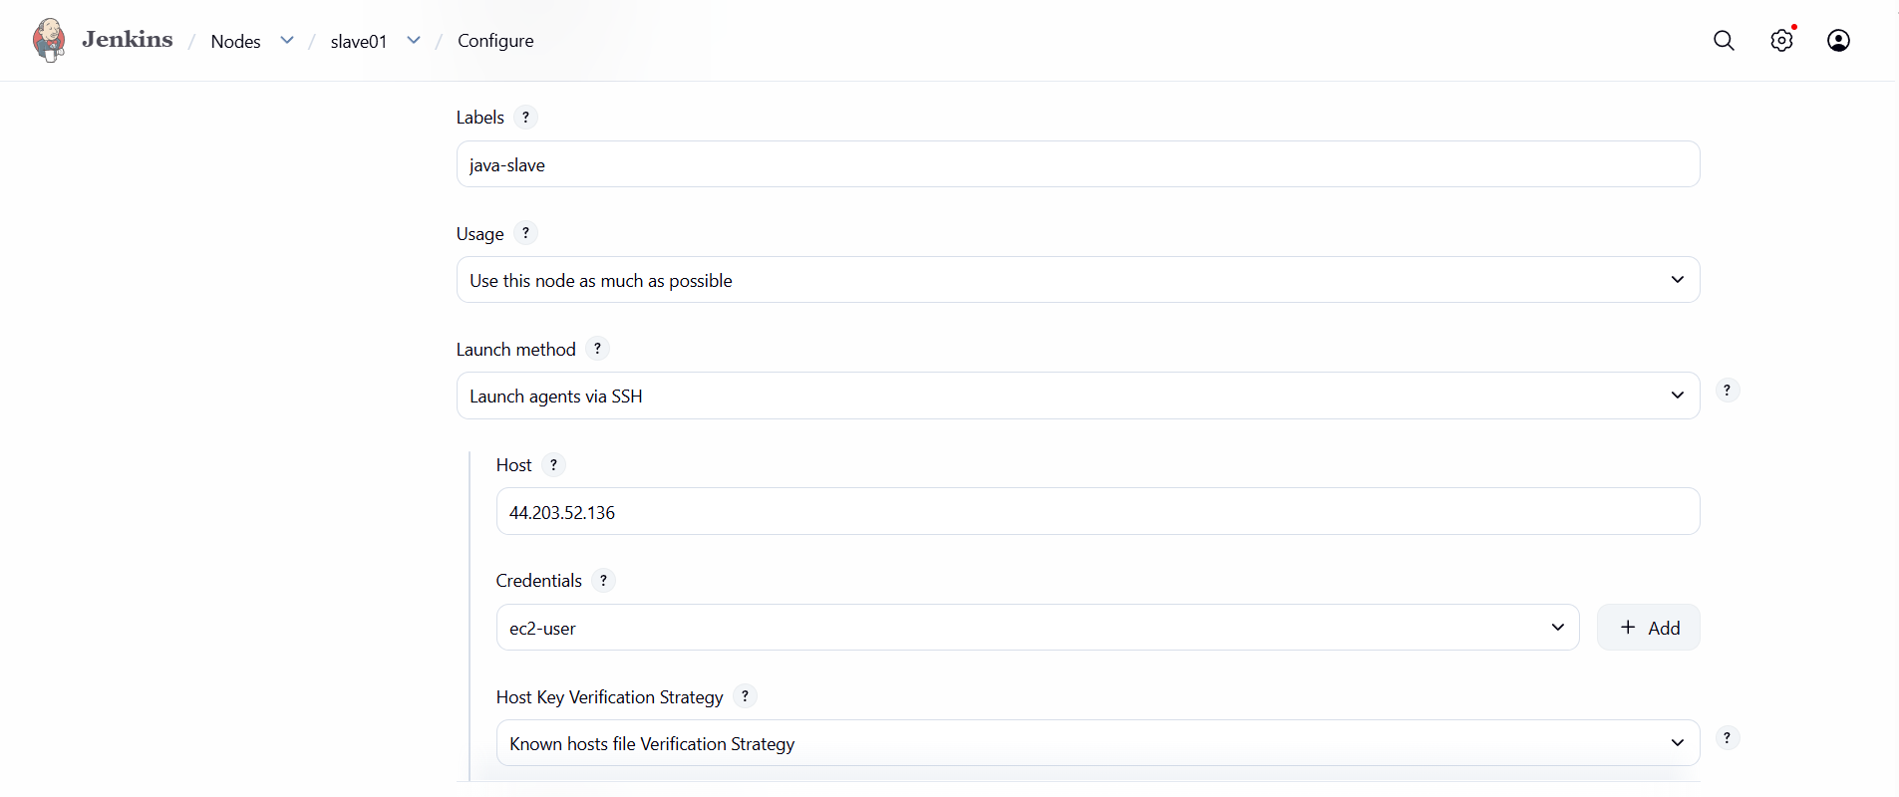
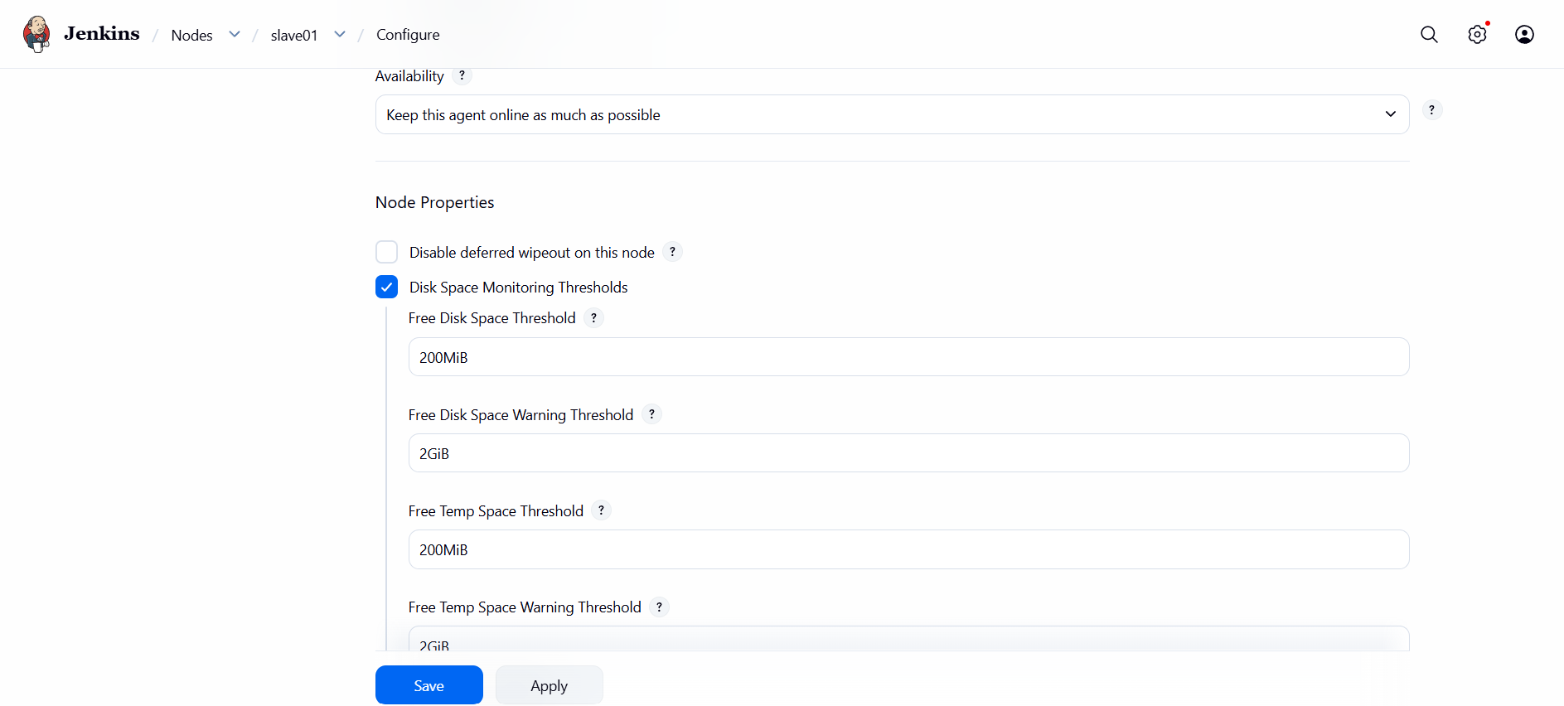
Created one job by giving label java slave.
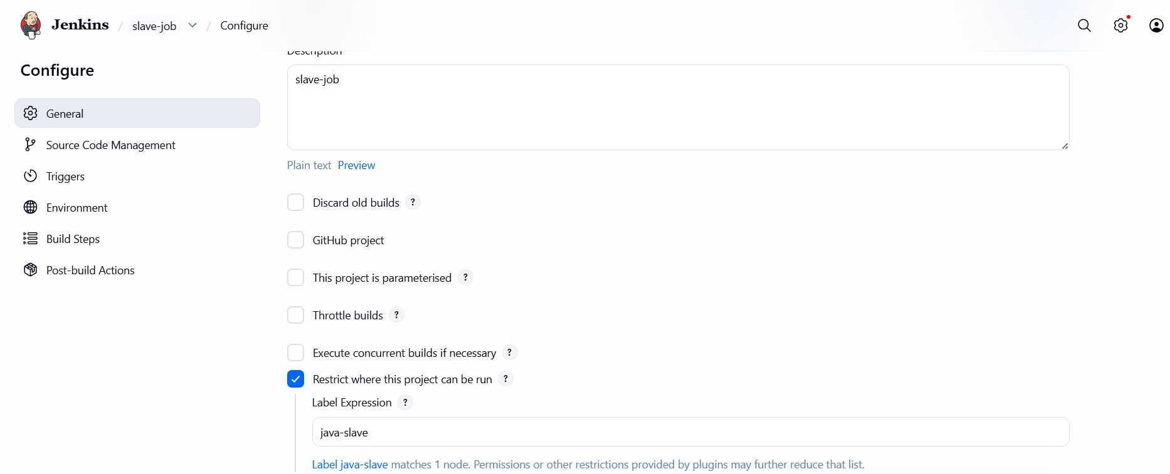

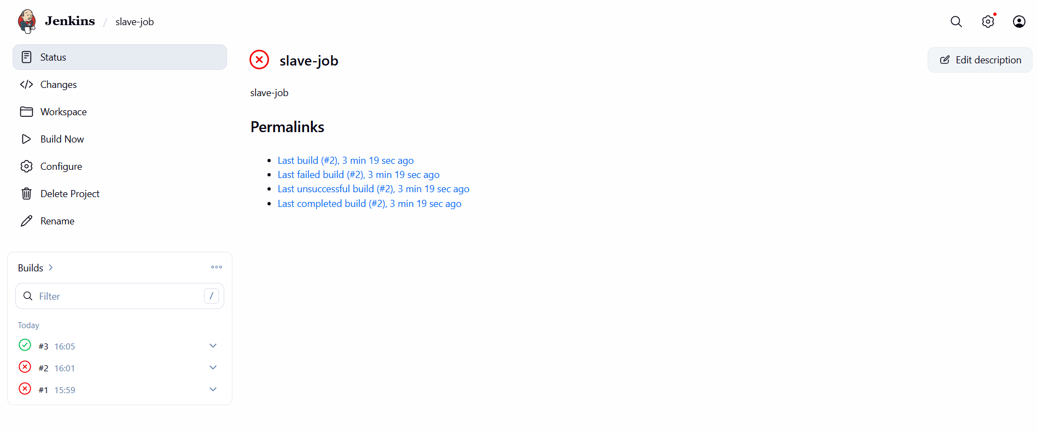

CONCLUSION:
Configuring slave machines in Jenkins enables distributed builds, reduces load on the master, and allows scalable, faster CI/CD execution across multiple environments.

2.Configure Webhooks to Jenkins job.

TITLE:
Webhooks to Jenkins job

OBJECTIVE:
Automatically trigger a Jenkins job when code is pushed to the repository.

PREREQUISITES:
Jenkins server is installed and running.
Jenkins URL is reachable from the internet.
A Jenkins job (Freestyle or Pipeline) is already created.
GitHub repository exists with admin access.
Git and GitHub plugins are installed in Jenkins.

STEP-BY-STEP-IMPLIMENTATION:
Created a webhooks in Jenkins.
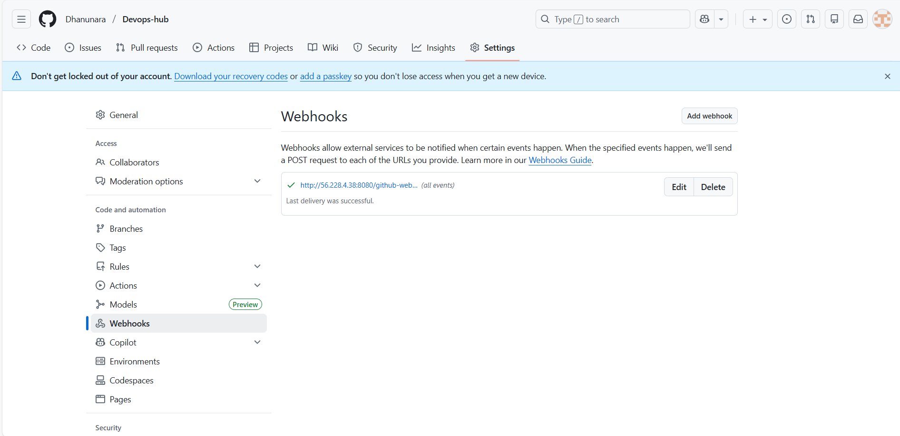

Select GIThub hook trigger
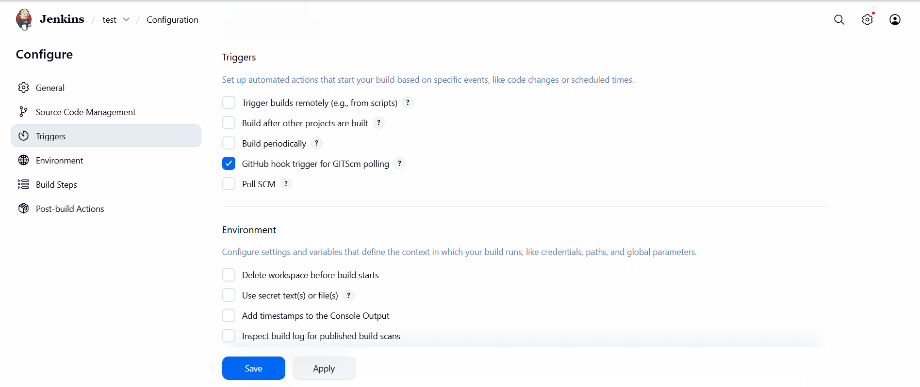
Now the job will automatically get builds.
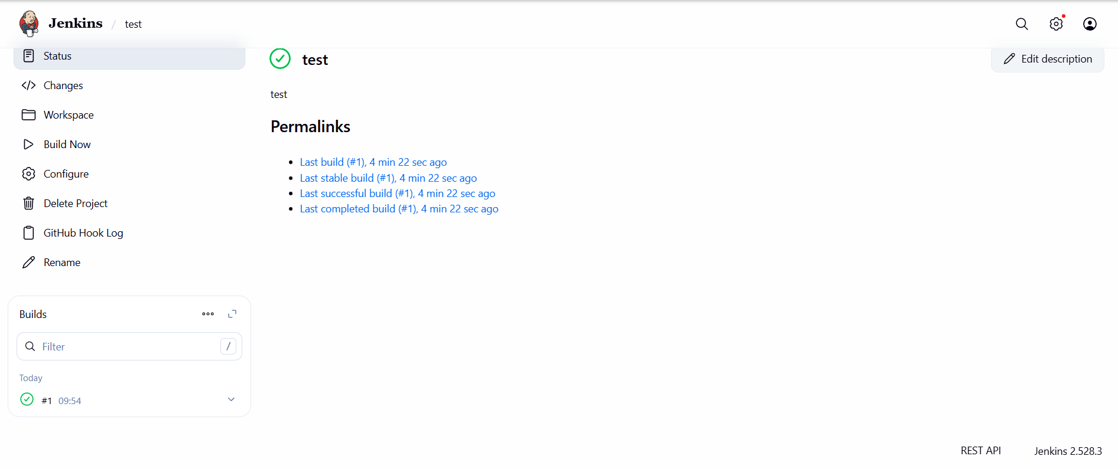

CONCLUSION:
Webhooks enable Jenkins to automatically trigger builds on every code change, making the CI/CD process fast and fully automated

3.Configure poll scm and build periodical options in Jenkins job.

TITLE:
Configuring Poll and build periodical options in Jenkins job.
OBJECTIVE:
Automatically trigger Jenkins builds either based on source code changes or on a fixed time schedule.

PREREQUISITES:
Jenkins server must be up and running.
A Jenkins job must already be created.
Source Code Management (SCM) must be configured in the job

STEP-BY-STEP-IMPLIMENTATION:
Select the option poll scm in triggers.
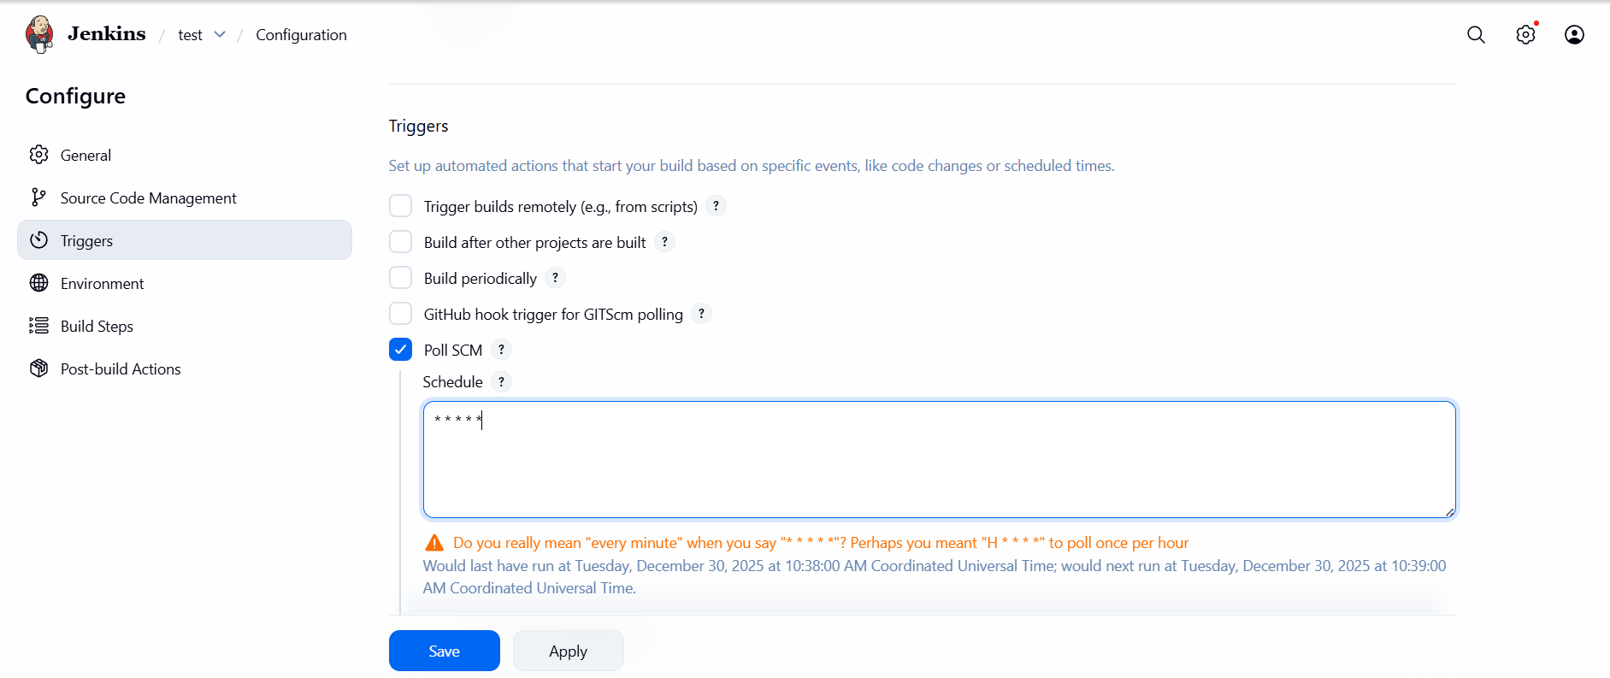
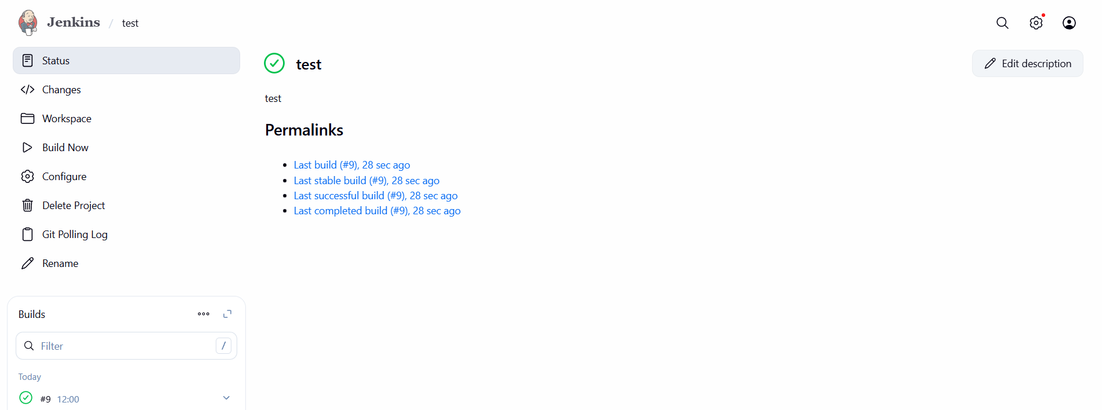

Select the option Build periodically in triggers.
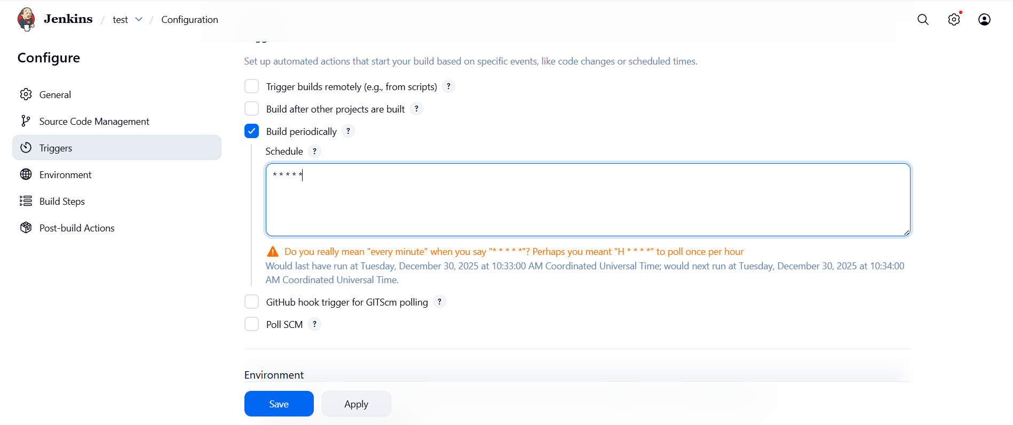
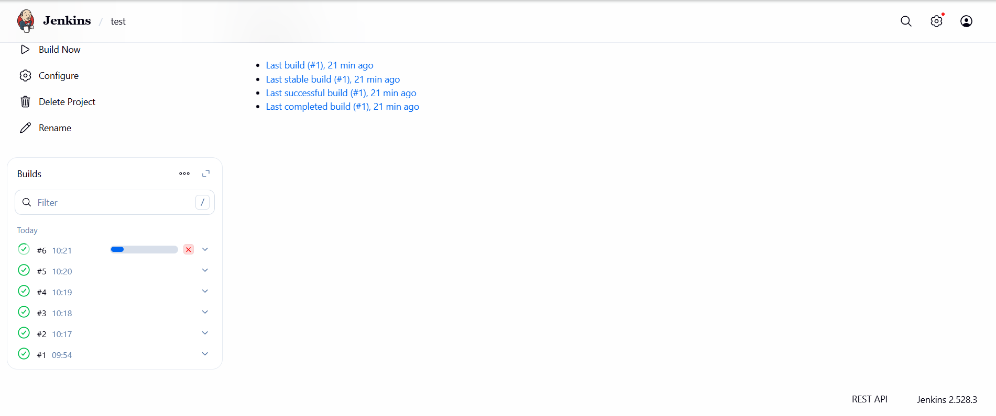

CONCLUSION:
Poll SCM triggers builds only when code changes occur, while Build Periodically triggers builds at scheduled times regardless of changes.

4.Take backup of Jenkins server by using bash script.

TITLE:
Bash script to take backup of Jenkins server.
OBJECTIVE:
Take a complete backup of Jenkins data (JENKINS_HOME) using a Bash script.

PREREQUISITES:
Jenkins installed and running
SSH access between old and new Jenkins servers
Sufficient disk space
Jenkins user permissions

STEP-BY-STEP-IMPLIMENTATION:
Created a bash script to take the backup and gave the permissions.
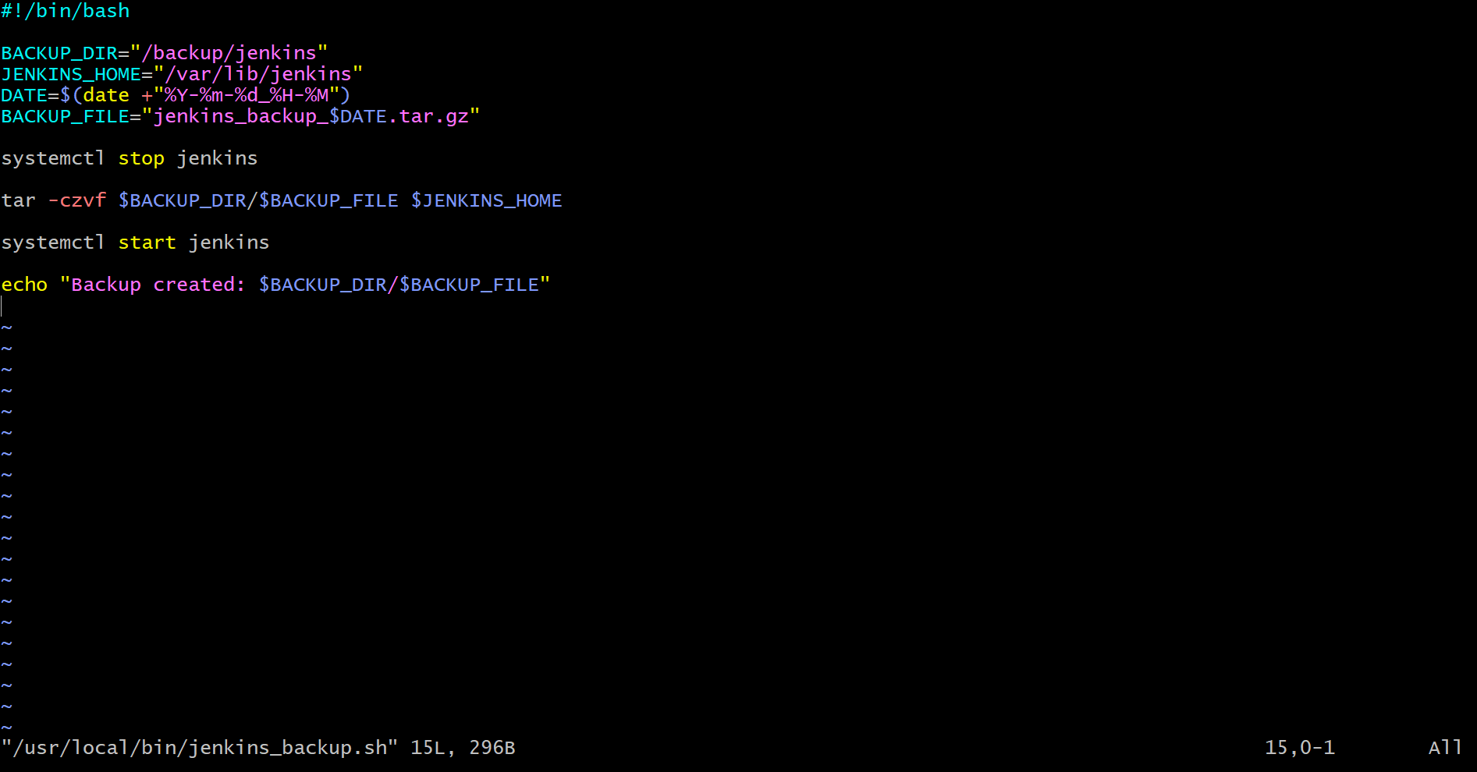
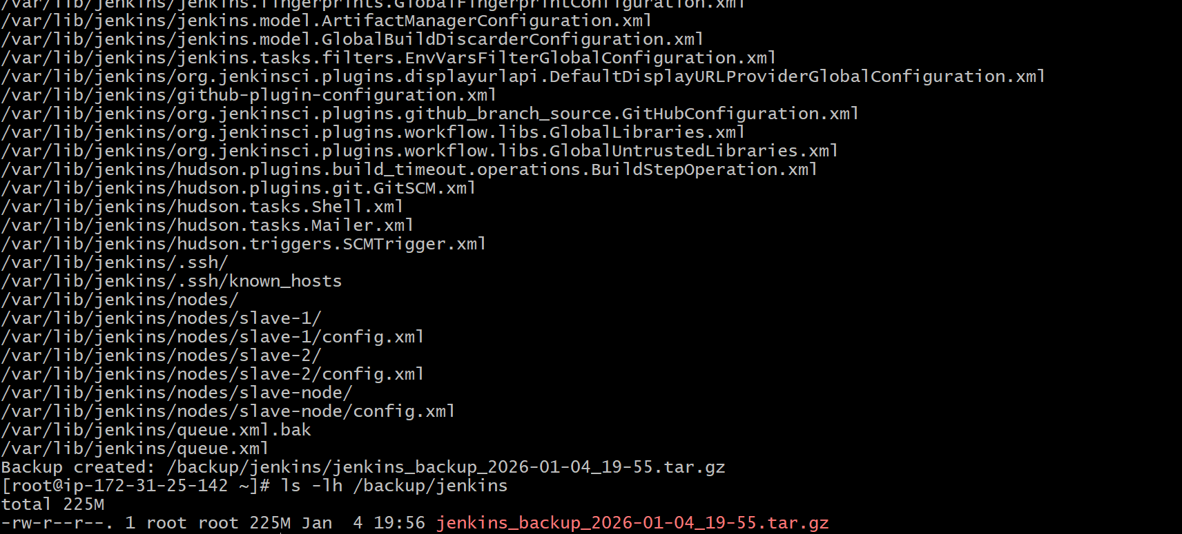

CONCLUSION:
This Bash script safely backs up the entire Jenkins server and allows easy restoration on a new server.

5.Take backup of Jenkins using rethin backup plugin.

TITLE:
Backup using rethin backup plugin

OBJECTIVE:
Take a backup of Jenkins jobs and configuration using the ThinBackup plugin.

PREREQUISITES:
Jenkins installed and running
Admin access to Jenkins
Enough disk space for backups
Jenkins user has write permission on backup directory

STEP-BY-STEP-IMPLIMENTATION:
Install the ThinBackup plugin and go to manage Jenkins and click on backup plugin.
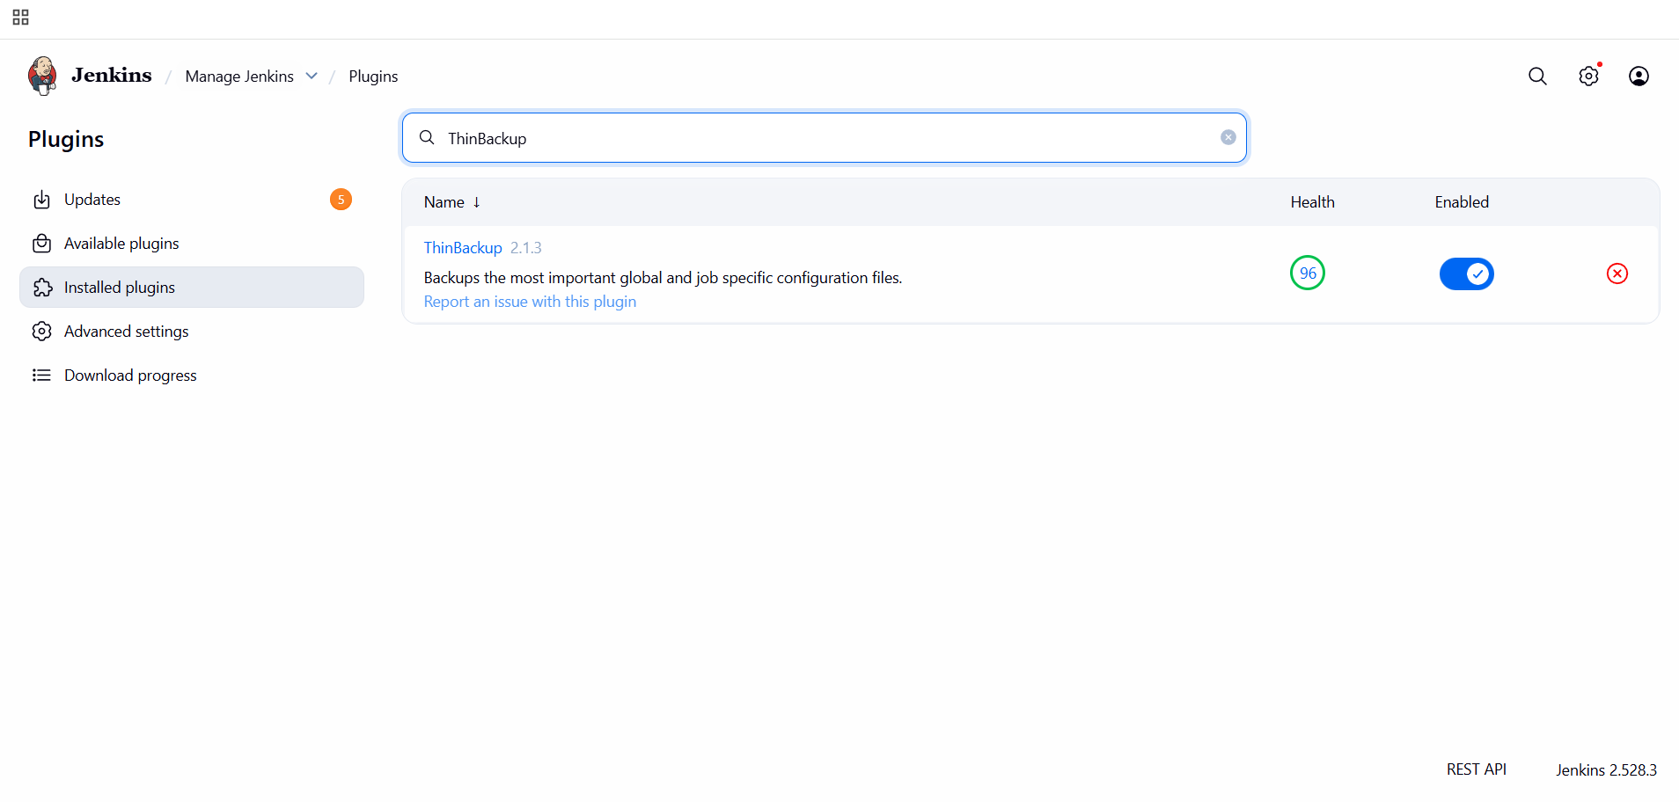
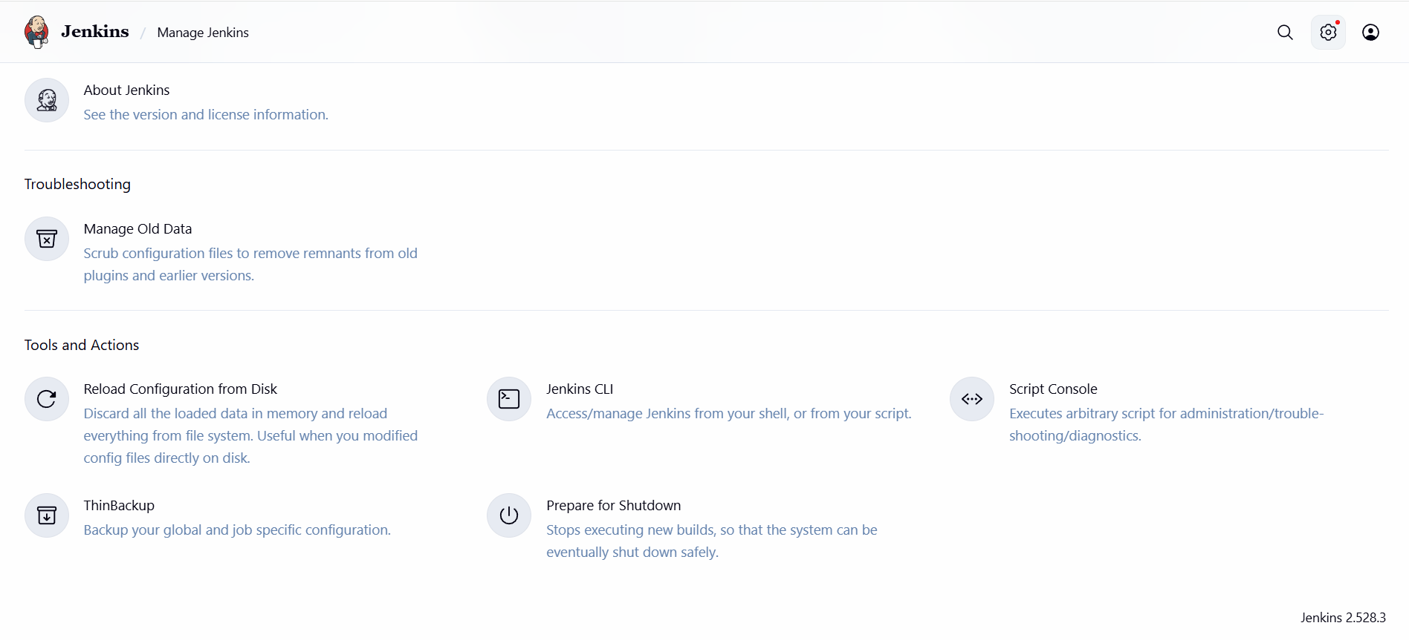
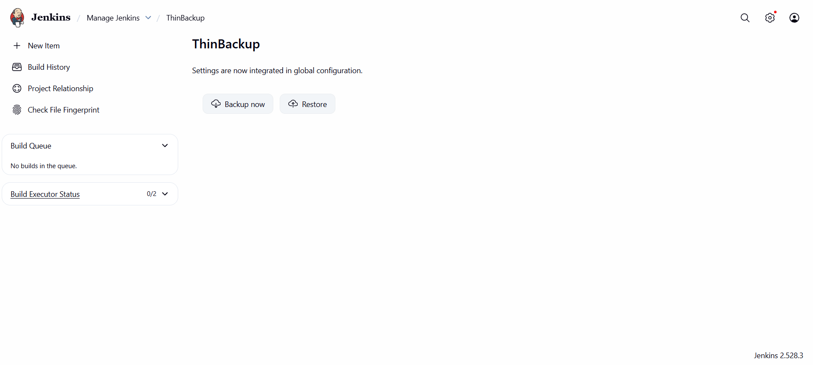
CONCLUSION:
ThinBackup plugin provides an easy, UI-based way to back up Jenkins jobs and configurations and restore them on another Jenkins server.

6.Setup a new Jenkins sever and dump the backup taken in task4.

TITLE:
Setup a new Jenkins server and dump the backup taken in task 4.

OBJECTIVE:
Set up a new Jenkins server and restore the backup taken from the old Jenkins server (Task-4).

PREREQUISITES:
New EC2/Linux server created
SSH access to the new server
Java installed (Jenkins dependency)
Jenkins backup file available (from Task-4)
Root or sudo access

STEP-BY-STEP-IMPLIMENTATION:
First we should login to the old Jenkins server and we should paste the pemkey inside a file and we should use scp command to dump.
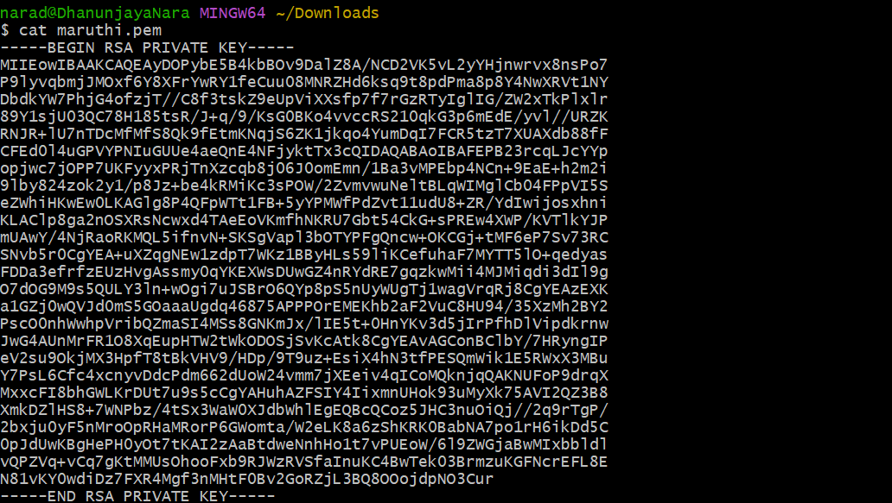
This is the target Jenkins server where we dumped the backup data
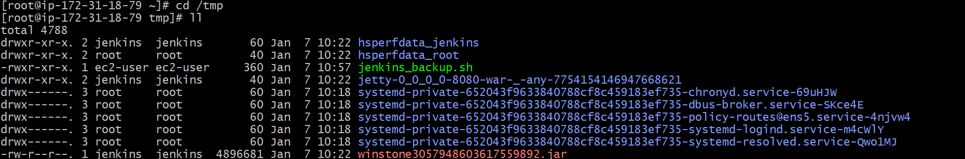

CONCLUSION:
A new Jenkins server is successfully set up and the backup from task-4 is restored by dumping the /var/lib/jenkins data, making all jobs and configurations available.

