Jenkins-03

Task 1
Create one Jenkins job using the below code and create three stages:
- stage1: Git clone to download the source code.
- stage2: Sonarqube Integration to check the quality of code.
- stage3: Slack Integration to send the alerts to slack.
URL: https://github.com/betawins/VProfile-1.git

TITLE:
Create a Jenkins Job with Git Clone and SonarQube Code Quality Analysis

OBJECTIVE:
To create a Jenkins job that downloads source code from a Git repository and performs code quality analysis using SonarQube through a structured multi-stage pipeline.

.PREREQUISITES:
Jenkins server installed and running
Git installed on the Jenkins server/agent
SonarQube server up and accessible
SonarScanner installed or configured in Jenkins
Jenkins configured with SonarQube server details

STEP-BY-STEP-IMPLIMENTATION:
Go to AWS and launch an instance and install Jenkins in the instance.
And paste public IP:8080 in browser

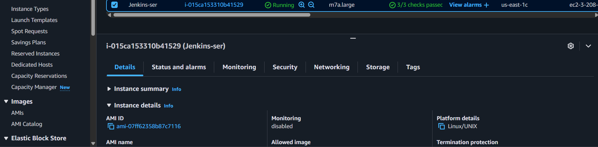
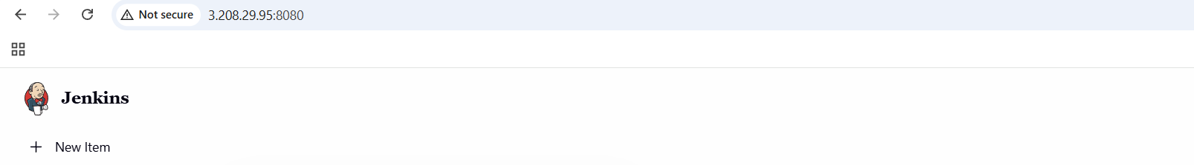

Now launch an instance with instance type m7large instance type and 20 GB volume
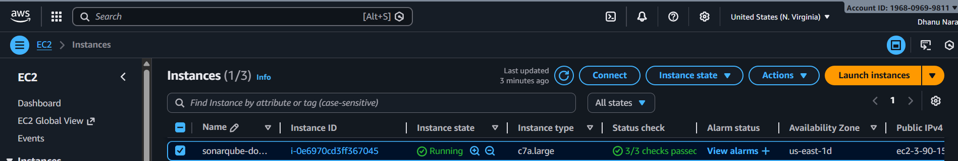

Yum install docker -y
Systemctl start docker
Systemctl enable docker
Systemctl status docker
docker pull sonarqube
docker images
docker run -itd -p 9003:9000 sonarqube
docker ps
{paste the “IP:9003” in the browser}
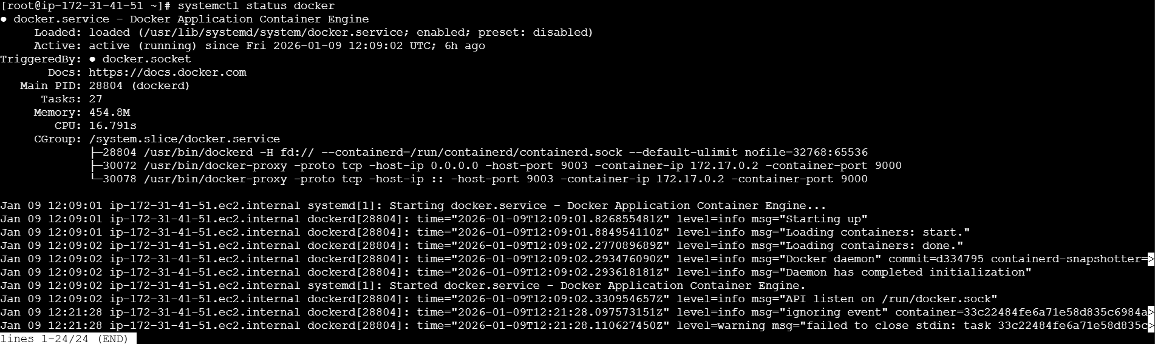
Now install sonar scanner in Jenkins server.
{cd /opt
wget https://binaries.sonarsource.com/Distribution/sonar-scanner-cli/sonar-scanner-cli-5.0.1.3006-linux.zip
unzip sonar-scanner-cli-5.0.1.3006-linux.zip
mv sonar-scanner-5.0.1.3006-linux sonar-scanner}.
cd conf
vi sonar-scanner properties
Now change to this“DockerIP:9003”.
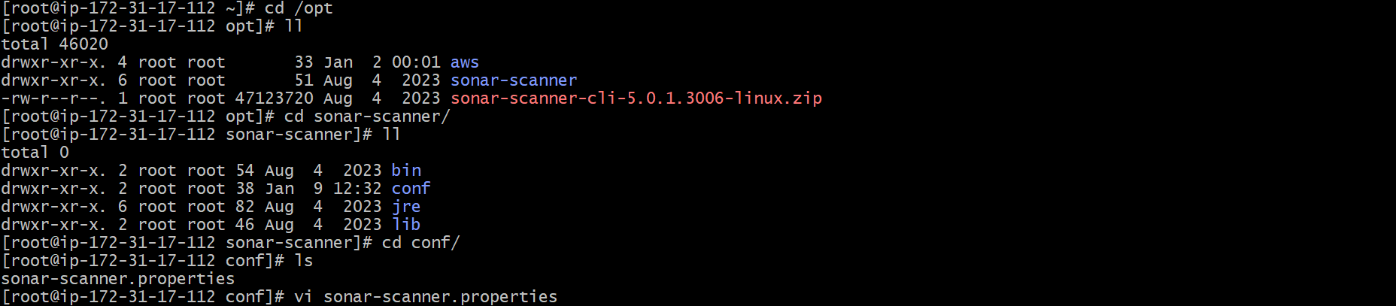
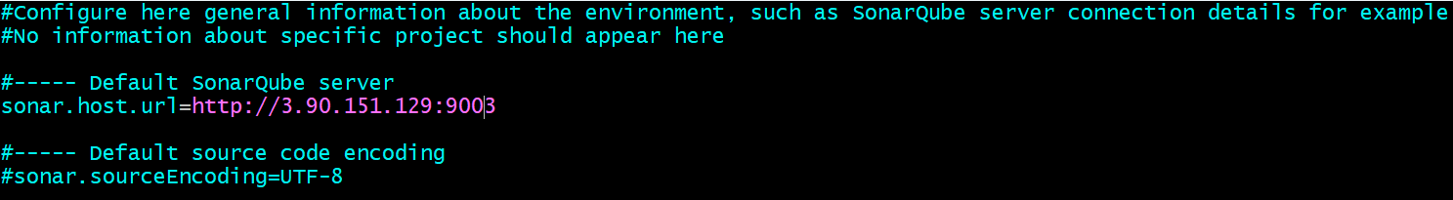

Now create a job in Jenkins using git hub URL.
Plugin – sonar-scanner plugin – build steps – select sonar-scanner – add credentials – select secret text – paste sonar token – save .
Now again go to build steps and select sonar executor and add code of github in analysis properties.

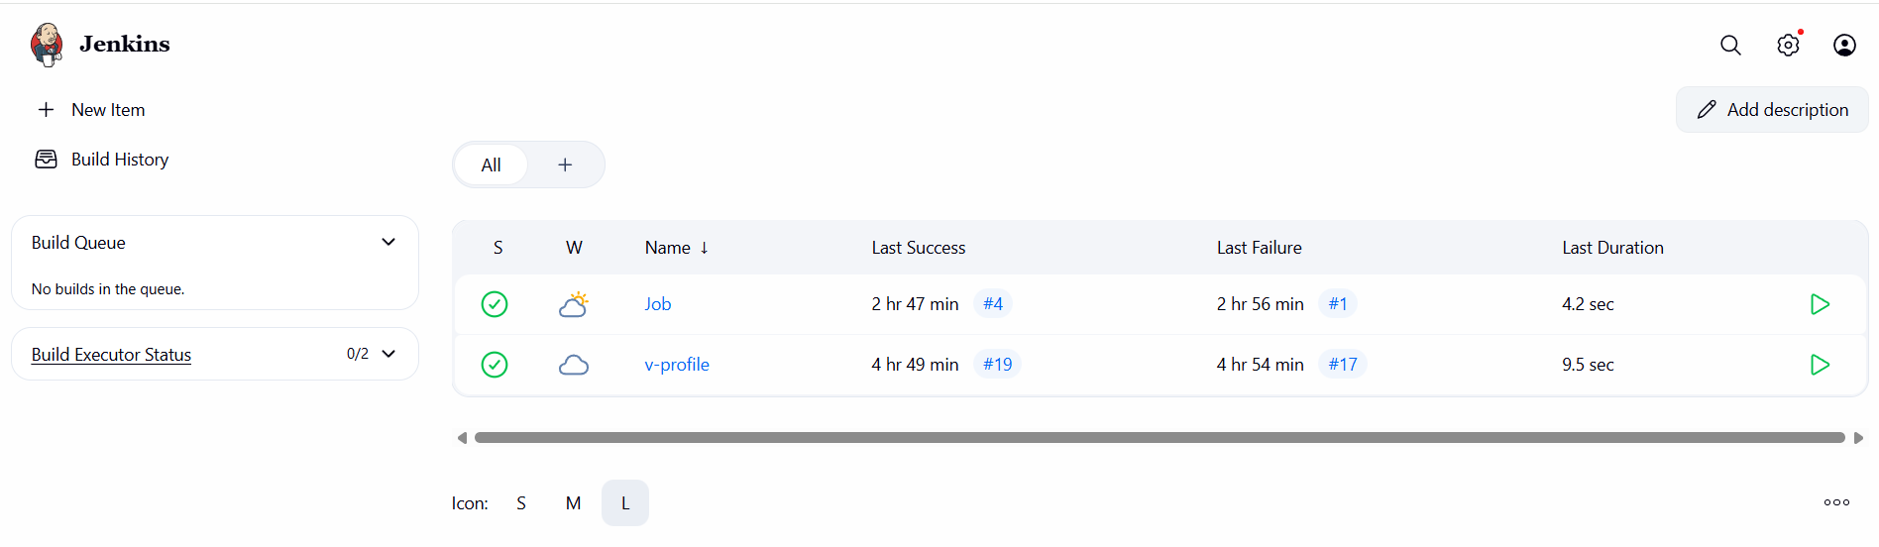
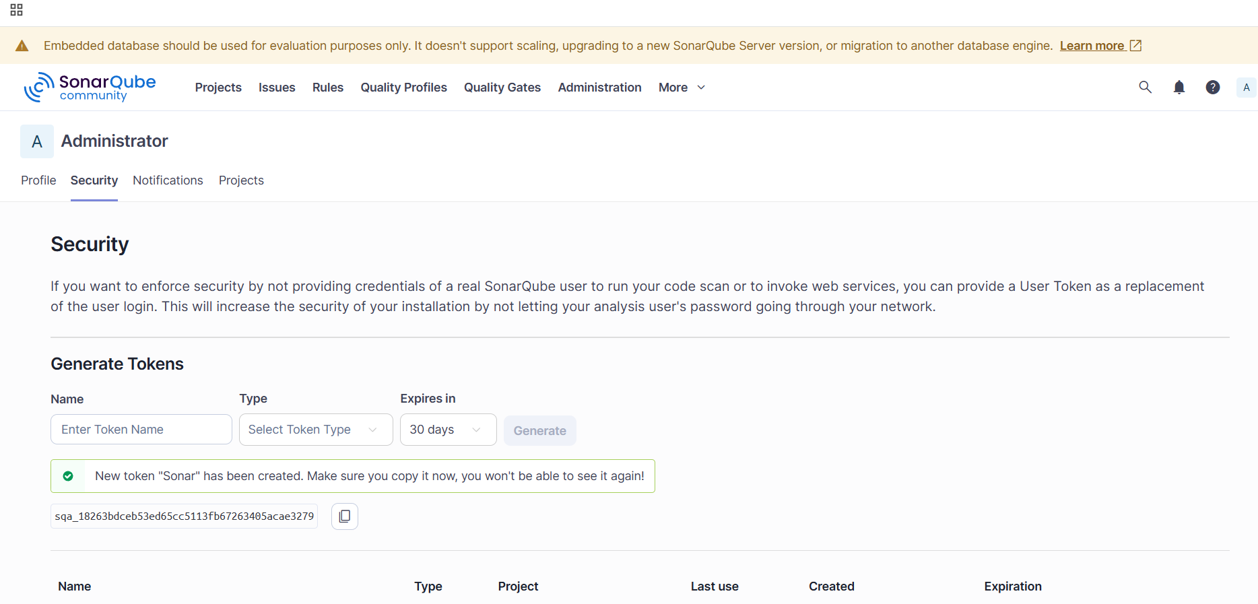

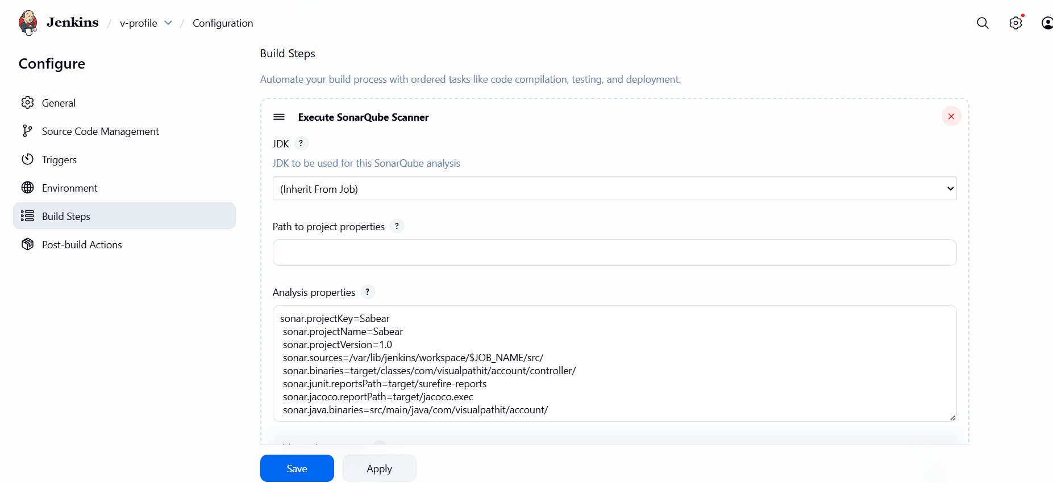

Now go to Jenkins dashboard and click on build job
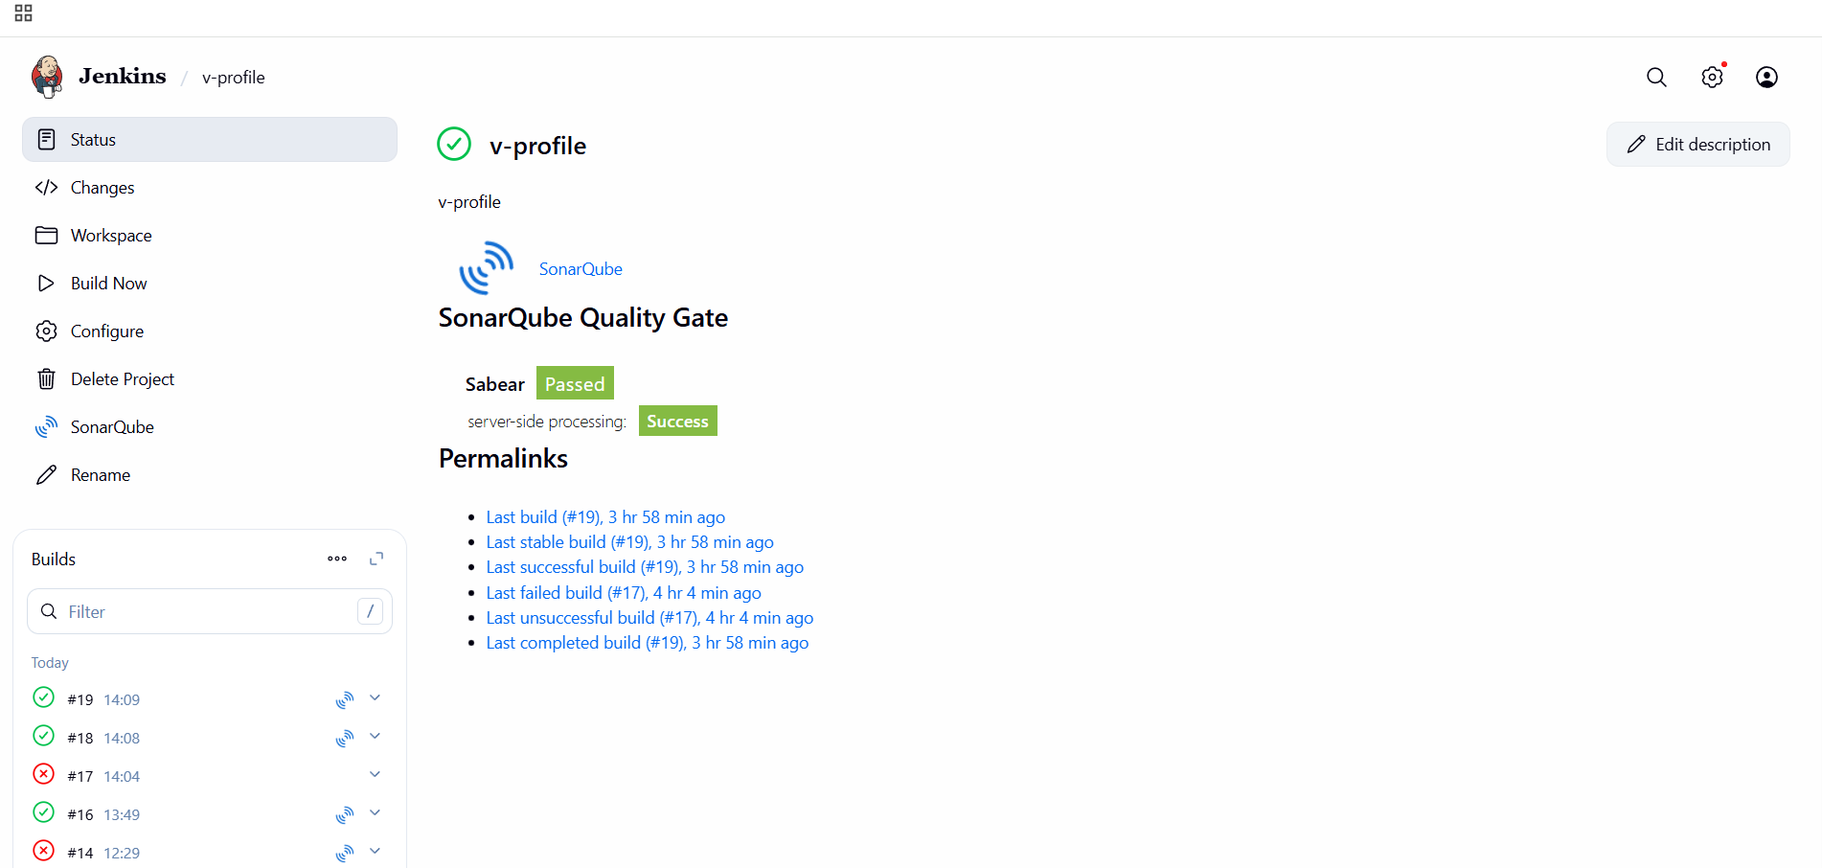

And go to sonarqube and quality gate will be visible
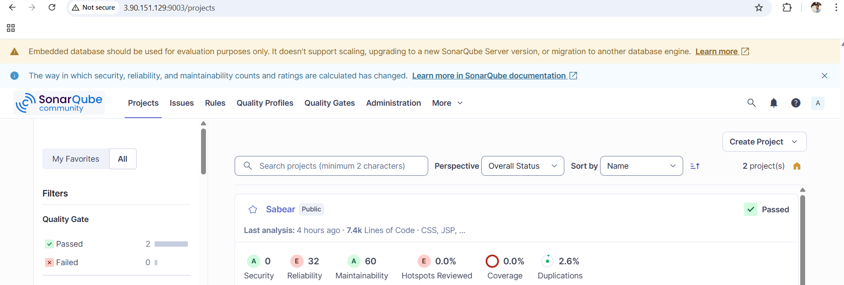

CONCLUSION:
This Jenkins job successfully automates source code retrieval and code quality validation using SonarQube, helping maintain consistent code standards in the CI process.

Task 2
Create one Jenkins job using the below code and create three stages:
- stage1: Git clone to download the source code.
- stage2: Sonarqube Integration to check the quality of code.
- stage3: Slack Integration to send the alerts to slack.
URL: https://github.com/betawins/hiring-app.git

TITLE:

Create a Jenkins Job with Git Clone and SonarQube Code Quality Analysis

OBJECTIVE:

To create a Jenkins job that downloads source code from a Git repository and performs code quality analysis using SonarQube through a structured multi-stage pipeline.

PREREQUISITES:
Jenkins server installed and running
Git installed on the Jenkins server/agent
SonarQube server up and accessible
SonarScanner installed or configured in Jenkins
Jenkins configured with SonarQube server details

STEP-BY-STEP-IMPLIMENTATION:
Create a job with URL
Create new token in sonarqube
Add the credentials in the build steps of sonarqube and save

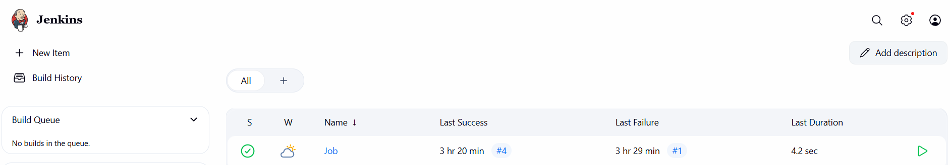

Now add the code of README in the analysis properties

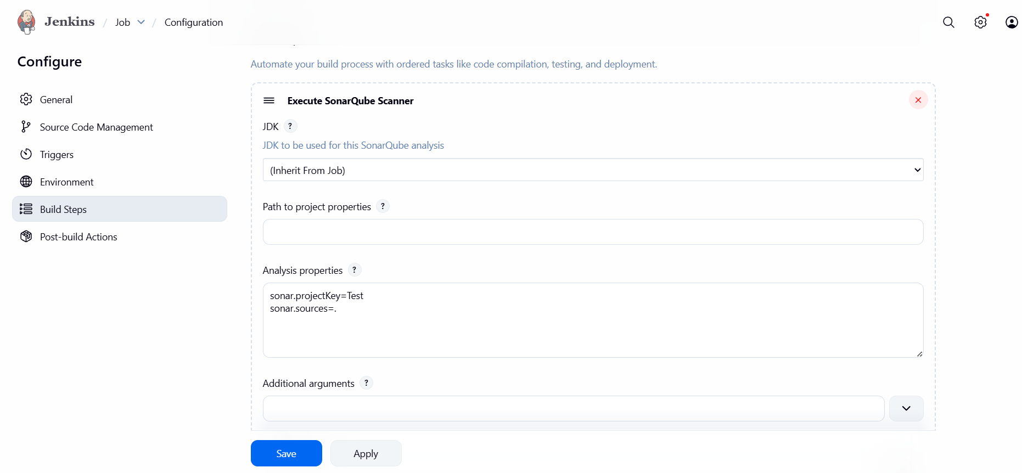

Now go to Jenkins dashboard and click on build now
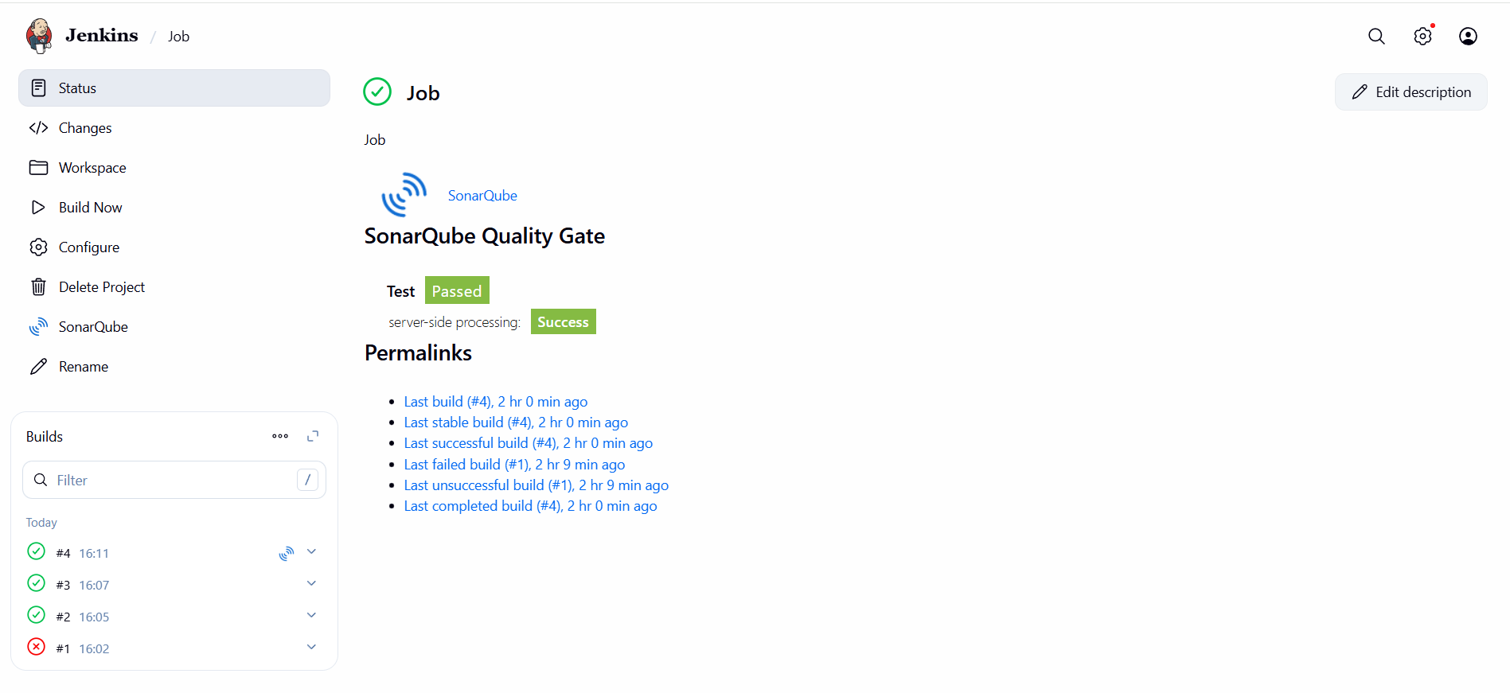

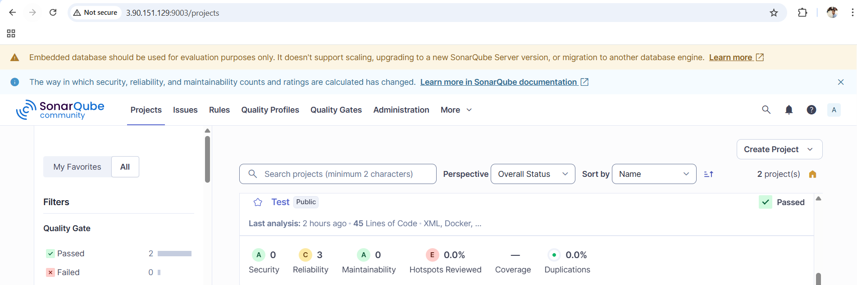

CONCLUSION:
This Jenkins job successfully automates source code retrieval and code quality validation using SonarQube, helping maintain consistent code standards in the CI process.

