Terraform-05

To provision s3 bucket using terraform configuration file.
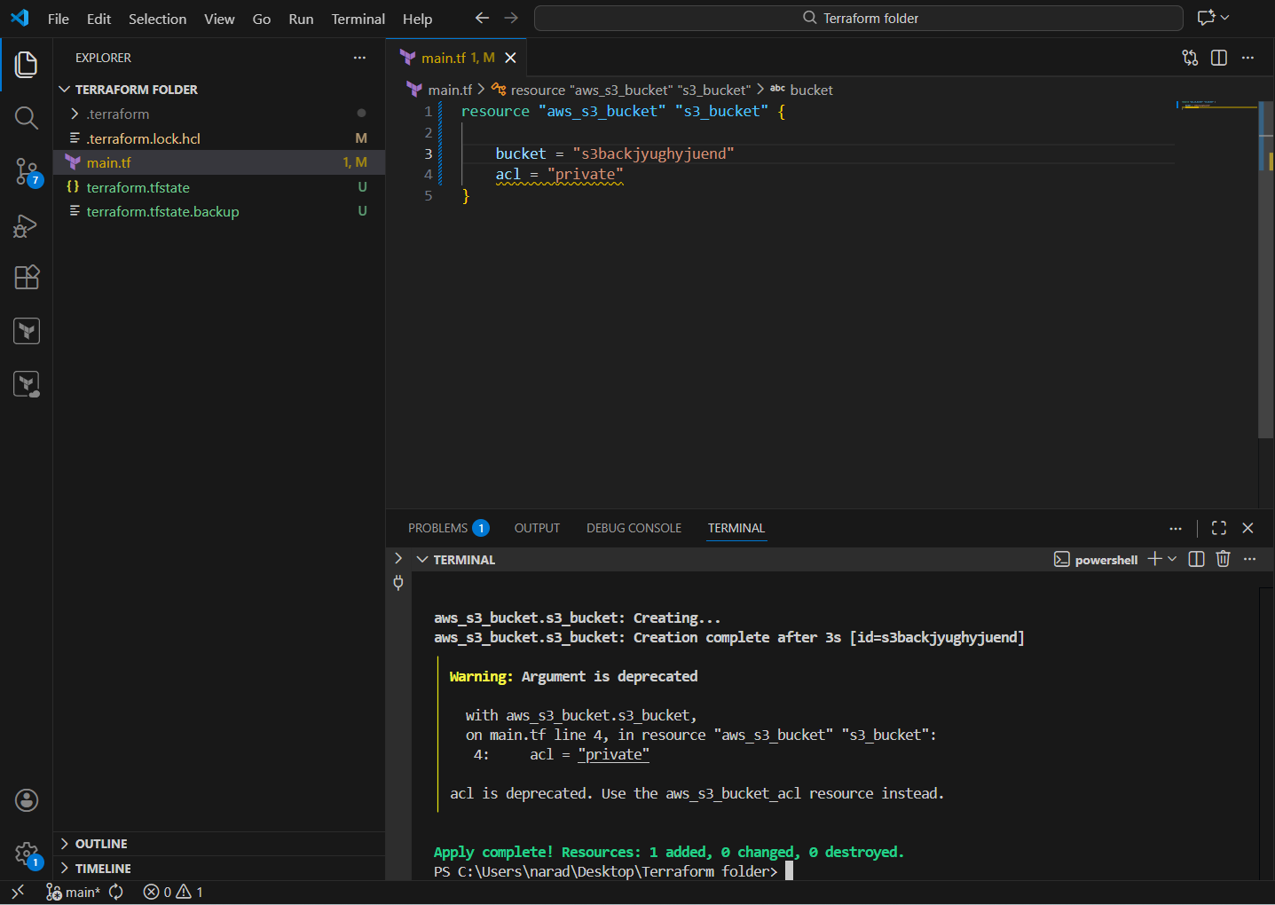

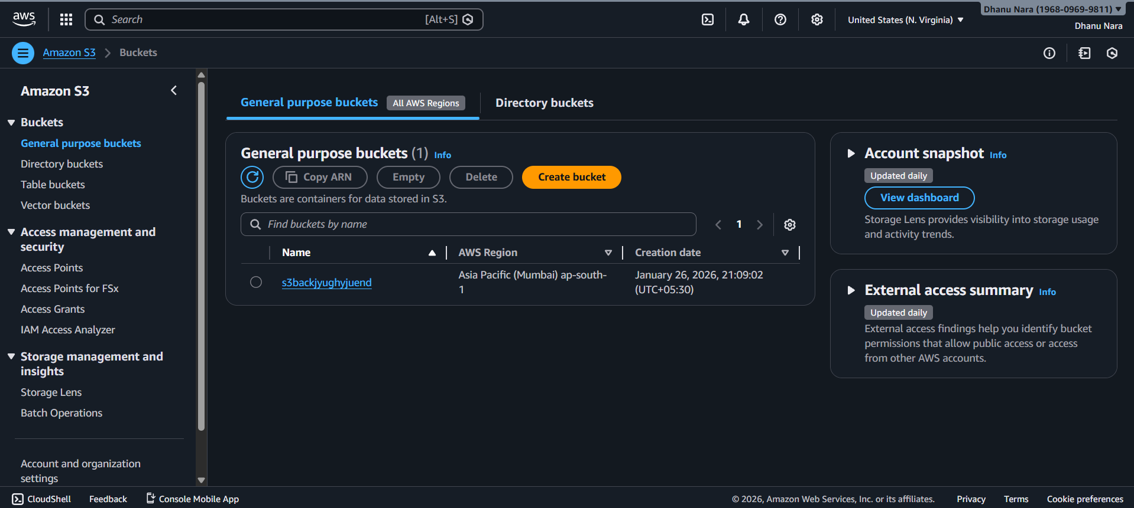

1️⃣ resource "aws_s3_bucket" "s3_bucket"
- This tells Terraform:
“I want to CREATE an AWS S3 bucket”
- aws_s3_bucket → AWS resource type
- s3_bucket → Terraform’s local name (used only inside Terraform)

2️⃣ bucket = "s3backyugbyuend"
- This is the actual S3 bucket name in AWS
- Bucket names:
  - Must be globally unique
  - Must be lowercase
- This name will appear in the AWS S3 console

3️⃣ acl = "private"
- ACL = Access Control List
- "private" means:
  - Only the AWS account owner can access the bucket
  - No public access
⚠️ Note (just explanation):
- Terraform now warns that acl is deprecated
- But it still works
- This is not an error, just a warning

What you see on the LEFT side (files)

📄 .terraform/
- Internal Terraform directory
- Stores:
  - Provider plugins
  - Backend metadata
- Never edit
- Never commit to Git

📄 .terraform.lock.hcl
- Lock file for provider versions
- Ensures:
  - Same provider versions for everyone
- Auto-generated by Terraform

📄 terraform.tfstate
- This is the state file
- Terraform uses it to track:
  - What resources exist
  - Their IDs
  - Their current configuration
Example:
“This S3 bucket already exists and Terraform manages it”

📄 terraform.tfstate.backup
- Backup of previous state
- Created automatically
- Used for recovery

What this means overall (important)
Right now:
- Terraform is using LOCAL STATE
- State is stored in:
- terraform.tfstate
- Terraform knows:
  - The S3 bucket exists
  - Terraform manages it

What Terraform is doing internally
When you run:
terraform apply
Terraform:
- Reads main.tf
- Checks terraform.tfstate
- Compares:
  - Desired state (code)
  - Actual state (AWS)
- Decides:
  - Create / Update / Do nothing

To provision DynamoDB using terraform configuration file.
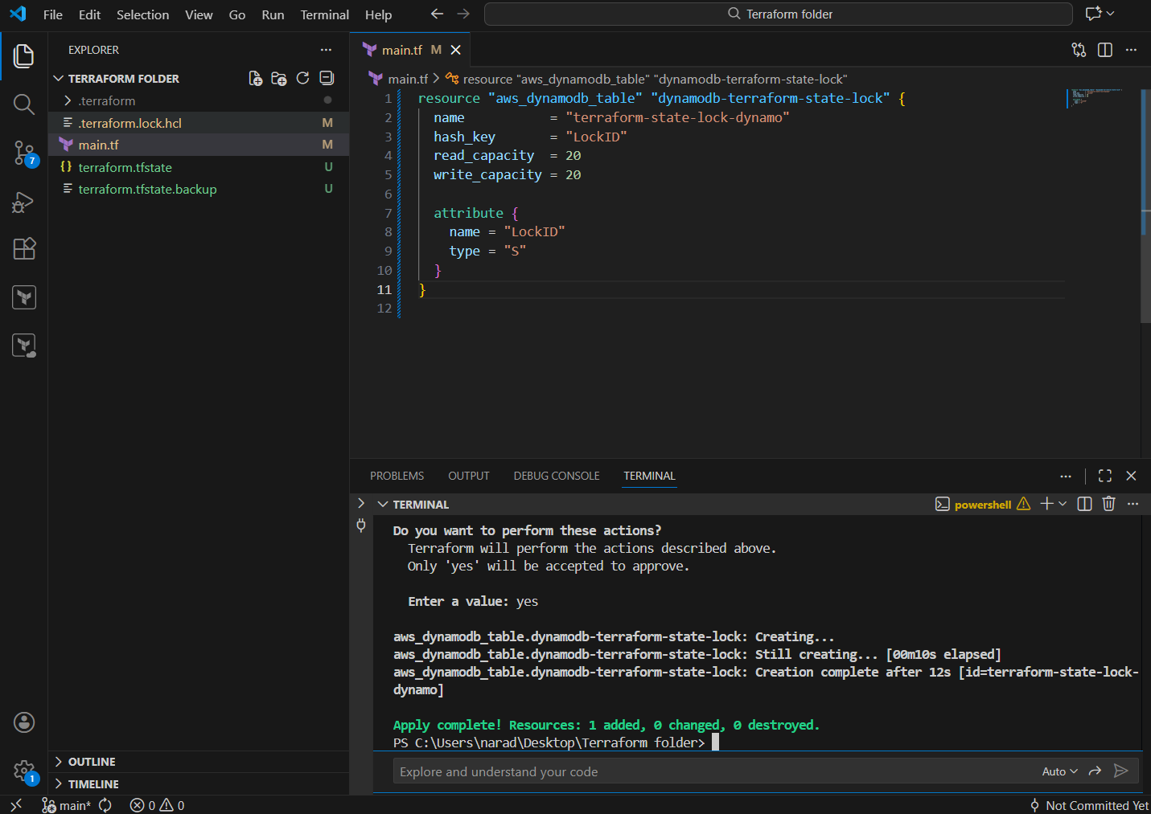

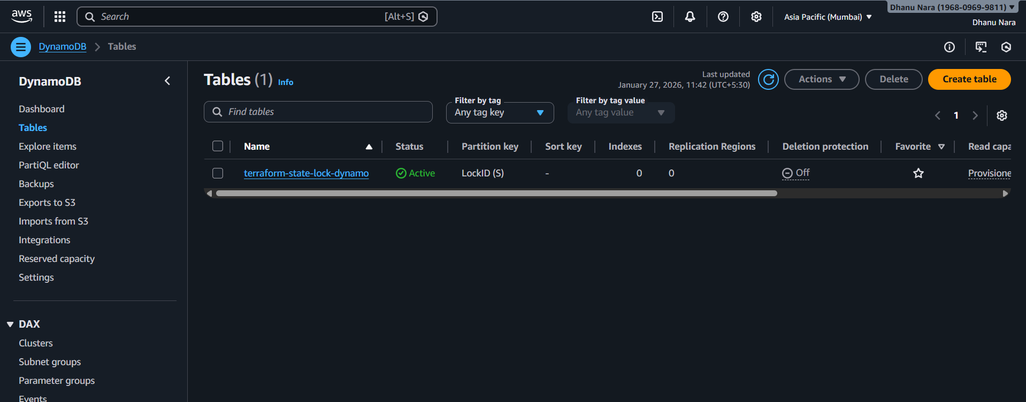

1️⃣ resource "aws_dynamodb_table" ...
resource "aws_dynamodb_table" "dynamodb-terraform-state-lock" {
- Creates a DynamoDB table
- Resource name: dynamodb-terraform-state-lock
- Used by Terraform to lock the state file
- Prevents two people running terraform apply at the same time

2️⃣ Table name
name = "terraform-state-lock-dynamo"
- Actual DynamoDB table name in AWS
- Terraform backend will reference this name

3️⃣ Hash key (Primary key)
hash_key = "LockID"
- Primary key for the DynamoDB table
- Terraform uses LockID to:
  - Create a lock
  - Check who owns the lock
  - Release the lock after apply

4️⃣ Read capacity
read_capacity = 20
- How many read requests per second
- 20 is more than enough for Terraform
- Only small reads happen during lock checks

5️⃣ Write capacity
write_capacity = 20
- How many write requests per second
- Used when:
  - Lock is created
  - Lock is released

6️⃣ Attribute block
attribute {
name = "LockID"
type = "S"
}
- Defines table schema
- LockID is:
  - Type S → String
- Must match hash_key

Provision one EC2.
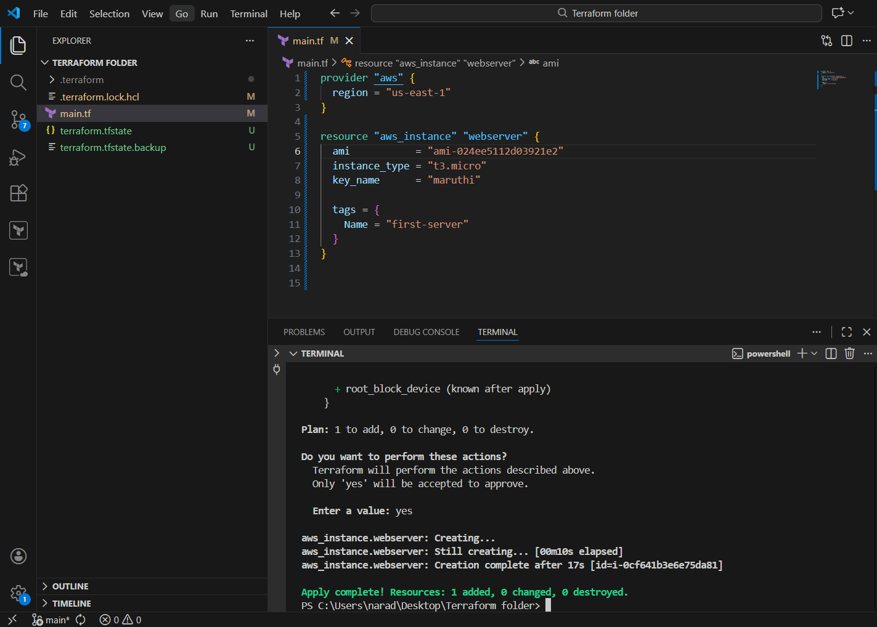

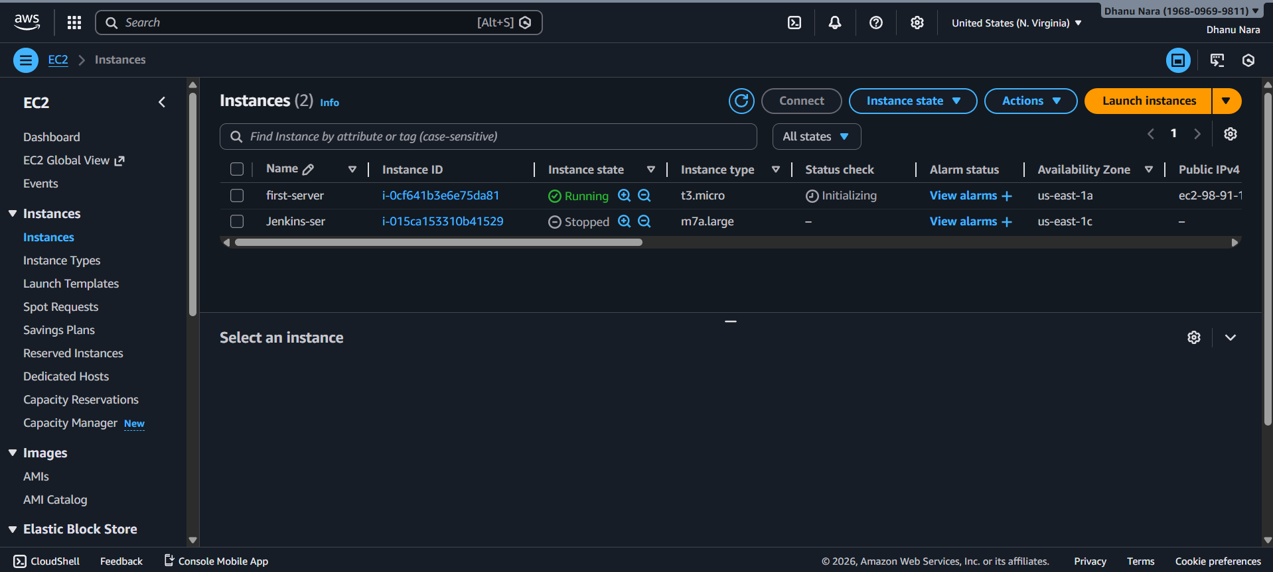

🟢 STEP 1: You created a Terraform folder
Terraform folder/
├── main.tf
Why this matters
- Terraform reads all .tf files in the folder
- Folder = one Terraform project

🟢 STEP 2: You wrote the AWS provider block
provider "aws" {
region = "us-east-1"
}

What this does
- Tells Terraform:
  - Cloud = AWS
  - Region = N. Virginia (us-east-1)
- Downloads AWS provider plugin into .terraform/
📌 Without this → Terraform cannot talk to AWS.

🟢 STEP 3: You selected a VALID AMI
ami = "ami-024ee5112d03921e2"

Why this worked
- AMI exists
- AMI is public
- AMI belongs to us-east-1
- AMI is not deprecated
💡 Earlier failures were only because the AMI didn’t exist.

🟢 STEP 4: You chose instance type
instance_type = "t3.micro"

What this means
- EC2 size
- Eligible for free tier (in many accounts)
- Supported by the AMI

🟢 STEP 5: You added an existing key pair
key_name = "maruthi"

Important rule
- Key pair must already exist in AWS
- Must be in same region (us-east-1)
Terraform does not create keys automatically.

🟢 STEP 6: You added tags
tags = {
Name = "first-server"
}

Why tags matter
- Easy identification in AWS Console
- Used for billing, automation, filtering
This shows as Instance Name in EC2 console.

1️⃣ What is a provisioner in Terraform?
A provisioner is used to run some extra actions AFTER a resource is created (or before it is destroyed).
👉 Terraform’s main job is:
- Create infrastructure (EC2, S3, VPC, etc.)
👉 A provisioner’s job is:
- Do extra setup work once the resource exists
Examples:
- Run a command
- Copy a file
- Write something to a file
- Configure software (not recommended much, but possible)

2️⃣ Why do we need a provisioner?
Terraform does NOT normally execute commands.
It only talks to cloud APIs.
But sometimes you want:
- A confirmation message
- A log file
- A small automation after creation
- To trigger scripts

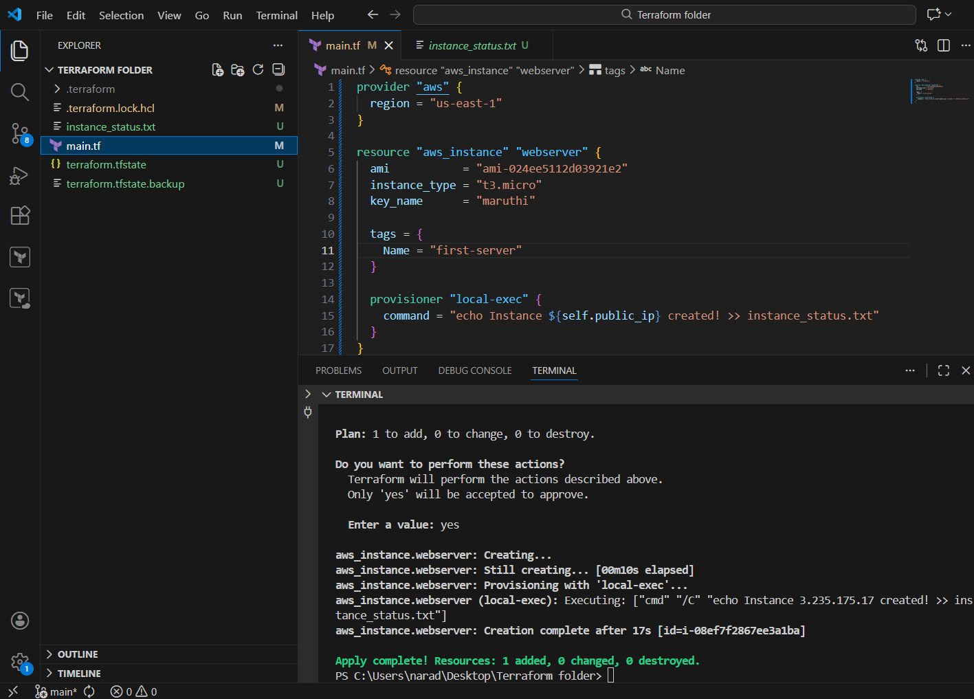
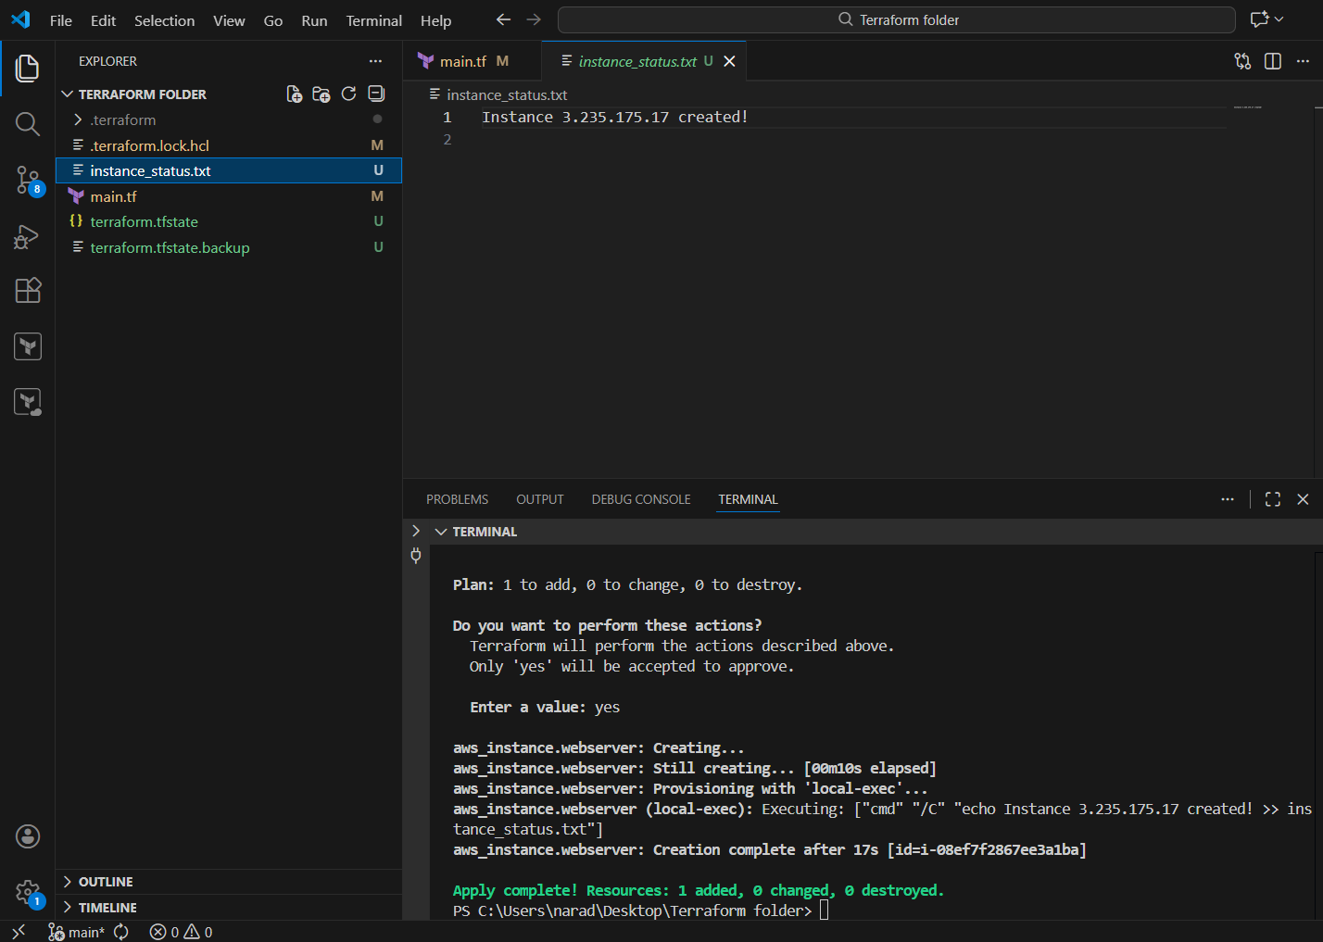

Whenever we are adding provisioners if there is something wrong in the command even though the instance will get created but the provisioner will not work.
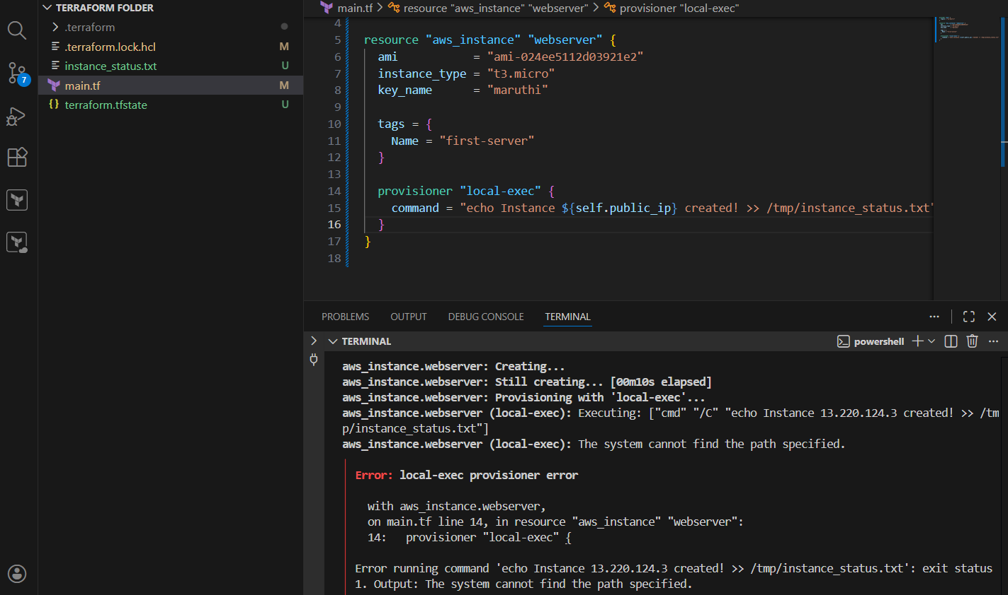
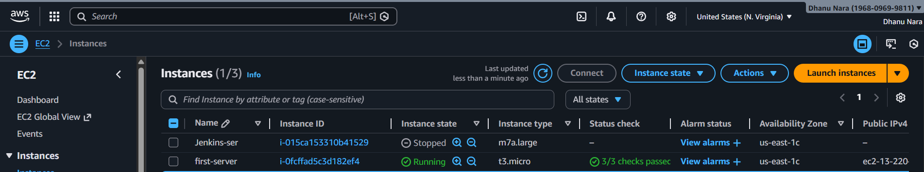

3. Create one EC2 instance with httpd installed using a Terraform script.

terraform {
required_providers {
aws = {
source = "hashicorp/aws"
version = "~> 5.0"
}
}
}

provider "aws" {
region = "us-east-1"
}

resource "aws_instance" "web_server" {
ami = "ami-0532be01f26a3de55"
instance_type = "t3.micro"

user_data = <<-EOF
#!/bin/bash
dnf update -y
dnf install -y httpd
systemctl start httpd
systemctl enable httpd
EOF

tags = {
Name = "web-server"
}
}

output "instance_public_ip" {
value = aws_instance.web_server.public_ip
}

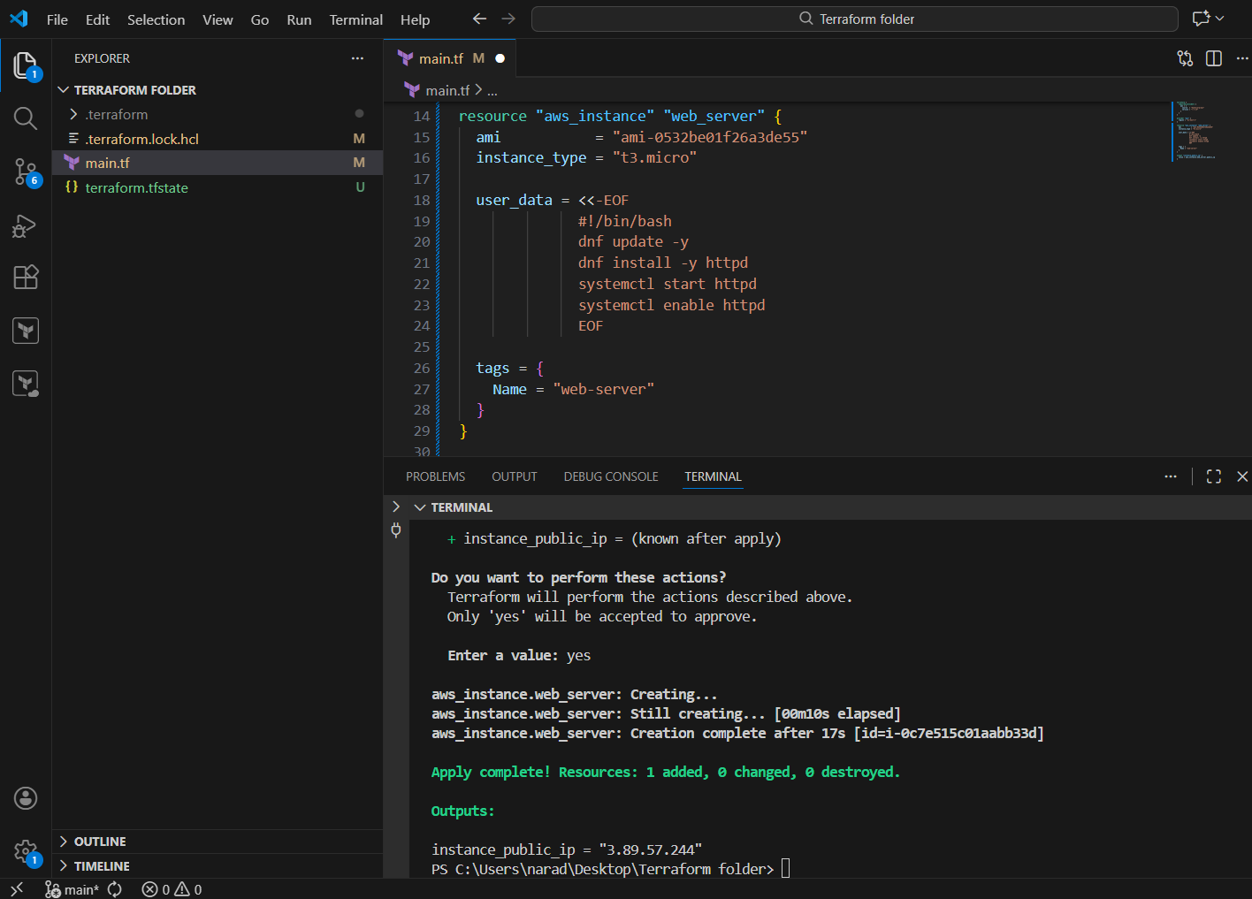
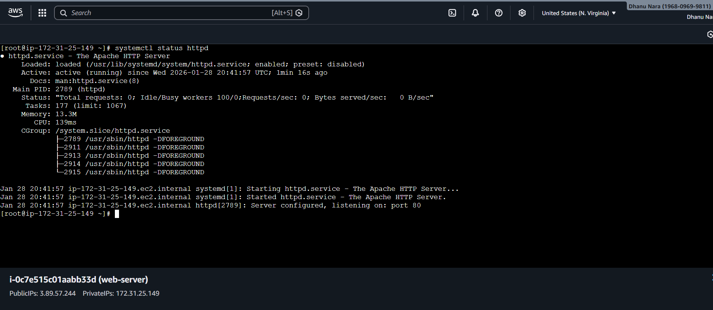

🔹 terraform {} BLOCK
terraform {
👉 Tells Terraform project-level settings.

required_providers {
👉 Declares which external plugins Terraform must download.

aws = {
source = "hashicorp/aws"
version = "~> 5.0"
}
- hashicorp/aws → official AWS provider
- ~> 5.0 → allow any 5.x version, block 6.x
Terraform uses this provider to call AWS APIs.

🔹 provider "aws" BLOCK
provider "aws" {
region = "us-east-1"
}
👉 Tells AWS provider which region to work in.
All resources below will be created in N. Virginia.

🔹 resource "aws_instance" BLOCK
resource "aws_instance" "web_server" {
- aws_instance → resource type
- web_server → Terraform name (internal reference)
Terraform identifies this resource as:
aws_instance.web_server

ami = "ami-0532be01f26a3de55"
👉 The OS image for EC2
This is Amazon Linux 2023.

instance_type = "t3.micro"
👉 EC2 hardware:
- CPU, RAM, network capacity
- Free-tier eligible

🔹 user_data BLOCK (VERY IMPORTANT)
user_data = <<-EOF
👉 Starts a multi-line shell script
Terraform sends this script to EC2.

#!/bin/bash
👉 Tells EC2:
“Run this using bash shell”

dnf update -y
👉 Updates OS packages
(dnf is used because Amazon Linux 2023)

dnf install -y httpd
👉 Installs Apache web server

systemctl start httpd
👉 Starts Apache immediately

systemctl enable httpd
👉 Makes Apache start automatically on reboot

EOF
👉 Ends the user_data script

🔹 tags BLOCK
tags = {
Name = "web-server"
}
👉 Adds Name tag in AWS console
Helps identify EC2 instance easily.

🔹 output BLOCK
output "instance_public_ip" {
👉 Defines what Terraform should print after apply

value = aws_instance.web_server.public_ip
👉 Fetches the public IP from the created EC2

}
👉 End of output block

5.Set up S3 as backend for task 3.

terraform {
required_providers {
aws = {
source = "hashicorp/aws"
version = "~> 5.0"
}
}

backend "s3" {
bucket = "my-terraform-ec2-state-12345"
key = "ec2-httpd/terraform.tfstate"
region = "ap-south-1"
}
}

provider "aws" {
region = "us-east-1"
}

resource "aws_instance" "web_server" {
ami = "ami-0532be01f26a3de55"
instance_type = "t3.micro"

user_data = <<-EOF
#!/bin/bash
dnf update -y
dnf install -y httpd
systemctl start httpd
systemctl enable httpd
EOF

tags = {
Name = "web-server"
}
}

output "instance_public_ip" {
value = aws_instance.web_server.public_ip
}

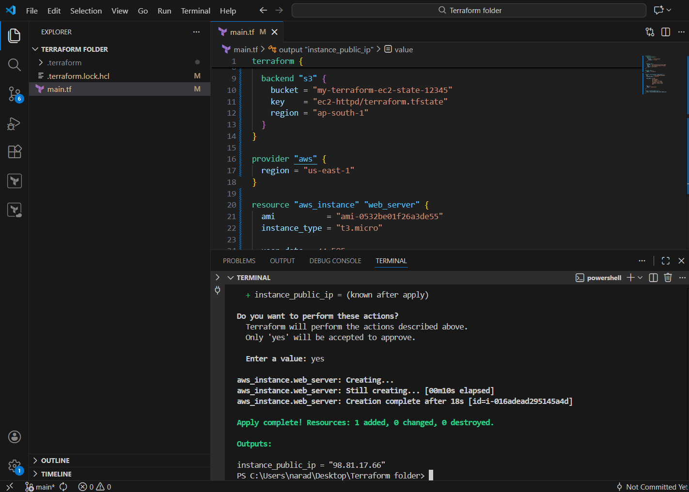
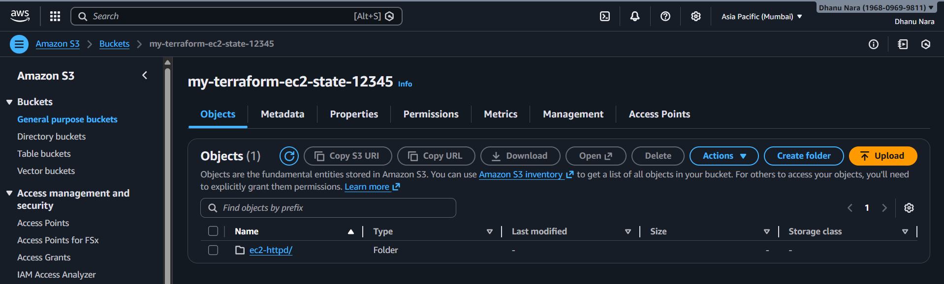

🔹 terraform {} BLOCK
👉 Terraform configuration block
terraform {
This block controls Terraform itself, not AWS resources.

🔹 required_providers
required_providers {
aws = {
source = "hashicorp/aws"
version = "~> 5.0"
}
}
- Tells Terraform which provider plugin to use
- hashicorp/aws = official AWS provider
- ~> 5.0 = allow any version 5.x, block 6.x
Terraform uses this plugin to call AWS APIs.

🔹 backend "s3" BLOCK
👉 Where Terraform state is stored
backend "s3" {
This tells Terraform:
“Do NOT store state locally. Store it in S3.”

bucket = "my-terraform-ec2-state-12345"
- Name of existing S3 bucket
- Bucket must exist before init

key = "ec2-httpd/terraform.tfstate"
- Logical path inside the bucket
- Creates:
- ec2-httpd/terraform.tfstate

region = "ap-south-1"
- Region where S3 bucket exists
- Backend region ≠ EC2 region (this is allowed)

🔹 provider "aws" BLOCK
👉 Where resources are created
provider "aws" {
region = "us-east-1"
}
- Tells AWS provider to create resources in N. Virginia
- Applies to all resources below unless overridden

🔹 resource "aws_instance" BLOCK
👉 Creates EC2 instance
resource "aws_instance" "web_server" {
- aws_instance = EC2 resource type
- web_server = Terraform logical name
Terraform reference:
aws_instance.web_server

ami = "ami-0532be01f26a3de55"
- OS image used for EC2
- Amazon Linux 2023 AMI

instance_type = "t3.micro"
- Hardware size (CPU/RAM/network)
- Free-tier eligible

🔹 user_data BLOCK
👉 Bootstrap script executed at first boot
user_data = <<-EOF
Starts a multi-line shell script.

#!/bin/bash
- Tells EC2 to execute script using bash

dnf update -y
- Updates all OS packages
- dnf is used for Amazon Linux 2023

dnf install -y httpd
- Installs Apache web server

systemctl start httpd
- Starts Apache immediately

systemctl enable httpd
- Ensures Apache starts on reboot

EOF
Ends the user_data script.

🔹 tags BLOCK
👉 AWS metadata
tags = {
Name = "web-server"
}
- Adds Name tag in AWS console
- Helps identify the instance

🔹 output BLOCK
👉 Prints value after apply
output "instance_public_ip" {
Defines an output variable.

value = aws_instance.web_server.public_ip
- Reads public IP from EC2
- Prints it after terraform apply

Conclusion:
- Uses AWS provider
- Stores state in S3
- Creates EC2 in us-east-1
- Installs and starts Apache automatically
- Prints public IP
- Keeps local machine stateless

4.Set up DynamoDB locking for task 3.

terraform {
required_providers {
aws = {
source = "hashicorp/aws"
version = "~> 5.0"
}
}

backend "s3" {
bucket = "my-terraform-ec2-state-12345"
key = "ec2-httpd/terraform.tfstate"
region = "ap-south-1"
dynamodb_table = "terraform-state-lock"
}
}

provider "aws" {
region = "us-east-1"
}

resource "aws_instance" "web_server" {
ami = "ami-0532be01f26a3de55"
instance_type = "t3.micro"

user_data = <<-EOF
#!/bin/bash
dnf update -y
dnf install -y httpd
systemctl start httpd
systemctl enable httpd
EOF

tags = {
Name = "web-server"
}
}

output "instance_public_ip" {
value = aws_instance.web_server.public_ip
}
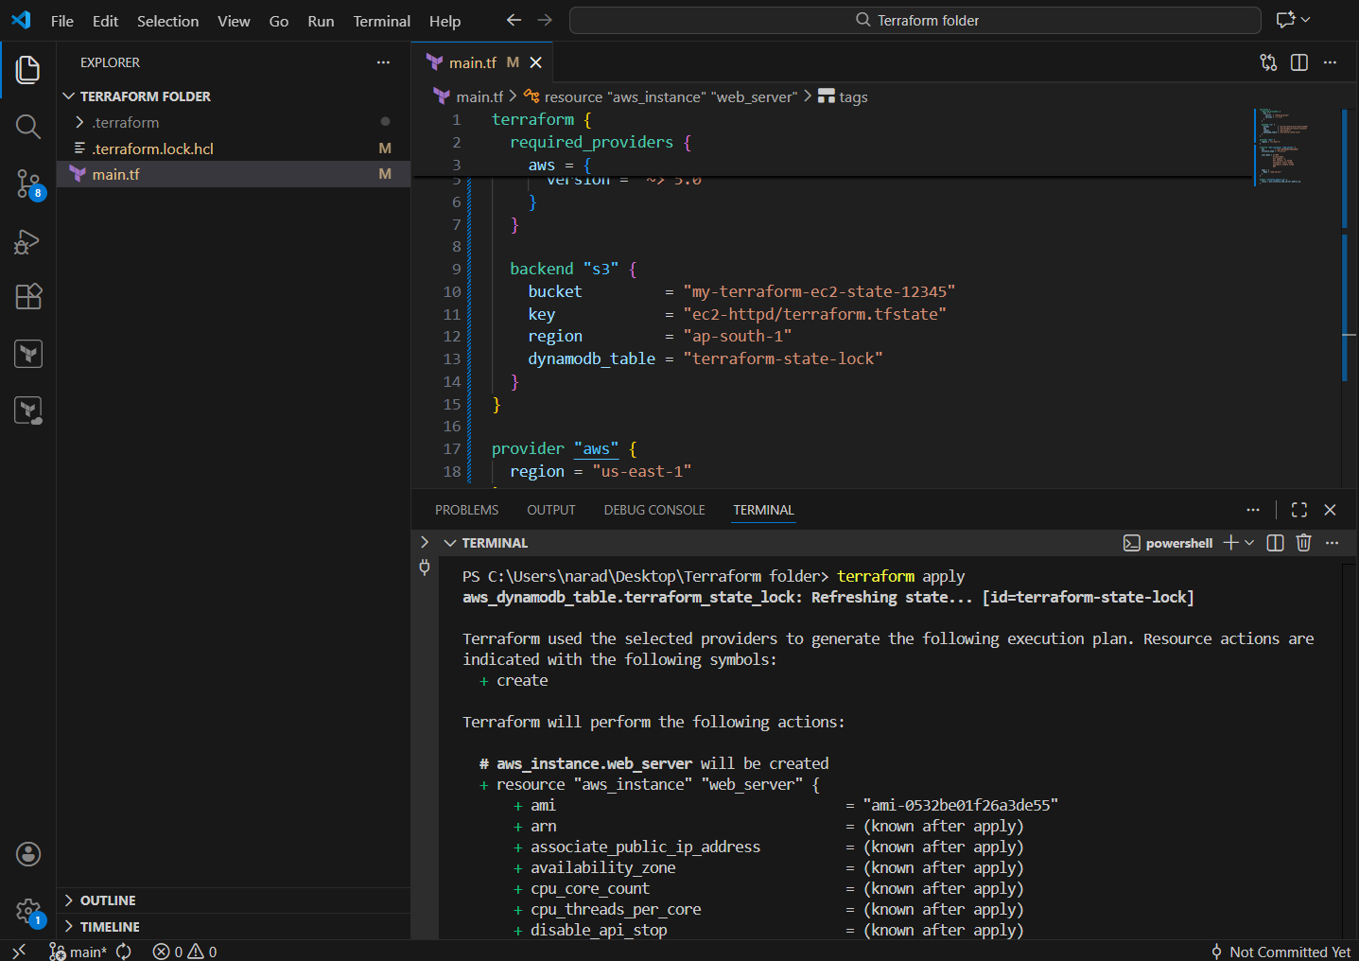
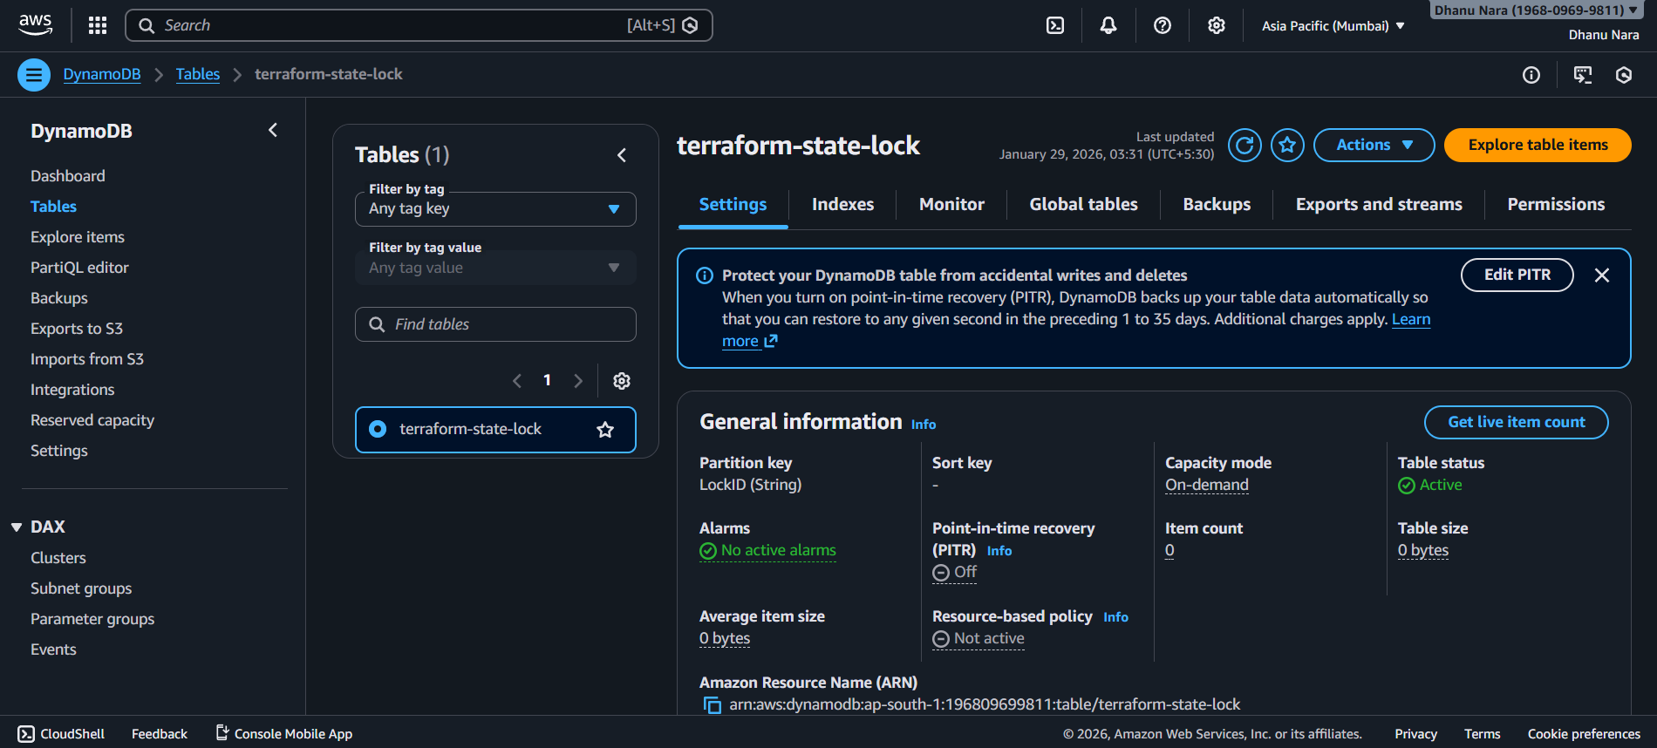
1️⃣ You run terraform apply
Terraform starts and tries to lock the state.
2️⃣ Terraform writes a lock entry in DynamoDB
This entry says:
“I’m using the state now. Nobody else touch it.”
3️⃣ Terraform reads the state from S3
It compares:
- what exists in AWS
- vs what’s written in main.tf
4️⃣ Terraform applies changes (or finds no changes)
- Creates / updates / deletes resources
- Updates the state file in S3
5️⃣ Terraform removes the lock from DynamoDB
State is free again for the next run.

Conclusion:
DynamoDB locking prevents multiple Terraform runs from corrupting the shared S3 state by allowing only one operation at a time.

