Terraform-06

Provision EC2, S3, and VPC using Terraform modules.

Title
Provision EC2, S3, and VPC using Terraform Modules

Objective
To use Terraform modules to provision a complete AWS infrastructure consisting of:
- A Virtual Private Cloud (VPC) with public and private subnets
- An EC2 instance deployed inside the VPC
- An S3 bucket with a unique name
The objective also includes demonstrating reusable, modular infrastructure design using official Terraform Registry modules.

Step-by-Step Implementation

Step 1: Prepare the working directory
Create a Terraform project folder and open it in VS Code.
Initialize basic Terraform files to define providers and configuration.

Step 2: Configure Terraform and AWS provider
Specify:
- Minimum Terraform version
- Required providers (AWS and Random)
- AWS region where resources will be created
This ensures consistent provider versions and compatibility.

Step 3: Use VPC module
Use the official VPC module from Terraform Registry to:
- Create a VPC with a defined CIDR block
- Create public and private subnets across multiple Availability Zones
- Enable a NAT Gateway for private subnet outbound access
- Apply tags for environment and identification
This avoids writing low-level networking resources manually.

Step 4: Use EC2 module
Use the EC2 instance module to:
- Launch an EC2 instance inside a public subnet
- Assign a public IP address
- Select instance type and AMI
- Attach tags for tracking and management
The EC2 instance depends on outputs from the VPC module.

Step 5: Use S3 module
Use the S3 bucket module to:
- Create an S3 bucket with a globally unique name
- Enable automatic deletion of objects when destroying infrastructure
- Apply environment tags
A random identifier is used to prevent bucket name conflicts.

Step 6: Manage dependencies automatically
Terraform automatically:
- Ensures VPC is created before EC2
- Ensures subnet availability before instance launch
- Resolves module dependencies using the resource graph
No manual ordering is required.

Step 7: Initialize and apply
Run Terraform initialization to download modules and providers, then apply the configuration to provision all resources.
Terraform maintains state and tracks infrastructure changes.

Step 8: Validate outputs
Terraform outputs:
- VPC ID
- EC2 public IP address
- S3 bucket name
These outputs confirm successful provisioning.

TERRAFORM CONFIGURATION FILE:

terraform {
required_version = ">= 1.3.0"

required_providers {
aws = {
source = "hashicorp/aws"
version = "~> 5.83"
}
random = {
source = "hashicorp/random"
version = "~> 3.6"
}
}
}

provider "aws" {
region = "us-east-1"
}

# ----------------------------
# VPC MODULE
# ----------------------------
module "vpc" {
source = "terraform-aws-modules/vpc/aws"
version = "5.21.0"

name = "task-vpc"
cidr = "10.0.0.0/22"

azs = ["us-east-1a", "us-east-1b", "us-east-1c"]

private_subnets = [
"10.0.0.0/26",
"10.0.0.64/26",
"10.0.0.128/26"
]

public_subnets = [
"10.0.1.0/26",
"10.0.1.64/26",
"10.0.1.128/26"
]

enable_nat_gateway = true
single_nat_gateway = true
enable_vpn_gateway = false

tags = {
terraform = "true"
environment = "dev"
}
}

# ----------------------------
# EC2 MODULE
# ----------------------------
module "ec2" {
source = "terraform-aws-modules/ec2-instance/aws"
version = "5.8.0"

name = "task-ec2"
ami = "ami-02dc6e3e481e2bbc5"
instance_type = "t3.micro"

subnet_id = module.vpc.public_subnets[0]
associate_public_ip_address = true

tags = {
terraform = "true"
environment = "dev"
}
}

# ----------------------------
# S3 MODULE
# ----------------------------
module "s3" {
source = "terraform-aws-modules/s3-bucket/aws"
version = "4.11.0"

bucket = "terratask-${random_id.bucket_task06sa.hex}"
force_destroy = true

tags = {
terraform = "true"
environment = "dev"
}
}

# Random suffix to avoid bucket name conflicts
resource "random_id" "bucket_task06sa" {
byte_length = 4
}

# ----------------------------
# OUTPUTS
# ----------------------------
output "vpc_id" {
value = module.vpc.vpc_id
}

output "ec2_public_ip" {
value = module.ec2.public_ip
}

output "s3_bucket_name" {
value = module.s3.s3_bucket_id
}

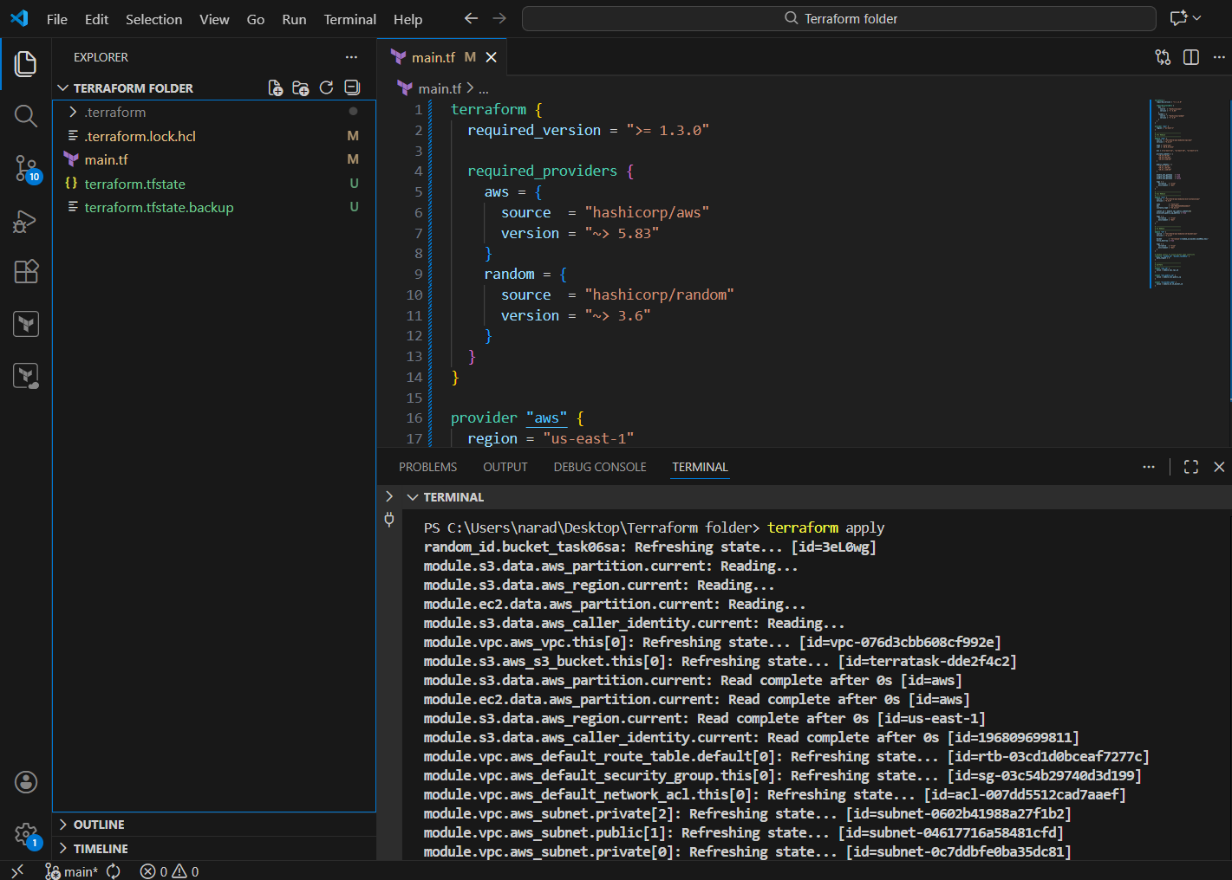

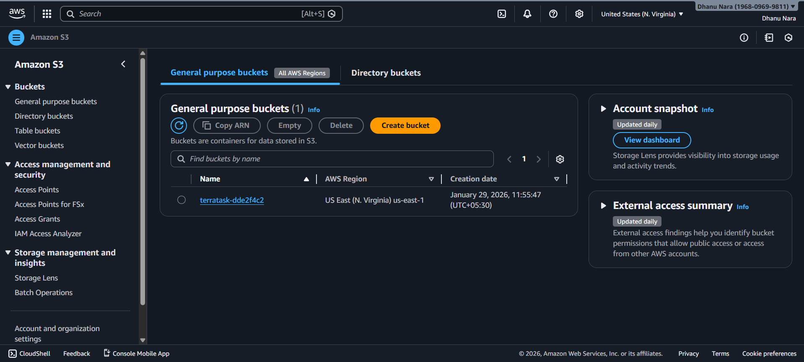
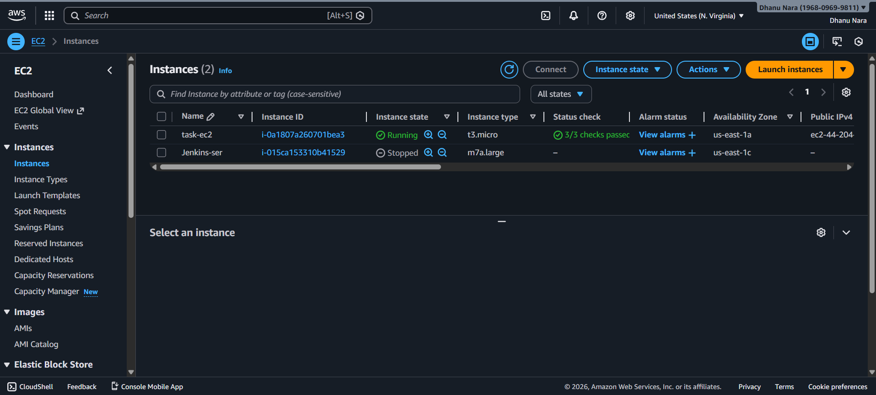

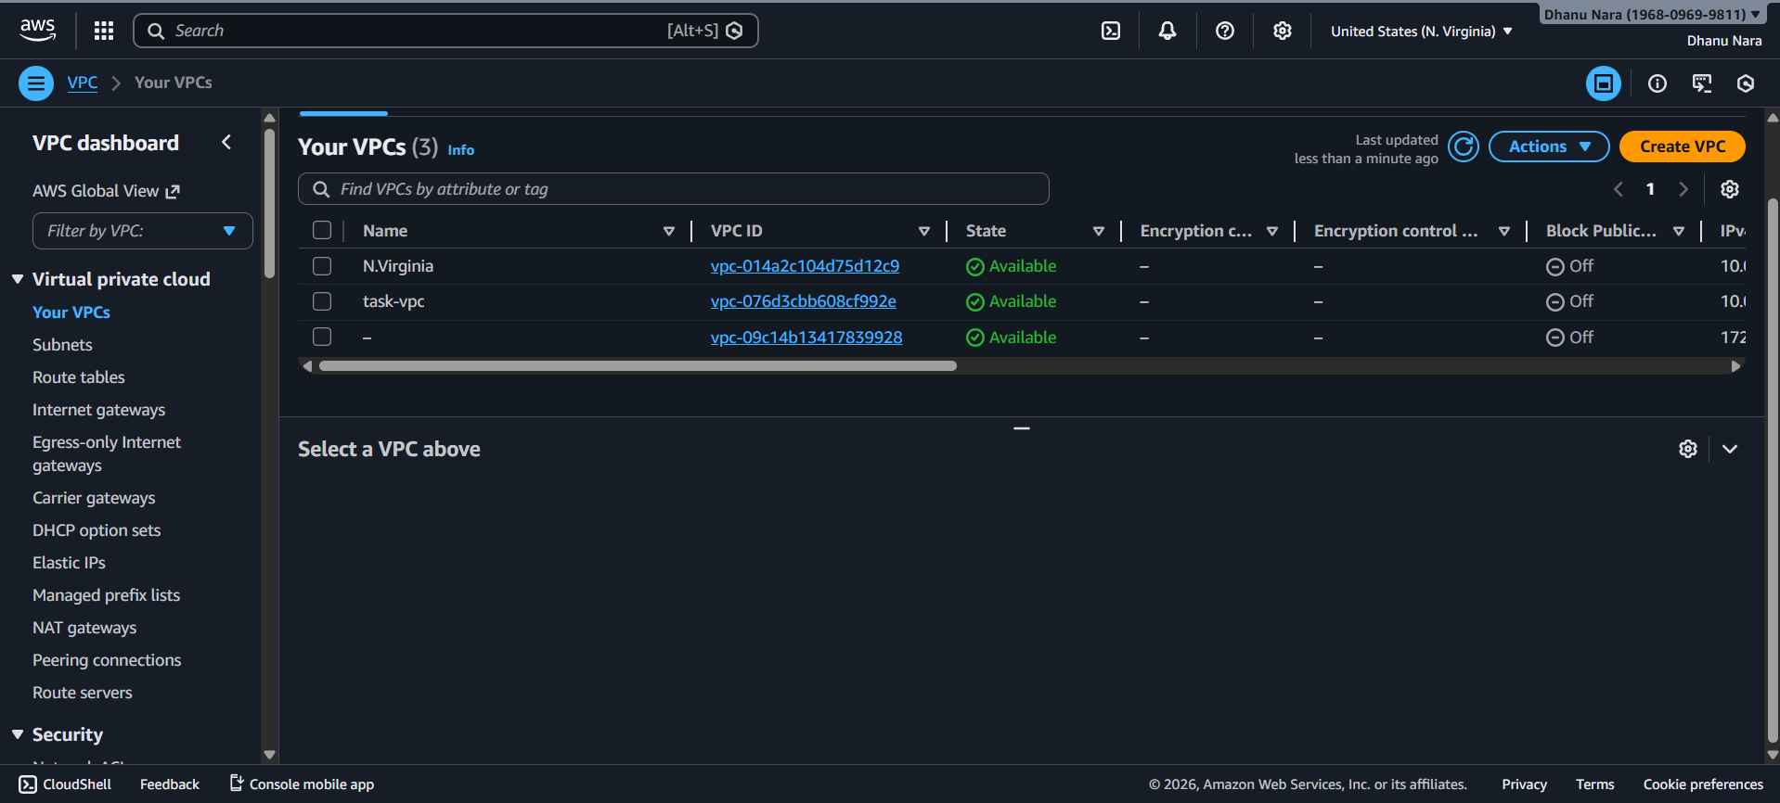

Conclusion
This task demonstrates how Terraform modules simplify infrastructure provisioning by abstracting complex AWS resource definitions into reusable components. Using official Terraform Registry modules improves reliability, reduces configuration errors, and promotes best practices. The infrastructure is modular, scalable, and easy to maintain, making it suitable for both learning and real-world cloud deployments.

Provision EC2 for 3 different environments (Dev, Staging, and Prod) using Terraform workspace.

Title
Provision EC2 for Dev, Staging, and Prod Environments Using Terraform Workspaces

Objective
To provision Amazon EC2 instances for three different environments—Dev, Staging, and Prod—using Terraform workspaces. Each workspace represents a separate environment and controls environment-specific configuration such as instance type and naming, while using a single Terraform configuration.

Step-by-Step Implementation

Step 1: Create Terraform configuration
Define the Terraform configuration with:
- Required Terraform and AWS provider versions
- AWS region
- Local values that map environment names to instance types and instance names
The environment is dynamically determined using terraform.workspace.

Step 2: Define environment-specific mappings
Use local maps to associate:
- Each environment with a specific EC2 instance type
- Each environment with a unique instance name
This ensures that the same Terraform code behaves differently based on the active workspace.

Step 3: Use the default AWS networking
Fetch the default VPC and its subnets using data sources.
This avoids manually creating networking resources and allows EC2 instances to launch using existing AWS infrastructure.

Step 4: Create a security group
Create a security group inside the default VPC to isolate EC2 traffic per environment.
The security group name and tags dynamically include the environment name.

Step 5: Provision EC2 instance
Create an EC2 instance where:
- The instance type is selected based on the active workspace
- The instance name is derived from the environment
- The instance is launched into the default subnet
- A public IP is associated for access
Each workspace results in a separate EC2 instance.

Step 6: Create and switch workspaces
Create and switch Terraform workspaces for each environment:
- Dev
- Staging
- Prod
Terraform automatically isolates state files per workspace, ensuring environments do not interfere with each other.

Step 7: Apply configuration per environment
Run Terraform apply separately in each workspace.
Terraform provisions one EC2 instance per environment using the same configuration but different state and values.

Step 8: Verify outputs
Terraform outputs display:
- The active environment
- The instance type used
- The public IP of the EC2 instance
These outputs confirm correct environment-based provisioning.

TERRAFORM CONFIGURATION FILE:

terraform {
required_version = ">= 1.3.0"
required_providers {
aws = {
source = "hashicorp/aws"
version = "~> 5.63"
}
}
}
provider "aws" {
region = "us-east-1"
}
locals {
env = terraform.workspace
instance_type_map = {
dev = "t3.micro"
staging = "t3.small"
prod = "t3.small"
}
instance_name_map = {
dev = "task-ec2-dev"
staging = "task-ec2-staging"
prod = "task-ec2-prod"
}
}
# Default VPC
data "aws_vpc" "default" {
default = true
}
# Default Subnets
data "aws_subnets" "default" {
filter {
name = "vpc-id"
values = [data.aws_vpc.default.id]
}
}
# Security Group
resource "aws_security_group" "sg" {
name = "${local.env}-sg"
description = "Security group for ${local.env} environment"
vpc_id = data.aws_vpc.default.id
tags = {
Name = "${local.env}-sg"
environment = local.env
terraform = "true"
}
}
# EC2 Instance
resource "aws_instance" "app" {
ami = "ami-02dc6e3e481e2bbc5"
instance_type = local.instance_type_map[local.env]
subnet_id = data.aws_subnets.default.ids[0]
vpc_security_group_ids = [aws_security_group.sg.id]
associate_public_ip_address = true
tags = {
Name = local.instance_name_map[local.env]
environment = local.env
terraform = "true"
}
}
output "environment" {
value = local.env
}
output "instance_type" {
value = aws_instance.app.instance_type
}
output "public_ip" {
value = aws_instance.app.public_ip
}

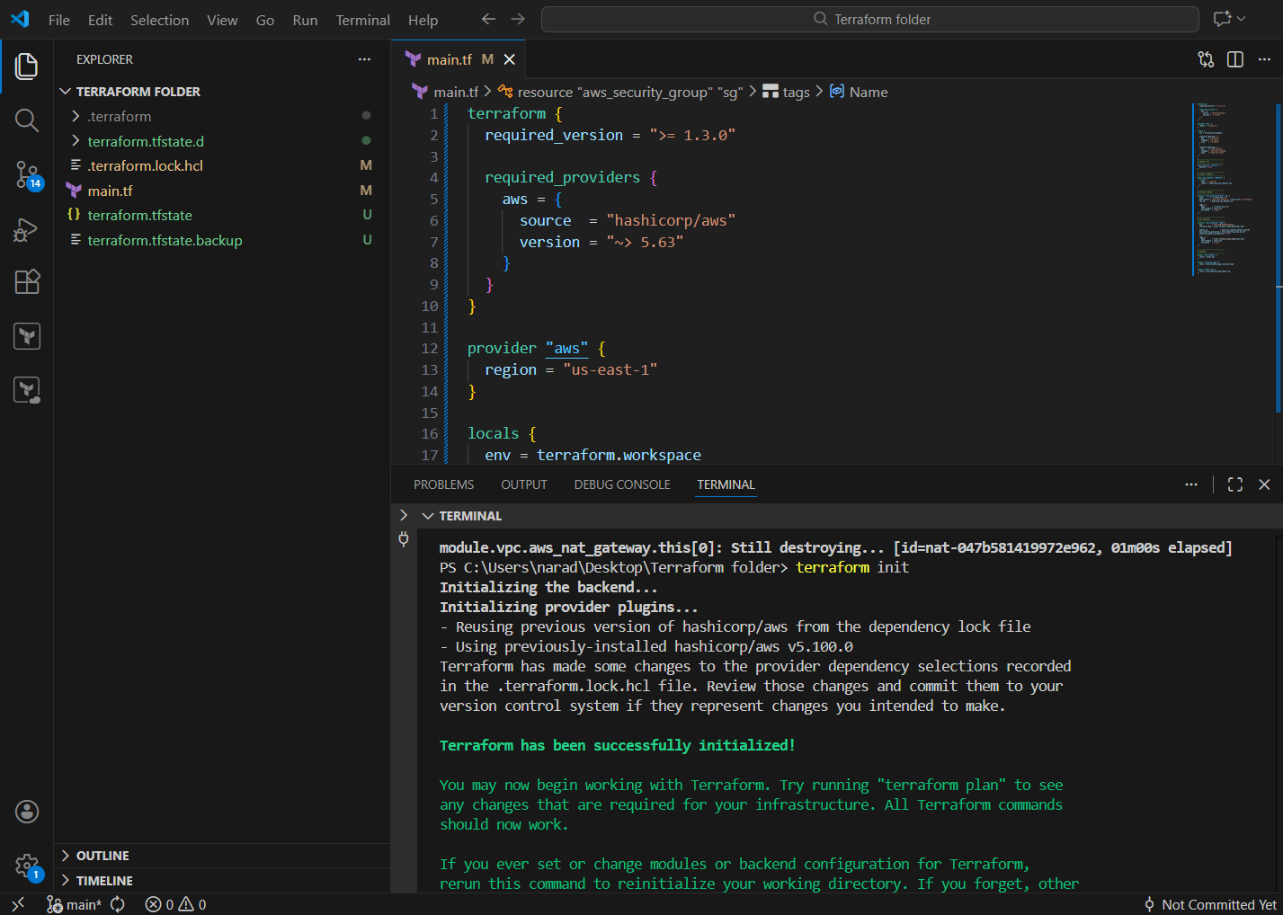

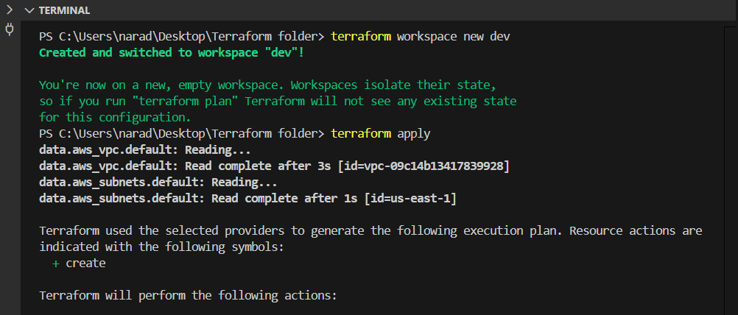

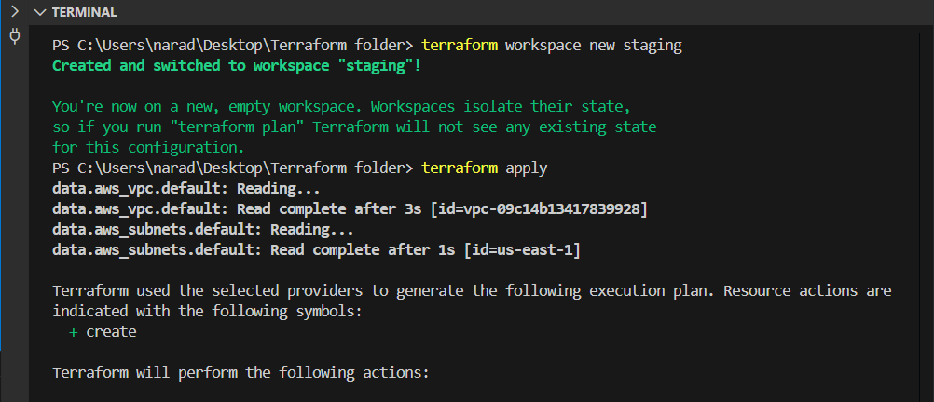

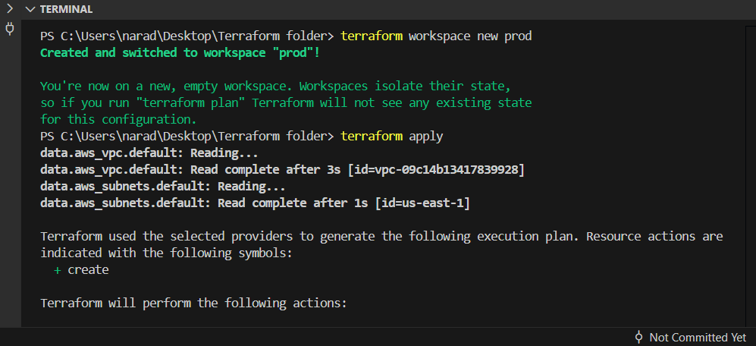

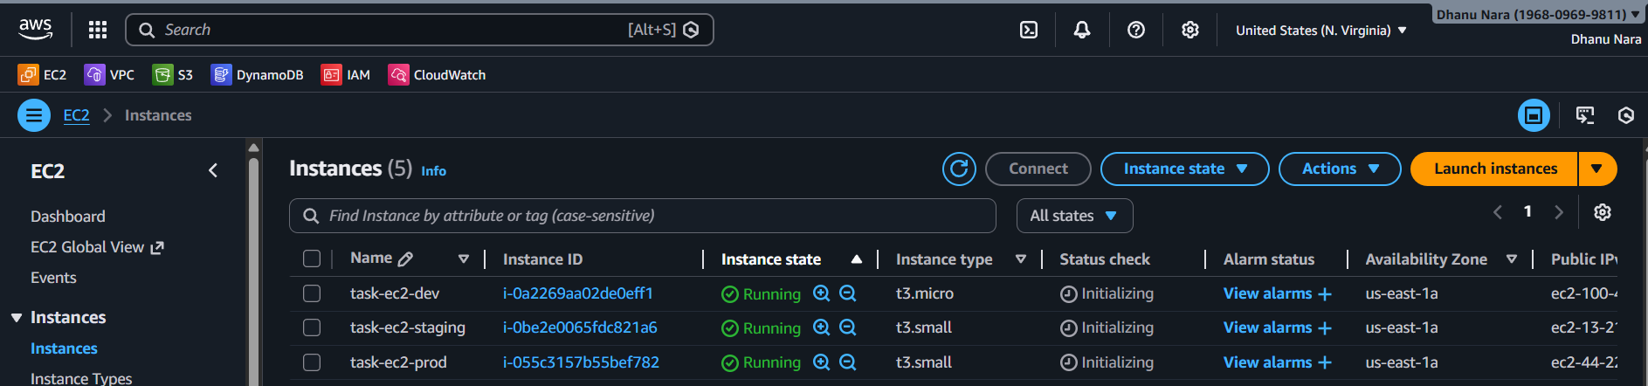

Conclusion
This task demonstrates how Terraform workspaces enable multi-environment infrastructure management using a single configuration. By combining workspaces with local variable mappings, environment-specific EC2 instances are provisioned efficiently without duplicating code. This approach improves maintainability, reduces configuration drift, and aligns with infrastructure-as-code best practices.

