S3-Task

1.Create an S3 bucket and upload some objects to S3.
First we should go to S3 console and click on create bucket.
We should assign one unique name to the bucket and add region.
Now click on the created bucket and click on upload and add click on add files.
Select the files and click on open they will transfer to bucket.
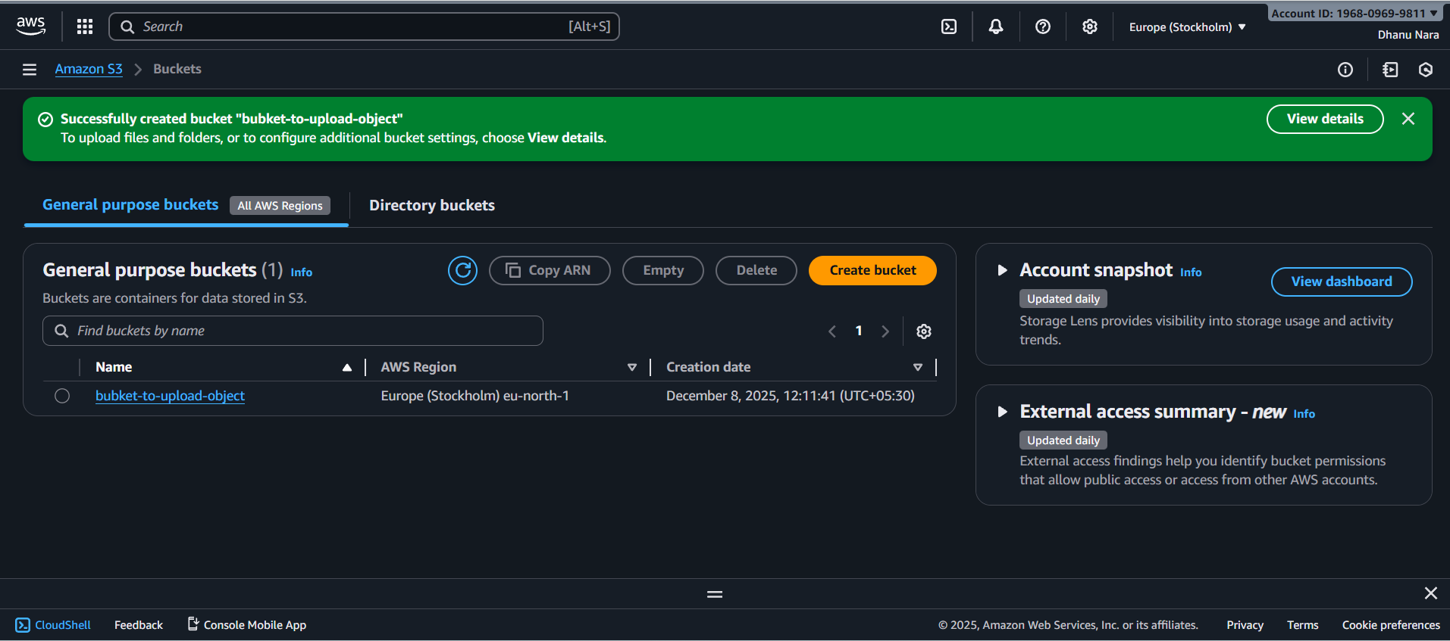
The file which is shared.
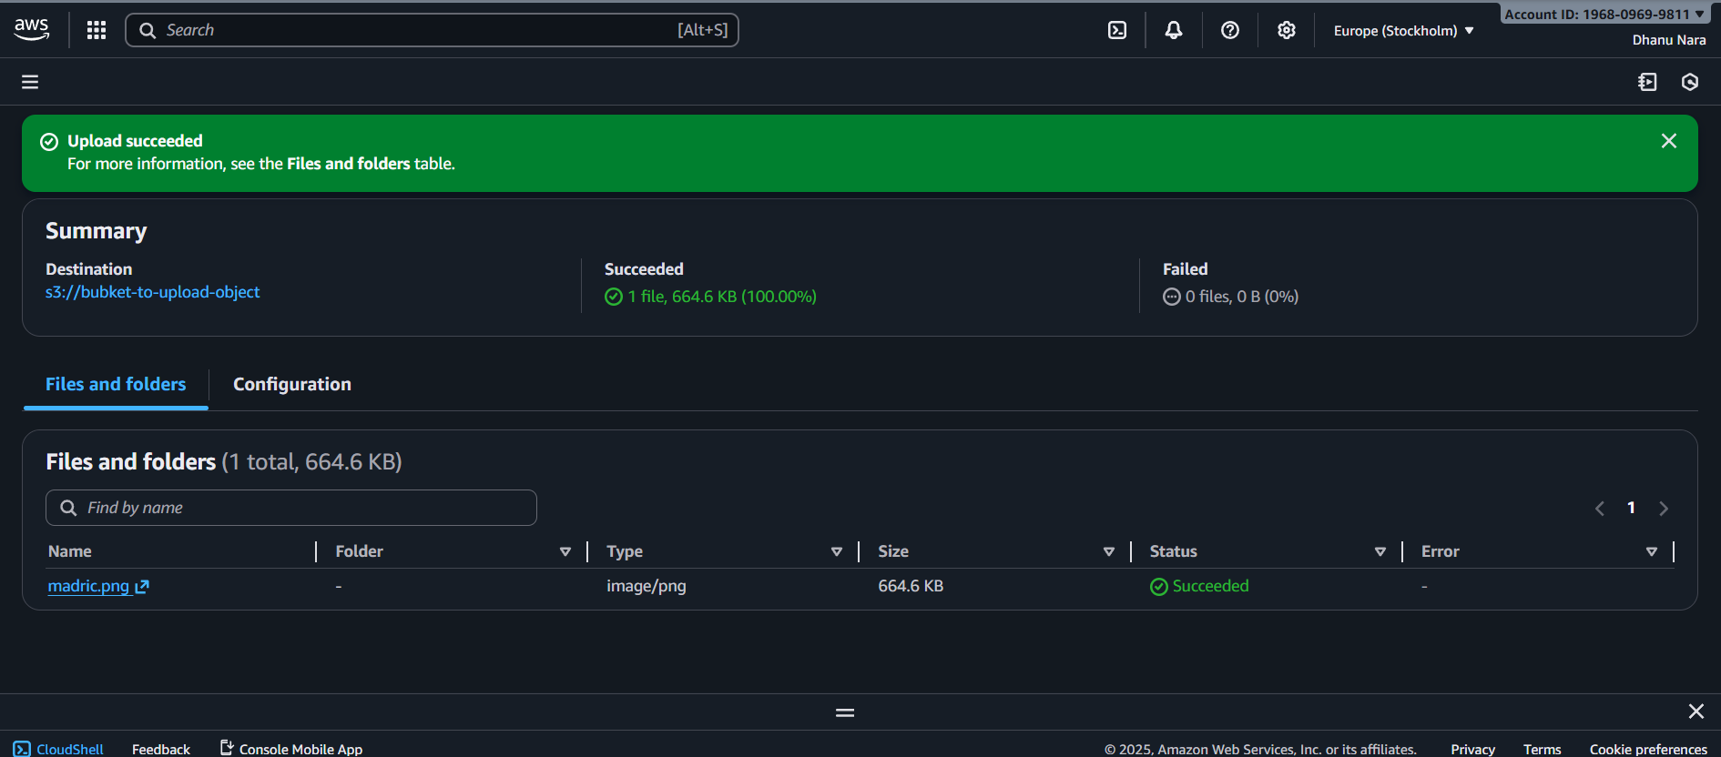

2.Deploy a static Website in the S3 bucket.
First we should create two files in the local.
And add the content using vi inside the file.
And go to properties of a bucket there we can find host a static website.
Add the two files there and click on save the changes.
Paste the bucket endpoint link in the browser then we can see the page.
If we delete the first one and refresh it will show the second file content.
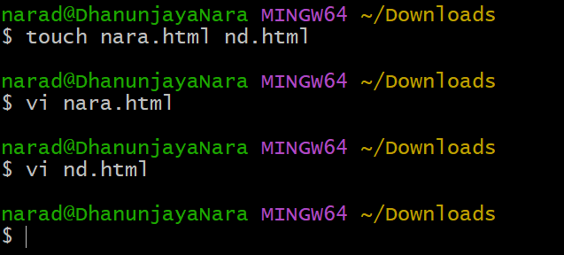
Two files
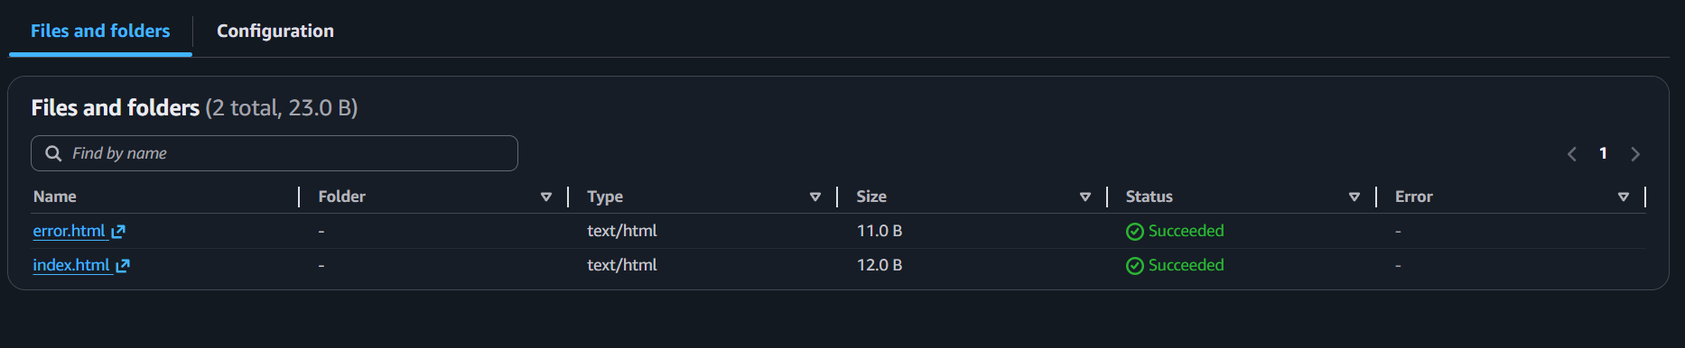
First file page
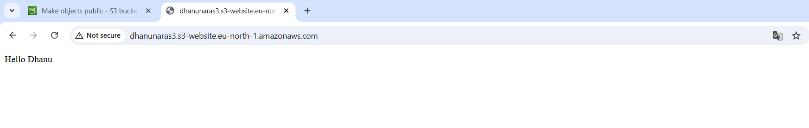

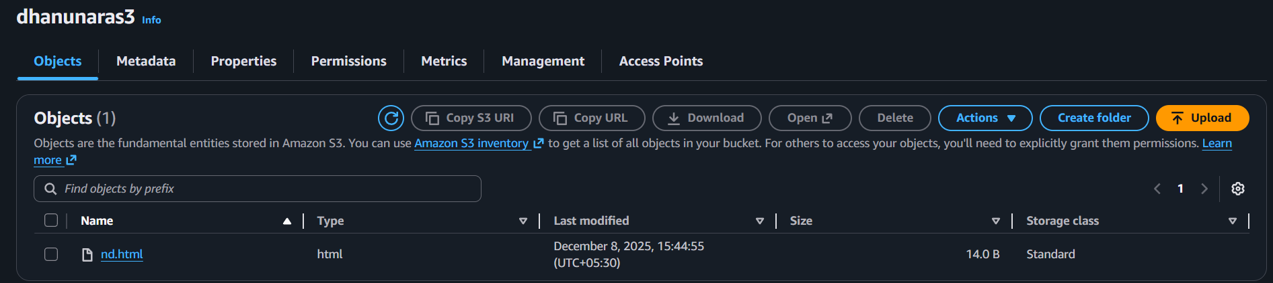
Second file page {error one}
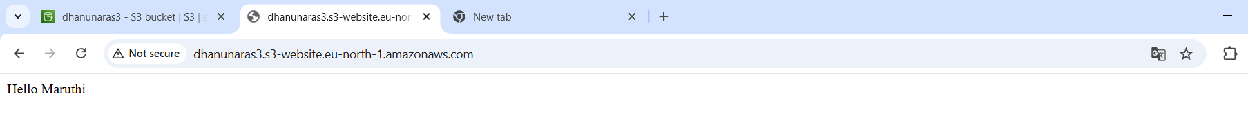

3.Enable cross-region replication on S3 buckets.
First we should create two buckets in two different regions.
And enable the versioning on both buckets, in properties bucket versioning and enable.
Now go to S3 console and select the source bucket and select management tab and click on replication rule.
Create the replication rule by giving some name and there choose the destination bucket created in another location and in IAM select the create new role and save.
Now the replication configuration is successfully configured.
Now upload one object in source bucket.
And go to destination bucket of another region object will be visible.
Source bucket {Stockholm}
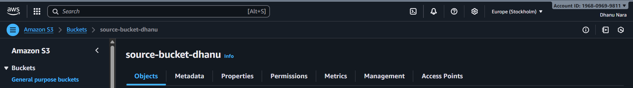
Destination bucket {Virginia}
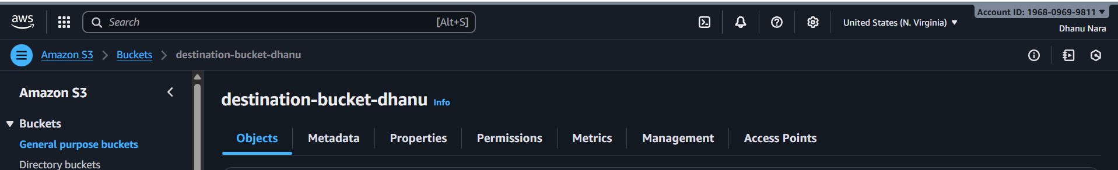

Replication configuration
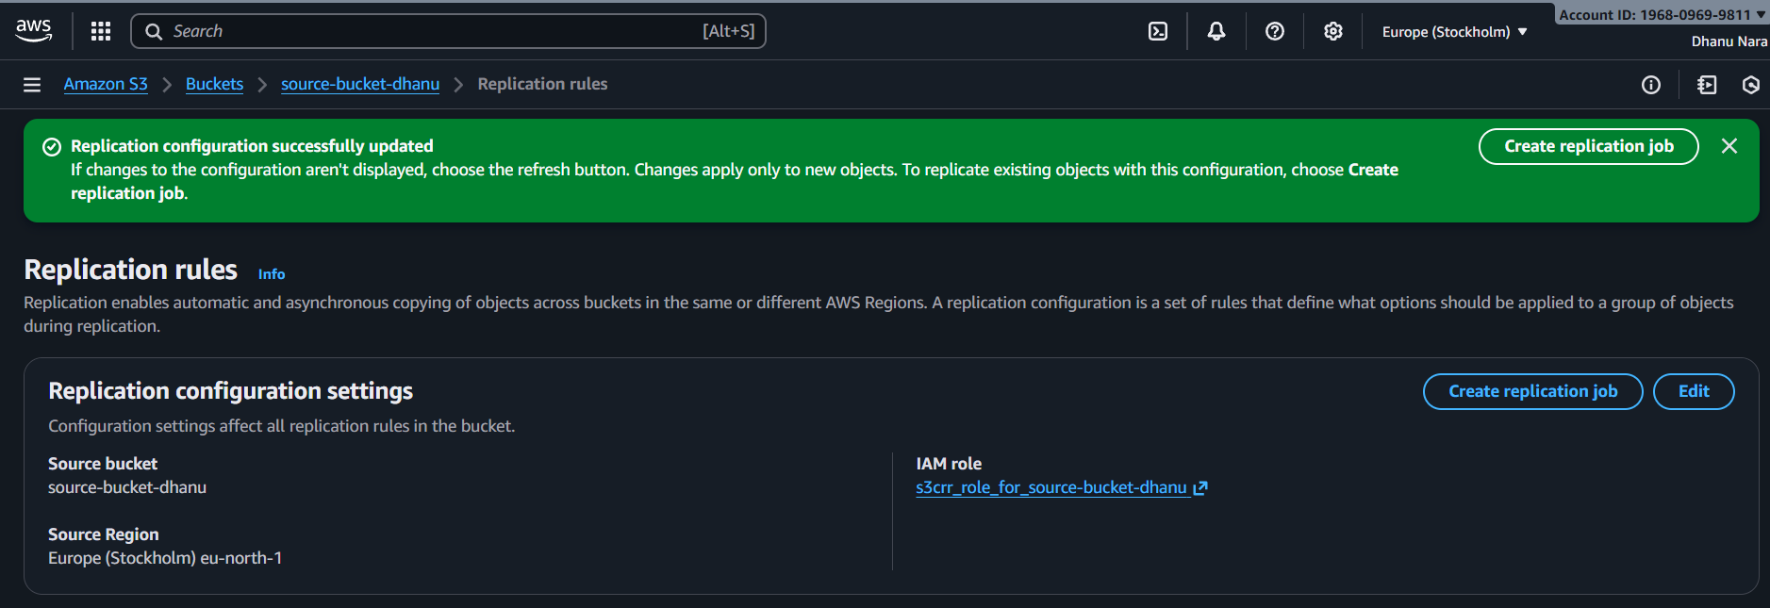
File uploaded in source bucket
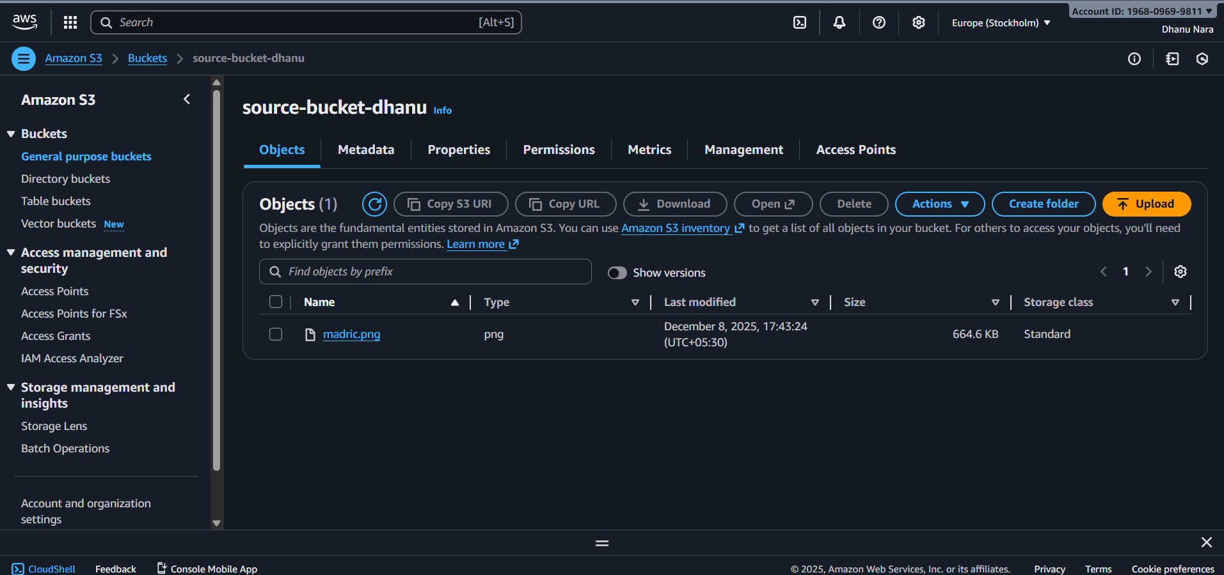
Object of source bucket visible in destination bucket
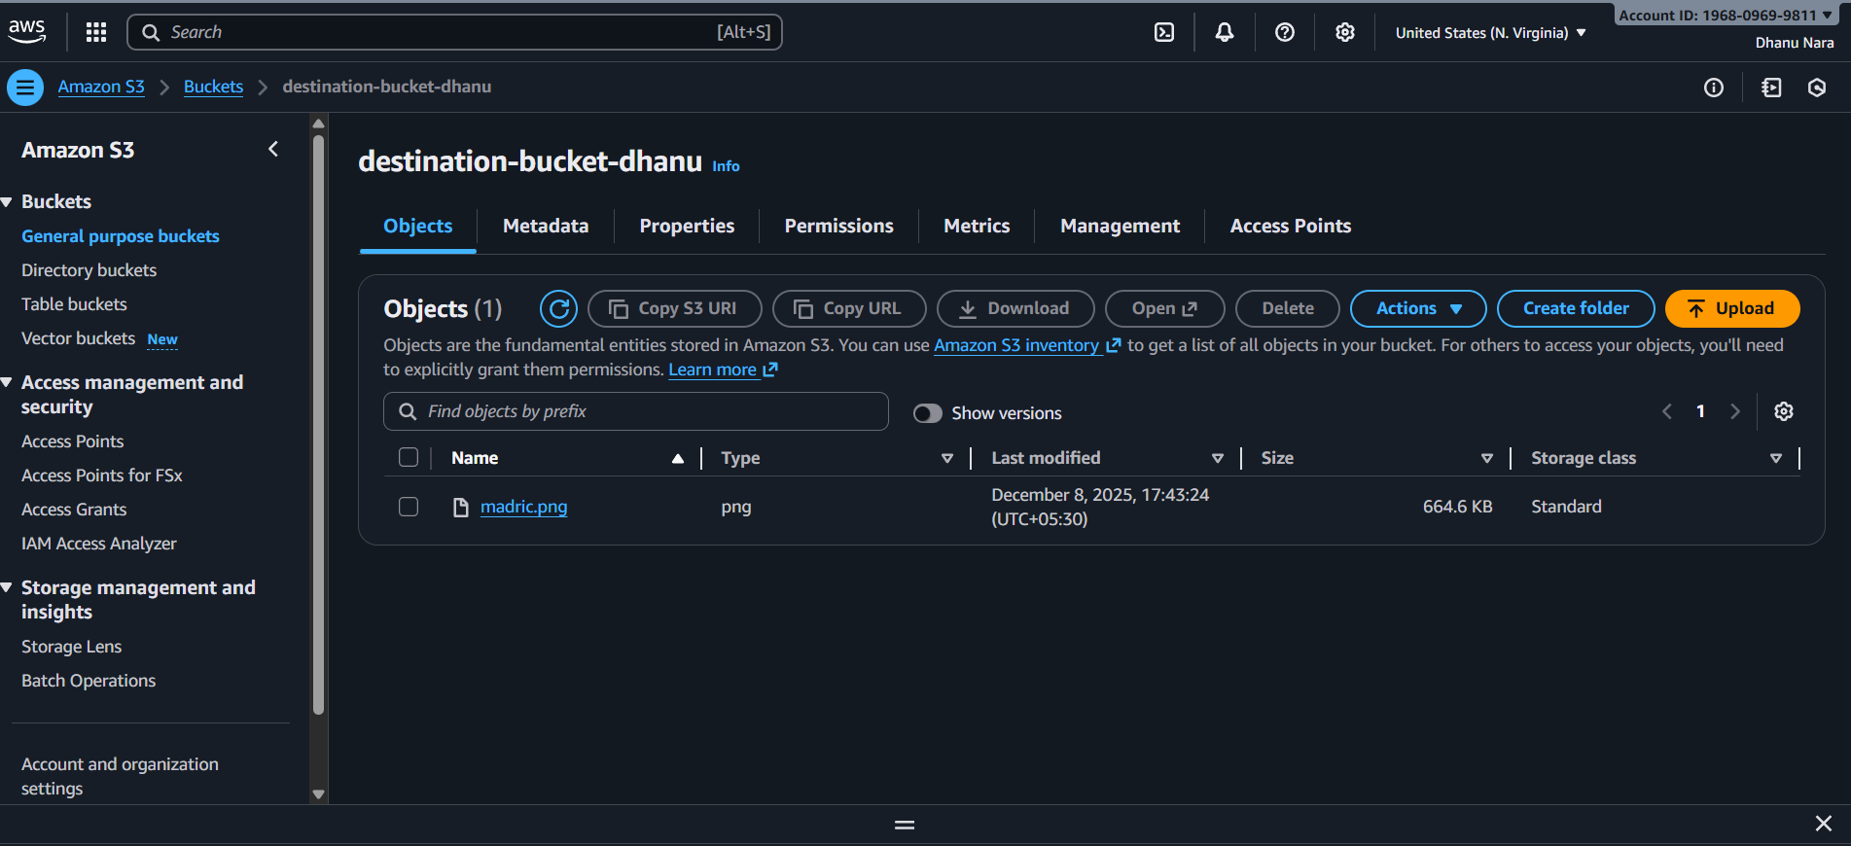

4.Configure a bucket policy so only the Admin user can see the objects of the S3 bucket.
First we should have one user give S3 full access to that user.
Create a bucket and go to permissions and create a policy so that only admn user can see the objects inside the bucket. Click on save changes.
Now go to new window and check whether admin user is getting access to see the objects inside the folder or not.
Create one more user and go to new window and try to access the objects inside a bucket, now he should not access the objects inside a bucket.

Users for testing
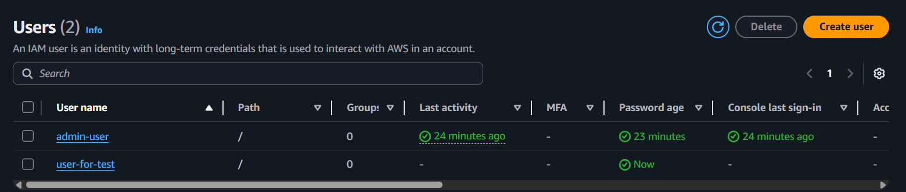
Bucket
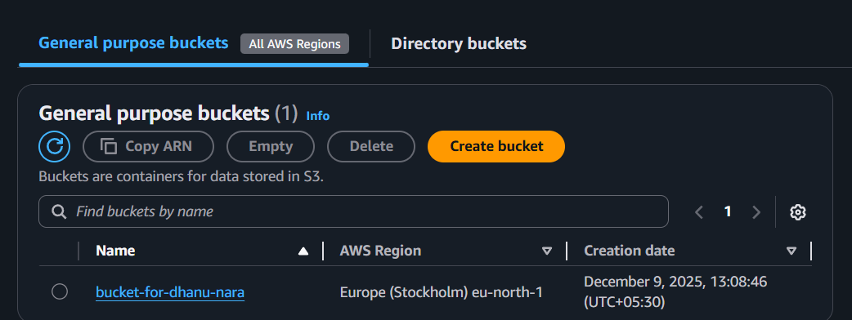

Bucket policy
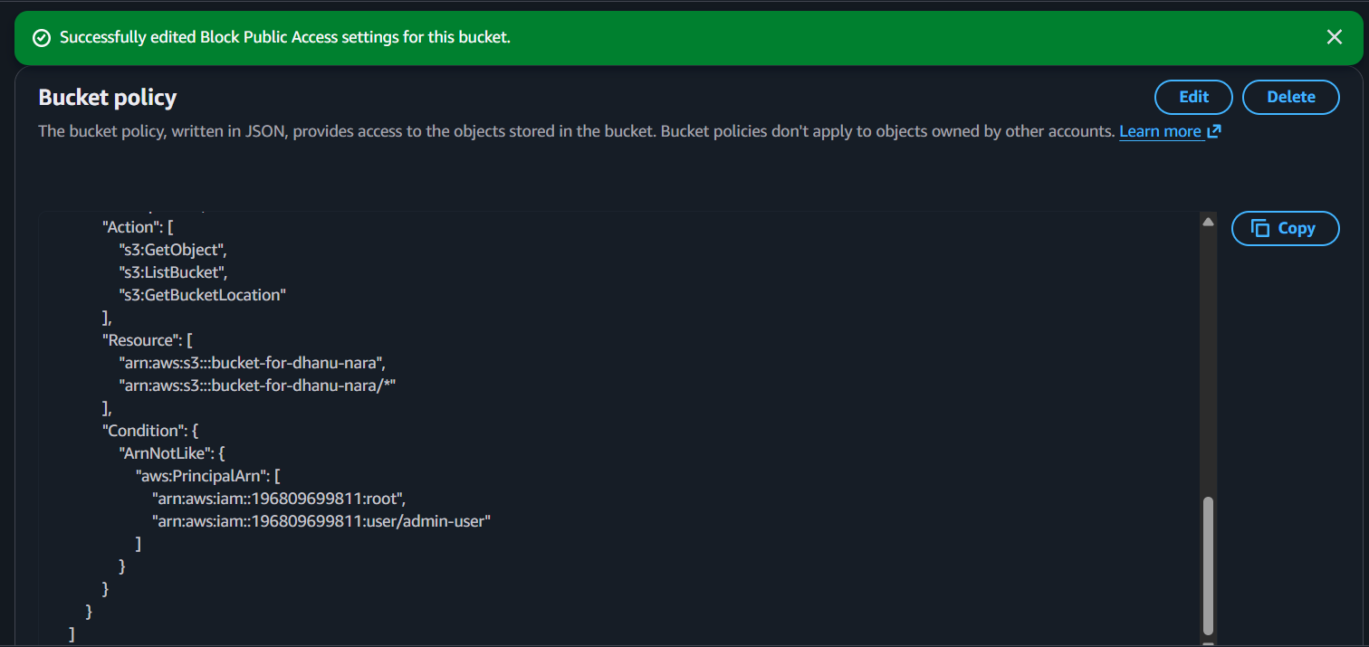
Checking access for admin user
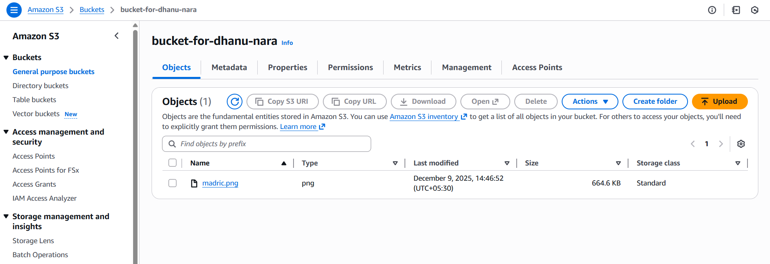

Checking access for other user
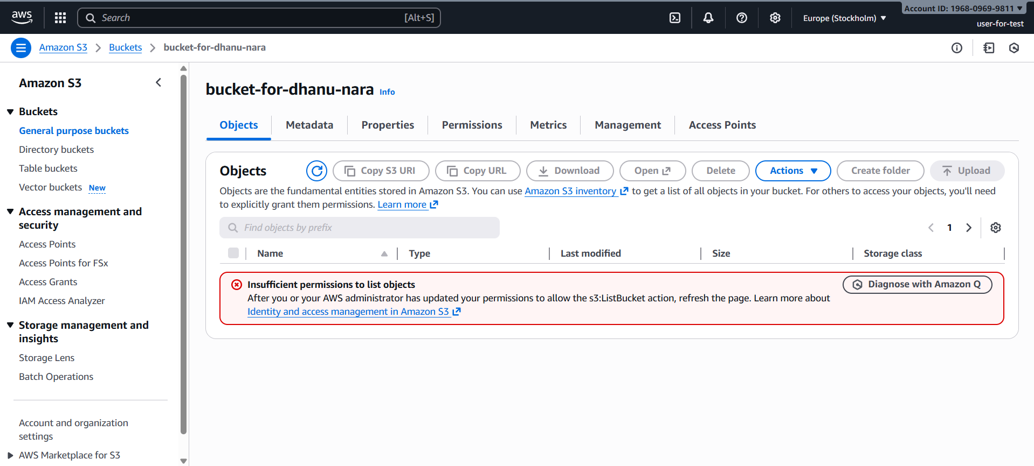

5.Set up a lifecycle policies to automatically transition or delete objects based on specific criteria.
First we should create one bucket in s3 console.
Click on the bucket and go management and click on create lifecycle rules.
Enter a name to that lifecycle process.
We should choose two boxes
1.Transition current versions of objects between storage classes.
2.Expire current versions of objects.
Now click on save changes.
{ By adding this lifecycle policy when you upload an object it stays in S3 standard (normal storage)
After 30 days your rule will automatically move to standard -1A (infrequent access). This is a cheaper storage class which will save money.
After 90 days your rule will automatically delete the object from the bucket. No manual deleting required object is permanently removed.}
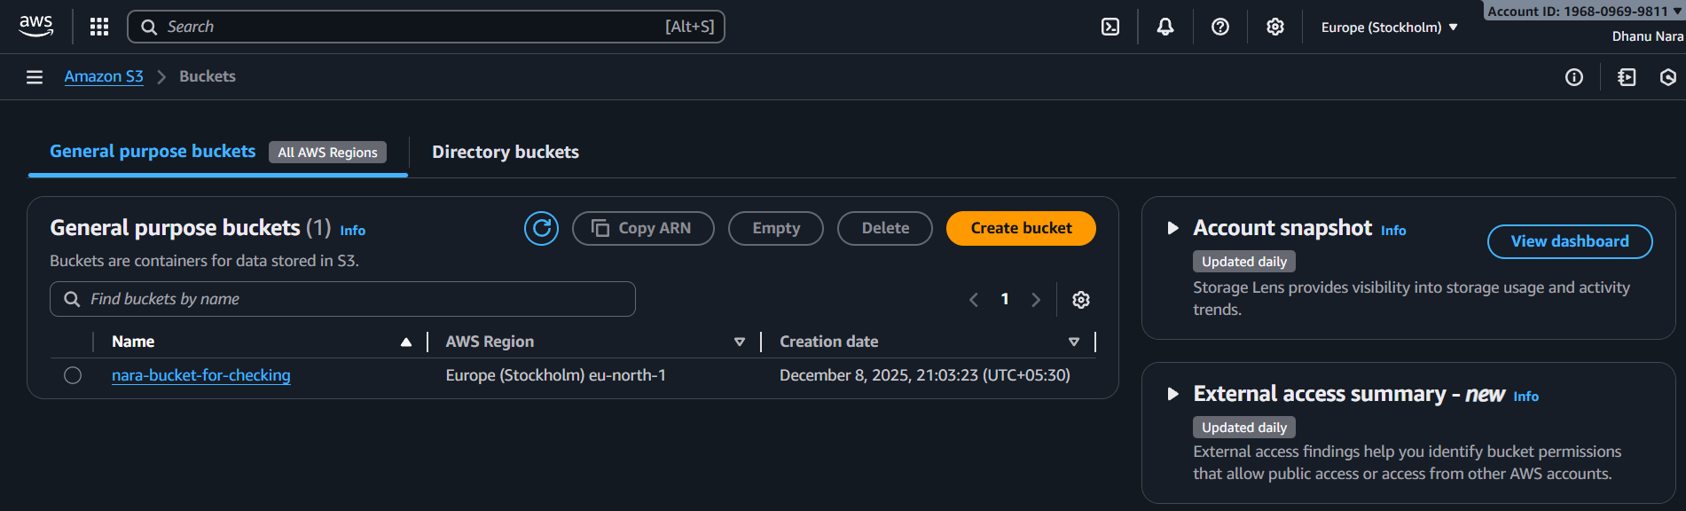
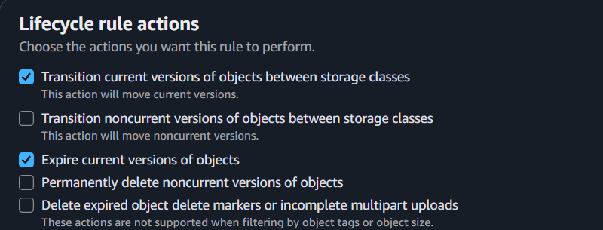

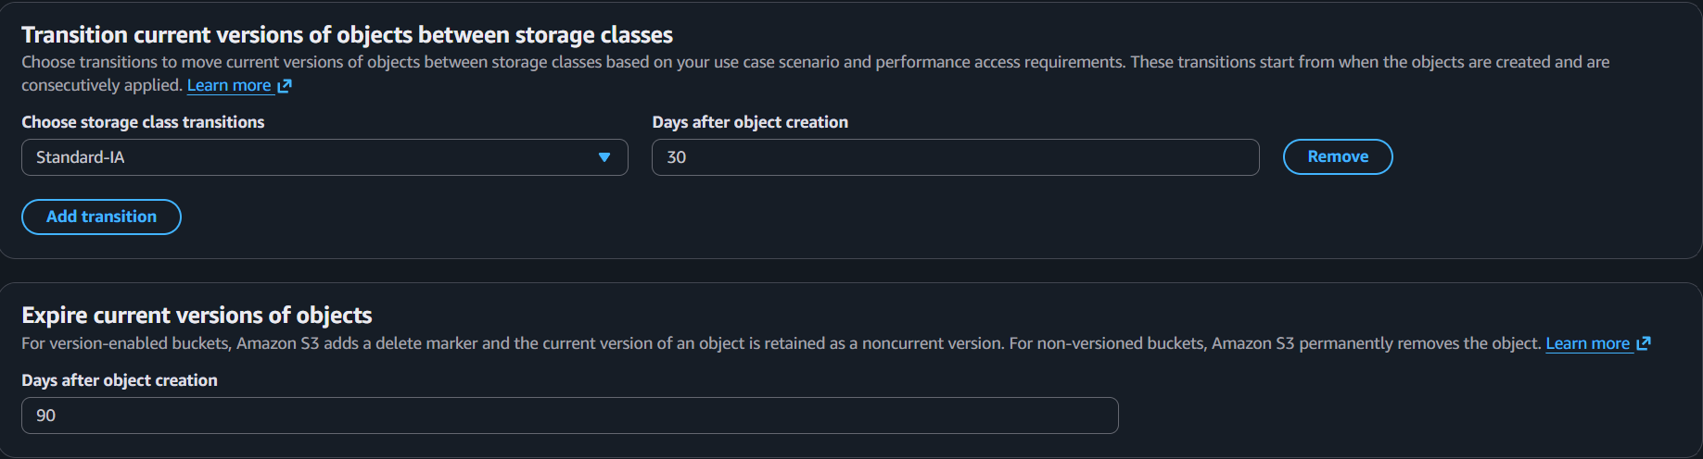
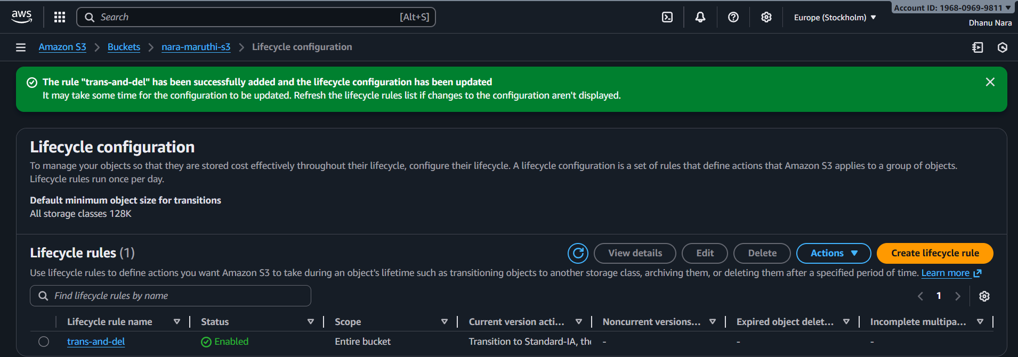

6.Push some objects to s3 using the AWS CLI.
First we need to configure aws in cli.
Now we should create a folder and change to that folder and create files in that folder.
Aws cli command to push files to s3 bucket.
{ aws s3 cp . s3://bucket-name/ --recursive }

Aws configuration in cli.
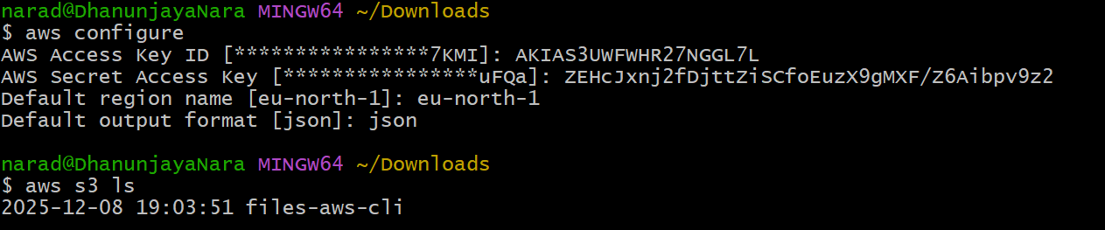
Files inside folder.
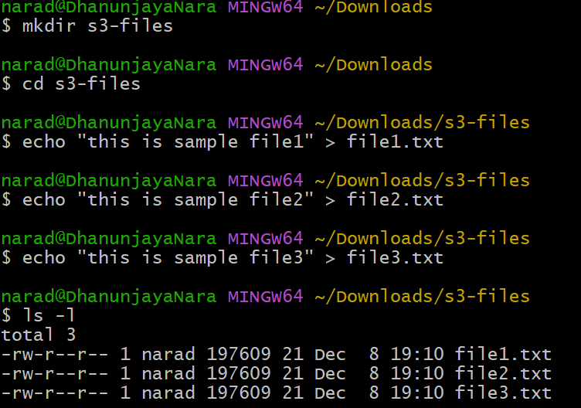

Pushing through cli command
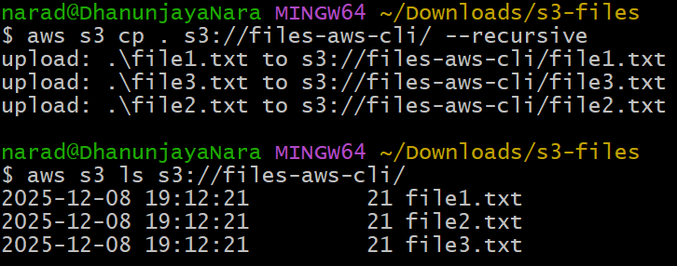

Files visible in console 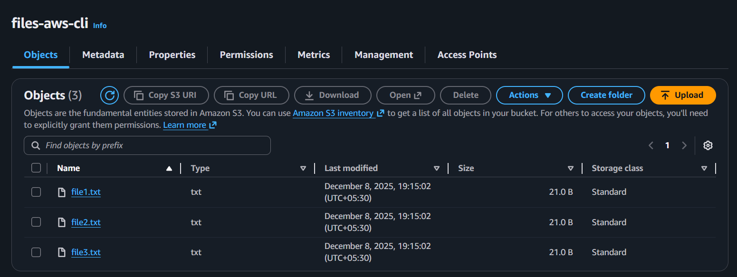

7.Write a bash script to create an S3.
First we should go to git bash and configure aws console.
Write the script using vi file.
Give the permissions chmod 755 file.
And execute the script.
Then it will execute and the s3 will be created.
script
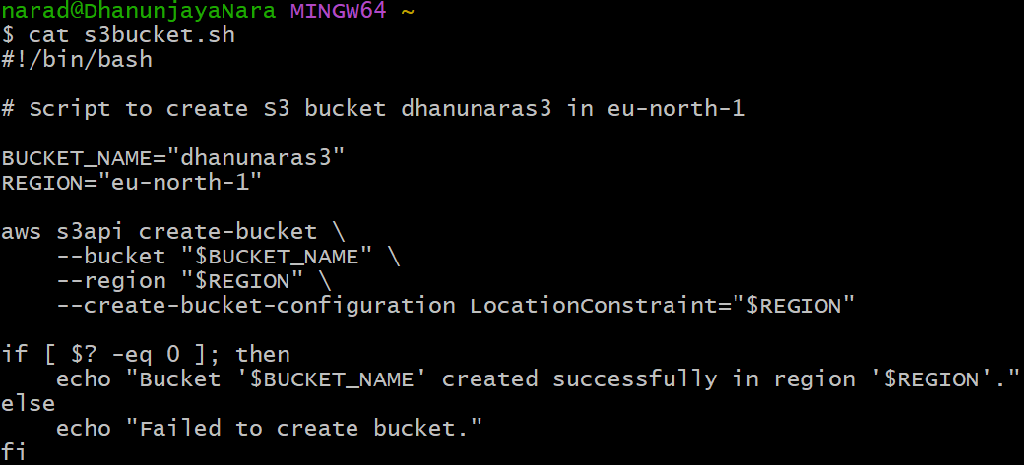
Script execution
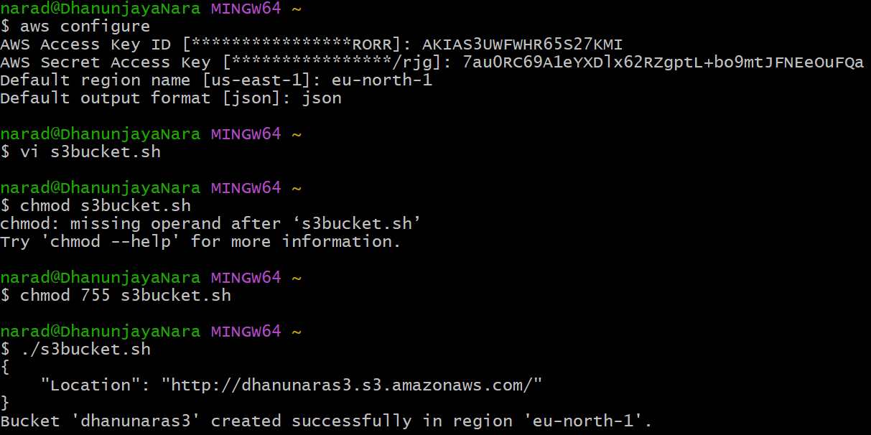

S3 bucket in console.
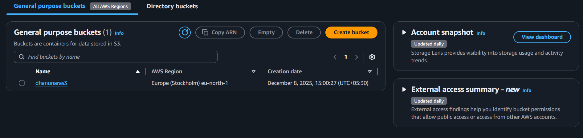

8.Upload a 1GB file to S3 using the CLI.
First we need to configure aws cli in git bash.
We can create 1 GB file using { dd if=/dev/zero of=bigfile.bin bs=1M count=1024 }.
Now we can push using { aws s3 cp bigfile.bin s3://files-aws-cli/.
Now commands will be pushed to the console.
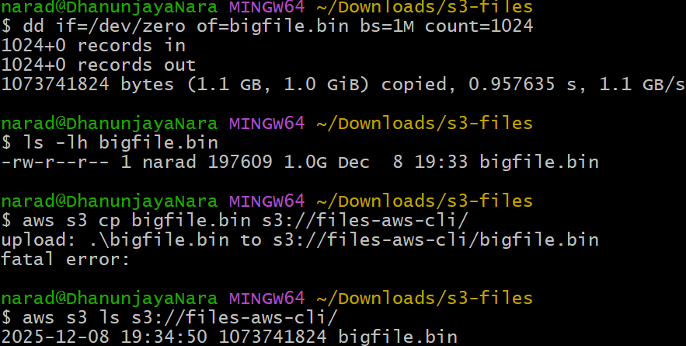
Console got that file bigfile.bin.
