**DATA VISUALISATION (ISM6419.901S23.22910)**

**FINAL PROJECT REPORT**

**THE EFFECTS OF OIL PRICES ON THE ECONOMY**

**Introduction:**

For many years, the price of oil has played a crucial role in the world economy. Periods of high prices and periods of low prices have both occurred on the oil market, each having a different effect on the world economy. The impacts of changing oil prices on various areas, industries, and sectors of the economy are complicated and influenced by several interrelated factors. For governments, corporations, and consumers alike, it is essential to comprehend these implications since oil prices can have a big impact on inflation, economic growth, and global trade.

Using data from a variety of sources, including oil prices, oil production, GDP, inflation rates, exchange rates, and fiscal balance, I hope to examine how the price of oil affects the economy in this paper. We will investigate how variations in oil prices affect various locations and industries, as well as how these effects relate to other economic issues, using data visualization techniques and statistical analysis.

This will give a general overview of the world's oil market, highlighting its key participants, supply and demand dynamics, and geopolitical issues that affect oil prices. It will also examine how oil prices affect various economic sectors, such as manufacturing, transportation, and energy. The final section of the report will examine the macroeconomic impacts of oil prices on inflation, economic expansion, and global commerce.

This project's overall goal is to present a thorough understanding of how oil prices affect the economy and to offer advice on how firms and policymakers may react to changes in the oil market.

In this project I’ll be answering the following questions:

1. What is the relation between oil price and Inflation rate?
2. How does oil price volatility affect economic growth of a country?
3. Do geopolitical factors affect the oil prices?

**Methodology:**

The data for this project has been taken from 4 different data sources, namely:

* Oil Prices from [Nasdaq.com](https://data.nasdaq.com/data/BP/CRUDE_OIL_PRICES-crude-oil-prices-from-1861)
* Exchange Rates from [OECD.org](https://data.oecd.org/conversion/exchange-rates.htm)
* GDP of countries from [theglobaleconomy.com](https://www.theglobaleconomy.com/download-data.php)
* Fiscal Balances from [IMF.org](https://data.imf.org/?sk=a0867067-d23c-4ebc-ad23-d3b015045405)
* Inflation rate from [worldbank.org](https://databank.worldbank.org/indicator/FP.CPI.TOTL.ZG/1ff4a498/Popular-Indicators)
* Oil production from [OECD.org](https://data.oecd.org/energy/crude-oil-production.htm)

The dataset on oil production included information on the annual production of oil by country, the dataset on oil prices only included information on the year, real price, and nominal price of oil. The fiscal balance dataset contained data on each country's annual fiscal balance, whilst the inflation rate dataset contained data on each country's annual inflation rate. The exchange rate dataset featured information on the exchange rate of each country per year, whilst the GDP dataset contained data on the GDP per country per year.

These datasets underwent several cleaning processes before display. For instance, redundant data was removed, superfluous columns and rows were eliminated, and fields were renamed to improve clarity. For ease of analysis, columns and rows were oriented differently, and computed fields were made to enhance the data. The data was then prepared for use in the development of dashboards and visualizations.

**Analysis:**

**1. Oil Prices (Nominal Price and Real Price) from 2000 to 2021**

**Interpretation:**

The visualization presented above depicts the fluctuation in oil prices over the span of 23 years from 2000 to 2023. It provides a clear and detailed representation of the changes in both the nominal and real prices of oil. The blue line represents the nominal price, which is the price that is typically reported in news and media outlets. The orange line, on the other hand, represents the real price, which is adjusted for inflation to provide a more accurate representation of the price changes over time.

Upon analyzing the visualization, we can observe that the oil prices experienced a significant decline in 2020, which was primarily due to the outbreak of the COVID-19 pandemic. The global economic downturn caused by the pandemic led to a decrease in demand for oil, which resulted in a sharp decline in oil prices.

However, in 2022, we can see that the oil prices started rising again, reaching their highest point in 8 years. This can be attributed to the Russia-Ukraine war that began in March 2022. The political tensions and conflicts between the two nations led to a decrease in oil supply, causing the prices to surge.

Moreover, the visualization also highlights a sudden increase and subsequent decrease in oil prices between 2008 and 2009. This significant price movement was due to the global financial crisis that began in 2008, commonly referred to as the great recession. The crisis had far-reaching implications and resulted in a significant decrease in oil demand, leading to a subsequent decrease in oil prices.

In conclusion, the visualization offers insightful information on the changes in oil prices over time and the numerous variables that have contributed to them. It emphasizes how crucial it is to comprehend how the world's political unrest and economic conditions affect oil prices. For people and organizations who rely on the oil market to make wise decisions and foresee future trends, such knowledge is essential.

**2. Comparing Oil Price with Oil Production**

**Interpretation:** The visualization presented above offers valuable insights into the relationship between oil production and oil prices over the period from 2000 to 2021. As we observe, the blue line representing oil production has been on the rise throughout the given timeline, with only a couple of downturns. However, we see a sharp decrease in oil production during the great recession and the COVID-19 pandemic, which are depicted as steep drops in the blue line.

On the other hand, the orange bar graph indicates the oil prices, which have been fluctuating throughout the timeline. We notice that the oil prices were at their lowest point in 2020 due to the COVID-19 pandemic's effects on global demand. There is also a significant fluctuation in the oil prices between 2008 and 2009, which occurred during the great recession.

These observations indicate that oil production and oil prices are closely related, as they depend on various factors such as demand, supply, and geopolitical events. As the production of oil increases, the prices tend to decrease, and vice versa.

**3. Comparing Oil Prices with Fiscal Balance:**

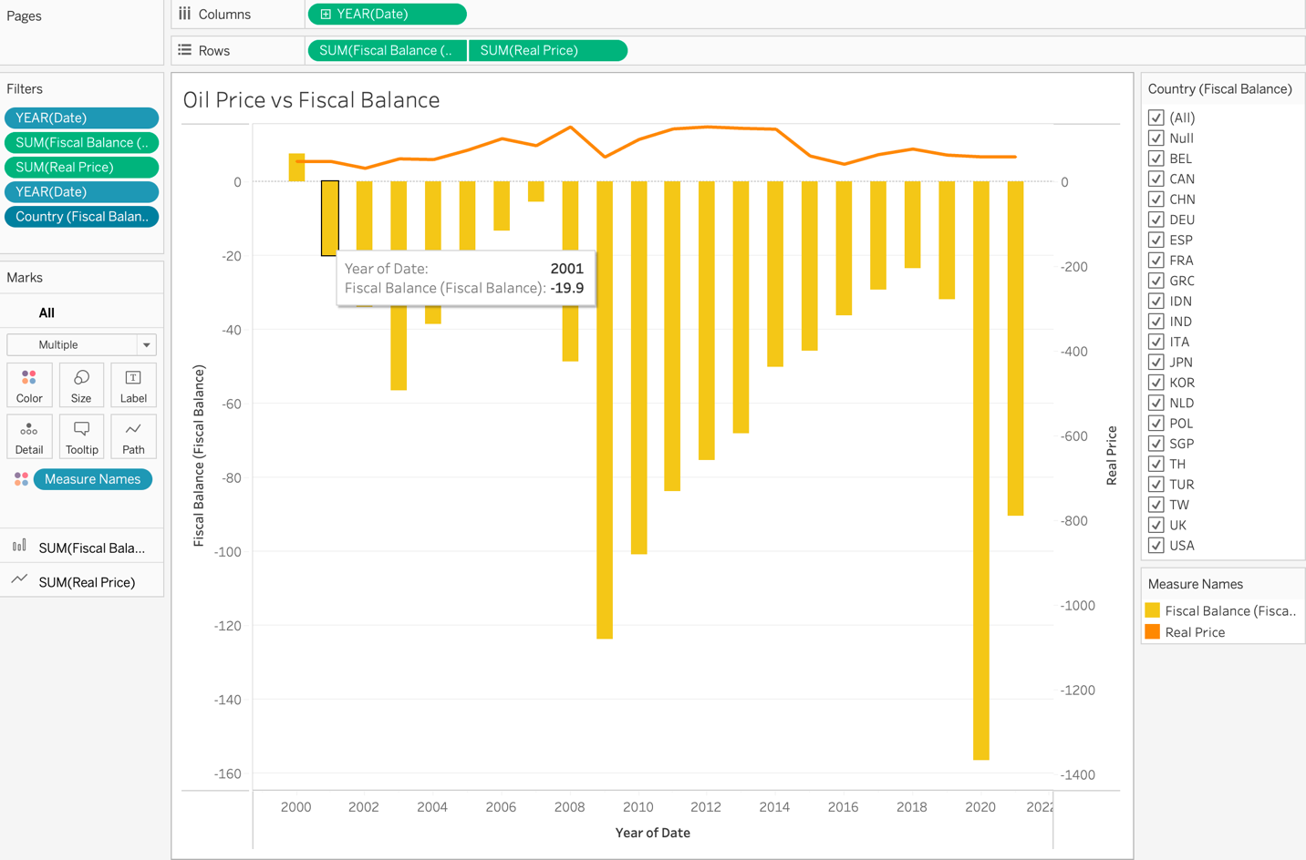

**Interpretation**: Fiscal balance is an important indicator of a government's financial health. A positive fiscal balance indicates that the government is generating more revenue than it is spending, which can be used to pay off debt or invest in public services. Conversely, a negative fiscal balance means that the government is spending more than it is generating, which can lead to budget deficits and accumulation of debt.

The visualization highlights the importance of oil prices on a government's fiscal balance. Since oil is a major source of revenue for many oil-producing countries, changes in oil prices can have a significant impact on a government's fiscal balance. For example, a sudden drop in oil prices can lead to a decrease in revenue, which can cause a government to cut spending or increase taxes to maintain a positive fiscal balance.

Overall, the visualization provides insights into the relationship between oil prices and fiscal balance and emphasizes the importance of oil prices as a factor that can significantly impact a government's financial health.

**4. Comparing Oil Prices with Inflation**

**Interpretation:** The visualization provided above depicts the relationship between the inflation rate and oil prices. The orange line represents the oil prices, while the blue line represents the inflation rate. By analyzing the graph, it can be observed that there is a strong correlation between the two factors. As the oil prices increase, the inflation rate also tends to increase, and as the oil prices decrease, the inflation rate tends to decrease as well.

It is also noteworthy that prior to 2004, the oil prices and the inflation rate followed different paths. However, since then, we can see that they have been moving in a similar direction. The reason for this could be attributed to the fact that oil is a crucial component in several industries and sectors, such as transportation and manufacturing. Hence, any fluctuations in oil prices can have a significant impact on the cost of production, which in turn can lead to changes in the overall price level of goods and services, leading to changes in the inflation rate.

Overall, the visualization provides an insight into how oil prices and inflation are interconnected. By analyzing the trends and patterns, we can gain a better understanding of the impact that oil prices have on the economy and the inflation rate. This information is essential for policymakers, investors, and individuals to make informed decisions and take appropriate actions to mitigate the impact of any fluctuations in oil prices on the economy.

**5. Comparing Oil Prices with GDP**

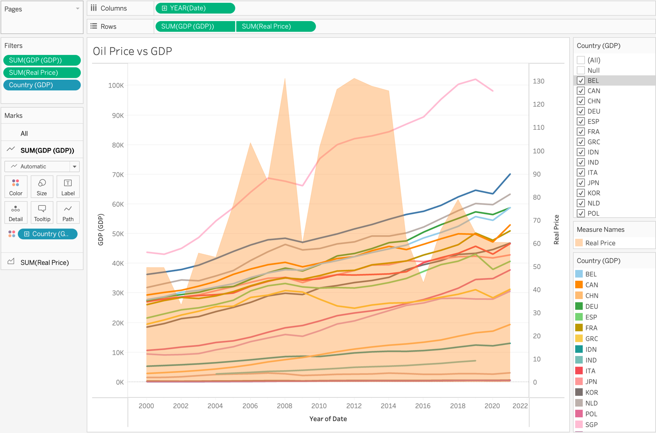

**Interpretation:** In the visualization, we see a clear distinction between the two measures being compared, the orange area represents the change in oil prices over time, while the colored lines represent different countries' GDP per capita.

The GDP per capita is an important measure of a country's economic well-being as it provides an estimate of the average income per person in each country. The increase in GDP per capita indicates that people in that country are becoming more productive and earning more money over time.

We can observe that despite the fluctuating oil prices over the years, the trend of the GDP per capita seems to be steadily increasing for most countries represented in the visualization. This indicates that economic growth is not solely dependent on the price of oil, and other factors such as technology, education, and innovation are also significant contributors. However, we can also see that in 2008 and 2020, the GDP per capita and the oil prices followed a similar path. This could be due to various reasons such as the global financial crisis of 2008 and the COVID-19 pandemic in 2020, which impacted the global economy and caused a significant decrease in oil demand and subsequently, prices.

Overall, the visualization provides an insightful comparison between oil prices and GDP per capita and highlights the importance of diversifying a country's economy beyond just oil production.

**6. Oil Production Map**

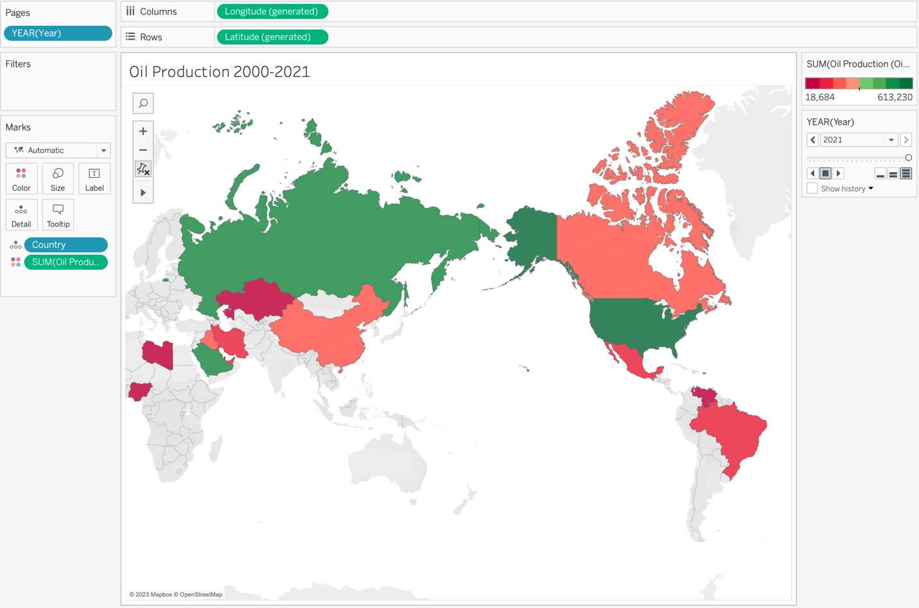

**Interpretation:** The map visualization above provides a comprehensive understanding of the oil production by the top 20 oil-producing countries globally from 2000 to 2021. The dark green color indicates the countries that have the highest oil production, whereas the dark red shows the countries with low oil production. By observing the year filter in the visualization, we can see the changes in the oil production of each country over time. For instance, in 2000, the United States was one of the top oil producers globally. However, as we move closer to the present time, we can see that the United States oil production has decreased, and other countries such as Saudi Arabia, Russia, and Iraq have become major oil producers.

Furthermore, the visualization shows that the countries in the Middle East, such as Saudi Arabia, Iraq, and Iran, have been major oil-producing countries throughout the years. These countries' economies have been heavily dependent on oil production and export revenues, making the fluctuations in the oil market vital to their economic growth.

The visualization also highlights that some countries, such as China and Brazil, have increased their oil production in recent years, indicating their growing importance in the oil market.

Overall, this map visualization provides valuable insights into the changing dynamics of oil production across countries and helps in understanding the importance of oil in the global economy.

**7. Economic Factors**

**Interpretation:** The above visualization provides a great tool for analyzing and comparing the economic factors of different countries. The green line represents the Exchange rate, which shows the rate at which one currency can be exchanged for another. The red line represents the Fiscal balance, which indicates whether a country's government is spending more or less than it is collecting in revenue. The yellow line represents the Gross Domestic Product (GDP), which shows the total value of all goods and services produced within a country's borders. Finally, the blue line represents the Inflation rate, which shows the rate at which the general level of prices for goods and services is rising. By using the filter, we can analyze the economic factors of each country at a point in time. For example, if we select a particular year, we can see how the exchange rate, fiscal balance, GDP, and inflation rate compare across different countries. This allows us to easily identify trends and patterns in the data and compare the economic performance of different countries.

Overall, this visualization is a powerful tool for understanding the interplay between different economic factors and how they affect the economic performance of different countries.

**8. Inflation Rate**

**Interpretation:** Inflation rate refers to the rate at which the general level of prices for goods and services is rising, and subsequently, purchasing power is falling. The above visualization provides a clear and easy-to-understand representation of the inflation rates of different countries over the years. The packed bubbles format makes it easy to compare the inflation rates of different countries at a glance, with the size of the bubble representing the inflation rate of the country, and the color representing the country itself.

Using the year filter, we can observe how the inflation rate of different countries has changed over the years. For example, we can see that in 2008, many countries experienced a sudden spike in inflation rates due to the global financial crisis. The visualization also allows us to identify countries with consistently high or low inflation rates over the years.

Overall, this visualization provides a useful tool for understanding the inflation rates of different countries and how they have changed over time. It can be particularly helpful for policymakers, economists, and investors who need to monitor and analyze inflation trends in different countries.

**9. GDP for the last 5 Years**

**Interpretation:** In this visualization, we can see the Gross Domestic Product (GDP) of the top 20 oil importing countries over the past 5 years. The size of each bar represents the GDP of a country, and the color represents different countries. By setting up a drill down filter, we can observe the GDP of each country for the past 5 years individually.

The visualization provides us with insights on the economic growth and development of the top oil importing countries. We can analyze the changes in the GDP of each country over the years and compare them with other countries. This visualization can clarify the economic impacts of oil imports on different countries and their respective GDP growth rates.

**10. Dashboard 1: Reasons for change in oil price in 2015**

**Interpretation:** The dashboard visualizes the different factors that contributed to the sudden decrease in oil prices in 2015. It could be observed that there was an increase in oil production by countries with low oil production and the diversification of oil production. These factors led to a supply glut in the oil market, causing a sudden drop in oil prices. The dashboard provides a comprehensive overview of the different factors that contributed to the drop in oil prices in 2015, making it easier for policymakers and industry players to understand the situation and make informed decisions. The visualizations on the dashboard are interactive and allow users to drill down into specific data points to gain a deeper understanding of the factors at play. Overall, the dashboard is a valuable tool for anyone interested in understanding the dynamics of the global oil market and the factors that influence oil prices.

**11. Dashboard 2: Effect of oil Prices**

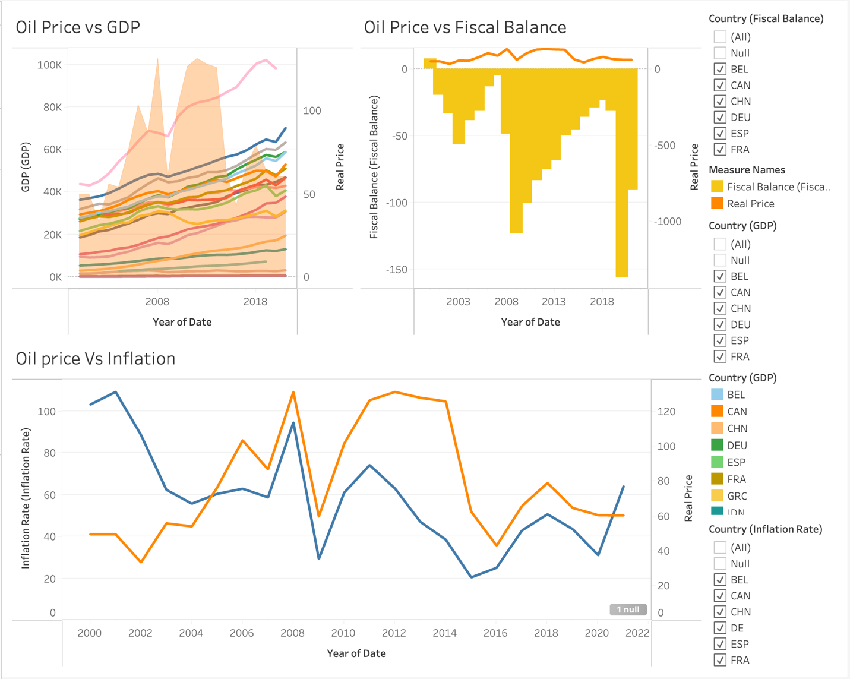

**Interpretation:** The dashboard provided presents a comprehensive view of the impact of oil prices on various economic factors such as GDP, fiscal balance, and inflation rate. It enables users to analyze and compare the trends and relationships between these economic factors and oil prices over time. By providing interactive visualizations and filters, the dashboard allows for a more detailed exploration and understanding of the data. Overall, this dashboard can be a valuable tool for policymakers, economists, and investors to make informed decisions based on the insights provided by the data.

**Conclusion:**

In conclusion, the above project aimed to analyze and visualize the relationship between oil prices and various economic factors such as GDP, inflation rate, and fiscal balance. By various data visualization tools, we were able to gain insights into how changes in oil prices affect these economic factors and vice versa.

We observed that oil prices and oil production have a significant impact on the economies of countries, with sharp declines in both during the Great Recession and COVID-19 pandemic. We also saw that while inflation rates tended to follow a similar path to oil prices, GDP and fiscal balance were not always impacted by changes in oil prices.

Furthermore, we were able to identify the reasons for sudden decreases in oil prices, such as the diversification of oil production and increased oil production by countries with low oil production.

Overall, this project demonstrates the power of data visualization in gaining insights into complex economic relationships and trends. By visualizing data in an intuitive and interactive way, we can better understand how different economic factors interact with each other and how they impact various industries and countries around the world.

**Future Research Questions:**

1. What will be the impact of new technologies like renewable energy sources on the oil prices?

2. How the analysis of climate change policies impact oil usage and the prices?

3. How do changes in oil prices affect the stock market and investment strategies?

4. How can countries diversify their economies to reduce their reliance on oil production and mitigate the effects of fluctuating oil prices?

5. How do oil prices and production affect income inequality and poverty rates in oil-dependent countries?