SIDDAGANGA INSTITUTE OF TECHNOLOGY

Club of Robotics, SIT

**HackFest’23**

*“Web Development”*

|  |  |  |
| --- | --- | --- |
| **TEAM NAME** | | |
| **Role** | **Name** | **College Name** |
| Team Leader* | Dhanush U | SIT |
| Member 1* | Dhanush B | SIT |
| Member 2 | Dhanush K Gowda | SIT |
| Member 3 |  |  |

(**\*Fields should not be left empty**)

**Problem statement:**

An innovative and user-friendly web platform that facilitates effective communication, collaboration, and resource sharing between teachers and students.

**Problem Description:**

Our hackathon project aims to create a dynamic and user-friendly web platform that revolutionizes the way teachers and students interact and collaborate. With a focus on seamless communication, effective resource sharing, and our platform will enhance the teaching and learning experience for all users.

The platform provides teachers with the ability to create custom groups based on the year and subject, allowing them to conduct classes, make announcements, and engage with students within their specific groups.

Teachers can make real-time announcements, fostering timely communication and addressing students' queries effectively. This feature promotes a sense of community and provides students with a platform to discuss topics, share ideas, and seek clarification.

**Proposed Solution:**

• User Registration and Authentication: Develop a secure user registration system where teachers can create accounts and access the platform with unique login credentials, ensuring personalized experiences and data privacy.

• Group Creation and Management: Enable teachers to effortlessly create and manage custom groups based on the year and subject, allowing targeted communication and organization of class materials.

• Announcement and Messaging System: Implement a real-time announcement and messaging feature that enables teachers to make timely announcements and facilitates interactive discussions among students, fostering effective communication and collaboration.

• Assignment Distribution: Streamline assignment management by providing teachers with the ability to create and distribute assignments to specific groups,

• Resource Library: Design a centralized repository where teachers can upload and share educational resources such as lecture slides, handouts, and study materials, providing students easy access to comprehensive learning materials.

•Mobile-Friendly Design: Ensure the platform is responsive and optimized for mobile devices, allowing teachers, students, and parents to access and utilize the platform seamlessly from their smartphones or tablets, enhancing accessibility and convenience.

**Use Case Scenario:**

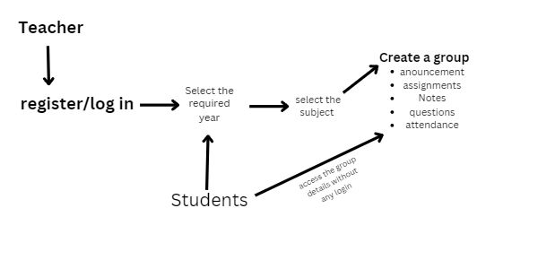

**Work Progress:**

UI with little frontend is Going On

**Contact Details:**

Team Leader*

E-mail : dhanushu834@gmail.com

Phone :7975789740

Member 1 Name*

E-mail : talktodhanush4554@gmail.com

Phone : 8618541131

Member 2 Name

E-mail : dhanushkgowda2226@gmail.com

Phone :6361304218

Member 3 Name

E-mail :

Phone :

**(*Fields should not be left empty)**