AI Usage DISCLOSURE FORM

1. Team Details
Team Name: Modern Global
Project / Product Name: AI Guided Troubleshooting
Organization / Institution (if any): SRMIST KTR
Submission Date: 30/09/2026

2. AI Usage Declaration
Did your team use any Artificial Intelligence (AI) in developing this project? Yes / No
_____________Yes__________________

3. Purpose of AI Usage ( Brief Details)
Idea generation / brainstorming: No
Code generation or assistance: Yes
UI / UX design : Yes
Content creation: Yes
Data analysis: No
Testing / debugging: Yes
Other : No

4. Feature Origin Classification ( Please add/delete based on the number of the feature)
1. Feature Name : Semantic Cache
1.1. Self-Generated/AI-Generated/Both: Both
1.2. Description ( include AI tools/platform Used, prompt used , Output Summary, Modification)
AI tools used : ChatGPT
AI assistance was used for implementing and debugging semantic caching of validated troubleshooting plans and testing the required cache-performance target.

2. Feature Name: Query Enrichment
2.2. Self-Generated/AI-Generated/Both : Bothd
2.3. Description (include AI tools/platform Used, prompt used , Output Summary, Modification) Ai used : ChatGPT and Google Gemini API.
Prompts were used to assist with designing and implementing a query-enrichment pipeline that converts noisy or colloquial troubleshooting queries into structured technical queries while generating diverse semantic paraphrases.
3. Feature Name : SIIS
3.1. Self-Generated/AI-Generated/Both : Both
3.2. Description (include AI tools/platform Used, prompt used , Output Summary, Modification)
Tools use : Cluade ,Chatgpt and Google gemini API
prompts were used to assist with designing and implementing a query-enrichment pipeline that converts noisy or colloquial troubleshooting queries into structured technical queries while generating diverse semantic paraphrases.
4. Feature Name : Deeplink Retrieval and verification
4.1. Self-Generated/AI-Generated/Both : AI generated
4.2. Description (include AI tools/platform Used, prompt used , Output Summary, Modification)
AI used : ChatGPT and Google Gemini API.
Prompts were used to assist with designing and implementing a query-enrichment pipeline that converts noisy or colloquial troubleshooting queries into structured technical queries while generating diverse semantic paraphrases.
5. Feature Name : Output validation and safety rules
5.1. Self-Generated/AI-Generated/Both : Both
5.2. Description (include AI tools/platform Used, prompt used , Output Summary, Modification)
AI used : Chatgpt
AI assistance was used for implementing and debugging semantic caching of validated troubleshooting plans and testing the required cache-performance target.

5. Ethical & Compliance Confirmation
AI usage complies with guidelines and policies. Yes
No proprietary or copyrighted data misused. I Agree

6. Declaration & Sign-Off
Name of Team Representative:Arpit Rath
Role:Developer
Signature:
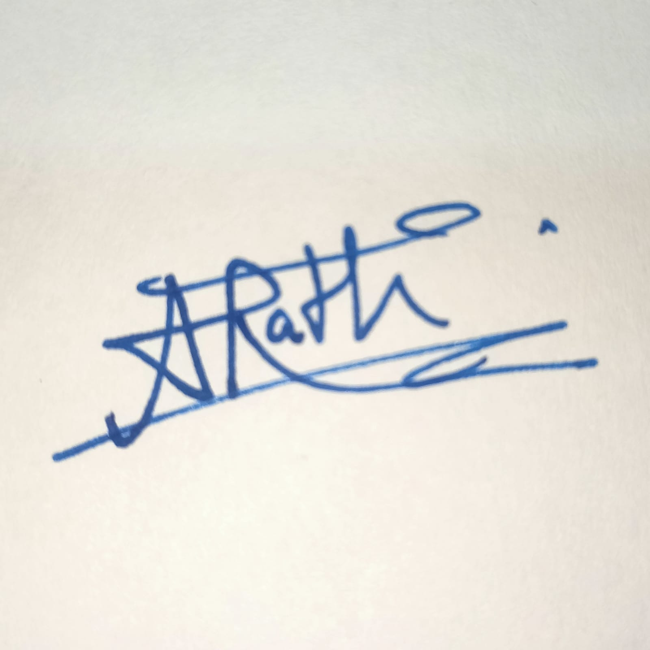

Date:30/09/2026

