**ADIDAS SALES DATA ANALYSIS**

**A PROJECT REPORT**

**Submitted by**

**NISHANT REDDY (1RVU23CSE120)**

**DHANUSH S GOWDA (1RVU23CSE145)**

**ANKUR T S (1RVU23CSE061)**

**DARSHAN B (1RVU23CSE135)**

*in partial fulfillment for the award of the degree of*

**B.Tech (Hons.) – Computer Science & Engineering**

*in* **Data Analysis with Python**

**to Dr. Sahana Prasad**



**School of Computer Science and Engineering**

**RV University**

**RV Vidyaniketan, 8th Mile, Mysuru Road, Bengaluru, Karnataka, India – 562112.**

**December 2023**

**ACKNOWLEDGEMENT**

It is a great pleasure for us to acknowledge the assistance and support of a large number of individuals who have been responsible for the successful completion of this project work.

First, we take this opportunity to express our sincere gratitude to the **School of Computer Science and Engineering, RV UNIVERSITY**, **Bengaluru** for providing us with a great opportunity to pursue our Bachelor’s Degree in this institution.

In particular, we would like to thank our professor, **Dr. Sahana Prasad, Data Analysis in Python Professor,** **RV** **UNIVERSITY**, **Bengaluru** for sparing her valuable time to extend help in every step of our project work, which paved the way for smooth progress and fruitful culmination of the project.

We would also like to thank **Dr. Sanjay R. Chitnis, Dean, School of Computer Science and Engineering, RV UNIVERSITY**, **Bengaluru** for his constant encouragement and expert advice.

It is a matter of immense pleasure to express our sincere thanks to **Dr. Mydhili K Nair, Head of Department, School of Computer Science & Engineering,** **RV** **UNIVERSITY**, **Bengaluru** for providing right academic guidance that made our task possible.

We are also grateful to our family and friends who provided us with every requirement throughout the course. We would like to thank one and all who directly or indirectly helped us in completing the Project work successfully.

Name:       **NISHANT REDDY** Signature

USN:        1RVU23CSE120

Name:       **DHANUSH S GOWDA**                                                 Signature

USN:        1RVU23CSE145

Name:       **ANKUR T S**Signature

USN:        1RVU23CSE061

Name:       **DARSHAN B**Signature

USN:        1RVU23CSE135

**TABLE OF CONTENTS**

|  | **TITLE** |  |
| --- | --- | --- |
| **1.0** | **INTRODUCTION** | **1** |
| **2.0** | **METHODOLOGY** | **2** |
| **3.0** | **INFERENCE** | **3** |
|  | 3.1 Importing necessary libraries and dataset.  3.2 Data Inspection.  3.3 Data Cleaning (Data Preprocessing).  3.4 Exploratory Data Analysis (EDA).  a. Sales analysis  b. Profitability analysis  c. Regional analysis  d. Retailer analysis  e. Pricing analysis | 3  3  3  3  3  5  7  8  10 |
| **4.0** | **RESULT AND DISCUSSION** | **13** |
| **5.0** | **CONCLUSION** | **15** |
| **6.0** | **APPENDIX** | **16** |

# **1. INTRODUCTION**

This project delves into the intricacies of Adidas Sales in the USA during 2020 & 2021, driven by the recognition of Adidas as a pivotal player in the clothing industry. The rationale behind selecting this dataset lies in its potential to offer valuable insights into consumer behaviour, market trends, and operational strategies within the clothing and sportswear sector.

Our objective encompasses deciphering patterns, identifying influential factors impacting sales, and furnishing actionable insights beneficial for strategic decision-making.

The significance of our analysis extends beyond the confines of a semester project. By comprehensively understanding Adidas sales dynamics, we aim to provide a foundation for future endeavours in market research and data analytics. The insights derived can inform Adidas's marketing strategies, inventory management, and overall business decisions. Furthermore, this analysis serves as a benchmark for other industry stakeholders seeking to enhance their understanding of market dynamics and consumer preferences.

The project required meticulous efforts from our team, spanning data preprocessing, exploratory data analysis, and the application of statistical methods. Challenges, such as handling missing data and outliers, were addressed systematically to ensure the integrity and reliability of our findings. The collaborative nature of our team, encompassing diverse skill sets in Python Programming and Statistical Analysis, has been instrumental in the success of this project.

The project's relevance lies not only in its contribution to academic learning but also in its practical applications for industry players. The effort invested in understanding and interpreting the data contributes to a holistic understanding of the complexities inherent in data analysis.

In conclusion, this project serves as a stepping stone for future investigations into market dynamics, consumer behavior, and data-driven decision-making. The insights gleaned from our analysis present a valuable resource for academia, industry professionals, and Adidas alike, positioning this endeavor as a meaningful contribution to the field of data analysis and business intelligence.

# **2. METHODOLOGY**

Table 2.1: Detailed methodological steps involved

| **Sl no.** | **Process** | **Description** |
| --- | --- | --- |
| 1. | Data Collection | The data collection process involves gathering, measuring, and recording information or data points, typically through systematic methods such as surveys, interviews, or sensor technology.  We collected Adidas Sales data from the years 2020 & 2021 in USA from various open data base sources and Kaggle. |
| 2. | Data Cleaning  (Data Preprocessing) | The data cleaning process involves identifying and rectifying errors, inaccuracies, and inconsistencies in a dataset to ensure its accuracy, reliability, and suitability for analysis. |
| 3. | Data Analysis | The data analysis process involves deriving insights from data through organizing, exploring, interpreting, and modeling, to make informed decisions and solve problems effectively.  We used various data analysis tools in Python,  including Pandas and Numpy to analyze the data and perform feature engineering. |
| 4. | Data Visualization | The data visualization process involves representing and presenting data in visual form using charts, graphs, and other visual elements to facilitate understanding and analysis.  We used Matplotlib and Seaborn to create visualizations that insights into key trends and patterns in the sales data. |

# **3. INFERENCE**

1. ***Importing necessary libraries and dataset.***

We begin by importing essential libraries for data manipulation and visualization. Then, we load the Adidas sales dataset into a Pandas data frame named 'df' and display the first 10 rows to get an initial look at the data.

1. ***Data Inspection.***

This section provides a quick overview of the dataset. We check its dimensions, column names, and information about data types and null values to understand its structure. There were 9648 rows and 13 columns out of which 12 columns were of type ‘object’ and one ‘int64’.

1. ***Data Cleaning (Data Preprocessing).***

This part involves cleaning and preprocessing the data. We removed ‘$’ and ‘%’ symbols from all columns and converted them to numeric type, calculate new columns for total sales and operating profit, ensure text consistency by converting to lowercase, and handle the 'Invoice Date' column as datetime. There were no duplicate rows and columns involved in the dataset.

1. ***Exploratory Data Analysis (EDA).***

We explore the dataset by obtaining descriptive statistics and calculating the range of numerical columns to understand the spread and characteristics of the data.

range of Price_per_Unit : 103.0

range of Units_Sold : 1275.0

range of Total_Sales : 82500.0

range of Operating_Profit : 39000.0

range of Operating_Margin : 70.0

Under EDA, we performed the following type of analysis to better understand the data set in all perspectives.

* 1. ***Sales Analysis***

In this section, we could identify that the most number of times listed product was ‘men’s athletic footwear’. But Sales wise the ‘men’s street footwear’ had the highest total sales.

The graph below illustrates the timeline of total sales and operating profits over the course of several months.

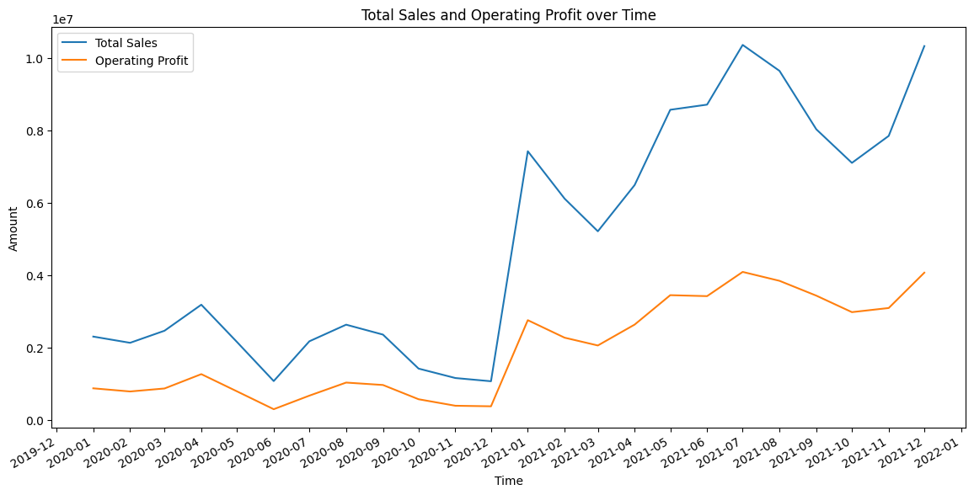

*Figure 1: Total Sales and Operating Profit for each month from Jan 2020 - Dec 2021*

By analyzing the timeline graph (Figure 1) from December 2020 to January 2021, a noticeable surge in total sales is apparent. However, the corresponding increase in operating profit is not proportional. This disparity could be attributed to significant discounts offered during the Christmas and New Year period or expenditure on advertisements. A similar trend is observed in December 2021. It's important to highlight that, post-December 2020, the company emphasized sales over profits.

Sales Method Total Sales

in-store 35664375.0

online 44965657.0

outlet 39536618.0

Sales Method Operating Profit

in-store 12759128.75

online 19552537.72

outlet 14913301.23

Sales Method Variation of units sold

in-store 203.410458

online 176.269773

outlet 232.193750

Among various sales methods (Online, In-Store, Outlet), ‘Online’ exhibits the highest total sales and profit, while ‘In-Store’ records the lowest. ‘Outlet’ shows the highest standard deviation, indicating significant daily unit sales variability, whereas ‘Online’ has the lowest variation. This observation suggests a consistent preference among consumers for online purchases.

The below information provided outlines the average number of units sold per product per day, essentially reflecting the average daily transaction.

Product Average units sold

men's apparel 190.960772

men's athletic footwear 270.513043

men's street footwear 368.521739

women's apparel 269.792910

women's athletic footwear 197.531756

women's street footwear 243.948383

Notably, 'Men's Street Footwear' exhibits the highest sold product per day, while 'Men's Apparel' indicates the least.

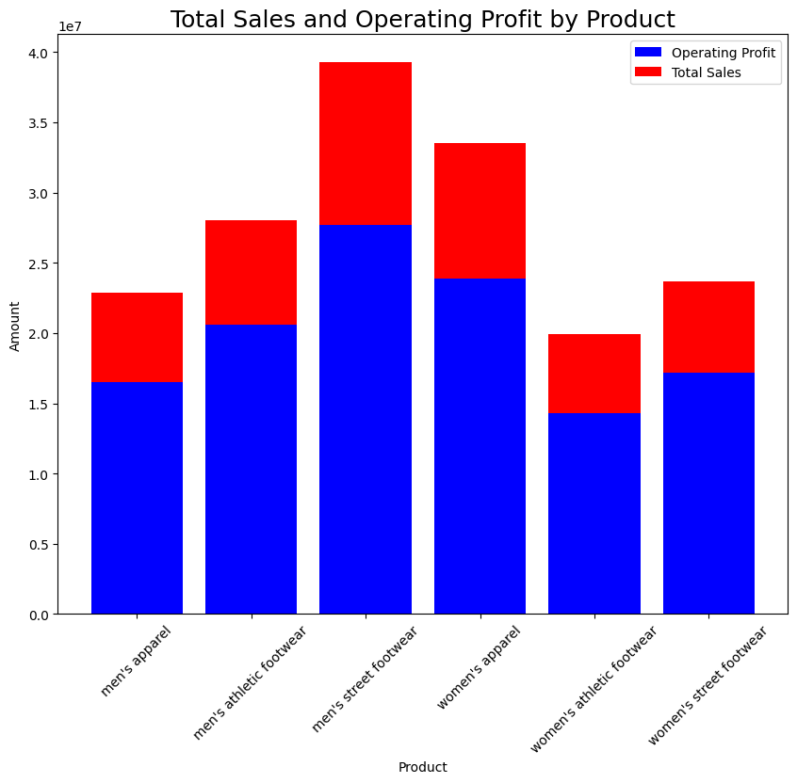

*Figure 2: Total Sales and Operating profit of each product*

From Figure 2, it is clear that men's street footwear has the highest total sales and operating profit.

* 1. ***Profitability Analysis.***

This segment focuses on profitability analysis. We determine the median operating profit and median operating margin by product.

Product median operating profit

men's apparel 2679.415

men's athletic footwear 3293.760

men's street footwear 5201.500

women's apparel 4004.200

women's athletic footwear 2357.100

women's street footwear 2703.000

Product Operating margin median

men's apparel 40.0

men's athletic footwear 40.0

men's street footwear 45.0

women's apparel 44.0

women's athletic footwear 41.0

women's street footwear 40.0

Interestingly, 'men’s street footwear' emerges with the highest median operating profit and the highest median operating margin. Furthermore, a time series plot (Figure 3) is generated to visually depict the fluctuation of the median operating margin over time.

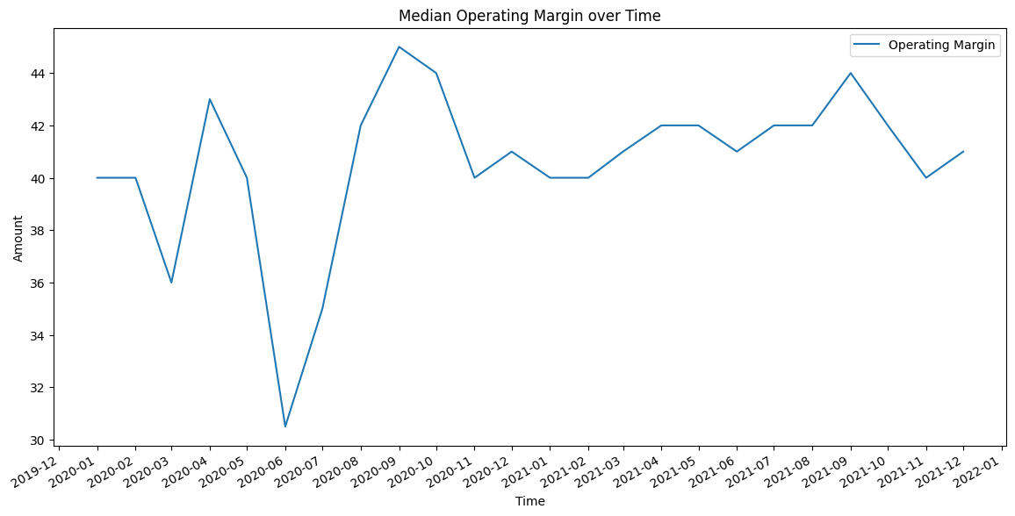

*Figure 3: Operating margin for each month from Jan 2020 - Dec 2021*

Significantly, during June 2020, the company experienced its lowest operating margin in a two-year span. This decline may be attributed to increased production costs or various economic factors, including the influence of the Covid-19 pandemic. Despite the company's sustained sales, the operating margin was adversely affected during this specific period.  
Upon analyzing the operating profits data over the two-year period, the calculated kurtosis (7.181) and skewness (2.335) reveal significant insights. The positive kurtosis signals a distribution with heavier tails and a sharper peak compared to a normal distribution. Moreover, the positive skewness indicates a right-skewed distribution, suggesting a notable stretch towards the right side of the data distribution.

The operating margin distribution for each sales method exhibits positive skewness.

Sales Method skewness of operating margin

in-store 0.363159

online 0.251876

outlet 0.148255

Notably, 'In-Store' records the highest skewness, while 'Outlet' demonstrates the lowest. The positive skewness in operating margins for each sales method suggests that there are occasional high values that extend the right tail of the distribution.

* 1. ***Regional Analysis.***

In this section, we conduct a regional analysis. Generally, the western region of USA exhibits the highest sales for the company, with New York emerging as the state and city with the highest sales.

Region wise: Region Total sales

midwest 16674434.0

northeast 25078267.0

south 20603356.0

southeast 21374436.0

west 36436157.0

State wise: new york

City wise: new york

Interestingly, ‘Men's Apparel’ stands out as the most popular product both at the city and state levels. However, on a broader scale ‘Men's Athletic Footwear’ takes the lead in popularity within the western region. It's crucial to note that the definition of popularity here is based on the frequency of product listings rather than the quantity of products sold. When considering the actual number of products sold, 'Men's Street Footwear' emerges as the more preferred choice among consumers overall.

The below information shows the total profits made in two years for each sales method in a particular region.

Region Sales Method Total operating profit

midwest in-store 2316565.00

online 3133263.98

outlet 1410116.25

northeast in-store 4254420.00

online 2246831.65

outlet 3231522.25

south in-store 134800.00

online 4149888.22

outlet 4936917.10

southeast in-store 2558256.25

online 5080401.63

outlet 754401.32

west in-store 3495087.50

online 4942152.24

outlet 4580344.31

While the 'West' region boasts the overall highest sales, it is noteworthy that in the 'Southeast' region, the 'Online' sales method achieves the highest total operating profit.

* 1. ***Retailer Analysis.***

This section focuses on retailer analysis. We calculate total sales and operating profit by retailer, visualize this information with pie charts, and explore average operating profit by retailer and sales method.

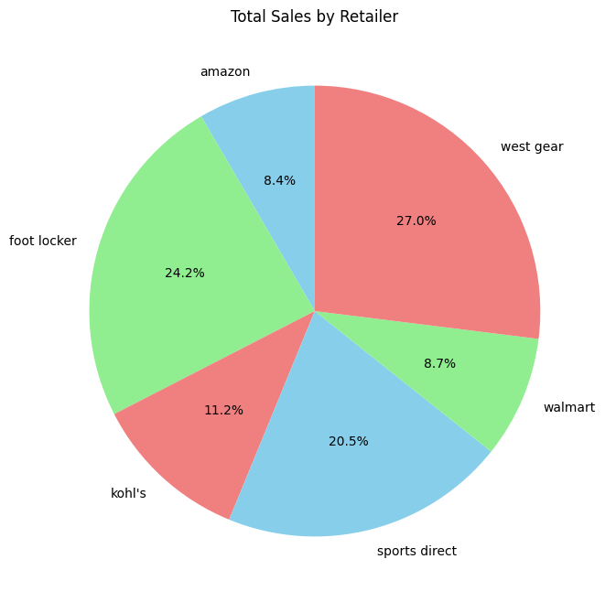

*Figure 4: Total Sales contribution by each retailer*

This pie chart (Figure 4) shows the total sales by each retailer. West Gear has the most total sales, followed by Foot Locker. Even though online sales are highest overall, it's interesting that Amazon has the lowest total sales among the retailers.

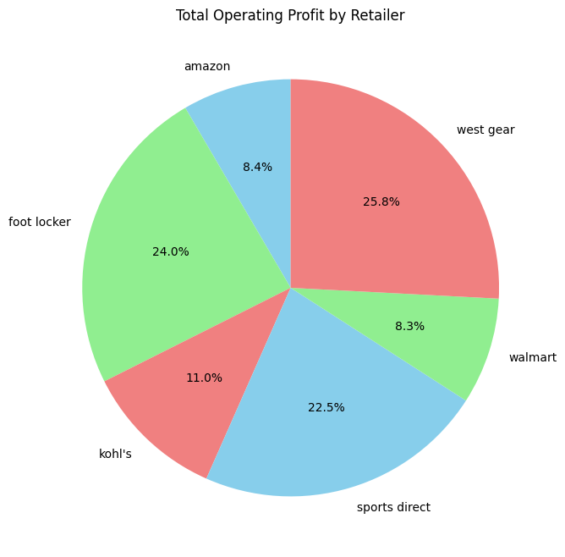

*Figure 5: Total Operating profit contribution by each retailer*

From Figure 5, it is clear that the retailer with the highest operating profit is West Gear, closely followed by Foot Locker. Despite online mode achieving the highest operating profit overall, it is notable that Amazon reports the least operating profit among the retailers.

Retailer Sales method Average operating profit

amazon in-store 7083.972458

online 3773.055296

outlet 3818.121821

foot locker in-store 6256.570156

online 3717.388738

outlet 4189.243405

kohl's in-store 7359.071181

online 3831.638194

outlet 6179.129774

sports direct in-store 7035.712457

online 4542.114372

outlet 5457.985430

walmart in-store 13325.337838

online 4781.102743

outlet 6753.334784

west gear in-store 7868.115165

online 3859.311032

outlet 4260.573448

Despite ‘West Gear’ securing the highest total operating profit, Walmart outperformed them in terms of average operational profits. While online mode dominated in overall operating profit, a closer examination by retailer's sales method revealed that in-store transactions yielded the highest average operating profit.

The below lists the most popular (most frequently listed) products sold by each retailer. This gives us an idea about how each retailer is making more profits through their products.

Retailer Product Highest number of times listed

amazon men's athletic footwear 159

men's street footwear 159

women's apparel 159

women's street footwear 157

foot locker men's street footwear 449

women's apparel 433

kohl's men's athletic footwear 172

men's street footwear 172

women's apparel 172

women's street footwear 172

sports direct women's street footwear 342

walmart men's apparel 113

west gear women's street footwear 400

* 1. ***Pricing Analysis.***

Finally, we enter the domain of pricing analysis. We calculate the correlation matrix for relevant columns and visualize the correlations using a heatmap.

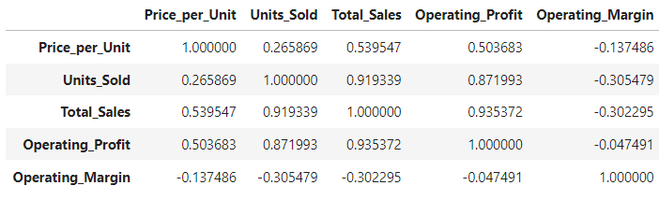

If Price per unit is more, the total sales & operating profit will be more since they are positively correlated. Conversely, price per unit shows a negative weak correlation with operating margin.

The correlation between price per unit and units sold is positive but weak, suggesting that an increase in price per unit doesn't guarantee a proportional increase in units sold. There is a strong positive correlation between units sold and operating profit, as well as between units sold and total sales, which aligns logically.

Interestingly, operating margin and units sold exhibit a negative moderate correlation. This implies that higher sales or units sold may be associated with increased advertising expenses, potentially leading to a scenario where sales are high, but the profit margin is comparatively lower.

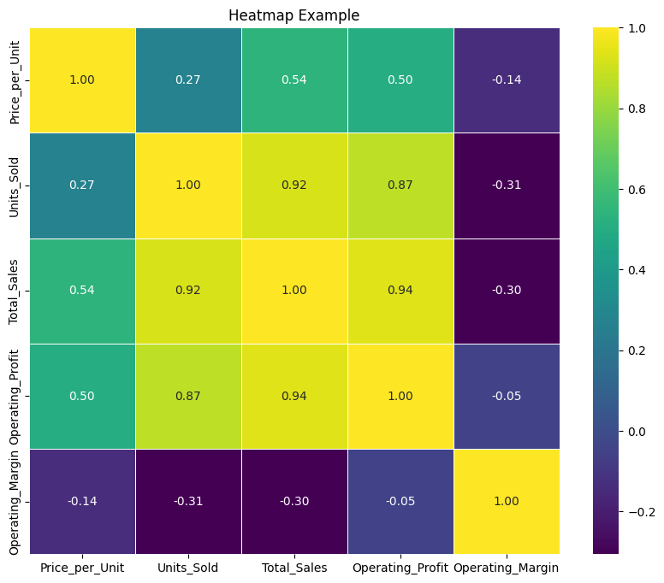

*Figure 6: Heat map to show the correlation between different variables.*

From figure 7, we can say that in general, the price per unit for each product follows a normal distribution. However, 'men's athletic footwear' exhibits a slight left skewness which suggests that a majority of units are priced lower, with some higher-priced units pulling the distribution towards the right, while 'Women's Athletic Footwear' shows a slight right skewness which suggests that a majority of units are priced higher, with some lower-priced units pulling the distribution towards the left.

The median price per unit is highest for ‘women's apparel’ and ‘men's apparel’, whereas ‘women's street footwear' and 'women's athletic footwear' have the lowest median price per unit.

Moreover, the presence of numerous outliers toward the right side of the graph is notable for each product.

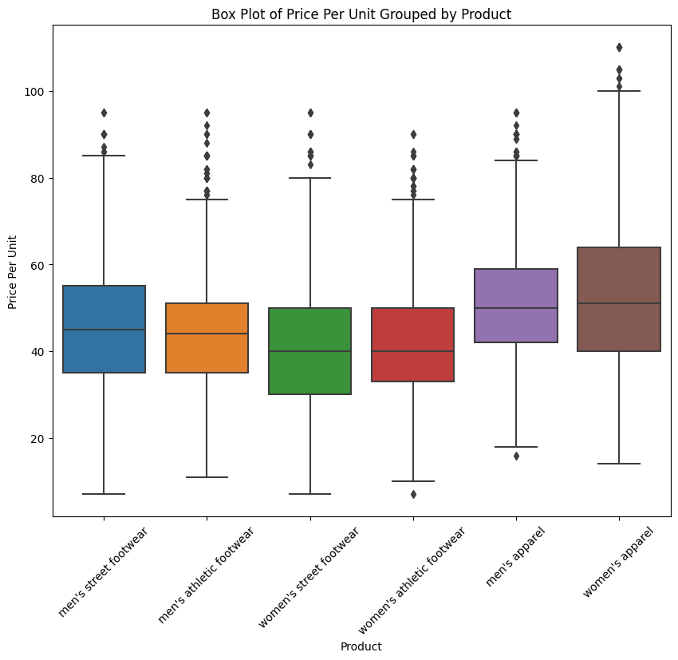

*Figure 7: Box plot for various products with respect to price per unit*

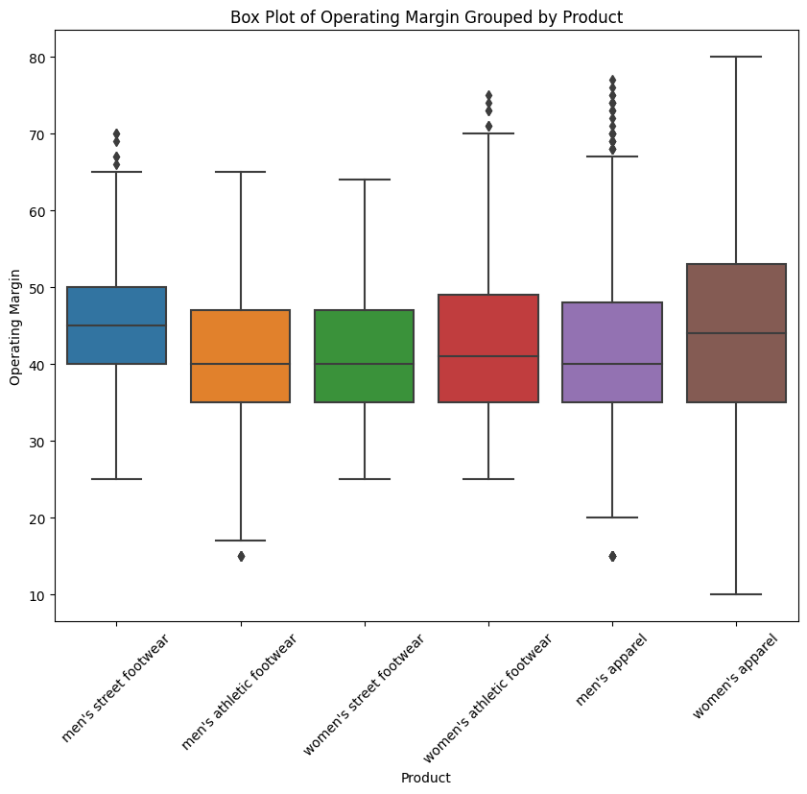

*Figure 8: Box plot for various products with respect to operating margin*

In general, the operating margin distribution for each product exhibits slight right skewness. However, interestingly, for 'Men's Street Footwear' and 'Women's Apparel,' the operating margin follows a normal distribution.

left skewness indicates that there are instances where the operating margin is lower than the average, and these lower values are influencing the overall distribution. This could be due to factors such as higher operating costs, lower profitability, or other issues affecting the financial performance of the product.

In practical terms, left skewness suggests that there are some periods or instances where the operating margin for the product is lower than usual, potentially impacting the profitability of that product.

# **4. RESULT AND DISCUSSION**

1. Data Cleaning (Data Preprocessing):
   * The process of removing symbols and converting data types is well-executed, ensuring consistency.
   * The handling of datetime columns is appropriately carried out.
   * However, further insights into why these specific cleaning steps were chosen and their potential impact on the analysis would enhance transparency.
2. Exploratory Data Analysis (EDA):
   * The identification of the most listed and highest sales product provides valuable insights.
   * The timeline graph effectively captures patterns, but deeper exploration into the factors causing the surge in total sales post-December 2020 would enhance the analysis.
3. Sales Analysis:
   * The identification of the most frequently listed product ('Men’s Athletic Footwear') and the highest total sales product ('Men’s Street Footwear') is insightful.
   * The timeline graph effectively captures patterns, particularly the surge in total sales post-December 2020.
4. Profitability Analysis:
   * The focus on median operating profit and margin is commendable.
   * The time series plot offers visibility into fluctuations, but a more detailed exploration of the June 2020 decline would provide a richer understanding.
5. Regional Analysis:
   * The recognition of the western region, especially New York, as the leader in overall sales is well-established.
   * The popularity of 'Men's Athletic Footwear' in the western region is an interesting observation.
6. Retailer Analysis:
   * The calculation of total sales and operating profit by retailer is thorough.
   * While pie charts visually represent the data, additional insights into why certain retailers outperform others would strengthen the analysis.
7. Pricing Analysis:
   * The correlation matrix and heatmap effectively visualize relationships between variables.
   * The interpretation of positive correlations aligns logically, but delving deeper into potential causation would add depth.
   * The box plots offer valuable insights into the distribution characteristics of product prices and operating margins.

A new data frame is being created, organized by region, state, city, sales method, and product, featuring the median of operating profit. This structured dataset serves as a valuable resource for decision-making, enabling the company to make informed investments for optimal returns. By converting this data frame into a CSV file, the company gains the ability to closely monitor the median operating profit for all products across various regions, states, cities, and sales methods. This facilitates a strategic approach in assessing and enhancing profitability in diverse market segments.

Overall, the analysis is comprehensive and insightful, providing a solid foundation for understanding Adidas sales dynamics.

# **5. CONCLUSION**

In conclusion, our Adidas Sales Project has provided valuable insights into the dynamics of the brand's performance in the USA market. Beginning with data cleaning and exploration, we ensured the foundation for our analysis was robust.

The sales analysis revealed key trends, identifying popular products and showcasing the evolution of total sales and operating profit over time. This phase set the stage for a comprehensive understanding of Adidas's market presence.

Profitability analysis deepened our insight into the financial performance of each product, offering a nuanced perspective on their contributions. The regional analysis brought geographical nuances to the forefront, emphasizing the impact of location on sales patterns.

Retailer analysis illuminated the distinctive contributions of each player, contributing to a more comprehensive understanding of Adidas's market partnerships. Finally, the pricing analysis delved into the strategic aspects, decoding the relationships between pricing metrics.

In essence, this project has been a systematic exploration, moving beyond the surface to uncover the intricacies of Adidas sales. Each phase added a layer of understanding, transforming raw data into meaningful insights. This comprehensive analysis not only informs our understanding of past performance but also lays a solid foundation for future strategic considerations in the dynamic landscape of the sportswear market.

# **6. Appendix**

**Complete code in detail**

## 1. Importing necessary libraries and dataset

**import** numpy **as** np  
**import** pandas **as** pd  
**import** seaborn **as** sns  
**import** matplotlib.pyplot **as** plt  
df = pd.read_csv('Adidas US Sales Datasets.csv')  
df.head(10)

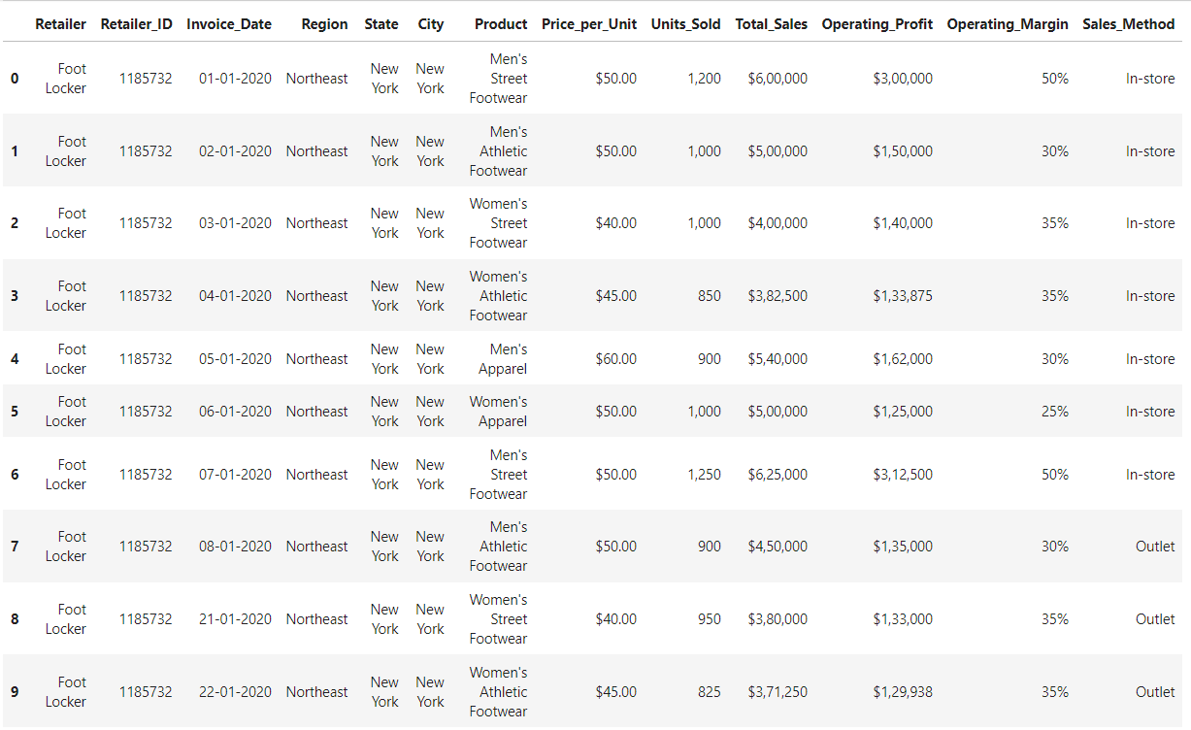

## 2. Data inspection

df.shape  
*#There are 9648 rows and 13 columns*

(9648, 13)

df.columns  
*#This gives us the list of columns in the dataset*

Index(['Retailer', 'Retailer_ID', 'Invoice_Date', 'Region', 'State', 'City',  
 'Product', 'Price_per_Unit', 'Units_Sold', 'Total_Sales',  
 'Operating_Profit', 'Operating_Margin', 'Sales_Method'],  
 dtype='object')

df.info()

<class 'pandas.core.frame.DataFrame'>  
RangeIndex: 9648 entries, 0 to 9647  
Data columns (total 13 columns):  
 # Column Non-Null Count Dtype   
--- ------ -------------- -----   
 0 Retailer 9648 non-null object  
 1 Retailer_ID 9648 non-null int64   
 2 Invoice_Date 9648 non-null object  
 3 Region 9648 non-null object  
 4 State 9648 non-null object  
 5 City 9648 non-null object  
 6 Product 9648 non-null object  
 7 Price_per_Unit 9648 non-null object  
 8 Units_Sold 9648 non-null object  
 9 Total_Sales 9648 non-null object  
 10 Operating_Profit 9648 non-null object  
 11 Operating_Margin 9648 non-null object  
 12 Sales_Method 9648 non-null object  
dtypes: int64(1), object(12)  
memory usage: 980.0+ KB

## 3. Data cleaning (Data preprocessing)

*# Ensure that the columns are of type string before trying to use string methods on them*  
df['Price_per_Unit'] = df['Price_per_Unit'].astype(str).str.replace('$', '').str.replace(',', '').astype(float)  
df['Total_Sales'] = df['Total_Sales'].astype(str).str.replace('$', '').str.replace(',', '').astype(float)  
df['Operating_Profit'] = df['Operating_Profit'].astype(str).str.replace('$', '').str.replace(',', '').astype(float)  
df['Units_Sold'] = df['Units_Sold'].astype(str).str.replace(',', '').astype(float)  
df['Operating_Margin'] = df['Operating_Margin'].astype(str).str.replace('%', '').astype(float)  
df.head()

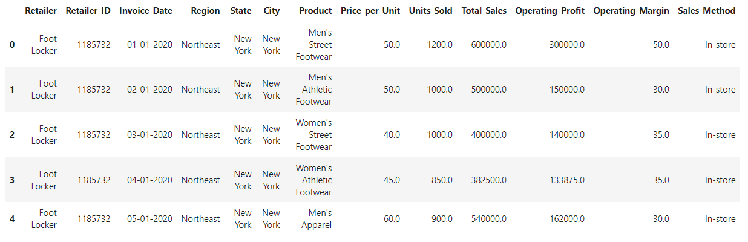

df_clean = df  
df_clean['Total_Sales'] = df_clean['Price_per_Unit'] * df_clean['Units_Sold']  
df_clean['Operating_Profit'] = df_clean['Total_Sales'] * df_clean['Operating_Margin']/100  
df_clean.head(3)  
*#The columns are now corrected and stored in a new dataframe called 'df_clean'*

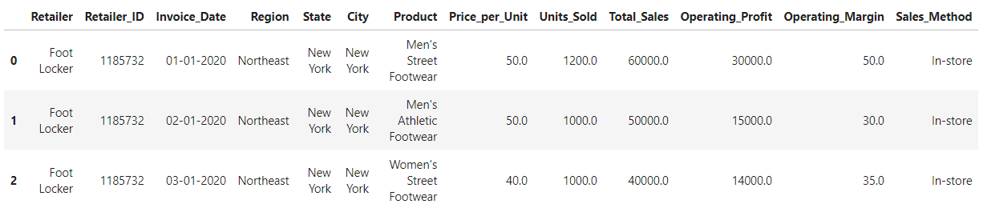

**for** column **in** df_clean.columns:  
 **if** df_clean[column].dtype == 'O':  
 df_clean[column] = df_clean[column].str.lower()  
df_clean.head(3)  
*#Converting all strings to lower case*

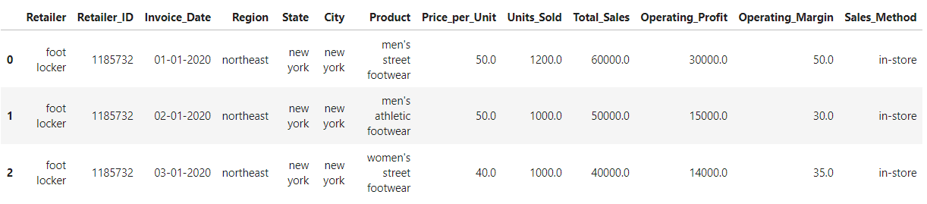

df_clean['Invoice_Date'] = pd.to_datetime(df_clean['Invoice_Date'], format="%d-%m-%Y")  
*#Converting Invoice Date to datetime format*  
df_clean.info()  
*#The new dataframe has all the columns of proper data types*

<class 'pandas.core.frame.DataFrame'>  
RangeIndex: 9648 entries, 0 to 9647  
Data columns (total 13 columns):  
 # Column Non-Null Count Dtype   
--- ------ -------------- -----   
 0 Retailer 9648 non-null object   
 1 Retailer_ID 9648 non-null int64   
 2 Invoice_Date 9648 non-null datetime64[ns]  
 3 Region 9648 non-null object   
 4 State 9648 non-null object   
 5 City 9648 non-null object   
 6 Product 9648 non-null object   
 7 Price_per_Unit 9648 non-null float64   
 8 Units_Sold 9648 non-null float64   
 9 Total_Sales 9648 non-null float64   
 10 Operating_Profit 9648 non-null float64   
 11 Operating_Margin 9648 non-null float64   
 12 Sales_Method 9648 non-null object   
dtypes: datetime64[ns](1), float64(5), int64(1), object(6)  
memory usage: 980.0+ KB

df_clean.drop_duplicates(inplace = True)  
df_clean.shape  
*#There are No Duplicate Rows in the Dataset*

(9648, 13)

df_clean.columns.value_counts()  
*#There are No Duplicate Columns in the Dataset*

City 1  
State 1  
Retailer 1  
Price_per_Unit 1  
Region 1  
Retailer_ID 1  
Operating_Profit 1  
Total_Sales 1  
Invoice_Date 1  
Product 1  
Units_Sold 1  
Operating_Margin 1  
Sales_Method 1  
dtype: int64

df_clean.isnull().sum()  
*#There are no null values in the data set*

Retailer 0  
Retailer_ID 0  
Invoice_Date 0  
Region 0  
State 0  
City 0  
Product 0  
Price_per_Unit 0  
Units_Sold 0  
Total_Sales 0  
Operating_Profit 0  
Operating_Margin 0  
Sales_Method 0  
dtype: int64

## 4. Exploratory Data Analysis

df_clean.describe()

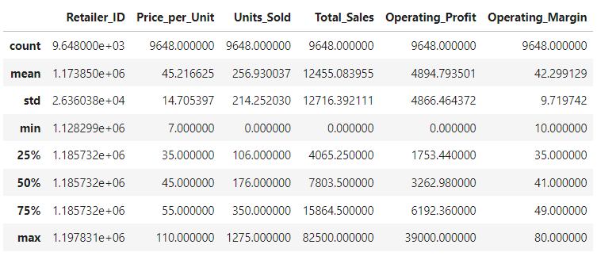

range = ['Price_per_Unit','Units_Sold', 'Total_Sales', 'Operating_Profit', 'Operating_Margin']  
**for** r **in** range:  
 print("range of ", r , " : ", df_clean[r].max() - df_clean[r].min())  
*#The range of numerical columns are as follows*

range of Price_per_Unit : 103.0  
range of Units_Sold : 1275.0  
range of Total_Sales : 82500.0  
range of Operating_Profit : 39000.0  
range of Operating_Margin : 70.0

### Sales Analysis

df_clean['Product'].value_counts().idxmax()  
*# The most listed product is 'men's athletic footwear'*

"men's street footwear"

product_sales = df_clean.groupby('Product')['Total_Sales'].sum()  
  
plt.figure(figsize=(8, 5))  
product_sales.plot(kind='bar', color='skyblue')  
plt.xlabel('Product')  
plt.ylabel('Total Sales')  
plt.title('Total Sales per Product')  
plt.show()  
*# Men's Street Footwear' has the highest total sales*

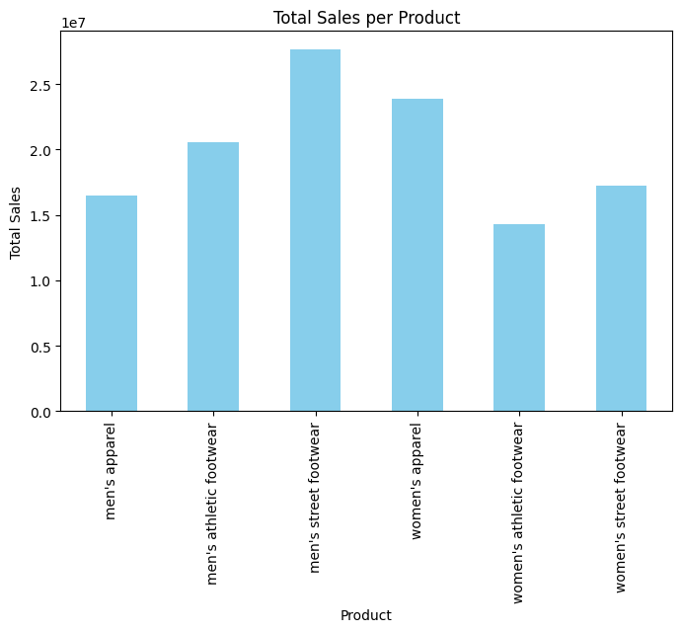

**import** matplotlib.dates **as** mdates  
  
df_clean['Year'] = df_clean['Invoice_Date'].dt.year  
df_clean['Month'] = df_clean['Invoice_Date'].dt.month  
monthly_data = df_clean.groupby(['Year', 'Month']).agg({  
 'Total_Sales': 'sum',  
 'Operating_Profit': 'sum'  
}).reset_index()  
monthly_data['Date'] = pd.to_datetime(monthly_data[['Year', 'Month']].assign(day=1))  
  
plt.figure(figsize=(14, 7))  
  
plt.plot(monthly_data['Date'], monthly_data['Total_Sales'], label='Total Sales')  
plt.plot(monthly_data['Date'], monthly_data['Operating_Profit'], label='Operating Profit')  
  
plt.gca().xaxis.set_major_formatter(mdates.DateFormatter('%Y-%m'))  
plt.gca().xaxis.set_major_locator(mdates.MonthLocator())  
plt.gcf().autofmt_xdate() *# for the x date angle*  
  
plt.title("Total Sales and Operating Profit over Time")  
plt.xlabel('Time')  
plt.ylabel('Amount')  
plt.legend()  
  
plt.show()  
*#The below graph shows trend of total sales and operating profit over time*  
*#There is a gradual increase in total sales and operating profit over time.*  
*#During dec 2020 to jan 2021, there is a sudden increase in total sales and operating profit but the point to note is that the extent of increase of profit is lesser than that of sales.*



print("Total sales: ", df_clean.groupby(['Sales_Method']).Total_Sales.sum())  
print("Total profit: ", df_clean.groupby(['Sales_Method']).Operating_Profit.sum())  
*# Out of different sales methods, 'online' has the highest total sales and profit whereas, 'in-store' has the lowest total sales and profit.*

Total sales: Sales_Method  
in-store 35664375.0  
online 44965657.0  
outlet 39536618.0  
Name: Total_Sales, dtype: float64  
Total profit: Sales_Method  
in-store 12759128.75  
online 19552537.72  
outlet 14913301.23  
Name: Operating_Profit, dtype: float64

df_clean.groupby(['Product'])['Units_Sold'].mean()  
*#The below lists the average number of units sold per product per day. That is, the average transaction per day.*  
*# men's street footwear has the highest transaction per day whereas, men's apparel has the least.*

Product  
men's apparel 190.960772  
men's athletic footwear 270.513043  
men's street footwear 368.521739  
women's apparel 269.792910  
women's athletic footwear 197.531756  
women's street footwear 243.948383  
Name: Units_Sold, dtype: float64

df_clean.groupby(['Sales_Method'])['Units_Sold'].std()  
*#The belows lists the amount of units sold variation for each sales method*  
*#It is clear that 'outlet' has the highest variation which means that the number of units sold every day differs a lot, while 'online' has the lowest variation*

Sales_Method  
in-store 203.410458  
online 176.269773  
outlet 232.193750  
Name: Units_Sold, dtype: float64

df_clean.groupby(['Product'])['Total_Sales'].std()  
*#These values represent the spread or variability of 'Total_Sales' within each product category.*  
*# A higher standard deviation indicates greater variability in sales within that product category.*

Product  
men's apparel 10783.845485  
men's athletic footwear 12707.987489  
men's street footwear 14978.931461  
women's apparel 14199.454793  
women's athletic footwear 9630.473858  
women's street footwear 11196.643353  
Name: Total_Sales, dtype: float64

product_sales_profit = df_clean.groupby('Product')[['Total_Sales', 'Operating_Profit']].sum()  
  
plt.figure(figsize=[10,8])  
plt.bar(product_sales_profit.index, product_sales_profit['Total_Sales'], color='blue')  
plt.bar(product_sales_profit.index, product_sales_profit['Operating_Profit'], bottom=product_sales_profit['Total_Sales'], color='red')  
  
plt.title("Total Sales and Operating Profit by Product", fontsize=18)  
plt.xlabel("Product")  
plt.ylabel("Amount")  
plt.legend(["Operating Profit", "Total Sales"])  
plt.xticks(rotation=45)  
plt.show()  
*#This visualization shows operating profit and total salesby product.*   
*#It is clear that men's street footwear has the highest total sales and operating profit.*



### Profitability Analysis

df_clean.groupby(['Product'])['Operating_Profit'].median()  
*#Considering median, there is more profit in men's street footwear and least in women's athletic footwear.*

Product  
men's apparel 2679.415  
men's athletic footwear 3293.760  
men's street footwear 5201.500  
women's apparel 4004.200  
women's athletic footwear 2357.100  
women's street footwear 2703.000  
Name: Operating_Profit, dtype: float64

df_clean.groupby(['Product'])['Operating_Margin'].median()  
*#men's street footwear has the highest operating margin . And the general operating margin is 40%.*

Product  
men's apparel 40.0  
men's athletic footwear 40.0  
men's street footwear 45.0  
women's apparel 44.0  
women's athletic footwear 41.0  
women's street footwear 40.0  
Name: Operating_Margin, dtype: float64

**import** matplotlib.dates **as** mdates  
  
df_clean['Year'] = df_clean['Invoice_Date'].dt.year  
df_clean['Month'] = df_clean['Invoice_Date'].dt.month  
monthly_data = df_clean.groupby(['Year', 'Month']).agg({  
 'Operating_Margin': 'median'  
}).reset_index()  
monthly_data['Date'] = pd.to_datetime(monthly_data[['Year', 'Month']].assign(day=1))  
  
plt.figure(figsize=(14, 7))  
plt.plot(monthly_data['Date'], monthly_data['Operating_Margin'], label='Operating Margin')  
  
plt.gca().xaxis.set_major_formatter(mdates.DateFormatter('%Y-%m'))  
plt.gca().xaxis.set_major_locator(mdates.MonthLocator())  
plt.gcf().autofmt_xdate() *# for the x date angle*  
  
plt.title("Median Operating Margin over Time")  
plt.xlabel('Time')  
plt.ylabel('Amount')  
plt.legend()  
  
plt.show()  
*#The below graph shows trend of median operating margin over time.*  
*#It is clear that the median operating margin is constantly changing over time and was the least in june 2020.*  
*#The highest median operating margin was in sept 2020*



*# Filter the dataframe for June 2020 and sales method as online*  
filtered_data = df_clean[(df_clean['Year'] == 2020) & (df_clean['Month'] == 6) & (df_clean['Sales_Method'] == 'online')]  
  
*# Calculate total sales*  
total_sales = filtered_data['Total_Sales'].sum()  
total_sales  
*#The total sales that happened via online in June 2020 is 223,569 units.*

223569.0

filtered_data = df_clean[(df_clean['Year'] == 2020) & (df_clean['Month'] == 9) & (df_clean['Sales_Method'] == 'online')]  
  
*# Calculate total sales*  
total_sales = filtered_data['Total_Sales'].sum()  
total_sales

456214.0

*# Calculate total sales for June 2020*  
total_sales_June2020 = df_clean[(df_clean['Year'] == 2020) & (df_clean['Month'] == 6)]['Total_Sales'].sum()  
  
*# Calculate percentage of online sales for June 2020*  
percentage_online_sales_June2020 = (total_sales / total_sales_June2020) * 100  
percentage_online_sales_June2020  
*#The percentage of sales via online in June 2020 is approximately 20.62%.*

42.078631683997514

total_sales_June2020 = df_clean[(df_clean['Year'] == 2020) & (df_clean['Month'] == 9)]['Total_Sales'].sum()  
  
*# Calculate percentage of online sales for Sept 2020*  
percentage_online_sales_June2020 = (total_sales / total_sales_June2020) * 100  
percentage_online_sales_June2020

19.268348928025084

print("Kurtosis : ", df_clean['Operating_Profit'].kurt())  
print("Skewness : ", df_clean['Operating_Profit'].skew())  
*#The positive kurtosis suggests that the distribution has heavier tails and a sharper peak compared to a normal distribution.*  
*#The positive skewness suggests that the distribution is right-skewed, meaning it is stretched more to the right.*

Kurtosis : 7.181164174449948  
Skewness : 2.334590765903441

df_clean.groupby(['Sales_Method'])['Operating_Margin'].skew()  
*#The operating margin for each sales method is right skewed or positively skewed. And in-store has the highest skewness whereas, outlet has the lowest skewness.*  
*#This means that the right tail is longer and fatter than the left tail.*

Sales_Method  
in-store 0.363159  
online 0.251876  
outlet 0.148255  
Name: Operating_Margin, dtype: float64

### Regional Analysis

print("Region wise: ",df_clean.groupby(['Region'])['Total_Sales'].sum())  
print("State wise: ", df_clean.groupby(['State'])['Total_Sales'].sum().idxmax())  
print("City wise: ", df_clean.groupby(['City'])['Total_Sales'].sum().idxmax())  
*#In general the western region has highest sales. The State with highest sales is New York.*

Region wise: Region  
midwest 16674434.0  
northeast 25078267.0  
south 20603356.0  
southeast 21374436.0  
west 36436157.0  
Name: Total_Sales, dtype: float64  
State wise: new york  
City wise: new york

print(df_clean.groupby(['Region'])['Product'].value_counts().idxmax())  
print(df_clean.groupby(['State'])['Product'].value_counts().idxmax())  
print(df_clean.groupby(['City'])['Product'].value_counts().idxmax())  
*#The following gives the overall most popular Product in each of region, state and city division.*  
*#men's apparel is the most popular , city and state wise but on a bigger picture, men's athletic footwear is the most popular product in western region.*  
*#Note: Here popularity is taken as the number of times a particular product is listed and not number of products sold.*

('west', "men's athletic footwear")  
('california', "men's apparel")  
('portland', "men's apparel")

print("Region wise: ", df_clean.groupby(['Region', 'Product'])['Units_Sold'].sum().idxmax())  
print("State wise: ", df_clean.groupby(['State', 'Product'])['Units_Sold'].sum().idxmax())  
print("City wise: ", df_clean.groupby(['City', 'Product'])['Units_Sold'].sum().idxmax())  
*#specific regional, state, city preferences for certain products are listed below. In each of them, men's street footwear is more preferred.*

Region wise: ('west', "men's street footwear")  
State wise: ('new york', "men's street footwear")  
City wise: ('charleston', "men's street footwear")

df_clean.groupby(['Region', 'Sales_Method'])['Operating_Profit'].sum()  
*#This tells us the best sales method for each region for max profit.*

Region Sales_Method  
midwest in-store 2316565.00  
 online 3133263.98  
 outlet 1410116.25  
northeast in-store 4254420.00  
 online 2246831.65  
 outlet 3231522.25  
south in-store 134800.00  
 online 4149888.22  
 outlet 4936917.10  
southeast in-store 2558256.25  
 online 5080401.63  
 outlet 754401.32  
west in-store 3495087.50  
 online 4942152.24  
 outlet 4580344.31  
Name: Operating_Profit, dtype: float64

### Retailer Analysis

sales_by_location = df_clean.groupby('Retailer')['Total_Sales'].sum()  
  
*# Plotting a pie chart for total sales by retailer*  
plt.figure(figsize=(8, 8))  
sales_by_location.plot.pie(autopct='%1.1f%%', startangle=90, colors=['skyblue', 'lightgreen', 'lightcoral'])  
plt.title('Total Sales by Retailer')  
plt.ylabel('')  
plt.show()  
*#The total sales is highest by the retailer - west gear followed by foot locker.*   
*#Even though online mode has the highest sales, amazon has the least total sales.*



sales_by_location = df_clean.groupby('Retailer')['Operating_Profit'].sum()  
  
*# Plotting a pie chart for operating profit by retailer*  
plt.figure(figsize=(8, 8))  
sales_by_location.plot.pie(autopct='%1.1f%%', startangle=90, colors=['skyblue', 'lightgreen', 'lightcoral'])  
plt.title('Total Operating Profit by Retailer')  
plt.ylabel('')  
plt.show()  
*#The operating profit is highest by the retailer - west gear followed by foot locker.*   
*#Even though online mode has the highest operating profit, amazon has the least operating profit.*



df_clean.groupby(['Retailer', 'Sales_Method'])['Operating_Profit'].mean()  
*# The below lists the average operating profit by each retailer.*  
*#Even though west gear had the highest total operating profit, walmart outperformed them in terms of average operational profits.*  
*# Even though online mode had the overall highest operating profit, considering each retailer's sales method, in-store had the highest operating profit.*

Retailer Sales_Method  
amazon in-store 7083.972458  
 online 3773.055296  
 outlet 3818.121821  
foot locker in-store 6256.570156  
 online 3717.388738  
 outlet 4189.243405  
kohl's in-store 7359.071181  
 online 3831.638194  
 outlet 6179.129774  
sports direct in-store 7035.712457  
 online 4542.114372  
 outlet 5457.985430  
walmart in-store 13325.337838  
 online 4781.102743  
 outlet 6753.334784  
west gear in-store 7868.115165  
 online 3859.311032  
 outlet 4260.573448  
Name: Operating_Profit, dtype: float64

df_clean.groupby('Retailer')['Product'].value_counts()  
*#The below lists the most popular products sold by each retailer. This gives us an idea about how each retailer is making more profits through their products.*

Retailer Product   
amazon men's athletic footwear 159  
 men's street footwear 159  
 women's apparel 159  
 women's athletic footwear 158  
 men's apparel 157  
 women's street footwear 157  
foot locker men's street footwear 449  
 men's athletic footwear 442  
 women's athletic footwear 442  
 women's street footwear 438  
 men's apparel 433  
 women's apparel 433  
kohl's men's athletic footwear 172  
 men's street footwear 172  
 women's apparel 172  
 women's street footwear 172  
 men's apparel 171  
 women's athletic footwear 171  
sports direct women's street footwear 342  
 women's apparel 341  
 men's apparel 339  
 women's athletic footwear 338  
 men's athletic footwear 337  
 men's street footwear 335  
walmart men's apparel 113  
 women's apparel 107  
 men's athletic footwear 104  
 women's athletic footwear 102  
 men's street footwear 101  
 women's street footwear 99  
west gear women's street footwear 400  
 men's athletic footwear 396  
 women's apparel 396  
 women's athletic footwear 395  
 men's street footwear 394  
 men's apparel 393  
Name: Product, dtype: int64

### Pricing Analysis

df_clean[['Price_per_Unit','Units_Sold', 'Total_Sales', 'Operating_Profit', 'Operating_Margin']].corr()  
*# If Price per unit is more, the total sales & operating profit will be more since they are positively correlated.*  
*# Whereas, price per unit and operating margin has negative weak correlation.*  
*# Price per unit and units sold are positively weakly correlated. This wouldn't guarantee that more price per unit would mean more units sold to some extent.*  
*# units sold and operating profit have positive strong correlation which is by logic correct and same with units sold and total sales.*  
*# Interestingly, operating margin and units sold are negatively moderately correlated.*  
*# As operating margin and unit sold is negatively moderately correlated, so we can say that the most sales/more units would be sold due to excess money spent on ads and hence we could justify that maybe the sales are high but the profit margin is comparatively less.*

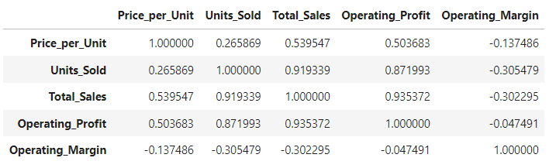

heatmap = df_clean[['Price_per_Unit','Units_Sold', 'Total_Sales', 'Operating_Profit', 'Operating_Margin']]  
plt.figure(figsize=(10, 8))  
sns.heatmap(heatmap.corr(), cmap='viridis', annot=True, fmt=".2f", linewidths=.5)  
plt.title('Heatmap')  
plt.show()



plt.figure(figsize=(10, 8))  
sns.boxplot(x='Product', y='Price_per_Unit', data=df_clean)  
plt.title('Box Plot of Price Per Unit Grouped by Product')  
plt.xlabel('Product')  
plt.ylabel('Price Per Unit')  
plt.xticks(rotation=45)  
plt.show()  
*#Generally, price per unit for each product has normal distribution but for "men's athletic footwear" it is slightly left skewed*  
*# and for "women's athletic footwear" it is slightly right skewed.*  
  
*#The median price per unit for "men's apparel" and "women's apparel" is the highest.*  
*#"women's street footwear" and "women's athletic footwear" has the lowest median price per unit.*  
*#There are many outliers towards the right side of the graph for each product.*



plt.figure(figsize=(10, 8))  
sns.boxplot(x='Product', y='Operating_Margin', data=df_clean)  
plt.title('Box Plot of Operating Margin Grouped by Product')  
plt.xlabel('Product')  
plt.ylabel('Operating Margin')  
plt.xticks(rotation=45)  
plt.show()  
*#In general, the operating margin for each product has slight right skewness,*   
*# but for "men's street footwear" and "women's apparel" it is normal distributed.*



final_table = df_clean.groupby(['Region', 'State', 'City','Sales_Method','Product']).Operating_Profit.median()  
final_table = final_table.sort_values(ascending=False)  
final_table.to_csv('Final_Profit_dataset.csv')

#This creates a new csv file which groups region, state, city, sales method and product based on median operating profits which helps the company make better decisions while investing to gain maximum profits.