ML-Based Software Design Pattern Detection in Source Code Using Neural Network
Due to advancement in technologies Software Code is getting complex and need to be efficiently manage to reuse code in future components. To manage code efficiently we can make use of design patterns which contains information about use of each class and its relationship in all the classes. So we need to identify design pattern from each class to know the reusability but manually analysing or annotating each class with Design Pattern is a complex and time consuming problem.
To overcome from above issue we are employing machine learning ANN (artificial neural network) algorithm which get trained on available SOURCE code of different design patterns and then generate a model. Test code can be applied on ANN train model to predict or detect its design pattern.
To implement this project we have used JAVA software repository source code on different design patterns from below website.
https://www.ptidej.net/tools/designpatterns/
From this website we have downloaded source code for GANG OF 4 different design patterns which is showing in below link
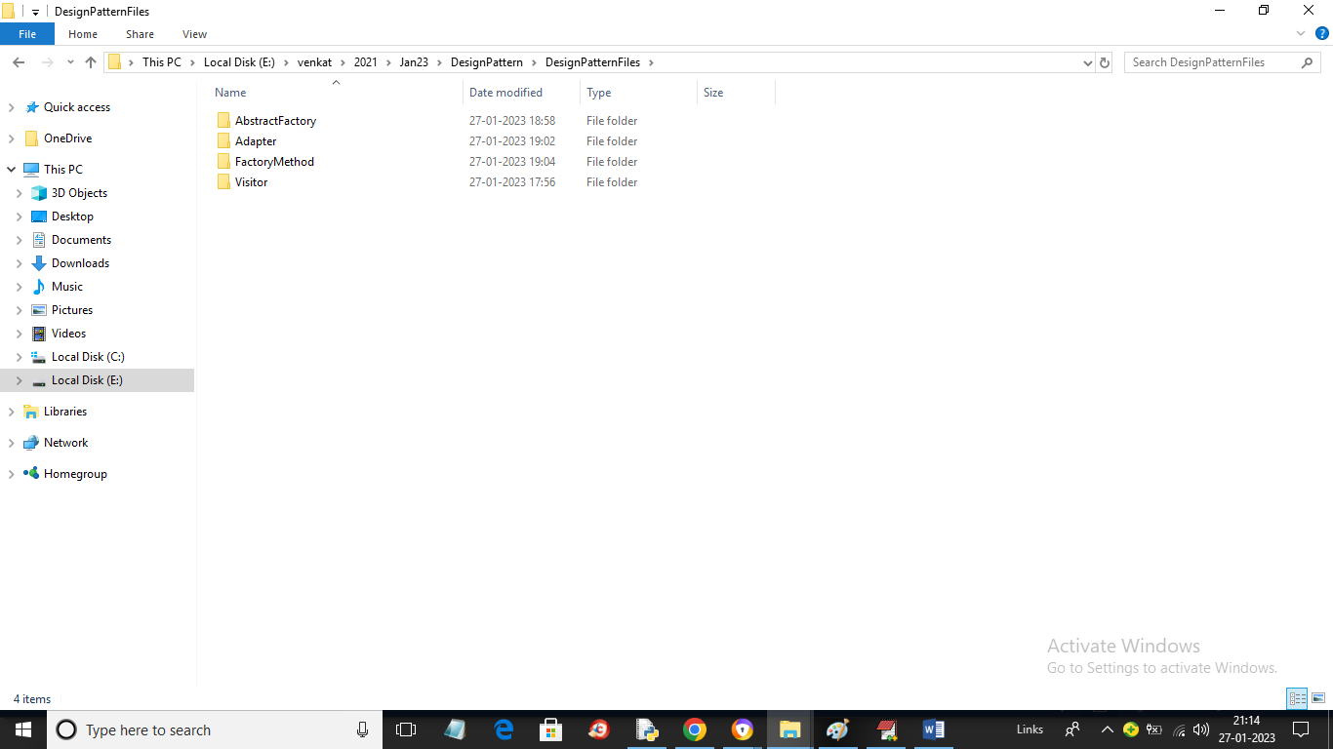
In above dataset screen we have 4 folders of different design pattern and just go inside any folder to view source code like below screen
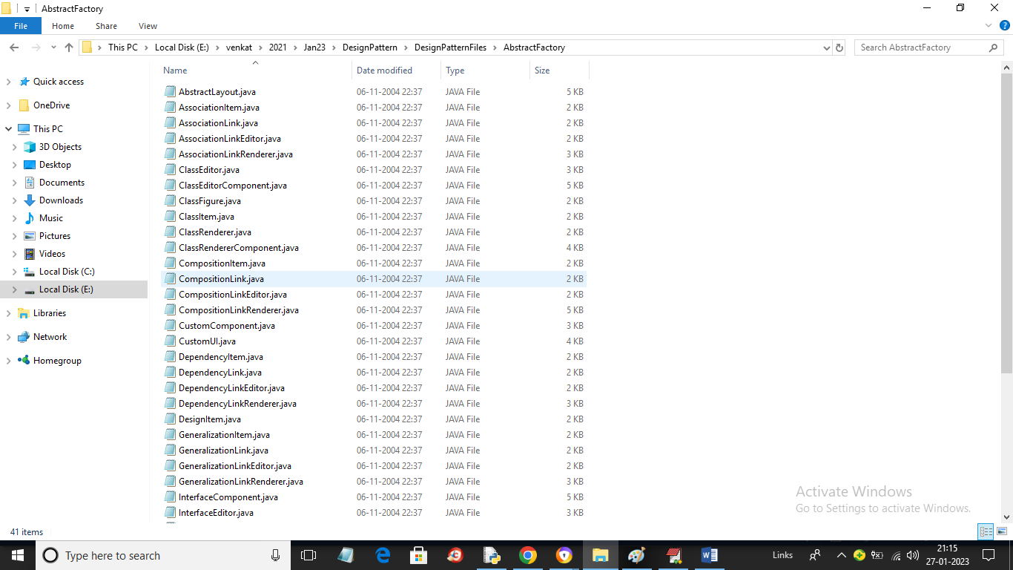
So by using above code files we will trained ANN model.
To implement this project we have designed following modules
- Upload Source Code Dataset: using this module we will upload dataset to application and then identify different design patterns available in dataset
- Preprocess & Normalize Dataset: using this module we will read each source code file and then build a numeric vector by replacing each words with its average frequency (often called as Term Frequency Inverse Frequency Document (TF-IDF)). This numeric vector will be normalized using MIN-MAX class and then plot graph with different design patterns source code file count found in dataset
- Dataset Train & Test Split: using this module we will split dataset into train and test where application used 80% dataset for training and 20% dataset size for testing
- Run ANN Algorithm: 80% training data will be input to ANN algorithm to train a model and then 20% test data will applied on ANN trained model to predict class labels for test data and then calculate accuracy between predicted and test label values
- ANN Training Graph: using this module we will plot ANN training accuracy and loss graph
- Design Pattern Detection from Test Code: using this module we will upload TEST SOURCE CODE file and then ANN will analyse source code and predict/detect DESIGN pattern from uploaded test code file
SCREEN SHOTS
To run project double click on ‘run.bat’ file to get below screen
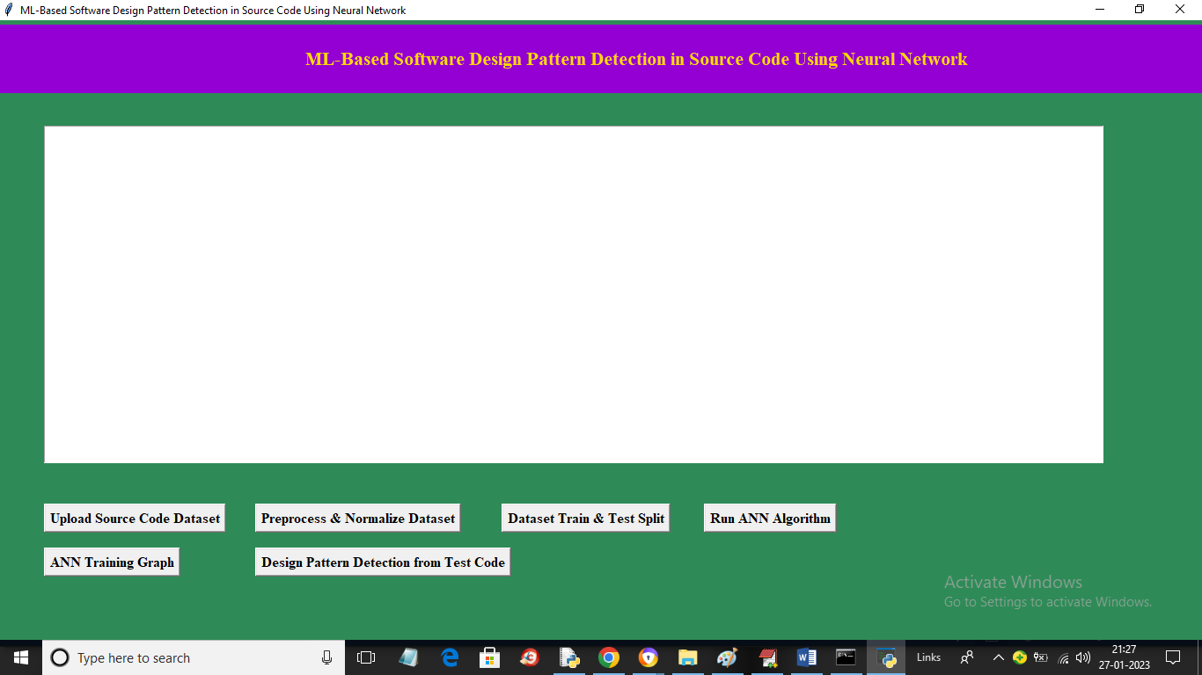
In above screen click on ‘Upload Source Code Dataset’ button to upload dataset and get below output
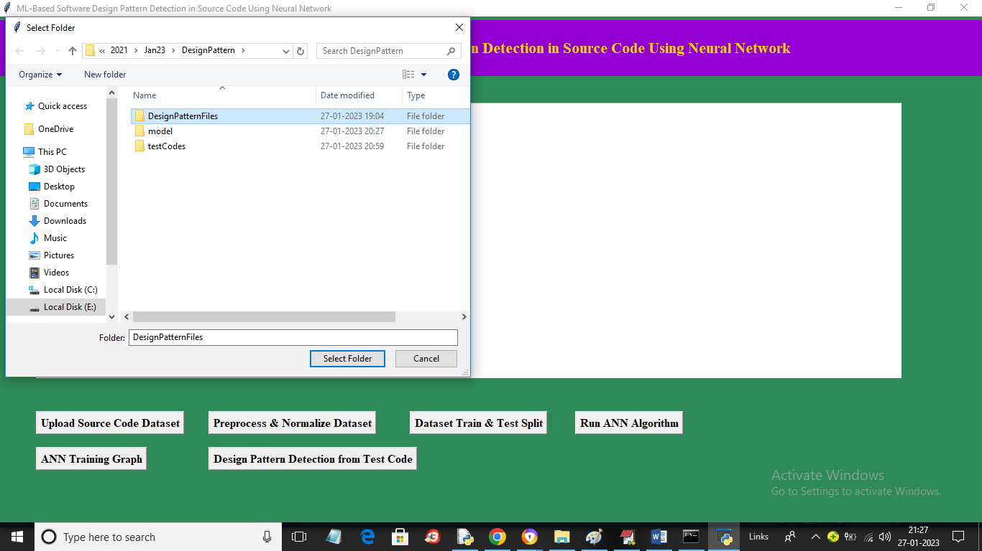
In above screen selecting and uploading entire ‘Design Pattern Files’ button to upload dataset file and then click on ‘Select Folder’ button to load dataset and get below output
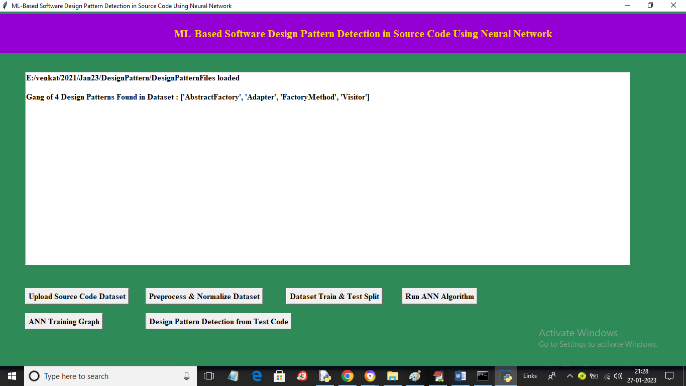
In above screen dataset loaded and in above screen in dataset we found 4 different design patterns. Now click on ‘Preprocess & Normalize Dataset’ button to process and normalize dataset and get below output
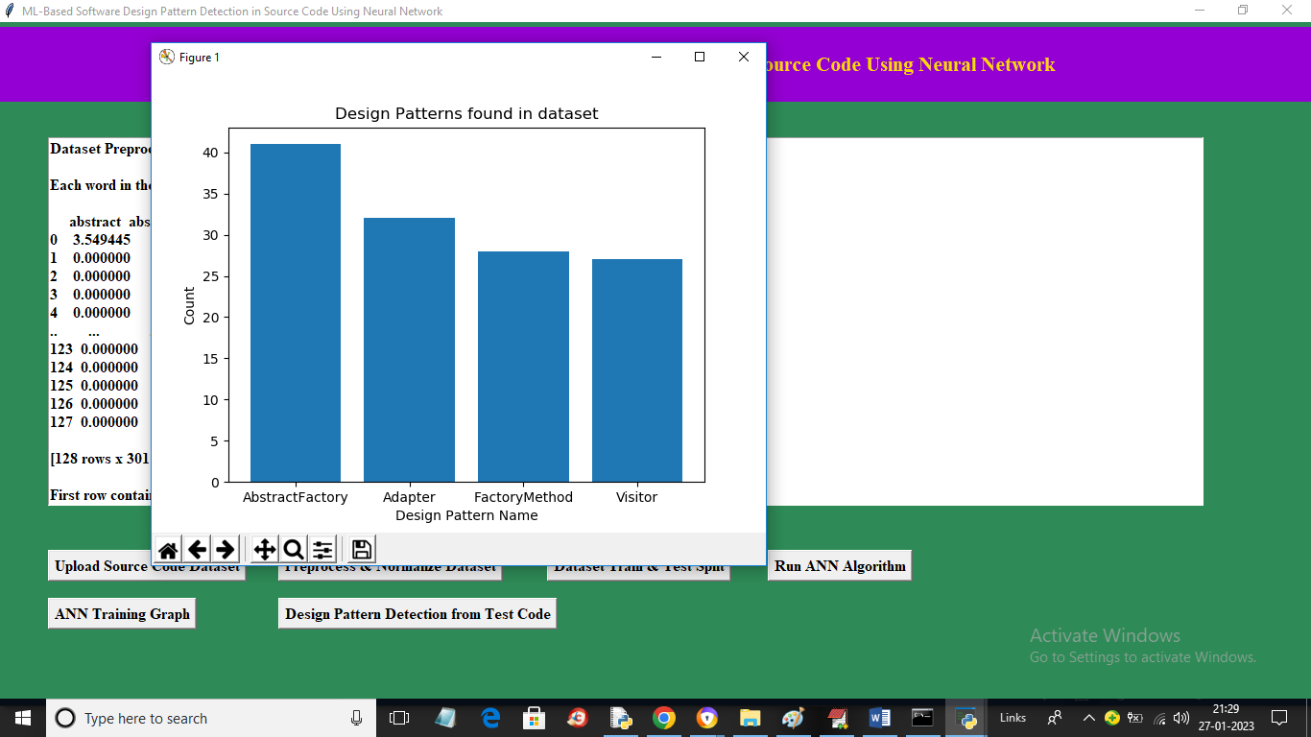
In above graph x-axis represents names of design patterns and y-axis represents count of source code files found in that design pattern and now close above graph to get below screen
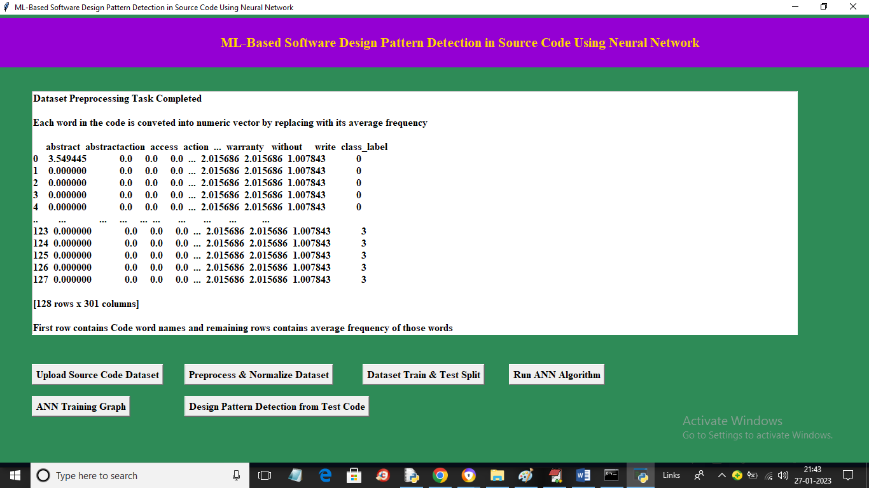
In above screen in 3rd we can see names of words found in source code and in remaining rows we can see average frequency of those words and now click on ‘Dataset Train & Test Split’ button to split above dataset into train and test and get below output
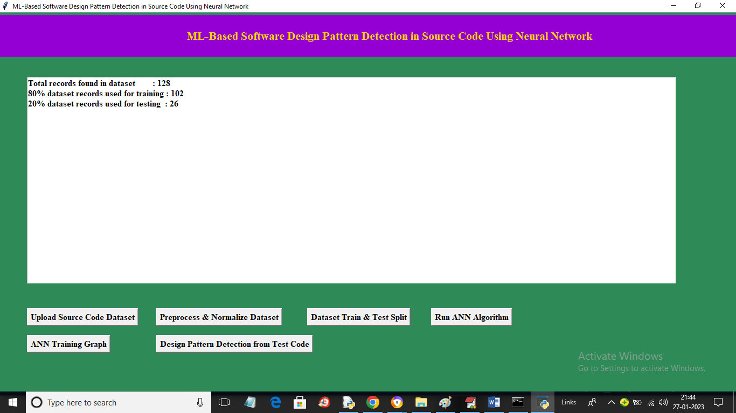
In above screen we can see dataset contains 128 source code files in which 80% (102 source code file) files for training and 20% (76) files are using for testing. Now train and test data is ready and now click on ‘Run ANN Algorithm’ button to train ANN and get below output
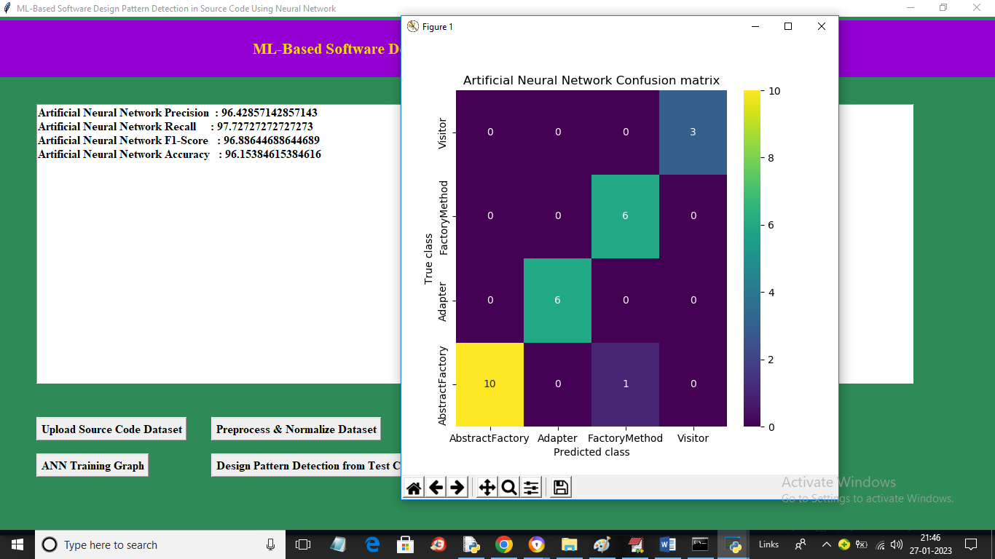
In above screen with ANN we got 96% accuracy and in confusion matrix graph x-axis represents Predicted Labels and y-axis represents True Labels and all different colour boxes in diagnol represents correct prediction count and remaining blue colour boxes contains Incorrect Prediction count which are very few. Now close above graph and then click on ‘ANN Training Graph’ button to get below ANN training Graph
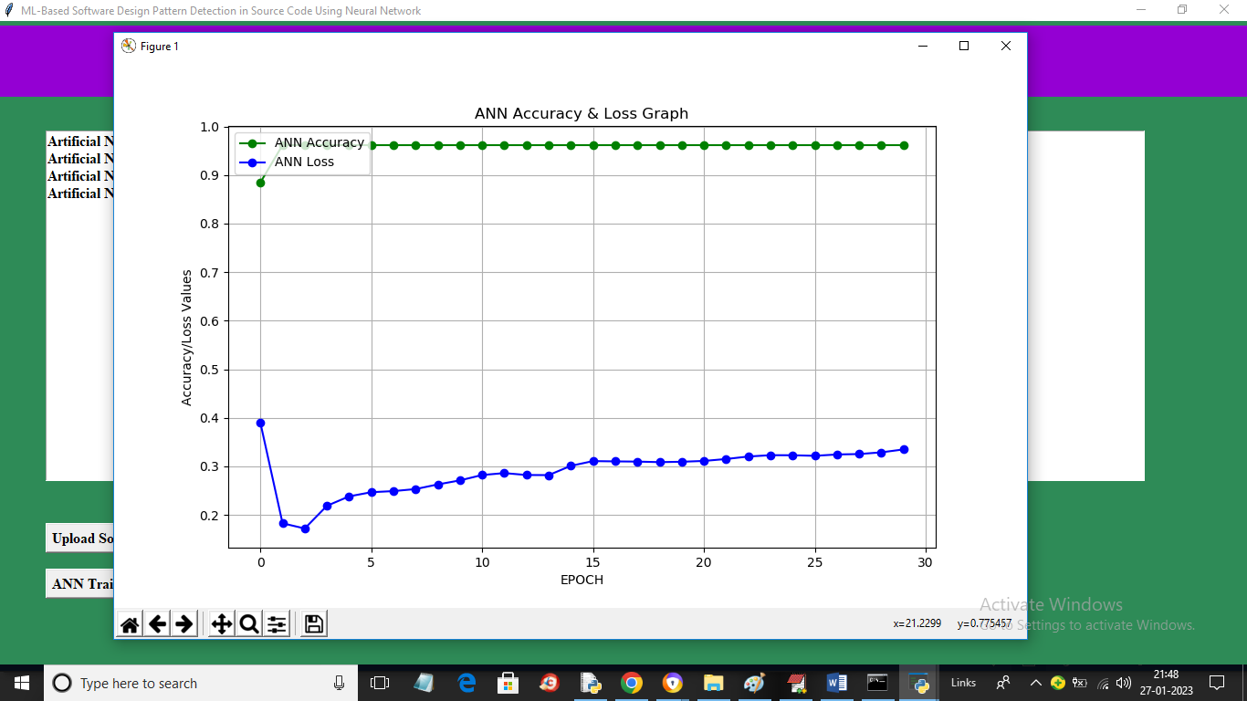
In above graph x-axis represents training EPOCH and y-axis represents accuracy and loss values. Green line represents Accuracy and blue line represents LOSS and with each increasing epoch accuracy got increase and reached closer to 1 and loss get decrease and reached closer to 0.3. for any model accuracy must be high and loss must be less. Now click on ‘Design Pattern Detection from Test Code’ button to upload test source file and get below output
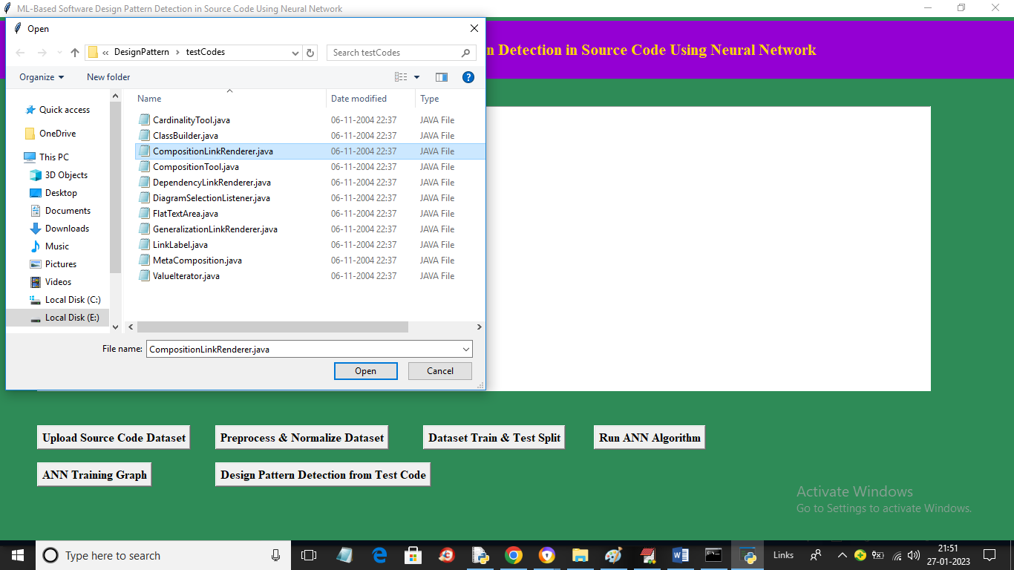
In above screen selecting and uploading Test Source File and then click on ‘Open’ button to load Test file and get below ANN prediction output
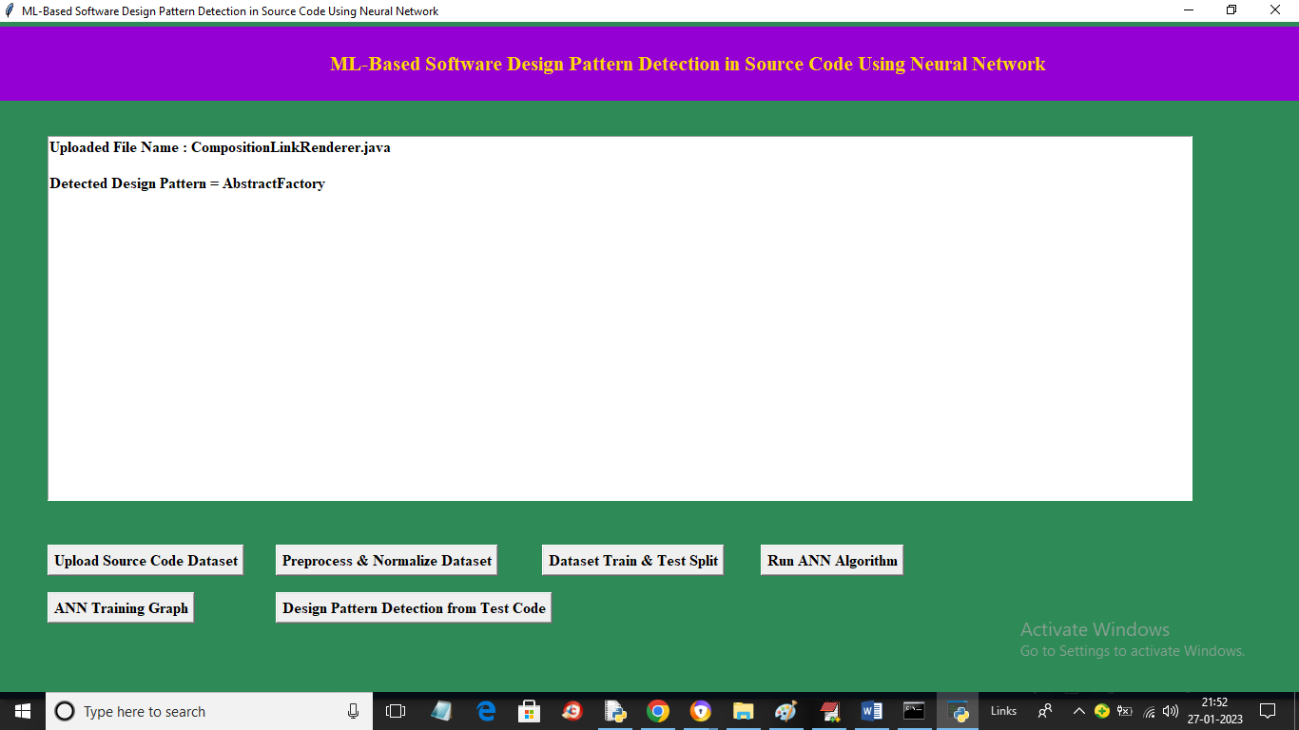
In above screen in first line displaying name of source code file and in second line displaying detected Design Pattern Name as ‘Abstract Factory’. Similarly you can upload and test other file
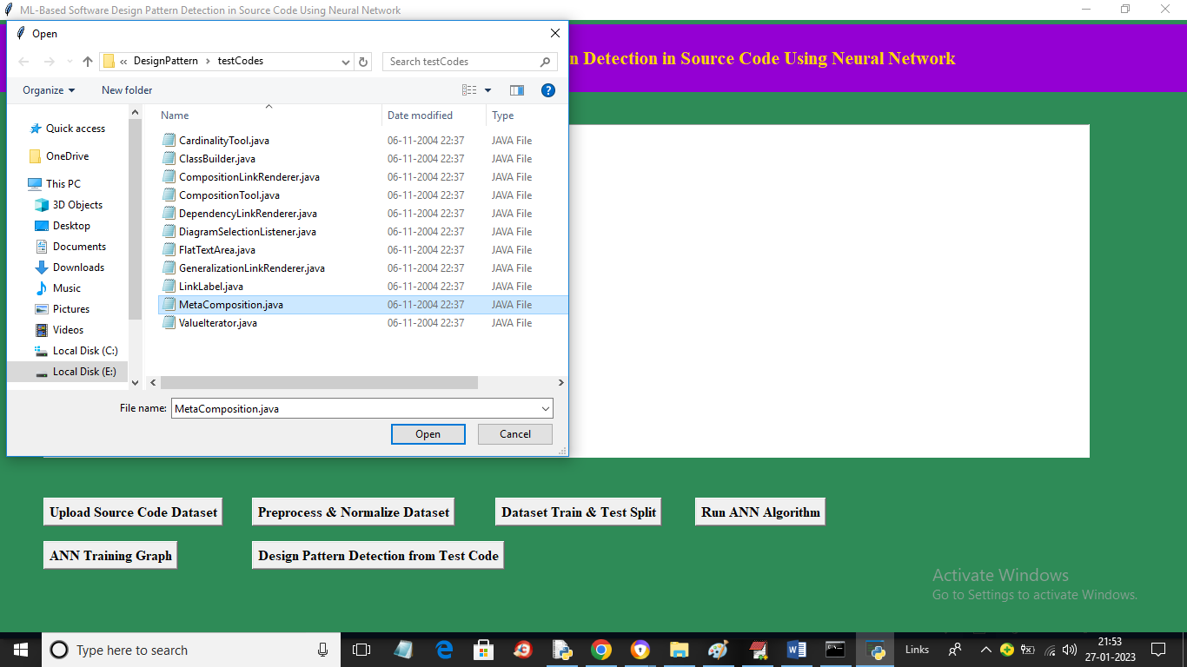
In above screen selecting and uploading different source code file and below is the output
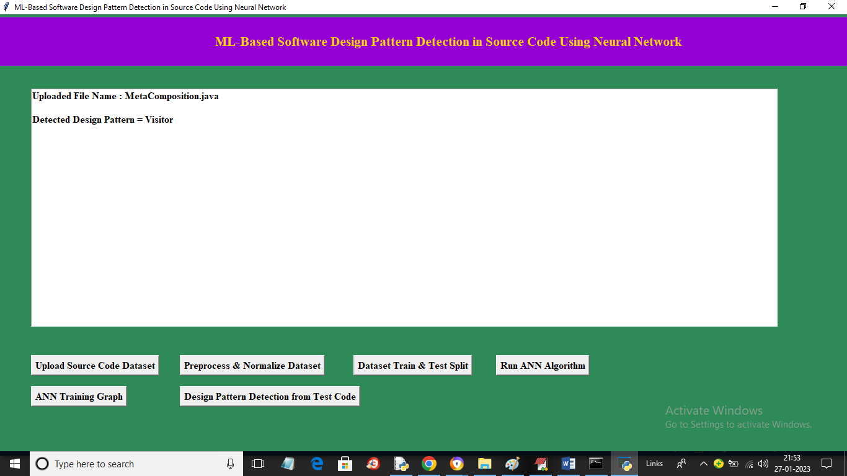
In above screen design pattern detected as ‘Visitor’.

