LEARNIVERSE AI
Project Architecture
and Technical Guide
System overview ? component architecture ? user flows ? data and deployment
Prepared from the application source and project documentation
Includes embedded architecture diagrams and flowcharts

This document describes the application as it is currently represented in the
repository: its user-facing features, runtime components, API boundaries,
important request flows, data stores, deployment shape, and areas where the
implementation differs from older or higher-level descriptions.
It is a code-oriented architecture guide, not a production security
certification, deployment approval, or guarantee that external services are
currently reachable.

1. Executive summary
Learniverse AI is a React single-page application (SPA) with a Python FastAPI
backend. The codebase combines several related products:
- A topic-based learning experience with AI Teacher and AI Peer personas.
- Topic overviews, generated practice questions, and answer evaluation.
- A placement-assessment system with candidate sessions, autosave, scoring,
administrative monitoring, and question-bank management.
- Code-editor and programming-practice flows backed by external code execution
services.
- Student progress, analytics, portfolio, and institutional (CDC) integrations.
The application is not a single uniform service backed by one database. It
combines API routes, local JSON content, PostgreSQL, development-only SQLite
fallbacks, browser state, optional Redis-backed caching, a persistent ChromaDB
directory, and external AI/execution services.

At-a-glance stack
Area | Technologies and implementation
Web client | React 18, TypeScript, Vite, React Router
UI | Tailwind CSS, Radix/shadcn-style components, Lucide icons
Client data/state tools | TanStack Query, React Hook Form, Zod, browser storage
API | FastAPI, Pydantic, Uvicorn
AI generation | OpenRouter-compatible chat-completions request, configured from backend settings
Embeddings/vector store | Gemini embedding code and persistent ChromaDB are present in a separate retrieval module
Main assessment persistence | PostgreSQL when configured; development-only SQLite fallback in assessment code
Content | JSON files, frontend data, and database-backed question data
Code execution | Judge0 integration with Piston API fallback
Cache | In-process TTL cache by default; optional Redis backend
Tests/CI | Pytest, Vitest, ESLint, TypeScript check, Vite production build, Docker Compose config validation

2. System context and component architecture
The browser is the user interface. In local development, Vite proxies /api
requests to FastAPI. The API composes several routers and direct endpoints. It
then calls internal modules, databases, or third-party services as needed.
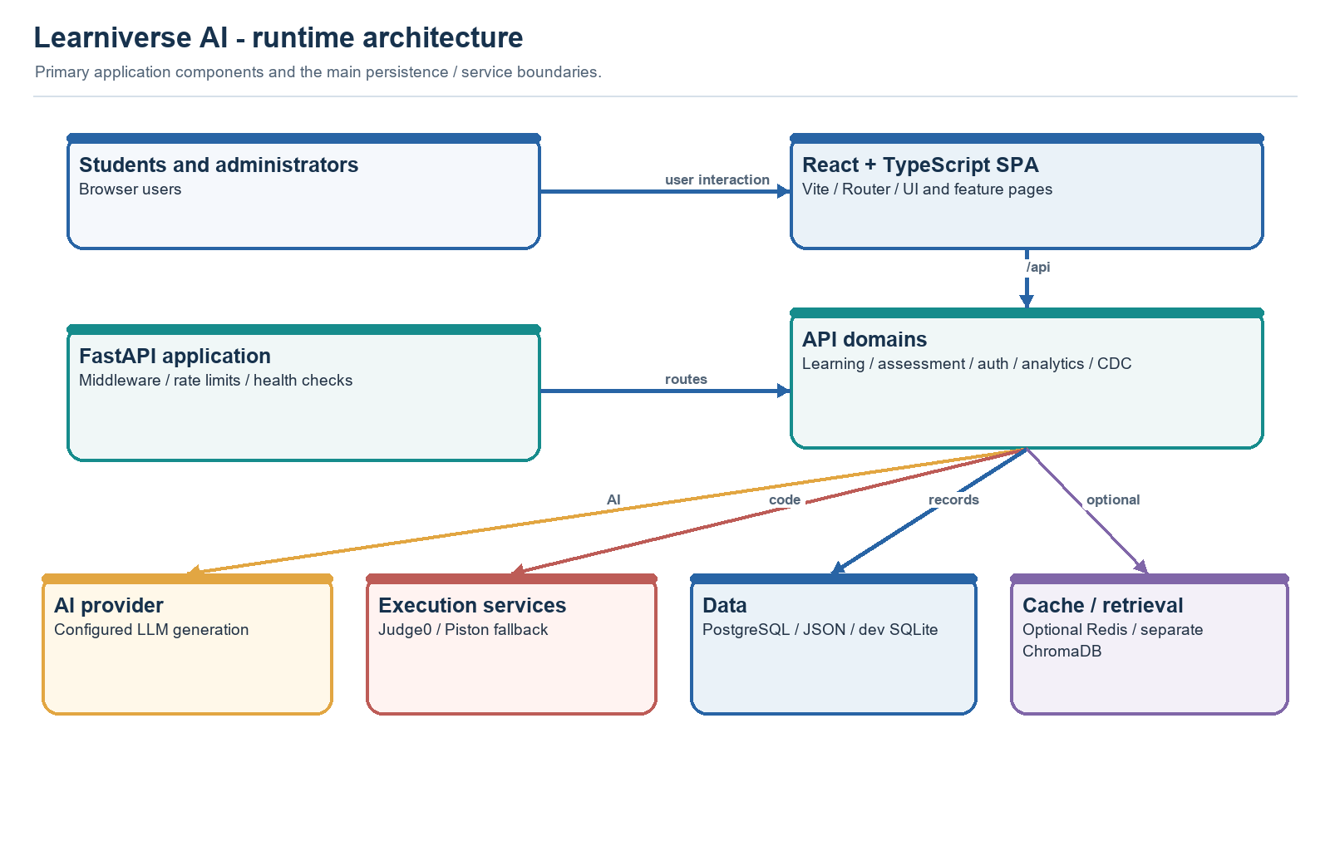
Figure 1. Runtime architecture and integration boundaries.
The diagram distinguishes the intended component boundaries from a key
implementation detail: the active /api/chat orchestrator currently does not
call the ChromaDB retrieval module. That flow is described in detail below.

Browser-to-API request path
In development, vite.config.ts configures port 8080
and proxies /api to http://localhost:8000. FastAPI is started separately.
The proxy avoids requiring a separate API origin for local frontend requests.
In a built deployment, backend/app.py contains conditional static-file
handling for a frontend dist directory. Whether that path is used depends on
the deployment packaging and build layout; it is separate from the Vite
development proxy.

3. Frontend organization
The SPA bootstrap is src/main.tsx. Global providers and
the route table are assembled in src/App.tsx, including:
- React Router browser navigation.
- TanStack Query's QueryClientProvider.
- Tooltip and toast providers.
- Lazy-loaded page modules with a reload-once helper for stale deployment
chunks.

Main routes
Path | Page/component | Purpose
/ | Index | Landing page
/topics | TopicsPage | Browse topics
/topics/:slug | TopicDetailPage | Topic learning and practice
/top-100-codes | Top100Codes | Coding practice interface
/assessment | PlacementAssessment | Candidate assessment flow and related UI
/dashboard | StudentDashboard | Student progress/dashboard
/admin | AdminAssessmentHub | Administrator assessment tools
/admin/assessments | AdminAssessmentHub | Assessment administration route
/about | AboutPage | Product information
/how-it-works | HowItWorksPage | Product/process explanation
Any unmatched path | Redirect to /topics | Fallback navigation

Page-level components are in src/pages. Shared UI is in
src/components, API-facing helpers in
src/services, and bundled learning/practice data in
src/data.
The frontend uses a mixture of local data and direct fetch calls. For
example, the conversation component calls /api/chat; assessment screens call
/api/assessment/...; code execution uses /api/code/execute-raw. Not every
feature uses a single centralized API client.

4. Backend organization and route composition
backend/app.py is the FastAPI composition root. It
configures application lifespan behavior, database connection pooling,
middleware, rate limiting, direct routes, and router inclusion.

Routers included by the application
The main app explicitly includes:
Router/module | Prefix or route area | Responsibility
placement_assessment_system.api | /api/assessment | Candidate sessions, questions, autosave, submission, monitoring, reporting
placement_assessment_system.question_bank_admin | /api/admin/question-bank | Admin question-bank and trainer-test management
cdc_integration | /api/cdc | CDC student results, reporting, sync and bulk operations
auth_api | /api/auth | Login and token issuance
analytics_api | /api/analytics | Activity events, dashboards, student/admin analytics

The main file also defines direct routes for chat/debate, topic content, AI
evaluation, portfolio/dashboard, health/readiness, genealogy, and code
execution.

Route modules present but not necessarily active
The repository also contains modules such as top_100_problems_api.py and
problems_dashboard_api.py. I did not see those routers included by the
main app.py composition code inspected for this guide. A module's presence
does not make its endpoints reachable: verify router inclusion and deployment
behavior before relying on those APIs.

5. AI tutoring and RAG: implemented flow
The frontend conversation UI is implemented in
src/components/ConversationBox.tsx.
It sends a message, topic, category, mode, and recent history to /api/chat.
The backend endpoint is in backend/app.py; it lazily imports
backend/rag/rag_pipeline.py.

Active /api/chat sequence
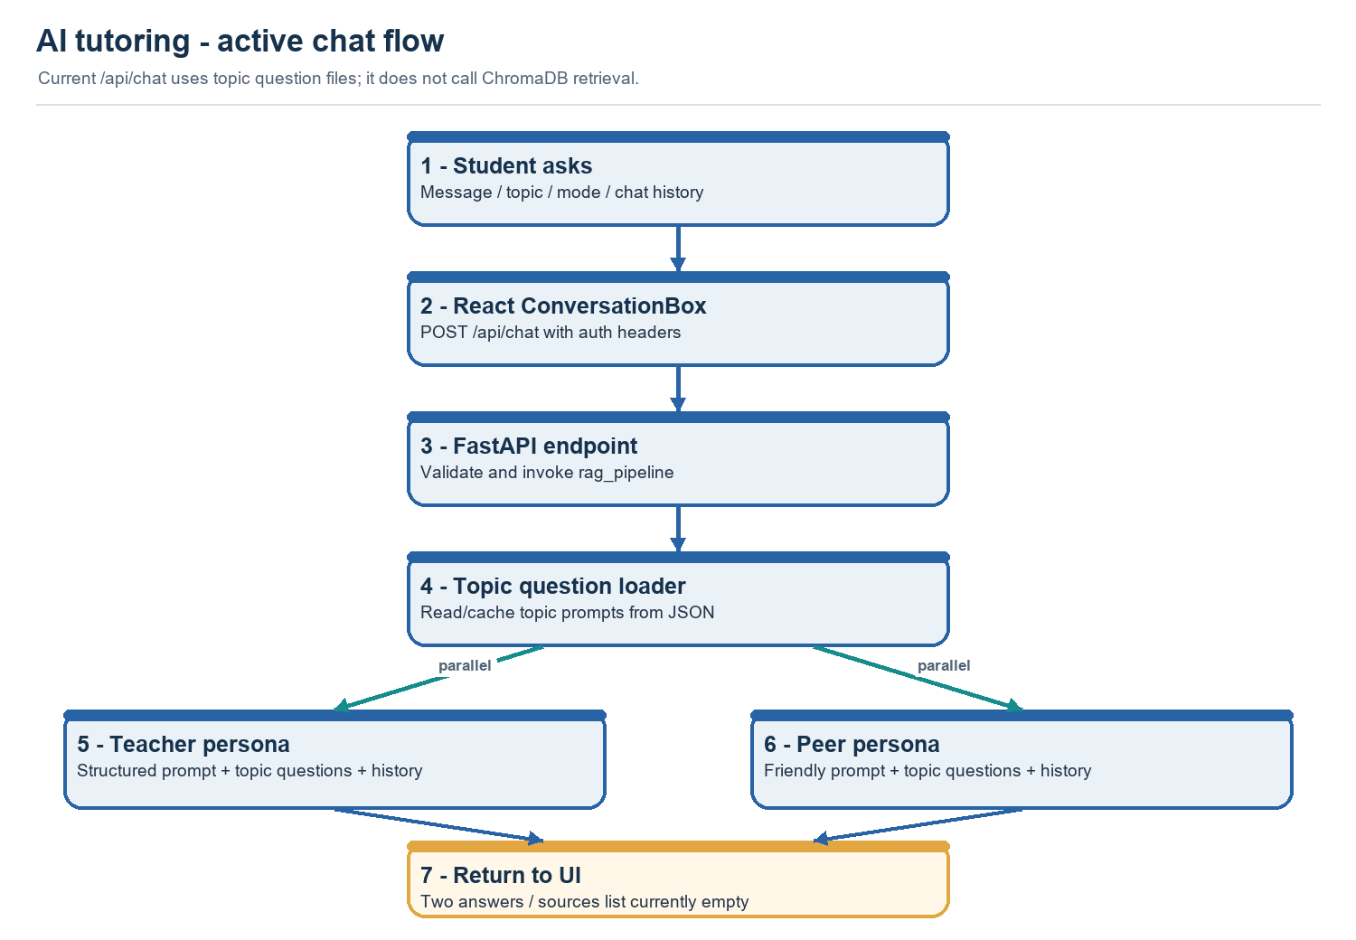
Figure 2. Current chat request and dual-persona generation.
The two persona-generation operations are run concurrently. The orchestrator
loads topic question prompts from backend/data/topics, constructs a query
prefix for the selected mode, and gives the prompts, query, topic, and history
to the persona generators.
If a persona generator raises an exception, the orchestrator currently returns
a persona-specific fallback string. The chat response's sources list is
currently empty in this active path.

Documentation/implementation discrepancy: textbook retrieval
Some project descriptions say chat answers are grounded in textbook passages
retrieved from ChromaDB and include textbook citations. The modules do contain
parts of such a pipeline:
- backend/rag/retriever.py configures Gemini query embeddings, opens a
persistent ChromaDB collection named dsa_books, and filters retrieved
chunks by a similarity threshold.
- backend/scraper contains book-download, parsing, chunking, and embedding
utilities.
- backend/rag/pipeline.py describes a retrieval-and-generation flow.
However, the active /api/chat path calls
backend/rag/rag_pipeline.py, which loads topic question JSON and invokes the
persona generators; it does not call retrieve_context or ChromaDB. That
orchestrator returns an empty sources array. The separate pipeline.py also
does not appear to match the currently exported retriever/generator interfaces.
Therefore, the safest description of the current code is:
- Dual-persona chat exists in the active request path.
- Topic-question data is included in persona prompts.
- Vector retrieval code exists in the repository.
- Textbook-grounded citations are not demonstrated by the active /api/chat
orchestrator inspected for this document.

AI provider configuration
The generator uses an OpenRouter-compatible chat-completions HTTP request. Its
model name and API credential are read through backend settings and environment
configuration. The default configured model name is not the same as the
Gemini model named in some README descriptions.
Gemini is also referenced by the separate embedding module. This is a distinct
integration from the active chat text-generation request.

Other AI endpoints
The backend also exposes:
- /api/debate: asks the model to analyze differences between Teacher and Peer
responses.
- /api/genealogy: attempts to connect an incorrect response to prerequisite
concepts.
- /api/topic/overview: generates a topic overview.
- /api/topic/mcqs: generates multiple-choice questions.
- /api/topic/coding: generates coding challenges.
- /api/evaluate: asks the model to evaluate a student's answer against an
expected solution.
These are separate endpoint flows; they should not be assumed to share the
same retrieval, citation, or persistence behavior.

6. Assessment lifecycle
The assessment interface is primarily in
src/pages/PlacementAssessment.tsx.
The API is in
backend/placement_assessment_system/api.py.
That router has a common API-authentication dependency, with additional
student-identity and admin-role checks on sensitive operations.

Candidate assessment flow
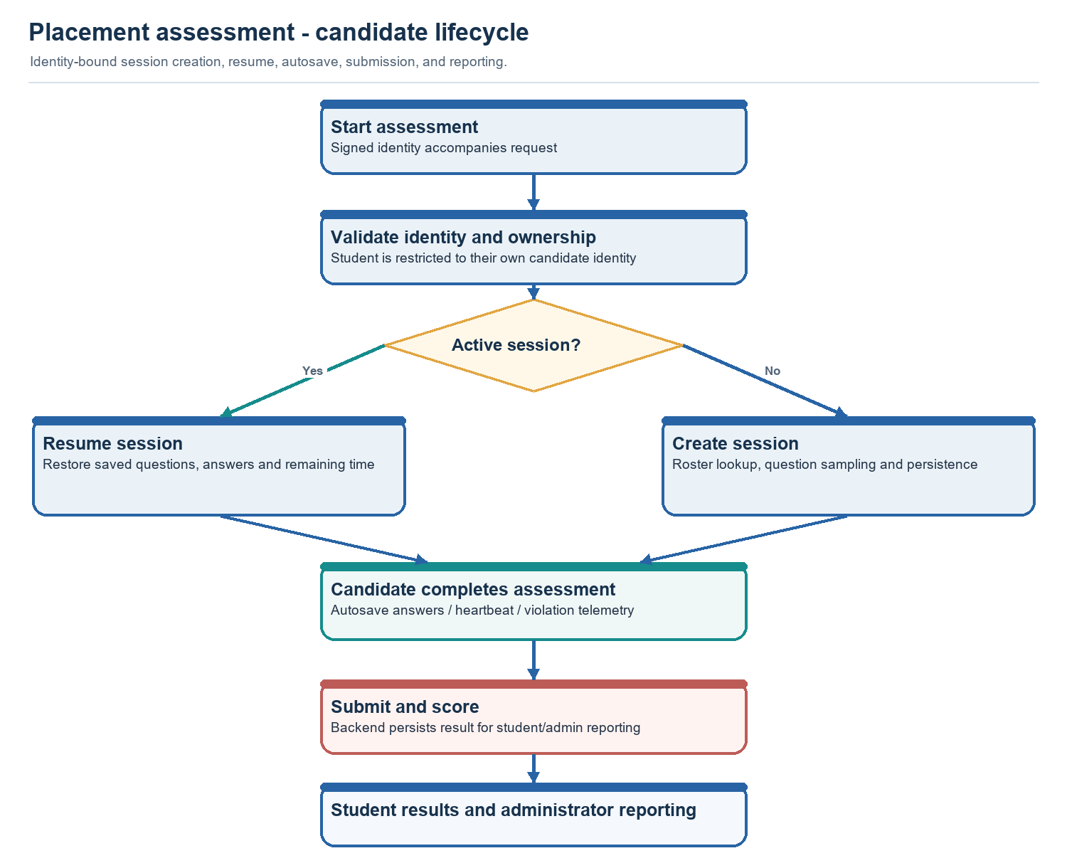
Figure 3. Candidate assessment lifecycle.
The inspected start flow creates a 120-minute session and samples a 62-question
placement assessment when the necessary pools are available:
- 20 aptitude questions.
- 20 verbal questions.
- 20 computer-fundamentals questions.
- Up to 2 coding questions.
Existing sessions may be resumed with saved responses and remaining time.
Questions returned to the candidate are passed through a sanitization step.
Other endpoints support autosave, heartbeat, violation logging, reset, resume,
submission, feedback, analytics, and administrator exports/monitoring.

Assessment administration
The assessment and question-bank APIs support administrative tasks such as
test creation, candidate assignment/reset, live monitoring, exports, question
review, collections, and trainer-test management. Admin endpoints use
administrator-role dependencies in addition to the router's authentication
dependency.
The assessment documentation contains an authorization matrix and open test
coverage notes in
AUTH_ASSESSMENT_REVIEW.md. Consult it
before changing identity, ownership, scoring, or session persistence behavior.

7. Code practice and execution
The frontend code editor service is
src/services/codeExecutionService.ts.
The main code-run and submit endpoints are in backend/app.py.

Execution request flow
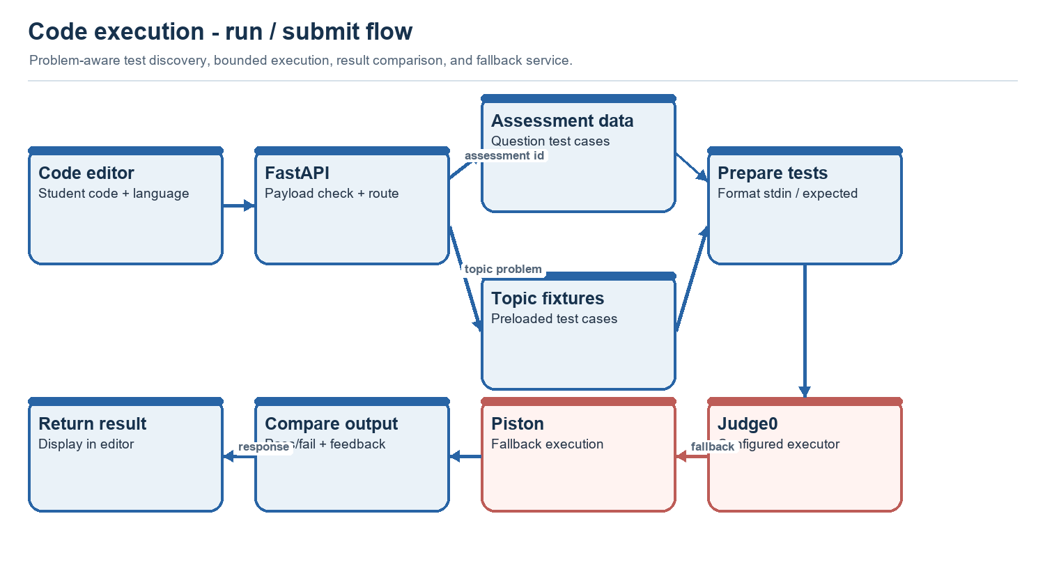
Figure 4. Code execution and test evaluation path.
The backend has separate paths for raw execution and problem-aware run/submit
behavior. Problem-aware operations look up test cases, format inputs, execute
the program, and compare the output. The code limits source payload sizes and
uses an asynchronous semaphore to constrain concurrent execution in relevant
paths.
Execution is an external-service boundary. Depending on configuration and
fallback behavior, student code and test input are sent to a code-execution
service. The optional Judge0 Compose stack
contains Judge0 server/workers and its own private Postgres and Redis services.
Those are for Judge0's operation, not automatically the application's
assessment database.

8. Authentication and request authorization
Authentication endpoints are in
backend/auth_api.py. Shared token validation and
FastAPI dependencies are in backend/auth.py.
The visible login flows include:
- Admin password login: Checks configured admin identity and password
verification, then issues an admin JWT.
- Google login: Verifies a Google credential against configured client IDs;
verified student identities are matched to provisioned identity/roster data,
while configured administrators receive the admin role.
- Manual HITAM login: Exists as a separate endpoint; consult the
authentication code and audit before relying on its current policy.
JWTs carry a subject and role and are checked by shared backend dependencies.
Assessment operations add candidate identity/session-ownership checks; admin
routes require an admin role. Analytics also has authentication/role handling.
The frontend helper in src/utils/apiAuth.ts
attaches stored session tokens and other request headers. Anything shipped to a
browser is visible to the client; a browser-bundled shared key cannot be
treated as a confidential server credential or as a replacement for
user-specific authorization. Do not copy secret values into documentation,
client code, or repository history. Review
AUTH_ASSESSMENT_REVIEW.md for known
security-review findings and residual verification gaps.

9. Data and persistence model
There is no single storage layer for all application state.
Store | Use evidenced in the code | Important behavior
PostgreSQL | Assessment and other server-side database operations when DATABASE_URL is configured | Backend creates/manages pooled connections; deployment must supply a reachable database
SQLite | Local assessment development fallback and local database files | Assessment code explicitly refuses this fallback in production
JSON files | Topic questions, roster data, question content, and some backups | File contents are deployed with the backend and may be used as seed/fallback data
ChromaDB | Persistent vector collection for the standalone retrieval implementation | Exists separately from the active chat orchestrator
Browser storage | Frontend token/user state and assessment drafts | Client-controlled storage; not authoritative for permissions or final assessment scores
Process memory | TTL cache and some transient per-process values | Not shared across workers and generally lost at process restart
Optional Redis | Cache backend when REDIS_URL is configured and reachable | Cache initialization falls back to in-process memory if Redis is unavailable
External services | AI generation, embeddings, code execution, institutional integrations | Availability, latency, limits, and data handling depend on provider/configuration

Database and cache behavior
The main app initializes a PostgreSQL connection pool during application
lifespan when a database URL is configured. The assessment module has its own
database cursor/pool management and a development-only SQLite fallback.
Consequently, a local development experience may continue with SQLite or
bundled files while a production environment correctly fails when the
configured database is unavailable.
The topic cache is implemented in
backend/utils/cache_manager.py. It
uses Redis if configured and reachable; otherwise, it uses an in-process,
thread-safe TTL cache. The in-memory version is per process and is not a
distributed cache.
Some values (for example saved algorithm notes) are held in process memory.
Unless a persistence endpoint/database is used instead, these values should be
assumed ephemeral and not shared across multiple backend workers.

10. API map
This table summarizes route families observed in the application source. It is
not a generated OpenAPI specification; endpoint auth and payload schemas
should be checked in source before integration.
Route family | Main purpose | Notes
/api/auth/* | Admin, Google, and student/institutional login | Issues signed application tokens
/api/chat | Dual-persona tutoring | Current orchestrator uses topic-question prompts; sources list is empty
/api/debate | Compare Teacher and Peer explanations | Separate model call
/api/genealogy | Prerequisite-gap explanation | Uses prerequisite/genealogy helpers
/api/topics | Topic/category listing | Static topic names
/api/topic/* | Overview, MCQ, coding prompt, and preloaded topic content | Mix of generated and file-backed responses
/api/evaluate | Evaluate student answer against expected solution | AI-assisted evaluation
/api/assessment/* | Candidate sessions, autosave, submission, analytics, admin management | Router prefix includes authentication; several routes add ownership/role checks
/api/admin/question-bank/* | Admin question bank and trainer tests | Router-level admin requirement
/api/analytics/* | Activity logging and analytics views | Student/admin authorization in module
/api/cdc/* | CDC integration and result sync/reporting | Router-level admin requirement
/api/code/* | Code execution, run/submit, algorithm storage | Run and submission behavior differs by endpoint
/api/portfolio/*, /api/student/dashboard/* | Student portfolio/dashboard API | Separate from React route names
/health, /readiness | Operational checks | Distinct health/readiness routes
/api/problems/* | Top-problem listing/attempt API source module | Router module exists; main app inclusion was not observed
/api/dashboard/* | Problem-progress API source module | Router module exists; main app inclusion was not observed

11. Configuration and deployment shape
Backend configuration is centralized in
backend/config.py. Important settings include:
- Environment mode (ENV) and development behavior.
- API/JWT signing configuration.
- AI API key and model name.
- DATABASE_URL and pool sizing.
- Retrieval similarity settings.
- Judge0 URL/API configuration and code-execution concurrency.
- Assessment duration/grace period.
- Redis URL, frontend URL, CORS allowlist, and CDC integration settings.
Use deployment environment variables or a secret manager for real credentials.
Do not treat repository/client defaults as safe production secrets. The
backend currently defines fallback values for some credential settings; a
production deployment should deliberately provide strong, unique values and
review the authentication and execution-service configuration.

Local development (Windows PowerShell)
The repository README describes separate backend and frontend terminals. From
the learniverse-ai project root:
# Backend terminal
cd backend
python -m venv .venv
.\.venv\Scripts\Activate.ps1
pip install -r requirements.txt
python -m uvicorn app:app --reload --port 8000
# Frontend terminal, from the project root
npm install
npm run dev
The frontend development server is configured for port 8080; API requests
are proxied to FastAPI on port 8000. Configure backend credentials and
database settings using an appropriate local environment file; never paste
real credentials into documentation or commit them.

Deployment topology caveat
The Compose file at the project root is specifically a Judge0 stack. It
contains Judge0, worker processes, Postgres, and Redis. It does not by
itself define a complete container deployment for the React SPA, Learniverse
FastAPI backend, and the application's assessment database.
The repository contains deployment guides for different workflows and
integration stages. Read them against the active code and target environment
before using commands from them. For example, deployment notes for a
Top-100-problems API should not be treated as proof that its router is mounted
or that the described frontend directory/build output matches this Vite
project.

12. Tests and continuous integration
Frontend scripts in package.json include:
npm run lint
npm run type-check
npm test
npm run build
Vitest uses a jsdom environment and a shared test setup. Backend tests are
under backend/tests and use Pytest.
The GitHub Actions workflow at
.github/workflows/ci.yml runs:
- Backend Pytest with a PostgreSQL service.
- Frontend lint, TypeScript type check, unit tests, and production build.
- Docker Compose configuration validation for the Judge0 services.
Presence of these checks does not imply they were run for a given local
working tree or that production integrations were exercised. Tests requiring
live Google login, external AI, external code execution, or a production
database require their own explicit verification.

13. Current architecture strengths
- The frontend and backend are separated by a clear HTTP API boundary.
- FastAPI routers group authentication, assessment, analytics, and question
bank features.
- Assessment sessions are persisted and support resume/autosave flows.
- Candidate question responses have a sanitization step before delivery.
- Code execution is separated behind an API and uses bounded concurrency in
relevant code paths.
- Redis is optional; local development can use an in-memory cache.
- CI covers backend tests, frontend quality/build checks, and Compose
configuration.
- Existing audit documents record security decisions, regression evidence,
and open verification gaps.

14. Architecture gaps and integration risks
These are observations about cohesion and verification, not a complete
security review.
- RAG path mismatch: ChromaDB retrieval is present but is not called by
the active chat orchestrator described above. The API returns no citation
sources from that path.
- Multiple RAG implementations: rag/pipeline.py and
rag/rag_pipeline.py describe different flows and do not appear to share
matching interfaces. Clarify the intended pipeline and remove or wire
obsolete code when implementing grounded chat.
- Router reachability: Some problem/dashboard router modules appear in
source but were not observed in the main app's include_router list.
Verify route mounting before relying on those endpoints or documenting
them as available features.
- Mixed persistence: PostgreSQL, SQLite, files, browser storage, ChromaDB,
Redis, and in-memory state have different durability and multi-worker
properties. Features should document which one is authoritative.
- Multiple API-call styles: Some frontend features use direct fetch
while others use dedicated services. A consistent API client could reduce
drift in authentication, error handling, and response validation.
- External service boundaries: AI, embeddings, code execution, Redis,
database, and institutional integrations add independent availability and
configuration requirements.
- Security-sensitive configuration: Review fallback credentials and
frontend-shipped request headers before production; a value embedded in a
client bundle is public by design.
- Operational docs vary in scope: Deployment instructions have been
written for several project features. Validate commands, paths, router
registration, ports, and build outputs against the current app before
following a particular guide.

15. Suggested next steps for improving the architecture
- Choose and wire the canonical chat retrieval path. If textbook-grounded
answers and citations are product requirements, make the active
orchestrator retrieve chunks, pass retrieved context to both personas, and
return source metadata. Add endpoint-level tests for citations and empty
retrieval.
- Reconcile architecture documentation and runtime config. Make the
README's model, embedding provider, and RAG description match the actual
environment-driven implementation.
- Audit router reachability. Compare all route modules with the app
composition and add integration tests that assert intended routes are
mounted.
- Centralize frontend API access. Establish typed request/response
contracts, consistent error handling, and a single authenticated API
client.
- Identify source-of-truth data. Document and enforce which database or
content source owns each question, session, user identity, and progress
record.
- Plan production configuration explicitly. Require deployment secrets,
avoid client-side shared credentials, and document dependencies, backup,
migration, health-check, and rollback procedures.
- Test external boundaries with fakes and controlled integration tests.
Keep normal CI deterministic while separately verifying real provider
configuration in a secure staging environment.

16. Source map
Concern | Main files
Frontend bootstrap/routes | src/main.tsx, src/App.tsx
Topic/conversation UI | src/pages, src/components/ConversationBox.tsx
Frontend auth headers | src/utils/apiAuth.ts
Frontend code execution | src/services/codeExecutionService.ts
FastAPI composition and direct APIs | backend/app.py
Backend configuration | backend/config.py
Authentication | backend/auth.py, backend/auth_api.py
AI prompts/generation | backend/rag/prompts.py, backend/rag/generator.py
Active chat orchestration | backend/rag/rag_pipeline.py
Separate vector retrieval implementation | backend/rag/retriever.py, backend/rag/pipeline.py
Assessment lifecycle | backend/placement_assessment_system/api.py
Admin question bank | backend/placement_assessment_system/question_bank_admin.py
Analytics and CDC | backend/analytics_api.py, backend/cdc_integration.py
Topic cache | backend/utils/cache_manager.py
Book ingestion | backend/scraper
Judge0 stack | docker-compose.prod.yml
CI | .github/workflows/ci.yml
Documentation index | docs/README.md

Scope note: This guide was prepared from repository source and documentation.
No application code was changed as part of the architecture analysis. Its
statements about current behavior reflect the inspected source paths; this
document does not claim that a build, test suite, deployment, or live external
integration was executed.

