# SMART INDIA HACKATHON 2024

## TEAM NAME: NeuralFlow

## THEME:

Miscellaneous

## PROBLEM STATEMENT:

### Problem Statement ID:

1605

### Problem Statement Title:

Women Safety Analytics – Protecting Women from Safety Threats

### Description:

In today's world, personal safety is a major concern for people from all walks of life. Many face dangers like harassment, violence, and environmental hazards, leading to feelings of fear and insecurity. Unfortunately, there isn't a centralized system to report and track these threats, which leaves individuals without vital information that could help them avoid unsafe situations.  
The resources available for safety are often scattered and difficult to access, making it hard for people to find the help they need during a crisis. Without real-time data on local safety conditions, it's challenging for individuals to make informed decisions about where they can be safe. This issue is especially pressing in cities, where crime rates and environmental risks can vary greatly from one neighborhood to another.  
Additionally, many people hesitate to report incidents due to fear of retaliation or distrust in existing systems. This lack of reporting can create a false sense of security and make it harder for communities to tackle safety problems effectively. Without a reliable way to share information and work together on safety efforts, our ability to respond to threats is severely limited.  
In the end, there's an urgent need for a strong safety analytics framework that can empower individuals to protect themselves and build a culture of safety awareness in our communities.

### Solution Proposed (Abstract):

The **‘Women Safety Analytics’** mobile application is a vital tool designed to protect women from **safety threats** by offering a centralized platform for real-time incident monitoring and reporting. Powered by **advanced AI and ML models**, this application not only gathers and analyzes data but also intelligently **predicts potential risks**, enabling proactive safety measures. With its comprehensive features, users are empowered to share crucial information, receive timely alerts, and access a wealth of resources designed to enhance their situational awareness. By leveraging AI-driven insights, the application facilitates a faster and more accurate response to potential dangers, ensuring that users are better equipped to navigate and avoid unsafe situations. This robust, data-driven approach transforms the way safety is managed, making it a cornerstone in the effort to create a safer environment for women everywhere. The key features of the application include:  
  
**1. Authentication:**  
The Safety Analytics application employs a strong authentication process to ensure user security and privacy. Users must register with their mobile numbers to create personalized accounts. For added security, the application utilizes mobile number verification, sending a **one-time password (OTP)** to the registered number for login. This robust system creates a safe environment for all users, ensuring their personal information remains protected.  
  
**2. Voice SOS:**  
The application integrates **AI-driven neural networks and natural language processing (NLP)** to power its Voice SOS feature. This function allows users to send immediate distress signals through voice commands, which are processed in real-time. Neural networks accurately recognize and interpret spoken phrases, ensuring that emergency requests are quickly identified and prioritized. NLP enhances this capability by understanding the context and intent behind the user's words, allowing for more tailored responses based on the situation. The AI-driven nature of this feature ensures that even subtle or indirect distress signals are recognized, streamlining the reporting process and enabling users to seek help effortlessly. This makes the application an essential tool for ensuring safety in a wide range of scenarios.  
  
**3. Button SOS and Night Support:**  
The application includes an AI-enhanced SOS button that sends live location data to the police and trusted contacts during emergencies, especially when activated by the Voice SOS feature. This instant alert system, powered by machine learning algorithms, ensures law enforcement can respond quickly and effectively to the user's location. Additionally, the application offers a Night Support button, **allowing users to share their live location with trusted contacts when they feel threatened.** AI models predict and highlight potentially unsafe areas based on historical data, providing users with added insights. This dual functionality enhances safety by enabling real-time location sharing and fostering a support network, ensuring help is always available when needed most.  
  
**4. SOS Activate:**  
The SOS Activate feature initiates **both audio and video recording during an emergency, leveraging AI to enhance the quality and relevance of the recordings.** This dual recording captures critical evidence and sends it to the police for immediate action. Machine learning models ensure that the most crucial moments of the incident are highlighted, making it easier for law enforcement to assess the situation quickly. **All recordings are securely stored in the database,** with AI-driven encryption protocols ensuring that the **data remains safe and accessible even if the user's device is compromised.** This feature not only aids law enforcement in understanding the situation but also provides users with peace of mind, knowing that crucial evidence is preserved and retrievable, regardless of the device's condition.  
**5. Password Protection for Mobile Shutdown:**  
The Safety Analytics application includes a crucial AI-powered feature that **requires a password to switch off the mobile phone during emergencies.** This ensures that the device cannot be powered down by unauthorized individuals. **AI algorithms monitor for unauthorized attempts to shut down** **the device,** providing additional security alerts if suspicious behavior is detected. This added security measure prevents attackers from disabling the phone and cutting off communication, allowing emergency services like SOS signals, live location sharing, and audio/video recording to remain active. By maintaining the device's functionality in high-risk situations, this feature ensures continuous connectivity with law enforcement and trusted contacts, providing users with an extended window to seek help and enhancing their overall safety.

In summary, the Safety Analytics application, powered by AI and ML models, offers a comprehensive and intelligent approach to protecting women from safety threats. By integrating advanced technologies into every aspect of the application, it ensures that users are supported, informed, and connected in real-time, making it a crucial tool in the ongoing effort to enhance personal safety.

**WORKFLOW:**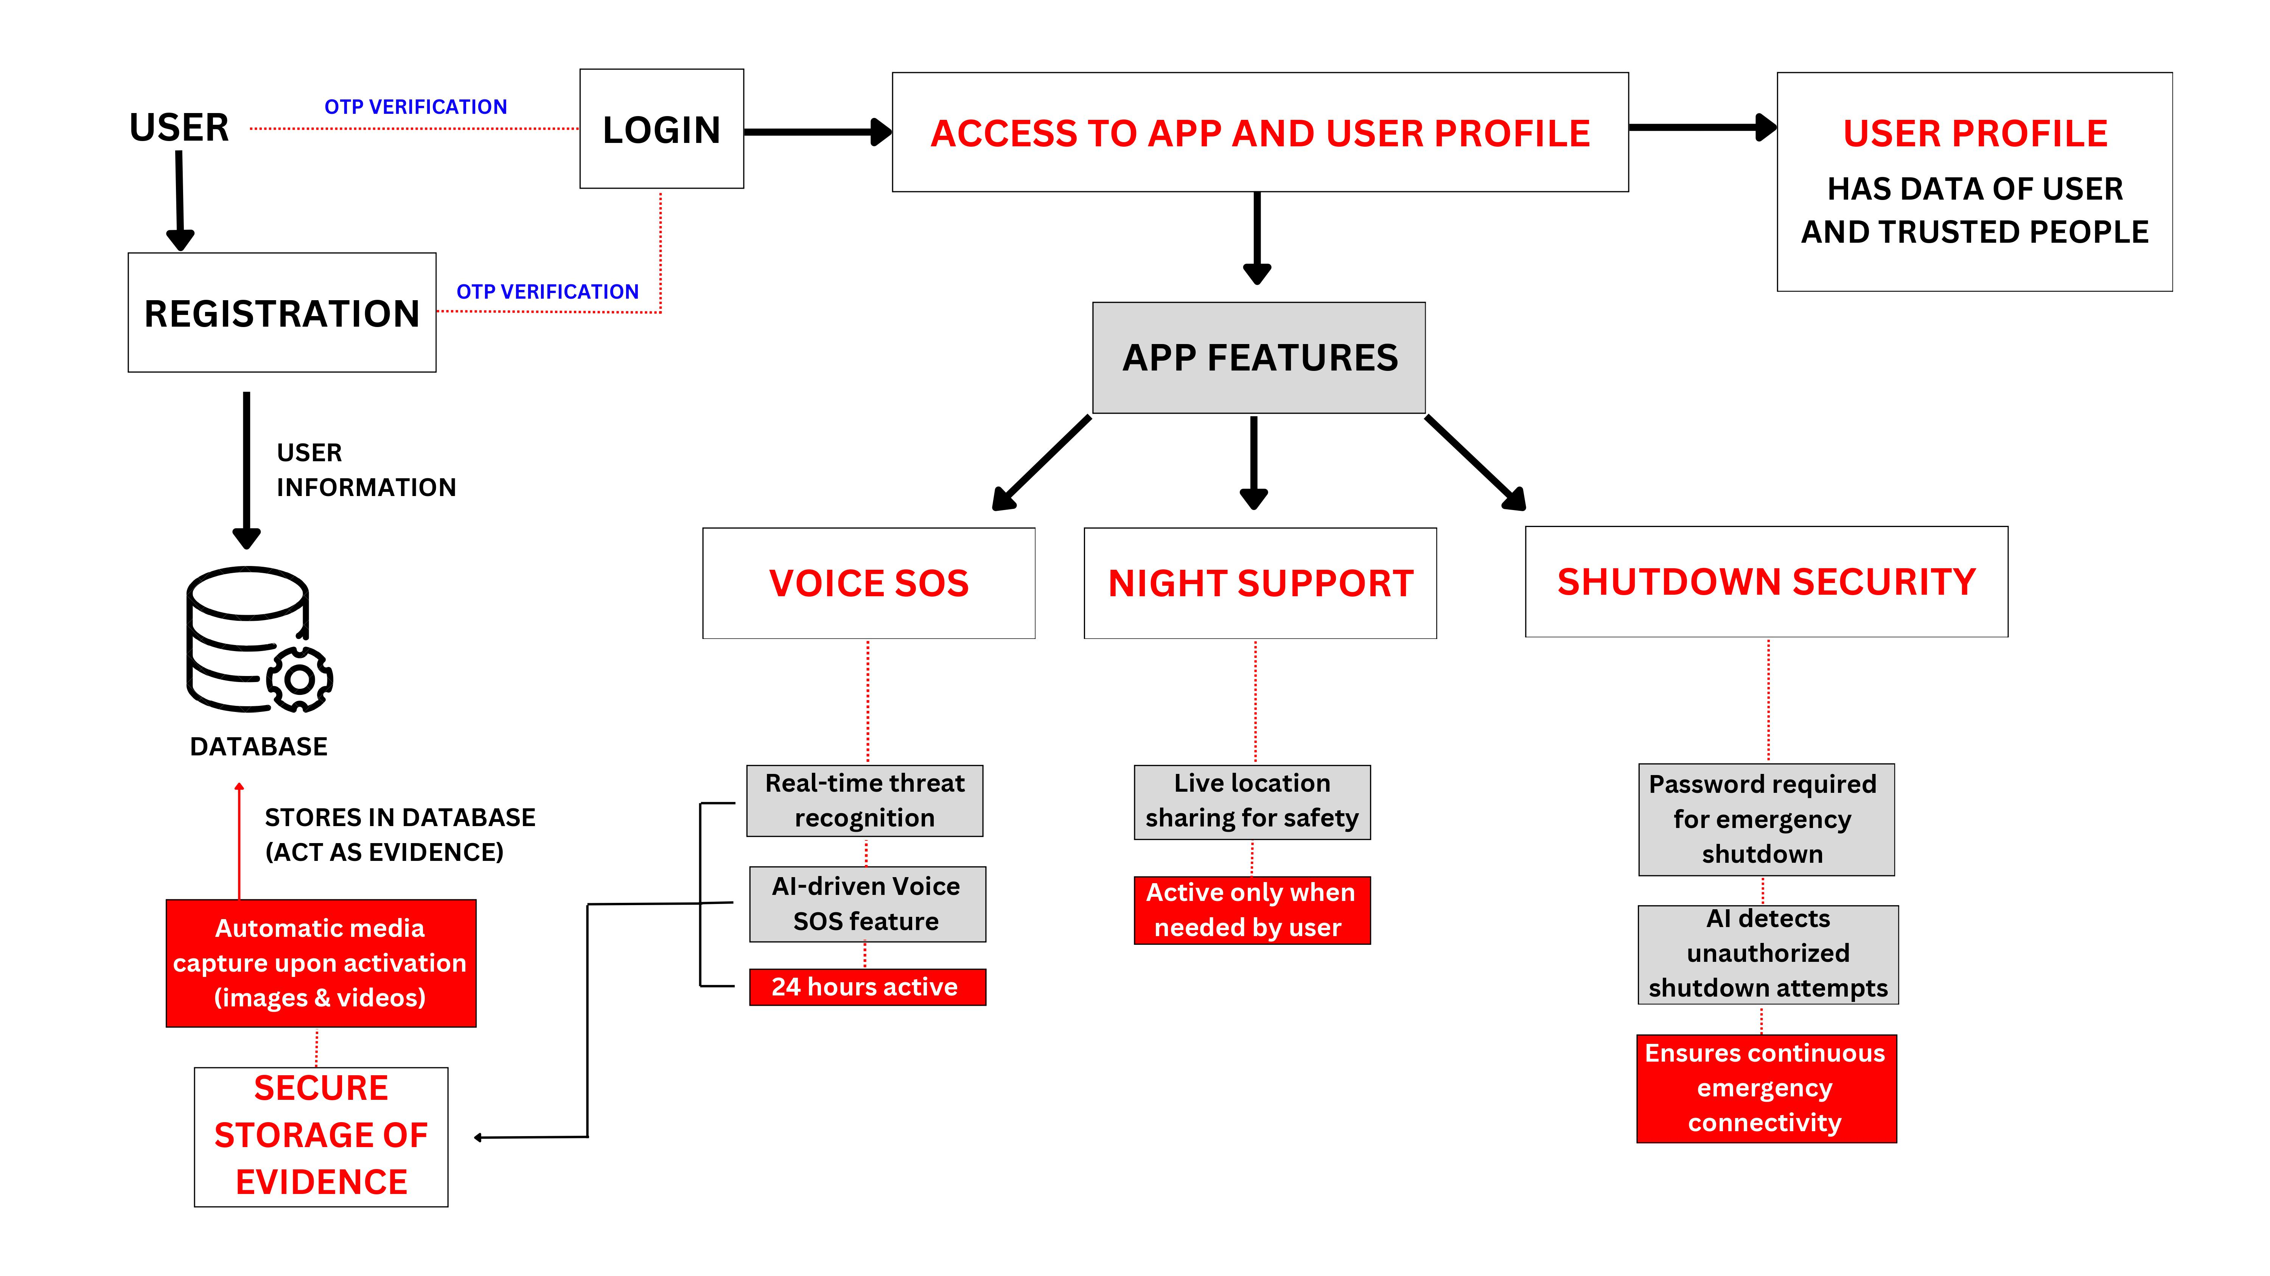

# TECH-STACK:

# Frontend Technologies

|  |  |
| --- | --- |
| Technology | Functionalities and Uses |
| React Native | Build cross-platform mobile applications with a native look and feel. Create interactive and dynamic user interfaces. |

# Backend Technologies

|  |  |
| --- | --- |
| Technology | Functionalities and Uses |
| Node.js | Run JavaScript code on the server side. |
| Express.js | Simplify routing and middleware management in Node.js applications. Build scalable and robust server-side applications. |
| Flask | Develop lightweight and flexible web applications in Python. Handle HTTP requests and responses efficiently. |
| MongoDB | Store and manage data in a NoSQL database. |
|  | Provide high scalability and flexibility with document-based storage. |
| Firebase | Offer real-time database, authentication, and hosting services. |
| Twilio API | Integrate communication services like SMS, voice, and video into applications. Facilitate notifications and real-time communication features. |

# ML Technologies

|  |  |
| --- | --- |
| Technology | Functionalities and Uses |
| TensorFlow | Develop and train machine learning models. |
|  | Build and deploy neural networks for various applications. |
| Neural Networks | Implement advanced AI models for pattern recognition and predictive analysis. |
| NLP | Enable natural language understanding and processing in applications. Enhance text and speech interactions with users |

# Team – Details:

|  |  |  |  |
| --- | --- | --- | --- |
| Name | USN | Phone Number | Email Address |
| Dhanush B | 1SI22CS055 | 8618541131 | talktodhanush4554@gmail.com |
| Dhanush N Prabhu | 1SI22IS026 | 9448121495 | dhanushprabhu0604@gmail.com |
| Dhanush K Gowda | 1SI22CI062 | 6361304218 | dhanushkgowda2226@gmail.com |
| Kruthi S | 1SI22IS044 | 9481555050 | kruthis35@gmail.com |
| Nesara N | 1SI22IS060 | 9353219611 | nesaran2704@gmail.com |
| Dhanush U | 1SI22CS056 | 7975789740 | dhanushu834@gmail.com |