Full Stack Development with MERN
Project Documentation
Online Book Store

1. Introduction
Project Title: Online Book Store

Team Members

- KONETI DHANUSH – Team Leader
- YAKKALA DIVYA JYOTHI – Team Member
- DHARMANA PAVITHRA – Team Member
- SUDHARSHAN KUMAR NAREE – Team Member
- DIDDY SRINIVAS PUNEETH – Team Member

2. Project Overview

Purpose
Online BookStore (branded in the application as “BookEase”) is a full-stack e-commerce platform that connects independent book sellers with readers. The goal of the project is to provide a lightweight marketplace where sellers can list and manage their own book inventory, customers can browse, search, and purchase books, and administrators can oversee and moderate the platform.

Features
- Customer storefront: browse the full catalog, search by title/author, and filter by genre.
- Shopping cart with add/remove items and quantity management.
- Checkout flow that captures a shipping address and converts a cart into one or more orders, decrementing stock automatically.
- Order history (“My Orders”) for logged-in customers.
- Seller dashboard with store statistics (books listed, orders received, revenue) and full CRUD management of book listings, including cover-image upload.
- Seller onboarding requires admin approval before a seller account can list books.
- Admin dashboard with platform-wide statistics (users, sellers, books, revenue) and tools to manage users, sellers (approve/block/delete), and book listings.
- Role-based authentication and authorization for three separate roles: User, Seller, and Admin, each with independent login sessions.

3. Architecture

Frontend
The client is a single-page application built with React 18 and Vite, styled with Tailwind CSS. Routing is handled with react-router-dom, and API communication is centralized through Axios instances (one per role — user, seller, admin) defined in src/services/api.js, each of which automatically attaches the correct JWT bearer token from localStorage and clears it on a 401 response.

Backend
The server is a Node.js REST API built with Express.js. It is organized into routes, controllers, models, and middleware layers. Cross-origin requests are restricted to the configured client origin via the cors package, and file uploads (book cover images) are handled with multer, storing images on disk under server/uploads and serving them statically.

Database
Data is persisted in MongoDB via Mongoose ODM. The schema is split across four collections:
Collection | Key Fields | Notes
User | name, email, password (hashed), isBlocked, cart[] | cart embeds bookId + quantity references to Book
Seller | name, email, password (hashed), isApproved, isBlocked | isApproved gates the ability to list books
Admin | name, email, password (hashed) | Full platform oversight role
Book | title, author, genre, price, quantity, itemImage, sellerId | quantity is decremented on checkout
MyOrder | buyer/seller/book snapshot, shipping address, status, BookingDate, Delivery | status enum: Placed, Shipped, Out for Delivery, Delivered, Cancelled

4. Setup Instructions

Prerequisites
- Node.js v18 or later (and npm)
- MongoDB — either a local install/Windows service, a Docker container, or a free MongoDB Atlas cluster
- Git (to clone/push the repository)

Installation
- Clone the repository: git clone <repository-url>
- Install backend dependencies: cd server && npm install
- Install frontend dependencies: cd ../client && npm install
- Create a server/.env file (see template below) with your MongoDB connection string and a JWT secret.
- Create a client/.env file with the backend API URL.
- Seed the database with sample books: cd server && npm run seed:local (or npm run seed).

Environment Variables — server/.env
Variable | Example / Description
PORT | 8000
MONGO_URI | mongodb://127.0.0.1:27017/bookstore (local) or an Atlas connection string
JWT_SECRET | a long, random secret string used to sign login tokens
CLIENT_URL | http://localhost:5173 (used for CORS)

Environment Variables — client/.env
Variable | Example / Description
VITE_API_URL | http://localhost:8000

5. Folder Structure

Client (React frontend)
- src/User — customer-facing pages (signup, login, browse, book detail, cart, checkout, orders, profile)
- src/Seller — seller signup/login and seller dashboard, listings management, add/edit book
- src/Admin — admin signup/login and admin dashboard, user/seller/book management
- src/Components — shared UI (Navbar, Footer, Home landing page, etc.)
- src/services/api.js — centralized Axios instances and auth/token helpers
- src/App.jsx, src/main.jsx — routing and application entry point

Server (Node.js backend)
- routes — userRoutes.js, sellerRoutes.js, adminRoutes.js (Express routers)
- controllers — UsersController.js, SellerControllers.js, AdminControllers.js (business logic)
- models — Users/, Seller/, Admin/ schemas (Mongoose models)
- middlewares — authMiddleware.js (JWT verification + role guard), upload.js (multer image upload config)
- config/connect.js — MongoDB connection setup
- seed — seedBooks.js / seedLocalBooks.js (sample data scripts)
- uploads — stored book cover images, served statically at /uploads
- server.js — Express app entry point

6. Running the Application
Run the backend and frontend in two separate terminals:

Backend
cd server npm run dev

Frontend
cd client npm run dev
The API runs at http://localhost:8000 and the client runs at http://localhost:5173 by default. Visiting http://localhost:8000 directly should return the health-check message “BookStore API is running...”

7. API Documentation
All endpoints are prefixed with /api. Protected routes require an Authorization: Bearer <token> header and are additionally restricted to the matching role (user, seller, or admin).

User routes — /api/users
Method | Endpoint | Access | Description
POST | /signup | Public | Register a new customer account
POST | /login | Public | Log in and receive a JWT
GET | /profile | User | Get the logged-in user's profile
PUT | /profile | User | Update profile / password
GET | /books | Public | Browse/search/filter the catalog (?search=&genre=)
GET | /books/:id | Public | Get a single book's details
GET | /cart | User | Get the current cart
POST | /cart | User | Add a book to the cart
DELETE | /cart/:bookId | User | Remove an item from the cart
POST | /checkout | User | Convert the cart into order(s)
GET | /orders | User | List the user's past orders

Seller routes — /api/sellers
Method | Endpoint | Access | Description
POST | /signup | Public | Register a new seller account (requires admin approval)
POST | /login | Public | Log in and receive a JWT
GET | /profile | Seller | Get the seller's profile
PUT | /profile | Seller | Update profile / password
POST | /books | Seller | Add a book (multipart form, field: itemImage)
GET | /books | Seller | List the seller's own books
PUT | /books/:id | Seller | Update a book listing
DELETE | /books/:id | Seller | Remove a book listing
GET | /orders | Seller | List orders containing the seller's books
PUT | /orders/:id | Seller | Update an order's fulfillment status

Admin routes — /api/admins
Method | Endpoint | Access | Description
POST | /signup | Public* | Register a new admin account
POST | /login | Public | Log in and receive a JWT
GET | /users | Admin | List all customer accounts
PUT | /users/:id/block | Admin | Block / unblock a customer
DELETE | /users/:id | Admin | Delete a customer account
GET | /sellers | Admin | List all seller accounts
PUT | /sellers/:id/approve | Admin | Approve a pending seller
PUT | /sellers/:id/block | Admin | Block / unblock a seller
DELETE | /sellers/:id | Admin | Delete a seller account
GET | /books | Admin | List every book on the platform
DELETE | /books/:id | Admin | Remove any book listing
GET | /orders | Admin | List every order on the platform
* Admin signup is open in this build for development convenience; it should be locked down or removed before production deployment (see Known Issues).
Example response — POST /api/users/login:
{ "success": true, "token": "<jwt>", "user": { "id": "...", "name": "...", "email": "..." } }

8. Authentication
Authentication is stateless and token-based using JSON Web Tokens (jsonwebtoken):
- Passwords are hashed with bcryptjs (10 salt rounds) before being stored; plaintext passwords are never persisted.
- On successful signup/login, the server signs a JWT containing the user's id and role, valid for 7 days.
- The client stores each role's token separately in localStorage (bookstore_user_token, bookstore_seller_token, bookstore_admin_token), allowing a user, seller, and admin session to coexist in the same browser.
- Every protected request attaches the token as an Authorization: Bearer <token> header via an Axios request interceptor.
- On the server, the protect middleware verifies the token's signature and expiry, and the authorizeRoles(...) middleware checks that the token's role matches the roles allowed for that route (e.g. only “admin” can call admin management routes).
- A 401 response (invalid/expired token) automatically clears the stored token on the client and returns the user to a logged-out state.

9. User Interface
Selected screens from the application, demonstrating the customer, seller, and admin experiences.

Fig. 1 — Customer landing page (BookEase home)
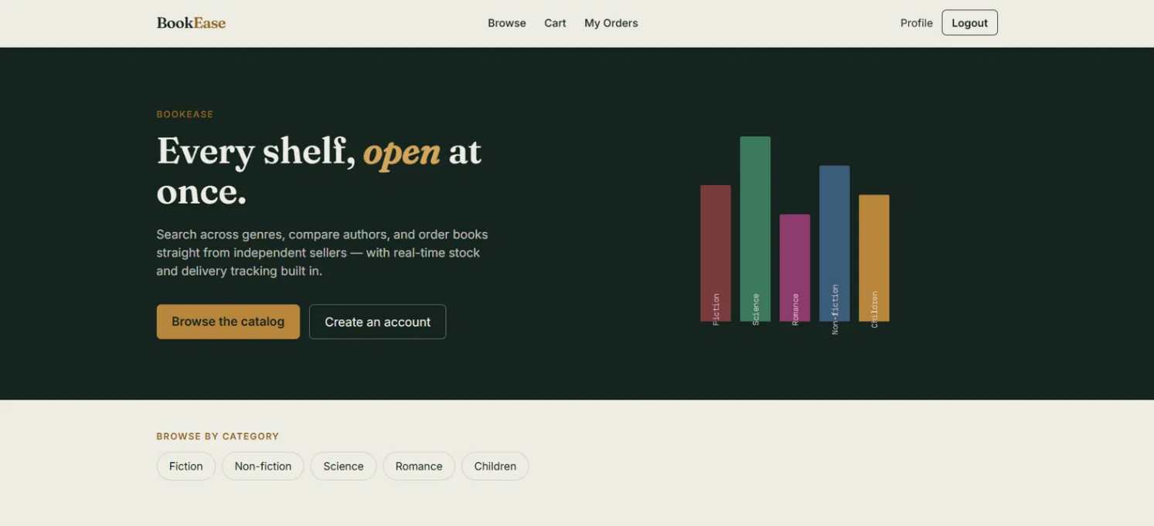

Fig. 2 — Admin dashboard: platform-wide statistics and management shortcuts
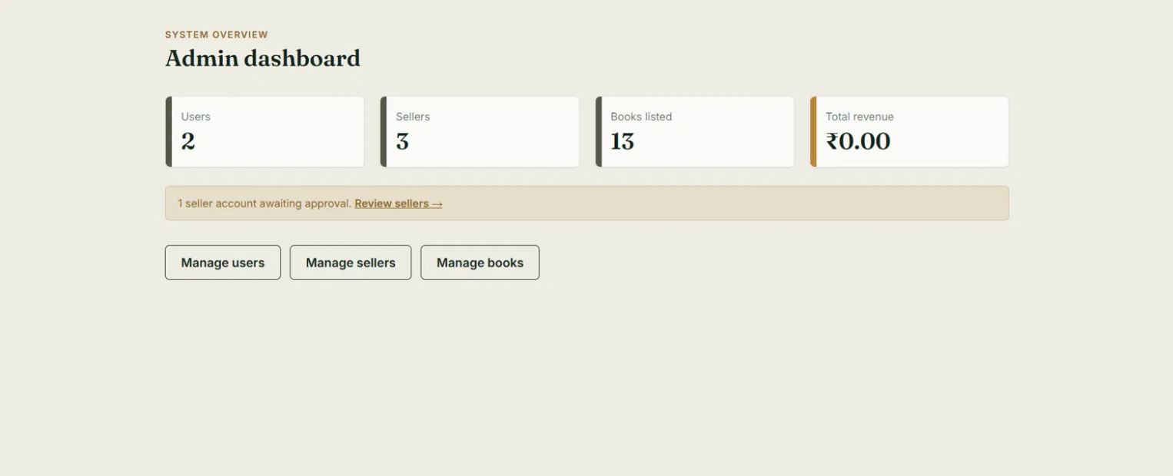

Fig. 3 — Seller dashboard: store-level statistics
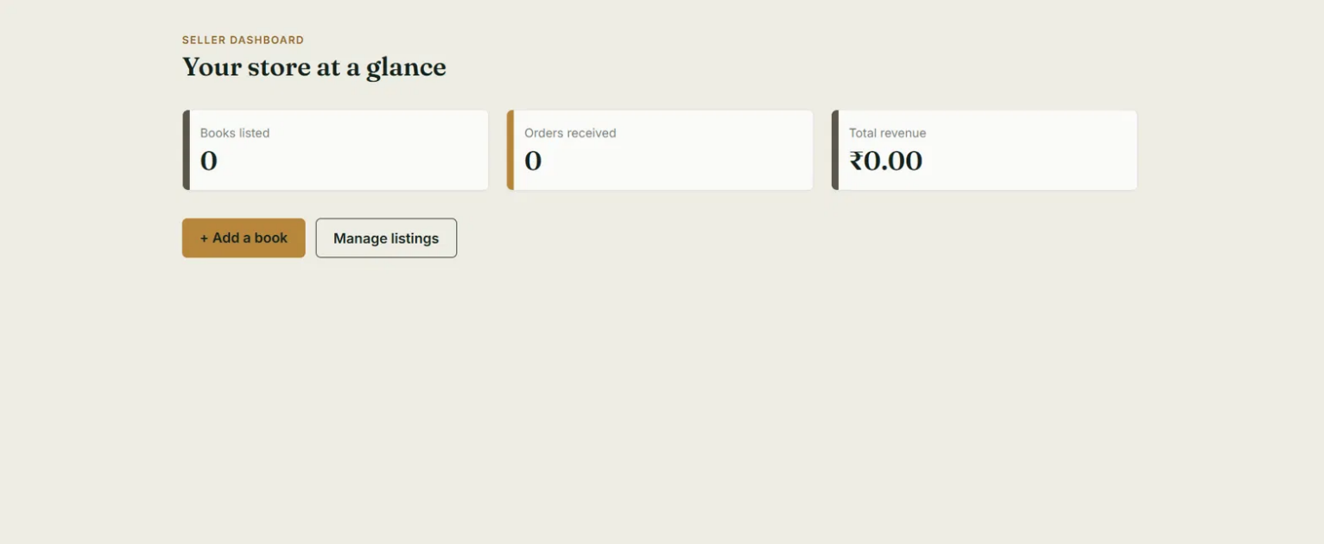

Fig. 4 — Seller “Add a book” form with cover-image upload
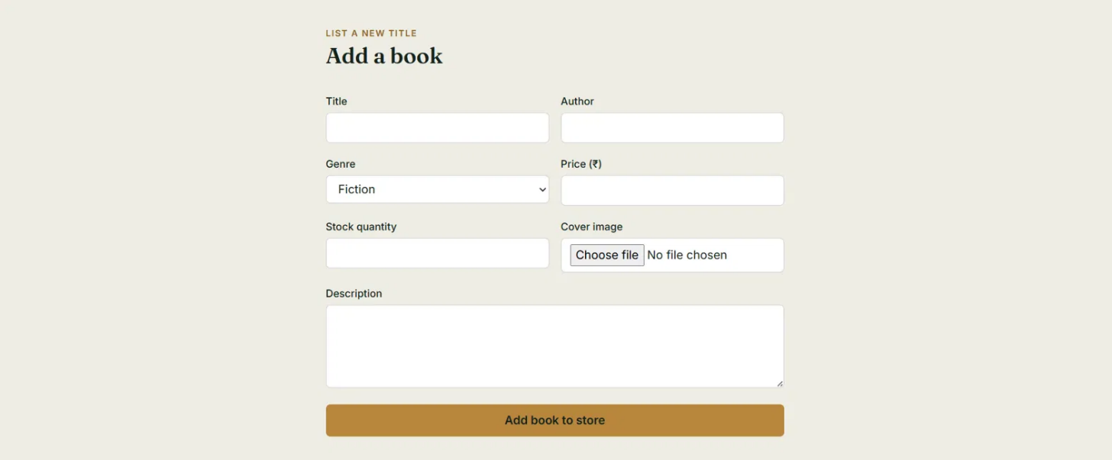

Fig. 5 — Seller book-listing management view
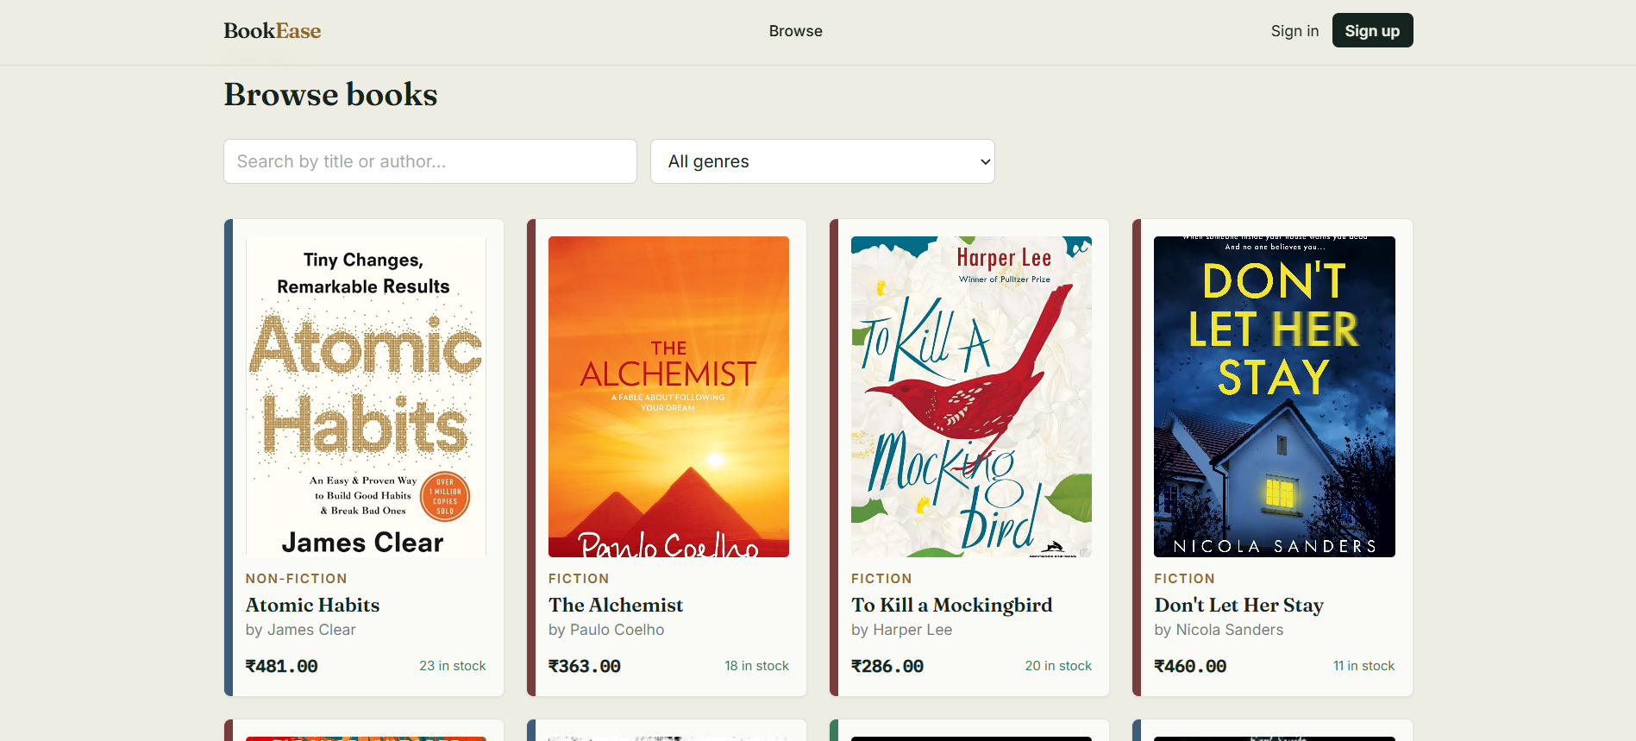

10. Testing
The application was tested manually during development:
- API endpoints were exercised through the live UI and via the browser's Network tab (DevTools) to confirm request/response payloads and status codes for signup, login, and role-restricted routes.
- End-to-end role flows were verified manually: customer signup → browse → add to cart → checkout → view orders; seller signup → admin approval → add/manage book listings; admin signup → login → manage users/sellers/books.
- Error handling was tested for common failure cases: missing environment variables, unreachable MongoDB instance, invalid credentials, and expired/invalid JWTs.
No automated test suite (e.g. Jest/Supertest) is currently included; this is listed under Future Enhancements.

11. Screenshots or Demo
A walkthrough demo of the application is available at the link below:
Demo Video (Google Drive)
Additional UI screenshots are included in Section 9 — User Interface.

12. Known Issues
- The admin dashboard's “Total revenue” figure is a static placeholder (₹0.00) and is not yet calculated from actual order data.
- Admin signup is publicly accessible with no invite/verification step, which is a security risk in a production deployment.
- There is no email verification or password-reset flow for any of the three roles.
- Order status updates (Placed → Shipped → Delivered) are supported on the backend but are not surfaced with real-time notifications to the customer.
- Uploaded book cover images are stored on local disk (server/uploads); this will not persist across deploys on most cloud hosting platforms and should be moved to object storage (e.g. S3/Cloudinary) for production use.

13. Future Enhancements
- Integrate a payment gateway (e.g. Razorpay/Stripe) and compute real order/seller/platform revenue.
- Add email verification, password reset, and two-factor authentication.
- Add product reviews and ratings for books.
- Add real-time order-status notifications (email or in-app).
- Migrate image storage to a cloud object store (S3, Cloudinary, etc.).
- Add automated testing (unit tests for controllers, integration tests for API routes, and end-to-end UI tests).
- Add pagination and more advanced filtering/sorting to the book catalog.
- Restrict or invite-gate admin signup before production deployment.

