Project Design Phase-II
Data Flow Diagram & User Stories

Date | 17 July 2026
Team ID
Project Name | Online Book Store
Maximum Marks | 4 Marks

Data Flow Diagrams:
A Data Flow Diagram (DFD) is a traditional visual representation of the information flows within a system. A neat and clear DFD can depict the right amount of the system requirement graphically. It shows how data enters and leaves the system, what changes the information, and where data is stored.

BookEase — Online BookStore Application: Level 0 (Context) and Level 1 (Detailed) Data Flow Diagrams

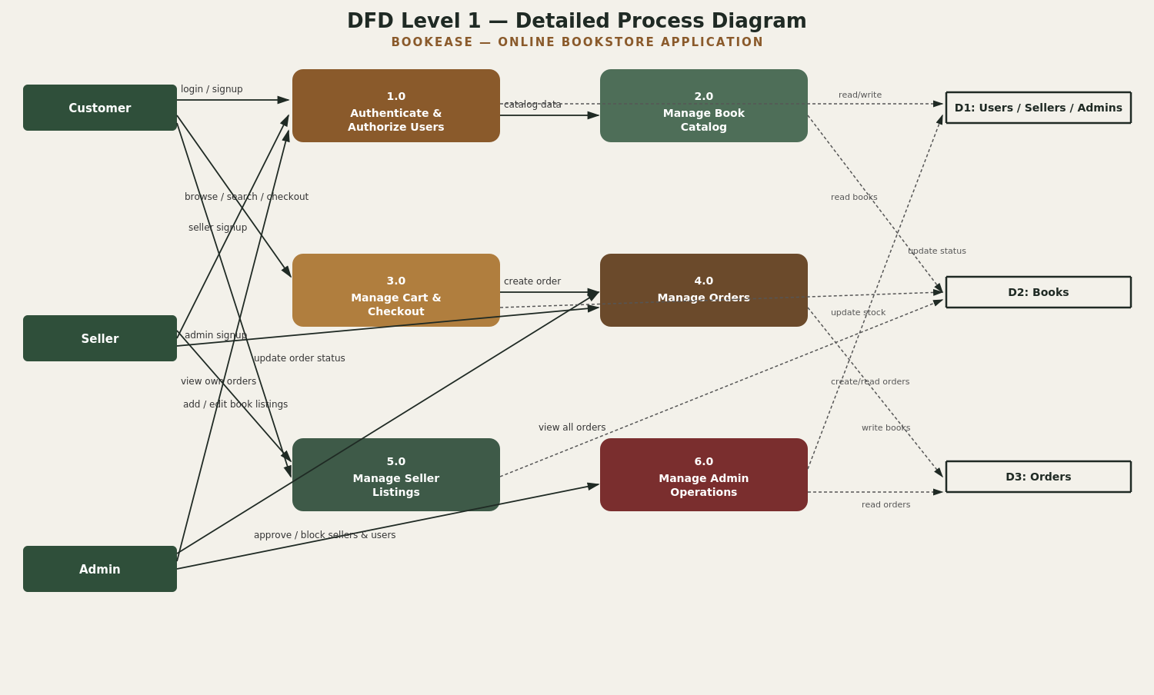

User Stories
Use the below template to list all the user stories for the product.
User Type | Functional Requirement (Epic) | User Story Number | User Story / Task | Acceptance criteria | Priority | Release
Customer | Registration | USN-1 | As a customer, I can register by entering my name, email, and password. | I can log in immediately after registering. | High | Sprint-1
 |  | USN-2 | As a customer, I want my password stored securely so my account stays safe. | Passwords are never stored in plain text (hashed with bcrypt). | High | Sprint-1
 | Login | USN-3 | As a customer, I can log in with my email and password to access my dashboard. | I receive a session token (JWT) and land on the Browse page. | High | Sprint-1
 | Browse & Search | USN-4 | As a customer, I can browse and filter the book catalog by genre. | Results update to show only books in the selected genre. | High | Sprint-2
 |  | USN-5 | As a customer, I can search for a specific book title or author. | Matching books appear in the search results. | Medium | Sprint-2
 | Cart & Checkout | USN-6 | As a customer, I can add books to my cart and check out with a shipping address. | My order is placed and the book's stock decreases accordingly. | High | Sprint-2
 | Order Tracking | USN-7 | As a customer, I can view my past orders in “My Orders.” | All my past orders display with the correct items and status. | Medium | Sprint-4
Seller | Registration | USN-8 | As a seller, I can sign up for a seller account. | My account is created but blocked from listing books until approved. | High | Sprint-1
 | Approval Workflow | USN-9 | As a seller, I want admin approval required before I can list books, so buyers can trust the marketplace. | I cannot add books until an admin approves my account. | High | Sprint-3
 | Book Listings | USN-10 | As a seller, I can add a new book with a cover image, price, and stock quantity. | The book appears in my listings and the public catalog. | High | Sprint-3
 | Store Dashboard | USN-11 | As a seller, I can view my store stats: books listed, orders received, and revenue. | Dashboard numbers match my actual listings and orders. | Medium | Sprint-4
Admin | Seller Approval | USN-12 | As an admin, I can approve or block seller accounts. | Approved sellers can list books; blocked sellers cannot log in. | High | Sprint-3
 | Platform Management | USN-13 | As an admin, I can manage all users, sellers, and books from a dashboard. | I can view, block, or delete any account or listing. | High | Sprint-3
 | Order Oversight | USN-14 | As an admin, I can view every order placed on the platform. | The order list reflects all orders across every seller. | Low | Sprint-4

