Project Design Phase-II
Technology Stack (Architecture & Stack)

Date | 17 July 2026
Team ID
Project Name | Online Book Store
Maximum Marks | 4 Marks

Technical Architecture:
The Deliverable shall include the architectural diagram as below and the information as per the table1 & table 2
BookEase — Online BookStore Application
Note: Diagram reflects the project's actual MERN stack (React/Vite client, Node.js/Express API, MongoDB via Mongoose), derived directly from the codebase's routes, middleware, controllers, and models.
Guidelines:
Include all the processes (As an application logic / Technology Block)
Provide infrastructural demarcation (Local / Cloud)
Indicate external interfaces (third party API’s etc.)
Indicate Data Storage components / services
Indicate interface to machine learning models (if applicable)
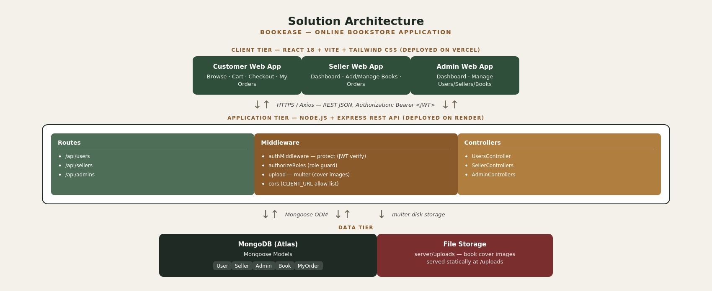

Table-1 : Components & Technologies:
S.No | Component | Description | Technology
- 1. | User Interface | How the three user roles interact with the application: a browsable customer storefront, a seller listing/management dashboard, and an admin moderation dashboard. | React 18, Vite, Tailwind CSS, react-router-dom, Axios
- 2. | Application Logic-1 | Core REST API logic: routing, request handling, and orchestration across the three roles. | Node.js, Express.js
- 3. | Application Logic-2 | Authentication and authorization logic: password hashing, JWT issuing/verification, and role-based route guarding. | bcryptjs, jsonwebtoken, custom authMiddleware (protect, authorizeRoles)
- 4. | Application Logic-3 | Book cover image upload handling for seller listings. | Multer (disk storage), served statically from /uploads
- 5. | Database | Persistent storage for users, sellers, admins, books, and orders, including stock levels that are decremented on checkout. | MongoDB (NoSQL) via Mongoose ODM
- 6. | Cloud Database | Cloud-hosted database service so the app isn't tied to a local MongoDB instance. | MongoDB Atlas
- 7. | File Storage | Storage for book cover images uploaded by sellers. | Local filesystem (server/uploads) in development; recommended migration to cloud object storage (e.g. AWS S3, Cloudinary) for production
- 8. | External API-1 | No external API is currently integrated for payments; planned for a future release. | Planned: Razorpay / Stripe payment gateway API
- 9. | External API-2 | No second external API is currently integrated. | Not applicable in the current build
- 10. | Machine Learning Model | No machine learning model is used in the current version of the application. | Not applicable
- 11. | Infrastructure (Server / Cloud) | Local development runs the client and API as separate processes; cloud deployment separates the static frontend from the stateless backend.  Local Server Configuration: Node.js v18+, npm, local/Atlas MongoDB, ports 5173 (client) / 8000 (API).  Cloud Server Configuration: Frontend on a static/CDN host, backend on a Node hosting platform, database on MongoDB Atlas. | Local: Node.js + npm scripts. Cloud: Vercel (frontend), Render (backend), MongoDB Atlas (database)

Table-2: Application Characteristics:
S.No | Characteristics | Description | Technology
- 1. | Open-Source Frameworks | Every major building block of the app is an open-source framework/library rather than a proprietary or paid service. | React, Express.js, Mongoose, Vite, Tailwind CSS, bcryptjs, jsonwebtoken, Multer, Axios
- 2. | Security Implementations | Passwords are hashed before storage; sessions are stateless signed tokens; every protected route checks both identity and role; cross-origin requests are restricted to the known client origin. | bcryptjs password hashing (10 salt rounds), JWT with 7-day expiry, role-based authorizeRoles middleware, CORS allow-list via CLIENT_URL
- 3. | Scalable Architecture | The app follows a classic 3-tier architecture (client / application / data) with a stateless REST API, so additional API instances can be added behind a load balancer without code changes. | React SPA (client tier) + stateless Express REST API (application tier) + MongoDB (data tier)
- 4. | Availability | The static frontend can be served from a CDN with high uptime; the backend is stateless so it can run as multiple replicas; MongoDB Atlas supports replica sets for database failover. | Vercel (frontend CDN), horizontally-replicable Node.js API, MongoDB Atlas replica set
- 5. | Performance | Vite produces optimized production bundles with code-splitting; MongoDB queries can be indexed on frequently filtered fields (genre, title); static assets (cover images) are served directly rather than through the API for lower latency. | Vite production build, MongoDB indexes, static file serving for images (planned CDN for images)

References:
https://c4model.com/
https://developer.ibm.com/patterns/online-order-processing-system-during-pandemic/
https://www.ibm.com/cloud/architecture
https://aws.amazon.com/architecture
https://medium.com/the-internal-startup/how-to-draw-useful-technical-architecture-diagrams-2d20c9fda90d

