SRINIVAS UNIVERSITY

INSTITUTE OF ENGINEERING & TECHNOLOGY

(SUBJECT : ADVANCED MACHINE LEARNING) (SUBJECT CODE : 24SAL051)
A INDIVIDUAL TASK REPORT ON

“STUDENT PERFORMANCE PREDICTION USING MACHINE LEARNING”
Submitted in the partial fulfilment of the requirements for the fifth semester

BACHELOR OF TECHNOLOGY IN AIML
Submitted by DHANUSH 01SU24AI025

UNDER THE GUIDENCE OF
Prof . Mahesh Kumar V B Department of AIML
SRINIVAS UNIVERSITY INSTITUTE OF ENGINEERING & TECHNOLOGY MUKKA, MANGALURU-574146

2026

SRINIVAS UNIVERSITY
INSTITUTE OF ENGINEERING AND TECHNOLOGY
MUKKA, MANGALURU-574146

Department of Artificial Intelligence and Machine Learning

CERTIFICATE

This is to certify that, Mr. Dhanush (01SU24AI025) has satisfactorily completed the assessment (Report) in Advanced Machine Learning (24SAL051) prescribed by the Srinivas University for the 5th semester B. Tech course during the year 2026.

MARKS AWAREDED

Staff In charge
Name: Prof . Mahesh Kumar V B Assistant Professor, Department of AIML Date: 11/09/2026

TABLE OF CONTENTS

No. | Section | Page
1. | Introduction | 5
2. | Problem Statement, Objectives and Scope | 6
3. | Dataset and Data Understanding | 7
4. | System Requirements and Development Environment | 9
5. | Methodology and System Architecture | 10
6. | Machine Learning Models | 11
7. | Implementation and Experimental Procedure | 12
8. | Results and Model Comparison | 13
9. | Discussion, Limitations and Applications | 16
10. | Conclusion, Future Scope and References | 18

ABSTRACT
Student performance is an important factor in evaluating the effectiveness of the educational process. Identifying students who are likely to perform poorly at an early stage can help educational institutions and teachers provide appropriate academic support and guidance. Machine learning provides an effective approach for analyzing student-related information and predicting academic outcomes based on patterns present in historical data. This project focuses on developing a machine learning-based classification system for predicting student performance as either Pass or Fail.
The project uses the Student Performance dataset, which contains information about students from a Portuguese secondary school. The dataset consists of 649 student records and 33 attributes covering different aspects of student life. These attributes include demographic information, family background, parental education, study habits, school support, family support, social activities, internet access, absences, and academic information. The final grade, represented by G3, is used as the basis for creating the target variable. Students with a final grade greater than or equal to 10 are classified as Pass, while students with a grade below 10 are classified as Fail.
To develop the classification system, three supervised machine learning algorithms are implemented: Logistic Regression, Decision Tree Classifier, and Gaussian Naive Bayes. Before model training, the dataset is examined for missing values and the relevant features are prepared for machine learning. Categorical variables are converted into numerical representations using encoding techniques. The previous grade attributes G1 and G2 are excluded from the prediction features so that the classification is based on other student characteristics rather than directly using previous-period grades. The processed dataset is divided into training and testing sets, with the training data used to build the models and the testing data used to evaluate their performance.
The performance of the three algorithms is compared using several suitable classification evaluation metrics. These include Accuracy, Precision, Recall, F1-score, and Confusion Matrix. Accuracy measures the overall percentage of correctly classified students, while precision measures the correctness of positive predictions. Recall evaluates the ability of the model to correctly identify students belonging to the target class, and the F1-score provides a balance between precision and recall. Confusion matrices are also used to visualize the number of correctly and incorrectly classified Pass and Fail cases.
The experimental results obtained from the three models are analyzed to identify the most suitable algorithm for the given student performance classification problem. A Decision Tree visualization is also included to provide a better understanding of how different student-related features contribute to the classification process. The comparison demonstrates the practical use of machine learning techniques in educational data analysis and student performance prediction.
Overall, this project demonstrates a complete machine learning classification workflow, beginning with dataset preparation and preprocessing, followed by model development, prediction, evaluation, visualization, and comparison. The resulting system can serve as a basic analytical tool for understanding student performance patterns and can potentially support educators in identifying students who may need additional academic attention.

INTRODUCTION

Machine learning has become an important technology for analyzing educational data and understanding factors that influence student academic performance. Student performance can be affected by several factors, including demographic characteristics, family background, study habits, school support, social activities, and previous academic experiences. Analyzing these factors can help educational institutions identify students who may require additional academic support.
This project focuses on Student Performance Prediction Using Machine Learning. The main purpose is to develop a classification system that predicts whether a student is likely to Pass or Fail based on the information available in the Student Performance dataset.
The dataset contains 649 student records and 33 attributes representing different aspects of student life and education. These attributes include information such as age, gender, address, family size, parental education, parental occupation, study time, previous failures, school support, family support, internet access, absences, and other personal and academic factors.
For this project, the final grade G3 is used to create the target variable. Students with a final grade greater than or equal to 10 are classified as Pass, while students with a final grade below 10 are classified as Fail. The attributes G1 and G2 are excluded from the prediction features to avoid directly using previous-period grades for determining the final classification.
Three supervised machine learning algorithms are implemented and compared: Logistic Regression, Decision Tree Classifier, and Gaussian Naive Bayes. These algorithms are selected because they provide different approaches to classification. Logistic Regression provides a statistical approach for binary classification, Decision Tree uses a tree-based structure to make decisions based on feature conditions, and Naive Bayes applies probabilistic classification based on the features.
The dataset undergoes preprocessing before model training. Categorical attributes are converted into numerical representations using one-hot encoding, while numerical features are prepared for use by the machine learning models. The processed dataset is divided into training and testing sets. The training data is used to develop the models, while the testing data is used to evaluate their ability to classify previously unseen student records.
The performance of the three models is evaluated using Accuracy, Precision, Recall, F1-score, and Confusion Matrix. These metrics provide a detailed comparison of the classification performance of each algorithm. A Decision Tree visualization is also included to provide a graphical representation of the decision-making process.
The final objective of the project is to compare the three machine learning algorithms and identify the best-performing model based on the evaluation results. The project demonstrates how machine learning can be applied to educational data to identify patterns in student performance and provide useful information that can support academic decision-making.

PROBLEM STATEMENT, OBJECTIVES AND SCOPE
2.1 Problem Statement
Student academic performance is influenced by several factors such as demographic characteristics, family background, study habits, school support, social activities, and previous academic experiences. However, identifying students who may be at risk of failing through manual analysis can be difficult when a large number of student attributes are involved.
The problem addressed in this project is to develop a machine learning classification system that predicts whether a student will Pass or Fail based on the available student-related information. The Student Performance dataset is used for this purpose, and the final grade G3 is converted into a binary target. A student with G3 ≥ 10 is classified as Pass, while a student with G3 < 10 is classified as Fail.
Three machine learning algorithms—Logistic Regression, Decision Tree Classifier, and Gaussian Naive Bayes—are applied to the prepared dataset. Their performance is then compared using suitable evaluation metrics to determine the most effective model for the classification task.
2.2 Objectives
The main objectives of the project are:
- To analyze the Student Performance dataset and understand the available student-related attributes.
- To preprocess the dataset and prepare the data for machine learning classification.
- To convert the final grade G3 into a binary Pass/Fail target variable.
- To exclude G1 and G2 from the input features so that the prediction does not directly depend on previous-period grades.
- To implement Logistic Regression for student performance classification.
- To implement a Decision Tree Classifier and visualize its decision-making structure.
- To implement Gaussian Naive Bayes for student performance classification.
- To evaluate the models using Accuracy, Precision, Recall, F1-score, and Confusion Matrix.
- To compare the performance of the three algorithms.
- To identify the best-performing machine learning algorithm for predicting student Pass/Fail outcomes.
2.3 Scope
The scope of this project is limited to the classification of student performance into two categories: Pass and Fail. The project uses the Student Performance dataset and considers student-related demographic, family, academic, and social attributes as input features.
The project covers data preprocessing, feature encoding, model training, prediction, evaluation, visualization, and comparison of three classification algorithms. The system is intended primarily as an academic machine learning project demonstrating the application of classification techniques to educational data.
The project does not attempt to replace teachers or educational professionals in making decisions about students. Instead, the predicted results can be considered as analytical information that may assist in identifying students who could require additional academic attention.

DATASET AND DATA UNDERSTANDING

Property | Value
Dataset file | student-por.csv
Observations | 649
Columns | 33
Input features | 30
Original target | G3
Classification target | Pass
Task | Binary Classification
Missing values | 0
Encoded features | 39
  - Dataset Variables
Variable(s) | Role | Description
G3 | Original Target | Final student grade
Pass | Target | Pass or Fail
school, sex, age | Demographic | School, sex and age
address, famsize, Pstatus | Family/Demographic | Location and family characteristics
Medu, Fedu | Family | Parents' education levels
Mjob, Fjob | Family | Parents' occupations
reason, guardian | Academic/Family | School choice and guardian
traveltime, studytime | Academic | Travel and study time
failures | Academic | Previous academic failures
schoolsup, famsup, paid | Support | Educational and paid support
activities, nursery, higher | Education/Lifestyle | Activities and educational plans
internet | Access | Internet availability
romantic, famrel, goout | Social | Social and family relationships
freetime, Dalc, Walc | Lifestyle | Free time and alcohol consumption
health, absences | Health/Academic | Health condition and absences

The original dataset has 16 numerical and 17 categorical variables. All columns contain 649 non-null values.
3.2 Target Distribution
The target variable Pass was created from G3 using the condition G3 ≥ 10. Students with G3 below 10 were classified as Fail. After this transformation, there were 549 Pass and 100 Fail observations.
Target Class | Count | Proportion
0 – Fail | 100 | 15.41%
1 – Pass | 549 | 84.59%
Total | 649 | 100%
The target distribution is imbalanced, with the Pass class forming the majority. Therefore, model performance is evaluated using Accuracy, Precision, Recall and F1-score, rather than relying only on accuracy.
3.3 Data Preprocessing
The G1 and G2 columns were removed because the project predicts final performance without using previous-period grades as input. The remaining categorical variables were converted into numerical form using one-hot encoding, resulting in 39 input features.
The dataset was divided into 80% training and 20% testing data, giving 519 training samples and 130 testing samples. StandardScaler was applied before training Logistic Regression and Naive Bayes models.
3.4 Data Understanding
The dataset provides a combination of demographic, family, academic, social, lifestyle and health-related attributes that can be used to classify whether a student is likely to pass. The processed dataset is then used to train and compare Logistic Regression, Decision Tree and Gaussian Naive Bayes classifiers.
The dataset contains a mixture of numerical and categorical variables, allowing the classification models to consider different aspects of student performance and background. Numerical variables include age, parental education levels, travel time, study time, previous failures, relationship and lifestyle ratings, health, and absences. Categorical variables describe factors such as school, gender, family characteristics, parental occupations, educational support, internet access, and other social and academic conditions.
After preprocessing, the categorical variables are transformed into numerical representations through one-hot encoding, while the selected numerical variables are retained for model training. G1 and G2 are excluded to avoid using previous-period grades when predicting the final performance category. The resulting 39 encoded features provide the input for the classification models, which are trained to predict whether a student will Pass or Fail based on the available demographic, academic, social, lifestyle, and family-related information.

SYSTEM REQUIREMENTS AND DEVELOPMENT ENVIRONMENT

4.1 Hardware Requirements
The project requires only basic computing resources because the Student Performance dataset contains 649 records.
Component | Requirement
Processor | Intel Core i3 or equivalent
RAM | 4 GB or above
Storage | 1 GB free space
Internet | Required for package installation
4.2 Software Requirements
Software / Library | Purpose
Python | Programming language
Jupyter Notebook | Development and execution
Pandas | Data handling and preprocessing
NumPy | Numerical operations
Matplotlib | Visualization
Scikit-learn | ML models and evaluation
4.3 Development Environment
The project was developed using Python and Jupyter Notebook. Pandas and NumPy were used for data processing, while Scikit-learn was used for Logistic Regression, Decision Tree Classifier, and Gaussian Naive Bayes. Matplotlib was used to visualize the Decision Tree and confusion matrix.
The dataset was divided into 80% training data and 20% testing data. StandardScaler was used for feature scaling before applying Logistic Regression and Naive Bayes.
4.4 Platform
The complete implementation, model training, evaluation, and visualization were performed within the Jupyter Notebook environment using the above Python libraries.

METHODOLOGY AND SYSTEM ARCHITECTURE
The methodology consists of data loading, data understanding, preprocessing, target creation, feature encoding, train-test splitting, model training, prediction, evaluation, and comparison of the three machine learning algorithms.
5.1 Methodology
The student-por.csv dataset contains 649 student records and 33 attributes. The dataset is first examined for structure, data types, and missing values. No missing values are present. The G1 and G2 columns are removed, and the final grade G3 is converted into a binary target: G3 ≥ 10 → Pass and G3 < 10 → Fail.
Categorical variables are converted into numerical form using one-hot encoding, resulting in 39 input features. The data is divided into 80% training and 20% testing, giving 519 training samples and 130 testing samples. StandardScaler is applied to the data used by Logistic Regression and Naive Bayes.
5.2 Data Processing and Experimental Setup
Step | Operation | Output
1 | Load dataset | 649 × 33
2 | Remove G1 & G2 | 30 input features
3 | Create target | Pass / Fail
4 | One-hot encoding | 39 features
5 | Train-test split | 519 / 130
6 | Scaling | StandardScaler
7 | Model training | 3 classifiers
8 | Evaluation | Accuracy, Precision, Recall, F1
5.3 Machine Learning Models
Three classification algorithms are implemented:
- Logistic Regression
- Decision Tree Classifier
- Gaussian Naive Bayes
The same training and testing data are used for all three models to ensure a fair comparison.

MACHINE LEARNING MODELS

Three supervised machine learning classification algorithms were implemented to predict whether a student will Pass or Fail: Logistic Regression, Decision Tree Classifier, and Gaussian Naive Bayes.
6.1 Logistic Regression
Logistic Regression is a classification algorithm used to predict the probability of a binary outcome. In this project, it predicts whether a student belongs to the Pass (1) or Fail (0) class. The model was trained using the scaled training features.
6.2 Decision Tree Classifier
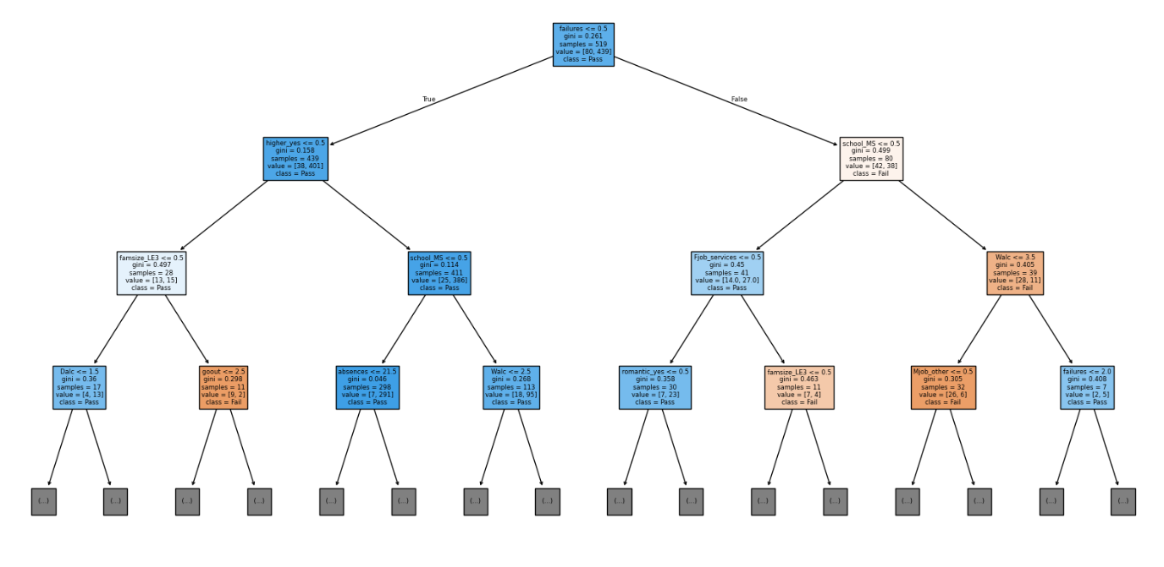
The trained tree was also visualized using plot_tree to understand its decision structure.
6.3 Gaussian Naive Bayes
Gaussian Naive Bayes is a probabilistic classification algorithm based on Bayes' theorem. It assumes that the features are conditionally independent and follows a Gaussian distribution for continuous variables. In this project, the model was trained using the scaled training data and used to classify students as Pass or Fail.
6.4 Model Comparison
The three models are evaluated using Accuracy, Precision, Recall, and F1-score. These metrics provide a comprehensive comparison, particularly because the dataset contains more Pass students than Fail students.
Model | Main Approach
Logistic Regression | Probability-based linear classification
Decision Tree | Rule and decision-based classification
Naive Bayes | Probability-based classification
The models are trained and tested using the same dataset split to ensure a fair and consistent comparison.

IMPLEMENTATION AND EXPERIMENTAL PROCEDURE

The project was implemented in Python using Jupyter Notebook. The experimental procedure followed a fixed sequence from data preparation to model evaluation.
7.1 Implementation Procedure
- Dataset Loading: The student-por.csv dataset was loaded using Pandas.
- Data Inspection: The dataset structure, data types, sample records, and missing values were examined.
- Target Preparation: G1 and G2 were removed, and G3 ≥ 10 was defined as Pass while G3 < 10 was defined as Fail.
- Feature Encoding: Categorical variables were converted using one-hot encoding, resulting in 39 input features.
- Train-Test Split: The data was divided into 80% training and 20% testing, giving 519 training and 130 testing samples.
- Feature Scaling: StandardScaler was fitted on the training data and used to transform the test data.
- Model Training: Logistic Regression, Decision Tree, and Gaussian Naive Bayes were trained on the prepared data.
- Prediction: Each model predicted the Pass/Fail class for the test data.
- Evaluation: The predictions were evaluated using Accuracy, Precision, Recall, F1-score, and Confusion Matrix.
7.2 Experimental Setup
The same train-test split was used for all three algorithms to ensure a fair and consistent comparison. Logistic Regression and Naive Bayes were trained using scaled features, while the Decision Tree used the encoded features directly. The Decision Tree was also visualized to understand its classification structure.
7.3 Evaluation Procedure
The performance of each model was recorded in a comparison table. Accuracy, Precision, Recall, and F1-score were used to compare the algorithms, with particular attention given to F1-score because the dataset contains an imbalanced Pass/Fail distribution.
The confusion matrix was used to examine the number of correctly and incorrectly classified students in each class. It provides a detailed view of True Positives, True Negatives, False Positives, and False Negatives, helping to identify whether a model performs well for both Pass and Fail categories. This is particularly useful for understanding errors that may not be visible from accuracy alone.
To maintain consistency in the experiment, all three algorithms were evaluated on the same unseen testing data. The evaluation results were then organized into a comparison table and analyzed to determine the strengths and weaknesses of each model. The algorithm achieving the best overall balance of Accuracy, Precision, Recall, and F1-score was considered the most suitable model for predicting student pass or fail status.

RESULTS AND MODEL COMPARISON
The three machine learning models were evaluated on the test dataset containing 130 student records. The performance was compared using Accuracy, Precision, Recall, and F1-score.
8.1 Performance Comparison
Model | Accuracy | Precision | Recall | F1-Score
Logistic Regression | 79.23% | 86.73% | 89.09% | 87.89%
Decision Tree | 77.69% | 85.84% | 88.18% | 87.00%
Naive Bayes | 63.85% | 87.95% | 66.36% | 75.65%
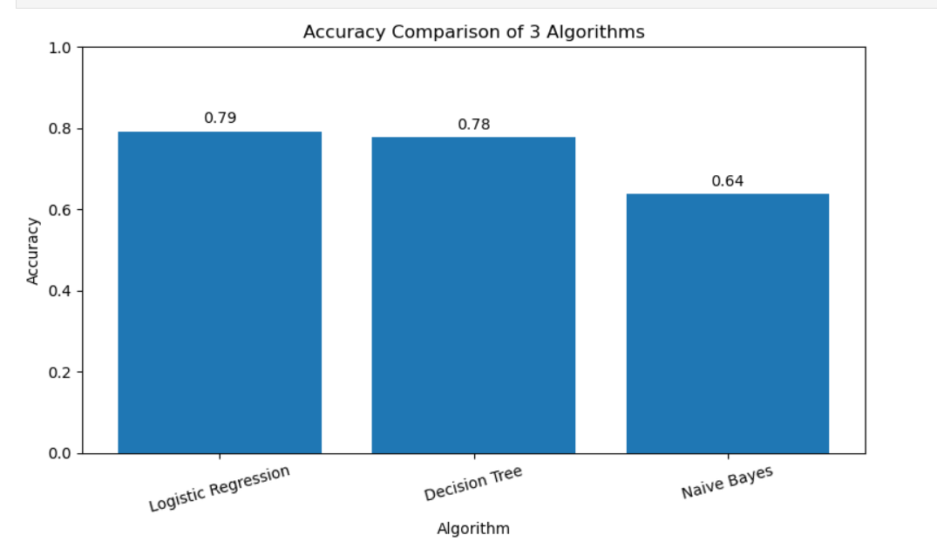
8.2 Accuracy Comparison
The accuracy comparison of the three algorithms is shown in the following graph.
Figure 8.1: Accuracy Comparison of Logistic Regression, Decision Tree and Naive Bayes
8.3 Result Analysis
- Logistic Regression achieved the highest accuracy of 79.23% and the highest F1-score of 87.89%. It also obtained the highest recall of 89.09%.
- Decision Tree achieved an accuracy of 77.69% and an F1-score of 87.00%, performing slightly below Logistic Regression.

- Naive Bayes achieved an accuracy of 63.85% and an F1-score of 75.65%. Although its precision was 87.95%, its recall was lower at 66.36%.

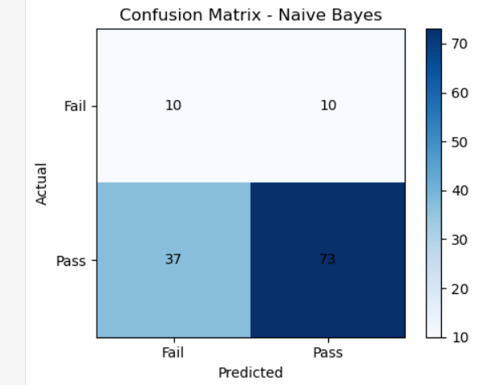

“The confusion matrix results provide further evidence of the differences between the models…”

8.4 Best Performing Model
Based on the overall evaluation, Logistic Regression was identified as the best-performing model. It achieved the highest accuracy (79.23%) and F1-score
The model demonstrated a good balance between correctly identifying Pass and Fail students, making it more suitable for the given classification task. Its performance indicates that the relationship between the selected student-related features and the final pass/fail outcome can be effectively captured using a linear classification approach.
Compared with the Decision Tree and Gaussian Naive Bayes models, Logistic Regression provided more consistent overall performance across the selected evaluation metrics. Therefore, Logistic Regression was selected as the most suitable model for predicting student performance in this project.

DISCUSSION, LIMITATIONS AND APPLICATIONS
9.1 Discussion
The experimental results demonstrate that machine learning can be applied to student performance prediction using demographic, family, academic, social, lifestyle, and health-related attributes. In this project, three classification algorithms—Logistic Regression, Decision Tree, and Gaussian Naive Bayes—were implemented to predict whether a student would Pass or Fail.
The models were trained and evaluated using the same training and testing procedure to ensure a fair comparison. The dataset was divided into training and testing sets using an 80:20 stratified split. G1 and G2 were removed from the input data, while G3 was converted into a binary target using the threshold of 10. Categorical variables were converted using one-hot encoding.
The results showed that Logistic Regression performed better than the other two models. It achieved an accuracy of 79.23%, precision of 86.73%, recall of 89.09%, and F1-score of 87.89%. The high recall indicates that the model was able to correctly identify a large proportion of Pass students. Its F1-score also shows a good balance between precision and recall.
Decision Tree produced a slightly lower accuracy of 77.69%, with a precision of 85.84%, recall of 88.18%, and F1-score of 87.00%. The difference between Logistic Regression and Decision Tree was relatively small. The Decision Tree also provides an advantage in terms of interpretability because its predictions can be represented through a series of decision rules based on the input features.
Naive Bayes produced the lowest overall accuracy of 63.85%. It achieved a precision of 87.95%, which was slightly higher than Logistic Regression and Decision Tree. However, its recall was only 66.36%, resulting in an F1-score of 75.65%. This indicates that the model was less consistent in identifying the Pass class.
The confusion matrix results provide further evidence of the differences between the models. Logistic Regression correctly classified 103 of the 130 test cases, while Decision Tree correctly classified 101 cases and Naive Bayes correctly classified 83 cases. Therefore, Logistic Regression produced the highest number of correct predictions.
The comparison also demonstrates why multiple evaluation metrics are necessary. Accuracy provides an overall measure of correct predictions, while precision and recall provide more detailed information about classification performance. The F1-score combines precision and recall and was particularly useful for comparing the models because the dataset contained more Pass students than Fail students.
Based on the combined evaluation results, Logistic Regression was selected as the best-performing algorithm for the Student Performance Prediction task.
9.2 Limitations
Although the developed system produced useful classification results, several limitations should be considered.
- Dataset size: The dataset contains 649 student records. A larger dataset containing students from multiple schools and different educational environments could provide more reliable and generalizable results.
- Class imbalance: The dataset contains 549 Pass students and 100 Fail students. This unequal distribution may influence the performance of the classification models, particularly their ability to identify the minority Fail class.
- Binary target: The original G3 grade was converted into only two categories, Pass and Fail. As a result, the system cannot predict the exact marks obtained by a student or distinguish between different grade levels.
- Removal of G1 and G2: G1 and G2 were excluded from the feature set. These variables can contain strong information about academic performance, but they were removed to avoid using previous assessment scores as direct predictors.
- Dataset-specific results: The dataset represents a particular student population. Therefore, the model's performance may change when applied to students from different schools, regions, or educational systems.
- Limited model selection: Only Logistic Regression, Decision Tree, and Gaussian Naive Bayes were considered. Other algorithms and ensemble methods may provide different or improved performance.
- Prediction limitations: A machine learning prediction represents an estimated outcome based on available data. It cannot account for every factor affecting a student's academic performance, such as personal circumstances, teaching quality, motivation, or sudden changes in academic conditions.
- Need for further validation: Before practical deployment, the model should be tested using larger and more diverse datasets and evaluated under different experimental conditions.
9.3 Applications
The proposed system can be used as an analytical support tool in educational environments. One important application is the early identification of students who may require additional academic attention. By analyzing available student information, the system can provide an indication of the predicted academic outcome.
Teachers can use such predictions as an additional source of information when monitoring student progress. Students identified as requiring attention can be considered for additional academic support, mentoring, or counselling.
Educational institutions can also use the system for performance monitoring. By analyzing student characteristics and prediction results, institutions can identify patterns associated with academic outcomes and develop suitable support programs.
The system can support academic counselling by providing information that may help counsellors understand student-related factors associated with performance. It can also assist in planning remedial classes, mentoring programs, and other academic interventions.
Another application is educational data analysis. The dataset contains information related to study time, previous failures, parental education, family support, absences, social relationships, internet access, and lifestyle factors. Machine learning can help analyze such information and identify patterns that may be useful for educational planning.
The proposed approach can also serve as a foundation for developing student performance monitoring systems. A future application could integrate the prediction model into an educational management platform where student information is periodically analyzed and performance trends are presented to teachers or administrators.

CONCLUSION AND FUTURE SCOPE
10.1 Conclusion
This project presented a machine learning-based approach for predicting student academic performance using the Student Performance dataset. The original dataset contained 649 student records with 33 attributes representing demographic, family, academic, social, lifestyle, and health-related information.
The final grade G3 was converted into a binary target consisting of Pass and Fail categories. G1 and G2 were excluded from the input features, and categorical variables were converted using one-hot encoding. Three classification algorithms—Logistic Regression, Decision Tree, and Gaussian Naive Bayes—were implemented and evaluated using Accuracy, Precision, Recall, F1-score, and Confusion Matrix.
Among the three models, Logistic Regression achieved the best overall performance with an accuracy of 79.23% and an F1-score of 87.89%. Decision Tree achieved 77.69% accuracy and an F1-score of 87.00%, while Naive Bayes achieved 63.85% accuracy and an F1-score of 75.65%.
The experimental results indicate that Logistic Regression was the most suitable model for the selected Student Performance classification task. The project demonstrates that machine learning can be used as an analytical support tool for understanding student performance and identifying patterns associated with academic outcomes.
10.2 Future Scope
The project can be further improved in several ways:
- A larger and more diverse dataset can be used to improve the generalization of the model.
- Additional machine learning algorithms such as Random Forest, Support Vector Machine, and ensemble methods can be evaluated.
- The system can be extended from binary Pass/Fail classification to multiple grade categories or exact score prediction.
- Feature selection and hyperparameter tuning can be applied to improve model performance.
- Cross-validation can be used to provide more reliable estimates of model performance.
- A graphical user interface or web-based application can be developed so that teachers or institutions can enter student information and obtain predictions easily.
- The system can be extended to provide early academic alerts and support personalized intervention strategies.
- Future versions can incorporate regularly updated student data to monitor changes in academic performance over time.
10.3 References
- UCI Machine Learning Repository, Student Performance Dataset.
- Pedregosa, F. et al., “Scikit-learn: Machine Learning in Python,” Journal of Machine Learning Research, 2011.
- Python Software Foundation, Python Documentation.
- McKinney, W., Python for Data Analysis, O'Reilly Media.
- Géron, A., Hands-On Machine Learning with Scikit-Learn, Keras, and TensorFlow, O'Reilly Media

APPENDIX A – IMPLEMENTATION SUMMARY

A.1 Dataset and Preprocessing
The Student Performance dataset (student-por.csv) was used for implementation. The dataset contains 649 records and 33 attributes. The target variable G3 was converted into a binary classification target using the following condition:
- G3 ≥ 10 → Pass (1)
- G3 < 10 → Fail (0)
The G1 and G2 attributes were removed from the input features. Categorical variables were converted using one-hot encoding, resulting in 39 input features. The dataset was divided into training and testing sets using an 80:20 stratified split.
A.2 Machine Learning Models
Three classification algorithms were implemented:
- Logistic Regression
- Decision Tree Classifier
- Gaussian Naive Bayes
StandardScaler was applied to the training and testing features used by Logistic Regression and Naive Bayes. The Decision Tree was trained using the encoded features without scaling.
A.3 Model Evaluation
The trained models were used to predict the Pass/Fail class of students in the test dataset. The following evaluation metrics were calculated:
- Accuracy
- Precision
- Recall
- F1-score
- Confusion Matrix
A Decision Tree visualization was also generated using plot_tree() to display the structure and decision rules of the trained tree.
A.4 Final Results
Model | Accuracy | Precision | Recall | F1-Score
Logistic Regression | 79.23% | 86.73% | 89.09% | 87.89%
Decision Tree | 77.69% | 85.84% | 88.18% | 87.00%
Naive Bayes | 63.85% | 87.95% | 66.36% | 75.65%
Based on the experimental results, Logistic Regression was selected as the best-performing model for the Student Performance classification task.

