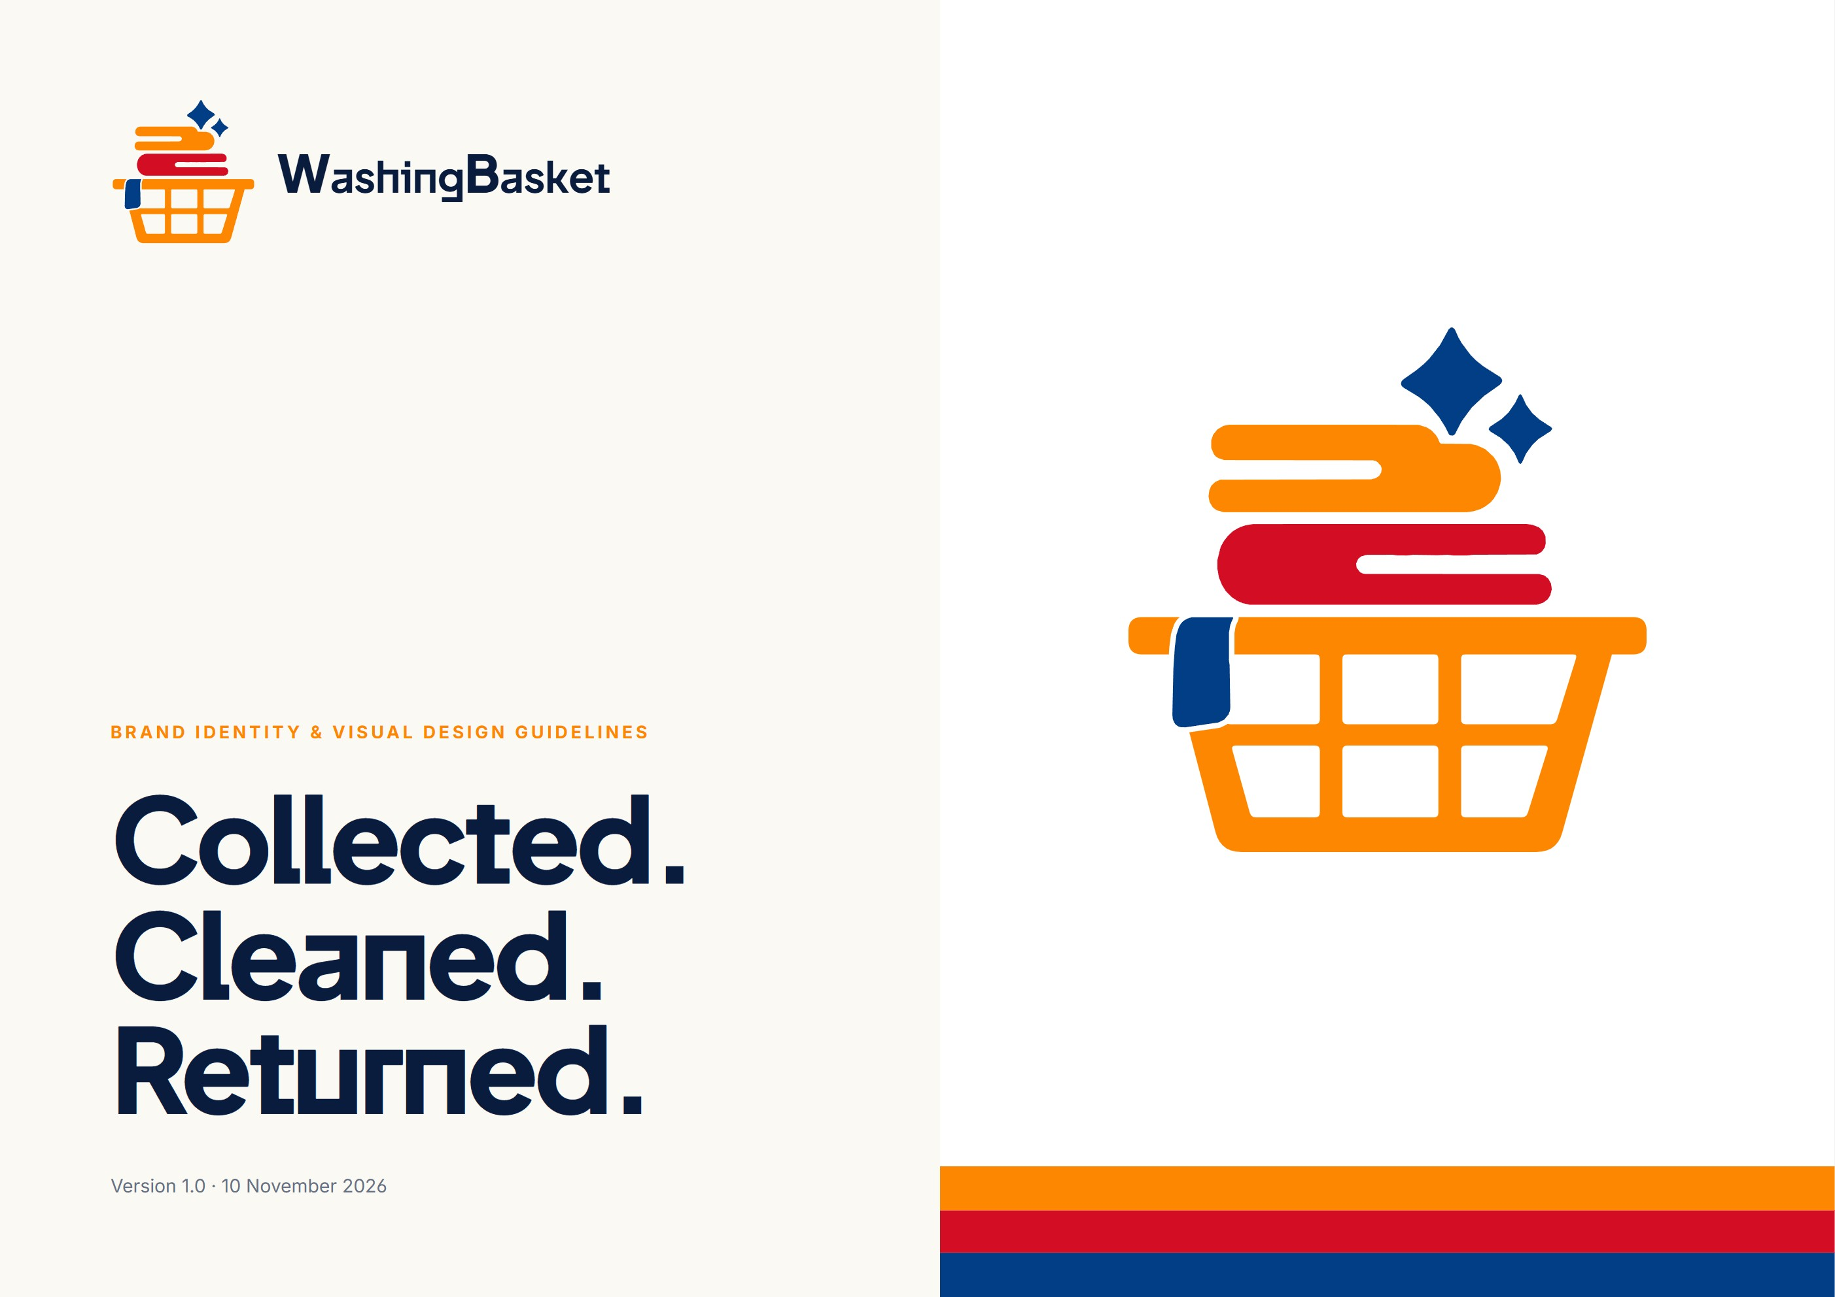

Brand Identity & Visual Design Guidelines
Washing Basket · Version 1.0 · 10 November 2026
DOCUMENT INFORMATION

About this edition
The official reference for how Washing Basket looks, sounds and behaves across its app, admin portal, website and everything printed or worn.
RULE This book documents the identity that already exists in the product. Nothing in it replaces the approved logo or invents official colours.
ITEM | DETAIL
Brand | Washing Basket
Document | Brand Identity & Visual Design Guidelines
Version | 1.0 — first edition
Date | 10 November 2026
Status | Approved elements documented; proposals awaiting sign-off
Owner | Washing Basket brand & product team
Audience | Designers, developers, marketing, content creators, agencies, new team members
Formats | Editable Word (.docx) and print PDF (A4 landscape) carrying the same content

Sources audited for this edition
SOURCE | WHAT IT CONTRIBUTED
assets/brand/WashingBasket-logo.png | Master logo (1254 × 1254 px), sampled colour values
website/src/logoGeometry.ts | Vector trace of the mark used to draw every logo in this book
mobile/src/theme/index.ts | Colour, type, radius, spacing and elevation tokens
admin/src/theme/tokens.ts · website/src/styles/base.css | Portal and website token mappings
mobile/src/components/logo/* | Wordmark, lockup proportions, logo animation timings
assets/artwork · assets/illustrations · assets/avatars | Illustration systems and characters
website/src/content.ts | Positioning, services, prices and real customer-facing copy
Running product (website, admin, mobile web) | Screenshots captured 10 Nov 2026

Revision history
VERSION | DATE | CHANGE
1.0 | 10 November 2026 | First edition, written from a full audit of the codebase and assets

CONTENTS

Contents
About this edition 2
Contents 3
Verified, proposed, and rules 5
What the brand owns today 6
Findings and how to resolve them 7
01 Brand foundations 8
Clean clothes, without the laundry day. 9
Campus life is full. Laundry should be simple. 10
Why we exist, where we are going 11
Five values, one calm personality 12
For people with full weeks 13
Manifesto 14
02 Logo identity 15
The mark 16
What the mark says 17
Geometry and proportion 18
Wordmark and lockups 20
Give it room to breathe 21
Colour versions 22
Backgrounds and placement 23
App icon and favicon 24
Never do this 25
03 Colour identity 26
Core palette 27
Logo Orange and Action Orange 28
Soft brand shades 29
Neutrals, surfaces and text 30
Status and feedback 31
Contrast and combinations 32
How much of each 33
Illustration plate colours 34
04 Typography system 35
Two families do the work 36
Plus Jakarta Sans 37
Inter 38
The scale in use 39
Slips, numbers and rules 40
05 Illustration & characters 41
Four illustration families 42
The people of Washing Basket 43
One step, one colour, one scene 44
Illustrating the order journey 45
Services and people 46
Making new illustration 47
06 Iconography & visual elements 48
Outline icons, rounded ends 48
Radius, borders, shadows 49
Graphic motifs 50
07 Photography & image direction 51
Illustration first, photography second 51
08 Digital design system 52
The marketing website 53
The customer app 54
The operations portal 55
Core components 56
Spacing, grid and layout 57
Accessible by default 58
09 Motion & animation 59
The basket fills itself 59
Timing, curves and interactions 60
10 Brand applications 61
Cards, ID and uniform 62
Bags, tags and slips 63
Social, email and banners 64
11 Communication & voice 65
Calm, clear, kind 65
How we sound, moment to moment 66
12 Brand governance 67
Before anything ships 67
Keeping it consistent 68
A Appendix 69
Token and asset reference 69

HOW TO USE THIS BOOK

Verified, proposed, and rules
Every page tells you how sure you can be. Some things are already in the product and approved. Some are recommendations to fill gaps the audit found.
VERIFIED  Verified  Exists in the codebase or approved assets today. Values were read from source files or sampled from the master artwork. Use as-is. | PROPOSED  Proposed  A recommendation that fills a gap: a missing logo version, a rule nobody wrote down, a print application. Needs sign-off before it becomes official. | RULE  Rule  Mandatory. Breaking a rule makes the work off-brand regardless of how good it looks. Rules are collected again in the Governance checklists.

FINDING “Finding” marks an inconsistency or gap discovered during the audit, such as two places in the code that disagree. Each finding carries a recommended resolution.

Who should read what
ROLE | START WITH
Designers | Logo (02), Colour (03), Typography (04), Illustration (05), Digital (08)
Developers | Colour tokens (03), Type scale (04), Digital design system (08), Motion (09), Appendix tokens
Marketing & content | Brand foundations (01), Applications (10), Voice (11)
Agencies & freelancers | Logo (02), Illustration rules (05), Governance checklists (12)

IDENTITY AUDIT

What the brand owns today
An inventory of every identity element found in the repository, where it lives, and its condition.
ELEMENT | LOCATION | CONDITION
Primary mark (basket, clothes, sparkles) | assets/brand/WashingBasket-logo.png · admin/public/logo.png | Verified · PNG only, no master vector file
Vector trace of the mark | website/src/logoGeometry.ts · mobile/src/components/logo/logoGeometry.ts | Verified · used by the product to draw and animate the logo
Wordmark “WashingBasket” | mobile/src/components/logo/Wordmark.tsx · admin brand.css | Verified · typeset live in Plus Jakarta Sans, no outlined artwork
Horizontal lockup | CinematicLogoLockup.tsx · admin sidebar · website nav | Verified
Favicon | admin/public/favicon.png · website/public/favicon.png | Verified
Mobile app icon & splash | mobile/assets/icon.png, android-icon-*.png, splash-icon.png | Finding · still the Expo template placeholder
Colour tokens | mobile/src/theme/index.ts (source of truth for all three products) | Verified
Fonts | Plus Jakarta Sans, Inter, Nunito, Courier Prime (Google Fonts, OFL) | Verified
Process illustration plates (6) | assets/artwork/1–6.png · mobile/assets/scenes | Verified
Status vignettes (10) | assets/illustrations · mobile/assets/illustrations | Verified
Service illustrations (5) | mobile/assets/services | Verified
Customer avatars (3) | assets/avatars (Ananya, Rahul, Sneha) | Verified
Brand films & loops | hero-loop/, brand-film/, website/public/media | Verified · rendered from the plates
Icon set | mobile/src/components/ui/icons.tsx · admin Icon.tsx | Verified · 24 px outline, 2 px stroke
Photography | — | None exists · illustration carries imagery
Print & merchandise | — | None exists · proposals in section 10

IDENTITY AUDIT

Findings and how to resolve them
Places where the identity is incomplete or where two parts of the product disagree. None of these change the brand; they make it consistent.
01 No master vector logo  The only logo files are PNGs. The product draws the mark from a vector trace (logoGeometry.ts), which proves the shapes, but there is no signed-off SVG/PDF/EPS for print.  Resolve: Export the trace as the official SVG and EPS, check it against the PNG at 400%, and store it in assets/brand. | 02 App icon is a placeholder  mobile/assets/icon.png and the Android adaptive icons are the Expo template (a blue chevron). The store listing would show no Washing Basket branding.  Resolve: Build the icon from the mark on a white tile (see page “Icon-only mark”) before store submission.

03 White text on Action Orange  Primary buttons put white text on #FFA742. That pair measures 1.9:1, below the 4.5:1 WCAG AA minimum for text.  Resolve: Use Ink (#0A1C3E) labels on Action Orange (9.3:1), or keep white text only at 18 px bold and above as a stopgap. | 04 Wordmark font comment  theme/index.ts names Nunito Black as the wordmark font, but Wordmark.tsx, the lockup and the admin portal all set it in Plus Jakarta Sans.  Resolve: Plus Jakarta Sans is the shipped wordmark. Update the comment; keep Nunito out of the identity until a use is approved.

05 Two primary-button colours  The token says CTAs are Action Orange, while the sign-in “Continue” and admin “Sign in” buttons are Ink.  Resolve: Adopt the rule: Orange for the one commercial action on a screen (Book, Pay, Top up); Ink for flow steps (Continue, Sign in). | 06 Placeholder contact details  Support email care@washingbasket.example is a placeholder domain.  Resolve: Replace with the live address before any print or store material uses it.

01 Brand foundations
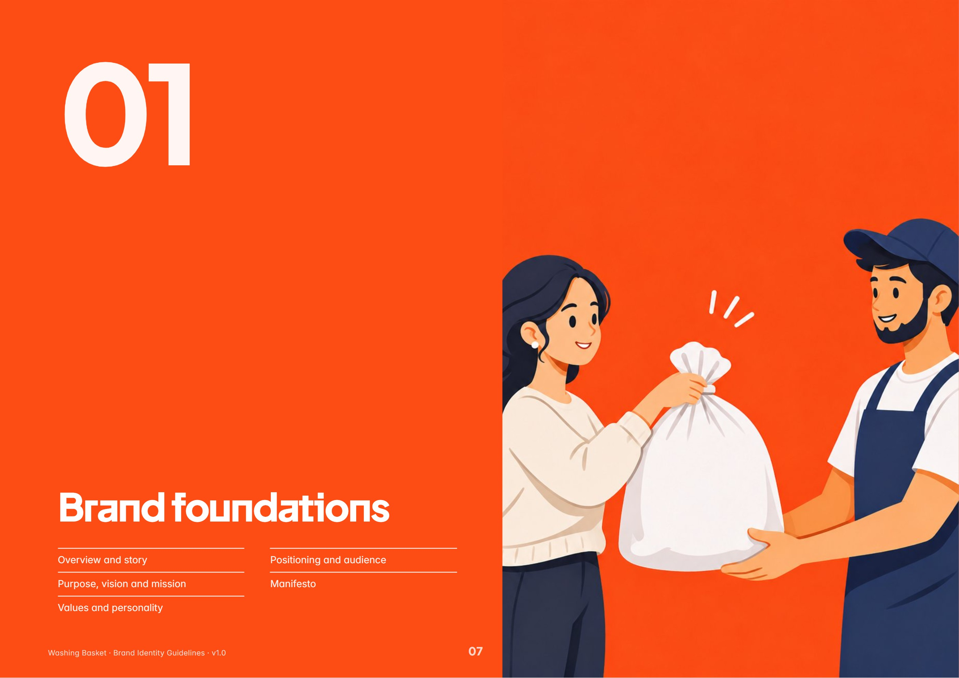
In this section: Overview and story · Purpose, vision and mission · Values and personality · Positioning and audience · Manifesto
BRAND OVERVIEW

Clean clothes, without the laundry day.
Washing Basket collects laundry at your door or a campus counter, washes, dries and irons it with care, and brings it back. Booked and followed in one app.
VERIFIED Headline and description are the live website hero (website/src/content.ts).
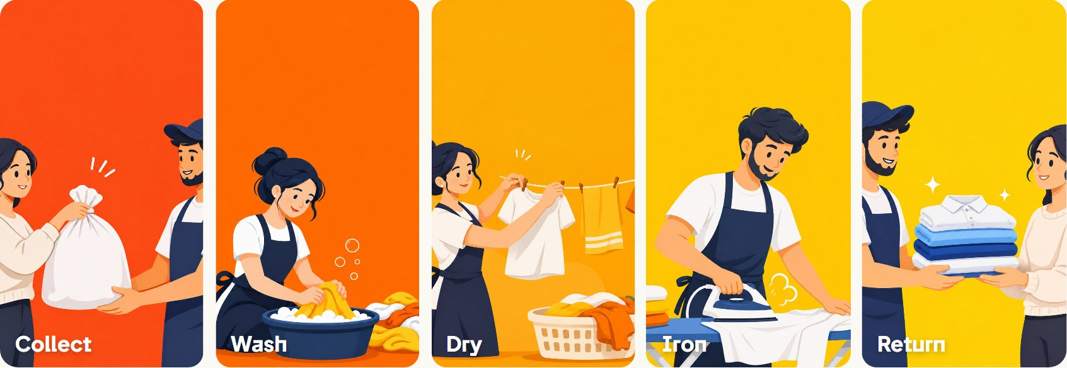
The five steps of every order, drawn as the brand’s process plates.
What it is  A digital laundry service with seven services, from Only Wash at ₹45/kg to dry cleaning, blankets, shoes and colour dye. Customers book, pay and track in a mobile app; staff run the counters with a QR scanner; operations run from an admin portal. | Where it works  Campus counters at Lovely Professional University and NIT Jalandhar, and doorstep pickup around Model Town, Jalandhar, in two-hour slots. | Origin  The brand was built for campus life, where laundry competes with lectures, labs and deadlines. Founding date, founders and early history are not recorded in the materials audited.  PROPOSED Add the founding story here once supplied. Do not invent one.

BRAND STORY

Campus life is full. Laundry should be simple.
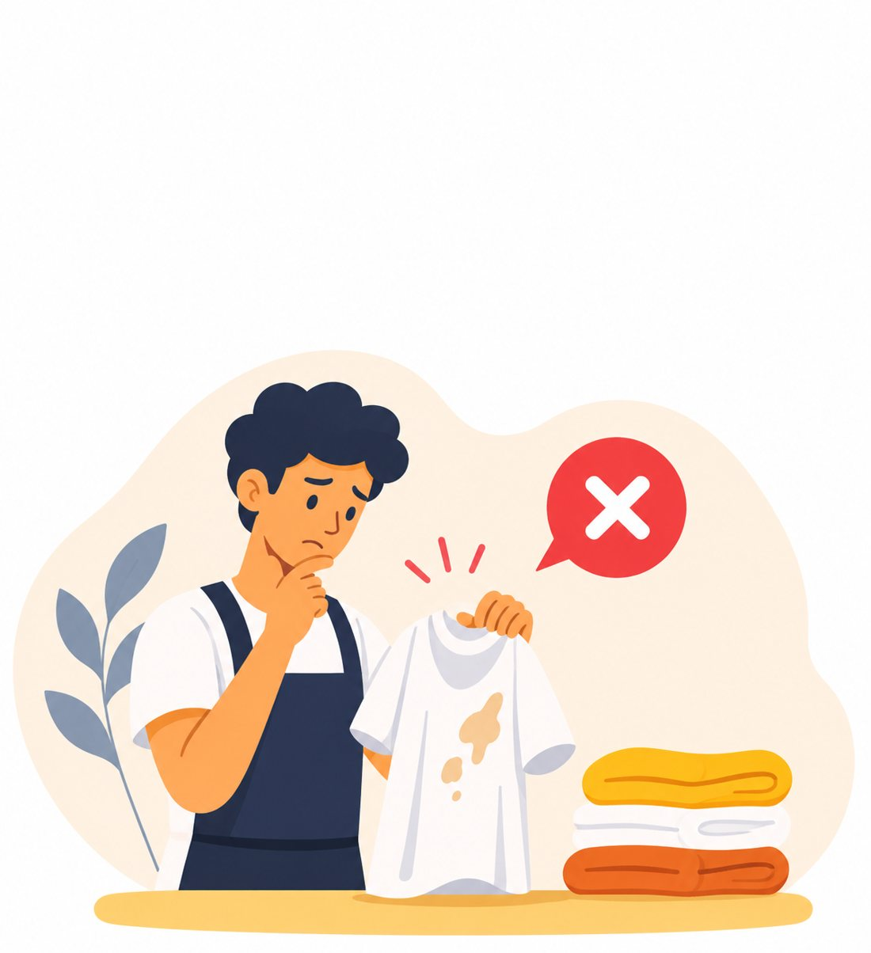
Lectures. Labs. Deadlines. Plans. And somewhere in between, the laundry that should never have been yours to worry about.
The story Washing Basket tells is not about washing machines. It is about time and headspace. A student with a stained shirt and a full week does not want a lesson in fabric care; they want the problem to disappear and come back folded.
So the service is built around three verbs, written on the website as a single brand moment: Collected. Cleaned. Returned. Everything else, from the app’s live progress timeline to the QR handover at the counter, exists to make those three words dependable.
VERIFIED Story lines, the four-word rhythm and the three brand bands are live on the website (STORY and BRAND in content.ts).
PURPOSE · VISION · MISSION

Why we exist, where we are going
PURPOSE  Give people their time back.  Take laundry off the list of things a busy person has to think about, and return it cared for.  PROPOSED | VISION  Laundry as dependable as a utility.  Wherever students and families live, laundry day should be a tap in an app and a basket handed over, nothing more.  PROPOSED | MISSION  Collect, care, return. Every order.  Run a counted, tracked, five-step process with hygiene, fabric care and professional handling, and show every step in the app.  PROPOSED

PROPOSED No written purpose, vision or mission exists in the codebase. These statements are drafted from what the product demonstrably does and from the live “quality promise”: hygiene, fabric care and professional handling. Approve or edit before external use.
VALUES & PERSONALITY

Five values, one calm personality
01  Care  Every piece counted in front of you, handled by fabric, checked on return.  Evidence: Quality promise; QR item count | 02  Clarity  Prices shown in full before you book. Every stage visible in the app.  Evidence: Price list; tracking timeline | 03  Reliability  Two-hour pickup slots, stated turnarounds: 48 h, 72 h, 5 days.  Evidence: services.json; pickup slots | 04  Ease  Book in a minute, hand over your basket, get on with your week.  Evidence: Website story copy | 05  Honesty  No invented numbers, awards or testimonials, ever.  Evidence: Stated rule in content.ts

Personality framework
 | WE ARE | WE ARE NOT
Feel | Warm, fresh, orderly. A folded stack of clean clothes. | Clinical, corporate, sterile.
Sound | Calm, short, concrete. Full stops, plain verbs. | Hype, exclamation marks, slang overload.
Behave | Helpful and transparent: show the price, show the step. | Pushy upsells, hidden fees, vague promises.
Look | Flat, friendly illustration; bright primaries on calm neutrals. | Stock photos, glossy gradients, neon.

VERIFIED Values are drawn from behaviour the product already shows; the evidence column cites where. The framework wording is new.
POSITIONING & AUDIENCE

For people with full weeks
Positioning statement  For students and busy households who would rather not spend a day on laundry, Washing Basket is the laundry service that collects, cleans and returns your clothes, booked and tracked in one calm app, with every piece counted and every price shown up front.  Brand promise  Collected. Cleaned. Returned. Your basket comes back the way you handed it over, only clean, on the day we said.  What sets it apart  - Campus counters with QR handover, counted in front of you  - Live, step-by-step order tracking in the app  - Transparent per-kg and per-piece pricing before booking  - Wallet, referrals and live offer codes built in  - A warm illustrated world instead of generic laundry imagery | Audience  Desired perception  Customers should describe Washing Basket as “the one that just handles it.” Dependable before delightful; friendly without being childish; modern without feeling like a tech company.  Emotional experience  Relief at hand-over, reassurance while tracking, and a small pleasure at return: the crisp, folded stack the logo itself depicts.  PROPOSED Audience and positioning are derived from the product’s locations, services and copy; refine with customer research.
  SEGMENT | NEED | WHERE THEY MEET US
  Hostel students (LPU, NITJ) | Quick, affordable, no-fuss laundry between classes | Campus counter, app
  Residents & families | Doorstep pickup that fits a schedule | Two-hour slots, Model Town
  Occasion & specialty | Dry cleaning, blankets, shoes, colour dye | Service catalogue

MANIFESTO

Manifesto
Your week is full.
Lectures. Labs. Deadlines. Plans.
Laundry was never meant to be one more thing.
So hand us the basket.
We will count every piece in front of you,
wash it the way you chose,
dry it right through, never rushed,
press it, fold it, pack it,
and bring it back when we said we would.
No fuss. No guesswork. No laundry day.
Collected. Cleaned. Returned.

PROPOSED Proposed manifesto. Built from live website lines (story, care steps and brand bands); approve before publishing.

02 Logo identity
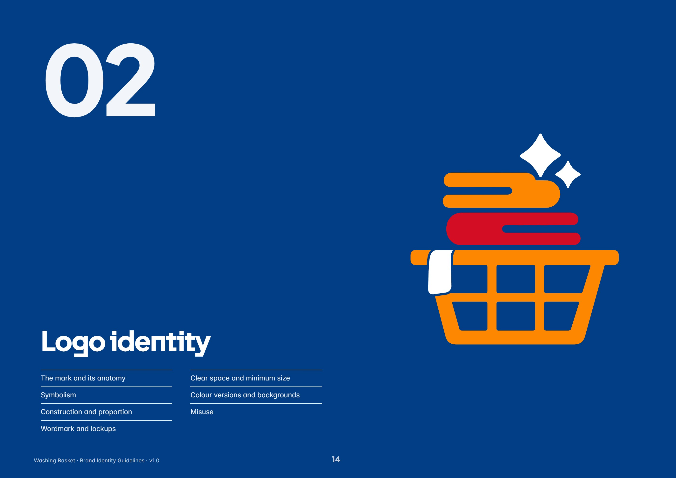
In this section: The mark and its anatomy · Symbolism · Construction and proportion · Wordmark and lockups · Clear space and minimum size · Colour versions and backgrounds · Misuse
PRIMARY LOGO

The mark
A laundry basket holding two folded cloths, a towel draped over its rim, and two sparkles above. Four shapes, three colours, one idea: clean laundry, ready to hand back.
VERIFIED Drawn here from the product’s own vector trace of the master PNG (logoGeometry.ts). Colours: Logo Orange #FE8701, Cloth Red #D30D24, Basket Navy #013E86.
RULE Never redraw, re-trace or “improve” the mark. Use supplied artwork only.
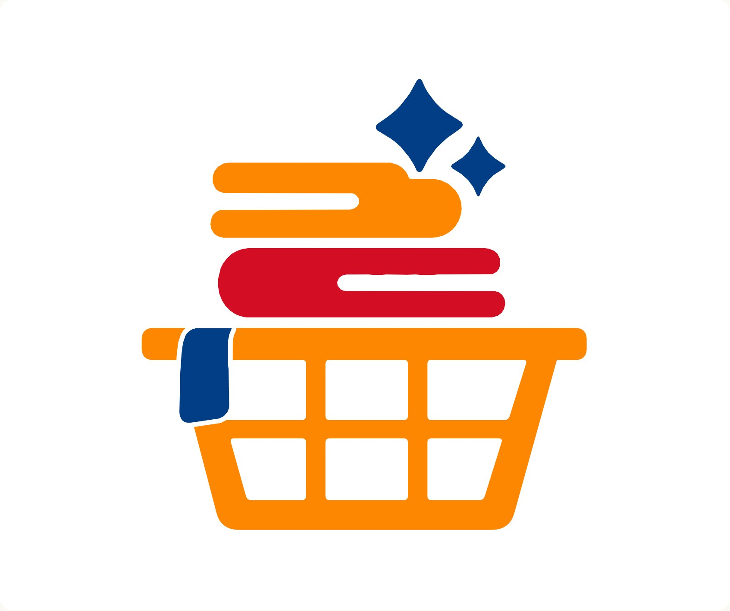
SYMBOLISM

What the mark says
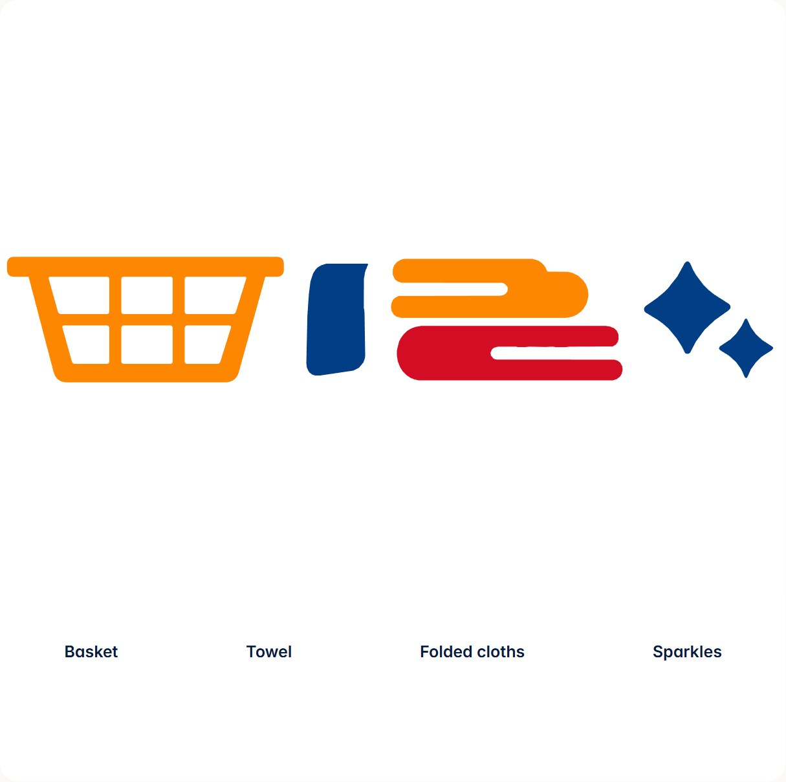 | Reading order. The mark reads bottom to top: basket, clothes, sparkle. It tells the service in one glance: collected, cared for, clean.  VERIFIED Part names (basket, basketRim, towel, clothOrange, clothRed, sparkleLarge, sparkleSmall) are the product’s own layer names, used to animate the mark.
  ITEM | DETAIL
  Basket | The hand-over. The product is named after it and the customer’s first act is giving it to us. The grid of six openings reads as a sturdy, everyday object.
  Folded cloths | The result. Stacked orange over red, each ending in a rounded fold with a tucked line, they show laundry already done: washed, pressed, folded.
  Towel | A navy towel draped over the rim, separated by a white knockout so it reads as a soft object resting on a hard one.
  Sparkles | Clean. Two four-point stars, large and small, the universal shorthand for freshness, set where your eye ends its journey up the stack.

CONSTRUCTION

Geometry and proportion
Measured in logo units (u) from the product trace. The mark is almost square: 776 u wide × 787 u tall.
PART | W × H (U) | SHARE OF HEIGHT
Whole mark | 776 × 787 | 100%
Basket incl. rim | 776 × 364 | 46%
Rim bar | 776 × 75 | 10%
Red cloth | 509 × 139 | 18%
Orange cloth | 448 × 149 | 19%
Sparkle large | 169 × 179 | 23%
Sparkle small | 113 × 122 | 16%

All terminals are round. The rim and cloths are capsule-ended bars; the basket body tapers inward toward a radius at the foot. There are no sharp corners outside the sparkle points.
VERIFIED Dimensions are bounding boxes from logoGeometry.ts. The 8 × 8 grid is a measuring aid, not a construction grid the mark was drawn on.
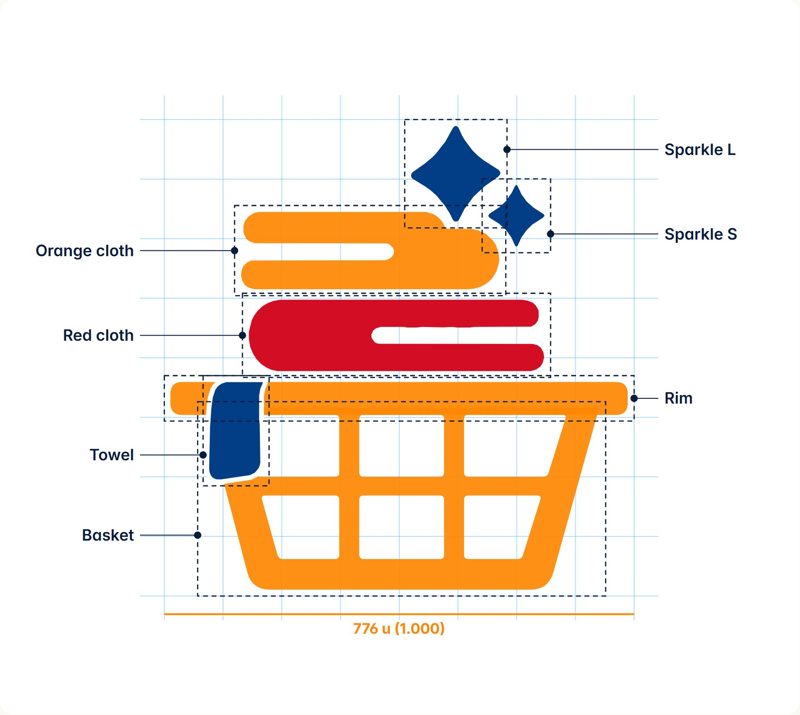
WORDMARK & LOCKUPS

Wordmark and lockups
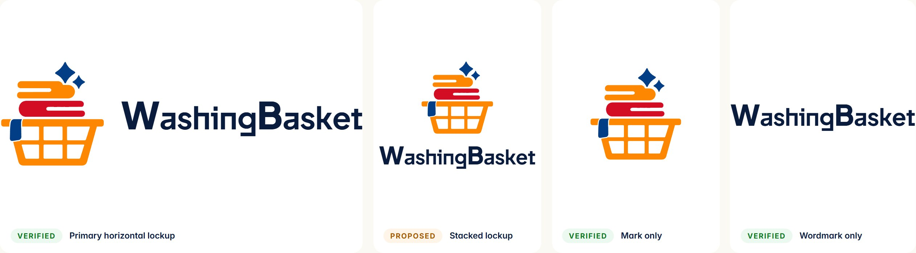
Wordmark specification | Lockup proportions  RULE In running text always write the name as two words, “Washing Basket”. The solid form belongs to the wordmark only. | When to use which  - Horizontal lockup: default for headers, nav bars, documents, signage.  - Mark only: app icon, favicon, avatars, loaders, small spaces where the name is already present.  - Wordmark only: rare; footers or legal lines where the mark appears elsewhere.  - Stacked: square formats such as social avatars and packaging fronts (proposed).
  ITEM | DETAIL
  Typeface | Plus Jakarta Sans
  Weights | Bold 700; capitals W and B ExtraBold 800
  Capitals | Set 1.22× the lowercase size (1.28× in the animated app intro)
  Tracking | −0.35 px at 24 px (≈ −0.015 em)
  Colour | Ink #0A1C3E; white on dark
  Spelling | Set solid: WashingBasket
  ITEM | DETAIL
  Mark width | 3.42 × wordmark font size (82 px at 24 px)
  Gap | 0.5 × font size (12 px at 24 px)
  Alignment | Wordmark vertically centred on the mark
  Source | CinematicLogoLockup.tsx; admin sidebar and website nav

CLEAR SPACE & MINIMUM SIZE

Give it room to breathe
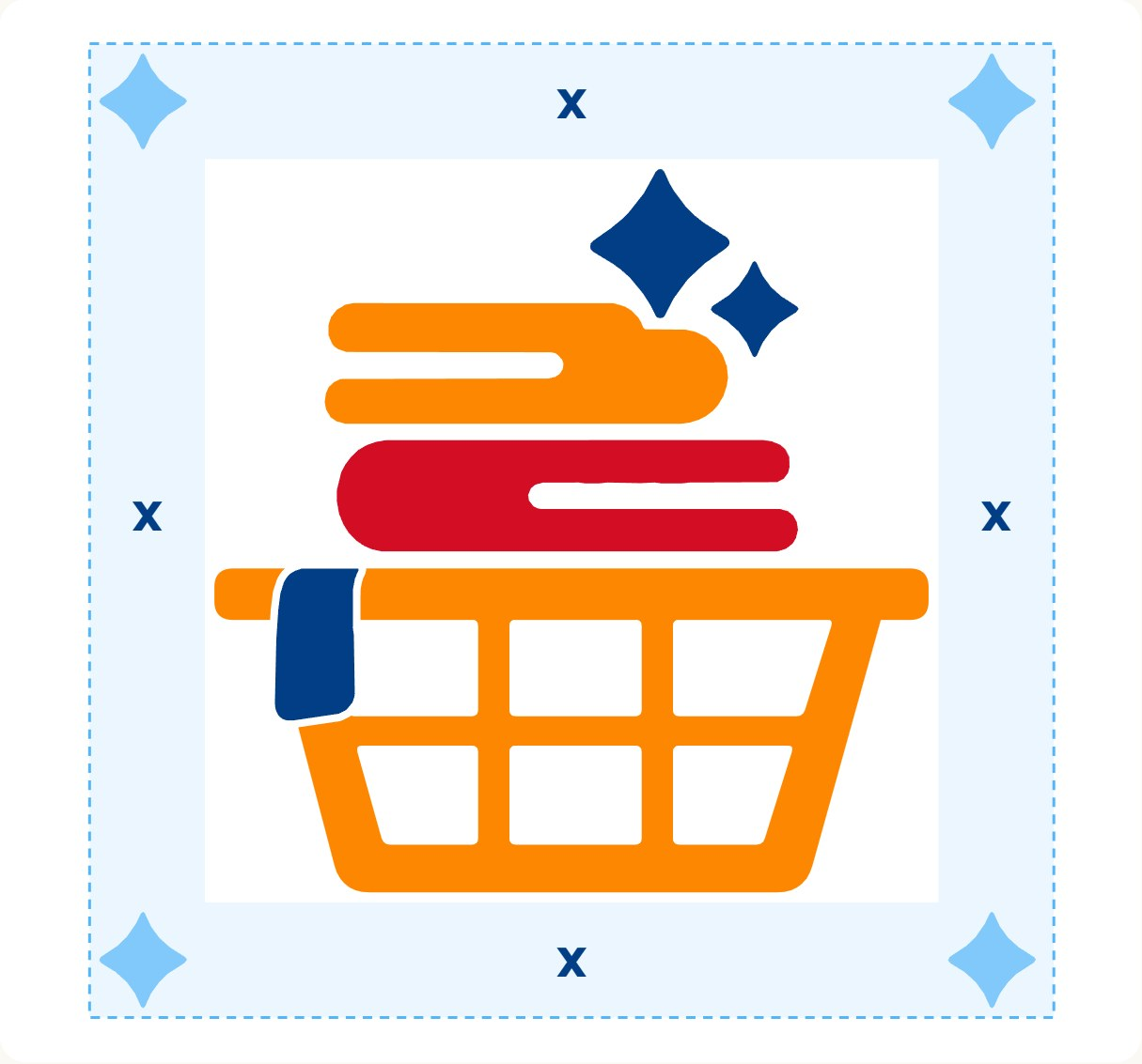 | Clear space  Keep a margin of x on every side, where x is the height of the small sparkle (122 u, about 15% of the mark’s height). Nothing — text, edges, other logos — enters this zone. For the horizontal lockup, measure x from the mark and apply it around the whole lockup.  Minimum size  Below these sizes the knockout between towel and rim, and the tuck lines in the cloths, fill in. The product’s smallest live use is the 38 px admin sidebar mark.  PROPOSED Clear space and minimum sizes are new rules derived from the mark’s geometry and from the smallest sizes the product already uses successfully.
  VERSION | DIGITAL | PRINT
  Mark only | 24 px tall | 8 mm tall
  Horizontal lockup | 28 px tall (mark) | 10 mm tall (mark)
  Favicon | 16 px (simplified pixel version) | —

COLOUR VERSIONS

Colour versions
Full colour is the default. Single-colour versions exist for situations where full colour cannot reproduce.
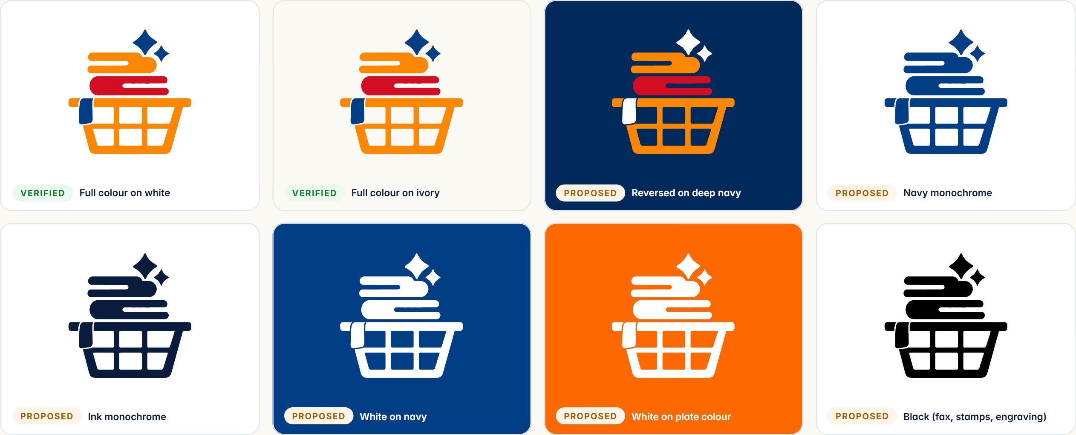
Reversed version. On deep navy the navy towel and sparkles would disappear, so they turn white while the orange and red stay. This is the only permitted colour swap. | Monochrome. The product already supports a one-colour mark (the tint option in LogoLayer.tsx). The towel knockout is drawn in the background colour, so the gap survives in every version. | PROPOSED Only full colour exists as approved artwork. Reversed and monochrome versions follow the product’s own tint logic; export and approve them as official files.

BACKGROUNDS & PLACEMENT

Backgrounds and placement
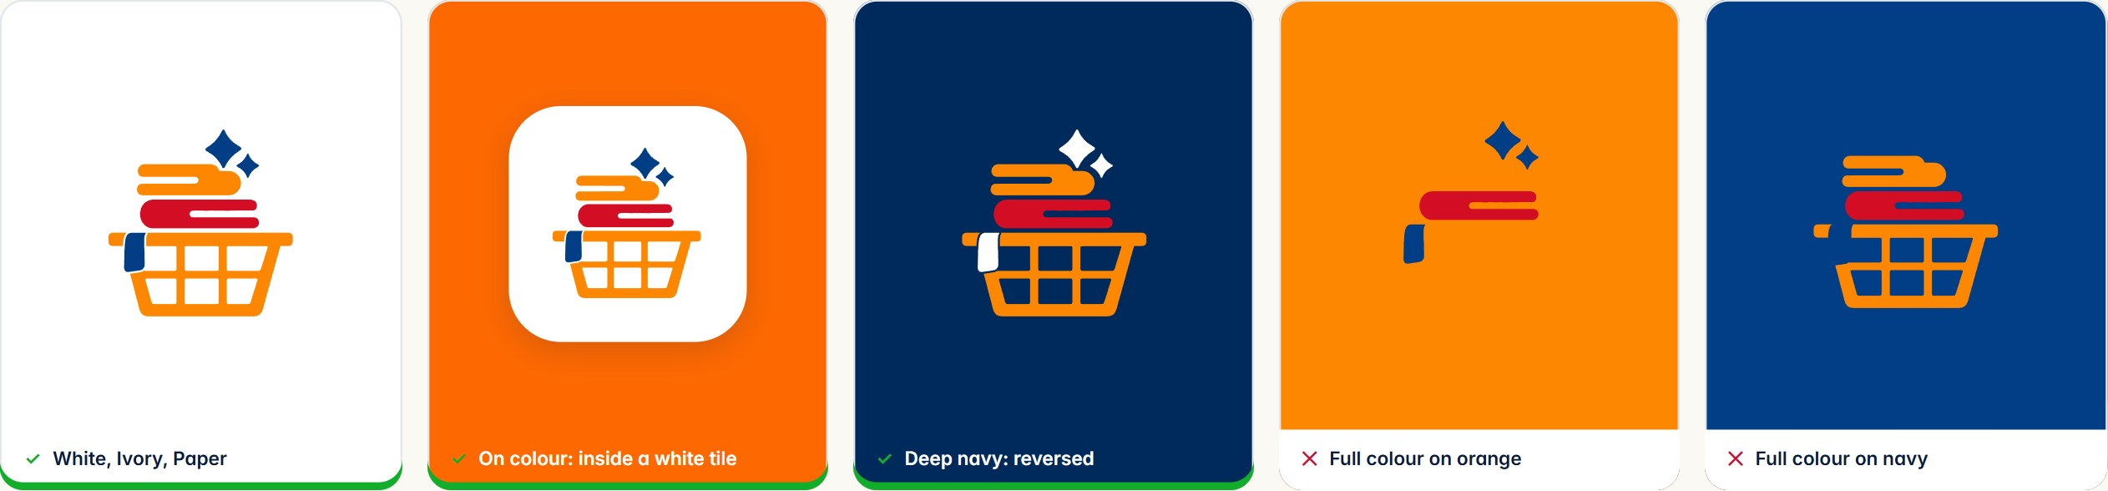
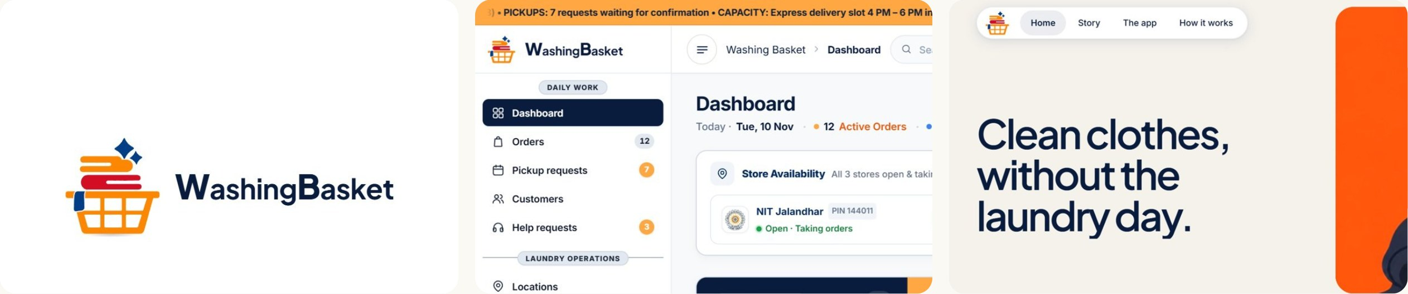
Live placements: mobile app intro lockup, admin sidebar, website navigation.
Placement. The lockup sits top-left in every product: app header, admin sidebar, website nav. On print, place it top-left or centred on the vertical axis; never in the middle of body content. | RULE On Logo Orange, plate colours or busy artwork, place the full-colour mark inside a white rounded tile, or use a single-colour white version.

ICON-ONLY MARK

App icon and favicon
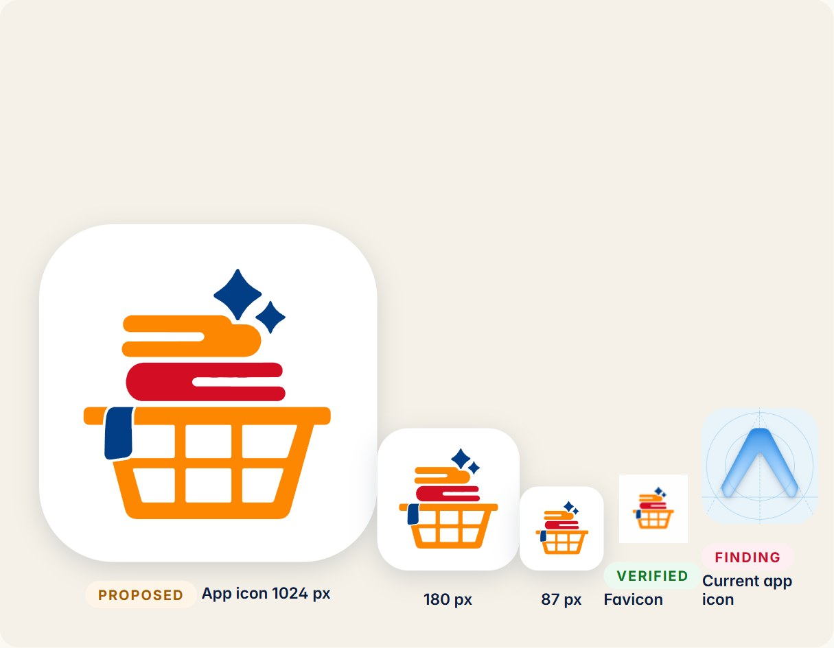 | The mark carries the brand wherever the name cannot fit. On device home screens it sits on a white tile with the mark at about 70% of the tile width, centred optically (nudge 2% down so the sparkles do not crowd the top).  FINDING The current mobile/assets/icon.png and android-icon-*.png are the Expo template. Replace before store submission.  VERIFIED The website and admin favicon is already the mark (favicon.png).
  ITEM | DETAIL
  Tile colour | White #FFFFFF
  Mark size | ~70% of tile width
  Android adaptive | Mark inside the 66% safe zone on a white background layer
  Monochrome (Android 13+) | Single-colour version from page “Colour versions”

INCORRECT USAGE

Never do this
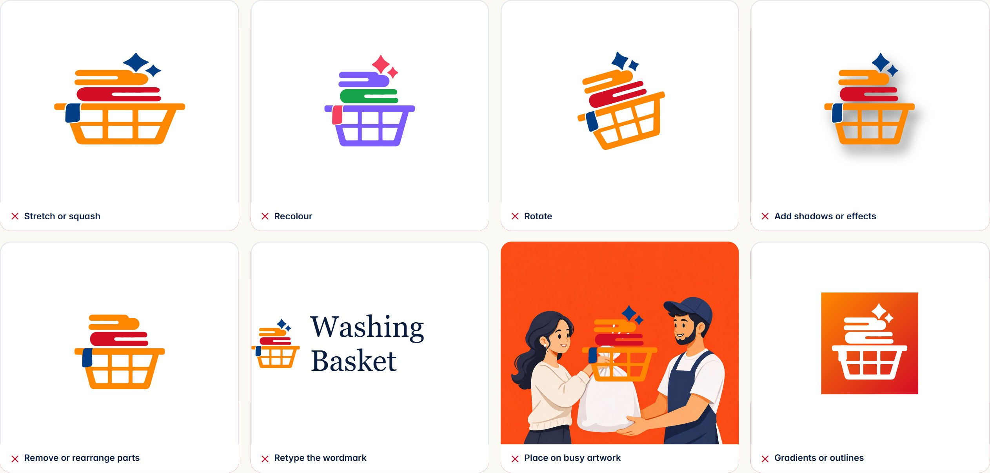
RULE Do not stretch, recolour, rotate, outline, add effects, separate or re-arrange the parts, retype the wordmark, or place the mark on a background that hides any of its shapes.

03 Colour identity
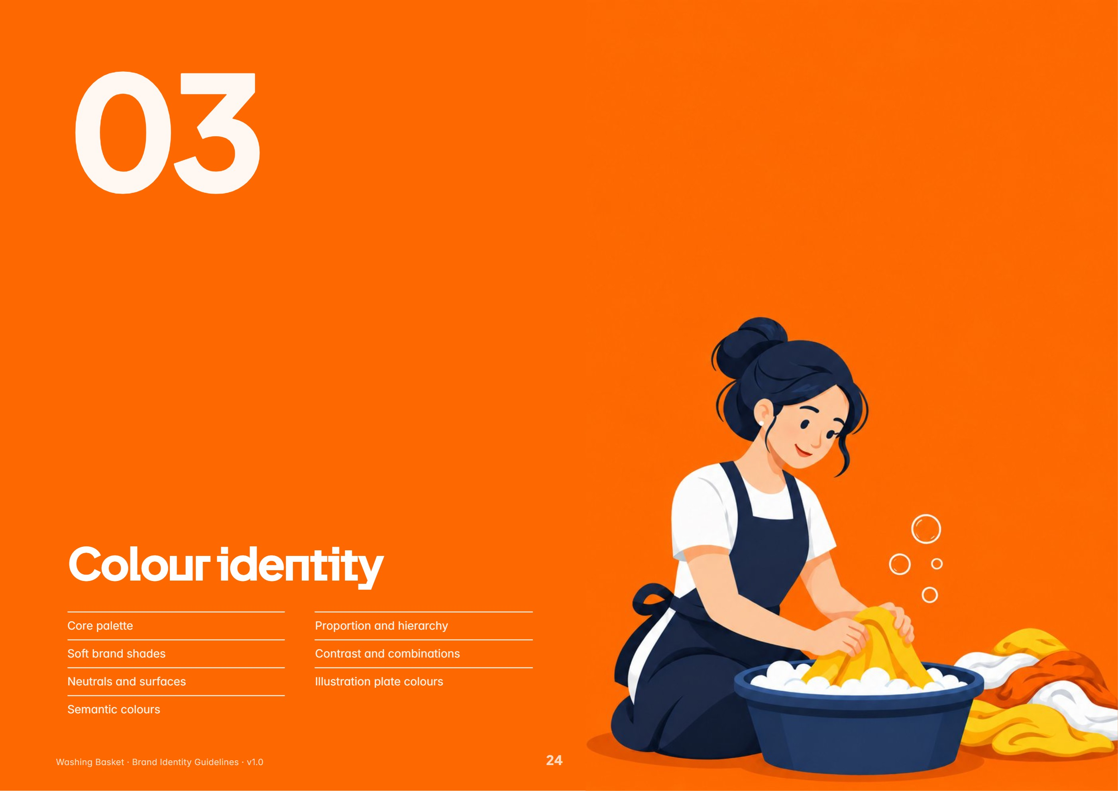
In this section: Core palette · Soft brand shades · Neutrals and surfaces · Semantic colours · Proportion and hierarchy · Contrast and combinations · Illustration plate colours
PRIMARY PALETTE

Core palette
Three colours come from the logo. Three more run the product. Together they are the brand’s signature.
Basket Navy  HEX #013E86  RGB 1 · 62 · 134  CMYK 99 · 54 · 0 · 47 | Logo Orange  HEX #FE8701  RGB 254 · 135 · 1  CMYK 0 · 47 · 100 · 0 | Cloth Red  HEX #D30D24  RGB 211 · 13 · 36  CMYK 0 · 94 · 83 · 17 | Ink  HEX #0A1C3E  RGB 10 · 28 · 62  CMYK 84 · 55 · 0 · 76 | Action Orange  HEX #FFA742  RGB 255 · 167 · 66  CMYK 0 · 35 · 74 · 0 | Deep Navy  HEX #012A5C  RGB 1 · 42 · 92  CMYK 99 · 54 · 0 · 64

COLOUR | HEX | TOKEN | USAGE
Basket Navy | #013E86 | theme brand.navy · sampled from logo | Logo sparkles and towel; links, focus rings, structure, dark offer tickets.
Logo Orange | #FE8701 | theme brand.logoOrange · sampled from logo | The basket and orange cloth in the logo. Reserved for the mark.
Cloth Red | #D30D24 | theme brand.red · sampled from logo | The red cloth in the logo; the “Cleaned.” brand band; seasonal tickets.
Ink | #0A1C3E | theme colors.ink | All primary text, the wordmark, dark buttons and dark stat cards.
Action Orange | #FFA742 | theme brand.orange / colors.cta | Primary buttons, wallet card, highlights, selection, active accents.
Deep Navy | #012A5C | theme app.navyDeep · site --navy-deep | Drawer, dark cards, website footer, pressed dark surfaces.

VERIFIED Navy, Logo Orange and Red re-sampled from the master PNG for this book: #013E86, #FE8701, #D30D24 match the theme exactly. CMYK values are mathematical conversions — confirm with a printer’s proof before production.
TWO ORANGES

Logo Orange and Action Orange
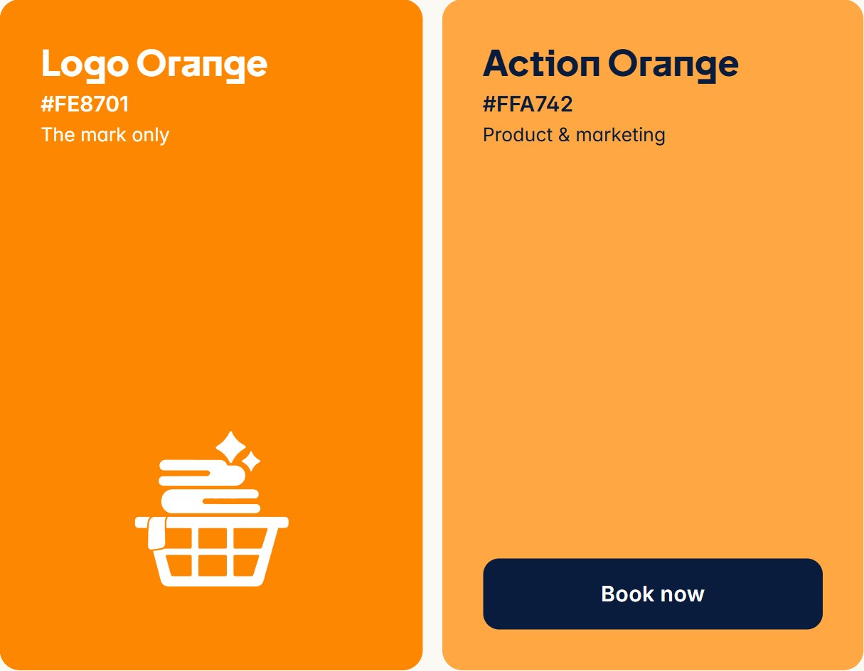 | The code keeps two oranges on purpose. Logo Orange (#FE8701) is the deep, saturated orange of the basket and cloth. Action Orange (#FFA742) is a softer, lighter tone the product uses for buttons, the wallet card and highlights — described in the theme as “modern, soft brand shades, inspired by the logo without being harsh”.  - Logo Orange appears inside the logo and nowhere else in UI.  - Action Orange is the orange of the product, website panels and campaigns.  - Never place the two side by side as flat fills; the near-match looks like an error.  RULE Keep the two oranges in their lanes: Logo Orange for the mark, Action Orange for everything else.  FINDING White text on Action Orange is 1.9:1 and fails WCAG. Use Ink labels (9.3:1), as shown.

SECONDARY PALETTE

Soft brand shades
Five soft shades, each paired with a tint for surfaces. They give the product its friendly, fresh character without diluting the core.
Soft Blue  #54B6F8  RGB 84 · 182 · 248 | Soft Orange  #FFA742  RGB 255 · 167 · 66 | Soft Green  #62D487  RGB 98 · 212 · 135 | Soft Red  #F87C87  RGB 248 · 124 · 135 | Soft Gold  #FED843  RGB 254 · 216 · 67
Blue Tint  #EBF6FE | Orange Tint  #FFF4E8 | Green Tint  #EBF9F0 | Red Tint  #FEF0F2 | Gold Tint  #FFFBEA

SHADE | HEX | TINT | HEX | USE
Soft Blue | #54B6F8 | Blue Tint | #EBF6FE | Towel and sparkle echo; info surfaces, calendar highlights.
Soft Orange | #FFA742 | Orange Tint | #FFF4E8 | Warmth; CTA, offer and wallet surfaces.
Soft Green | #62D487 | Green Tint | #EBF9F0 | Fresh and delivered; completed states.
Soft Red | #F87C87 | Red Tint | #FEF0F2 | Cancelled and error surfaces, gentle alerts.
Soft Gold | #FED843 | Gold Tint | #FFFBEA | Warm highlights, rewards, referral moments.

VERIFIED From brandShades in mobile/src/theme/index.ts and the website’s --blue … --gold tokens.
NEUTRALS & SURFACES

Neutrals, surfaces and text
White  #FFFFFF  App canvas, cards, sheets | Ivory  #FBF9F4  Website canvas (--ivory) | Paper  #F5F1E8  Website panels (--paper) | Stone  #EAE6DB  Website deep panels (--stone) | Field  #F4F2EB  Resting text-field fill | Subtle  #F4F5F7  Secondary surfaces (app.cream)
Admin Canvas  #F8F9FA  Admin portal background | Line  #E3E6EB  Hairlines and dividers | Line Strong  #CBD5E1  Input borders, table rules | Ink Muted  #667085  Captions, helper text | Ink Soft  #5B6475  Body copy, labels | Ink  #0A1C3E  Headings, primary text

Backgrounds  White is the app canvas (“clean pure white behind everything, no cream”). Ivory, Paper and Stone form the warmer environment of the website. The admin portal sits on a cool #F8F9FA. | Text  Ink for headings and primary text, Ink Soft for body and labels, Ink Muted for captions and helper text. Never use pure black for type. | Lines & fields  Line for hairlines, Line Strong for input and table borders. Text fields rest on Field #F4F2EB and turn white with a navy edge on focus.

VERIFIED All values from mobile/src/theme/index.ts, admin/src/theme/tokens.ts and website/src/styles/base.css.
SEMANTIC COLOURS

Status and feedback
 | Semantic colours appear as small signals — a dot, a badge, an icon, a thin bar — on their tint. They never fill large areas, and status is never shown by colour alone: pair it with a word (“Delivered”) or an icon.  VERIFIED success, danger, warning and their tints from the theme; admin adds success-ink #0D7A21 for text on green tint.
  Success  #12AD2B | Warning  #B97800 | Danger  #C8102E | Information  #013E86
  ● Delivered  Tint #EBF9F0 | ● Payment pending  Tint #FFF4D9 | ● Cancelled  Tint #FEF0F2 | ● Drop-off ready  Tint #EEF3FB
  ROLE | COLOUR | TINT | MEANING
  Success | #12AD2B | #EBF9F0 | Paid, delivered, live. “Parrot green: bright and unmistakably positive.”
  Warning | #B97800 | #FFF4D9 | Pending payment, slot nearly full, needs attention.
  Danger | #C8102E | #FEF0F2 | Errors, failed payments, cancelled orders, destructive actions.
  Information | #013E86 | #EEF3FB | Navy doubles as the info colour (navyTint surface).

ACCESSIBILITY

Contrast and combinations
Measured WCAG 2.2 contrast ratios for the combinations the product uses. AA requires 4.5:1 for body text and 3:1 for large text (18 px bold / 24 px regular) and UI parts.
Aa  Ink on White  16.8:1 · AAA | Aa  Ink on Ivory  16.0:1 · AAA | Aa  Ink Soft on White  6.0:1 · AA | Aa  Ink Muted on White  5.0:1 · AA | Aa  White on Navy  10.3:1 · AAA | Aa  White on Deep Navy  14.1:1 · AAA | Aa  Ink on Action Orange  8.7:1 · AAA | Aa  White on Action Orange  1.9:1 · Fail
Aa  White on Logo Orange  2.4:1 · Fail | Aa  White on Red  5.5:1 · AA | Aa  Ink on Gold  12.1:1 · AAA | Aa  White on Success  3.0:1 · Fail | Aa  Success ink on tint  5.1:1 · AA | Aa  Danger on tint  5.3:1 · AA | Aa  Warning on tint  3.3:1 · AA Large | Aa  Navy on Navy tint  9.3:1 · AAA

RULE Body text must reach 4.5:1. Use Ink on light surfaces and white on Navy, Deep Navy or Red. | FINDING White on Action Orange (1.9:1) and on Logo Orange (2.4:1) fail for text. Use Ink on oranges and yellows. | VERIFIED Ratios computed for this book from the token HEX values.

HIERARCHY & PROPORTION

How much of each
 | The product reads as calm first, bright second. Most of every screen is white or ivory. Ink and Navy give structure. Orange marks the one thing to do next. Shades and semantic colours are accents.  - One Action Orange element per view where possible: the primary action.  - Red is a brand colour, not an alert colour, except in the semantic Danger role.  - Plate colours (next page) belong to illustration and campaigns, not UI chrome.  - Dark sections use Deep Navy, never pure black.  PROPOSED Percentages are a guide measured from the live app and website screens, not a mathematical rule.  VERIFIED The orange-red-navy band sequence is the website’s brand moment: Collected. Cleaned. Returned.
  62%  Neutrals  White · Ivory · Paper | 16%  Ink & Navy | 12%  Action Orange | 6%  Shades | 4%
  COMBINATION | STATUS | COLOURS
  App | Verified | White · Ink · Action Orange
  Website | Verified | Ivory · Ink · Navy · Action Orange
  Brand bands | Verified | Logo Orange · Cloth Red · Basket Navy
  Two oranges side by side | Avoid | Logo Orange next to Action Orange
  Red with green | Avoid | Cloth Red next to Success green
  Navy text on ink | Avoid | Basket Navy on Ink

CAMPAIGN PALETTE

Illustration plate colours
Each step of the care process has its own saturated plate colour. Together they run warm, from red-orange to gold, with one navy plate for contrast.
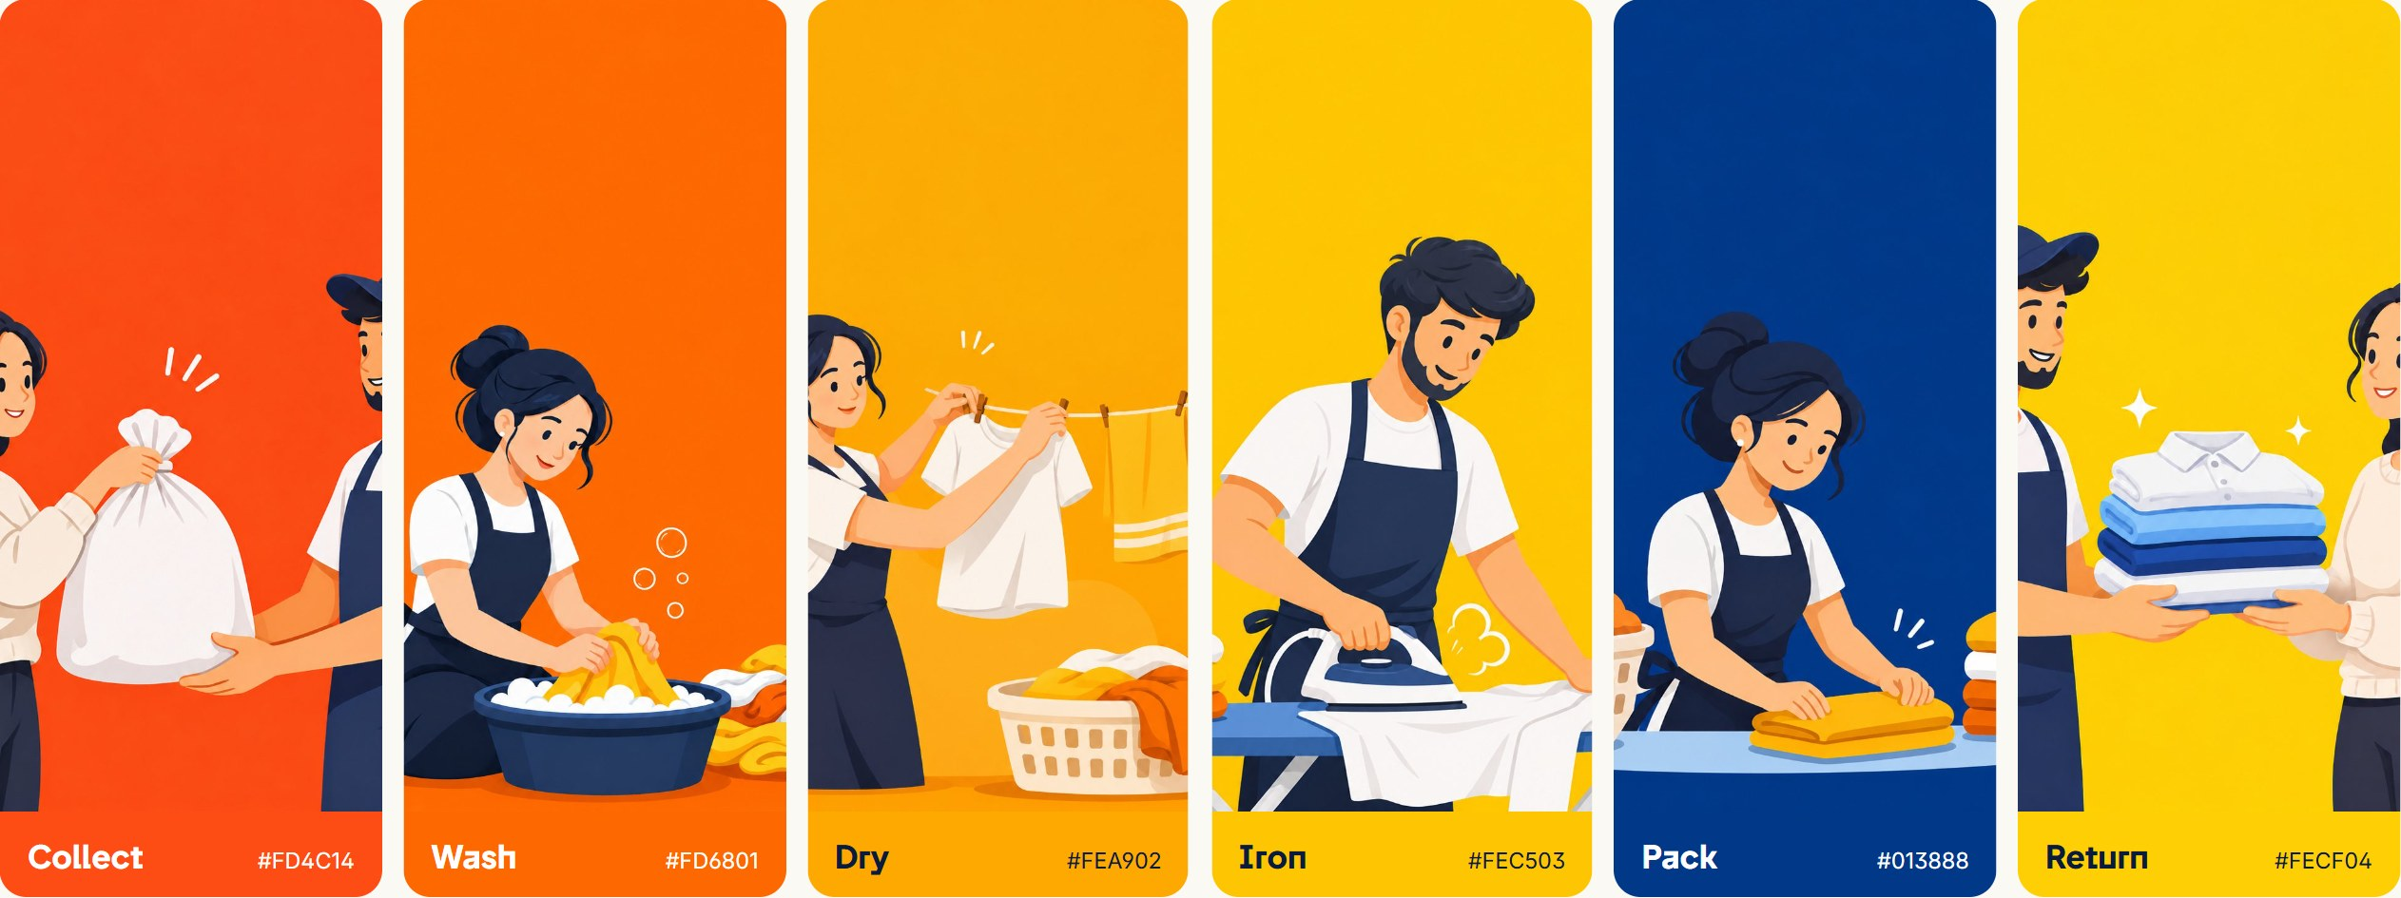
These colours live inside the artwork. They are the backgrounds of the six process plates and the hero cards (Collect #FC4C13, Care #FE6900, Return #FDCE03 in content.ts). | Offer tickets borrow the same family: #FF6F3C, #013E86, #FEC837, #D30D24 and #FEDB7D, each with a darker stub. | VERIFIED Sampled from assets/artwork/1–6.png; values vary slightly across each plate’s grain. Not for UI text or buttons.

04 Typography system
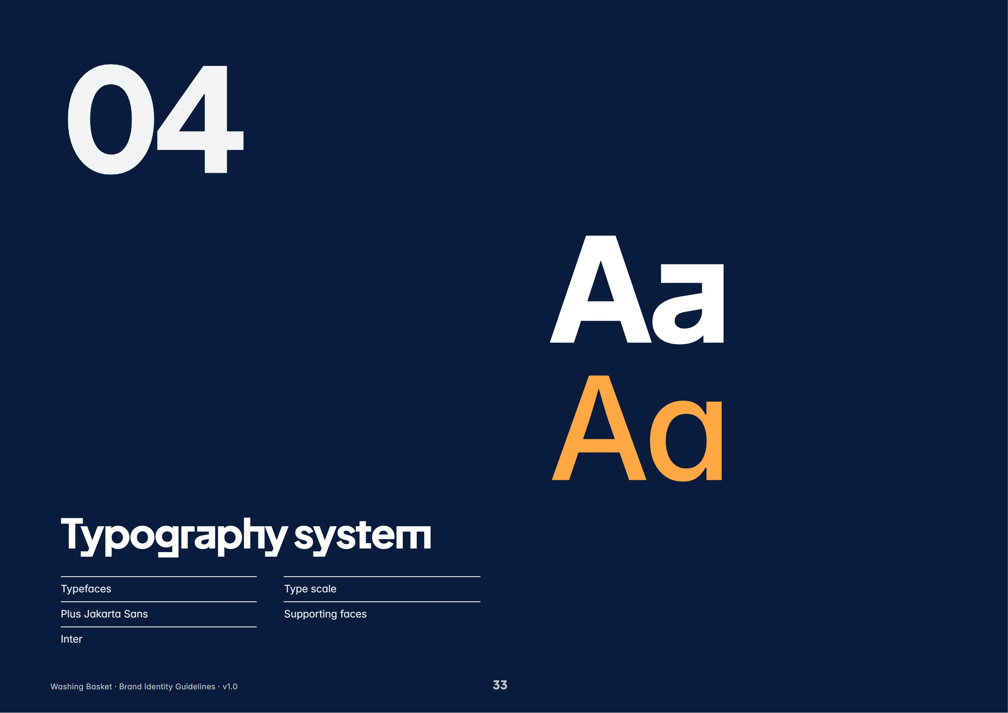
In this section: Typefaces · Plus Jakarta Sans · Inter · Type scale · Supporting faces
TYPEFACES

Two families do the work
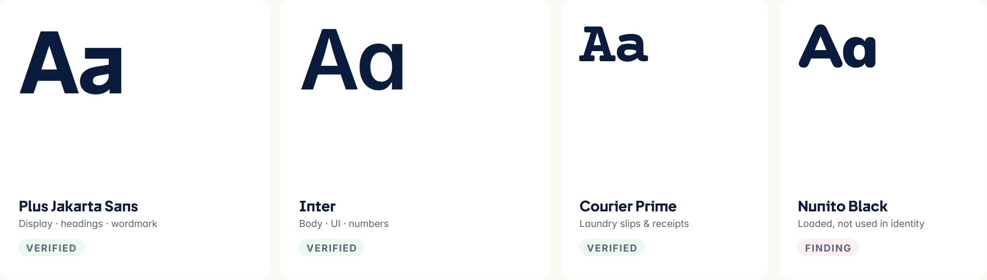
TYPEFACE | ROLE | WHY IT BELONGS | WEIGHTS IN USE
Plus Jakarta Sans | Primary · display | A geometric sans with open, friendly curves and a modern edge. Its round bowls echo the capsule-ended cloths of the mark. | 500, 600, 700, 800
Inter | Secondary · text & UI | “Crisp, precise and highly legible at every size.” Tabular figures keep prices and order numbers aligned. | 400, 500, 600, 700
Courier Prime | Supporting · print slips | “The typewriter print on the laundry slip” — a tactile, receipt-like voice for order tickets and tags. | 400, 700
Nunito | Not in identity | Bundled in the app and named in a theme comment, but no shipped screen uses it for the wordmark. | —

VERIFIED All four are open-source Google Fonts (SIL OFL) loaded by @expo-google-fonts and @fontsource. This book is set in the same files.
PRIMARY TYPEFACE

Plus Jakarta Sans
Aa Bb Cc  ABCDEFGHIJKLMNOPQRSTUVWXYZ  abcdefghijklmnopqrstuvwxyz  0123456789 ₹ & @ ? ! % ( ) / – | Medium 500 Collected. Cleaned. Returned.  SemiBold 600 Collected. Cleaned. Returned.  Bold 700 Collected. Cleaned. Returned.  ExtraBold 800 Collected. Cleaned. Returned.
  ITEM | DETAIL
  Personality | Confident, warm, contemporary
  Use for | Hero headlines, section titles, big numbers, the wordmark
  Tracking | Tight: −0.03 em at display sizes, −0.01 em at 20–32 px
  Line height | 1.05–1.15 for display, 1.2 for headings
  Avoid | Body paragraphs, small labels under 14 px, all-caps blocks

SECONDARY TYPEFACE

Inter
Aa Bb Cc  ABCDEFGHIJKLMNOPQRSTUVWXYZ  abcdefghijklmnopqrstuvwxyz  0123456789 ₹ & @ ? ! % ( ) / – | Regular 400 Collected. Cleaned. Returned.  Medium 500 Collected. Cleaned. Returned.  SemiBold 600 Collected. Cleaned. Returned.  Bold 700 Collected. Cleaned. Returned.
  ITEM | DETAIL
  Personality | Neutral, precise, highly legible
  Use for | Body text, UI labels, buttons, forms, tables, prices
  Numbers | Tabular figures (tnum) for amounts, order IDs, times
  Admin | Stylistic sets cv11 and ss01 enabled
  Line height | 1.4–1.55 body; 1.3 for labels

TYPE SCALE

The scale in use
HERO HEADLINE Clean clothes, without the laundry day.  SECTION HEADING Five careful steps, every single order.  SUBHEADING Schedule a pickup  SCREEN TITLE (APP) Welcome to Washing Basket  BODY PARAGRAPH Pick a date, a time slot and your address. A partner collects your basket during your two-hour slot.  BUTTON LABEL Book now  NAVIGATION LABEL Home Orders Wallet Profile  AMOUNT ₹1,293.00  CAPTION We’ll text you a 6-digit code to confirm it’s you. | VERIFIED App styles from type and text in mobile/src/theme/index.ts. Hero and section sizes are the website’s desktop values (fluid on smaller screens). Example sizes in the figure are reduced to fit the page.
  STYLE | FONT | WEIGHT | SIZE / LINE | TRACKING
  Hero headline | Plus Jakarta Sans | 800 | 64 / 67 px | -0.035em
  Section heading | Plus Jakarta Sans | 800 | 40 / 43 px | -0.03em
  Subheading | Plus Jakarta Sans | 700 | 24 / 30 px | -0.6px
  Screen title (app) | Inter | 700 | 22 / 28 px | -0.6px
  Body paragraph | Inter | 400 | 14 / 20 px | 0
  Button label | Inter | 600 | 15 / 18 px | 0.2px
  Navigation label | Inter | 500 | 12 / 16 px | 0.2px
  Amount | Inter | 600 | 18 / 24 px | -0.3px
  Caption | Inter | 400 | 12 / 16 px | 0

SUPPORTING FACES & RULES

Slips, numbers and rules
 | Courier Prime is the voice of the physical laundry slip, the order tag and the receipt. Use it in uppercase for labels and mixed case for line items; never for headlines or UI.  Typography rules  - Sentence case for every heading, button and label. No Title Case, no ALL CAPS except short eyebrow labels and slips.  - Headlines often break into two short lines with a full stop: “Seven services, / one basket.”  - Use the rupee sign ₹ before amounts with no space; tabular figures in lists.  - Left-align text. Centre only short headlines on marketing moments.  - Never set body text in Plus Jakarta Sans, or headlines in Courier Prime.  - Never substitute Arial, Helvetica or system fonts in brand materials; install the brand fonts.  RULE Only Plus Jakarta Sans, Inter and Courier Prime may appear in Washing Basket materials.  PROPOSED The slip shown is a concept built on the theme’s stated use of Courier Prime; layout to be approved.
  WASHING BASKET
  LAUNDRY SLIP · MODEL TOWN
  ORDER WB-1011
  DATE 08 NOV 2026
  Normal wash · 4.2 kg ₹189
  Shirt — steam press × 3 ₹45
  Stain treatment × 1 ₹70
  TOTAL ₹304
  COUNTED IN FRONT OF YOU · THANK YOU

05 Illustration & characters
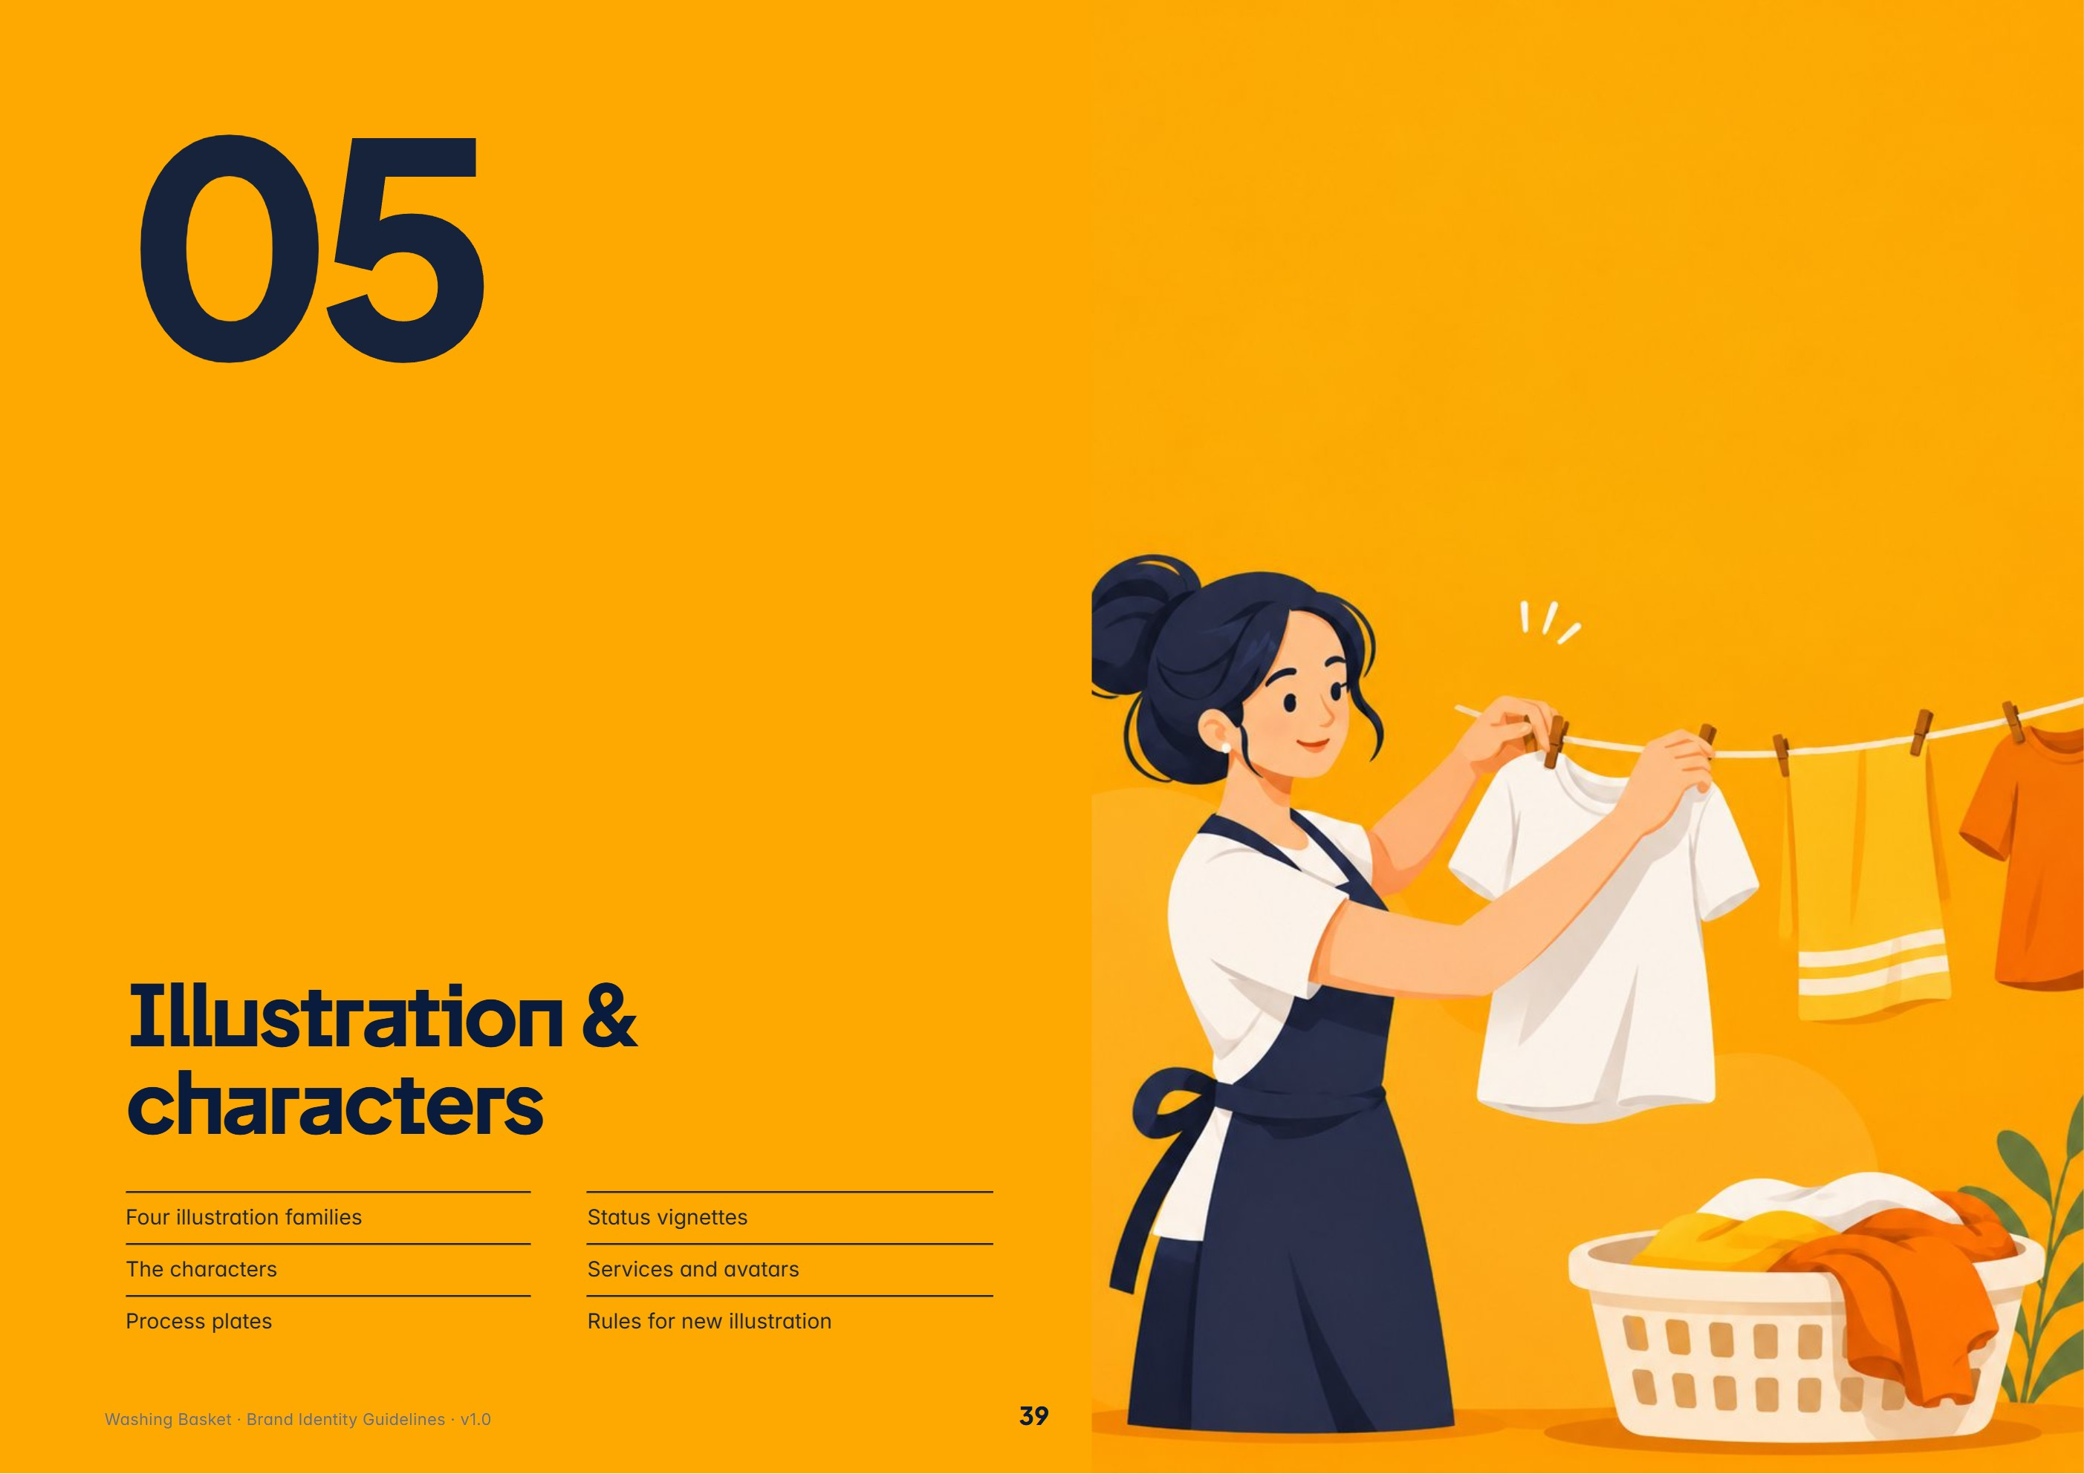
In this section: Four illustration families · The characters · Process plates · Status vignettes · Services and avatars · Rules for new illustration
GRAPHIC LANGUAGE

Four illustration families
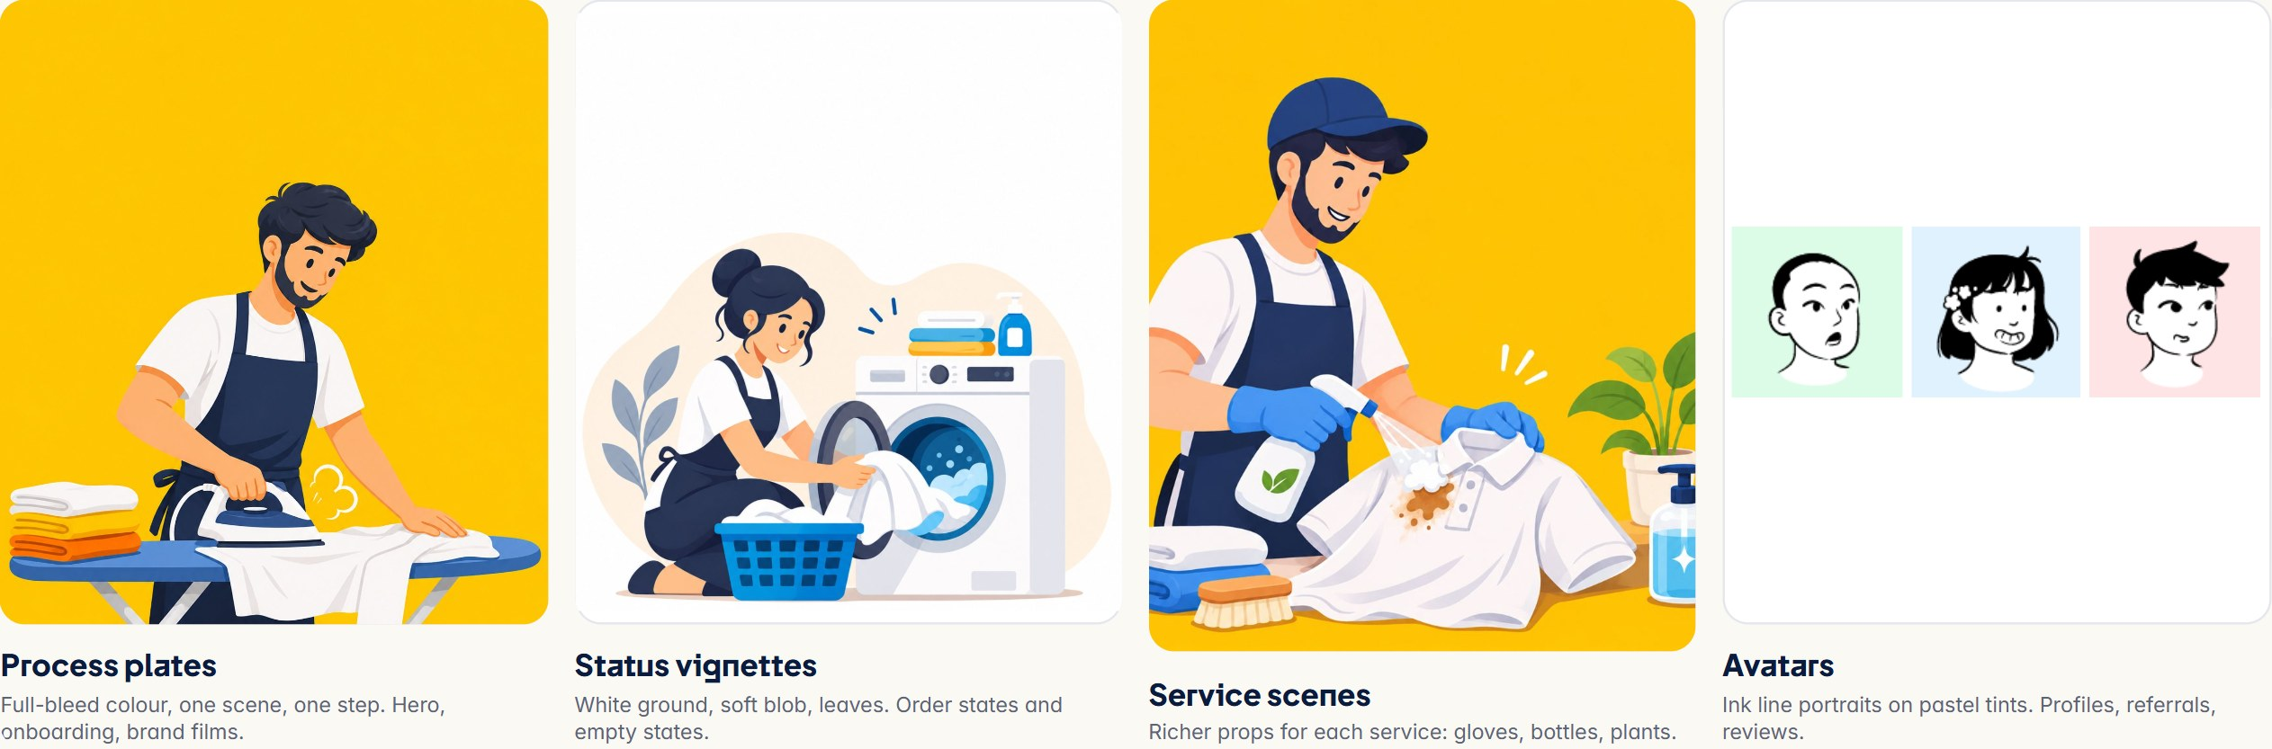
ATTRIBUTE | SHARED RULE ACROSS ALL FAMILIES
Style | Flat vector with soft cel shading; no outlines on bodies, minimal texture, gentle grain on plates
Shape language | Rounded and soft; capsule folds on cloth stacks, round baskets and tubs, no sharp angles
Line | Only avatars use line; elsewhere shapes are defined by colour. Hair and apron details in ink navy
Palette | Navy uniforms, white tees, brand oranges, warm yellows, a little green from plants and lavender-grey leaves
Mood | Calm, competent, kind. People are mid-task and smiling, never posed or exaggerated

VERIFIED Families and attributes catalogued from assets/artwork, assets/illustrations, mobile/assets/services and assets/avatars.
CHARACTERS

The people of Washing Basket
There is no mascot. The brand is carried by three recurring people: two care partners and a customer, drawn consistently across every family.
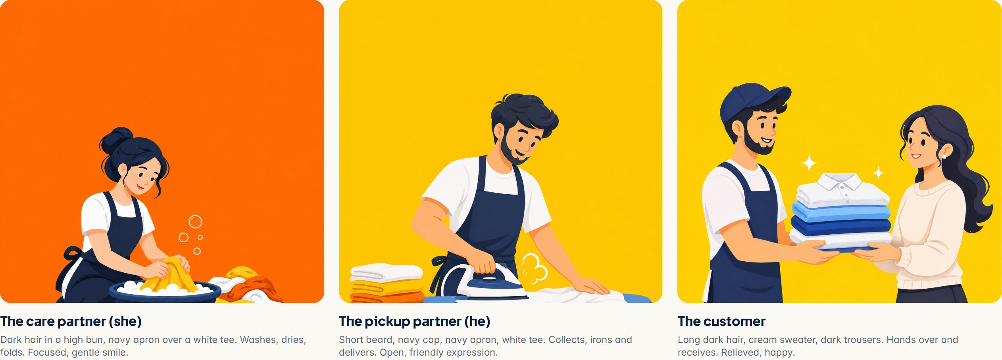
Uniform  Partners always wear a navy apron over a white crew-neck tee; the pickup partner adds a navy cap. This is the brand’s only fixed costume — it makes staff instantly recognisable. | Expressions & poses  Calm concentration at work; warm smiles at hand-over; one worried look for the “stained shirt” problem state. Poses are mid-action: handing, scrubbing, hanging, pressing, folding, riding. | Proportions  Naturalistic adult proportions, slightly enlarged heads and hands for readability. Faces are simple: dot-and-curve eyes, small nose, clear brows.  PROPOSED Character names are not defined. Leave them unnamed unless the team approves names.

PROCESS PLATES

One step, one colour, one scene
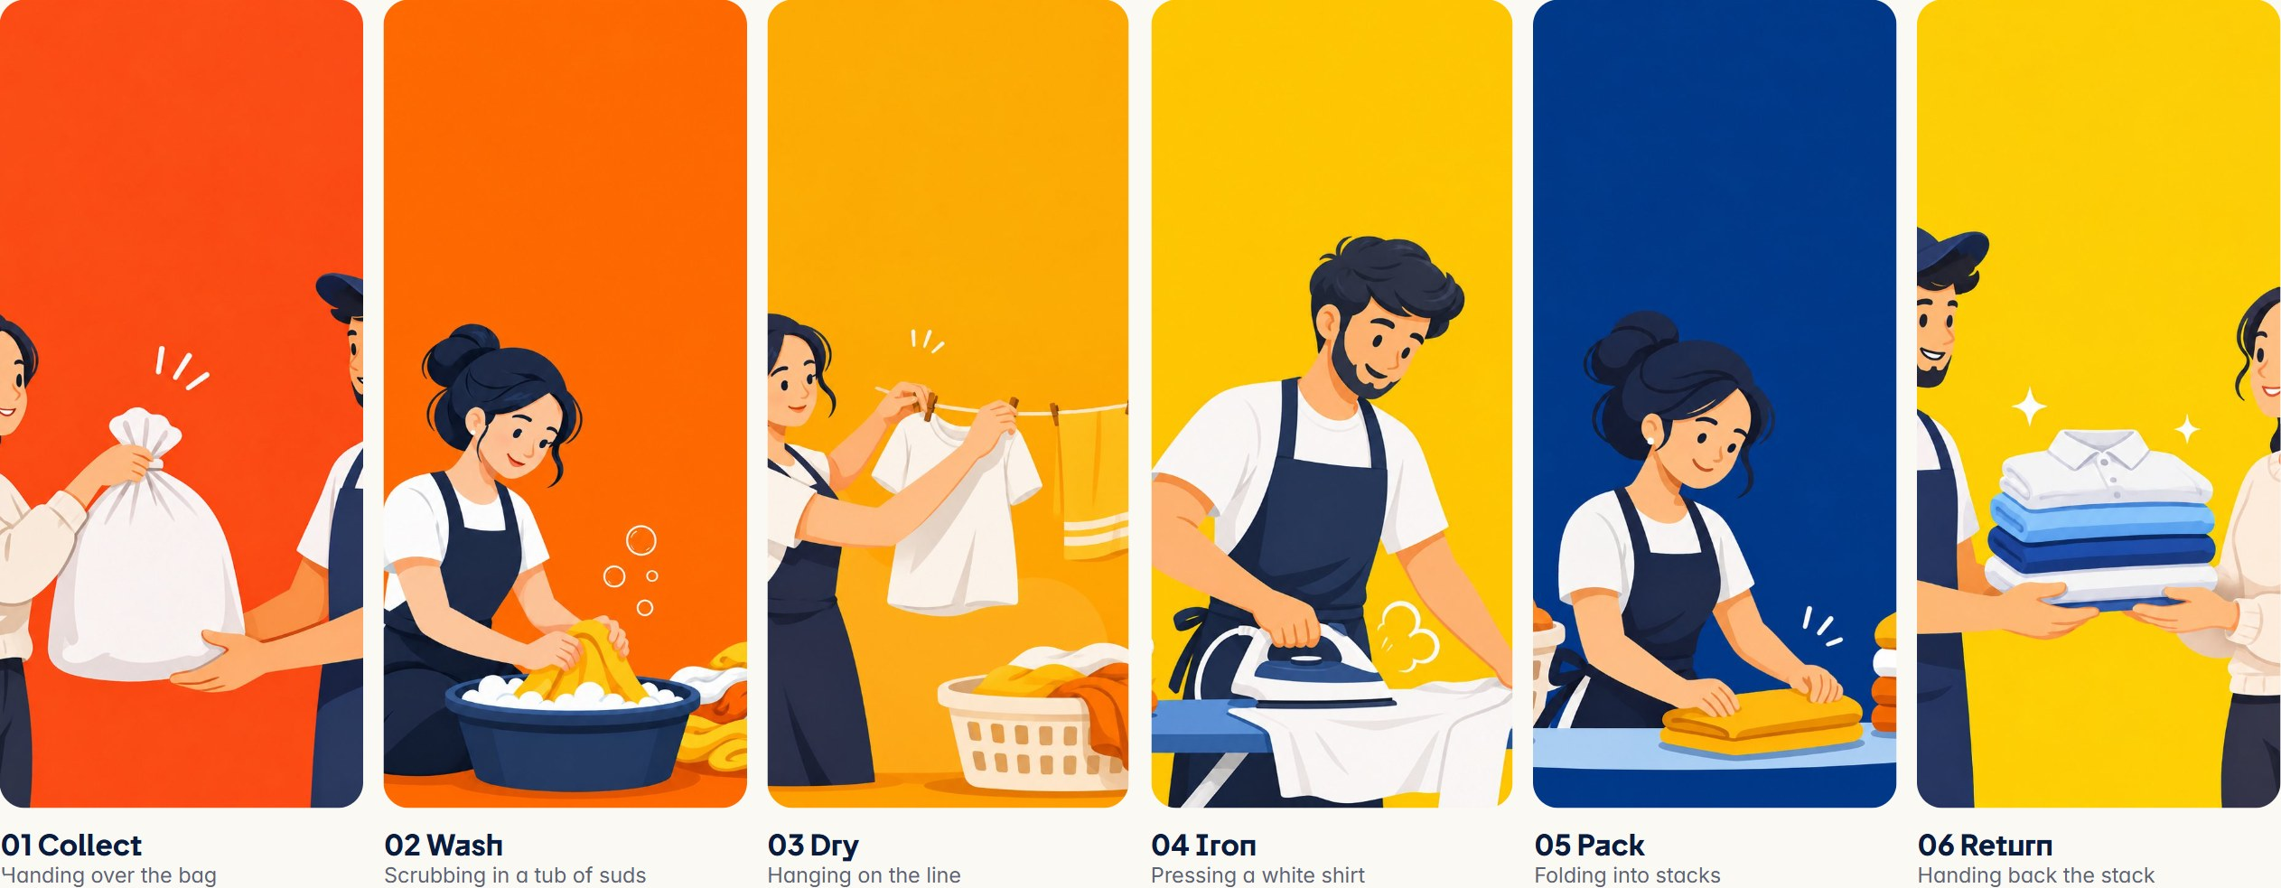
Composition. One or two figures, cropped at the waist or knees, filling the lower two-thirds. A plain saturated background with soft grain; a few props only (tub, basket, line, iron, stack). | Use. Website hero cards and care journey, the mobile sign-in carousel, the admin sign-in film, and the hero loop and brand film generated from these plates. | VERIFIED assets/artwork/1–6.png; also mobile/assets/scenes and website/src/assets/art-*.webp.

STATUS VIGNETTES

Illustrating the order journey
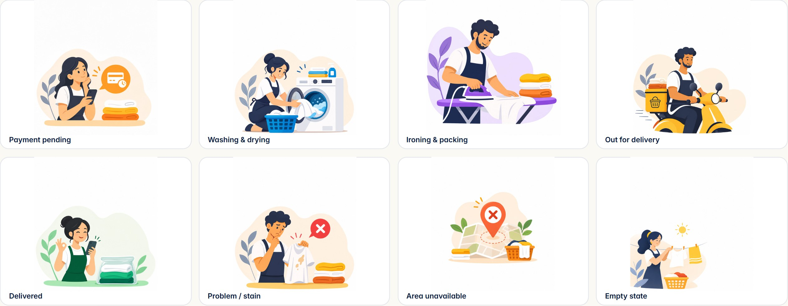
Style. White ground; a soft, pale blob (cream, mint or lilac) behind the scene; lavender-grey leaves framing one side; a single bright accent icon (✕ badge, card, sun) to tell the state. | Where. Order tracking states, empty and error states, unavailable-area screen (pincode check), loading interstitials and onboarding confirmations. | VERIFIED assets/illustrations and mobile/assets/illustrations, used by the app’s order and pincode screens.

SERVICE SCENES & AVATARS

Services and people
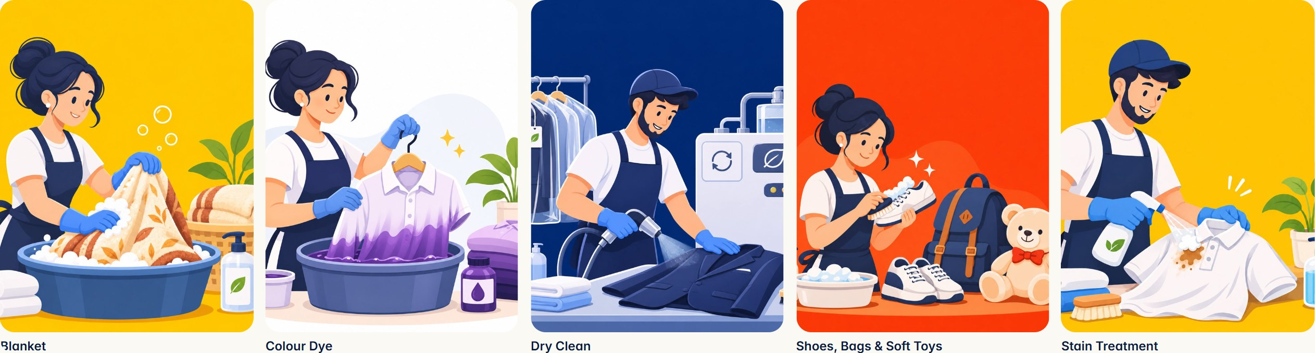
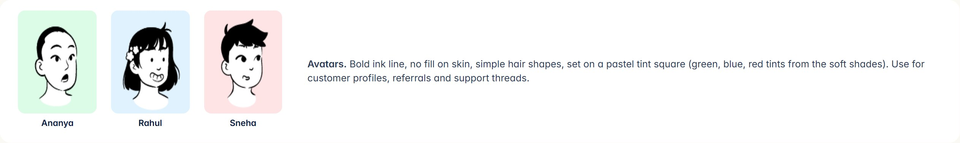
VERIFIED Service scenes add blue nitrile gloves, spray bottles and potted plants — signals of hygiene and care that match the quality promise.
RULES

Making new illustration
Mandatory  - Flat vector with soft shading, no outlines on figures (avatars excepted).  - Partners wear the navy apron over a white tee; keep the three established characters consistent.  - Plates: one step, one saturated plate colour from the campaign palette, one or two figures.  - Vignettes: white ground, pale blob, lavender-grey leaves, one accent icon.  - Represent real campus and Indian household settings; vary skin tones and body types respectfully.  - Every new illustration is reviewed against this page before release.  RULE No 3D renders, stock clip-art, photo-realism, mascots or emoji-style faces in the brand illustration set. | Flexible  - Props and backgrounds can change for seasonal campaigns (monsoon, winter bedding).  - Crops can be tighter for small UI spots, as long as faces stay complete.  - Material textures (cloth, wood, wicker) may be used on the website as stage sets, separate from character art.  Production notes  PROPOSED These production specs reflect the existing files; adopt as standard.
  ITEM | DETAIL
  Master size | ≥ 1200 px wide, PNG with transparency for vignettes
  Plates | Portrait ≈ 11:12, full-bleed background
  Export | WebP for web, PNG for app, layered source kept in assets/
  Animation | Cut into layers for hero-loop/brand-film pipelines

06 Iconography & visual elements
ICON LANGUAGE

Outline icons, rounded ends
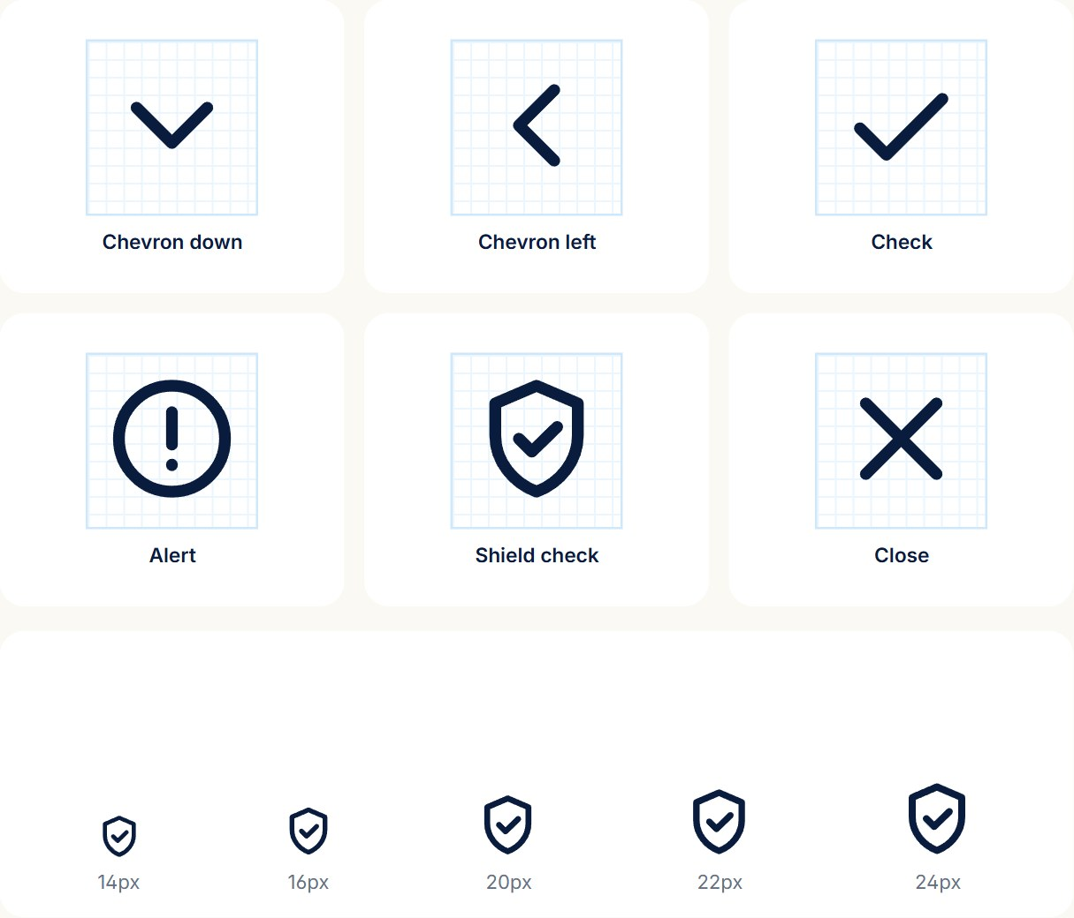 | Spacing. Icons sit 8 px from a label. Tap targets are at least 44 × 44 px even when the glyph is 20 px — round icon buttons in the app give that room.  VERIFIED Glyphs reproduced from mobile/src/components/ui/icons.tsx. The style matches Lucide/Feather-like outline icons used across admin.
  ITEM | DETAIL
  Grid | 24 × 24 viewBox, 2 px padding
  Stroke | 2 px default; 1.8 for small shields; 2.4–2.8 for checks
  Ends & joins | Round caps, round joins
  Fill | None. Outline only; filled glyphs only inside status dots
  Corner radius | Follow the stroke; no hard corners
  Sizes | 14, 16, 20, 22, 24 px
  Colour | Ink Muted #64748B at rest; Ink or Navy active; semantic colour for status

VISUAL ELEMENTS

Radius, borders, shadows
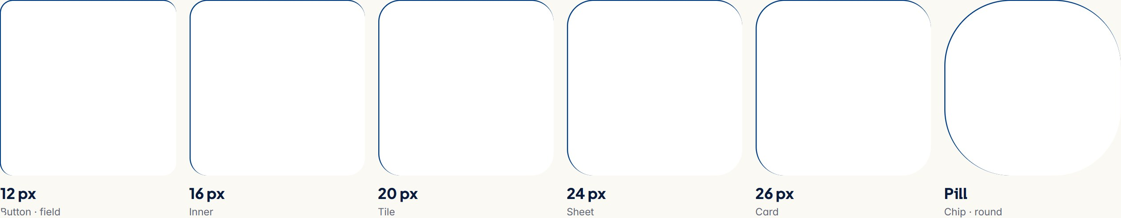
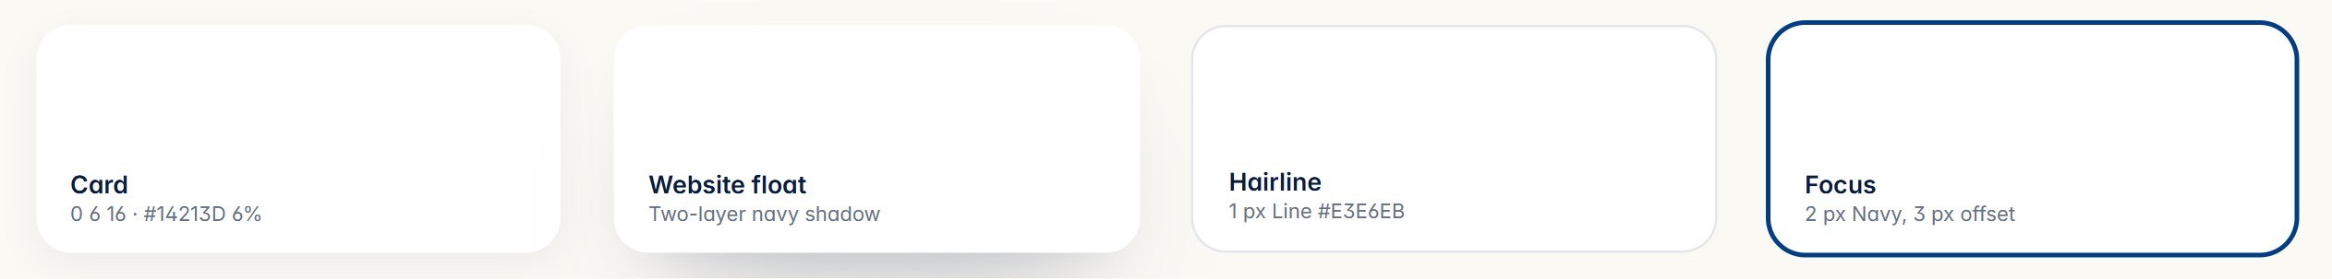
ELEMENT | APP | ADMIN | WEBSITE
Card radius | 26 px (shape.card) | 14 px (dense) | 26 px (--r-card)
Tile radius | 20 px | 12 px | 20 px
Field radius | 12 px | 10 px | Pill (999)
Shadow | One soft level; most surfaces use colour, not shadow | Borders over shadows | Floating navy shadow on device frames

VERIFIED radius, shape and elevation in mobile/src/theme; admin overrides in tokens.ts; website in base.css. The admin is intentionally tighter for dense data.
SIGNATURE ELEMENTS

Graphic motifs
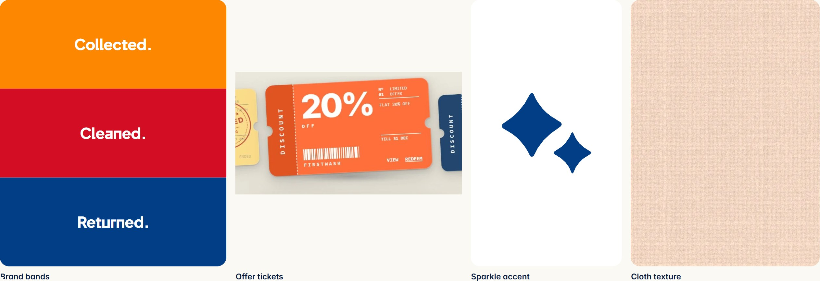
Brand bands. Three full-width stripes in logo orange, red and navy with one word each. The single strongest graphic device outside the mark. | Offer tickets. Perforated coupons with a darker stub, vertical side label and barcode. Used for every offer in app and web. | Sparkles. The two stars may appear alone as a “fresh / clean” accent next to success messages. Always navy or white, never rotated.  PROPOSED Sparkles-only use is a proposal; currently they appear only inside the mark.

07 Photography & image direction
IMAGE DIRECTION

Illustration first, photography second
VERIFIED The audit found no photography in the brand. Every image is illustration or a rendered material texture — a distinctive choice worth keeping.  Keep illustration as the face of the brand. Add photography only where proof matters — real counters, staff and folded orders — and make it feel like the illustrations brought to life.  Proposed photography direction  PROPOSED All photography guidance is a recommendation for future shoots. | 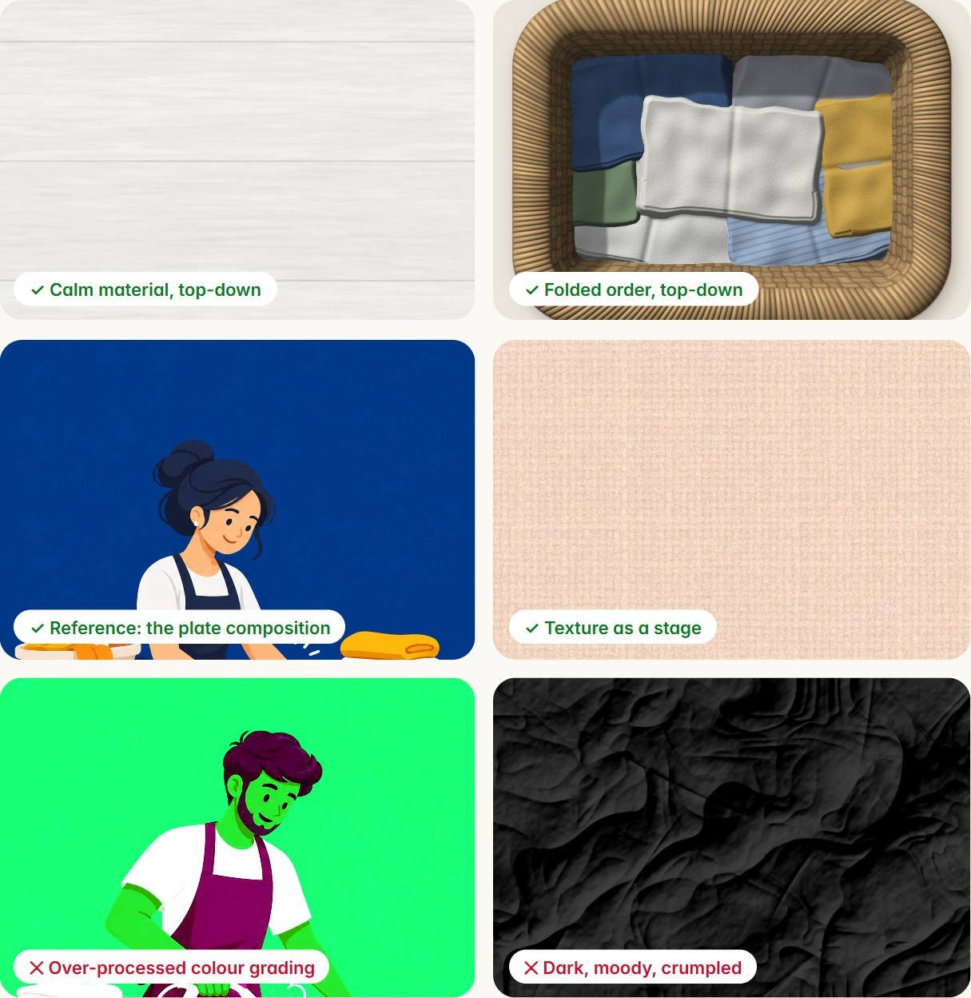
  ITEM | DETAIL
  Light | Bright, soft daylight; no harsh flash, no dark moody shadows
  Background | Plain walls in white, ivory or a plate colour; uncluttered
  Composition | One subject, centred or rule-of-thirds, generous negative space for type
  Perspective | Eye level for people; top-down for folded stacks and baskets on Ivory or Paper
  People | Real staff in navy aprons and white tees, mid-task, natural smiles
  Grading | Warm whites, true navy, slightly lifted shadows; no filters

08 Digital design system
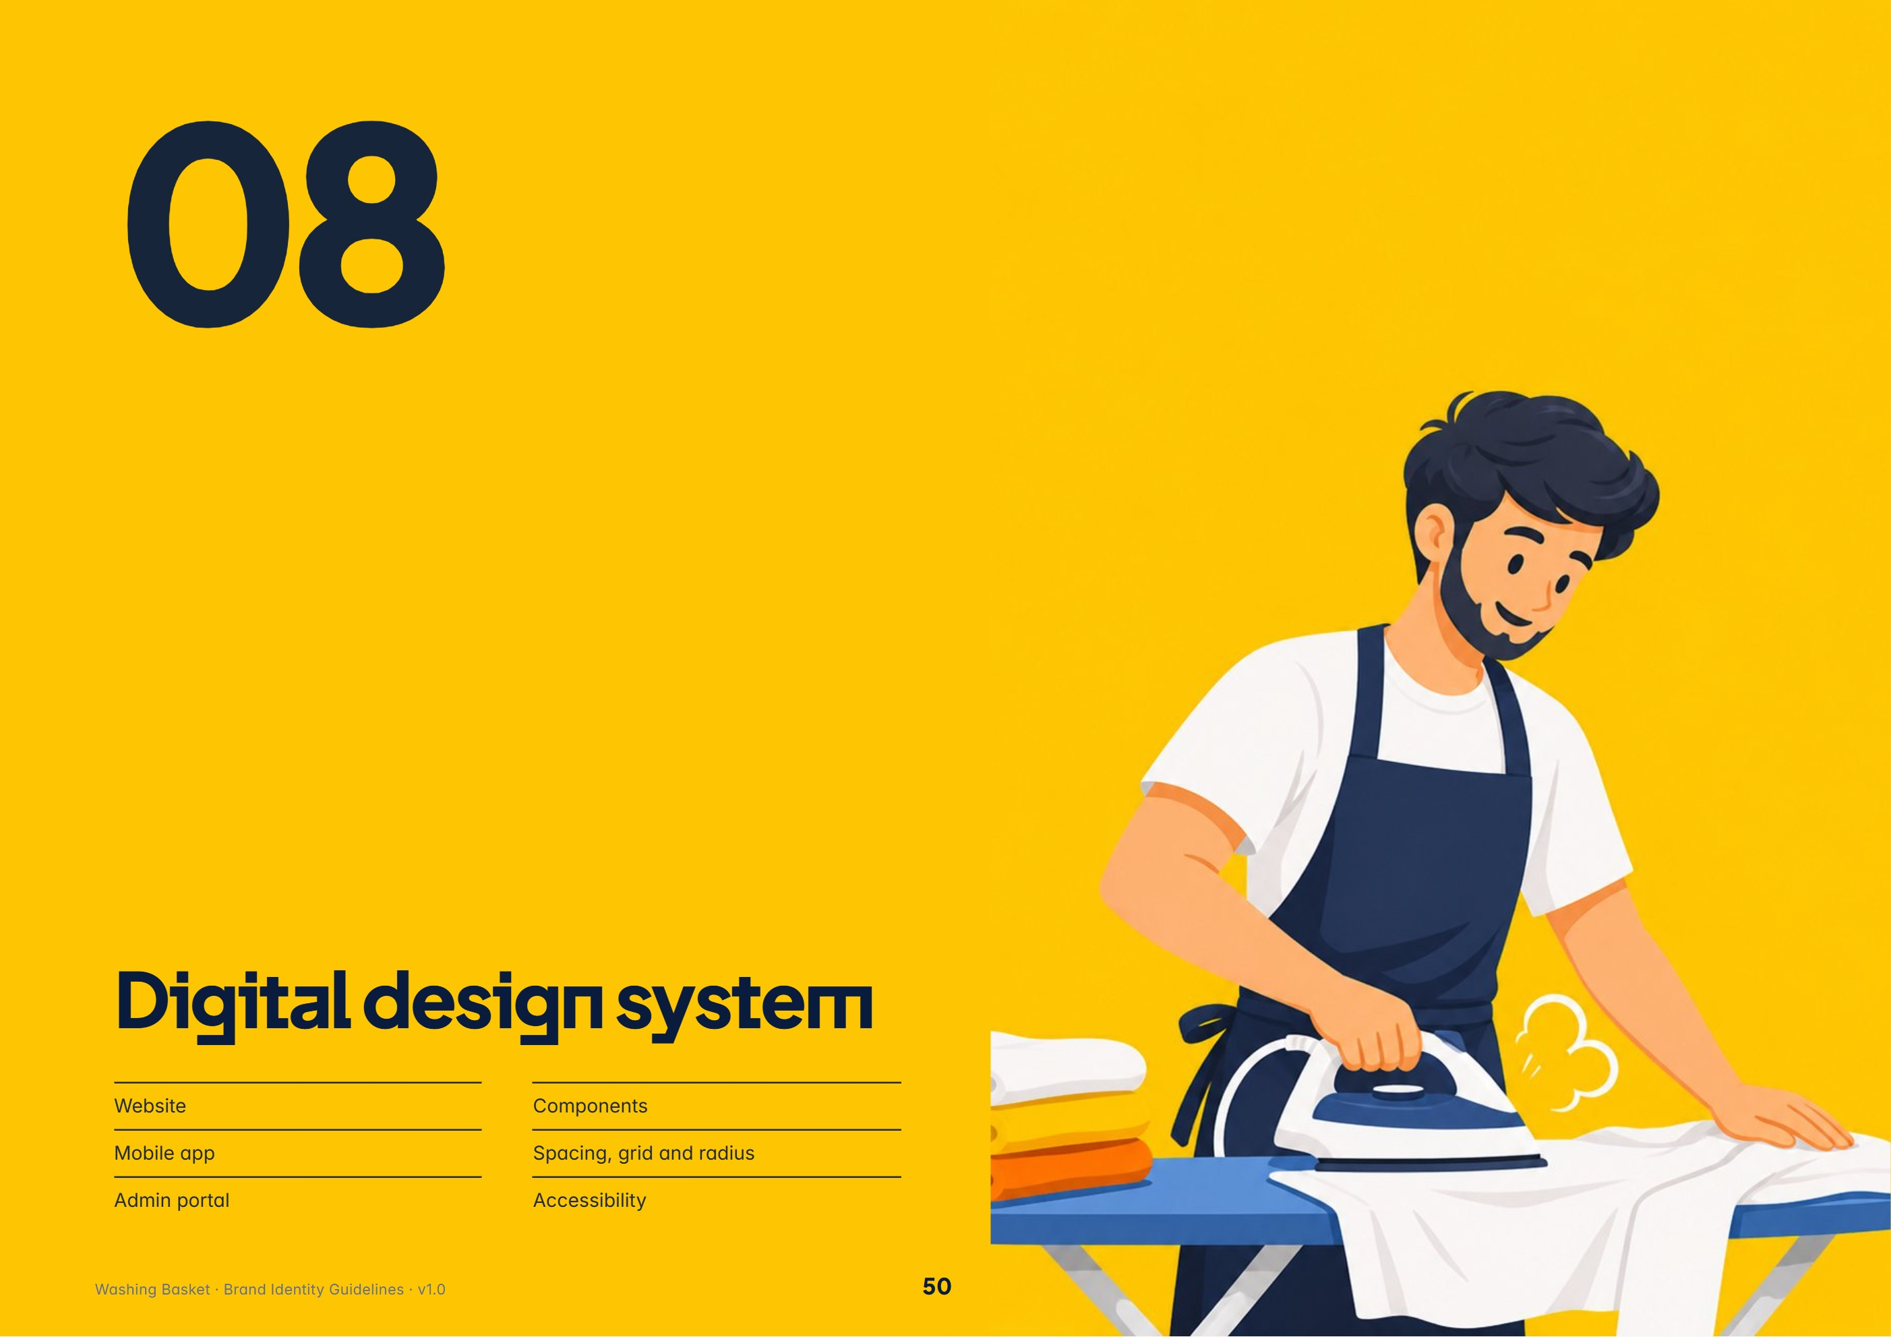
In this section: Website · Mobile app · Admin portal · Components · Spacing, grid and radius · Accessibility
WEBSITE

The marketing website
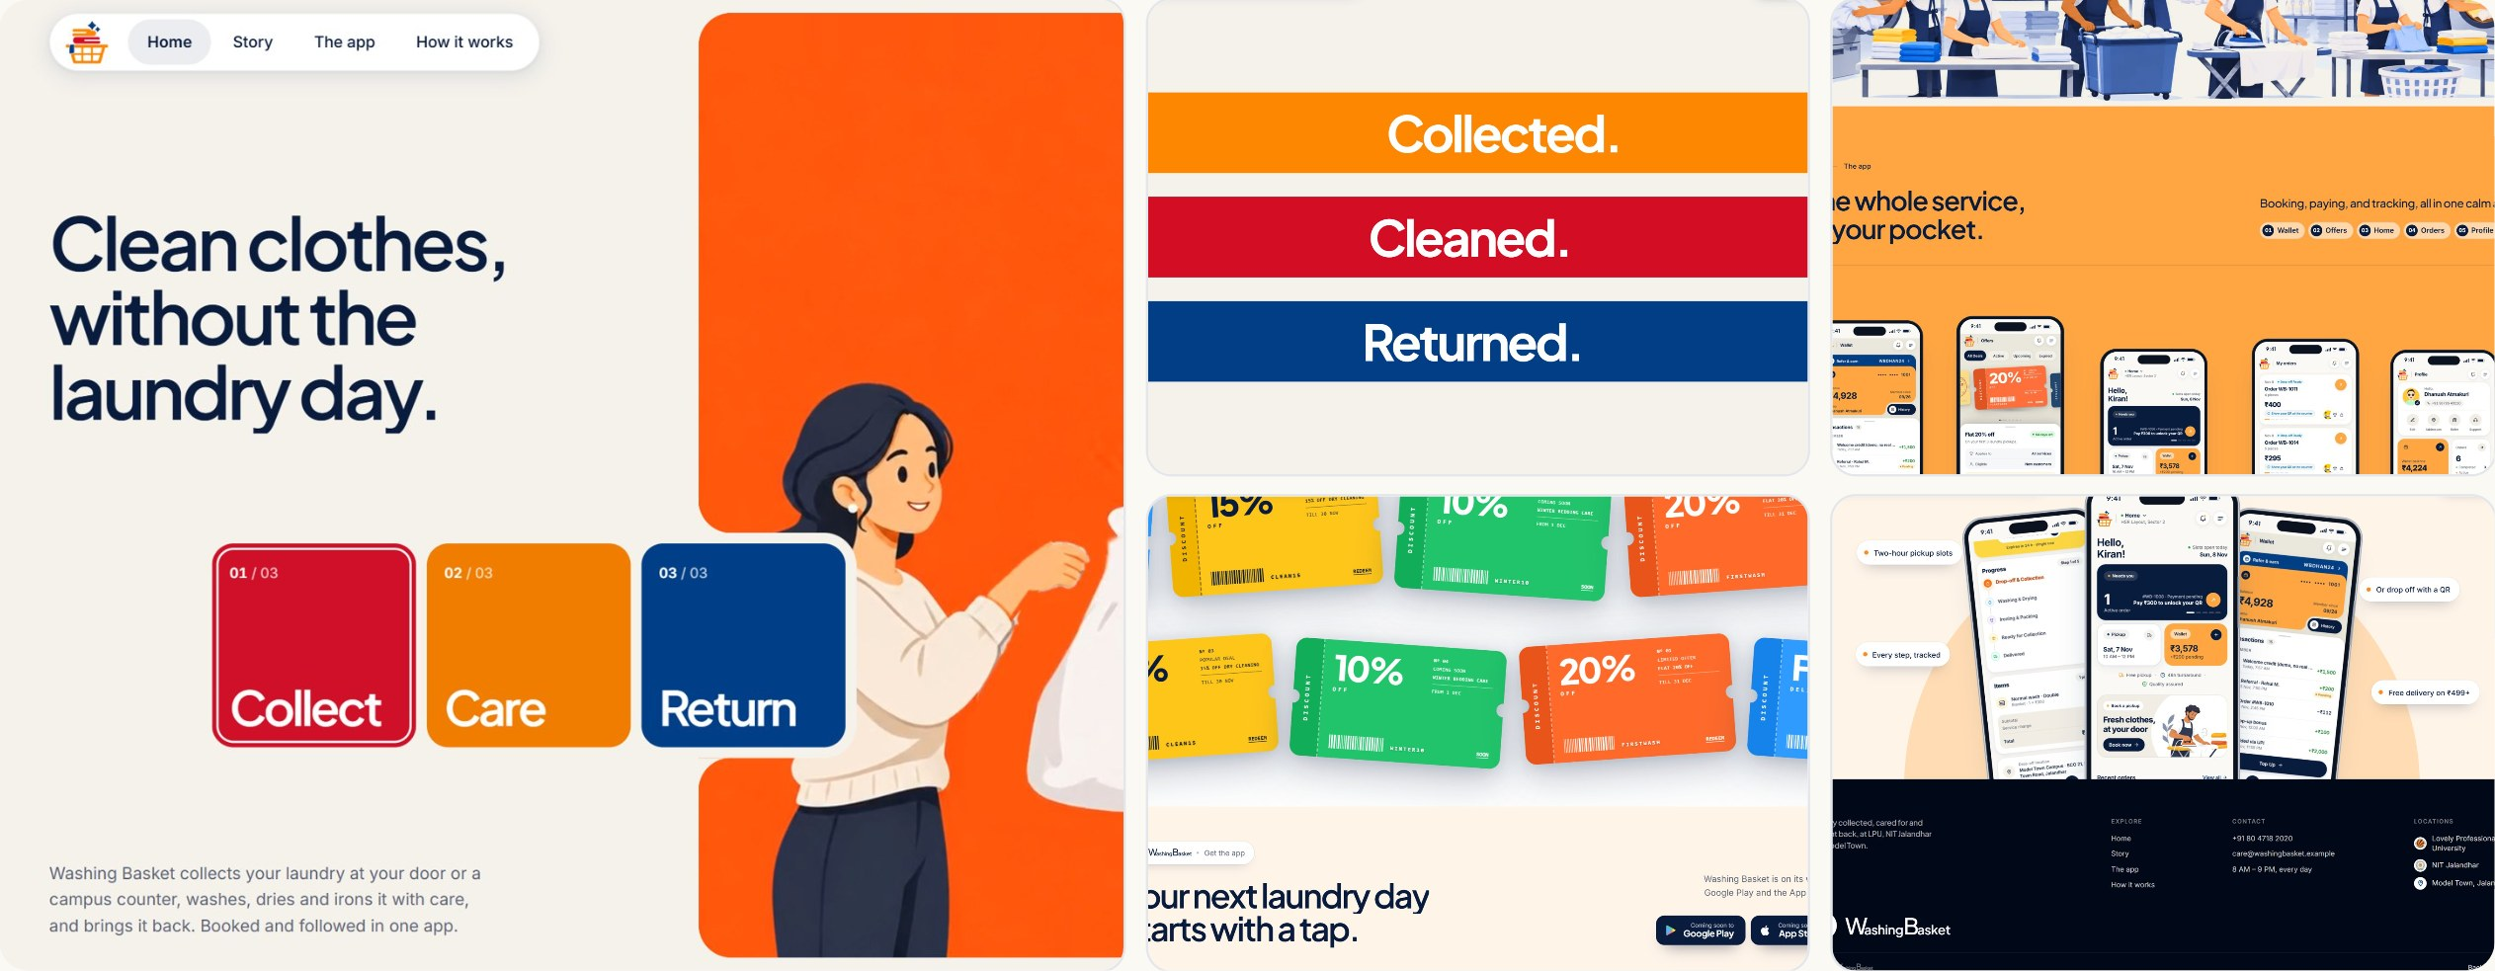
Live website, captured 10 Nov 2026: hero, brand bands, the app section, offers and footer.
Navigation. A floating pill nav (Home, Story, The app, How it works) with the lockup left and a dark “Get the app” pill right. | Hero. Two-column: three-line headline left, an illustration card stack (Collect, Care, Return) right on the ivory canvas. | Sections. Full-bleed panels alternate Ivory, Action Orange and texture stages; GSAP scroll scenes; Deep Navy footer. | Responsive. Fluid gutters clamp(20px, 4vw, 64px), 1360 px max width; layouts switch at 900 px.

MOBILE APPLICATION

The customer app
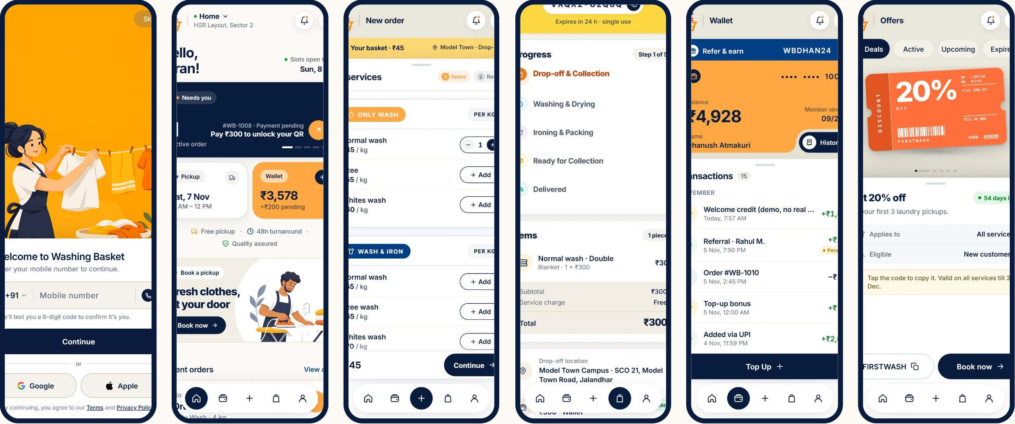
Sign-in, Home, Services, Track, Wallet and Offers screens from the app.
Bottom navigation. Five round icon buttons on a floating bar; the active item fills Ink. A centred “+” books a new order. | Cards. White, 26 px radius, soft elevation; dark Ink stat cards and Action Orange wallet card for emphasis. | Sheets & modals. Rising bottom sheets, 24 px top radius, spring motion; sign-in sits on a sheet over the plate carousel. | States. Status pills with dot, live progress timeline, vignettes for empty and error states.

ADMIN PORTAL

The operations portal
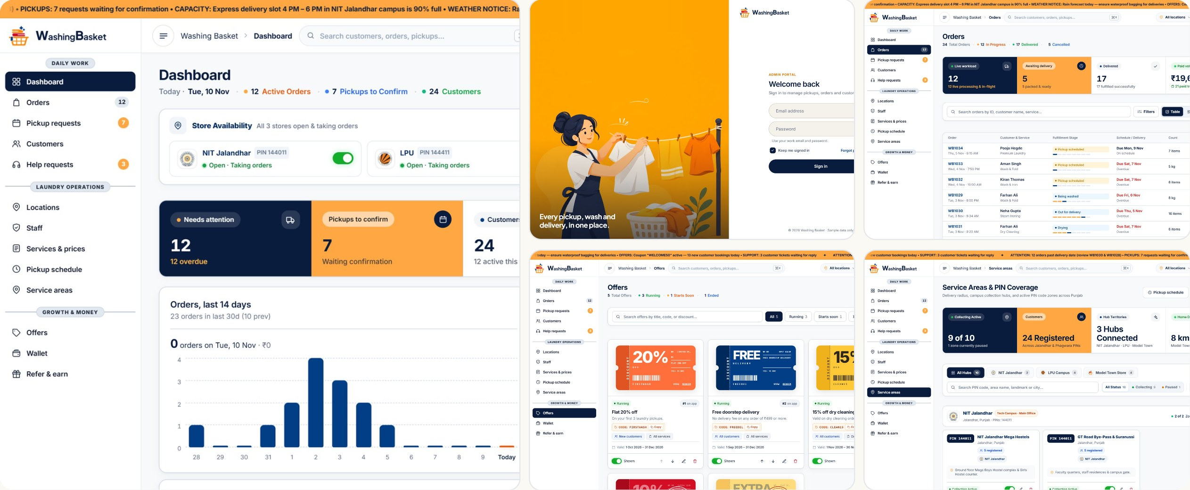
Admin portal: sign-in, dashboard, orders, offers, service areas and mobile help-desk view.
Same brand, denser. Identical colour and type tokens, imported straight from the app theme. Radii drop to 14/12/10 px; tables replace cards. | Stat cards. The signature row: an Ink card, an Action Orange card and white cards, each with an icon button and one big number. | Layout. 260 px white sidebar (72 px collapsed) with grouped sections, a top bar with search and location picker, and an orange announcement ticker.

COMPONENTS

Core components
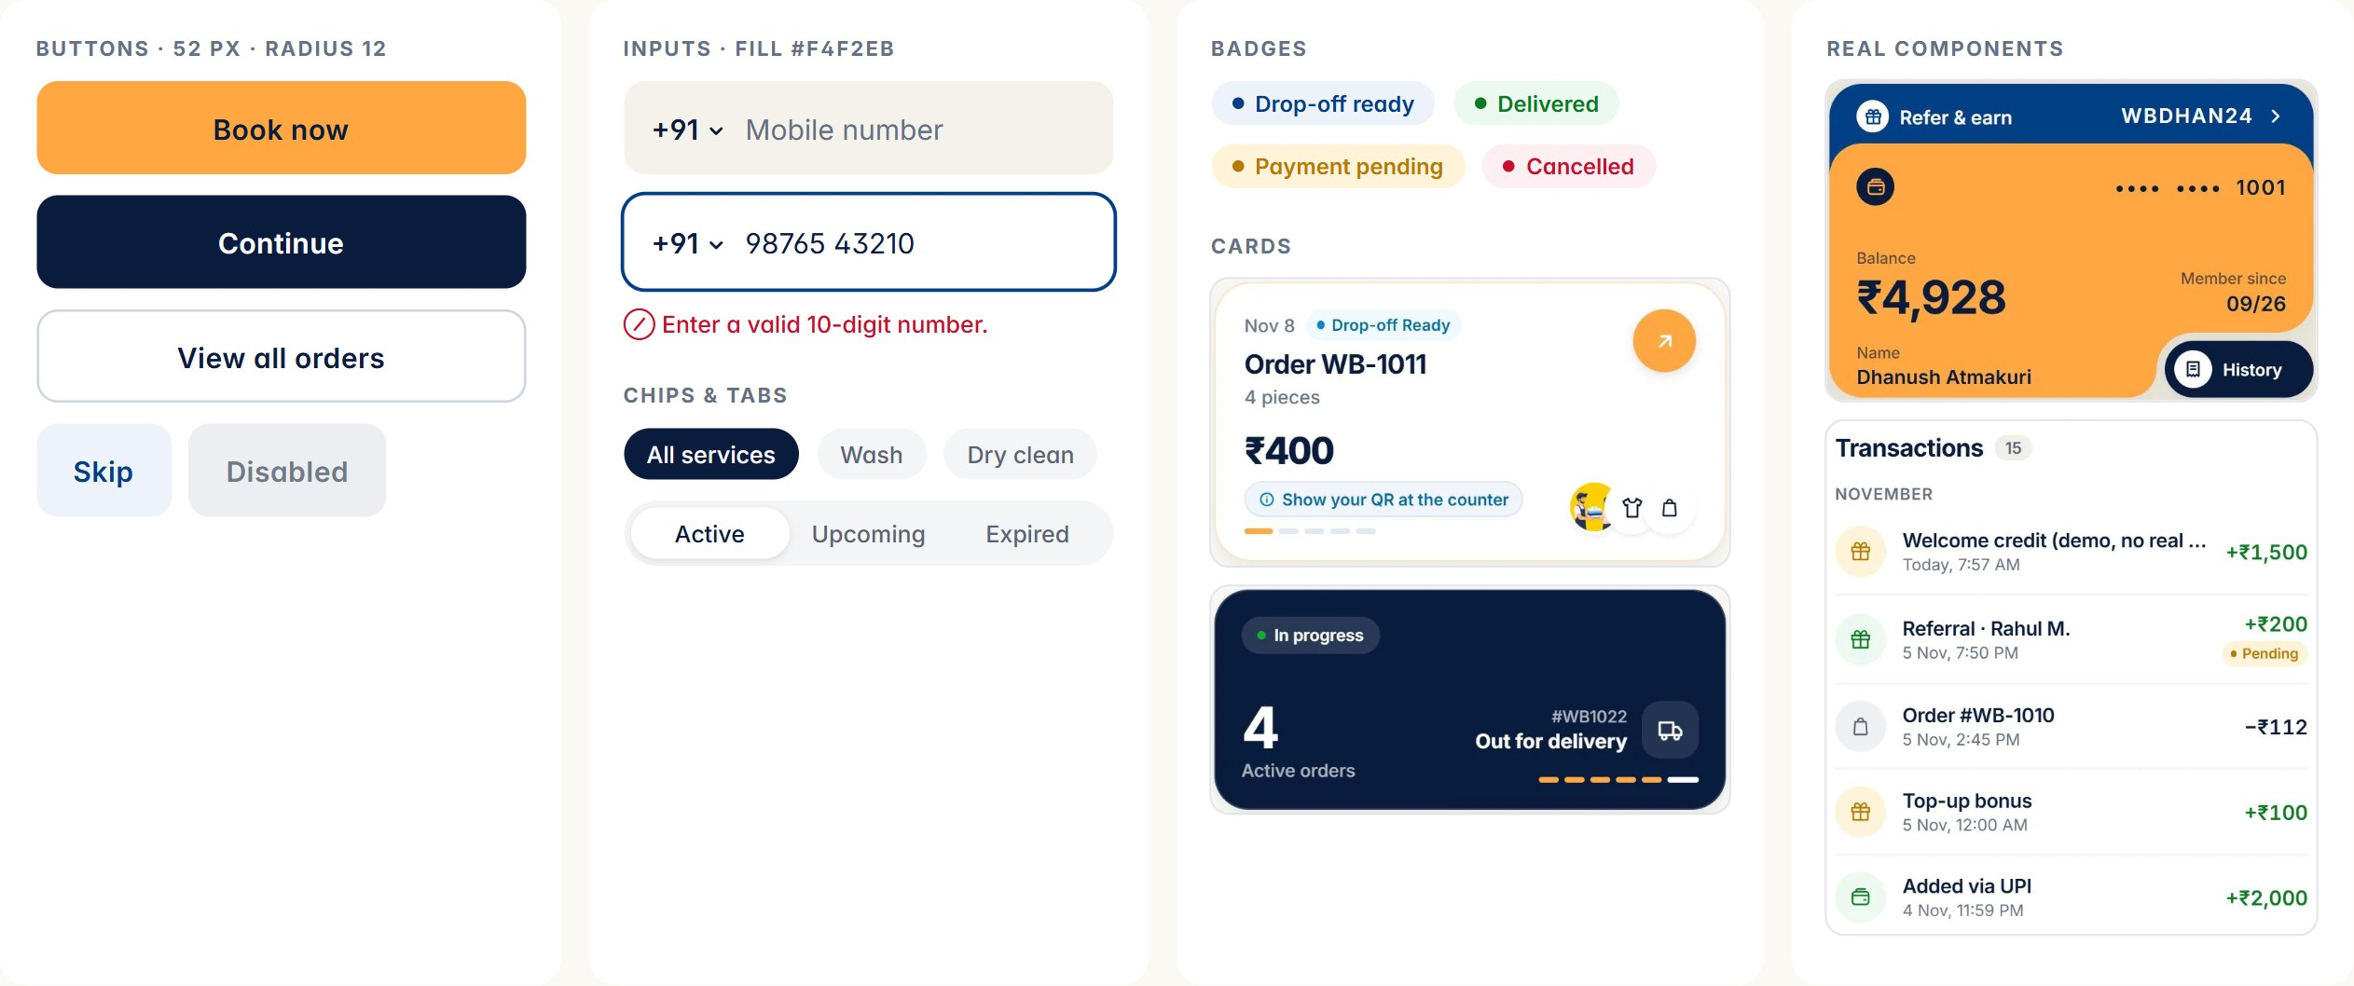
COMPONENT | SPECIFICATION
Primary button | Action Orange, 52 px tall, 12 px radius, Inter SemiBold 15 / +0.2 px; pressed #E58E2E and scale 0.98; success state turns green with a check
Dark button | Ink fill, white label; for flow steps (Continue, Sign in) and the app’s floating actions
Text field | 52 px, Field #F4F2EB at rest, 12 px radius; focus = white fill + navy edge; errors in Danger with an icon and words
Badge | Pill, coloured dot + label in the semantic colour on its tint

SPACING & GRID

Spacing, grid and layout
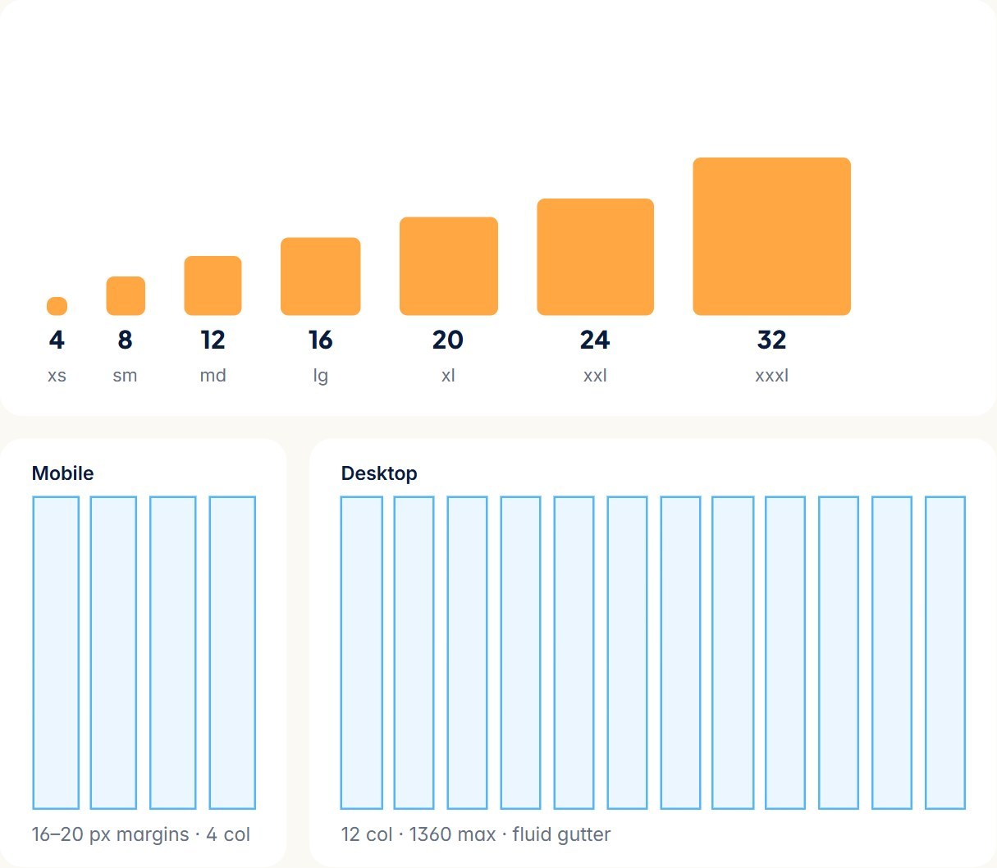 | Layout principles  - Calm first: one primary action per screen, lots of white.  - Group with surfaces and space before lines and shadows.  - Hierarchy by size and weight, not by colour.  - Content max width ~68 characters for reading.  VERIFIED space tokens and CONTROL_HEIGHT in mobile/src/theme; website --gutter and --max in base.css; admin --sidebar-w in layout.css. Column grids are proposed formalisations.
  ITEM | DETAIL
  Base unit | 4 px; tokens xs 4 → xxxl 32
  Control height | 52 px for fields and buttons
  Mobile margins | 16–20 px; cards stack with 12–16 px gaps
  Website | Gutter clamp(20px, 4vw, 64px), max width 1360 px, break at 900 px
  Admin | Sidebar 260 / 72 px; content grid of stat cards and tables

ACCESSIBILITY

Accessible by default
Already in the product  - Visible 2 px navy focus rings with 3 px offset on web and admin.  - Skip link on the website; reduced-motion support that removes smooth scrolling and scene motion.  - Accessibility labels on the logo and wordmark (“WashingBasket”).  - Errors written in words with an icon, never colour alone.  - Tabular figures for amounts.  VERIFIED From base.css, motion.ts, Wordmark.tsx and TextField components. | Rules for new work  - Text contrast ≥ 4.5:1; large text and UI parts ≥ 3:1 (see Colour · Contrast).  - Ink, not white, on Action Orange, Gold and yellow plates.  - Tap targets ≥ 44 × 44 px.  - Minimum body size 14 px in app, 16 px on web.  - Every illustration gets alt text describing the action (“A partner hands a stack of folded clothes back to a customer”).  - Honour prefers-reduced-motion everywhere.  RULE Accessibility is not optional. A design that fails contrast or target size is not on-brand.

09 Motion & animation
LOGO ANIMATION

The basket fills itself
The brand moves the way laundry does: things drop in with a little weight, settle, and rest. Physical, quick, never bouncy for its own sake.
LAYER | STARTS AT | COLOUR | POSITION ON THE 4.4 S TIMELINE
Basket | 50 ms | #FE8701 | ▮
Towel | 560 ms | #013E86 | ▮▮▮▮▮
Red cloth | 980 ms | #D30D24 | ▮▮▮▮▮▮▮▮▮
Orange cloth | 1400 ms | #FE8701 | ▮▮▮▮▮▮▮▮▮▮▮▮▮
Sparkle L | 1790 ms | #013E86 | ▮▮▮▮▮▮▮▮▮▮▮▮▮▮▮▮
Sparkle S | 1910 ms | #013E86 | ▮▮▮▮▮▮▮▮▮▮▮▮▮▮▮▮▮
Wordmark | 2250 ms | #0A1C3E | ▮▮▮▮▮▮▮▮▮▮▮▮▮▮▮▮▮▮▮▮
Complete | 4400 ms | #667085 | ▮▮▮▮▮▮▮▮▮▮▮▮▮▮▮▮▮▮▮▮▮▮▮▮▮▮▮▮▮▮▮▮▮▮▮▮▮▮▮▮

Sequence. The basket slides in from the right, leaning with momentum, and sits upright. The towel flops over the rim. The red cloth drops in, the basket gives; the orange cloth lands on top, the basket gives again. Two sparkles pop. The mark glides left and the wordmark rises letter by letter (38 ms stagger, 520 ms each). | Where. App intro splash, admin sign-in intro, website opening. A shorter 1.5 s loop (clothes dropping) is the brand loader. Tap anywhere to skip; every element rests at its final position, so “no animation” shows the finished logo.  VERIFIED Times from INTRO_TIMELINE in AnimatedLogo.tsx; ported to admin brand.css.

DURATIONS & EASING

Timing, curves and interactions
VERIFIED Curves and springs from mobile/src (Easing.bezier, withSpring), website motion.ts and base.css --ease. | What motion should communicate  Care and weight. Objects have mass: clothes fall with gravity (~285 ms), baskets give when they land. Progress. The order timeline fills step by step. Reassurance. Success turns the button green with a check; payments get a short celebration.  Do  - Ease out on entrances; settle with one small overshoot at most.  - Stagger lists by 30–60 ms.  - Animate transform and opacity only.  - Offer skip on anything over 1 s; respect reduced motion.  Don’t  - Elastic, wobbly, spinning or flipping logos.  - Linear movement on UI (except progress and timelines).  - Motion that blocks input or loops endlessly in UI.  - Parallax on text.  RULE The logo only ever animates with its official fill-the-basket sequence or the loader; never spin, flip or morph it.
  TOKEN | VALUE | USE
  Ease out (signature) | cubic-bezier(0.16, 1, 0.3, 1) | Entrances, glides, page scenes
  Ease decel | cubic-bezier(0.22, 1, 0.36, 1) | Slides, basket entry
  Ease in-out | cubic-bezier(0.45, 0, 0.55, 1) | Fades, shadows
  GSAP default | power3.out | Website scroll scenes
  Sheet spring | damping 22 · stiffness 240 · mass 0.8 | Bottom sheets
  Pop spring | damping 13 · stiffness 190 | Reveal / success pops
  Press | 90 ms down · spring 300 ms back, scale 0.98 | Buttons
  Smooth scroll | Lenis, 1.15 s, expo out | Website
  ITEM | DETAIL
  Micro (press, hover) | 90–150 ms
  Small (toggle, chip) | 200–300 ms
  Medium (sheet, card) | 320–500 ms
  Large (intro, scene) | 600–1000 ms

10 Brand applications
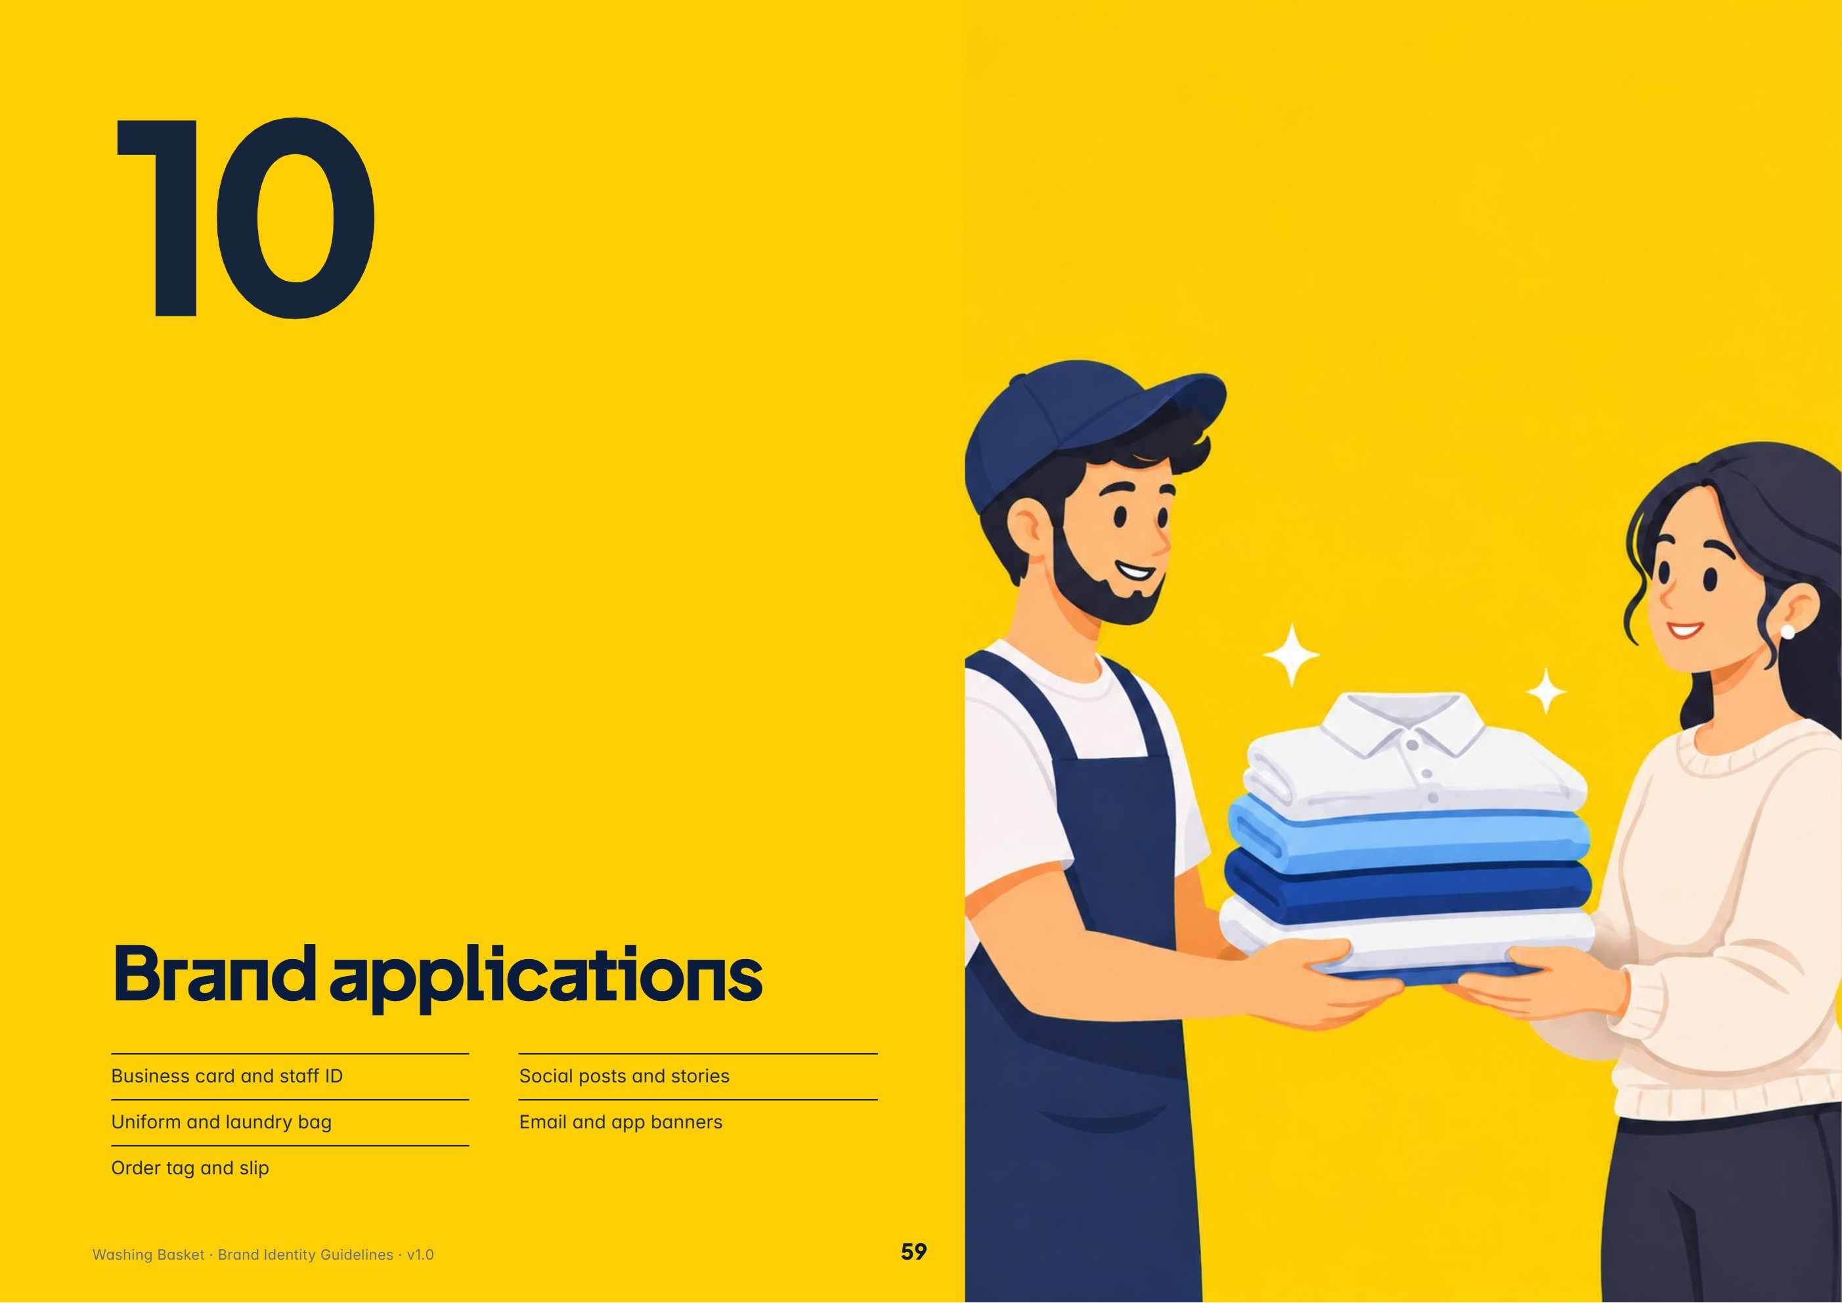
In this section: Business card and staff ID · Uniform and laundry bag · Order tag and slip · Social posts and stories · Email and app banners
IDENTITY APPLICATIONS

Cards, ID and uniform
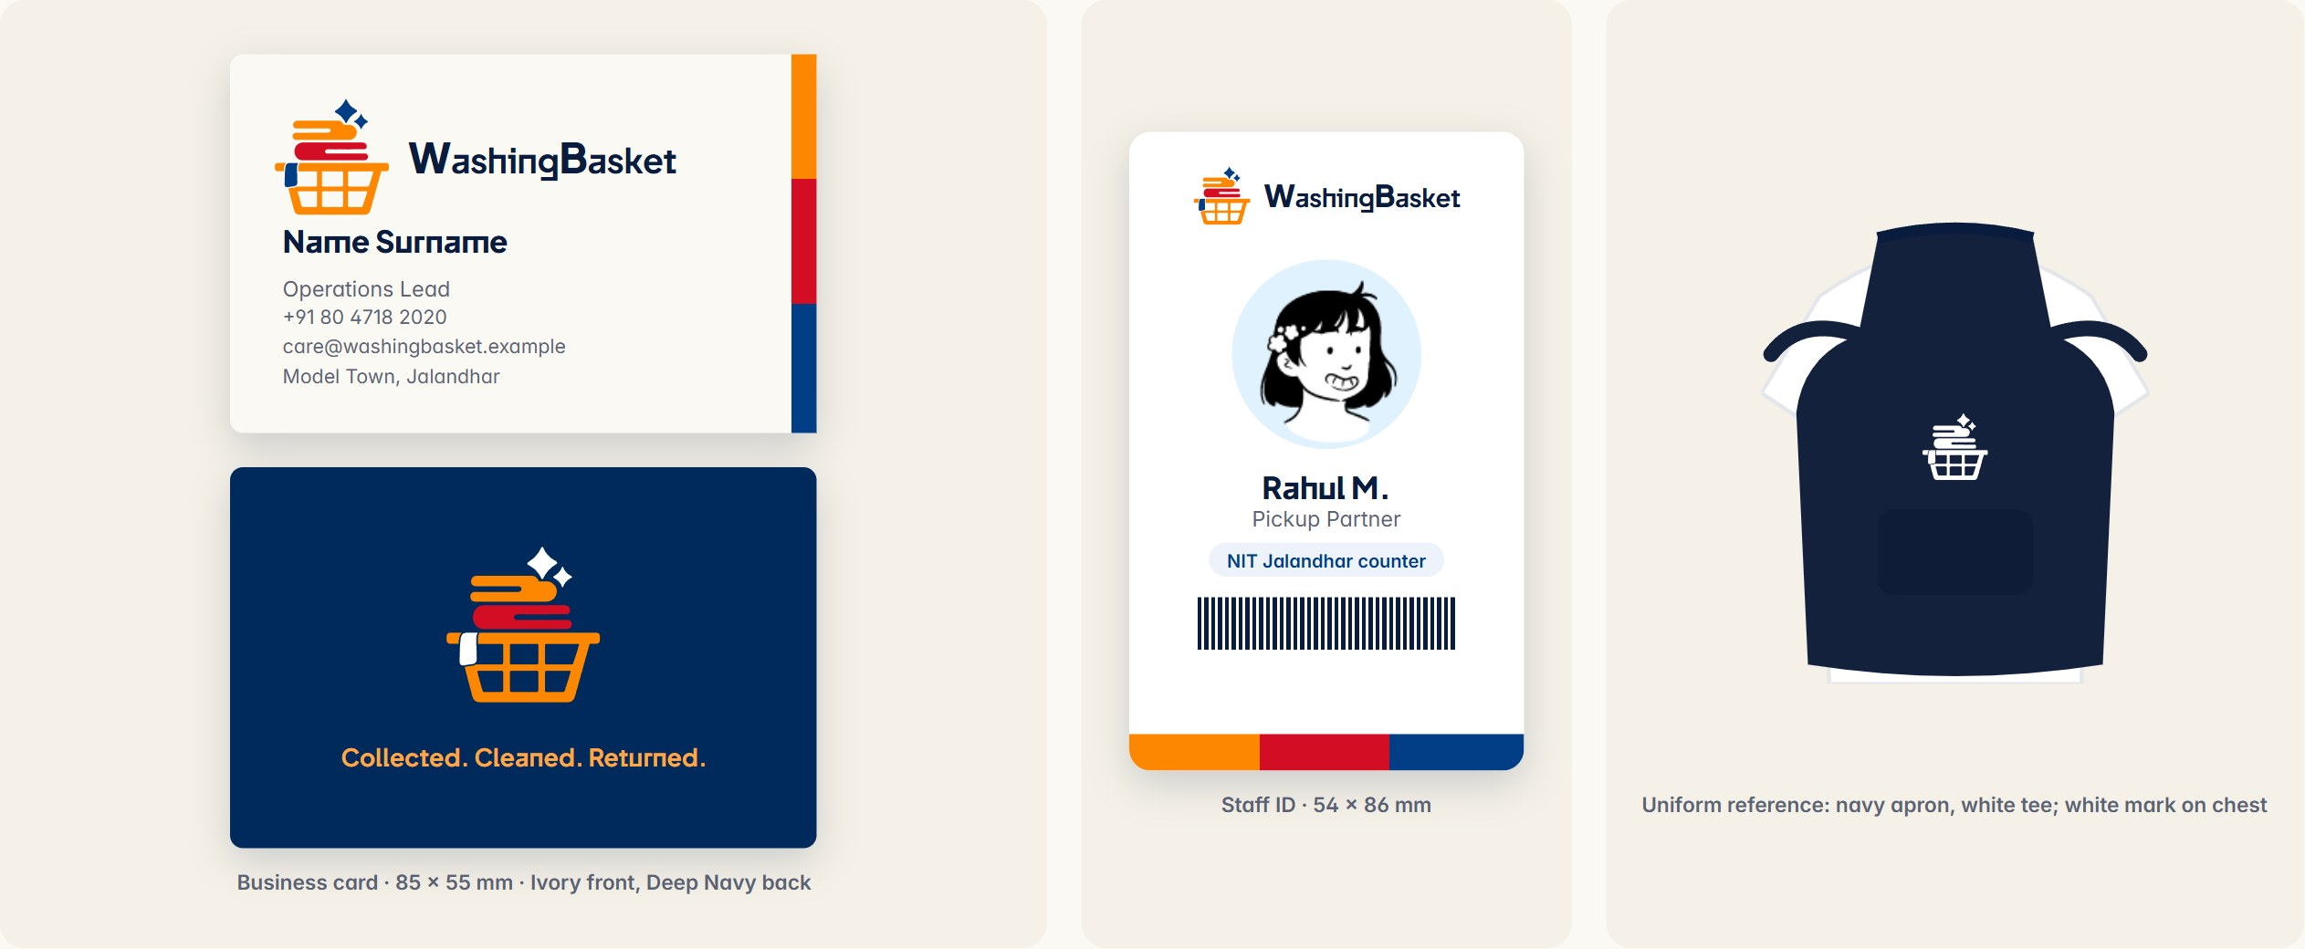
Business card. Horizontal lockup top-left on Ivory; Inter for details; back in Deep Navy with the reversed mark and the brand line. | Staff ID. White card, lockup top, avatar or photo, name in Plus Jakarta Sans, role in Inter, the brand bands as a footer stripe. | Uniform. The navy apron over a white tee already defines staff in every illustration. Add a white single-colour mark on the chest, 60–70 mm wide. | PROPOSED All applications on these pages are concept mockups. No printed materials exist yet.

OPERATIONS APPLICATIONS

Bags, tags and slips
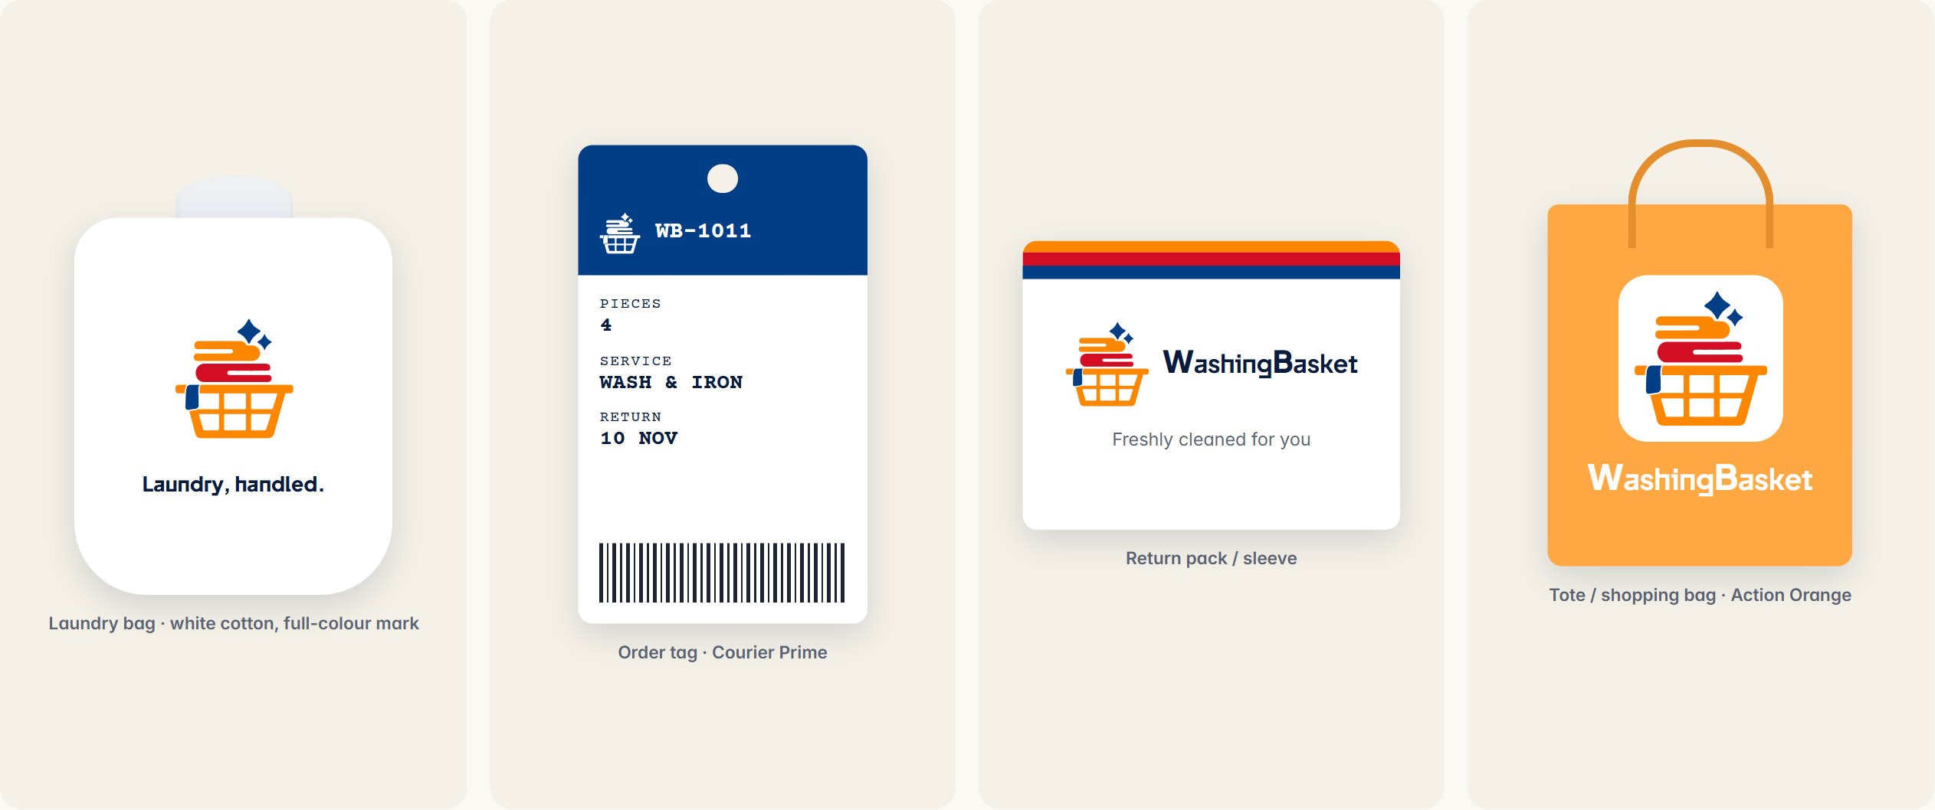
Laundry bag. Echoes the white drawstring bag in the Collect plate. The bag is the customer’s “basket” on the move. | Order tag. Navy header with order number, Courier Prime fields for pieces, service and return date, and a barcode/QR area that matches the counter scanner. | Return pack & tote. The brand bands as a closing seal; on Action Orange use the mark inside a white tile or in white.  PROPOSED Concepts; confirm materials and print methods with suppliers.

MARKETING APPLICATIONS

Social, email and banners
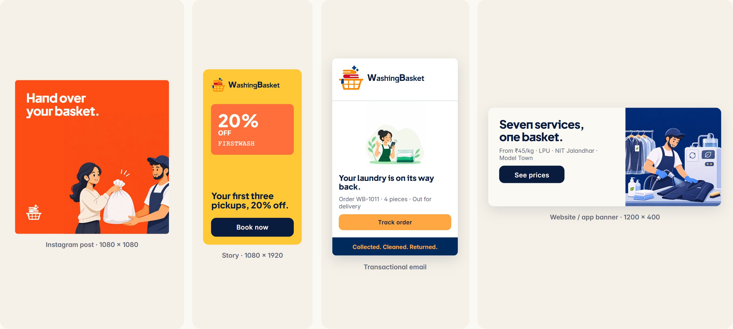
Social. A plate illustration, a two-line Plus Jakarta Sans headline with a full stop, the white mark small in a corner. One message per post. | Offers. Use the ticket motif and the real offer code; Ink text on yellow or Action Orange. | Email. White body, lockup header, a status vignette, one Action Orange button, brand line in the footer.  PROPOSED Concept layouts using real offer codes and copy from the app.

11 Communication & voice
TONE OF VOICE

Calm, clear, kind
Washing Basket sounds like a capable friend who has it handled. It speaks in short sentences, plain verbs and real facts. It is warm without being cute, and confident without boasting.  Writing principles  VERIFIED Principles are distilled from live copy in website/src/content.ts and the app; “no invented history, numbers, awards, testimonials” is a rule written in that file. | Vocabulary  Preferred phrases  - Clean clothes, without the laundry day.  - Hand over your basket.  - Counted in front of you.  - Every stage, live in the app.  - Book your pickup and leave the rest to us.
  ITEM | DETAIL
  Short and rhythmic | Full stops do the work. “Collected. Cleaned. Returned.”
  Concrete | Say the price, the slot, the step. “48 hours.” “₹45/kg.” “Two-hour slot.”
  True | No invented numbers, awards, testimonials or history. Ever.
  Customer first | “Your basket”, “your door”, “your week”. Talk about their day, not our machines.
  Calm | No exclamation marks in UI. No urgency tricks.
  SAY | AVOID
  Basket, hand over, collect, return | Consignment, drop shipment
  Partner (for staff) | Worker, boy, guy
  Care, fresh, folded, pressed | Hygienic-certified, germ-killing (unless proven)
  Counter, doorstep, slot | Facility, logistics window
  Washing Basket (two words) | WashingBasket, WB, Washing-Basket in prose
  From ₹45/kg | Cheapest, best price guaranteed
  Track your laundry | Monitor your consignment

MESSAGING BY MOMENT

How we sound, moment to moment
MOMENT | TONE | EXAMPLE (LIVE COPY)
Welcome / sign-in | Simple, welcoming | “Welcome to Washing Basket. Enter your mobile number to continue.”
Home | Personal, glanceable | “Hello, Kiran!” · “Fresh clothes, at your door.”
Booking | Clear, step-by-step | “Pick a date, a time slot and your address.”
Tracking | Reassuring, factual | “Washing & Drying” · “Out for delivery” · “Every stage, live in the app.”
Help text | Helpful, honest | “We’ll text you a 6-digit code to confirm it’s you.”
Errors | Calm, says how to fix | “Enter your email and password.”
Offers | Light, specific | “Flat 20% off on your first 3 laundry pickups.”
Admin | Efficient, operational | “Every pickup, wash and delivery, in one place.”

Headlines  - Clean clothes, without the laundry day.  - Seven services, one basket.  - Five careful steps, every single order.  - The whole service, in your pocket.  - Your next laundry day starts with a tap. | CTAs  Verb first, two or three words, sentence case: Book now · Continue · Track order · Top up · Get the app · See prices. Never “Click here” or “Submit”. | Social  One idea per post, a short headline, a real fact (service, price, slot, campus). Emoji sparingly — at most one, never in place of words. Reply to customers by name, in the same calm voice.  PROPOSED Social guidance is new; no social channels are recorded in the codebase.

12 Brand governance
CHECKLISTS

Before anything ships
Logo  Supplied artwork, not redrawn  Correct version for the background  Clear space x on all sides  Above minimum size  Not stretched, rotated or recoloured  “Washing Basket” two words in text | Colour  Only palette colours from this book  Logo Orange only in the mark  Text contrast ≥ 4.5:1  Ink, not white, on orange/yellow  Status colour paired with words | Typography  Plus Jakarta Sans / Inter / Courier Prime only  Sentence case  Tight tracking on display  Tabular figures for amounts  No font substitution

Illustration & imagery  From an existing family  Navy apron, white tee on partners  Correct plate colour per step  Alt text written  No stock photos or 3D clip-art | Digital UI  Tokens from mobile/src/theme  52 px controls, 12 px radius  One primary action per screen  Focus states visible  Reduced motion respected | Marketing  Facts and prices match the app  Real offer codes and validity  No invented claims or testimonials  One message per piece  Contact details are live (not .example)

GOVERNANCE

Keeping it consistent
Mandatory rules vs creative freedom  Approval workflow  - 1 · Brief names the audience, message and channel.  - 2 · Creator self-checks against the checklists.  - 3 · Brand owner reviews logo, colour, type and claims.  - 4 · Product owner verifies prices, offers and app facts.  - 5 · Approved files are stored with version and date.  PROPOSED Workflow and owners to be confirmed by the team. | Asset organisation  Consistency audit · every quarter  - Diff theme tokens across mobile, admin and website.  - Screenshot every key screen; check against this book.  - Review new illustrations and marketing pieces.  - Re-run contrast checks on any new colour pair.  - Log findings and update this book’s version.
  MANDATORY | FLEXIBLE
  Logo artwork, versions, clear space | Layout and composition of each piece
  Core palette and contrast | Which shades accent a campaign
  Three typefaces | Headline wording and line breaks
  Partner uniform in illustration | Props, scenes and seasonal themes
  Truthful copy, real prices | Tone shading by channel
  Accessibility minimums | Motion choreography inside the rules
  FOLDER | CONTENTS
  assets/brand/logo/ | SVG, EPS, PDF, PNG per version (to create)
  assets/brand/app-icon/ | iOS and Android icon sets (to create)
  assets/brand/fonts/ | Licences and TTFs for the three faces
  assets/artwork/ | Process plates (existing)
  assets/illustrations/ | Status vignettes (existing)
  assets/avatars/ | Customer avatars (existing)
  assets/brand/guidelines/ | This book, .docx and .pdf

A Appendix
APPENDIX

Token and asset reference
Colour tokens (CSS)  --navy: #013E86; --navy-deep: #012A5C;  --logo-orange: #FE8701; --red: #D30D24;  --orange: #FFA742; --orange-pressed: #E58E2E;  --ink: #0A1C3E; --ink-soft: #5B6475;  --ink-muted: #667085; --line: #E3E6EB;  --ivory: #FBF9F4; --paper: #F5F1E8;  --field: #F4F2EB; --subtle: #F4F5F7;  --success: #12AD2B; --warning: #B97800;  --danger: #C8102E; --navy-tint: #EEF3FB;  --blue: #54B6F8; --green: #62D487;  --gold: #FED843; --soft-red: #F87C87;  Type & shape tokens  --display: 'Plus Jakarta Sans';  --text: 'Inter'; --mono: 'Courier Prime';  --control-h: 52px; --r-button: 12px;  --r-field: 12px; --r-sheet: 24px;  --r-card: 26px; --r-tile: 20px;  --space: 4 8 12 16 20 24 32;  --ease: cubic-bezier(0.16, 1, 0.3, 1); | Source of truth  mobile/src/theme/index.ts is the single source. The admin portal imports it directly (admin/src/theme/tokens.ts) and the website mirrors it in base.css. Change a colour there first.  Brand asset index  Font licences. Plus Jakarta Sans, Inter, Nunito and Courier Prime are licensed under the SIL Open Font License 1.1 and are free for commercial use.
  ASSET | PATH
  Master logo PNG | assets/brand/WashingBasket-logo.png
  Logo vector trace | website/src/logoGeometry.ts
  Favicon | admin/public/favicon.png
  Process plates | assets/artwork/1.png – 6.png
  Status vignettes | assets/illustrations/*.png
  Service scenes | mobile/assets/services/*.png
  Avatars | assets/avatars/*.png
  Hero loop / films | website/public/media · hero-loop · brand-film
  Fonts | @expo-google-fonts/* · @fontsource/*



