SIOP Forecast Performance Dashboard
CASE STUDY 2

SUBMITTED BY: DHANUSH P
NEO ID: Z3S4J0H2
REGNO: 22MIA1113

1. Executive Summary
This report presents a Power BI solution developed for the SIOP (Sales, Inventory & Operations Planning) case study. The objective was to transform multi-snapshot forecast data into a side-by-side comparison (Resultant, Lag0, Lag1), merge it with actual demand, and build an interactive dashboard that quantifies forecast accuracy, bias, and stability across countries, regions, and products.
The solution was built entirely using Power Query (M) for data transformation and DAX for dynamic, slicer-driven measures. Beyond the core requirements, the dashboard adds a Forecast Volatility Index, a Forecast Improvement % metric, a country/period accuracy heatmap, and Pareto-style error analysis — providing a more complete view of forecast health than the base specification alone.

2. Business Context
In SIOP, demand forecasts are revised every month as new information becomes available. Comparing how a forecast made several months ago (Lag1), one month ago (Lag0), and the most recent snapshot (Resultant) evolved relative to what actually happened (Actuals) tells planners whether the forecasting process is improving, where systematic over/under-forecasting exists, and which markets or products need attention.
This analysis answers four core questions: (1) Are forecasts becoming more accurate as the planning horizon shortens? (2) Which countries/regions show persistent bias? (3) Which products contribute most to total forecast error? (4) Where should planning effort be concentrated?

3. Data Sources
Dataset | Description
Forecast | ~246K rows. Forecast quantities (Revenue, Non-Revenue, CAPEX) by Item, Country, AsOfPeriod (snapshot month) and Period (forecasted month).
Actual | ~500K rows. Realized Revenue, Non-Revenue and CAPEX quantities by Item, Country and Period.
Calendar Table | Fiscal calendar with period labels, used for time-based filtering and the Forecast_Period relationship.
Product Hierarchy | SKU-level attributes (Franchise, Business Unit, Segment, Brand) for product drill-down.
Entity Mapping | Maps entity/country codes to Region and Cluster groupings.

4. Data Transformation (Power Query)

4.1 Dynamic Snapshot Ranking
Rather than hardcoding 2023 P12 / P11 / P10, a scalable ranking approach was used:
- A reference query (Forecast_Latest) groups the Forecast table by Item, Country and Period and uses List.Max(AsOfPeriod) to find the latest snapshot for each combination.
- This latest AsOfPeriod is merged back into the main Forecast table, and an Offset is computed: Offset = LatestAsOfKey − AsOfKey.
- Offsets are mapped to labels: 0 = Resultant, 1 = Lag0, 2 = Lag1. Because the rank is computed dynamically, the model automatically adapts when new monthly snapshots are added — no hardcoded periods.

4.2 Pivoting Forecast Values
Three reference queries (Forecast_NonRev, Forecast_Revenue, Forecast_CAPEX) were created from the labelled Forecast table, each retaining all dimension columns (Item, Country, Period, Segmentation_*, Lifecycle, Set_vs_FG, etc.) and one forecast measure. Each was pivoted on the LagLabel column, producing 9 columns in total:
Resultant / Lag0 / Lag1 × Revenue Forecast, Non Revenue Forecast, CAPEX Forecast
The three pivoted queries were merged on Item + Country + Period into a single fact table, Forecast_Transformed.

4.3 Merging Actuals & Building Relationships
The Actual table was merged into Forecast_Transformed using a left-outer join on Item, Country and Period, bringing in Actuals Revenue Qty, Actuals NonRevenue Qty and Actuals Capex Qty. A Period_Key calculated column (e.g. “2024 P08” → “P202408”) was added to align the Period format with the Calendar table’s FISCL_PRD_YR_PRD_LBL, enabling the Calendar relationship. A relationship was also created from Item to the Product Hierarchy SKU field for product drill-down.

5. Data Model & DAX Measures

5.1 Dynamic Lag Selector
A disconnected table, LagSelection {Resultant, Lag0, Lag1}, drives all dynamic measures via SELECTEDVALUE + SWITCH, so a single slicer controls every chart on the dashboard without filtering the model directly.
Selected Revenue Forecast = SWITCH(SELECTEDVALUE(LagSelection[LagLabel]), "Resultant", SUM([Resultant Revenue Forecast]), "Lag0", SUM([Lag0 Revenue Forecast]), "Lag1", SUM([Lag1 Revenue Forecast]) )
Identical measures were created for Non-Revenue and CAPEX forecasts.

5.2 KPI Measures
Forecast Accuracy % = 1 − ABS(Selected Forecast − Actuals) / Actuals
Forecast Bias % = (Selected Forecast − Actuals) / Actuals
Additional measures developed beyond the base requirement:
- Forecast Improvement %: Change in Forecast Accuracy % from Lag1 to Resultant, indicating whether forecasts get better as the horizon shortens.
- Forecast Volatility Index: Magnitude of forecast revision across snapshots, flagging unstable planning inputs.
- Revenue Forecast Gap: ABS(Selected Forecast − Actuals), the absolute deviation in volume terms.

6. Dashboard Overview

Page 1 — Executive Summary
Provides a high-level view of overall forecast health: Lag selector, Period slicer, KPI cards (Forecast Accuracy %, Forecast Bias %, Selected Revenue Forecast, Actual Revenue, Revenue Forecast Gap), and Revenue / Non-Revenue / CAPEX forecast charts by Country.
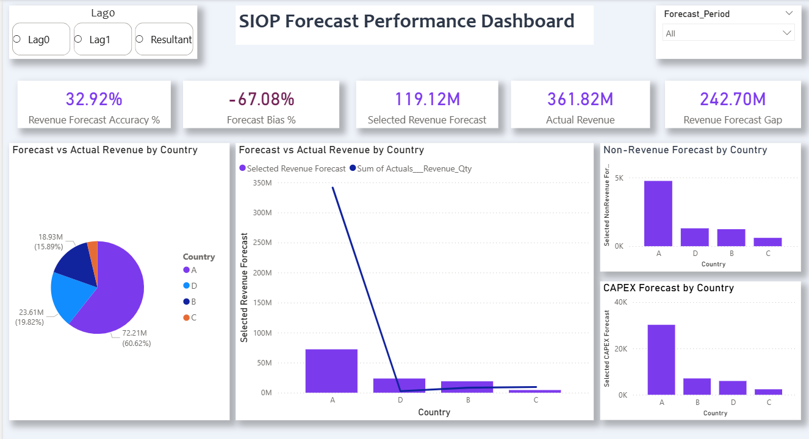

Page 2 — Forecast Analysis
Evaluates how forecast quality evolves across snapshots and time: Forecast Improvement % KPI, a Forecast Accuracy heatmap (Country × Period), a Revenue Forecast vs Actual trend line, and a Forecast Convergence chart comparing Lag1, Lag0, Resultant and Actuals side by side per country.
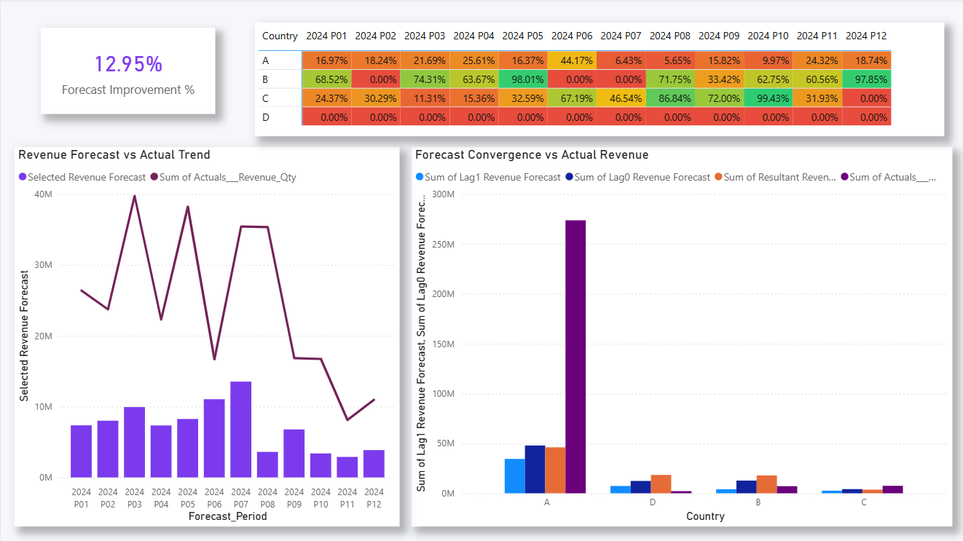

Page 3 — Strategic Insights (Proposed Analysis)
Identifies root causes and improvement areas: Forecast Bias by Region and by Country, Revenue Forecast Accuracy % by Period Offset (impact of planning horizon), Forecast Volatility Index by Country, a Pareto chart of top error-contributing items, and an Executive Insights summary panel.
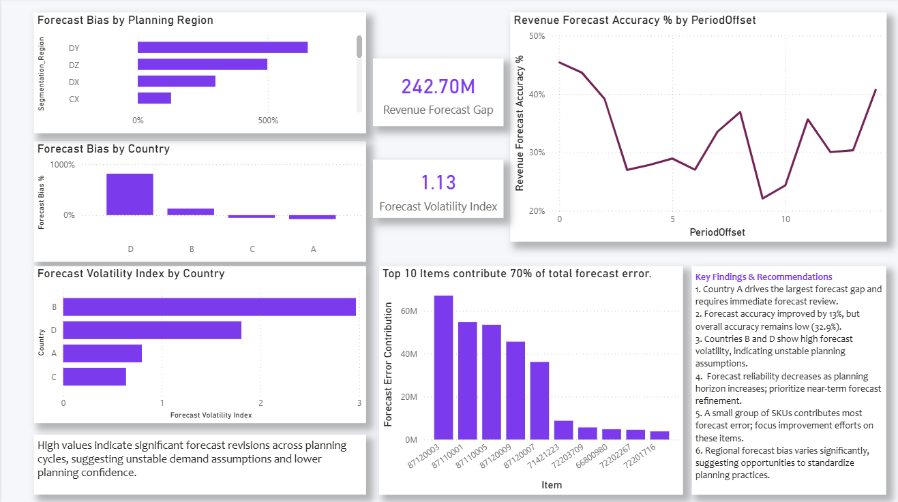

7. Key Findings
- Accuracy improves closer to the event: Forecast Improvement of ~13% was observed from Lag1 to Resultant, indicating forecasts do refine as the planning horizon shortens, though overall accuracy remains low (~33%).
- Country A drives the largest gap: Country A accounts for the largest share of total Revenue Forecast Gap (≈242.7M) and should be prioritised for forecast-process review.
- Reliability declines with horizon: Forecast Accuracy generally trends lower (with notable volatility) as PeriodOffset increases, confirming near-term forecasts are more reliable than long-range ones.
- High volatility in B and D: Countries B and D show the highest Forecast Volatility Index, suggesting unstable demand assumptions or frequent re-planning.
- Error is concentrated in few SKUs: A small set of SKUs accounts for a disproportionate share of total forecast error — targeted review of these items offers the highest leverage for improvement.
- Regional bias patterns exist: Certain planning regions show consistent positive or negative bias, pointing to systematic over- or under-estimation rather than random error.

8. Predictive Modelling Approach
While the core deliverable is a BI dashboard, a predictive layer was scoped to extend this solution:
- Objective: Predict Actuals more accurately than the raw Lag0 forecast, using Lag0/Lag1 forecast values, PeriodOffset, Lifecycle stage, Segmentation_Region and historical Forecast Bias % as input features.
- Model Selection: A regression-based model (e.g., Linear Regression or Gradient Boosted Trees in Python/scikit-learn) was selected over more complex time-series models, since the dataset is structured as snapshot/lag comparisons rather than a continuous series — making tabular regression a better fit and easier to validate against the existing Bias/Accuracy KPIs.
- Validation: Train on historical Item/Country/Period rows where Actuals are known; validate using a holdout set of recent periods; compare the model’s predicted-vs-actual error against the existing Lag0 Forecast Accuracy % to quantify uplift.
- In-dashboard demonstration: Within Power BI, the built-in Analytics → Forecast feature was applied to the Revenue trend line as a lightweight, in-tool demonstration of forecasting with confidence intervals, while the regression approach above is recommended for a production-grade implementation.

9. Data Limitations & Assumptions
- Country and Item codes in the dataset are anonymised (e.g., Country A–D), so external mapping to real markets/products was not possible; analysis is presented at the code level.
- Forecast Accuracy % and Bias % are highly sensitive when Actuals are small or zero — this can produce very large percentage values for individual countries/regions; absolute Gap values should be read alongside the percentages for context.
- Where a country shows 0% accuracy across all periods, this may reflect missing/zero Actuals for that country rather than genuinely poor forecasting, and is flagged for data-source verification.

10. Recommendations
- Conduct a detailed forecast review for Country A to identify the demand drivers behind its large forecast gap.
- Prioritise and resource near-term (low PeriodOffset) forecasting, where confidence is highest.
- Introduce additional forecasting governance/review cycles for high-volatility countries (B, D).
- Focus improvement initiatives on the top error-contributing SKUs identified in the Pareto analysis.
- Standardise forecasting practices across regions to reduce systematic bias.
- Adopt Accuracy %, Bias % and Volatility Index as recurring monitoring KPIs, reviewed monthly alongside the Lag-based dashboard.

11. Conclusion
This solution transforms raw multi-snapshot forecast data into a scalable, lag-based comparison model, merges it with actual demand, and surfaces forecast accuracy, bias and stability through an interactive Power BI dashboard. The analysis shows that while forecast revisions do improve accuracy as the horizon shortens, meaningful gaps, bias and volatility remain - concentrated in specific countries, regions and products. The dashboard, together with the proposed predictive extension, provides a reusable framework for ongoing SIOP forecast quality monitoring.

