**WEEK 4**

**EX: 1 Create a Spring Web Project using Maven**

**SpringLearningApplication.java:**

SpringLearningApplication.java:  
package com.cognizant.spring_learn;

import org.slf4j.Logger;

import org.slf4j.LoggerFactory;

import org.springframework.boot.SpringApplication;

import org.springframework.boot.autoconfigure.SpringBootApplication;

@SpringBootApplication

public class SpringLearnApplication {

private static final Logger LOGGER = LoggerFactory.getLogger(SpringLearnApplication.class);

public static void main(String[] args) {

LOGGER.info("START");

SpringApplication.run(SpringLearnApplication.class, args);

LOGGER.info("END");

}

}

**Output Screenshot:**

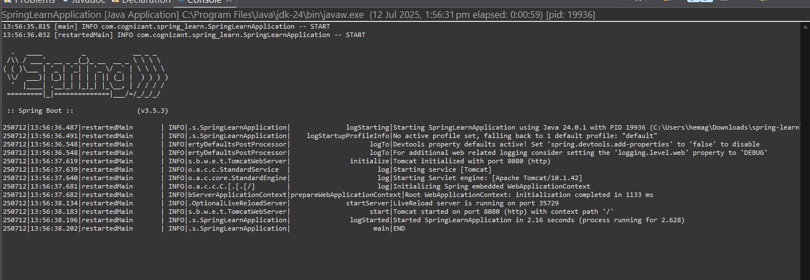

**Pom.xml:**<?xml version="1.0" encoding="UTF-8"?>

<project xmlns="http://maven.apache.org/POM/4.0.0" xmlns:xsi="http://www.w3.org/2001/XMLSchema-instance"

xsi:schemaLocation="http://maven.apache.org/POM/4.0.0 https://maven.apache.org/xsd/maven-4.0.0.xsd">

<modelVersion>4.0.0</modelVersion>

<parent>

<groupId>org.springframework.boot</groupId>

<artifactId>spring-boot-starter-parent</artifactId>

<version>3.5.3</version>

<relativePath/> <!-- lookup parent from repository -->

</parent>

<groupId>com.cognizant</groupId>

<artifactId>spring-learn</artifactId>

<version>0.0.1-SNAPSHOT</version>

<name>spring-learn</name>

<description>Demo project for Spring Boot</description>

<url/>

<licenses>

<license/>

</licenses>

<developers>

<developer/>

</developers>

<scm>

<connection/>

<developerConnection/>

<tag/>

<url/>

</scm>

<properties>

<java.version>24</java.version>

</properties>

<dependencies>

<dependency>

<groupId>org.springframework.boot</groupId>

<artifactId>spring-boot-starter-web</artifactId>

</dependency>

<dependency>

<groupId>org.springframework.boot</groupId>

<artifactId>spring-boot-devtools</artifactId>

<scope>runtime</scope>

<optional>true</optional>

</dependency>

<dependency>

<groupId>org.springframework.boot</groupId>

<artifactId>spring-boot-starter-test</artifactId>

<scope>test</scope>

</dependency>

</dependencies>

<build>

<plugins>

<plugin>

<groupId>org.springframework.boot</groupId>

<artifactId>spring-boot-maven-plugin</artifactId>

</plugin>

</plugins>

</build>

</project>

**EX2 Spring Core — Load Country from Spring Configuration XML**

**HelloController.java:**  
package com.cognizant.spring_learn.controller;

import org.slf4j.Logger;

import org.slf4j.LoggerFactory;

import org.springframework.web.bind.annotation.GetMapping;

import org.springframework.web.bind.annotation.RestController;

@RestController

public class HelloController {

private static final Logger LOGGER = LoggerFactory.getLogger(HelloController.class);

@GetMapping("/hello")

public String sayHello() {

LOGGER.info("START");

String message = "Hello World!!";

LOGGER.info("END");

return message;

}

}

**Country.java**package com.cognizant.spring_learn.model;

public class Country {

private String code;

private String name;

public String getCode() {

return code;

}

public void setCode(String code) {

this.code = code;

}

public String getName() {

return name;

}

public void setName(String name) {

this.name = name;

}

@Override

public String toString() {

return "Country [code=" + code + ", name=" + name + "]";

}

}

**SpringLearnApplication.java**

package com.cognizant.spring_learn;

import org.slf4j.Logger;

import org.slf4j.LoggerFactory;

import org.springframework.boot.SpringApplication;

import org.springframework.boot.autoconfigure.SpringBootApplication;

import org.springframework.context.ApplicationContext;

import org.springframework.context.support.ClassPathXmlApplicationContext;

import java.text.SimpleDateFormat;

import java.util.Date;

@SpringBootApplication

public class SpringLearnApplication {

private static final Logger LOGGER = LoggerFactory.getLogger(SpringLearnApplication.class);

public static void main(String[] args) {

LOGGER.info("START");

// Start the Spring Boot application

SpringApplication.run(SpringLearnApplication.class, args);

// Call method from Hands-on 2

displayDate();

LOGGER.info("END");

}

public static void displayDate() {

LOGGER.info("START");

// Load Spring XML configuration

ApplicationContext context = new ClassPathXmlApplicationContext("date-format.xml");

// Get dateFormat bean

SimpleDateFormat format = context.getBean("dateFormat", SimpleDateFormat.class);

try {

Date date = format.parse("31/12/2018");

LOGGER.debug("Date: {}", date);

} catch (Exception e) {

LOGGER.error("Error parsing date", e);

}

LOGGER.info("END");

}

}

**RESOURCES**

**Application.properties:**spring.application.name=spring-learn

logging.level.org.springframework=info

logging.level.com.cognizant.spring_learn=debug

logging.pattern.console=%d{yyMMdd}|%d{HH:mm:ss.SSS}|%-20.20thread|%5p|%-25.25logger{25}|%25M|%m%n

server.port=8085

**Country.xml**

<?xml version="1.0" encoding="UTF-8"?>

<beans xmlns="http://www.springframework.org/schema/beans"

xmlns:xsi="http://www.w3.org/2001/XMLSchema-instance"

xsi:schemaLocation="

http://www.springframework.org/schema/beans

http://www.springframework.org/schema/beans/spring-beans.xsd">

<bean id="in" class="com.cognizant.spring_learn.model.Country">

<property name="code" value="IN"/>

<property name="name" value="India"/>

</bean>

</beans>

**Date_format.xml**

<?xml version="1.0" encoding="UTF-8"?>

<beans xmlns="http://www.springframework.org/schema/beans"

xmlns:xsi="http://www.w3.org/2001/XMLSchema-instance"

xsi:schemaLocation="http://www.springframework.org/schema/beans

https://www.springframework.org/schema/beans/spring-beans.xsd">

<bean id="dateFormat" class="java.text.SimpleDateFormat">

<constructor-arg value="dd/MM/yyyy" />

</bean>

</beans>

**SpringLearnApplicationTest.java**

package com.cognizant.spring_learn;

import org.junit.jupiter.api.Test;

import org.springframework.boot.test.context.SpringBootTest;

@SpringBootTest

class SpringLearnApplicationTests {

@Test

void contextLoads() {

}

}

**EX 1: HELLO WORLD**

**HelloWorldServiceApplication.java:**package com.cognizant.spring_learn;

import org.springframework.boot.SpringApplication;

import org.springframework.boot.autoconfigure.SpringBootApplication;

@SpringBootApplication

public class HelloWorldServiceApplication {

public static void main(String[] args) {

SpringApplication.run(HelloWorldServiceApplication.class, args);

}

}

**Pom.xml**<project xmlns="http://maven.apache.org/POM/4.0.0"

xmlns:xsi="http://www.w3.org/2001/XMLSchema-instance"

xsi:schemaLocation="http://maven.apache.org/POM/4.0.0

https://maven.apache.org/xsd/maven-4.0.0.xsd">

<modelVersion>4.0.0</modelVersion>

<groupId>com.cognizant.spring-learn</groupId>

<artifactId>hello-world-service</artifactId>

<version>0.0.1-SNAPSHOT</version>

<description>Hello World REST Service</description>

<packaging>jar</packaging>

<parent>

<groupId>org.springframework.boot</groupId>

<artifactId>spring-boot-starter-parent</artifactId>

<version>3.2.0</version>

<relativePath/>

</parent>

<properties>

<java.version>17</java.version>

</properties>

<dependencies>

<dependency>

<groupId>org.springframework.boot</groupId>

<artifactId>spring-boot-starter-web</artifactId>

</dependency>

<dependency>

<groupId>org.springframework.boot</groupId>

<artifactId>spring-boot-starter-logging</artifactId>

</dependency>

<dependency>

<groupId>org.springframework.boot</groupId>

<artifactId>spring-boot-starter-test</artifactId>

<scope>test</scope>

</dependency>

</dependencies>

<build>

<plugins>

<plugin>

<groupId>org.springframework.boot</groupId>

<artifactId>spring-boot-maven-plugin</artifactId>

</plugin>

</plugins>

</build>

</project>

**Output Screenshot:**

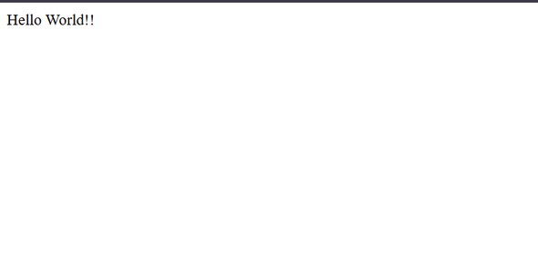

**EX2 REST - Country Web Service**

**CountryController.java:**package com.cognizant.spring_learn.controller;

import com.cognizant.spring_learn.model.Country;

import org.springframework.context.ApplicationContext;

import org.springframework.context.support.ClassPathXmlApplicationContext;

import org.springframework.web.bind.annotation.RequestMapping;

import org.springframework.web.bind.annotation.RestController;

@RestController

public class CountryController {

@RequestMapping("/country")

public Country getCountryIndia() {

ApplicationContext context = new ClassPathXmlApplicationContext("country.xml");

Country country = (Country) context.getBean("country");

return country;

}

}

**CountryServiceApplication.java**package com.cognizant.spring_learn;

import org.springframework.boot.SpringApplication;

import org.springframework.boot.autoconfigure.SpringBootApplication;

@SpringBootApplication

public class CountryServiceApplication {

public static void main(String[] args) {

SpringApplication.run(CountryServiceApplication.class, args);

}

}

**Country.xml**

<?xml version="1.0" encoding="UTF-8"?>

<beans xmlns="http://www.springframework.org/schema/beans"

xmlns:xsi="http://www.w3.org/2001/XMLSchema-instance"

xsi:schemaLocation="http://www.springframework.org/schema/beans

https://www.springframework.org/schema/beans/spring-beans.xsd">

<bean id="country" class="com.cognizant.spring_learn.model.Country">

<property name="code" value="IN" />

<property name="name" value="India" />

</bean>

</beans>

**Output Screenshot:**

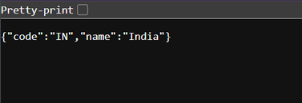

**EX3 Get Country based on Country code**

**CountryController.java:**

package com.cognizant.spring_learn.controller;

import com.cognizant.spring_learn.model.Country;

import com.cognizant.spring_learn.service.CountryService;

import org.springframework.beans.factory.annotation.Autowired;

import org.springframework.web.bind.annotation.GetMapping;

import org.springframework.web.bind.annotation.PathVariable;

import org.springframework.web.bind.annotation.RestController;

@RestController

public class CountryController {

@Autowired

private CountryService countryService;

@GetMapping("/countries/{code}")

public Country getCountry(@PathVariable String code) {

return countryService.getCountry(code);

}

}

**Country.java**

package com.cognizant.spring_learn.model;

public class Country {

private String code;

private String name;

public Country() {}

public Country(String code, String name) {

this.code = code;

this.name = name;

}

public String getCode() {

return code;

}

public void setCode(String code) {

this.code = code;

}

public String getName() {

return name;

}

public void setName(String name) {

this.name = name;

}

}

**CountryLookupApplication**

package com.cognizant.spring_learn;

import org.springframework.boot.SpringApplication;

import org.springframework.boot.autoconfigure.SpringBootApplication;

@SpringBootApplication

public class CountryLookupApplication {

public static void main(String[] args) {

SpringApplication.run(CountryLookupApplication.class, args);

}

}

**Country.xml**

<?xml version="1.0" encoding="UTF-8"?>

<beans xmlns="http://www.springframework.org/schema/beans"

xmlns:xsi="http://www.w3.org/2001/XMLSchema-instance"

xsi:schemaLocation="http://www.springframework.org/schema/beans

https://www.springframework.org/schema/beans/spring-beans.xsd">

<bean id="country1" class="com.cognizant.spring_learn.model.Country">

<property name="code" value="IN"/>

<property name="name" value="India"/>

</bean>

<bean id="country2" class="com.cognizant.spring_learn.model.Country">

<property name="code" value="US"/>

<property name="name" value="United States"/>

</bean>

<bean id="country3" class="com.cognizant.spring_learn.model.Country">

<property name="code" value="JP"/>

<property name="name" value="Japan"/>

</bean>

<bean id="countryList" class="java.util.ArrayList">

<constructor-arg>

<list>

<ref bean="country1"/>

<ref bean="country2"/>

<ref bean="country3"/>

</list>

</constructor-arg>

</bean>

</beans>

**Pom.xml**

<project xmlns="http://maven.apache.org/POM/4.0.0"

xmlns:xsi="http://www.w3.org/2001/XMLSchema-instance"

xsi:schemaLocation="http://maven.apache.org/POM/4.0.0

https://maven.apache.org/xsd/maven-4.0.0.xsd">

<modelVersion>4.0.0</modelVersion>

<groupId>com.cognizant.spring-learn</groupId>

<artifactId>country-lookup-service</artifactId>

<version>0.0.1-SNAPSHOT</version>

<description>Country Lookup REST Service</description>

<packaging>jar</packaging>

<parent>

<groupId>org.springframework.boot</groupId>

<artifactId>spring-boot-starter-parent</artifactId>

<version>3.2.0</version>

<relativePath/>

</parent>

<properties>

<java.version>17</java.version>

</properties>

<dependencies>

<dependency>

<groupId>org.springframework.boot</groupId>

<artifactId>spring-boot-starter-web</artifactId>

</dependency>

<dependency>

<groupId>org.springframework</groupId>

<artifactId>spring-context</artifactId>

</dependency>

<dependency>

<groupId>org.springframework.boot</groupId>

<artifactId>spring-boot-starter-test</artifactId>

<scope>test</scope>

</dependency>

</dependencies>

<build>

<plugins>

<plugin>

<groupId>org.springframework.boot</groupId>

<artifactId>spring-boot-maven-plugin</artifactId>

</plugin>

</plugins>

</build>

</project>

**Output Screenshot:**

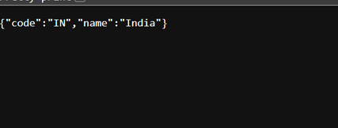

**EX5 JWT Hands on**

**Util:**package com.example.jwt;

import org.springframework.boot.SpringApplication;

import org.springframework.boot.autoconfigure.SpringBootApplication;

@SpringBootApplication

public class JwtAuthExampleApplication {

public static void main(String[] args) {

SpringApplication.run(JwtAuthExampleApplication.class, args);

}

}

**Pom.xml**

<project xmlns="http://maven.apache.org/POM/4.0.0"

xmlns:xsi="http://www.w3.org/2001/XMLSchema-instance"

xsi:schemaLocation="http://maven.apache.org/POM/4.0.0 http://maven.apache.org/xsd/maven-4.0.0.xsd">

<modelVersion>4.0.0</modelVersion>

<groupId>com.example</groupId>

<artifactId>jwt-auth-example</artifactId>

<version>1.0-SNAPSHOT</version>

<packaging>jar</packaging>

<name>jwt-auth-example</name>

<description>Spring Boot JWT Authentication Example</description>

<parent>

<groupId>org.springframework.boot</groupId>

<artifactId>spring-boot-starter-parent</artifactId>

<version>2.7.15</version>

<relativePath/>

</parent>

<dependencies>

<dependency>

<groupId>org.springframework.boot</groupId>

<artifactId>spring-boot-starter-web</artifactId>

</dependency>

<dependency>

<groupId>org.springframework.boot</groupId>

<artifactId>spring-boot-starter-security</artifactId>

</dependency>

<dependency>

<groupId>io.jsonwebtoken</groupId>

<artifactId>jjwt-api</artifactId>

<version>0.11.5</version>

</dependency>

<dependency>

<groupId>io.jsonwebtoken</groupId>

<artifactId>jjwt-impl</artifactId>

<version>0.11.5</version>

<scope>runtime</scope>

</dependency>

<dependency>

<groupId>io.jsonwebtoken</groupId>

<artifactId>jjwt-jackson</artifactId>

<version>0.11.5</version>

<scope>runtime</scope>

</dependency>

</dependencies>

<build>

<plugins>

<plugin>

<groupId>org.springframework.boot</groupId>

<artifactId>spring-boot-maven-plugin</artifactId>

</plugin>

</plugins>

</build>

</project>

