Persona: Decide on the personality and tone of this chatbot. Is it formal, friendly, or professional? This will influence how it interacts with users.

Conversation Flow: Outline the typical user interactions and the flow of the conversation. Think about the primary tasks the chatbot should handle.

Intents: Identify the user intents or goals. What are the main reasons users will interact with the chatbot? Examples could include asking questions, making reservations, or requesting information.

Entities: Define relevant entities, which are pieces of information that your chatbot needs to understand to fulfill user requests. For instance, if your chatbot handles restaurant reservations, an entity might be "date" or "party size."

Dialog Nodes: Create dialog nodes that guide the conversation. Each node should correspond to a specific user intent or action and determine how the chatbot responds.

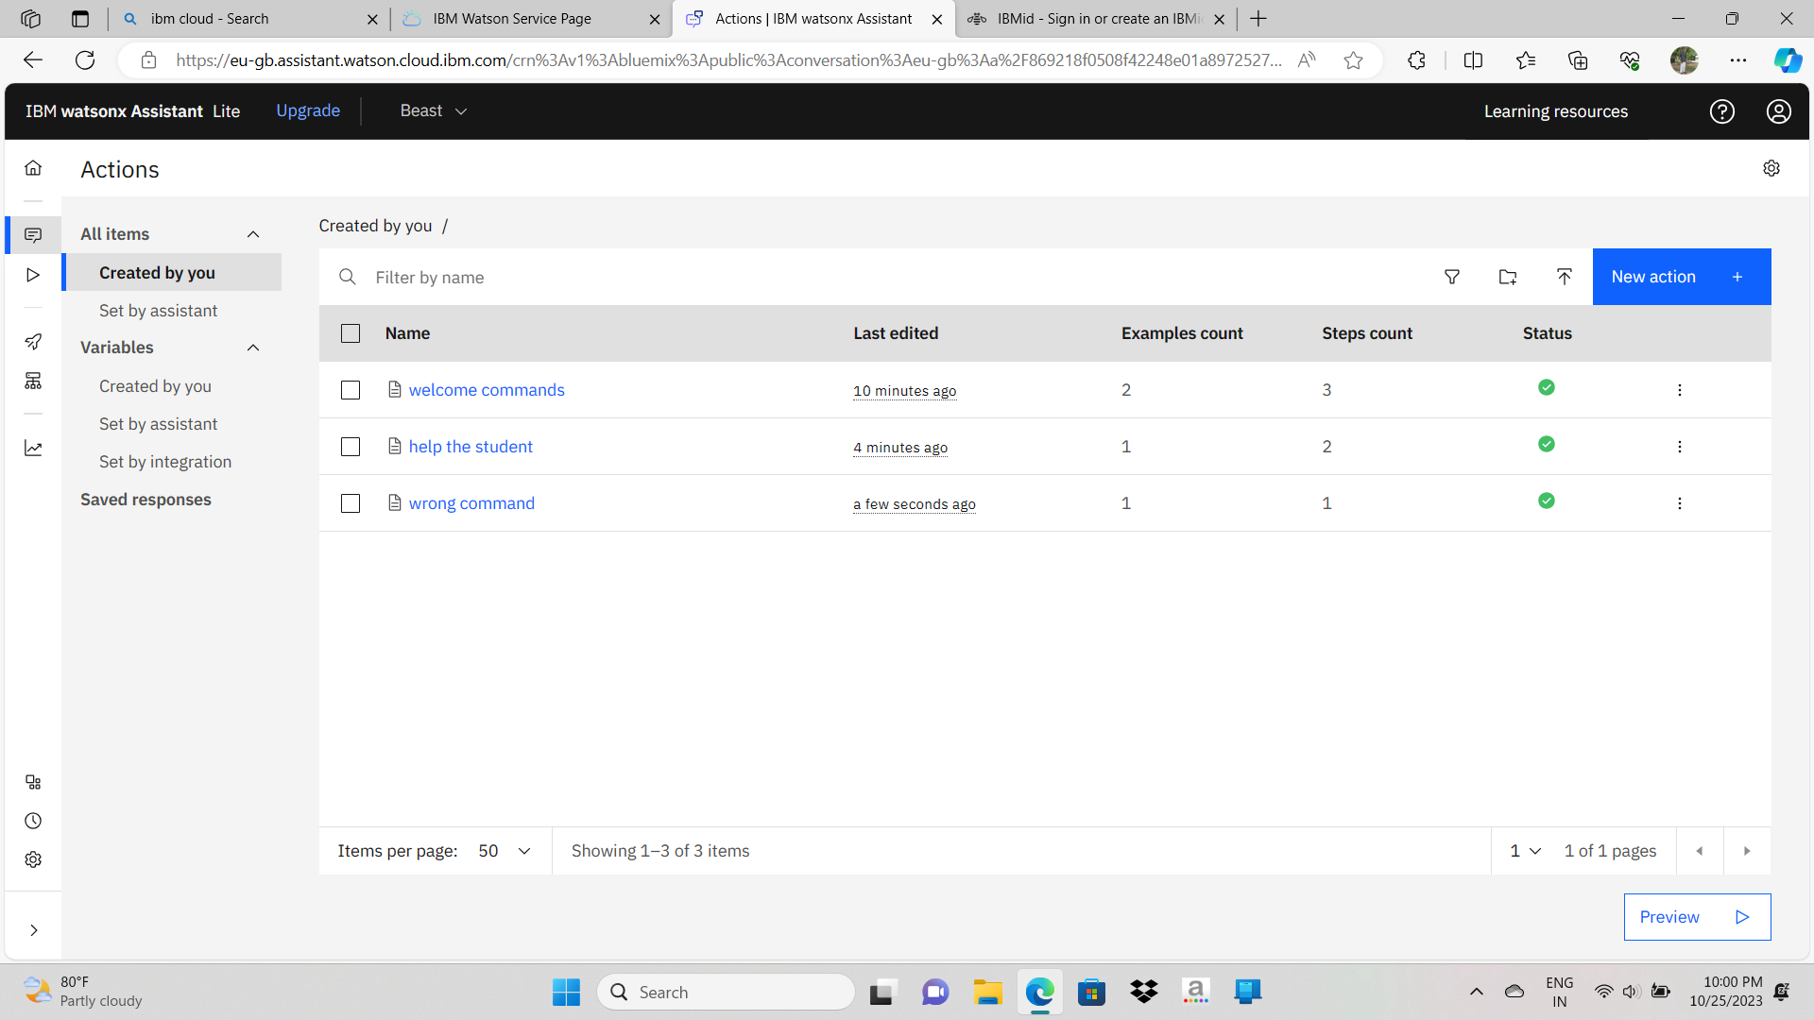

The above figure is flow of my chatbot persona and design the conversation of flow

Step2: create the intents of the chatbots

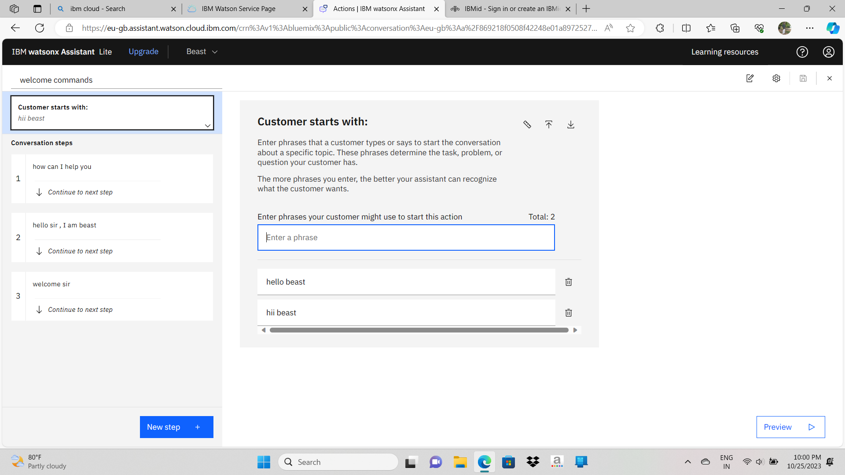

Create a welcome command

* Hello beast
* Hii beast

Step3: create the response dialogue from the chatbot

Some basic instruction are trained by chatbot

* Welcome sir
* Yes sir, I am beast

Create a help command

* How can I help you
* Can I assist you

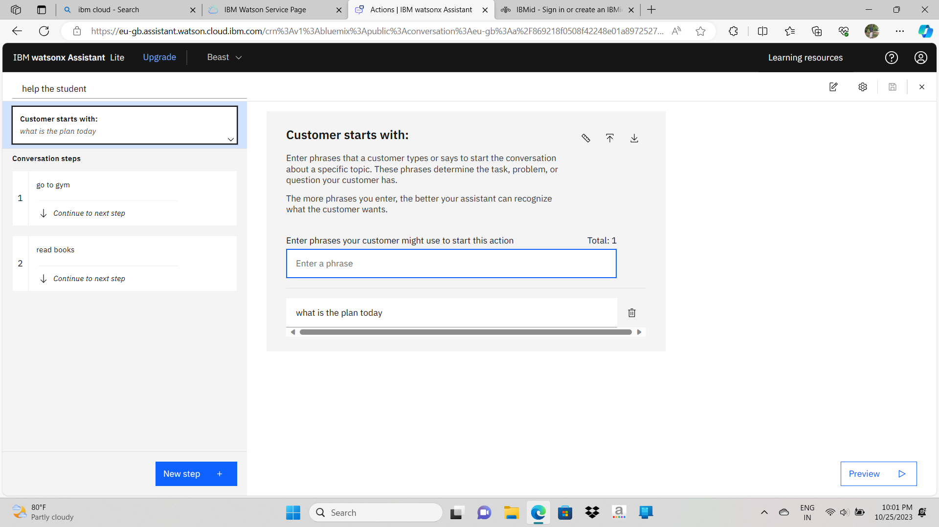

Some basic commands are trained by our chatbot

They above queries are used our assistance and trained by some dialog nodes in Watson assistant.