# NAAN MUTHALVAN

ARTIFICIAL INTELLIGENCE PROJECT TITLE

SENTIMENTAL ANALYSIS FOR

MARKETING

REG.NO : 712221104001

NAME:DHANUSH A

DEPT : COMPUTER SCIENCE AND ENGINEERING YEAR & SEM : III & 05

COLLEGE : PARK COLLEGE OF ENGINEERING AND TECHNOLOGY

PHASE 1

# PROBLEM DEFINITION AND DESIGN THINKING

PROBLEM DEFINITION

Sentiment analysis, also referred to as opinion mining, is an approach to natural language processing (NLP) that identifies the emotional tone behind a body of text. This is a popular way for organizations to determine and categorize opinions about a product, service or idea.

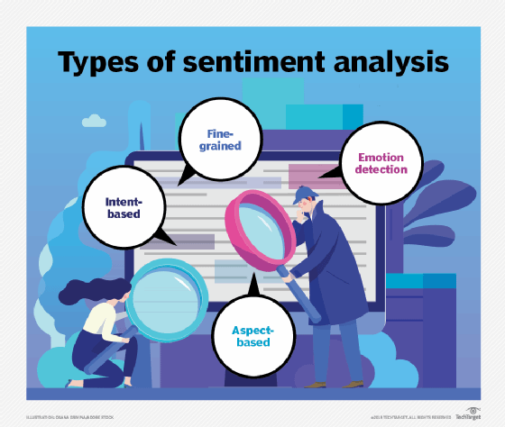

## DESIGN THINKING



Visualization



Data

collection



Design Thinking



Data Preprocessing



Insights Generation



Feature

Extraction



Sentiment Analysis

## Data collection

Identify a dataset containing customer reviews and sentiments about competitor products.



## Data Preprocess

 Clean and preprocess the textual data for analysis.



Clean

Analysis

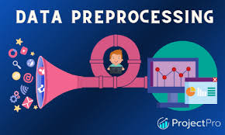

Preprocess

## Sentiment Analysis Techniques

Employ different NLP techniques like Bag of Words, Word Embeddings, or Transformer models for sentiment analysis.

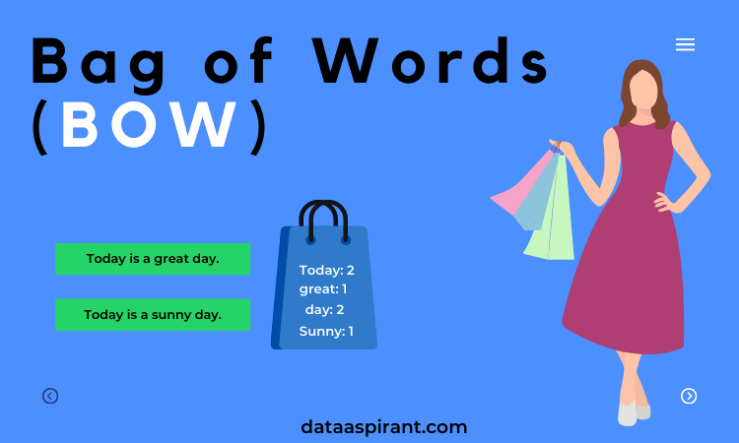

Bag of words

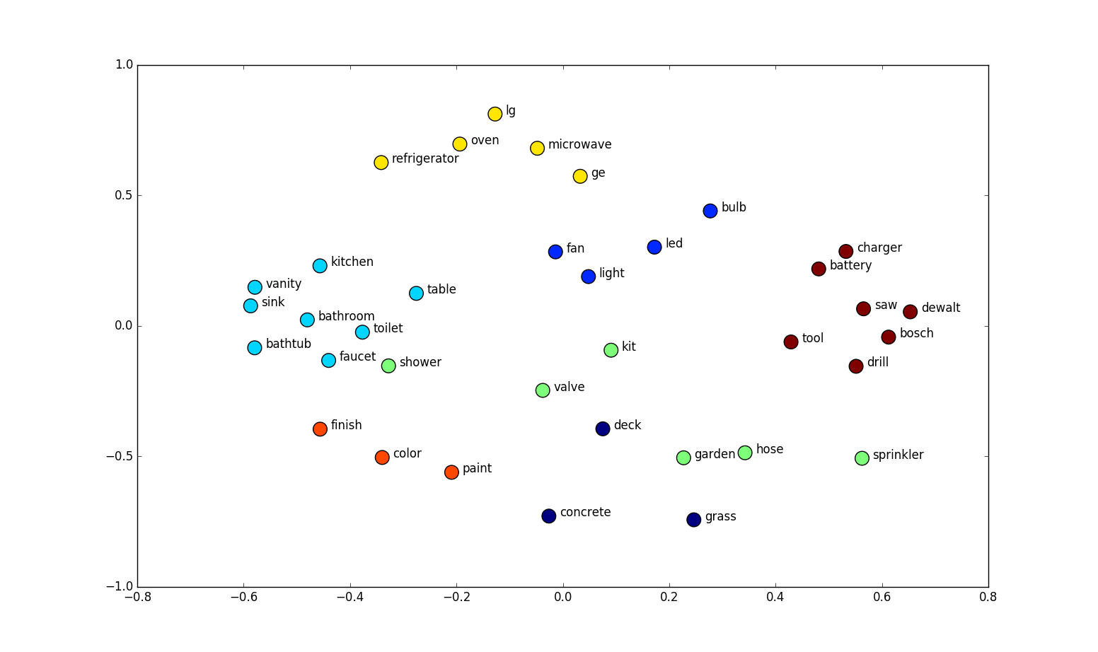

Word Embeddings

Feature Extraction

Extract features and sentiments from the text data

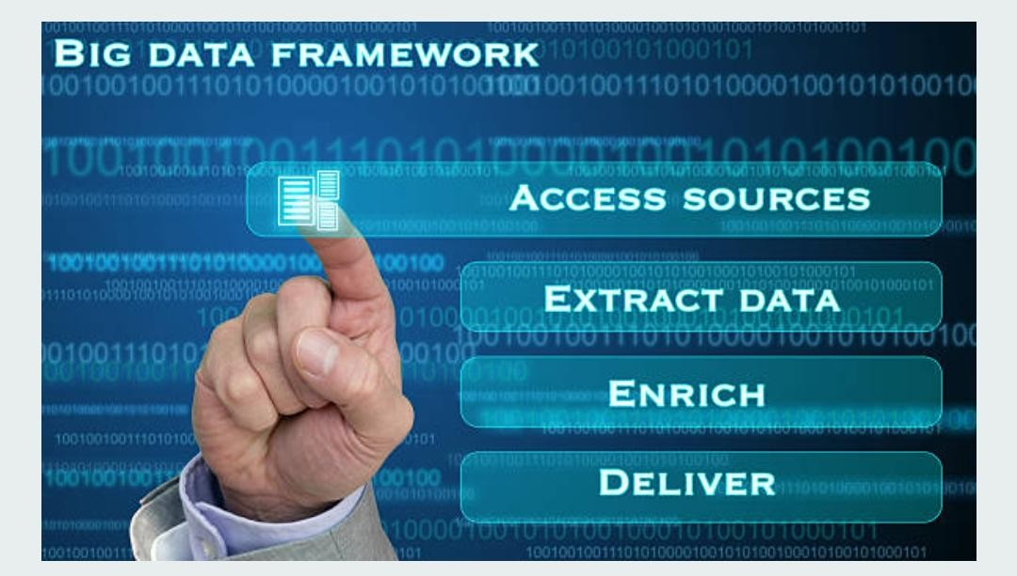

## Visualization

Create visualizations to depict the sentiment distribution and analyze trends.



Visual Insights

## Insights Generation

Extract meaningful insights from the sentiment analysis results to guide business decisions.

Visualization Process

