Who delivers when it matters?
Pressure performance in IPL and T20I cricket, 2022-2026. SupeRR Selector Season 2, Round 1 methodology report.

The answer
Rank 1 is our highest-rated player. Names and player IDs are as they appear in the supplied data.
Table 1. Final top-10 lists (also in outputs/tables/top10_batters.csv and top10_bowlers.csv)
Rank | Batter | Batter ID | Bowler | Bowler ID
1 | Suryakumar Yadav | 1699 | Varun Chakravarthy | 6256
2 | Abhishek Sharma | 6281 | Kuldeep Yadav | 3644
3 | Vaibhav Sooryavanshi | 50284 | Sunil Narine | 781
4 | Heinrich Klaasen | 4260 | Jasprit Bumrah | 2933
5 | Jos Buttler | 813 | Josh Hazlewood | 830
6 | Tim David | 6396 | Matheesha Pathirana | 8661
7 | Yashasvi Jaiswal | 6819 | Rashid Khan | 4722
8 | Namboori Tilak Varma | 7897 | Krunal Pandya | 4219
9 | Andre Russell | 1318 | Bhuvneshwar Kumar | 360
10 | Sai Sudharsan | 23450 | Noor Ahmad | 7967

1. Summary
- Pressure is how much a single delivery can change who wins. We estimate it for all 193,988 deliveries with a ball-by-ball win-probability model and call it the Pressure Index (PI). The 20% of deliveries with the highest PI (PI >= 1.31) are "high pressure". Knock-out matches get a 1.2x stakes multiplier.
- These deliveries carry 42% of all win-probability movement in the data. In chases, 97% of deliveries are high pressure when the match is in the balance (win probability 40-60%) and 3% when it is decided. At the death of a chase, high-pressure deliveries produce 2.1x the run-outs and more wides and no-balls than other deliveries in the same overs.
- Performance on each delivery is the runs a player produced (or saved) above what an average player would produce in exactly that situation, with a dismissal costing the runs it takes off the innings. Ratings are adjusted for the quality of the opponent faced and shrunk for sample size.
- Key finding: a player's record in ordinary situations predicts his pressure record in other matches better than his own pressure record does, and the gap between pressure and usual performance does not repeat (correlation +0.02 for batters and +0.01 for bowlers between random halves of the matches). "Rising to the occasion" is not a stable trait we can detect. The players who deliver under pressure are very good players who do it often.
- Ranking = 60% expected run value per high-pressure delivery + 40% consistency (share of pressure innings or spells that beat the average-player expectation), minus one bootstrap standard error so that a high rank needs both a high score and enough evidence. Eligibility: at least 120 high-pressure deliveries and 10 pressure innings or spells (96 batters and 97 bowlers qualify).
- The lists hold up under 15 alternative specifications: the median top-10 overlap with the main list is 8/10 for batters and 8/10 for bowlers. Over 10,000 bootstrap resamples of matches, the top four batters finish in the top 10 at least 79% of the time.

2. Data and preparation

2.1 Scope
We rate 837 matches with ball-by-ball data: 367 IPL matches (2022-2026) and 470 T20 Internationals, 193,988 deliveries in all. The 30 matches from the Emerging Teams Asia Cup 2024 and Asia Cup Rising Stars 2025 are excluded because they are neither IPL nor senior T20I cricket. Super overs (38 deliveries) are left out of the ratings. Every player ID maps to a single name and the same ID is used in both competitions, so a player's IPL and T20I records are combined. Players are identified by ID, not by name: two names belong to two different players each (Abdul Samad of Pakistan and the IPL's Abdul Samad; Haider Ali of Pakistan and of the UAE), and a second ID for Basil Hameed appears only in an excluded A-team event.
All six files are used. ball_by_ball.csv provides the deliveries; matches.csv the results, rain-revised targets and overs, stages and dates; competitions.csv separates IPL, T20I and A-team cricket and gives the season; teams.csv gives team names. The two player files cross-check the deliveries: all 18,182 player-match appearances in the ball-by-ball data (0 missing) are in that side's playing XI in playing_eleven.csv, and all 4,791 player-team-competition combinations (0 missing) are in the squads in competition_team_player_mapping.csv, with the same names for all 892 players. These files also supply each player's appearances (including IPL Impact Player substitutions: 535 of 558 substitutes batted or bowled) and his national side for the tables.

2.2 Rebuilding the scoreboard
The ball-by-ball file stores runs off the bat, but not how many runs came from byes, leg-byes or wides (the field extras1_runs is an extras-type code, not a run count). Without those runs the score, the target and the required run rate are wrong. We recover them in two steps:
- Odd or even? If the batters changed ends, an odd number of runs was taken. We read this from the next delivery's striker (allowing for the change of ends at the end of the over). On ordinary deliveries this rule reproduces the parity of the bat runs 99.98% of the time.
- How many? Odd byes and leg-byes are counted as 1 and even ones as 4; wides as 1 (2 if the batters crossed); no-balls as 1 plus any byes; penalty runs as 5. Of the combinations we tested, these values agree best with the published winning margins.
- Check. In 388 matches won by the side batting first, the rebuilt totals reproduce the published margin exactly in 63% of matches (simple counting: 31%) and the mean error falls from 2.2 to 1.2 runs.
- Targets are anchored on the result. If the side batting first won by N runs, the target is the chasing side's total + N + 1; if the chase succeeded, the target is placed inside the winning delivery; rain-affected chases use the revised target and overs in matches.csv. This makes 'runs needed' exact at the end of the chase, where pressure is highest.
Scoring rates differ a lot between competitions and seasons (IPL scoring rose from 8.50 to 9.86 runs per over over the period), so every model below conditions on the league and season.

3. Defining pressure

3.1 The idea
A delivery is high pressure when its outcome can swing the result. A dot ball at 60 for 0 after 6 overs changes little; the same dot ball with 12 needed off 6 can decide the match. We measure this directly: for every delivery we ask how much the batting side's chance of winning would move, on average, across all the things that could happen on that ball. This is the leverage idea used in baseball's Leverage Index (Tango), built on a ball-by-ball win-probability recursion of the kind used by the WASP model on New Zealand television (Brooker and Hogan). One number captures the factors the brief lists: required run rate, wickets in hand, balls remaining, stage of the innings and closeness of the contest.

3.2 Win-probability model
- Ball-outcome model. A gradient-boosted classifier predicts the probability of each team outcome (wicket, 0, 1, 2, 3, 4, 6, wide/no-ball) from context only: balls left, wickets lost, scoring environment and, in a chase, runs needed and the required rate. No player identities are used, so it describes an average player in that situation. Out-of-sample log-loss (5 folds grouped by match) is 1.5955 in the first innings and 1.5972 in the chase, against 1.6063 and 1.6070 for a table of outcome rates by over.
- Chase. Dynamic programming over every state (balls left 0-120, wickets 0-10, runs needed 0-330) gives the chasing side's win probability, with ties counted as half a win.
- First innings. The same recursion gives the full distribution of runs still to come; combining it with the chase table gives the batting side's win probability at any score.
- Calibration. Brier score 0.217 in the first innings and 0.125 in the chase (constant forecast: 0.250 and 0.250). The average forecast at the first ball is 51.3% against an actual batting-first win rate of 49.6%. The model is a little over-confident in lopsided first-innings states (Figure 1). A re-calibration on match results improves the Brier score only in the third decimal and proved unstable, so the Pressure Index uses the model as estimated from ball outcomes.
- Common-sense constraints. The fitted outcome model is not monotone by construction, and in a few end-of-innings states it implied that losing a wicket helps the batting side. Every table is therefore forced to be non-increasing in wickets lost and non-decreasing in balls left. This adjusts 5.9% of chase states and 16.2% of first-innings states, by at most 0.091 in win probability, mostly in combinations that rarely occur, such as many balls left with eight or nine wickets down. The run-expectancy table gets the same treatment (largest change 3.0 runs), so a wicket never has a negative run cost.
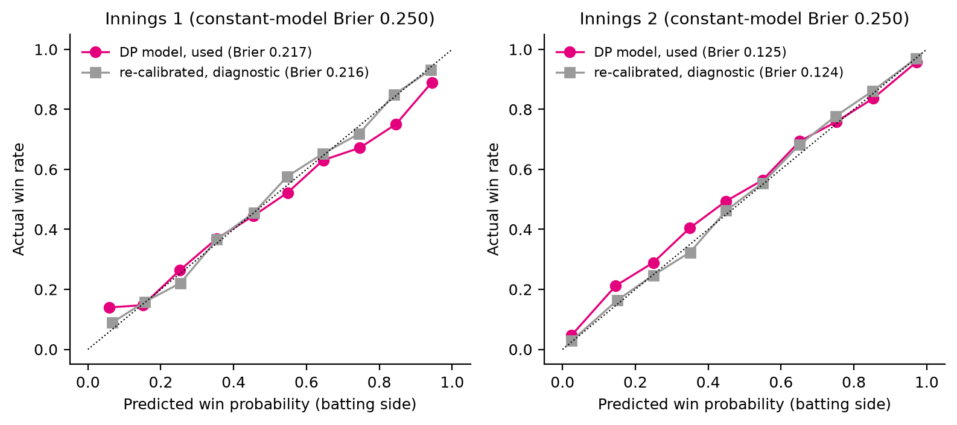
Figure 1. Predicted win probability against actual win rate, in bins of 10 percentage points.

3.3 From win probability to the Pressure Index
For each delivery, Leverage = the sum over possible outcomes of P(outcome) x |win probability after that outcome - win probability now|. Dividing by the average over all deliveries gives the Leverage Index (LI): 1 is an average delivery, 3 is three times as consequential. The Pressure Index multiplies LI by 1.2 in knock-out matches (finals, qualifiers, eliminators, semi-finals), where a defeat ends the campaign. Deliveries in the top 20% of PI (PI >= 1.31) are high pressure. A binary split keeps the comparison easy to read and gives every high-pressure delivery equal weight, so a handful of last-ball finishes cannot dominate a player's rating.
The multiplier is a deliberate judgement about stakes, not something the scoreboard shows: on leverage alone, 21% of knock-out deliveries reach the top fifth, against 20% of other deliveries. With the multiplier, 37% of the deliveries in the 25 knock-out matches count as high pressure. Removing it, or raising it to 1.5, barely changes the rankings (Section 7.3).
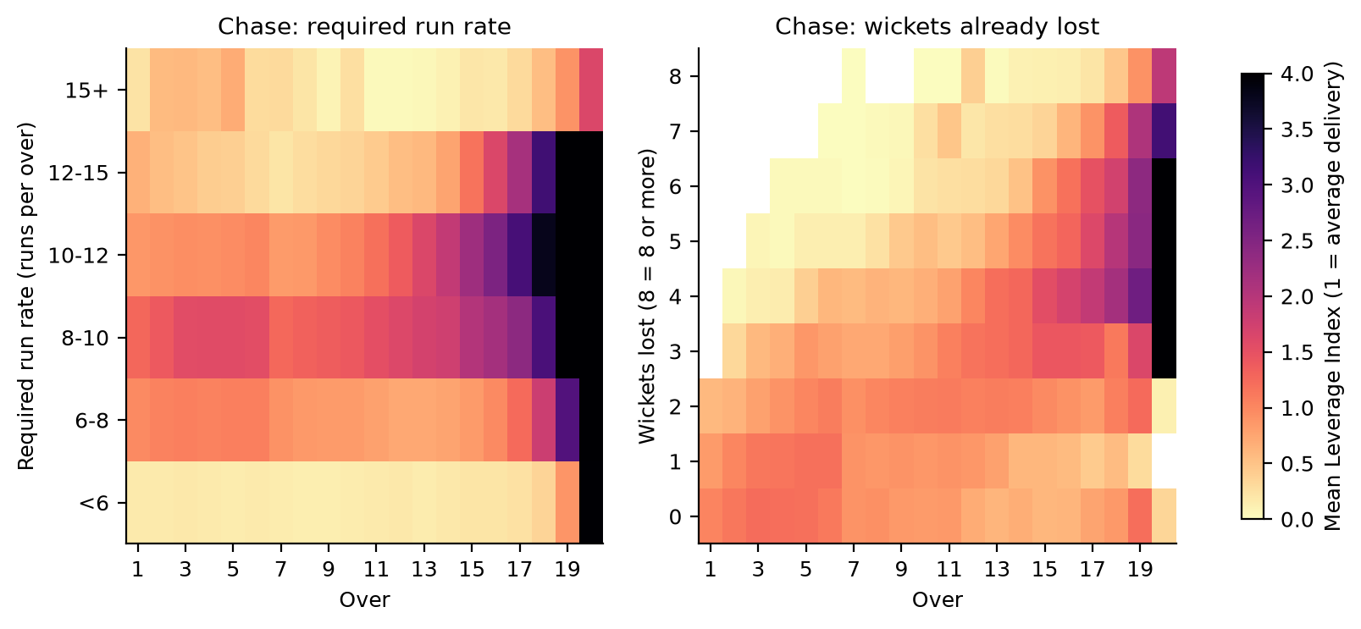
Figure 2. Average Leverage Index of chase deliveries by over and required run rate (left) and by over and wickets lost (right). Pressure peaks late in close chases and fades when the chase is easy (required rate under 6) or out of reach (15+).
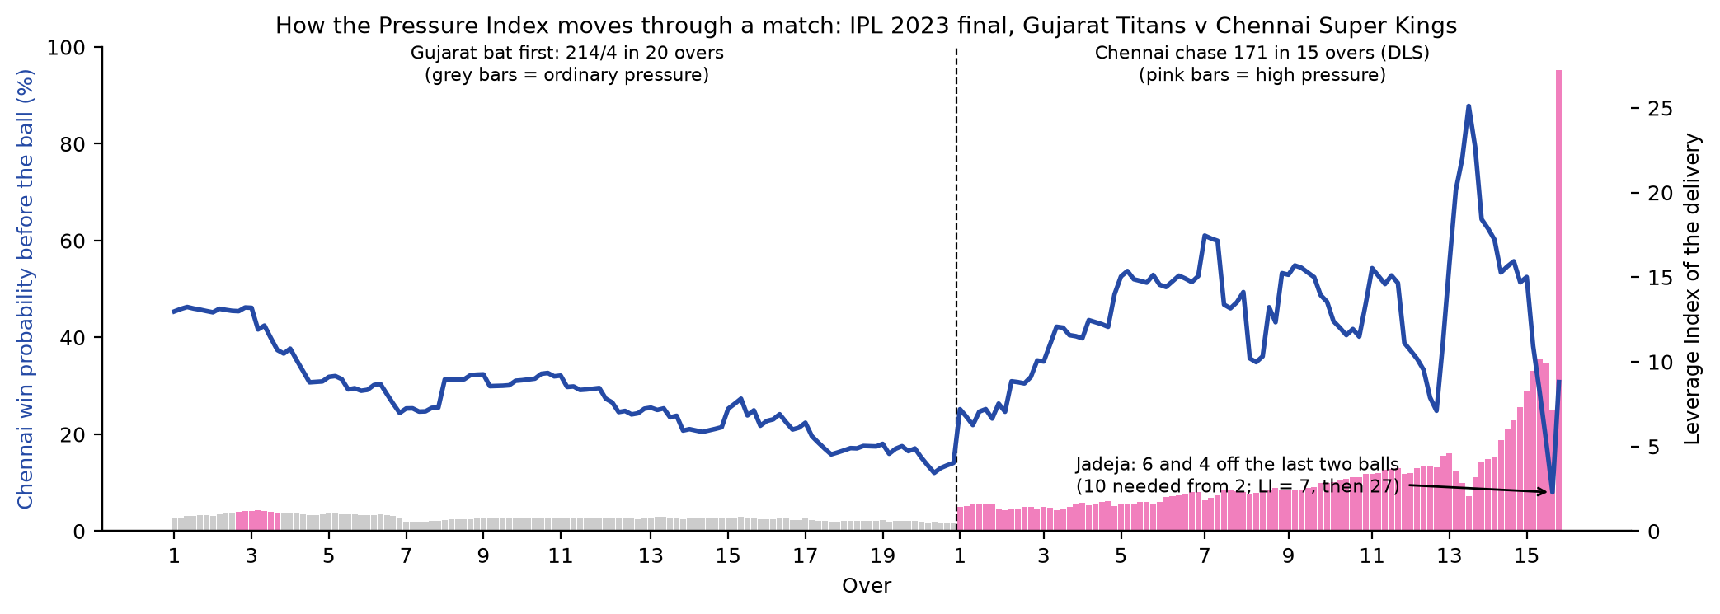
Figure 3. The IPL 2023 final. 7 of 122 first-innings deliveries are high pressure; all 94 deliveries of the rain-reduced chase are, and leverage peaks on the last two balls.

3.4 Evidence that the index separates pressure from ordinary play
- It finds the deliveries that decide matches. High-pressure deliveries are 20% of the data but carry 42% of all win-probability movement; the top 5% carry 18%.
- It tracks closeness. Mean LI in chases is 2.18 when the win probability is 40-60% and 0.34 when it is below 10% or above 90%. By required rate it rises from 0.30 (under 6 an over) to 1.60 (8-10) and falls back to 0.58 (15+).
- Players behave differently under it, even in the same phase. At the death of a chase, high-pressure deliveries have 8.7 run-outs per 1000 balls against 4.2, 7.1 wides and no-balls per 100 balls against 6.0, and 29% dot balls against 34% as batters take more risks. In the powerplay, wickets rise from 4.7 to 5.1 per 100 balls (Figure 4).
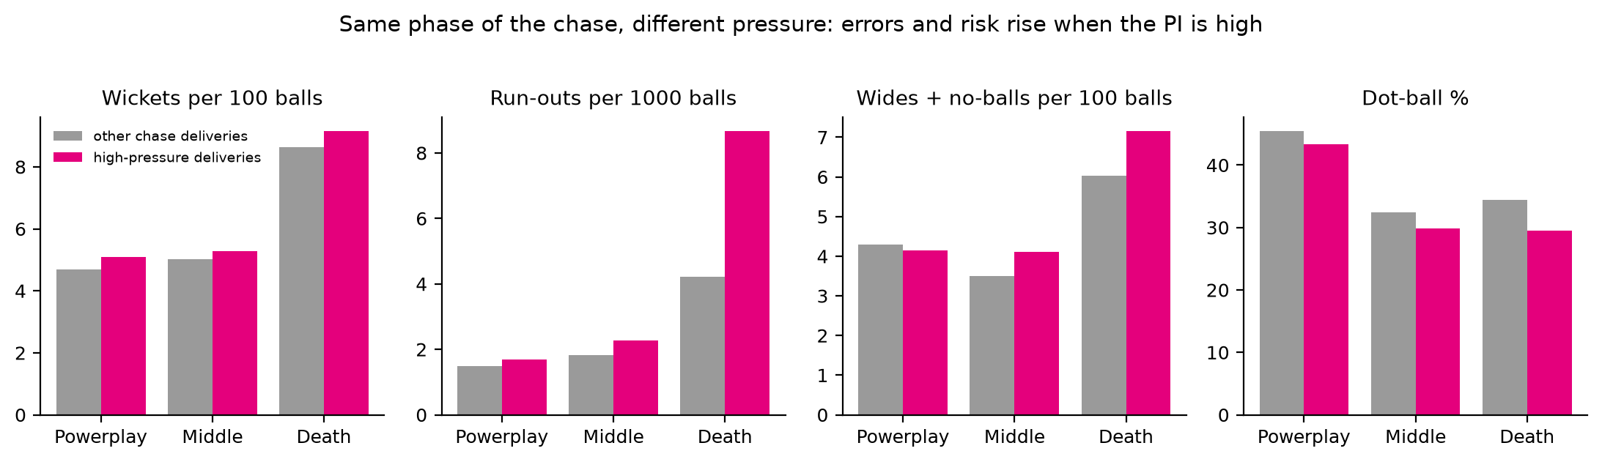
Figure 4. League-wide behaviour of chase deliveries in the same phase, split by the Pressure Index.

3.5 Where pressure lives
87% of high-pressure deliveries come in chases: 32% in the chase powerplay, 37% in overs 7-15 and 19% at the death. Only 4.8% of first-innings deliveries qualify (25% in knock-outs, 4% in other matches), almost all in the powerplay (42%) or the death overs (50%). This is a property of T20 cricket rather than a quirk of the model: while setting a total, a whole innings remains to make up for any single ball, so first-innings deliveries move the result less. Every player gets these chances: the median player bats in the chase in 50% of his matches and bowls while defending in 50%. Section 7.3 shows the rankings with an alternative that takes the top 20% within each innings separately.
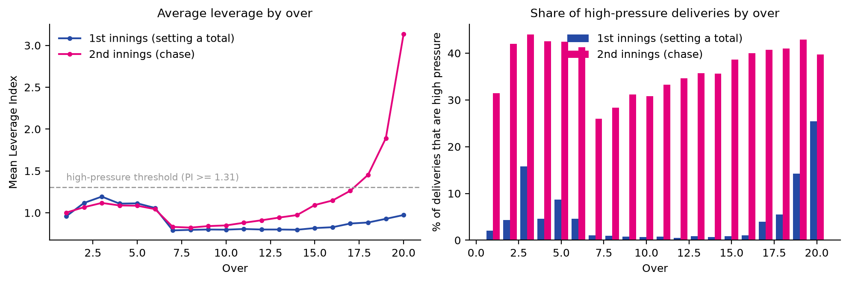
Figure 5. Average leverage and share of high-pressure deliveries by over, first innings against chase.

4. Measuring performance

4.1 Run value per delivery
Raw strike rates and economy rates mix skill with situation: death overs inflate scoring and powerplay fields change risk. We compare every delivery with what an average player would do in the identical situation:
- Batting: RV = (bat runs - expected bat runs) - wicket cost x (dismissed - expected dismissal probability). Non-striker run-outs are charged to the batter who is out.
- Bowling: RV = (expected runs conceded - runs conceded) + wicket cost x (wicket - expected wicket probability). Runs conceded include wides and no-balls; byes and leg-byes are not charged; run-outs are not credited to the bowler.
- Expected values come from gradient-boosted models that see only the match context (innings, balls left, wickets lost, score, runs needed, required rate, league and season), fitted out-of-fold by match. They are unbiased overall: actual/expected = 0.999 for bat runs, 0.997 for dismissals, 1.000 for runs conceded and 0.998 for wickets.
- Wicket cost is the expected runs an innings loses with one more wicket down at that point, from the same dynamic programme: on average 13.5 runs in the powerplay, 8.2 in the middle overs and 3.1 at the death. In chases it agrees with the run-equivalent implied by the win-probability table (Table 2).
Table 2. Cost of a wicket in a chase, IPL 2025 scoring environment. The run-expectancy cost used in the ratings tracks the win-probability equivalent; it slightly under-values wickets in the last two overs.
Balls left | Wickets lost | Runs needed | Chase win prob. | Wicket cost (run expectancy) | Wicket cost (win-prob. equivalent)
110 | 0 | 175 | 62% | 16.2 | 17.6
100 | 1 | 150 | 63% | 16.1 | 15.3
80 | 2 | 110 | 75% | 11.4 | 12.1
60 | 3 | 90 | 62% | 8.6 | 7.8
36 | 4 | 60 | 57% | 5.4 | 6.0
24 | 5 | 40 | 59% | 4.8 | 4.3
12 | 6 | 22 | 52% | 2.2 | 3.2
6 | 7 | 12 | 43% | 0.6 | 1.7

4.2 Adjusting for the opposition
A batter who faced weaker bowling should not get full credit for it. A ridge regression on every delivery estimates, at the same time, each player's value per ball and the quality of every opponent (bowlers faced by a batter; batters bowled to by a bowler). The ridge penalty shrinks small samples toward the league average and is chosen by match-grouped cross-validation (lambda = 650 for batting and 650 for bowling, in pseudo-deliveries). Switching the adjustment off changes the lists little (Section 7.3): it is a safeguard for players whose T20Is include associate nations rather than a driver of the rankings.

4.3 Pressure record against usual record
For every player we compute, on opponent-adjusted run value: the pressure record (runs above average per 100 high-pressure deliveries), the usual record (the same on all other deliveries) and their difference, with standard errors. This is the direct answer to how a player performs under pressure compared with his usual level, and it is reported for every player in the ranking tables.
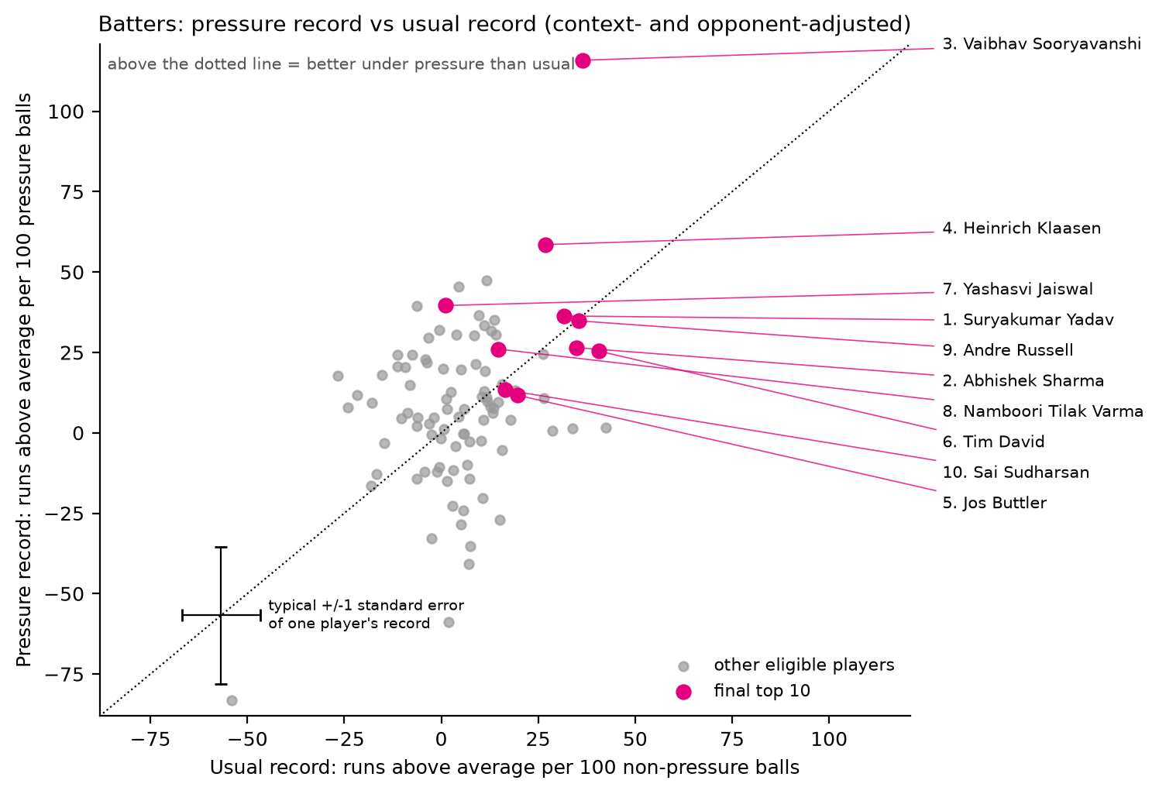
Figure 6. Batters: pressure record against usual record. Points above the dotted line did better under pressure. The cross shows the typical standard error of one player's record.

4.4 The clutch test: is rising to the occasion a repeatable skill?
Before ranking on pressure-specific numbers we tested whether they carry a signal that persists. Four checks, run separately for batters and bowlers:
- Split-half. We split the matches into two random halves (20 times) and correlate players' numbers between halves. The usual record predicts the other half's pressure record better (r = 0.24 batting, 0.21 bowling) than the pressure record itself does (0.13, 0.08). Once the usual record is known, the pressure record adds almost nothing (partial r = 0.07, 0.05). The rise or dip (pressure minus usual) does not repeat at all (r = +0.02, +0.01).
- Over time. Matches before July 2024 against matches after: the rise or dip correlates -0.26 (batting) and -0.06 (bowling).
- Prediction. We added player-by-pressure terms to the ridge model and predicted held-out high-pressure deliveries: for batters, only the most heavily penalised version helps, by 0.0000% of the variance, and every less-penalised version predicts worse; for bowlers, only the most heavily penalised version helps, by 0.0005% of the variance, and every less-penalised version predicts worse.
- Noise check. Among eligible batters, pressure-minus-usual differences spread by SD 24.0 runs per 100 balls, and sampling noise alone accounts for 23.7 (root-mean-square standard error). The leftover true spread (estimated 3.6) cannot be told apart from zero (z = +0.2). 4 batters sit more than two standard errors from zero, where chance alone gives 4.4. Among eligible bowlers, pressure-minus-usual differences spread by SD 23.9 runs per 100 balls, and sampling noise alone accounts for 21.9 (root-mean-square standard error). The leftover true spread (estimated 9.5) cannot be told apart from zero (z = +1.3). 5 bowlers sit more than two standard errors from zero, where chance alone gives 4.4.
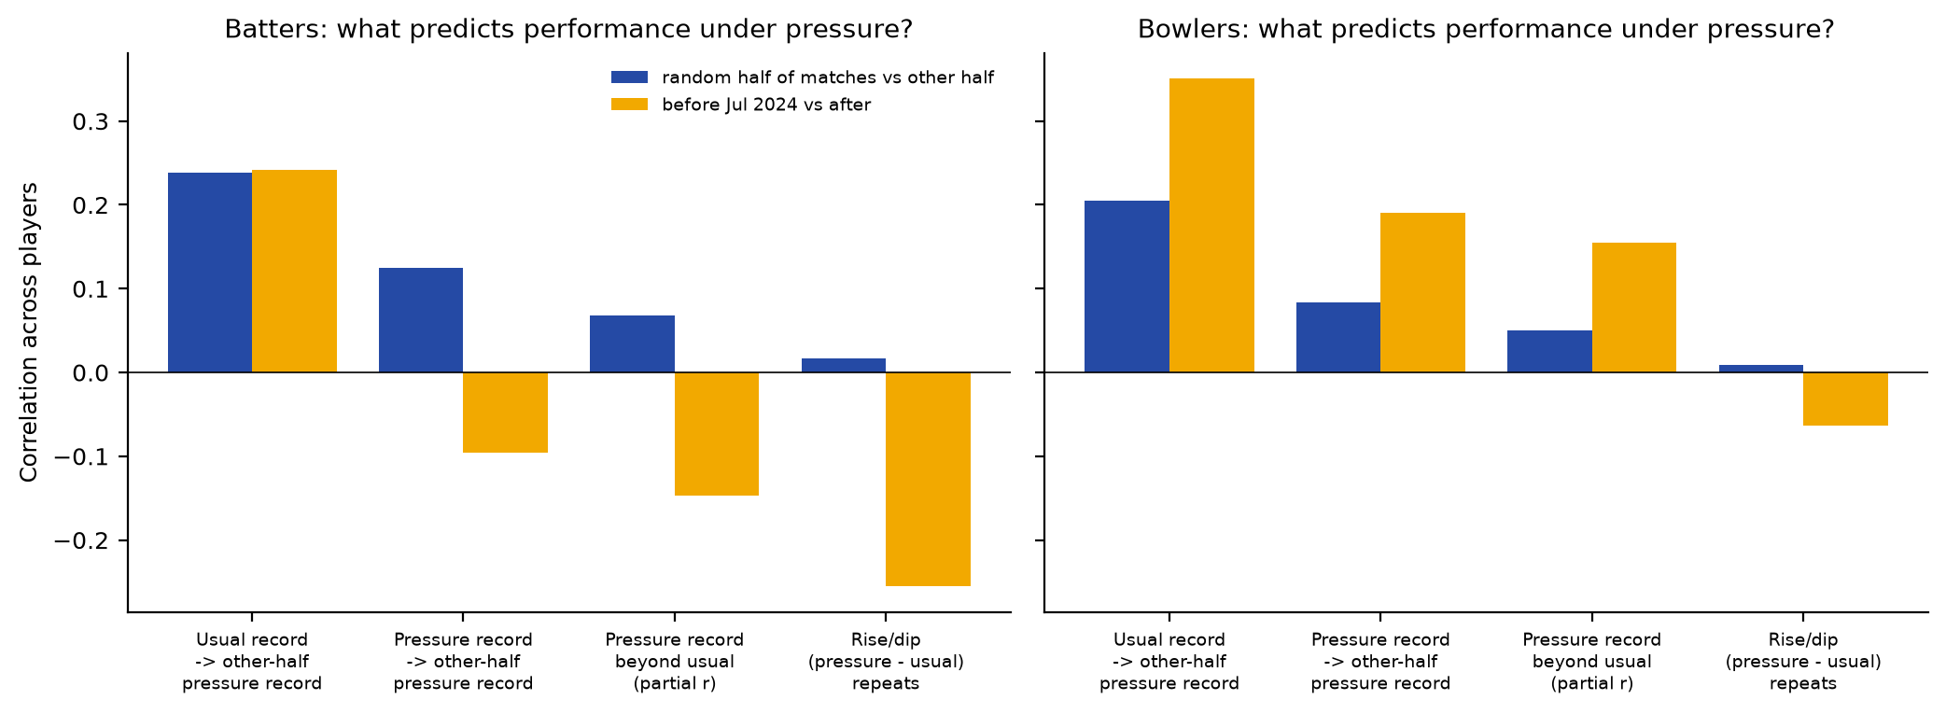
Figure 7. What predicts a player's performance under pressure in unseen matches? Mostly his all-situation level.
What this means for the ranking. Ranking on pressure-only numbers would mostly reward luck. An eligible player typically has about 194 (batters) or 225 (bowlers) pressure deliveries, so his pressure record has a standard error of about 21 runs per 100 balls (19 for bowlers). Across eligible batters, pressure records spread by SD 25 runs per 100 balls, of which sampling noise accounts for 21, leaving a true spread of about 14; for bowlers the figures are 23, 19 and 12. Only about 30% (batters) and 29% (bowlers) of the variation in pressure records reflects real differences between players, and the tests above show that those differences mostly mirror the players' general level: what the pressure record adds beyond it is small and inconsistent (partial r between -0.15 and +0.15 across the four comparisons). The best estimate of how a player will perform in the next high-pressure situation is his opponent-adjusted value per ball across all situations. We use that as the level component and keep the pressure-specific evidence where it is measurably informative: eligibility requires a body of pressure work, and 40% of the score is consistency in pressure innings.

4.5 Consistency across pressure innings
A pressure innings (batting) is a match in which the player faced at least 4 high-pressure deliveries; a pressure spell (bowling) needs 6. The innings is a success if the player's opponent-adjusted run value over those deliveries is positive, that is, he beat what an average player would have done. Success rates are shrunk toward the league rate with an empirical-Bayes beta-binomial prior whose strength is estimated from the data (24 pseudo-innings for batters around 53%, 139 for bowlers around 48%). Consistency is the most repeatable pressure-specific measure we found (split-half r = 0.17 batting, 0.12 bowling).

4.6 Final score
Score = 0.6 x level + 0.4 x consistency, where each component is the shrunk estimate divided by the estimated true spread between players. Dividing by the true spread rather than taking z-scores keeps the shrinkage: a player with little evidence stays near average instead of being stretched back out. Weighting by split-half reliability alone (0.40 against 0.17 for batters, 0.34 against 0.12 for bowlers) would give roughly 70/30; we use 60/40 because the brief asks explicitly who delivers most consistently. We then resample matches 10,000 times (five independent runs of 2,000), recompute every component each time, and rank on score minus one bootstrap standard error. Players with thin or volatile records drop a few places; established players keep theirs.

5. Fair comparisons
- Sample size and eligibility. At least 120 high-pressure deliveries (20 overs) and 10 pressure innings or spells. Above that floor, ridge and empirical-Bayes shrinkage handle sample size, and the bootstrap penalty favours larger bodies of evidence.
- Match context. Expected values condition on innings, balls left, wickets lost, score, runs needed, required rate and the league-season scoring rate, so a death-over finisher is compared with what an average batter does at the death, and an opener with what an average batter does in the powerplay.
- Opposition. Opponent quality is estimated jointly with player value (Section 4.2).
- IPL and T20I. Both are pooled, because the model already adjusts for scoring environment and opponent quality; T20Is against associate nations count, but weak opposition earns less credit. An IPL-only version of the ranking is in Section 7.
- Role. Openers, finishers, powerplay and death bowlers are all measured against the average player in the same situations, so no role is favoured by construction.

6. Results: the top 10s and the evidence

6.1 Batters
Table 3. Top-10 batters. Records and expected value are runs above an average batter per 100 balls, context- and opponent-adjusted. 'Beat exp.' = pressure innings with positive run value. Strike rates use balls faced; 'Press. deliveries' (used for eligibility) also counts the rare dismissal off a wide or as non-striker.
# | Batter | Team | Press. deliveries | Press. inns (beat exp.) | SR press. / usual | Avg press. | Press. / usual record | Expected value /100 | P(top 10)
1 | Suryakumar Yadav | Mumbai Indians / India | 455 | 22/32 | 171 / 165 | 35.5 | +36 / +32 | +31.5 | 95%
2 | Abhishek Sharma | Sunrisers Hyderabad / India | 469 | 25/37 | 190 / 185 | 31.9 | +26 / +35 | +30.7 | 87%
3 | Vaibhav Sooryavanshi | Rajasthan Royals / India | 172 | 12/15 | 260 / 202 | 74.7 | +116 / +36 | +31.2 | 83%
4 | Heinrich Klaasen | Sunrisers Hyderabad / South Africa | 188 | 12/16 | 195 / 162 | 40.7 | +59 / +27 | +25.8 | 79%
5 | Jos Buttler | Gujarat Titans / England | 515 | 27/36 | 161 / 154 | 33.2 | +12 / +20 | +20.0 | 64%
6 | Tim David | Royal Challengers Bengaluru / Australia | 282 | 15/26 | 185 / 175 | 26.1 | +25 / +41 | +28.4 | 65%
7 | Yashasvi Jaiswal | Rajasthan Royals / India | 492 | 26/30 | 179 / 148 | 46.4 | +40 / +1 | +12.9 | 49%
8 | Namboori Tilak Varma | Mumbai Indians / India | 597 | 25/37 | 150 / 142 | 37.2 | +26 / +15 | +18.8 | 40%
9 | Andre Russell | Kolkata Knight Riders / West Indies | 141 | 10/14 | 178 / 169 | 22.8 | +35 / +36 | +22.2 | 49%
10 | Sai Sudharsan | Gujarat Titans / India | 395 | 16/21 | 148 / 149 | 48.8 | +13 / +16 | +16.0 | 29%

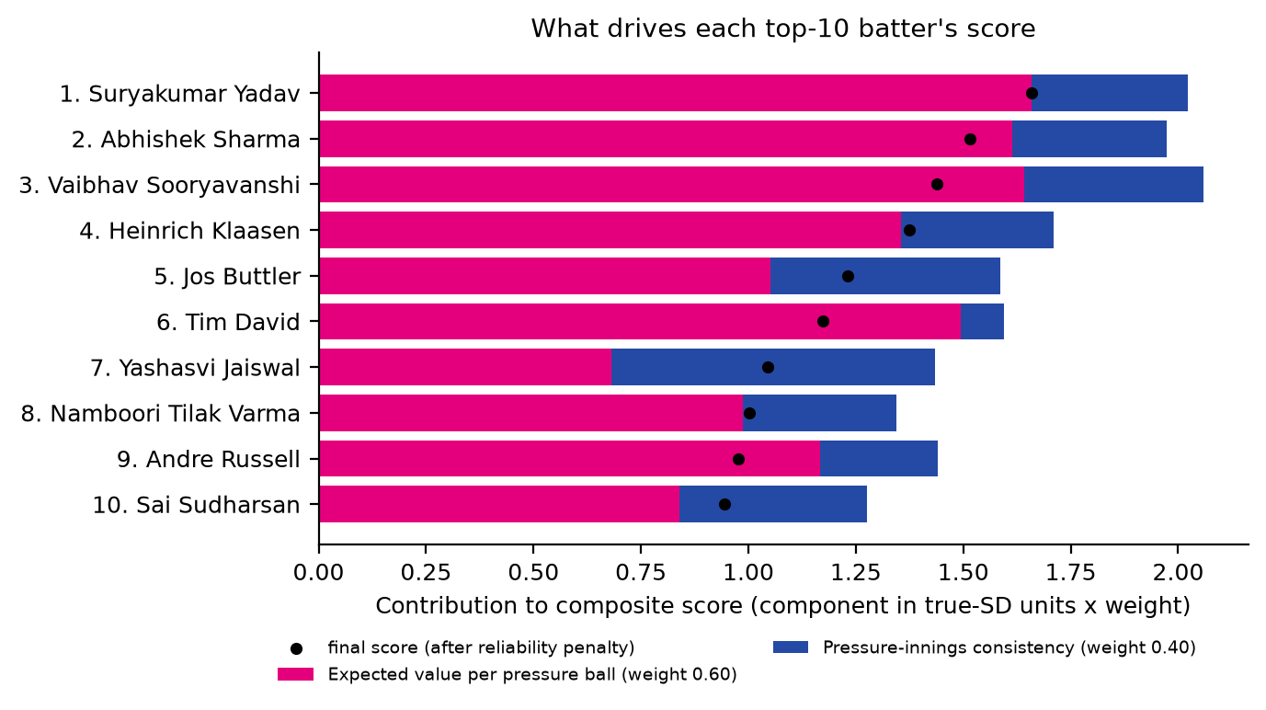
Figure 8. What drives each batter's score.
- 1. Suryakumar Yadav. Expected value +31.5 runs per 100 balls; beat the expectation in 22/32 pressure innings; under pressure he struck at 171 (165 otherwise) and averaged 35.5. Pressure record +36 against +32 usually (455 pressure balls).
- 2. Abhishek Sharma. Expected value +30.7 runs per 100 balls; beat the expectation in 25/37 pressure innings; under pressure he struck at 190 (185 otherwise) and averaged 31.9. Pressure record +26 against +35 usually (469 pressure balls).
- 3. Vaibhav Sooryavanshi. Expected value +31.2 runs per 100 balls; beat the expectation in 12/15 pressure innings; under pressure he struck at 260 (202 otherwise) and averaged 74.7. Pressure record +116 against +36 usually (172 pressure balls).
- 4. Heinrich Klaasen. Expected value +25.8 runs per 100 balls; beat the expectation in 12/16 pressure innings; under pressure he struck at 195 (162 otherwise) and averaged 40.7. Pressure record +59 against +27 usually (188 pressure balls).
- 5. Jos Buttler. Expected value +20.0 runs per 100 balls; beat the expectation in 27/36 pressure innings; under pressure he struck at 161 (154 otherwise) and averaged 33.2. Pressure record +12 against +20 usually (515 pressure balls).
- 6. Tim David. Expected value +28.4 runs per 100 balls; beat the expectation in 15/26 pressure innings; under pressure he struck at 185 (175 otherwise) and averaged 26.1. Pressure record +25 against +41 usually (282 pressure balls).
- 7. Yashasvi Jaiswal. Expected value +12.9 runs per 100 balls; beat the expectation in 26/30 pressure innings; under pressure he struck at 179 (148 otherwise) and averaged 46.4. Pressure record +40 against +1 usually (492 pressure balls).
- 8. Namboori Tilak Varma. Expected value +18.8 runs per 100 balls; beat the expectation in 25/37 pressure innings; under pressure he struck at 150 (142 otherwise) and averaged 37.2. Pressure record +26 against +15 usually (597 pressure balls).
- 9. Andre Russell. Expected value +22.2 runs per 100 balls; beat the expectation in 10/14 pressure innings; under pressure he struck at 178 (169 otherwise) and averaged 22.8. Pressure record +35 against +36 usually (141 pressure balls).
- 10. Sai Sudharsan. Expected value +16.0 runs per 100 balls; beat the expectation in 16/21 pressure innings; under pressure he struck at 148 (149 otherwise) and averaged 48.8. Pressure record +13 against +16 usually (395 pressure balls).
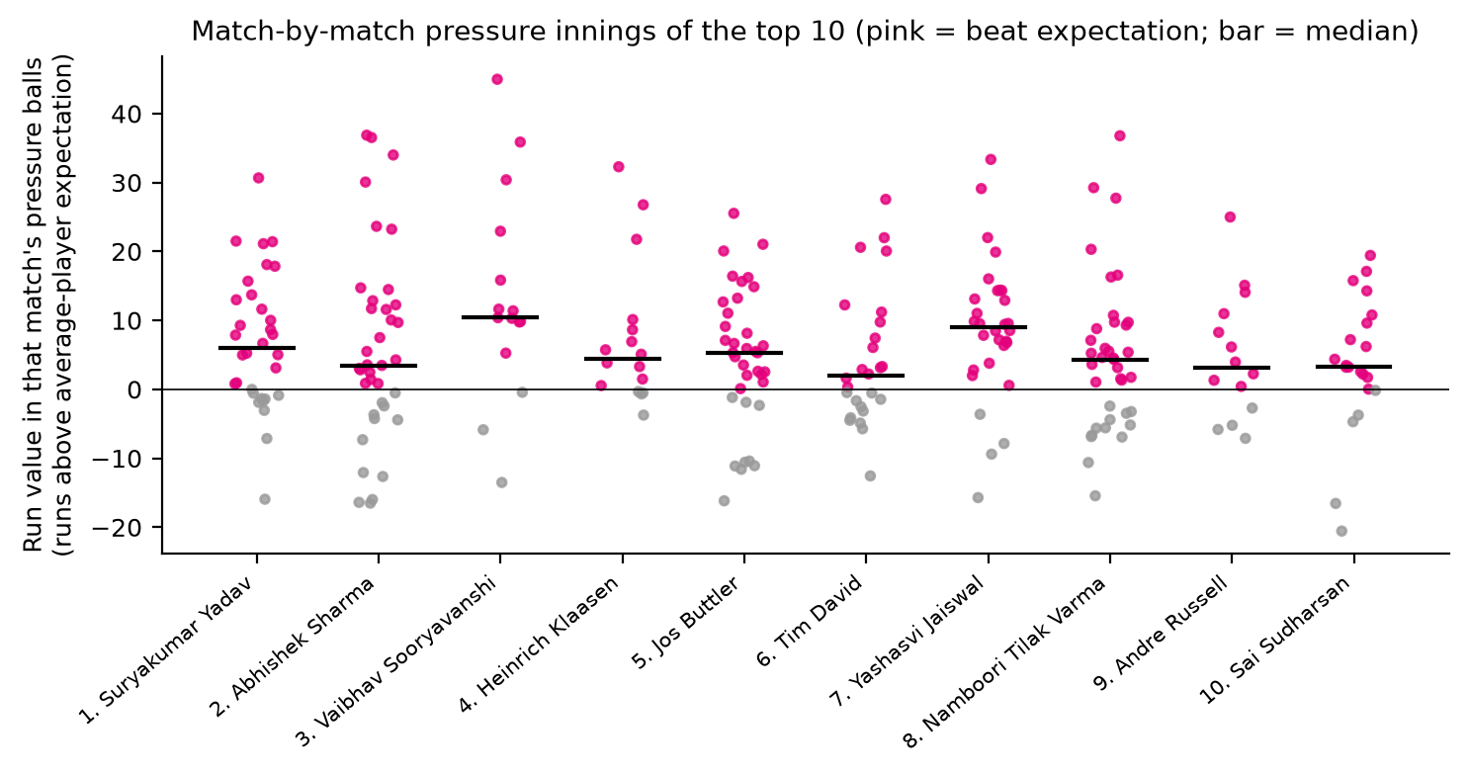
Figure 9. Every pressure innings of the top-10 batters.

6.2 Bowlers
Table 4. Top-10 bowlers. Records and expected value are runs saved against an average bowler per 100 balls, context- and opponent-adjusted. 'Press. deliveries' includes wides and no-balls; economy rates and balls per wicket use legal balls.
# | Bowler | Team | Press. deliveries | Press. spells (beat exp.) | Econ press. / usual | Wkts press. (balls/wkt) | Press. / usual record | Expected value /100 | P(top 10)
1 | Varun Chakravarthy | Kolkata Knight Riders / India | 363 | 15/24 | 8.24 / 7.92 | 22 (16) | +13 / +27 | +21.0 | 83%
2 | Kuldeep Yadav | Delhi Capitals / India | 341 | 16/21 | 7.61 / 8.10 | 22 (15) | +32 / +19 | +18.0 | 80%
3 | Sunil Narine | Kolkata Knight Riders | 279 | 13/21 | 6.76 / 6.90 | 14 (20) | +32 / +22 | +18.9 | 72%
4 | Jasprit Bumrah | Mumbai Indians / India | 373 | 10/22 | 8.04 / 6.95 | 14 (26) | +11 / +30 | +21.4 | 62%
5 | Josh Hazlewood | Royal Challengers Bengaluru / Australia | 392 | 18/27 | 8.61 / 8.17 | 34 (11) | +35 / +16 | +16.6 | 65%
6 | Matheesha Pathirana | Kolkata Knight Riders / Sri Lanka | 254 | 11/15 | 9.76 / 8.43 | 19 (12) | +26 / +17 | +14.5 | 52%
7 | Rashid Khan | Gujarat Titans / Afghanistan | 486 | 18/31 | 7.40 / 7.41 | 29 (17) | +14 / +16 | +15.4 | 47%
8 | Krunal Pandya | Royal Challengers Bengaluru | 307 | 15/21 | 7.28 / 7.93 | 19 (16) | +27 / +9 | +11.1 | 35%
9 | Bhuvneshwar Kumar | Royal Challengers Bengaluru / India | 473 | 16/31 | 9.26 / 7.99 | 24 (19) | +20 / +15 | +15.2 | 38%
10 | Noor Ahmad | Chennai Super Kings / Afghanistan | 284 | 5/15 | 9.08 / 7.71 | 15 (17) | +8 / +26 | +18.1 | 34%

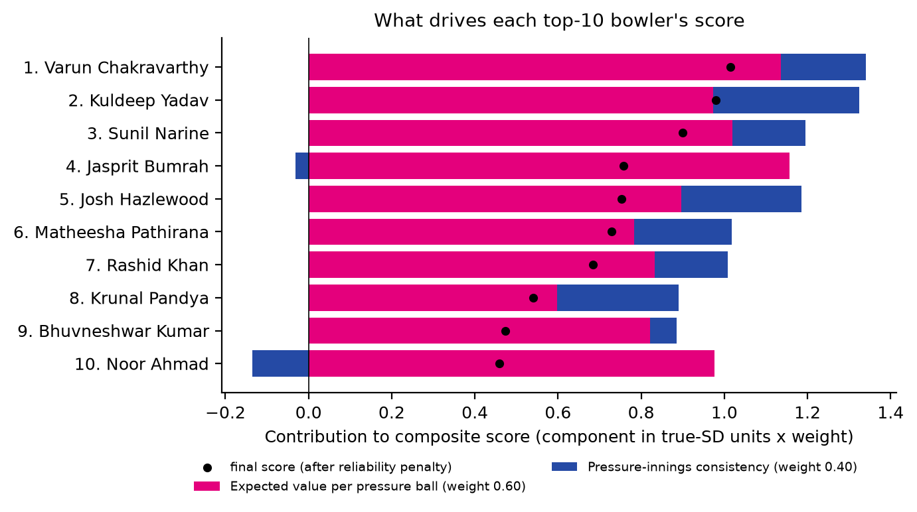
Figure 10. What drives each bowler's score.
- 1. Varun Chakravarthy. Expected value +21.0 runs saved per 100 balls; beat the expectation in 15/24 pressure spells; economy 8.24 under pressure (7.92 otherwise) with 22 wickets, one every 16 balls. Pressure record +13 against +27 usually.
- 2. Kuldeep Yadav. Expected value +18.0 runs saved per 100 balls; beat the expectation in 16/21 pressure spells; economy 7.61 under pressure (8.10 otherwise) with 22 wickets, one every 15 balls. Pressure record +32 against +19 usually.
- 3. Sunil Narine. Expected value +18.9 runs saved per 100 balls; beat the expectation in 13/21 pressure spells; economy 6.76 under pressure (6.90 otherwise) with 14 wickets, one every 20 balls. Pressure record +32 against +22 usually.
- 4. Jasprit Bumrah. Expected value +21.4 runs saved per 100 balls; beat the expectation in 10/22 pressure spells; economy 8.04 under pressure (6.95 otherwise) with 14 wickets, one every 26 balls. Pressure record +11 against +30 usually.
- 5. Josh Hazlewood. Expected value +16.6 runs saved per 100 balls; beat the expectation in 18/27 pressure spells; economy 8.61 under pressure (8.17 otherwise) with 34 wickets, one every 11 balls. Pressure record +35 against +16 usually.
- 6. Matheesha Pathirana. Expected value +14.5 runs saved per 100 balls; beat the expectation in 11/15 pressure spells; economy 9.76 under pressure (8.43 otherwise) with 19 wickets, one every 12 balls. Pressure record +26 against +17 usually.
- 7. Rashid Khan. Expected value +15.4 runs saved per 100 balls; beat the expectation in 18/31 pressure spells; economy 7.40 under pressure (7.41 otherwise) with 29 wickets, one every 17 balls. Pressure record +14 against +16 usually.
- 8. Krunal Pandya. Expected value +11.1 runs saved per 100 balls; beat the expectation in 15/21 pressure spells; economy 7.28 under pressure (7.93 otherwise) with 19 wickets, one every 16 balls. Pressure record +27 against +9 usually.
- 9. Bhuvneshwar Kumar. Expected value +15.2 runs saved per 100 balls; beat the expectation in 16/31 pressure spells; economy 9.26 under pressure (7.99 otherwise) with 24 wickets, one every 19 balls. Pressure record +20 against +15 usually.
- 10. Noor Ahmad. Expected value +18.1 runs saved per 100 balls; beat the expectation in 5/15 pressure spells; economy 9.08 under pressure (7.71 otherwise) with 15 wickets, one every 17 balls. Pressure record +8 against +26 usually.
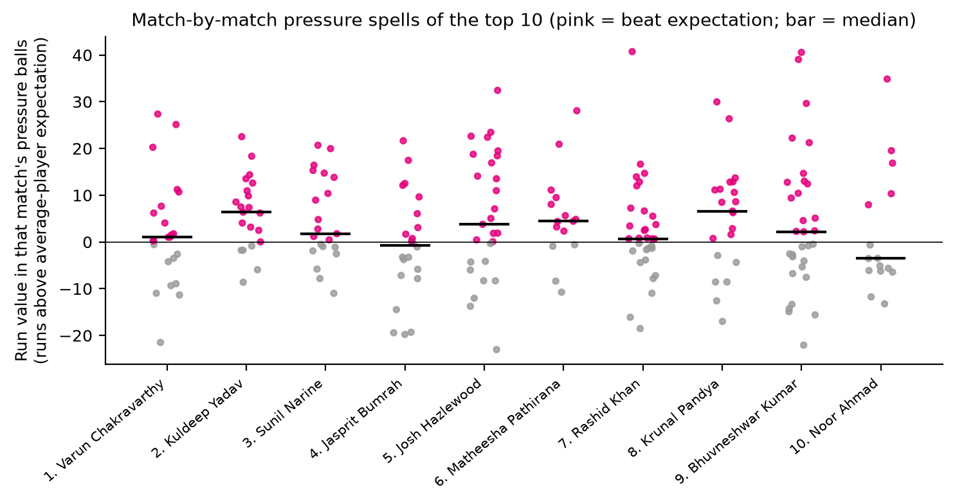
Figure 11. Every pressure spell of the top-10 bowlers.
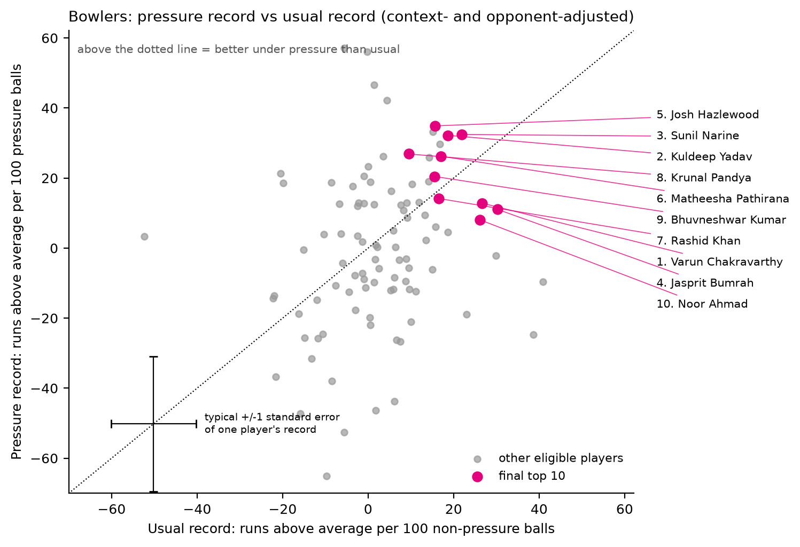
Figure 12. Bowlers: pressure record against usual record.

6.3 Well-known players outside the top 10
- Virat Kohli ranks 13 of 96: expected value +14.1, beat the expectation in 20/28 pressure innings, pressure record +21 against +9 usually (chance of a top-10 place 17%).
- Phil Salt ranks 12 of 96: expected value +21.1, beat the expectation in 16/26 pressure innings, pressure record +11 against +27 usually (chance of a top-10 place 36%).
- Nicholas Pooran ranks 20 of 96: expected value +17.5, beat the expectation in 16/27 pressure innings, pressure record +30 against +14 usually (chance of a top-10 place 17%).
- Pathum Nissanka ranks 16 of 96: expected value +11.9, beat the expectation in 24/33 pressure innings, pressure record +32 against 0 usually (chance of a top-10 place 19%).
- Rinku Singh ranks 17 of 96: expected value +13.3, beat the expectation in 10/13 pressure innings, pressure record +37 against +10 usually (chance of a top-10 place 13%).
- Mohammad Nawaz ranks 11 of 97: expected value +14.1, beat the expectation in 11/18 pressure spells, pressure record +30 against +17 usually (chance of a top-10 place 39%).
- Lockie Ferguson ranks 20 of 97: expected value +8.4, beat the expectation in 13/17 pressure spells, pressure record +56 against 0 usually (chance of a top-10 place 24%).
- Patrick Cummins ranks 16 of 97: expected value +5.8, beat the expectation in 15/17 pressure spells, pressure record +57 against -6 usually (chance of a top-10 place 22%).
- Axar Patel ranks 24 of 97: expected value +8.1, beat the expectation in 17/30 pressure spells, pressure record +26 against +4 usually (chance of a top-10 place 9%).
- Arshdeep Singh ranks 29 of 97: expected value +7.5, beat the expectation in 28/56 pressure spells, pressure record -6 against +10 usually (chance of a top-10 place 5%).
Several of these players have outstanding pressure records (Nissanka, Rinku Singh, Ferguson, Cummins). Section 4.4 shows why we do not rank on that alone: a pressure record built on 184-549 deliveries is too noisy to separate players, and it does not predict the next pressure situation better than the overall level.

7. Reliability and limitations

7.1 How repeatable is each measure?
Table 5. Correlation of each measure between two halves of the matches (average of 20 random splits; full-sample value by Spearman-Brown) and between the two periods. Typical overlap: 63 batters and 74 bowlers.
Measure | Batting split-half r | Batting full-sample | Bowling split-half r | Bowling full-sample | Batting pre/post Jul 2024 | Bowling pre/post Jul 2024
Expected value (all situations, opponent-adjusted) | +0.40 | +0.57 | +0.34 | +0.51 | +0.31 | +0.41
Pressure record only | +0.13 | +0.22 | +0.08 | +0.16 | -0.10 | +0.19
Usual record only | +0.34 | +0.50 | +0.31 | +0.47 | +0.21 | +0.34
Rise/dip (pressure minus usual) | +0.02 | +0.03 | +0.01 | +0.02 | -0.26 | -0.06
Pressure-innings consistency | +0.17 | +0.29 | +0.12 | +0.22 | +0.05 | +0.30

Expected value is the most repeatable measure, which is why it carries the level component. Consistency is less repeatable but positive in every test. The pressure-only record and the rise/dip are close to noise.

7.2 How certain are the ranks?
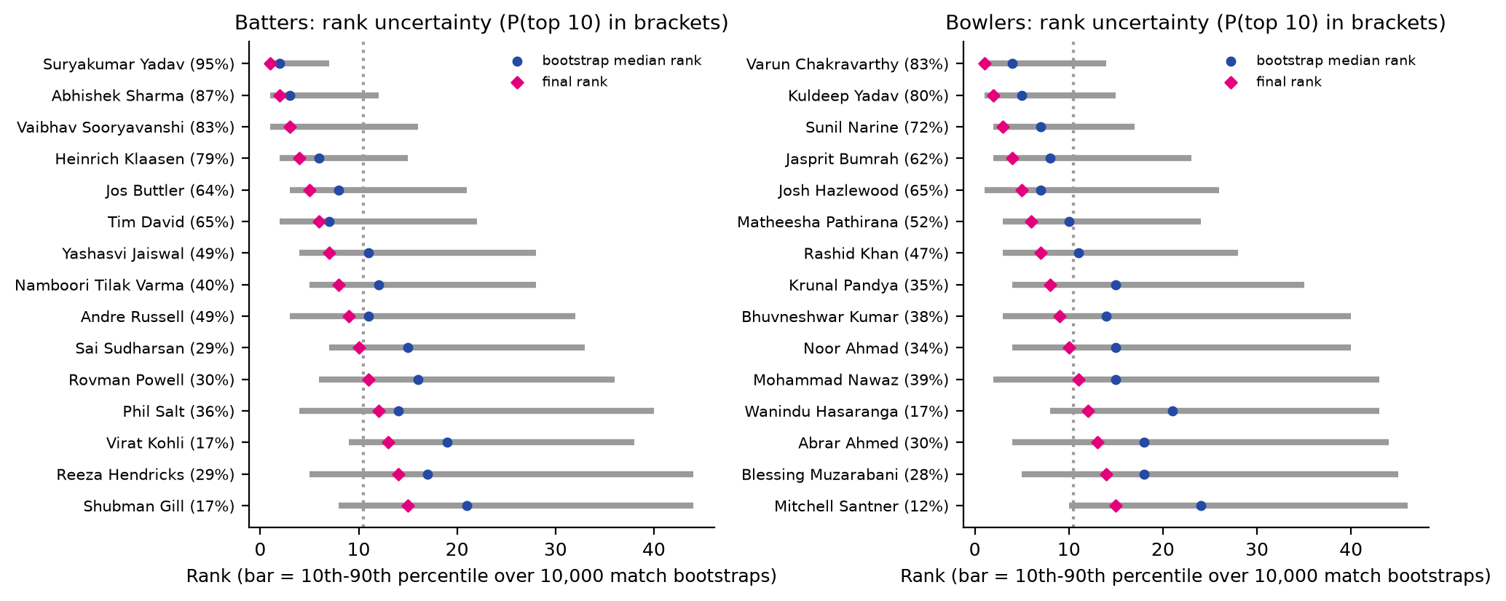
Figure 13. Rank intervals over 10,000 bootstrap resamples of matches, with each player's probability of a top-10 finish.
The top four batters (top-10 probability 79%-95%) and the top three bowlers (72%-83%) are the most secure selections. Ranks 5-10 sit inside overlapping intervals, so the order there is our best estimate rather than a certainty. The least secure players in the lists (Sai Sudharsan, 29%; Noor Ahmad, 34%) have about the same top-10 probability as the best-placed players outside them (Phil Salt, 36%; Mohammad Nawaz, 39%).
At the cut-off for batters, Sai Sudharsan (10th, reliability score 0.945) is ahead of Rovman Powell (11th, 0.834). Each of the 5 bootstrap runs of 2,000 resamples, taken on its own, picks the same ten batters, in the same order. At the cut-off for bowlers, Noor Ahmad (10th, reliability score 0.458) is ahead of Mohammad Nawaz (11th, 0.442). Mohammad Nawaz has the higher point score (0.908 against 0.842), but his record is less certain (bootstrap standard error 0.466 against 0.384), so the penalty puts him just below. Each of the 5 bootstrap runs of 2,000 resamples, taken on its own, picks the same ten bowlers; 3 of them order ranks 4-6 differently.

7.3 Do the lists depend on our choices?
Table 6. Each alternative re-runs the full rating (with its own bootstrap) and is compared with the main ranking over the players eligible in both.
Alternative | Top-10 overlap (bat) | Rank correlation (bat) | Top-10 overlap (bowl) | Rank correlation (bowl)
Top 30% of PI = pressure | 7 | 0.95 | 8 | 0.97
Top 15% of PI = pressure | 8 | 0.97 | 8 | 0.97
No knock-out multiplier | 10 | 0.99 | 8 | 0.99
Knock-out multiplier 1.5 | 9 | 0.99 | 9 | 0.99
Pressure ranked within each innings | 6 | 0.91 | 9 | 0.97
Weights: level only | 8 | 0.93 | 9 | 0.97
Weights: 50/50 | 10 | 0.99 | 8 | 0.99
Reward raw rise/dip (20% weight) | 8 | 0.91 | 7 | 0.91
Level = pressure-only record | 5 | 0.77 | 5 | 0.73
Level = 50/50 overall and pressure-only | 7 | 0.94 | 7 | 0.96
Level shrinkage penalty 450 | 10 | 1.00 | 9 | 1.00
Level shrinkage penalty 1000 | 9 | 1.00 | 10 | 1.00
No opponent adjustment | 9 | 0.99 | 8 | 0.99
No reliability penalty (point score) | 9 | 1.00 | 9 | 1.00
IPL deliveries only | 7 | 0.93 | 8 | 0.92

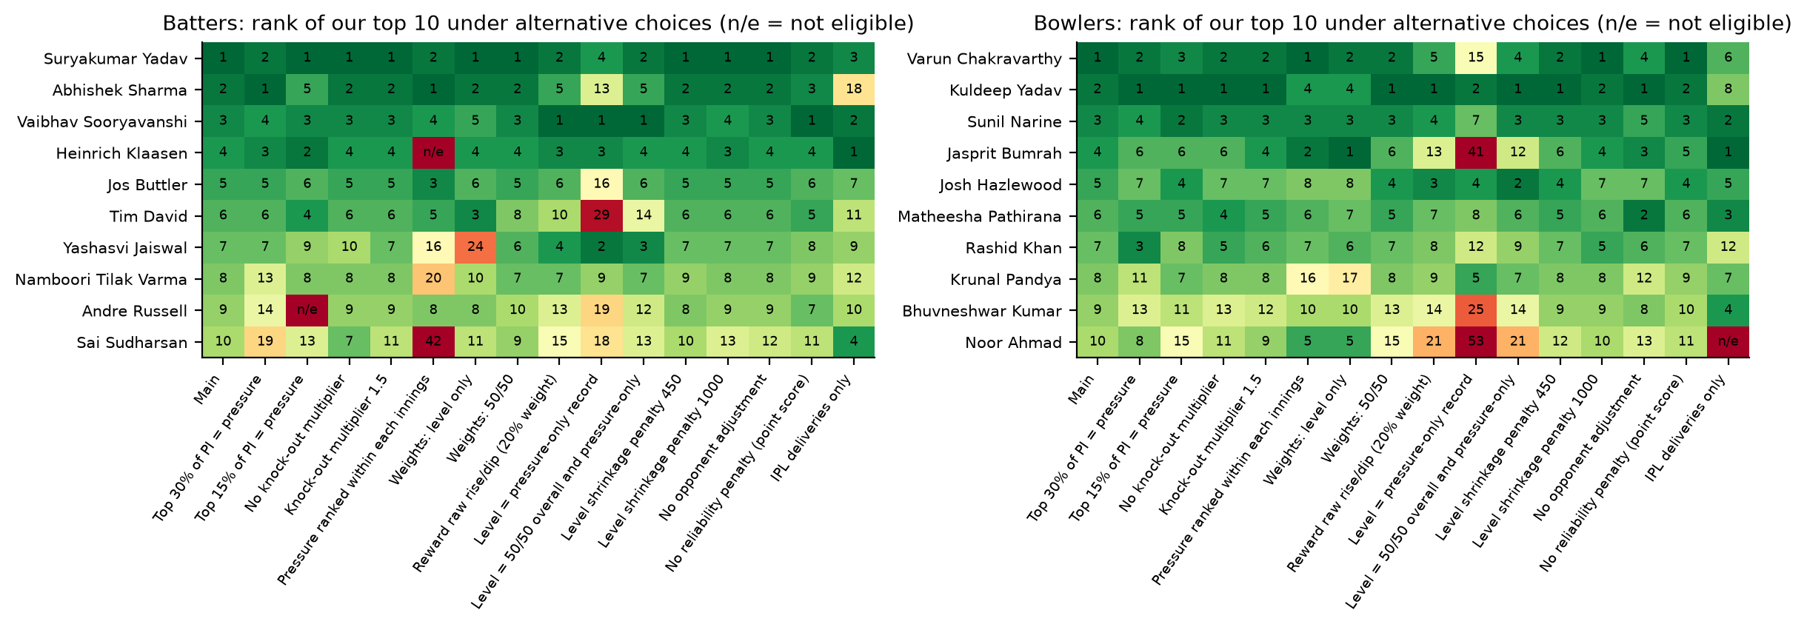
Figure 14. Rank of each top-10 player under every alternative (n/e = not eligible).
Choices about the pressure threshold, the knock-out multiplier, the weights, the shrinkage penalty, the opponent adjustment and the reliability penalty move individual players by a few places but leave most of each list intact: every one of them keeps at least 6 of the 10 batters and 7 of the 10 bowlers. The largest change comes from ranking on the pressure-only record (5/10 batters and 5/10 bowlers kept), which Section 4.4 shows is mostly noise.

7.4 Limitations
- Missing extras runs. Runs from byes, leg-byes and wides are inferred, not recorded. The rebuilt margin is exact in 63% of checkable matches and within 2 runs in 78%. Anchoring targets on results keeps late-chase states exact, but early-chase pressure carries a little noise.
- Team strength is not in the win probability. The model gives every side an average team's chance from a given scoreboard, so pressure in heavy mismatches (for example against associates) may be overstated. Opponent adjustment limits the effect on ratings.
- First-innings pressure is under-represented by design. Only 4.8% of first-innings deliveries are high pressure. Collapses while setting a total feel like pressure but move the result less than late chase deliveries do.
- Not modelled: venue and pitch, dew, batter-bowler type match-ups, fielding, and the indirect effect of a tight over on the bowler at the other end.
- Bowlers who build pressure but take few wickets score less, because run value counts the wickets an average bowler would have taken. Late-chase wickets are slightly under-valued (Table 2).
- Short careers. Vaibhav Sooryavanshi (172 pressure deliveries over two seasons) has the least certain score in the batting top 10 (bootstrap standard error 0.62, against 0.33-0.46 for the others); the reliability penalty moves him from first on point score to third.
- Clutch is not ruled out. We cannot detect a repeatable pressure skill in five seasons of data. A small effect could exist below what 124-811 pressure deliveries per player can reveal.

8. Reproducing the analysis
All code is in pressure_model/. With Python 3 and the packages in requirements.txt, one command rebuilds every table, figure and this report from the supplied CSV files (about 2-3 minutes on a laptop; random seed 42):
python pressure_model/run_all.py
Table 7. Pipeline steps
Step | What it does
prepare.py | Scoreboard state, extras reconstruction, targets
outcome_model.py | Ball-outcome model for an average player
win_probability.py | Win-probability tables, Leverage and Pressure Index
player_value.py | Expected values and run value per delivery
ratings.py | Ratings, consistency, clutch test, bootstrap, sensitivity
analysis.py | Pressure-definition evidence
figures.py | Charts
report.py | This report (DOCX and Markdown)

Table 8. Parameters (pressure_model/config.py)
Parameter | Value
High-pressure threshold | top 20% of PI (PI >= 1.31)
Knock-out multiplier | 1.2
Eligibility (batters and bowlers) | >= 120 pressure deliveries and >= 10 pressure innings
Pressure innings / spell | >= 4 (bat) / >= 6 (bowl) pressure deliveries in the match
Score weights | level 0.6, consistency 0.4
Reliability penalty | 1.0 bootstrap standard error
Bootstrap | 10,000 resamples of matches (5 runs of 2,000, seeds 42, 1, 2, 3, 4)
Ridge penalty, opponent model | 650 (bat), 650 (bowl), by cross-validation
Ridge penalty, pressure / usual records | 300 / 750 (bat), 2500 / 1500 (bowl), by cross-validation

Appendix A. Ranks 11-25
Table 9. Batters ranked 11-25
# | Player | Team | Press. deliveries | Press. inns (beat exp.) | Press. / usual record | Expected value /100 | P(top 10)
11 | Rovman Powell | Kolkata Knight Riders / West Indies | 279 | 19/26 | +34 / +11 | +15.2 | 30%
12 | Phil Salt | Royal Challengers Bengaluru / England | 359 | 16/26 | +11 / +27 | +21.1 | 36%
13 | Virat Kohli | Royal Challengers Bengaluru / India | 521 | 20/28 | +21 / +9 | +14.1 | 17%
14 | Reeza Hendricks | South Africa | 186 | 8/11 | +24 / +26 | +18.1 | 29%
15 | Shubman Gill | Gujarat Titans / India | 639 | 26/39 | +10 / +12 | +14.3 | 17%
16 | Pathum Nissanka | Delhi Capitals / Sri Lanka | 549 | 24/33 | +32 / 0 | +11.9 | 19%
17 | Rinku Singh | Kolkata Knight Riders / India | 184 | 10/13 | +37 / +10 | +13.3 | 13%
18 | Rashid Khan | Gujarat Titans / Afghanistan | 130 | 10/11 | +47 / +12 | +11.9 | 20%
19 | Shreyas Iyer | Punjab Kings / India | 374 | 14/20 | +30 / +8 | +14.3 | 17%
20 | Nicholas Pooran | Lucknow Super Giants / West Indies | 324 | 16/27 | +30 / +14 | +17.5 | 17%
21 | Tristan Stubbs | Delhi Capitals / South Africa | 276 | 16/22 | +9 / +15 | +12.3 | 14%
22 | Mitchell Marsh | Lucknow Super Giants / Australia | 418 | 15/26 | +13 / +19 | +17.4 | 13%
23 | Rajat Patidar | Royal Challengers Bengaluru | 129 | 6/13 | +1 / +34 | +21.0 | 16%
24 | Fakhar Zaman | Pakistan | 200 | 13/14 | +30 / -3 | +6.1 | 7%
25 | Shivam Dube | Chennai Super Kings / India | 272 | 12/19 | +6 / +13 | +13.0 | 5%

Table 10. Bowlers ranked 11-25
# | Player | Team | Press. deliveries | Press. spells (beat exp.) | Press. / usual record | Expected value /100 | P(top 10)
11 | Mohammad Nawaz | Pakistan | 264 | 11/18 | +30 / +17 | +14.1 | 39%
12 | Wanindu Hasaranga | Rajasthan Royals / Sri Lanka | 400 | 11/25 | +5 / +19 | +14.3 | 17%
13 | Abrar Ahmed | Pakistan | 189 | 9/14 | +33 / +15 | +12.3 | 30%
14 | Blessing Muzarabani | Kolkata Knight Riders / Zimbabwe | 226 | 8/16 | -25 / +39 | +14.0 | 28%
15 | Mitchell Santner | Mumbai Indians / New Zealand | 230 | 9/19 | +19 / +14 | +12.9 | 12%
16 | Patrick Cummins | Sunrisers Hyderabad / Australia | 232 | 15/17 | +57 / -6 | +5.8 | 22%
17 | Jofra Archer | Rajasthan Royals / England | 297 | 12/19 | +42 / +4 | +10.7 | 23%
18 | Jacob Duffy | Royal Challengers Bengaluru / New Zealand | 224 | 9/18 | -2 / +30 | +14.9 | 34%
19 | Nathan Ellis | Chennai Super Kings / Australia | 222 | 5/10 | +26 / +14 | +11.9 | 12%
20 | Lockie Ferguson | Punjab Kings / New Zealand | 211 | 13/17 | +56 / 0 | +8.4 | 24%
21 | Mustafizur Rahman | Delhi Capitals / Bangladesh | 336 | 14/26 | +2 / +14 | +10.2 | 10%
22 | Kagiso Rabada | Gujarat Titans / South Africa | 287 | 9/16 | +18 / +10 | +10.4 | 13%
23 | Mohsin Khan | Lucknow Super Giants | 209 | 7/15 | -10 / +41 | +14.5 | 30%
24 | Axar Patel | Delhi Capitals / India | 427 | 17/30 | +26 / +4 | +8.1 | 9%
25 | Mujeeb Ur Rahman | Mumbai Indians / Afghanistan | 288 | 11/19 | +13 / +12 | +8.8 | 11%

Appendix B. Glossary
- Win probability (WP): chance that the batting side wins from the current scoreboard, for average teams.
- Leverage Index (LI): expected absolute change in WP on this delivery, divided by the average over all deliveries.
- Pressure Index (PI): LI x 1.2 in knock-out matches. High pressure = top 20% of PI.
- Run value (RV): runs above (batting) or saved against (bowling) an average player in the same situation, with dismissals valued at their run cost.
- Pressure record / usual record: opponent-adjusted RV per 100 balls on high-pressure / other deliveries.
- Expected value: opponent-adjusted RV per 100 balls over all deliveries, shrunk for sample size; our estimate of value per high-pressure delivery.
- Consistency: share of pressure innings or spells with positive opponent-adjusted RV, shrunk toward the league rate.
- P(top 10): share of 10,000 match bootstraps in which the player finishes in the top 10.

