1. Initialize a VehicleManager object named 'manager'.

2. Add vehicles to 'manager' using addVehicle function:

a. Add a Car with brand "BENZ", model name "Model1", engine capacity 1500, price $20000, availability true, and color "Red".

b. Add a Car with brand "BMW", model name "Model2", engine capacity 1800, price $25000, availability true, and color "Blue".

c. Add a Car with brand "LEXUS", model name "Model3", engine capacity 1700, price $22000, availability true, and color "Black".

3. Display all car brands using displayAllBrands function.

4. Prompt user to enter a car brand and store the input in 'brand'.

5. Display models and count for the entered 'brand' using displayModelsAndCount function.

6. Prompt user to enter a model name and store the input in 'modelName'.

7. Display details of the entered 'modelName' using displayModelDetails function.

8. Sell the vehicle with 'modelName' using sellVehicle function.

9. Update details of the vehicle with 'modelName' using updateVehicleDetails function.

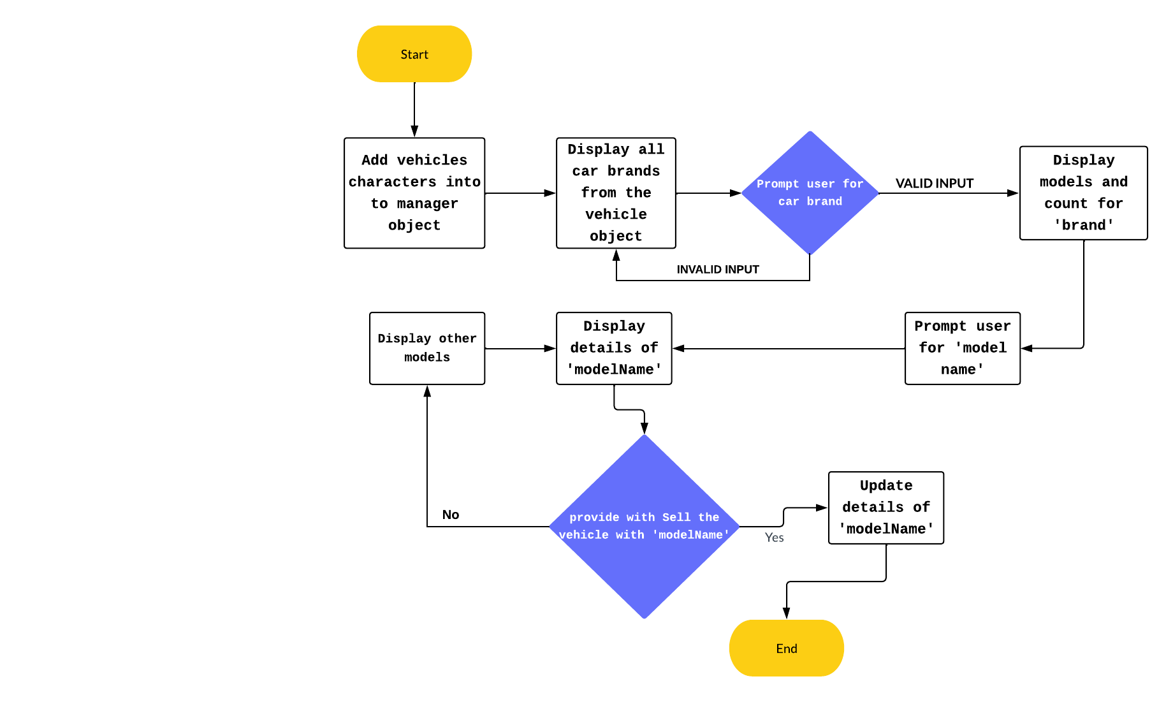 FLOW DIAGRAM