

**PRIYADARSHINI ENGINEERING COLLEGE**

**Public Transport Efficiency Analysis**

**Abstract:**

* Transit authorities have been searching for the indicators to measure transit service quality and the key factors to attract citizens who do not prefer public transport.
* The aim of this study is to propose metrics to improve transit service.
* The focus is on bus transportation since it is more flexible compared to rail transportation and widely preferred by the masses in cities.

**`1.Introduction:**

* The subject of smart cities is a very new research area in the world.
* Transit authorities have been searching for the indicators to measure transit service quality and the key factors to attract citizens who do not prefer public transport.
* Inputs are 1-Physical measure (such as number of vehicles, seat capacity, drivers and so on); 2-Capital expenses; 3- Operating expenses.
* Outputs are 1-Service supply (such as vehicles travelled kilometres, vehicles hours of operations, seats offered hours of operations and so on); 2-Service Consumption (such as passengers travelled kilometres, number of passengers, number of trips and so on); 3-Revenue (such as fare revenues and total revenue).

**2.Methodology**:

* In this study, the focus is on bus transportation,since it is more flexible compared to rail transportation and widely preferred by the masses in cities.
* The primary data source of this study comes from the Department of Transportation for the City of Antalya.
* We load the complete boarding data of December 18,2019 which is a standard weekday.
* The data set formed consist of 305 lines and 608 routes. A route consist of a sequential list of bus stops in either forward or backward (return) directions.
* Each line has opposite two directions except two lines which are omitted in analysis.
* On December 18, 2019, a total of 7347 trips (single direction services) were made and with these trips a total of 381962 passengers were carried.
* However, in this study we slowly focus on the route efficiency.

**2.1 Traversal Route Evaluation:**

* When lines are designed they often start from an origin and return back to where it start.
* Each line may have consider to have 2 routes, a forward and backward route.
* Typically, when trips are completed at the end of the day. the number of passengers at the forward and backward routes are nearly equal.

**2.2 Variance-Area Curves for Route Boarding**

* Simply put, the between-area variance curves are obtained by calculating the variances of gray scale pixel values while varying rectangular unit areas within the 2-D gray scale matrix.
* This 2-D gray scale matrix is constructed from the heatmap image

**2.3 Bus Stop Analysis** :

* Analysis of bus stops can be comprehensive.
* Location of bus stops depends on demand nearby. For the purpose of this study, we do not suggest new bus stops but rather evaluate the boarding demand on existing routes.
* – Bus Stop Id / Name
* – Boarding Count
* – Route Count
* – Service Count
* – Average Boarding Per Route Arrival at Stop
* – Average Boarding Per Bus Service at Stop

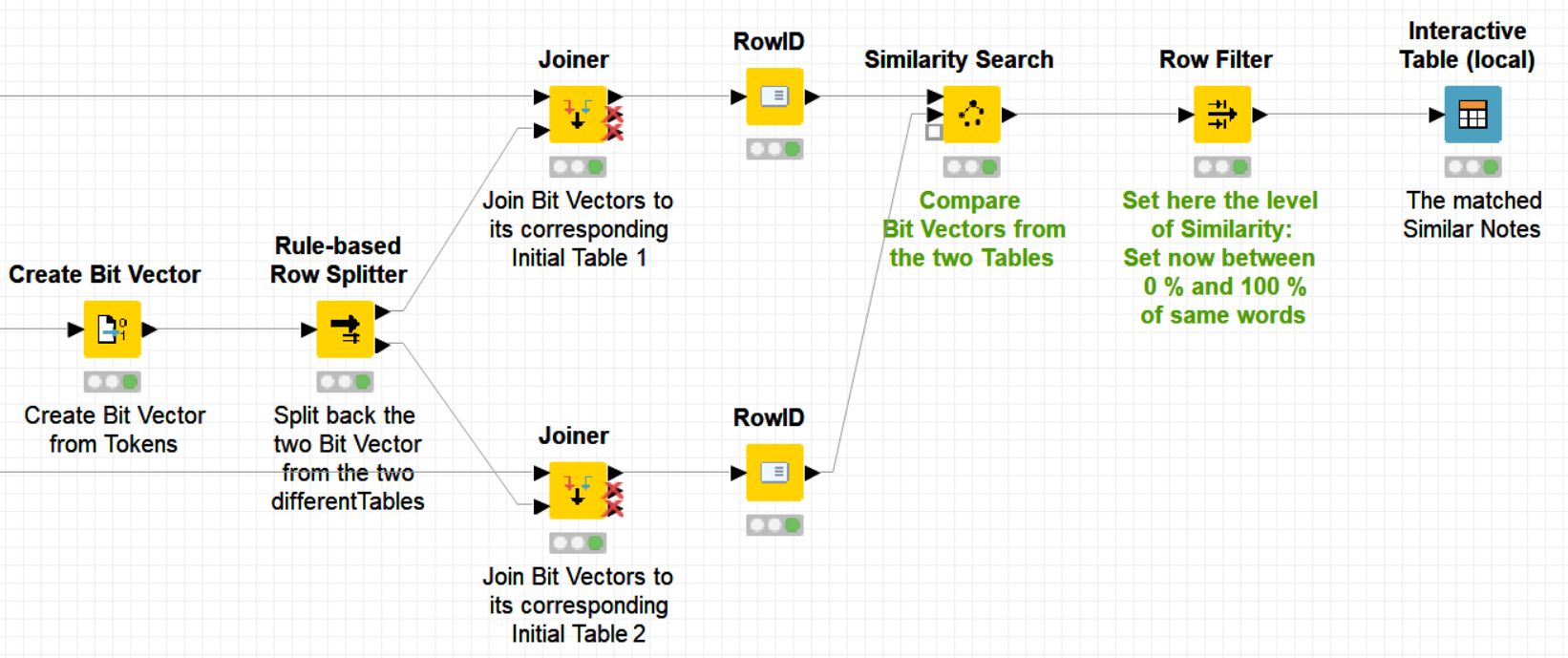

Calculation of Route Similarity and Subsequent Hierarchical Clustering Knime Workflow.

**2.4 Results and Discussion**

* Several metrics are proposed in Methodology section executed on the transportation data obtained from Antalya Municipality. We have discussed Route Efficiency, Traversal Route Evaluation,Variance-Area Curves for Route Board ing, Bus Stop Analysis, and Clustering of Bus Lines with respect to overlapping bus stops.

**3.Route Efficiency- RE:**

* RE The simplest way to evaluate route efficiency (RE) is to calculate the number of passengers per unit distance (km) travelled.
* RE for a route i is given by: RE = Pactual(i) Di (1) where Pactual(i) be the actual number of passengers for Route i and D(i) is the total travel distance in kilometers for this Route.
* Currently, there is not a single number on literature that is suggested to be the benchmark for this metric.
* Because, such metric depends on multiple factors including the dynamics of the population, geography and resources, we calculated RE for all routes and normalize routes with respect to total travel distance via Linear Regression.

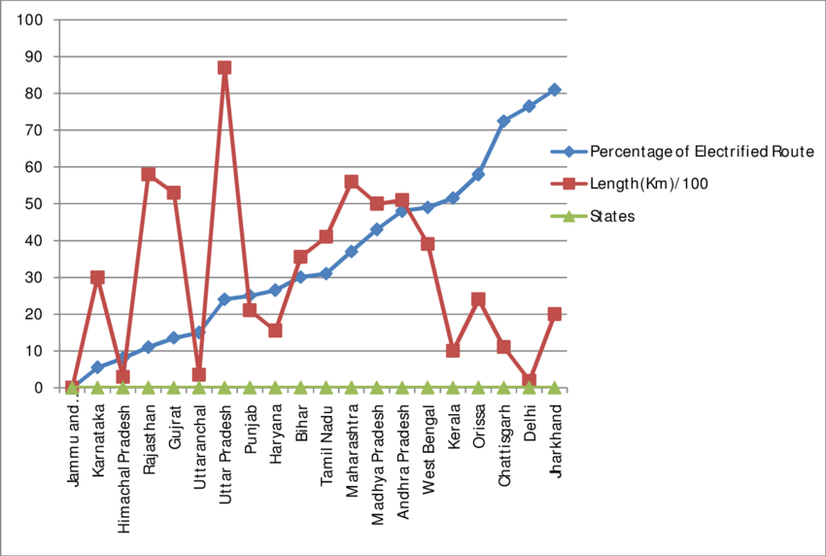

UP C = Pactual(i) + σr

LCL = Pactual(i) – σr

**3.1 Traversal Route :**

* Evaluation When lines are designed they often start from an origin and return back to where it start.
* Each line may have consider to have 2 routes, a forward and backward route.

**3.2 Time-Location Variance Analysis of Route Boarding :**

* Time-Location mapping of route boarding provides us to analyze the variation of boarding in both time domain and as well as route bus stop sequences.
* Mapping involves counting boarding in subsequent bus stops for each trip on a route

**3.3 Bus Stop Analysis:**

* For the selected date, there were 3140 distinct bus stops and among which 2804 has boarding data (at least 1 boarding).
* Among them infrequent bus stops are listed in Table 3. One can conclude from the table that there are 567 ( % 18).

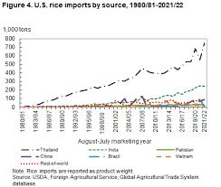

**3.4 Hierarchical Clustering of Routes for Bus Stop Similarity:**

* In Antalya, a major reason for low REs, low bus utilization, high boarding variances on bus stops may be resulted from lengthy bus lines with many overlapping sections.
* This can be investigated by clustering of routes according to their common bus stops.
* The resulted dendrogram presented in Figure 8 shows the hierarchical clustering of bus routes.
* Here x- axis denotes route Ids and y-axis represent similarity distances (y=1 means no similarity whereas y=0 means one hundred percent similarity).

**4. Conclusion :**

* The aim of this study is to identify inefficient routes and to propose improvements by the evaluation of route efficiencies, the analysis of bus stop boarding counts and the clustering of routes.
* Several metrics are proposed in Methodology section executed on the transportation data obtained from Antalya Municipality.