**INTRODUCTION:**

**Analyzing public transport efficiency with IBM Cognos involves utilizing its robust business intelligence and data analytics capabilities to gain valuable insights from the data collected. Here's a step-by-step guide on how to perform a public transport efficiency analysis using IBM Cognos:**

**1. Data Collection and Integration:**

**Data Sources: Gather data from various sources including ridership data, operational data, financial records, customer surveys, and external factors like weather and traffic conditions.**

**Data Integration: Use IBM Cognos Data Manager to integrate data from different sources, ensuring it's clean, consistent, and ready for analysis.**

**2. Data Modeling:**

**Create Data Models: Use IBM Cognos Framework Manager to create data models that represent the integrated data. Define relationships, calculations, and business rules to prepare the data for analysis.**

**3. Report and Dashboard Creation:**

**Interactive Reports: Build interactive reports using IBM Cognos Report Studio to visualize key performance indicators (KPIs) such as on-time performance, ridership trends, and cost per passenger.**

**Dashboards: Develop dynamic dashboards using IBM Cognos Workspace to provide a real-time overview of public transport metrics. Dashboards should include widgets displaying KPIs, route performance, and customer satisfaction scores.**

**4. Data Analysis:**

**Ad-Hoc Analysis: Use IBM Cognos Analysis Studio for ad-hoc analysis. Explore data, identify patterns, and generate insights on the fly.**

**Predictive Analytics: Apply predictive modeling using IBM Cognos Statistics to forecast ridership trends and optimize routes and schedules.**

**DATASET:**

**Source: data.world.com**

**Sample dataset**

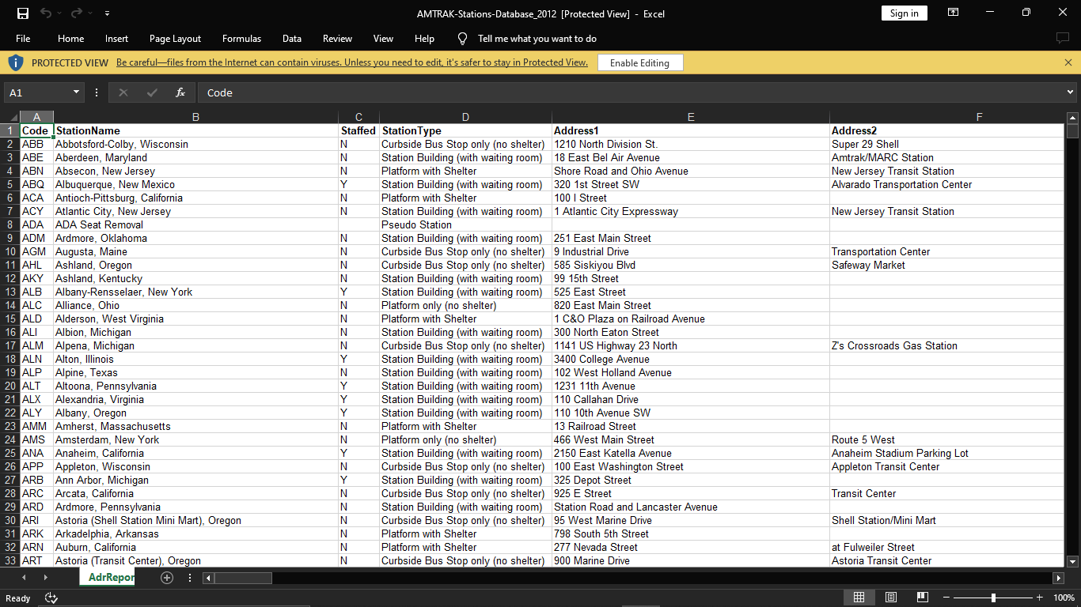

**INNOVATION OBJECTIVES:**

1. **Real-time Data Analytics**:
   * Utilize real-time data from sensors, GPS devices, and passenger feedback to monitor bus and train performance. Analyze this data to make on-the-fly adjustments, such as route optimization and vehicle maintenance.
2. **Machine Learning for Predictive Maintenance**:
   * Implement predictive maintenance using machine learning algorithms. By monitoring the health of transportation assets like buses and trains, you can schedule maintenance proactively, reducing breakdowns and service disruptions.
3. **Rider Behavior Analysis**:
   * Analyze passenger data to understand ridership patterns. This includes where people board and alight, their travel times, and preferences for routes. This information can be used to optimize schedules and routes.
4. **Fare and Pricing Optimization**:
   * Analyze fare structures and pricing models to maximize revenue and ridership. Dynamic pricing based on demand and season, as well as introducing different ticket options, can be explored.
5. **Multi-Modal Integration**:
   * Promote seamless integration between different modes of transportation, such as buses, trains, trams, and bicycles. Analyze data on how passengers transfer between these modes and look for opportunities to improve connectivity.
6. **Traffic Flow Modeling**:
   * Use traffic flow modeling software to optimize signal timings and road layouts to reduce congestion and improve the efficiency of public transportation routes.
7. **Energy Efficiency Assessment**:
   * Analyze the energy consumption of public transportation vehicles. Consider alternatives such as electric buses and evaluate the feasibility and benefits of transitioning to more eco-friendly options.
8. **Crowdsourcing Solutions**:
   * Engage the community in collecting data and suggesting improvements. Crowdsourced data can be valuable in identifying issues that passengers encounter daily.
9. **Digital Ticketing and Contactless Payments**:
   * Implement digital ticketing systems and contactless payment options. Analyze transaction data to understand passenger behavior, peak travel times, and fare evasion rates.
10. **Traffic Signal Priority (TSP)**:
    * Implement TSP systems that give public transportation vehicles priority at traffic signals. Analyze the impact of TSP on travel times and on-time performance.
11. **Autonomous Vehicles and Mobility as a Service (MaaS)**:
    * Investigate the feasibility of integrating autonomous vehicles into public transportation fleets. Explore MaaS platforms that allow passengers to plan and pay for multi-modal trips.
12. **Route Optimization Algorithms**:
    * Develop and implement advanced route optimization algorithms that consider real-time traffic, weather, and passenger demand data to provide efficient and dynamic route planning.
13. **Environmental Impact Assessment**:
    * Analyze the environmental impact of public transportation services and explore strategies for reducing emissions and promoting sustainability.
14. **Customer Satisfaction Surveys**:
    * Regularly survey passengers to gather feedback on their experiences. Analyze the data to identify pain points and areas for improvement in service quality.
15. **Smart Infrastructure and IoT**:
    * Utilize IoT sensors and smart infrastructure to monitor traffic and transportation assets. Analyze this data to enhance efficiency, safety, and sustainability.
16. **GIS and Spatial Analysis**:
    * Use Geographic Information Systems (GIS) and spatial analysis to optimize bus stop and station locations, taking into account population density and urban development.
17. **Benchmarking with Other Cities**:
    * Compare the efficiency and performance of your public transportation system with similar systems in other cities to identify best practices and areas for improvement.
18. **Collaboration with Ride-Sharing Services**:
    * Partner with ride-sharing companies to complement public transportation services. Analyze data on shared rides and explore cost-effective integration.Top of Form

**CONCLUSION:**

**Thus by implementing these innovative ideas in the upcoming phases we can achieve the public transport efficiency.**