

**PRIYADARSHINI ENGINEERING COLLEGE**

**Public Transport Efficiency Analysis IBM Cognos Phase-4**

**Development part-2 using IBM Cognos for Visualization**

**Introduction:**

Analyzing public transport efficiency with IBM Cognos involves utilizing its robust business intelligence and data analytics capabilities to gain valuable insights from the data collected. Here's a step-by-step guide on how to perform a public transport efficiency analysis using IBM Cognos.

**1. Data Collection and Integration:**

**Data Sources:** Gather data from various sources including ridership data, operational data, financial records, customer surveys, and external factors like weather and traffic conditions.

**Data Integration:** Use IBM Cognos Data Manager to integrate data from different sources, ensuring it's clean, consistent, and ready for analysis.

**2. Data Modeling:**

Create Data Models: Use IBM Cognos Framework Manager to create data models that represent the integrated data. Define relationships, calculations, and business rules to prepare the data for analysis.

**3. Report and Dashboard Creation:**

Interactive Reports: Build interactive reports using IBM Cognos Report Studio to visualize key performance indicators (KPIs) such as on-time performance, ridership trends, and cost per passenger.

Dashboards: Develop dynamic dashboards using IBM Cognos Workspace to provide a real-time overview of public transport metrics. Dashboards should include widgets displaying KPIs, route performance, and customer satisfaction scores.

**4. Data Analysis:**

Ad-Hoc Analysis: Use IBM Cognos Analysis Studio for ad-hoc analysis. Explore data, identify patterns, and generate insights on the fly.

Predictive Analytics: Apply predictive modeling using IBM Cognos Statistics to forecast ridership trends and optimize routes and schedules.

**DATASET:**

**Source:**[**https://www.kaggle.com/datasets/rednivrug/unisys?select=20140711.CSV**](https://www.kaggle.com/datasets/rednivrug/unisys?select=20140711.CSV)

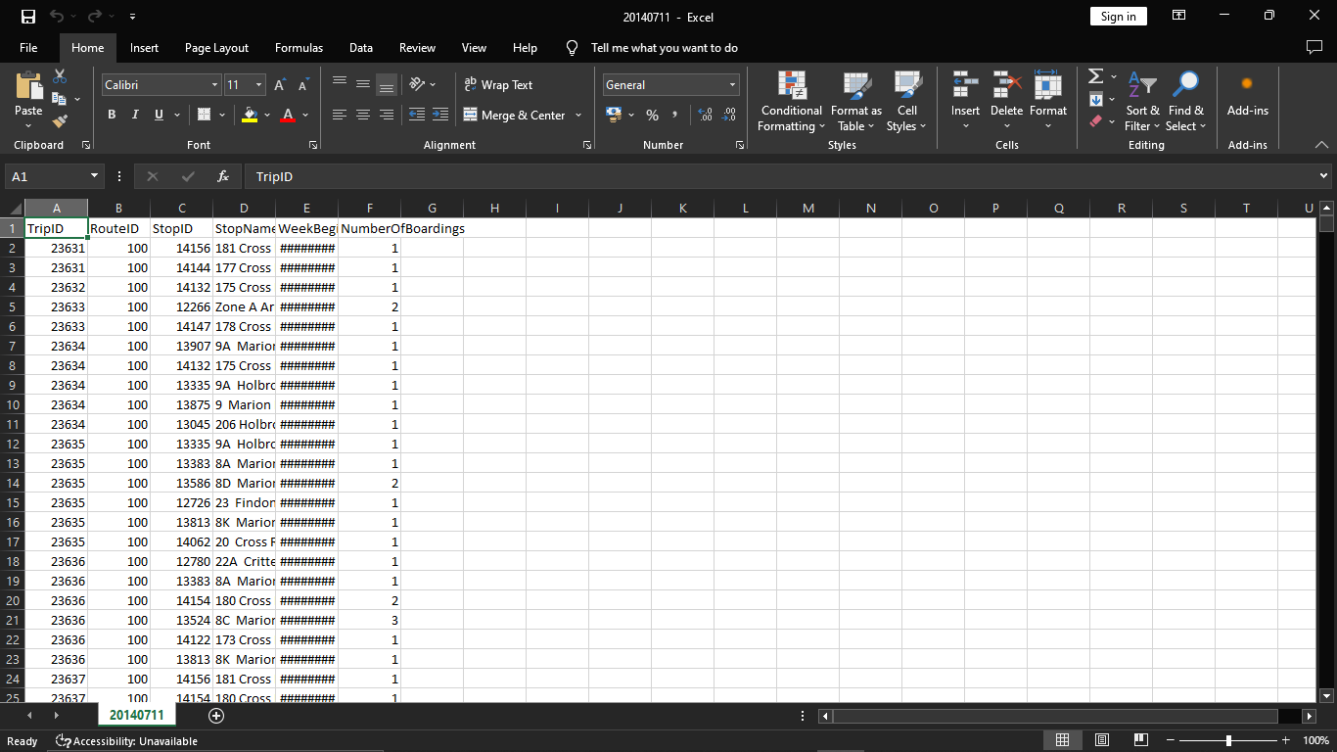

The above dataset has: 1048553 Rows.

**Development part-2 using IBM Cognos for visualization**

Building a public transportation efficiency analysis using IBM Cognos for visualization involves several steps. In this process, you'll collect data, prepare it, create data models, and generate visualizations to analyse the efficiency of public transportation services. Here's a step-by-step guide:

**Step 1: Define Your Objectives** Clearly define the objectives of your analysis. Determine what aspects of public transportation efficiency you want to measure and improve, such as on-time performance, ridership, cost-effectiveness, or route optimization.

**Step 2: Data Collection and Integration** Collect relevant data from various sources, including historical transportation records, scheduling information, geographic data, and real-time tracking systems. Ensure that the data is accurate, complete, and up-to-date. IBM Cognos can connect to various data sources, including databases, spreadsheets, and APIs, to import and integrate data.

**Step 3: Data Preparation** Clean, transform, and shape your data to make it suitable for analysis. This involves handling missing data, removing duplicates, and converting data types. IBM Cognos provides data preparation tools to assist with this.

**Step 4: Create Data Models** Design data models that represent the relationships between different data elements. You can use IBM Cognos Framework Manager or the Data Modules feature to create data models that are optimized for performance and user-friendliness.

**Step 5: Report and Dashboard Creation** Now, it's time to build reports and dashboards in IBM Cognos. Here's how:

**a. Create a New Report or Dashboard:** Start by creating a new report or dashboard in IBM Cognos.

**b. Select Data Sources:** Connect your report or dashboard to the data models you've created.

**c. Choose Visualization Types:** Decide on the type of visualizations you want to use. This could include bar charts, line graphs, maps, and tables. IBM Cognos offers a variety of visualization options.

**d. Build Visualizations:** Design and customize your visualizations. For example, you can create a bar chart to display on-time performance by route or a map showing stop locations and their average wait times.

**e. Create Interactivity:** Add interactive elements to your dashboard, such as filters, drill-through capabilities, and parameters that allow users to interact with the data.

**Step 6: Data Analysis and Insights** Use the visualizations in your report or dashboard to analyze the efficiency of public transportation. Identify trends, outliers, and areas for improvement. For example, you can track the most and least efficient routes, analyze peak hours, or evaluate the impact of schedule changes.

**Step 7: Sharing and Collaboration** IBM Cognos allows you to share your reports and dashboards with relevant stakeholders. Collaborate with decision-makers, transportation authorities, and analysts to ensure that the insights are used for making informed decisions.

**Step 8: Schedule and Automation** Set up schedules or triggers for your reports and dashboards to be automatically updated and shared at regular intervals. This ensures that your analysis remains up-to-date.

**Step 9: Monitor and Iterate** Continuously monitor the performance of public transportation and gather user feedback. Use this information to refine your reports and dashboards, making them more insightful and valuable.

By following these steps, you can use IBM Cognos to create an efficient and insightful analysis of public transportation. It helps decision-makers optimize transportation services and improve the overall efficiency of the system.

Top of Form

Bottom of Form

**Trip ID:**

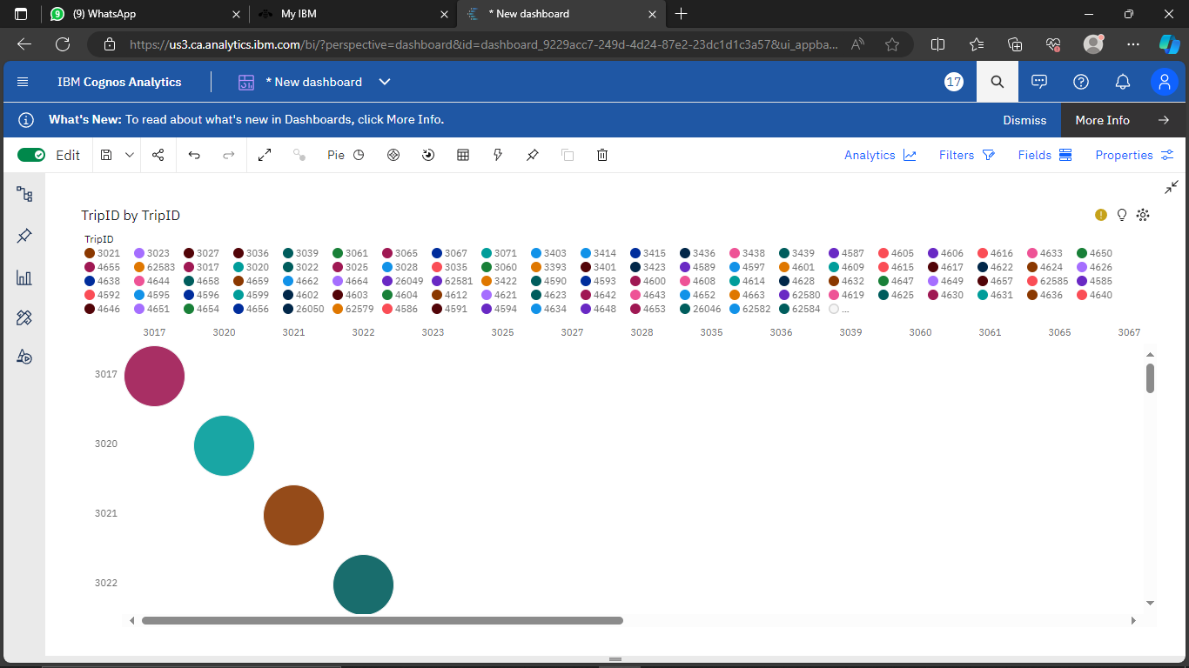

**Stop ID:**

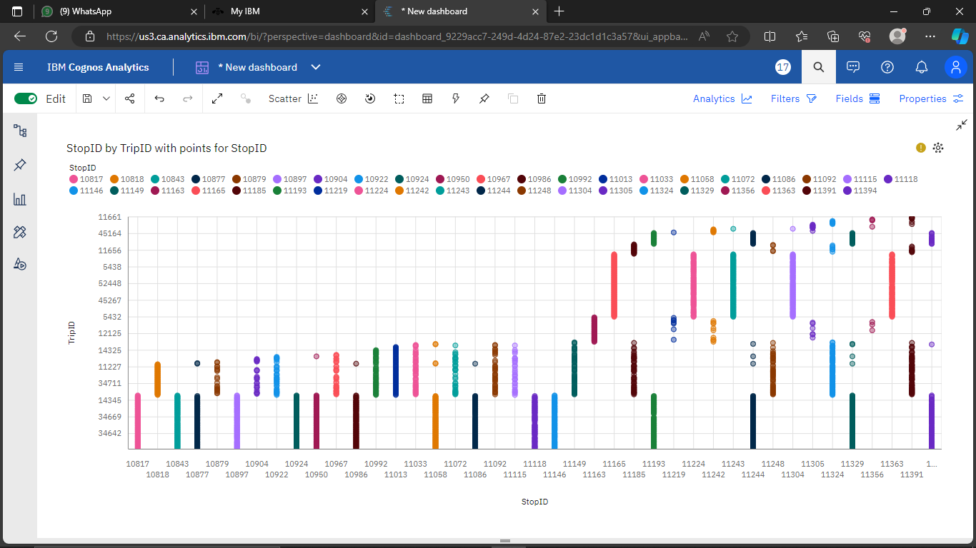

**Number of boardings:**

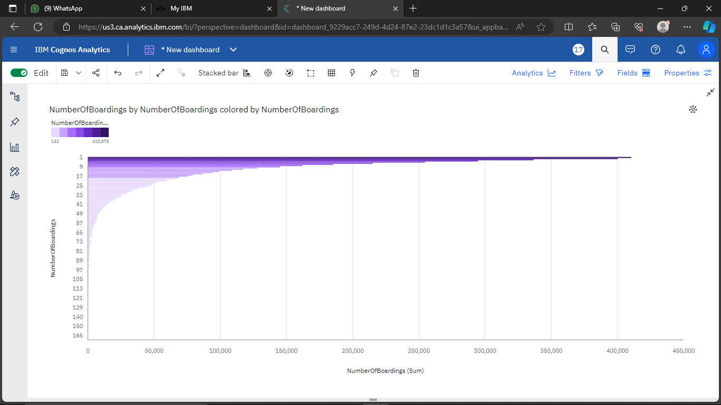

**Route ID:**

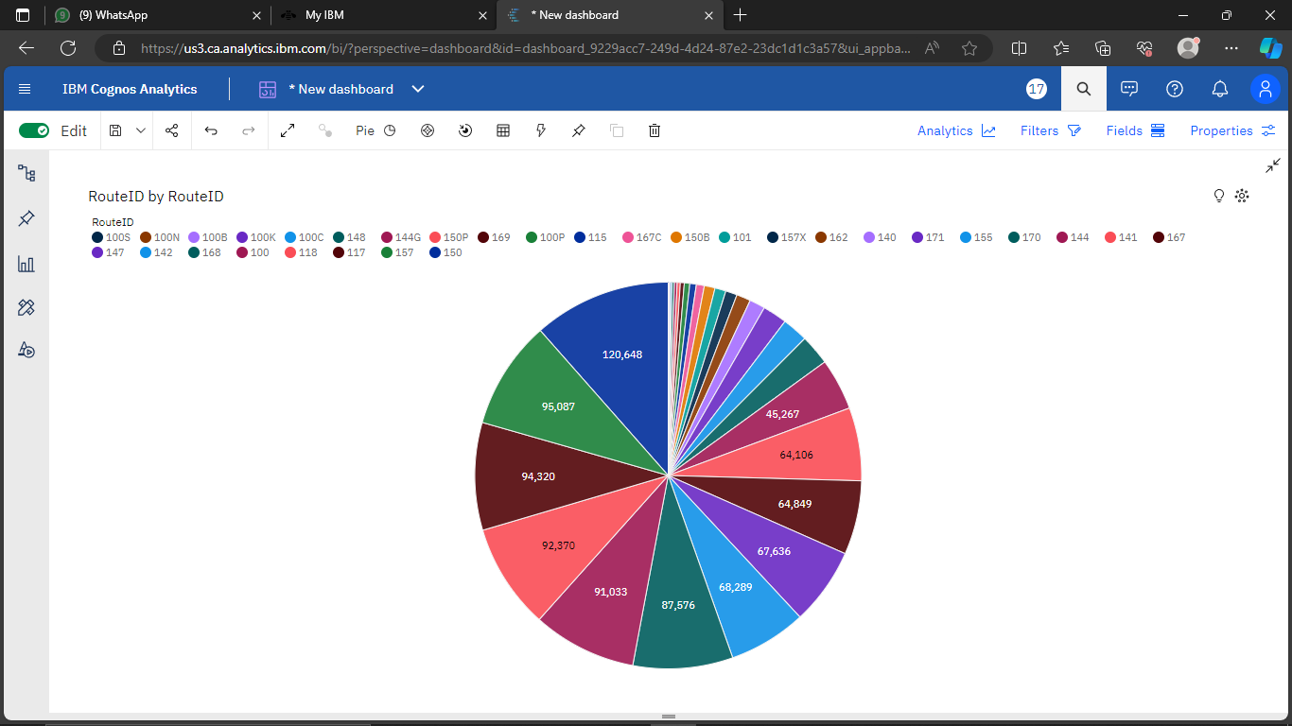

**Week Beginning:**

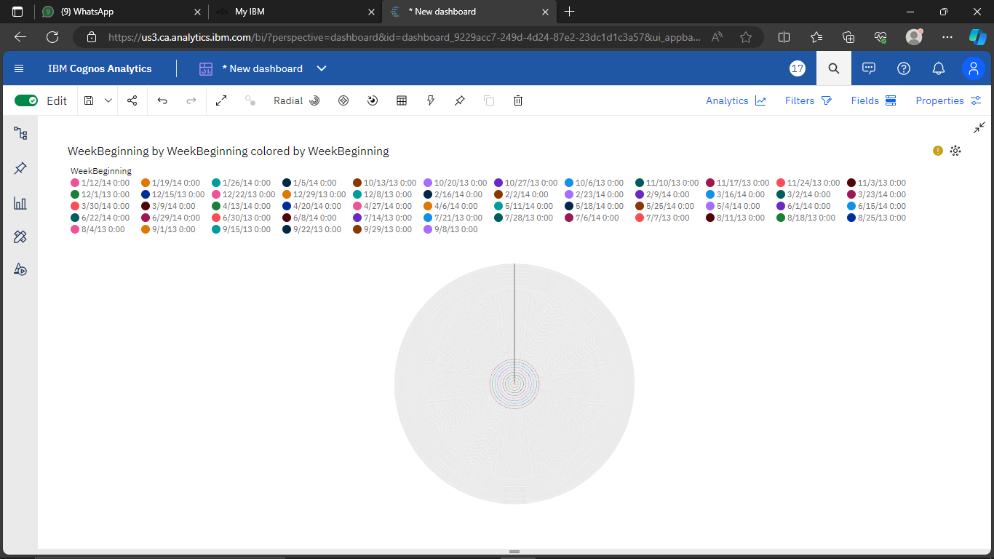

**Stop Names:**

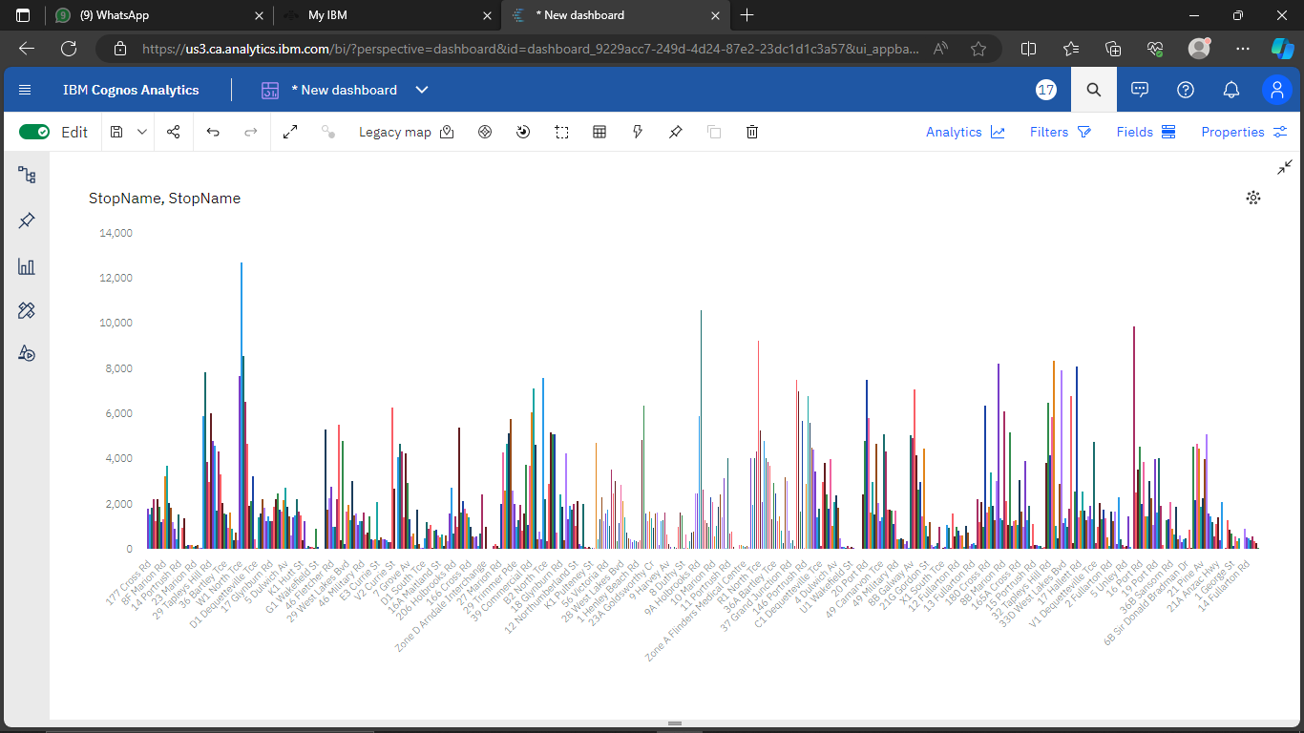

**Python Integration**

**Objective:**

In this notebook, We have explored how people are travelling from different stops in Adelaide Metropolitan area and managing the buses on each route according to the no of passenger commuting through the buses.

**1. Installing pandas:**

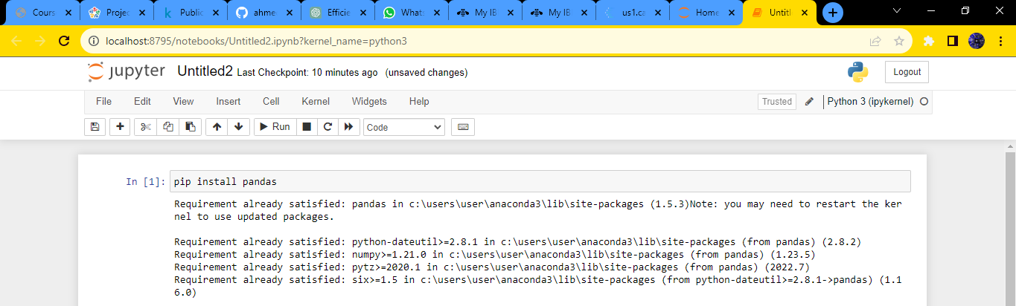

**2. Importing Libraries:**

import pandas as pd

import numpy as np

from sklearn.model_selection import train_test_split

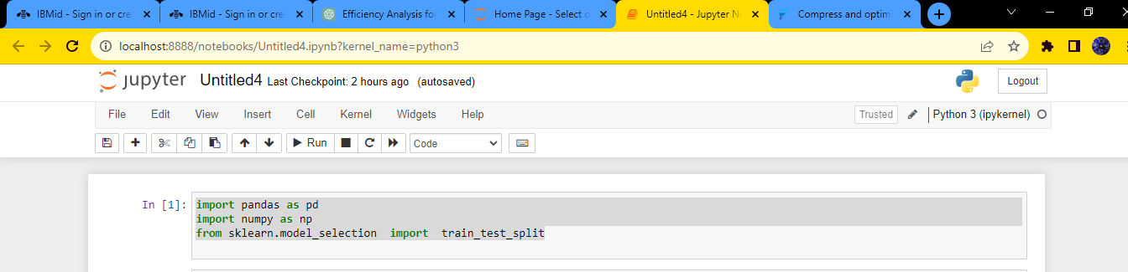

**3. Reading the dataset:**

import pandas as pd

# Replace 'your_file.csv' with the actual path to your CSV file.

file_path = 'C:/Project_dataset.csv'

# Read the CSV file using pandas

try:

df = pd.read_csv(file_path)

# Display the first few rows of the dataframe

print("First few rows of the CSV file:")

print(df.head())

except FileNotFoundError:

print(f"File not found at {file_path}. Please provide a valid file path.")

except Exception as e:

print(f"An error occurred: {e}")

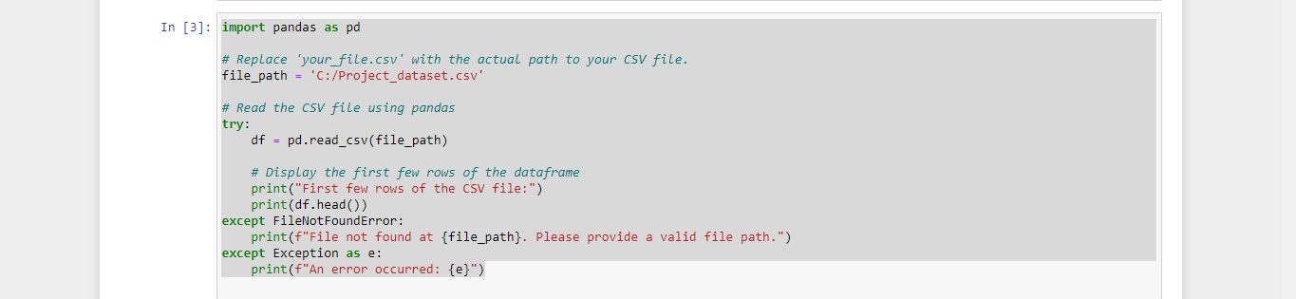

**Output:**

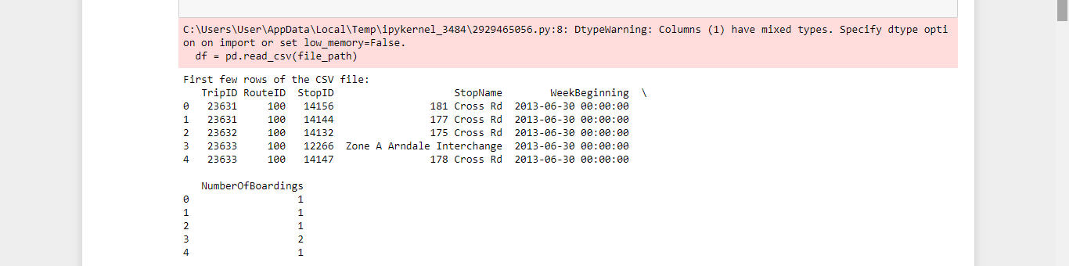

**4. Loading the dataset:**

import pandas as pd

import numpy as np

import seaborn as sns

import matplotlib.pyplot as plt

from sklearn.model_selection import train_test_split

from sklearn.preprocessing import StandardScaler

from sklearn.metrics import r2_score

from sklearn.linear_model import LinearRegression

from sklearn.linear_model import Lasso

from sklearn.ensemble import RandomForestRegressor

from sklearn.svm import SVR

%matplotlib inline

import warnings

warnings.filterwarnings("ignore")

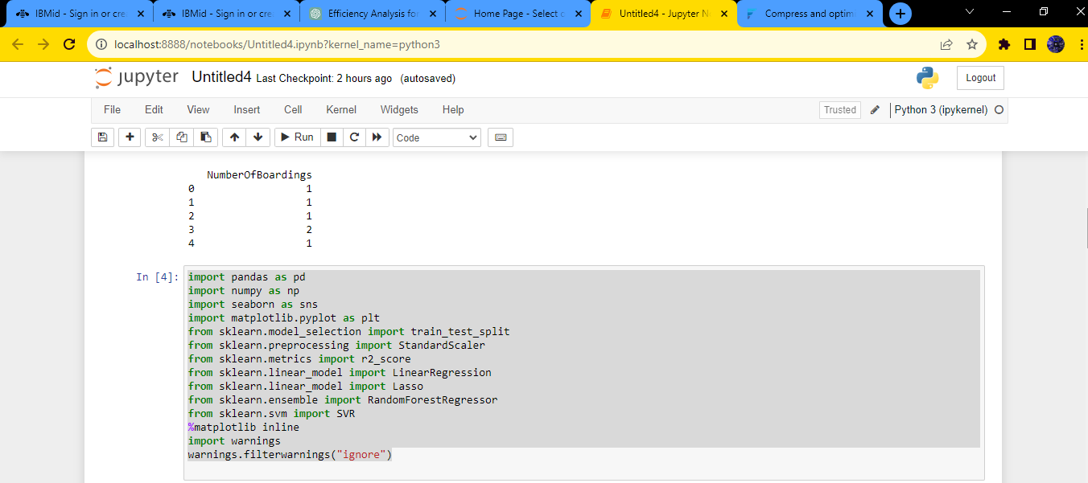

**5. Bar chart:**

sns.histplot(df, x='TripID', bins=50, color='y')

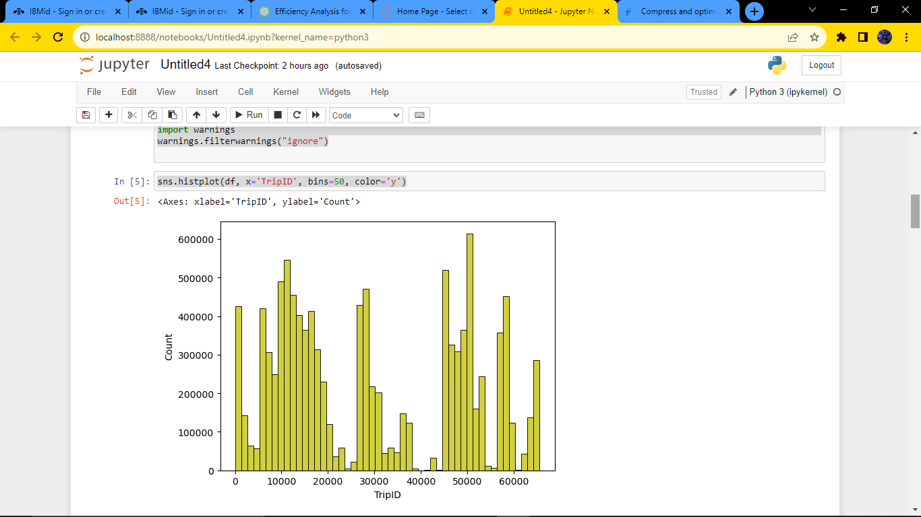

**6. Boxplot:**

sns.boxplot(df, x='TripID', palette='Blues')

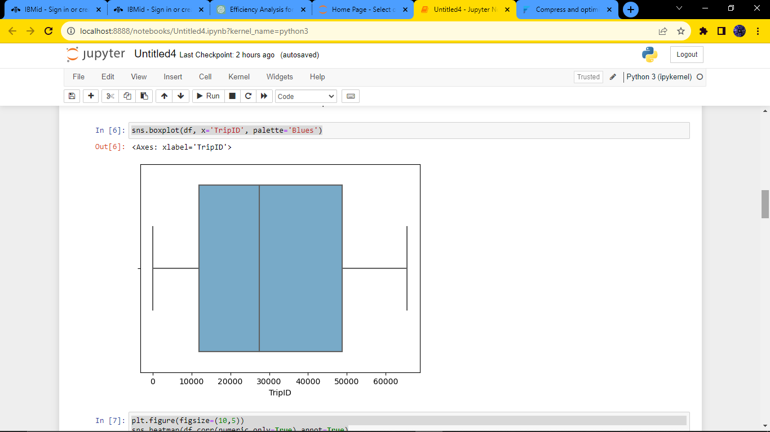

**7. Heatmap:**

plt.figure(figsize=(10,5))

sns.heatmap(df.corr(numeric_only=True),annot=True)

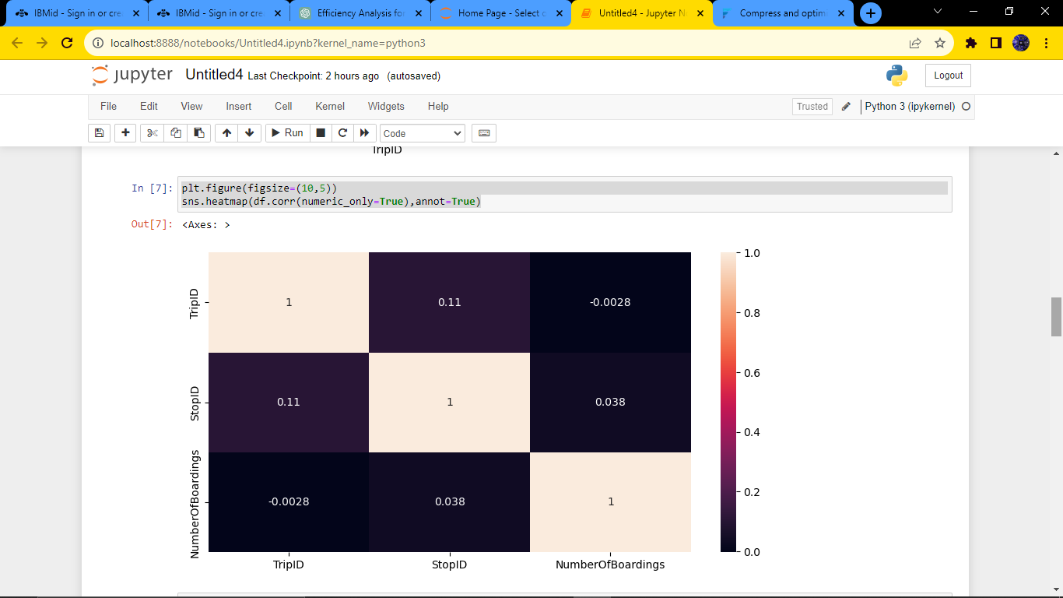

**8. Correlation:**

df.corr(numeric_only=True)

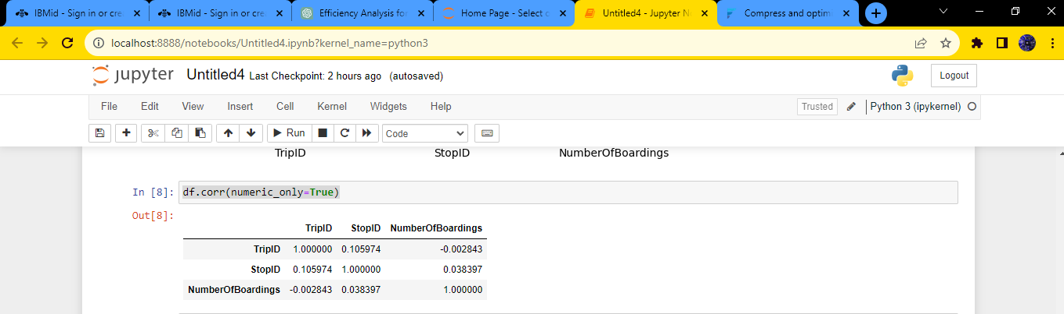

**9. Histogram:**

df.hist(figsize=(10,8))

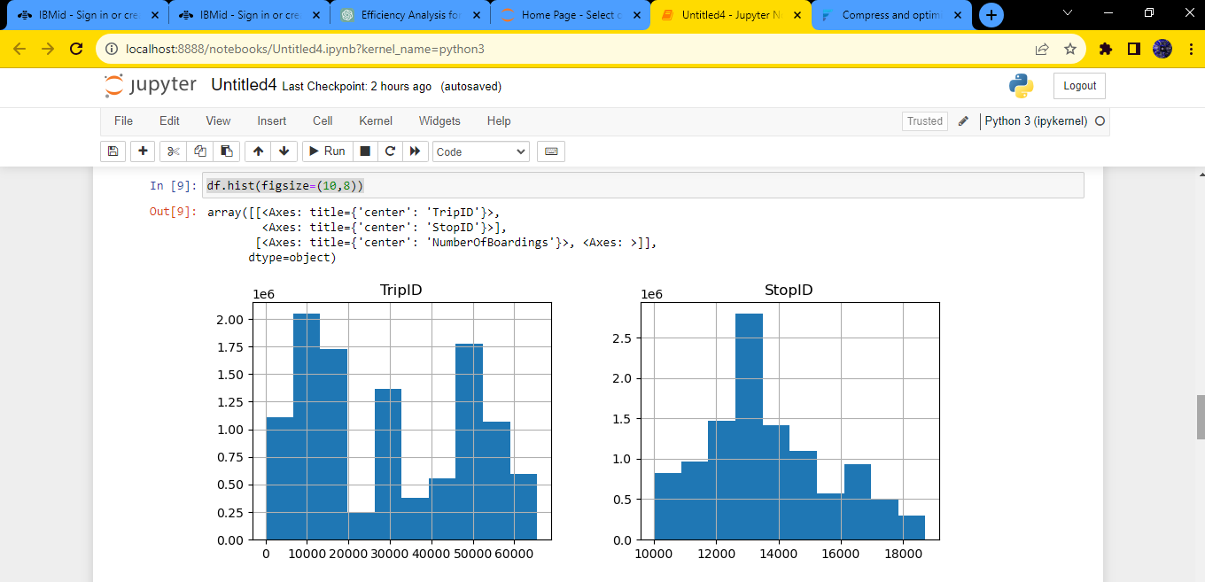

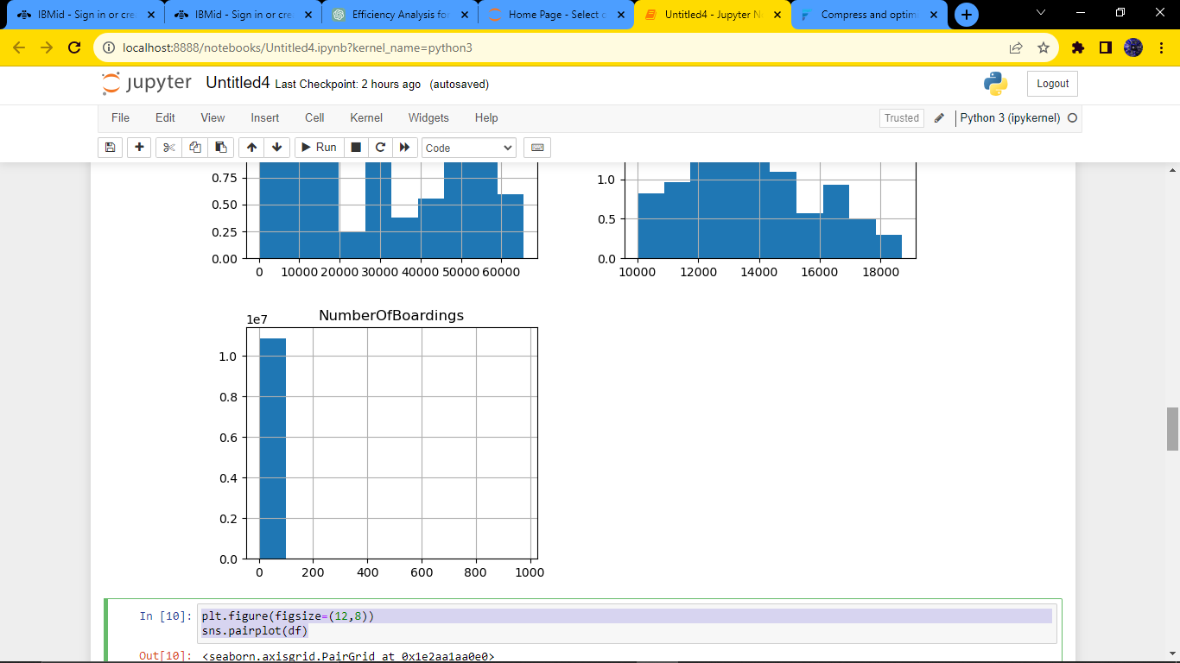

**10. Pair plot:**

plt.figure(figsize=(12,8))

sns.pairplot(df)

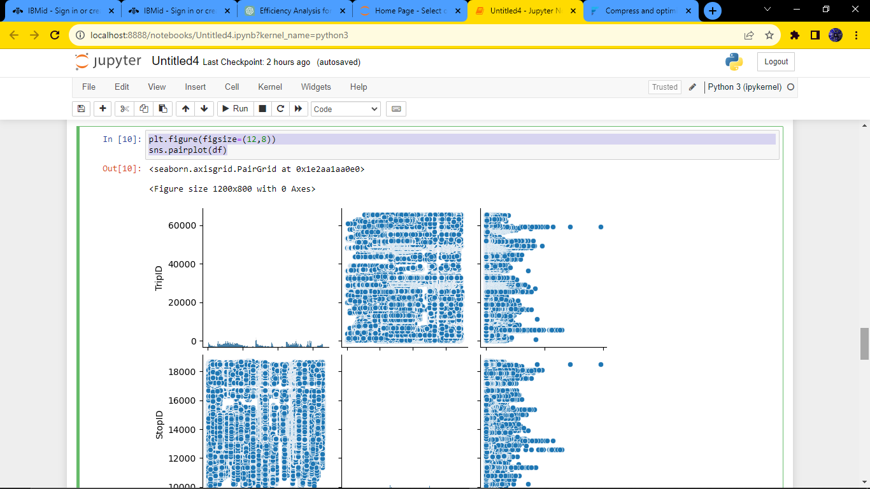

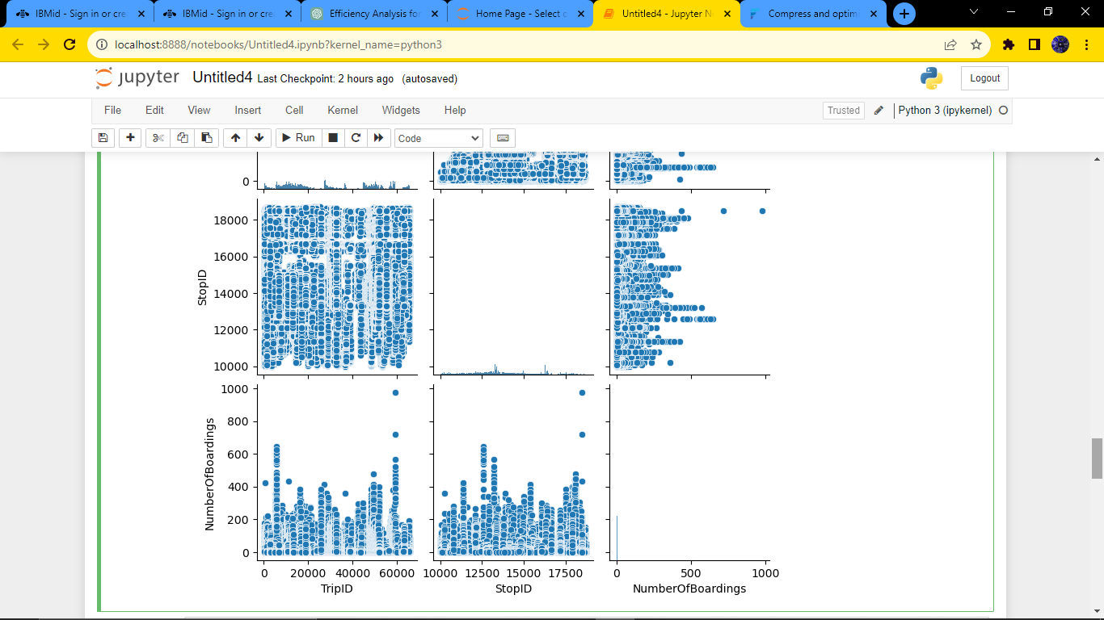

**Conclusion:**

In conclusion, the use of IBM Cognos for visualization in the public transportation efficiency analysis project has brought about positive changes, leading to more efficient and user-friendly services, better decision-making, and improved sustainability.