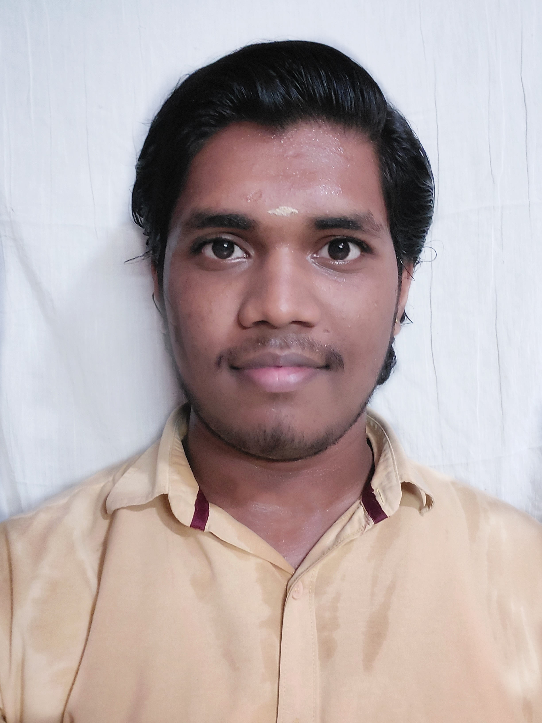
DHANUSH N

Plot, no 8, lalbagadhur sastri st (last cross), Mudichur , Chennai-600048 | 9677185751 | dhanushnagarajan18072003@gmail.com | Linkedin : (26) Dhanush N | LinkedIn

Objective

To secure a challenging position as a Software Engineer, utilizing my technical skills and knowledge acquired through education and internships, while contributing to the growth and success of a dynamic software development team.

Education

 | Bachelor of Engineering in Computer
Graduation | Science and Engineering, | 8.53(Present)
 | Agni College of Technology,
 | Anna University.
12th standard | Gurukulam matriculation Higher Secondary | Board Exam :467/ 78%
 | School
10th standard | Sri S.Badalchand Sugankavur Chordia Vivekananda Vidyalaya matriculation | Board Exam : 417/84%
 | School
Projects

- SHOPPING WITH INTERACTIVE SHOWROOM EXPERIENCE – we developed an Interactive Showroom Experience solution to enhance the user interface and experience. It provides a new form of web interactivity with images and gives a new experience to users than traditional shopping experience.

Source: fin_ijprems1683775942.pdf

Skills & Abilities

TECHNICAL SKILLS
Languages: Java / Python.

Media profession: Adobe Photoshop / Premiere pro / Illustrator / After Effects.

Platforms: Windows XP/ 7/8/8.1/10, Linux, Ubuntu, Mac OS.

Web Design: HTML, CSS.

Database: MySQL.

Areas of Interest
- Database Management Systems.
- Software Engineering.
- Web development.
- Backend Engineering.

Personal Abilities

- Decisive problem solver with strong communication and organizational skills.
- Rapidly conveys complex information for easy understanding by others.
- Seeks practical software development role emphasizing sound decision-making abilities.
- Pragmatic software professional with a focus on efficient problem-solving approaches.

Extra-Curricular Activities & Hobbies

- Won many prizes in school level oratory and essay competitions.
- Casual gaming enthusiast. Engaging in film watching and music listening.
- Active volunteer in ROTARACT CLUB of Agni college of Technology.
- Aspiring to become a professional software Engineer.

