Raha: Customer and Market Discovery
Compliance for Indians who get paid in foreign currency. The job is proving that income counts as a zero-rated export at 0% GST instead of a domestic supply at 18%.
Aleti Dhanush, solo founder. VentureArch IITM, IDEA SPRINT Part 02. Product live at raha.software. Written 21 August 2026.
_______________________________________________________________________________________________

0. How I'm labelling claims
I've separated what I can prove from what I'm still guessing at. Everything below carries one of these labels.
Label | What it means
VERIFIED FACT | I can point to a primary source or a public record.
PUBLIC SIGNAL | People say it in public, repeatedly. I don't know how common it is.
PRODUCT FACT | It's built and running in the deployed product.
HYPOTHESIS | I'm testing it. All my pricing sits here.
CUSTOMER VALIDATION | Real customer behaviour proves it. Nothing here has this label yet.

The method was desk research, one structured practitioner interview, about ten informal conversations, and my own cold outreach. No surveys. Public forum posts are demand signal, not interviews. Nothing in this document comes from a conversation that didn't happen.
One thing I want to be upfront about. Over the last two to three months I've had roughly ten informal conversations with students who freelance and with people I met at meetups and events, all of them getting paid by clients abroad. They talked about their own situations. I didn't take notes at the time, which was a mistake. I can tell you who they were. I can't quote them, and I'm not going to reconstruct what they said from memory and dress it up as findings. So none of the conclusions in this document rest on those ten. Everything below comes from the sources, the one recorded interview, or my own outreach log. From here on I'm writing conversations down the day they happen.

1. What I actually did
Six pieces of work between June and 21 August 2026.
Workstream | What I did | What came out
Practitioner interview | Interviewed a practising chartered accountant who handles freelancer clients with foreign income. Four rounds of questions and answers over a week on LinkedIn. Asked what goes wrong in their practice and pushed for a real case, rather than asking what they thought of my idea. | The finding that most challenges my current product. Section 2.1
Informal conversations | About ten conversations over two to three months with students who freelance and people met at meetups and events, all paid by clients abroad. Undocumented at the time, so treated as background only. | Shaped my instincts. Deliberately not used as evidence anywhere in this document
Rules and primary sources | Read the actual rules rather than summaries of them. Export of services under Sec 2(6) IGST, what zero-rating is conditional on, how the LUT works, and the 2016 change that stopped FIRCs being issued for exports. Checked Google's own support pages to confirm which company pays Indian AdSense creators. | The wedge, plus a terminology mistake I had to fix in my own copy
Public demand signals | Went through about 12 months of r/IndiaTax posts about FIRC, FIRA, LUT, 44ADA and foreign income. Sorted them by how urgent the person sounded. | 22 or so threads catalogued. 5 people openly asking to hire for this
Competitor teardown | Looked at four groups: filing services, creator business apps, payment companies, and the CA plus spreadsheet status quo. Also checked whether search was worth chasing. | Competitor brief, and the finding that rails already solve half of it
My own cold outreach | Built a 60 row lead list, 50 with verified emails. Sent 28 cold emails from 23 July, 23 to talent agencies and 5 to creators. Checked each person was actually India resident before sending. | 28 sent, 0 bounces, 1 reply, 0 calls

2. What I found

2.1 A practising CA moved the problem earlier than I built for [VERIFIED FACT]
This is my only interview so far and it produced the finding that cuts hardest against my own product. I went in expecting them to say the LUT or the paperwork was the mess. They said close to the opposite.
Their words: once someone is set up correctly, the LUT and the documentation are relatively straightforward. The recurring trouble sits earlier. Freelancers taking foreign payments often don't realise they're making an export of services at all. They don't know when GST registration starts to matter. Plenty of them assume that being paid in USD, GBP or EUR is by itself enough to make it an export.
I pushed for a real case and got one. A freelancer doing software and consulting work for a US client started taking payments in USD and assumed that a foreign client meant it was automatically an export with nothing else to do. Invoices went out, money came in through the bank, and nobody had looked at GST registration, the LUT, or how any of it should be documented. It only surfaced when they came to the CA for regularisation, and the work then was reconstructing services, turnover, invoices and payment trail from the beginning.
The CA's conclusion: the moment to intervene is "I'm about to start working for a foreign client, what do I need to set up before I invoice them?"
What this does to Raha. I built for the documentation stage: FIRA matching, LUT status, reconciliation. A practitioner just told me that stage is the easy one and the damage is done upstream, at classification, before the first invoice. I'm not throwing out the product over one interview, and there's a real bias to note, since a CA only meets people who eventually reached a CA. The ones who never get there are exactly who I'm building for, and they may look different. But it's enough to change what I ask people at intake, and it's the sharpest argument I've heard against the shape of what I've built.
So I went and checked the rules again, and the interview turns out to be half right in a way that helps. The CA is correct that the setup has to happen before the first invoice. The LUT has to be on the GST portal before you make the supply, not after. But the LUT is not a one-time setup. It expires and has to be re-filed every financial year, before the first export after 1 April. Miss that date and every invoice you raise from then on is treated as taxable at full IGST until a new LUT is filed and accepted.
That gives me an answer to the contradiction. Classification and registration are an onboarding problem, which is the CA's point and it's where I should be finding people. The LUT is an annual problem that resets every April. FIRA collection is a per-payment problem. Export proceeds have to be realised within nine months under FEMA, which is per-transaction too. So the setup is the way in, and the recurring cycle is the reason anyone would keep paying after it. I don't have to choose between the two stages. I do have to stop assuming people arrive at the documentation stage on their own.

2.2 The mechanic is real and the downside is big [VERIFIED FACT]
If you're in India and someone abroad pays you for a service, that's an export. Exports are zero-rated at 0% GST. But zero-rated isn't the same as exempt, and the 0% is conditional on two separate things that fail in two different ways.
Miss the LUT and it's a cash problem. Every export invoice raised without a valid LUT carries 18% IGST you pay upfront and then wait 30 to 60 days to get back as a refund. On ₹40L that's ₹7.2L out of your account while you wait. Miss the remittance proof and it stops being a timing problem. Refund claims get rejected without evidence that the money actually came in as foreign exchange, so the 18% you fronted can become 18% you lost. There's a second exposure most people never hear about: export proceeds have to be realised within nine months under FEMA, and failing to document foreign exchange inflows carries penalties of up to three times the transaction value.
I had these two conflated in my earlier write-ups, treating a missing LUT and a missing FIRA as the same 18% loss. They aren't. One is working capital, the other is permanent, and the FEMA exposure sits on top of both.
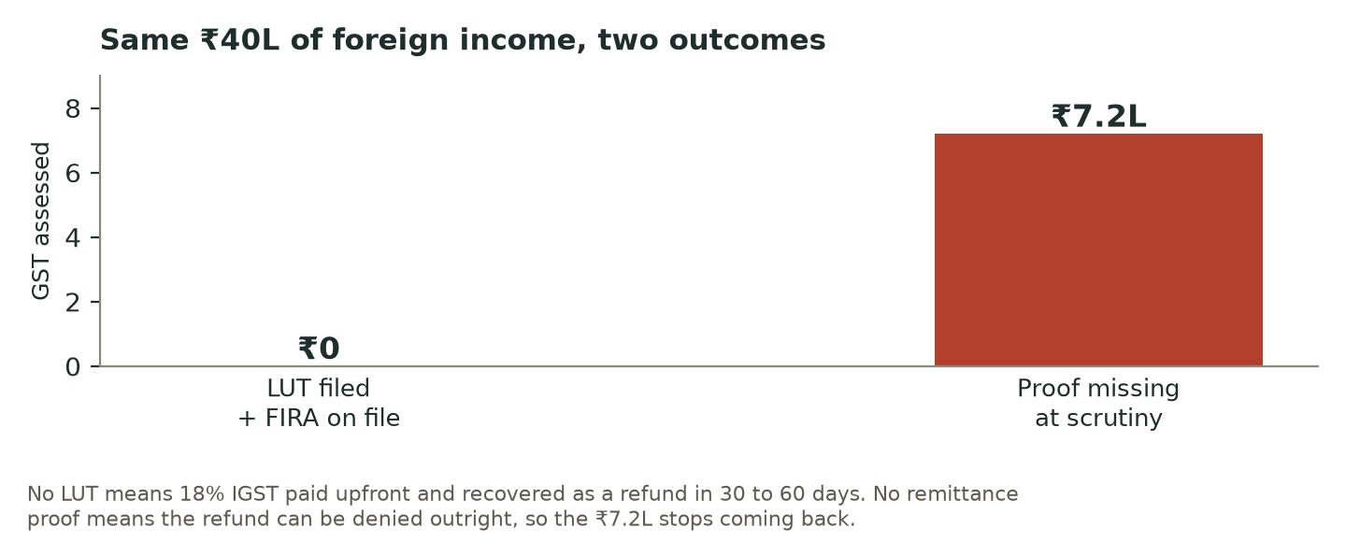
Every number the product shows says "estimate, verify with your CA before filing". Raha doesn't file anything for anyone, and the ₹2,000 diagnostic is a risk report, not signed advice.

2.3 Almost every monetised creator is an exporter and doesn't know it [VERIFIED FACT]
AdSense pays Indian creators from Google Asia Pacific Pte. Ltd. in Singapore, in foreign currency. That's on Google's own support pages. So a creator whose entire audience is Indian is still exporting a service, because what matters is where the payer sits, not where the viewers are. That one fact makes the affected group far larger than the set of people who'd ever describe themselves as exporters.

2.4 I had the terminology wrong [VERIFIED FACT]
FIRCs stopped being issued for export transactions in 2016. Banks issue a FIRA now. FIRC only survives for FDI and FII. This matters because my early positioning and all 28 emails I'd already sent said FIRC, which to any practising CA reads like someone who hasn't done the homework. I fixed it across the whole public site on 14 August. I'm recording it rather than quietly correcting it, because being wrong in front of the market and fixing it fast is the actual finding.

2.5 The payment companies already solve half of this [VERIFIED FACT]
Skydo, Karbon, Payoneer and BriskPE now issue FIRA automatically and for free. That half is solved and I can't sell it. Any plan that depended on selling it was already dead. What nobody covers:
- Wise, Stripe and PayPal. money lands in your account looking like an ordinary domestic transfer, and no bank will certify it.
- Direct bank transfers. no payment company is involved, so nothing gets documented automatically.
- Old years. rails only document from the day you join. The years before that stay undocumented.
- Several rails at once. nobody reconciles someone who gets paid three different ways at once.
This narrowed the product from "foreign income compliance" down to the specific gaps the rails can't close.

2.6 People ask for this out loud [PUBLIC SIGNAL]
Across about 12 months of r/IndiaTax, five people posted publicly asking to hire someone for this exact scope: FIRC or FIRA, LUT, GST and 44ADA for foreign income. One asks almost word for word for "someone to handle international payments via 44ADA, FIRC, LUT, GST and other stuff". Another group fits the customer profile and is visibly confused: a freelancer with around ₹40L of US client income asking whether GST even applies to him, a creator on AdSense and Patreon with no FIRC who's thinking about quitting, and a thread of Indian SaaS founders asking each other whether they're getting FIRAs at all.
These people described my product before they'd heard of me. That's the strongest signal you can get without talking to anyone. But it's still only signal. It shows the problem keeps happening and people go looking for help. It doesn't show they'll pay me.

2.7 A price benchmark, and the finding that hurt most [VERIFIED FACT]
There's a practising CA on r/IndiaTax openly selling this same scope (ITR, GST, LUT, FIRC) for ₹20,000 a year. It took me five minutes to find. That's a market benchmark and it works against me, not for me. It is not evidence I can charge that. My own delivery plan uses a partnered CA, so at ₹20,000 I'd be offering the same thing with more risk attached. I'm writing it down because it's the finding that did the most damage to my original plan.
Two things changed. First, the opening ask became a ₹2,000 written diagnostic, so the first thing I sell is small and low risk instead of a straight fight with a licensed professional. Second, I flipped who I go after. Selling to people whose CA is doing fine is hard. Selling to people whose CA has already missed the FIRA is not, and they're easy to find because they post about it.
To be exact, because this is where it'd be easy to fool myself: I am testing ₹2,000. Nobody has paid it. ₹20,000 a year is a competitor's published price that I'm using as a benchmark and a warning. Neither is validated pricing and neither will be until money changes hands. [HYPOTHESIS]

2.8 Search isn't worth chasing [VERIFIED FACT]
Twelve funded companies rank for these queries, and they make their money on the payments underneath. They can give the content away forever. I'm not going to outspend a competitor whose content is a loss-leader for a payments business, so I stopped working on SEO.

3. My outreach, and how badly it went
No spin on this. The bad result is the useful part.
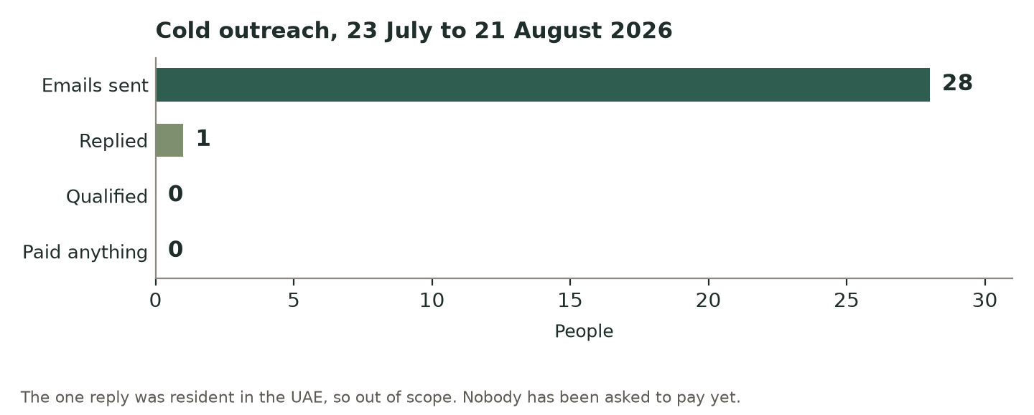
What | Result
Cold emails sent from 23 July 2026 | 28. 23 talent agencies, 5 creators
Bounces | 0. Every address was verified, none guessed
Replies | 1
Replies that qualified | 0. The one reply lives in the UAE, so out of scope
Calls booked | 0
Customers and revenue | 0 and ₹0
People I've asked to pay | 0

Two honest readings. The agency angle failed: 23 emails, zero replies, so I cut it rather than sending more of the same. But the test was weaker than it looks. I left the audit link out of all 28 emails to protect deliverability, which means 0 out of 28 barely tested whether the message works. I'm not claiming the market said no. I'm saying I haven't run the real test yet.

4. Who I considered, and where I landed
Segment | Status | Why
Talent agencies | CUT | Was my main plan. 23 emails, 0 replies. Kept only as a slow background channel.
Creators only, around 100K people | WIDENED FROM | Real, but it caps the business roughly two orders of magnitude below what I want to build. Still a subset, just not the definition.
Anyone in India paid from abroad, 2 to 3M | COMMITTED, 28 July 2026 | Freelancers, software consultants, indie SaaS founders and creators all have the same paperwork problem. Wide audience, narrow problem.
Chartered Accountants | CHANNEL, NOT BUYER | A CA whose client shows up with foreign income can pass the work on instead of turning it down. I haven't partnered with one yet, so this is a plan and not a fact.
Sitting under the payment rails | THESIS ONLY | The long term idea is that rails move money but may not want to own compliance. I'm researching it, not committing to it.

The rule I hold to: widening who I sell to must never widen what I sell. "All tax for everyone" is word for word an incumbent's positioning, and walking into that with no brand loses.

How big the pool actually is [VERIFIED FACT]
I had been carrying a rough guess of 2 to 3 million people. Two figures put a floor under it. India's services exports reached USD 421.3 billion in FY 2025-26, according to the Press Information Bureau, led by computer, telecommunications and business services. India also has over 15 million freelancers and is the third largest freelancing nation in the world. Not every one of them is exposed, since the ₹20 lakh registration threshold counts all income together and someone below it may not need to register at all. That's exactly why the first question at intake has to be how much and through which route, before anyone tries to sell them anything.

5. What none of this proves
People wanting the problem solved isn't the same as people paying me to solve it. All of the above shows the problem is real, current, and already supports a small industry of guides and tools. None of it shows anyone will pay me.

Still open:
- Will anyone pay ₹2,000? I've never tested it on one human. Everything else waits behind this.
- How often does it bite? Does someone hit this every payment, or once a year at filing? I don't know.
- What's the right price? ₹20,000 a year makes no sense for someone billing ₹25L. I haven't modelled the curve.
- Is the unserved bit big enough? Old years and multi-rail are uncontested partly because hardly anyone searches for them.
- Is my tax logic right? I wrote it from primary sources. No qualified professional has checked it. I know that's a risk.
- Are the payment companies partners or competitors? Started looking, haven't finished.
I've set myself a gate: three paying customers, or I pivot. I haven't passed it, and this application isn't pretending otherwise.

6. What I'm doing next
One test matters more than everything else: if nobody will pay ₹2,000, nobody was ever going to pay ₹20,000. I haven't run it, because running it means asking a person for money instead of building more product.
# | Action | What it settles
1 | Answer 3 or 4 live r/IndiaTax threads properly, without mentioning Raha | Builds the standing I need before approaching anyone, and shows whether my answer lands
2 | Message the 5 people who publicly asked to hire for this, and name the ₹2,000 test price | The real willingness to pay test. Not "would you use this" but "will you pay ₹2,000 for this". A "no, I already hired someone" is just as useful, it tells me who I lost to
3 | Run 5 to 10 proper interviews and 2 or 3 workflow walkthroughs | How often it happens, how bad it is, what they do today, what it costs them
4 | Ask "how do you get paid" at intake | Decides whether the person has a problem at all before I try to sell them anything
5 | Get a CA partnered on written terms | Removes the one dependency that can stop me delivering

I've fixed the interview rules in advance so I don't talk myself into the answer I want. Ask what they did last time they got paid from abroad, and what they pay their CA now. Never ask whether they'd use it. Interest isn't validation. Payment is.

7. Where the research changed my mind
Research that changes nothing was decoration. Five things I got wrong:
What I thought | What I do now | Why
"Raha, creator taxes handled" | Foreign income as a provable 0% export, for anyone paid from abroad | Creators alone cap the business too low, and the problem is identical for a much wider group
Talent agencies first | People who publicly say they have this problem | 23 emails, 0 replies
Say FIRC | Say FIRA | FIRCs stopped for exports in 2016
Open at ₹20,000 a year | Test a ₹2,000 diagnostic first | A CA publicly sells the same scope at ₹20,000
Build SEO | Dropped it | 12 funded competitors own the results and monetise payments

_______________________________________________________________________________________________
Short version. The problem is real and it's caused by rules that weren't written with solo cross-border earners in mind. More people are caught by it than realise, because what matters is where the payer sits. The part nobody serves is offshore rails, direct transfers, old undocumented years, and people using several rails at once. What I haven't shown is that anyone will pay me for it, and that's the next thing I do, not something I'm claiming I've already done.

