Job Market Analysis:
Understanding the Health of the U.S. Labor Market

DATS 6401 – Data Visualization

Dr. Anya Mendenhall

Josh Schechter
Dhanush Mathivanan
Halima Al Balushi

The George Washington University

March 2026

Background: The Health of the Job Market
One of the most significant transitions many individuals experience is the shift from college to the professional workforce. Upon graduation, students are expected to secure stable employment, begin repaying student loan debt, and take on the financial responsibilities associated with independent adult life.
In recent years, concerns surrounding the job prospects of recent graduates have grown significantly. During the 2010s, students were frequently encouraged to pursue degrees in business, science, technology, engineering, and mathematics, as these fields were widely viewed as providing strong job security and high earning potential. However, with the advancement of artificial intelligence (AI) and task automation, concerns have emerged that technological change may reshape the labor market more broadly.
While entry-level roles are currently viewed as the most vulnerable, AI technologies have the potential to affect a wide range of occupations across many industries. In response to these concerns, this project uses data visualization techniques to examine trends in unemployment and job openings in order to better understand the current state of the job market.
This analysis aims to answer the following questions:
- Is the job market actually as strong as it has been in previous years?
- How does the current job openings trend compare to that of other significant economic events in recent years?
- Does the AI boom predict potential risks for the job market?
- Are certain regions of the country more susceptible to unemployment during major economic downturns?

Datasets: Kaggle, FRED/JOLTS
For this analysis, our team used five datasets from two different sources. The first source is a Kaggle dataset containing unemployment statistics across all 50 states (Oh, n.d.). This dataset provided the geographic variables, time in years, and unemployment trends used in our analysis.
The Kaggle dataset contains data from 1976 through 2025 for all 50 states. Each row is organized by year, month, and state. In other words, for each month there are 50 rows, one for each state. The key variables included in this dataset are percent of the labor force unemployed and percentage of the labor force employed. From these variables, we derived an additional metric: unemployment percent change from the previous year. Together, these variables provided comprehensive data of unemployment trends across time and geographic regions.
Our secondary dataset was obtained from the Federal Reserve Bank of St. Louis (Federal Reserve Bank of St. Louis, n.d.), where we collected job opening rates in specific fields. These data originate from the Job Openings and Labor Turnover Survey (JOLTS) conducted by the U.S. Bureau of Labor Statistics (U.S. Bureau of Labor Statistics, n.d.).
From this source, we incorporated four additional datasets representing job openings in four sectors: non-farm jobs, professional business services, information technology, and financial and insurance. Each of these sectors includes a metric called the job opening index. The baseline for the job opening index begins in the year 2000, and all changes are measured relative to that baseline.
Before conducting our analysis, it was important to acknowledge several limitations of the data. One limitation is that job opening data are aggregated by industry rather than by specific occupations. As a result, trends in specialized fields such as software engineering or data science may not be fully captured. Additionally, unemployment data are aggregated at the state or area level, meaning localized economic events may not be reflected in the dataset. These factors may cause short-term fluctuations in labor markets to go undetected in our analysis.

Data Story: How Healthy Is the Current Job Market?
To address the research questions outlined in the background section, our analysis focuses on two primary labor market indicators: unemployment rates and job opening levels. To provide meaningful historical context for these trends, we examine data beginning in the year 2000. This allows us to observe the effects of several major economic disruptions/downturns, including the dot-com bubble, the 2008 financial crisis, and the COVID-19 pandemic.
In the time-series visualizations that follow, these events are represented by vertical red dashed reference lines. Additionally, a fourth reference line marks the release of ChatGPT, which we refer to as the “AI Boom,” and is represented by a vertical black dashed line. For consistency, these reference lines are applied across all time-series visualizations.

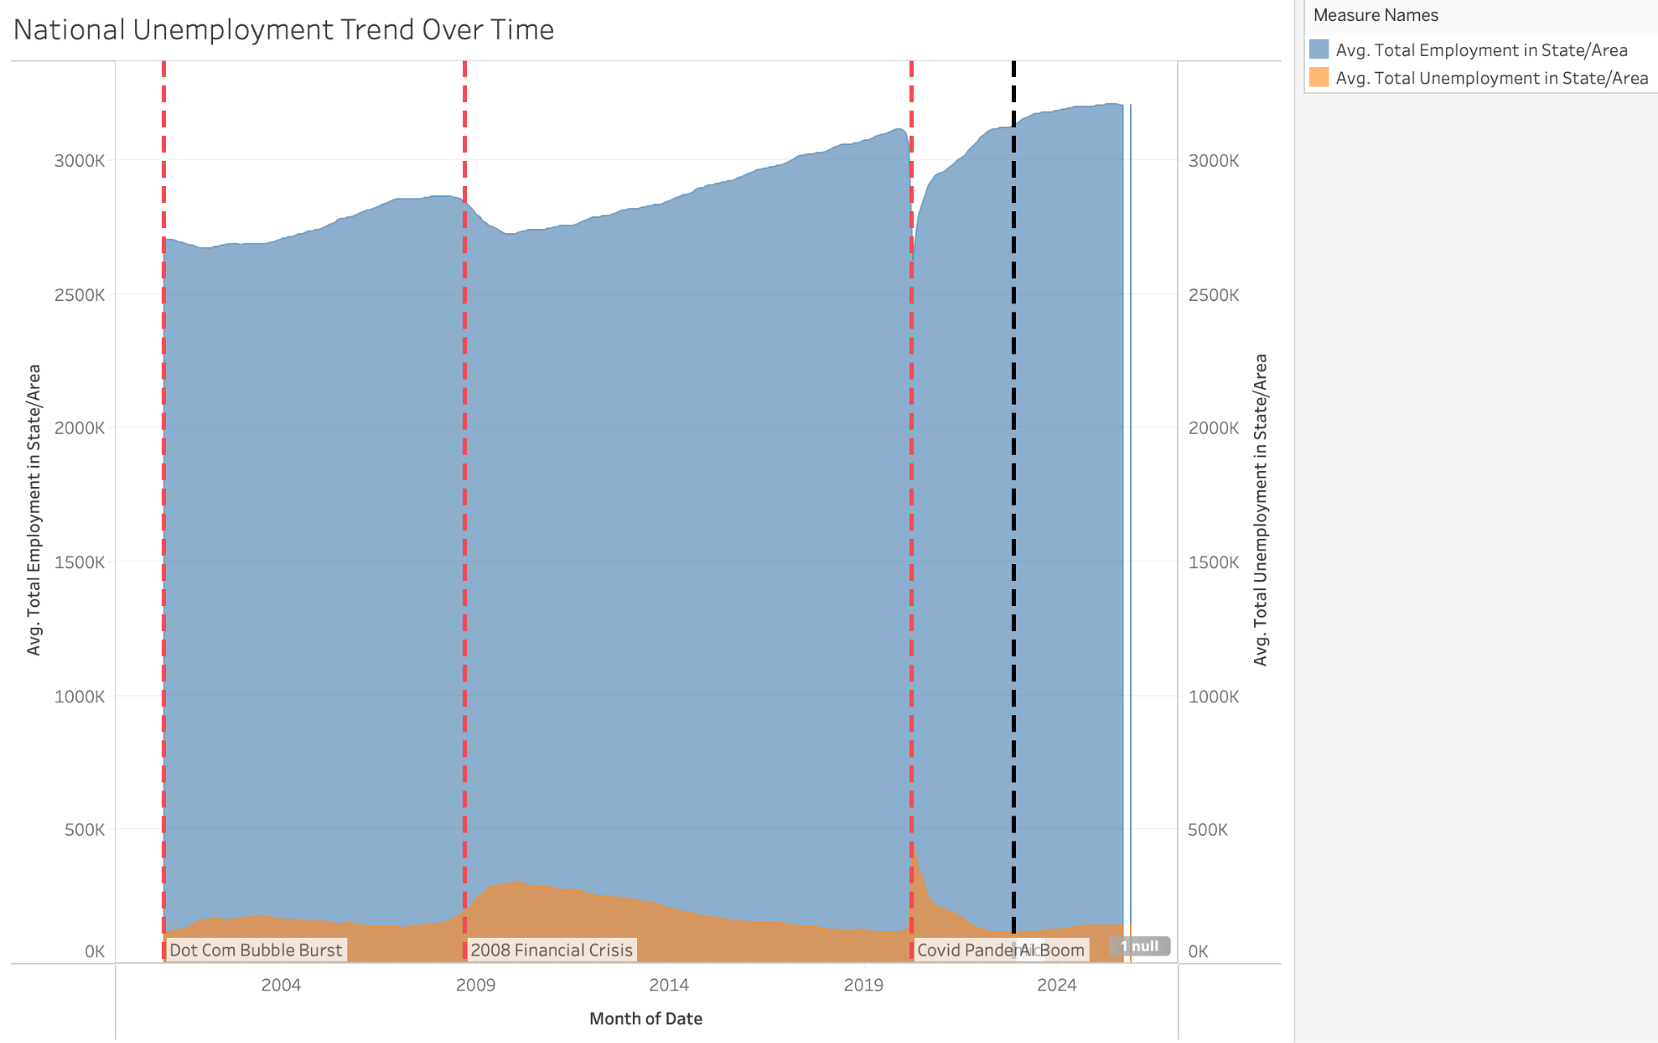
Figure 1: National Employment and Unemployment Totals
Figure 1 presents national employment and unemployment totals from 2000 to 2025 using a stacked area chart. An area chart was selected because it allows viewers to observe how the composition of employment and unemployment changes over time. The blue region represents total employment, while the orange region represents total unemployment. As explained above, the vertical reference lines allow viewers to quickly identify how unemployment levels respond to key historical economic events.
When examining these historical events, unemployment, represented by the orange area, increases noticeably. Since employment is inversely related to unemployment, we observe a dip in employment totals during these periods, as expected. This visualization clearly shows that unemployment rises during each of the major economic disruptions marked in the figure.
Notably, employment levels remain relatively high even during these economic downturns, indicating overall resilience in the labor market. One significant finding from this visualization is that the two largest increases in unemployment occurred during the 2008 financial crisis and the COVID-19 pandemic. Due to these significant changes, we decided to examine these two periods more closely in subsequent visualizations.

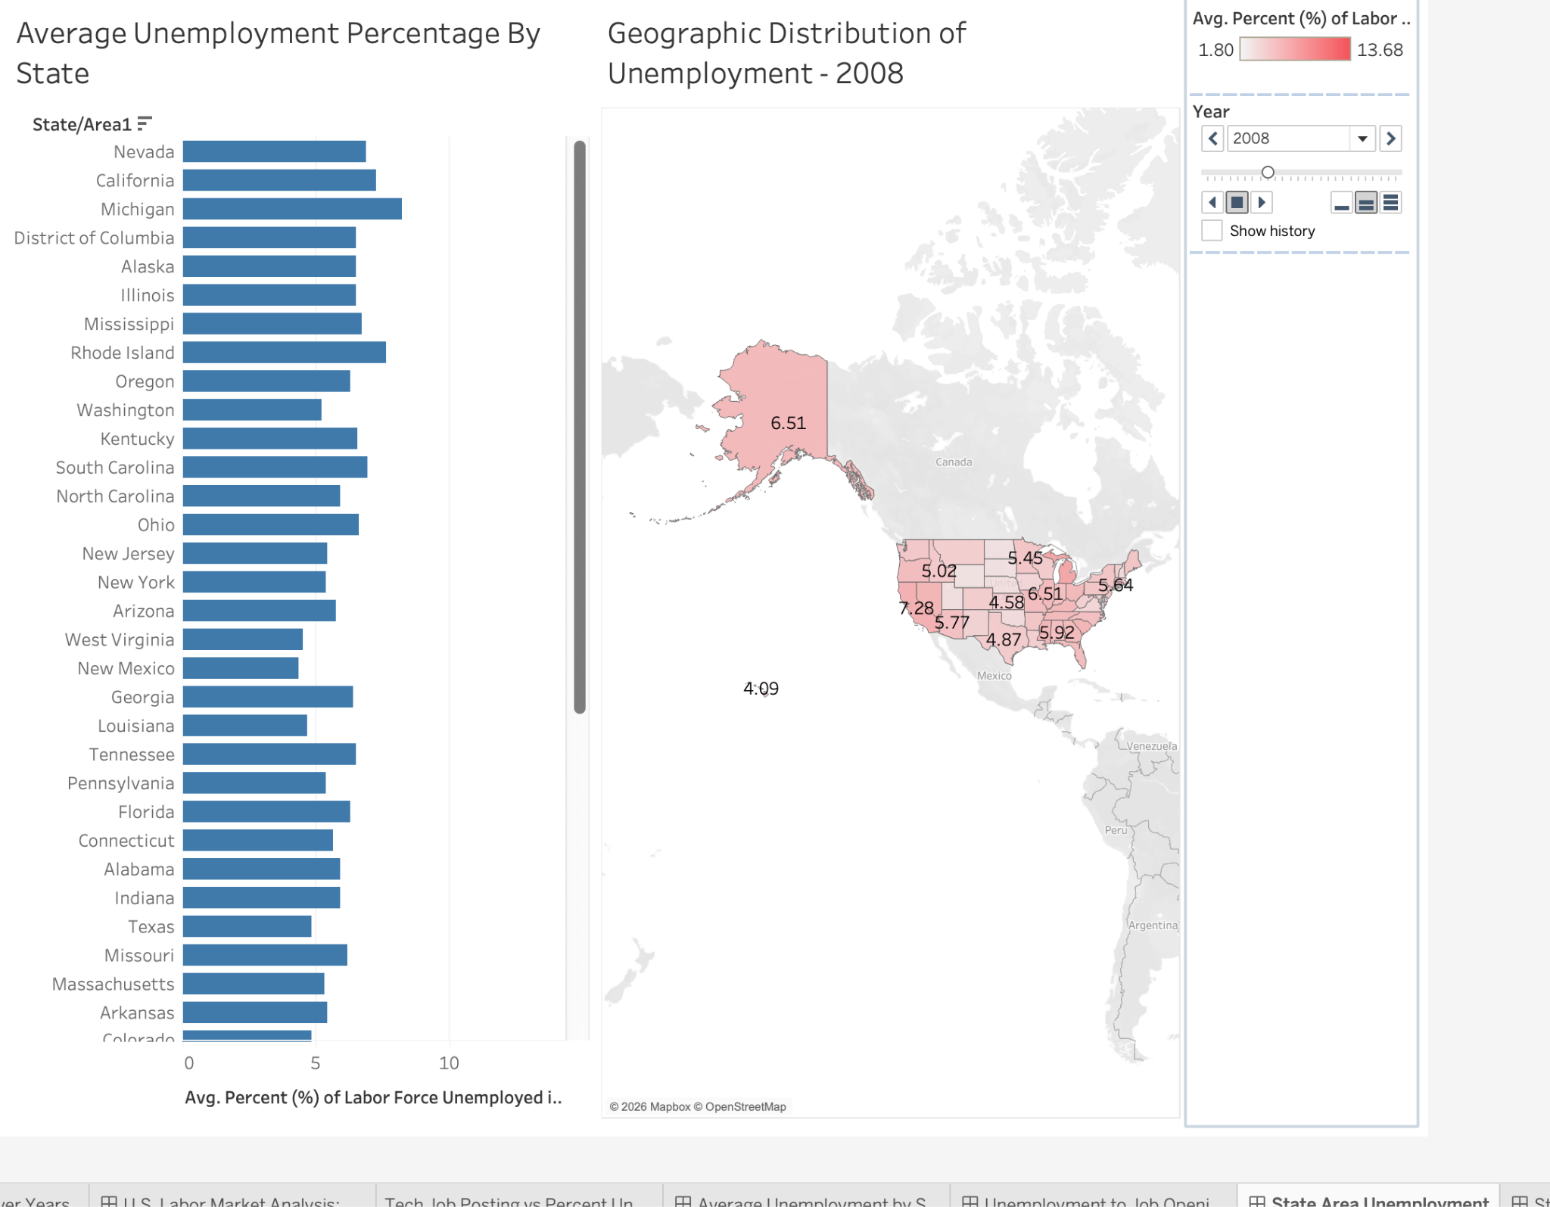
Figure 2a: Unemployment Averages by State in 2008

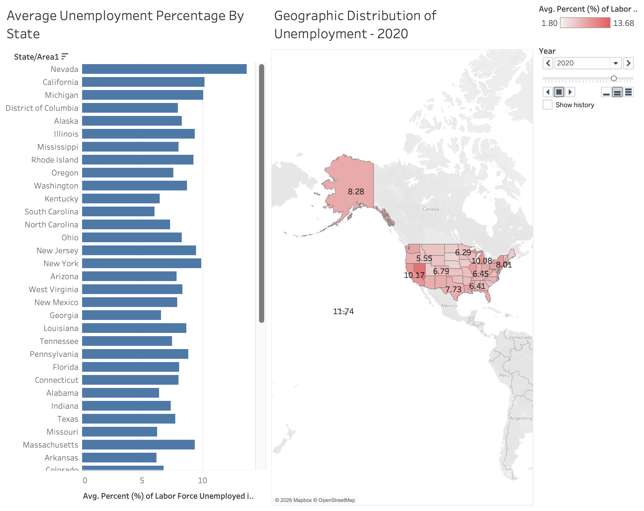
Figure 2b: Unemployment Averages by State in 2020

Figures 2a and 2b display average unemployment rates by state for the years 2008 and 2020 using geographic maps paired with bar charts. These years were selected because they correspond to the two largest spikes in unemployment observed in the time-series analysis. A geographic map was chosen to highlight how unemployment varies across regions, as mapping the data allows spatial patterns to be quickly identified. Color intensity represents the magnitude of unemployment rates, with darker shades of red indicating higher unemployment.
By comparing the maps across the two years, the states most affected by these economic downturns can be clearly identified.

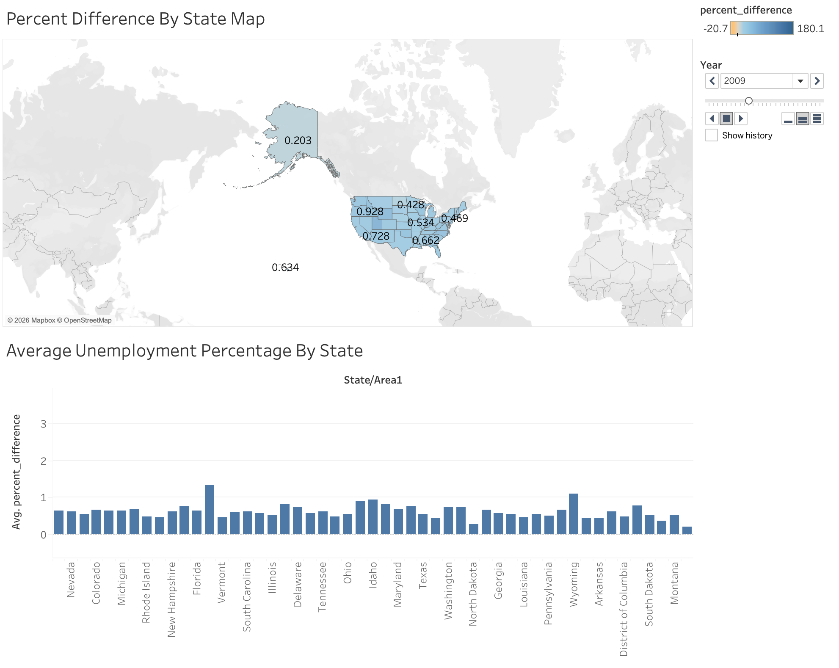
Figure 2c: Percent Difference Unemployment 2009

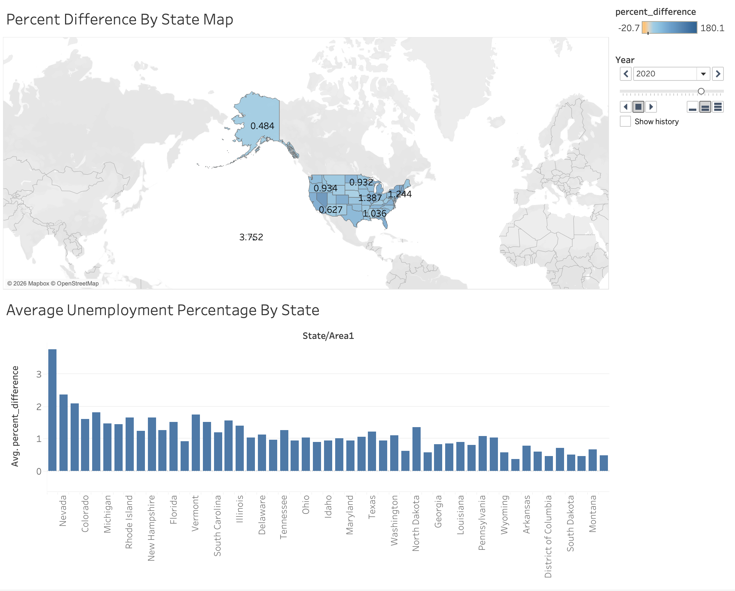
Figure 2d: Percent Difference Unemployment 2021

Figures 2c and 2d again pair a bar chart with a map to illustrate how individual states were affected by the key historical events in 2008 and 2020. In this case, the metric of interest is the percent change in unemployment from one year to the next. Note that in figures 2c and 2d, our interest is the change in unemployment from the previous year. This is why these graphs reference 2009 and 2021, both being one year after their corresponding reference line. The map uses color intensity to represent the change, where darker shades of blue indicate larger increases in unemployment and darker shades of orange represent decreases in unemployment.
By combining the map and bar chart, the visualization allows for quick identification of both the regional patterns and the magnitude of unemployment changes across states.
From these visualizations, we observe that Nevada and California are consistently among the most affected states during these economic downturns. Additionally, the increase in unemployment during the COVID-19 pandemic appears to be larger than the increase observed during the 2008 financial crisis. This indicates that the pandemic produced a broader disruption across the labor market. Importantly, these visualizations only capture immediate impacts of the key historical events, not long term impact.

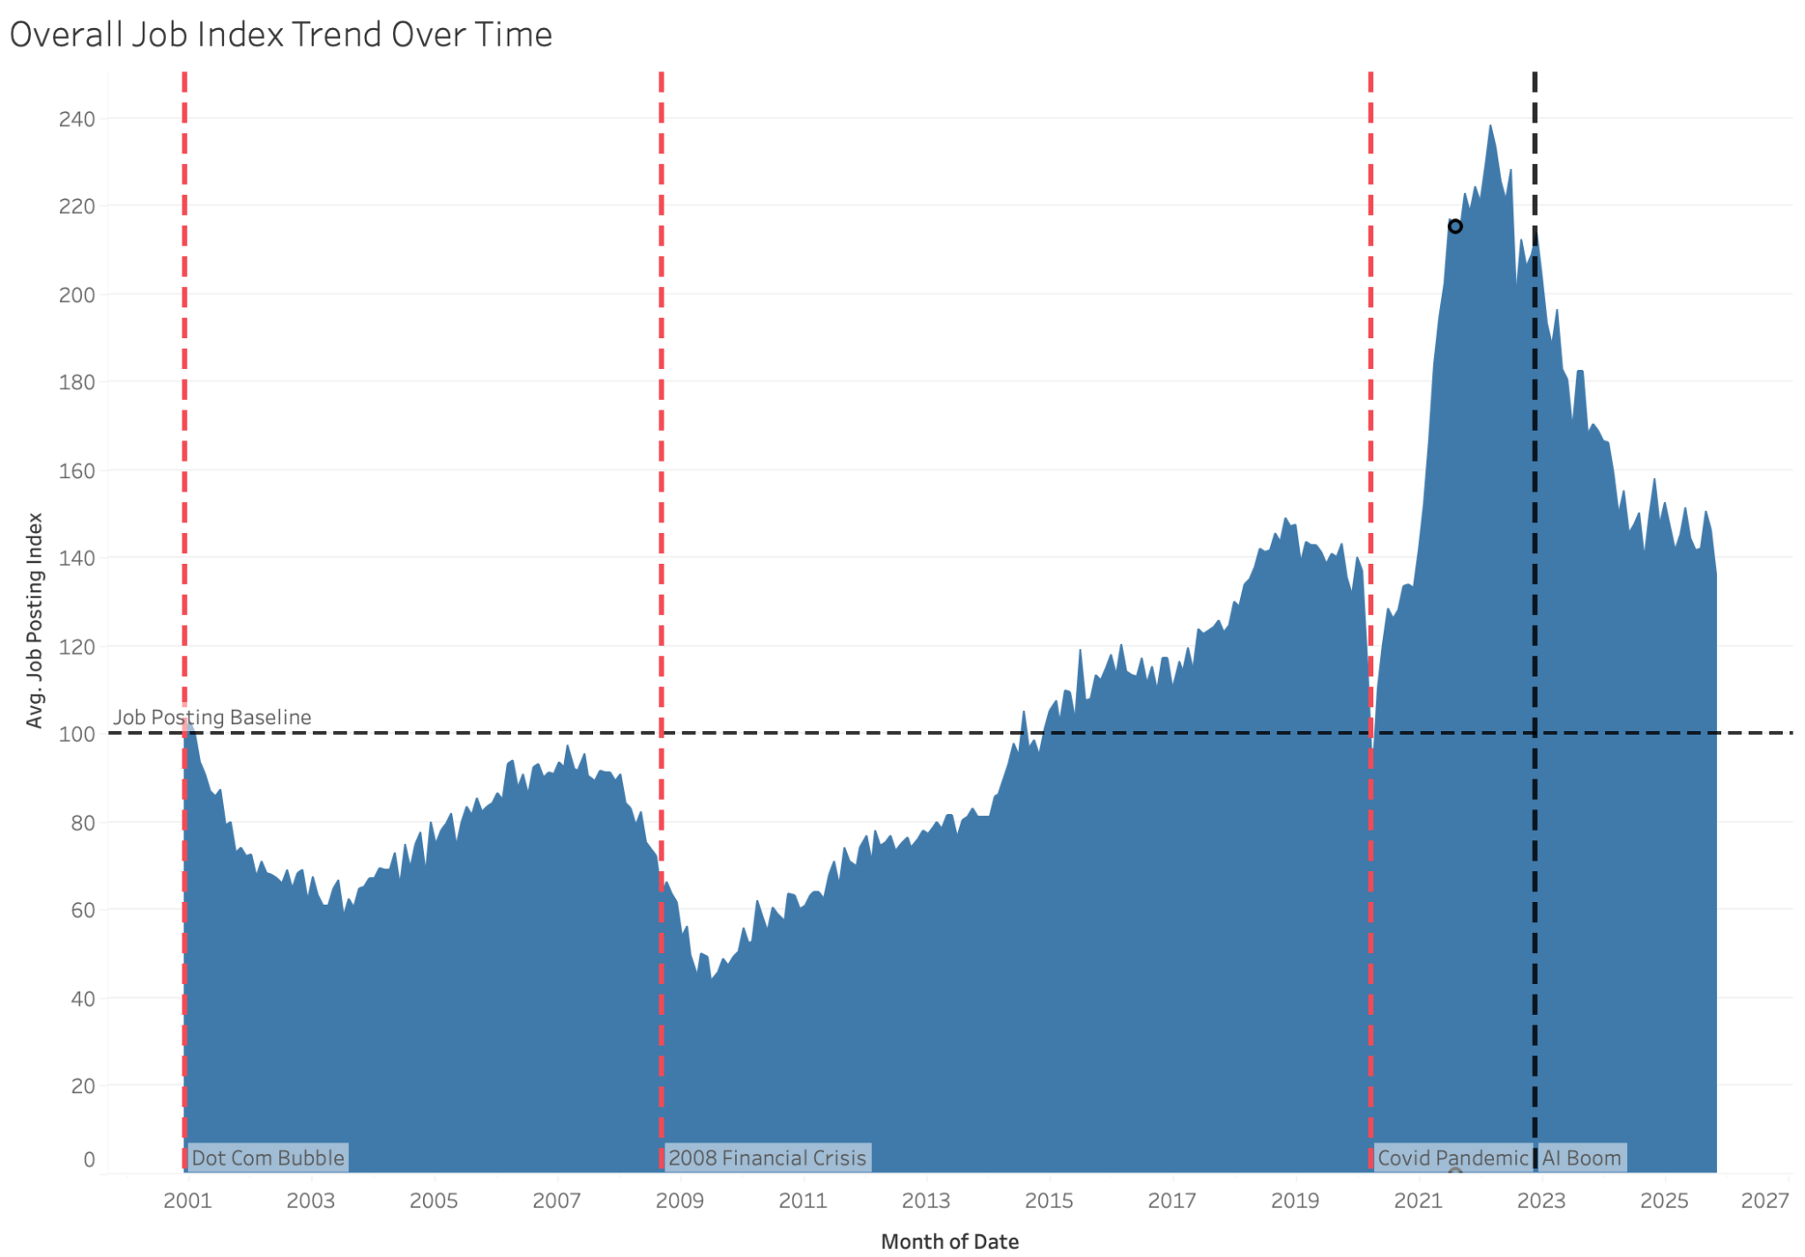
Figure 3: Job Posting Index Over Time

Figure 3 illustrates the job posting index over time using an area chart. This visualization was chosen because it clearly communicates how a variable changes across time while allowing long-term trends and inflection points to be easily identified. The job posting index is normalized to a base value of 100, where deviations from this number represent the percent change relative to the baseline.
When examining the three historical events highlighted in the chart, it is observed that each is followed by a decline in job postings, which is to be expected during major economic disruptions. However, the recovery period following each decline varies significantly. This suggests that there is no consistent recovery timeline for labor market disruptions.
Additionally, the visualization shows that job postings increased substantially following the COVID-19 pandemic, reaching levels well above the baseline before gradually declining again. This pattern indicates a strong rebound in labor demand after the pandemic shock. The decline observed after the AI Boom in 2023 may suggest that artificial intelligence could be influencing hiring patterns and overall job demand.

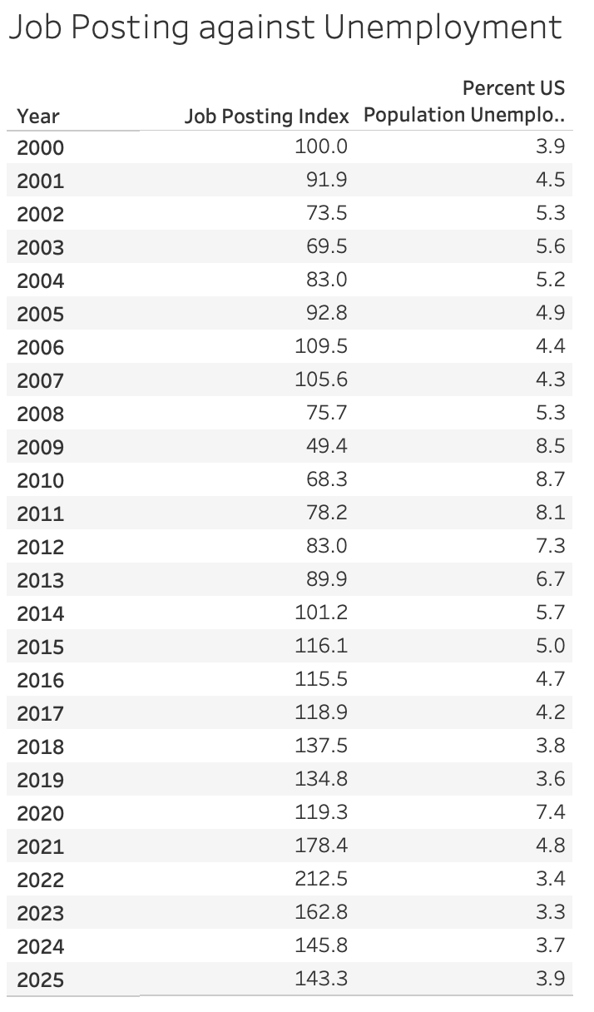
Figure 4: Job Posting vs Unemployment over Years

Figure 4 presents a table comparing unemployment rates and the job posting index across years. The table format allows the exact values of both variables to be displayed simultaneously, enabling precise comparison to complement the overall trends observed in the visualizations. To further illustrate these trends, Figure 5 is shown below.

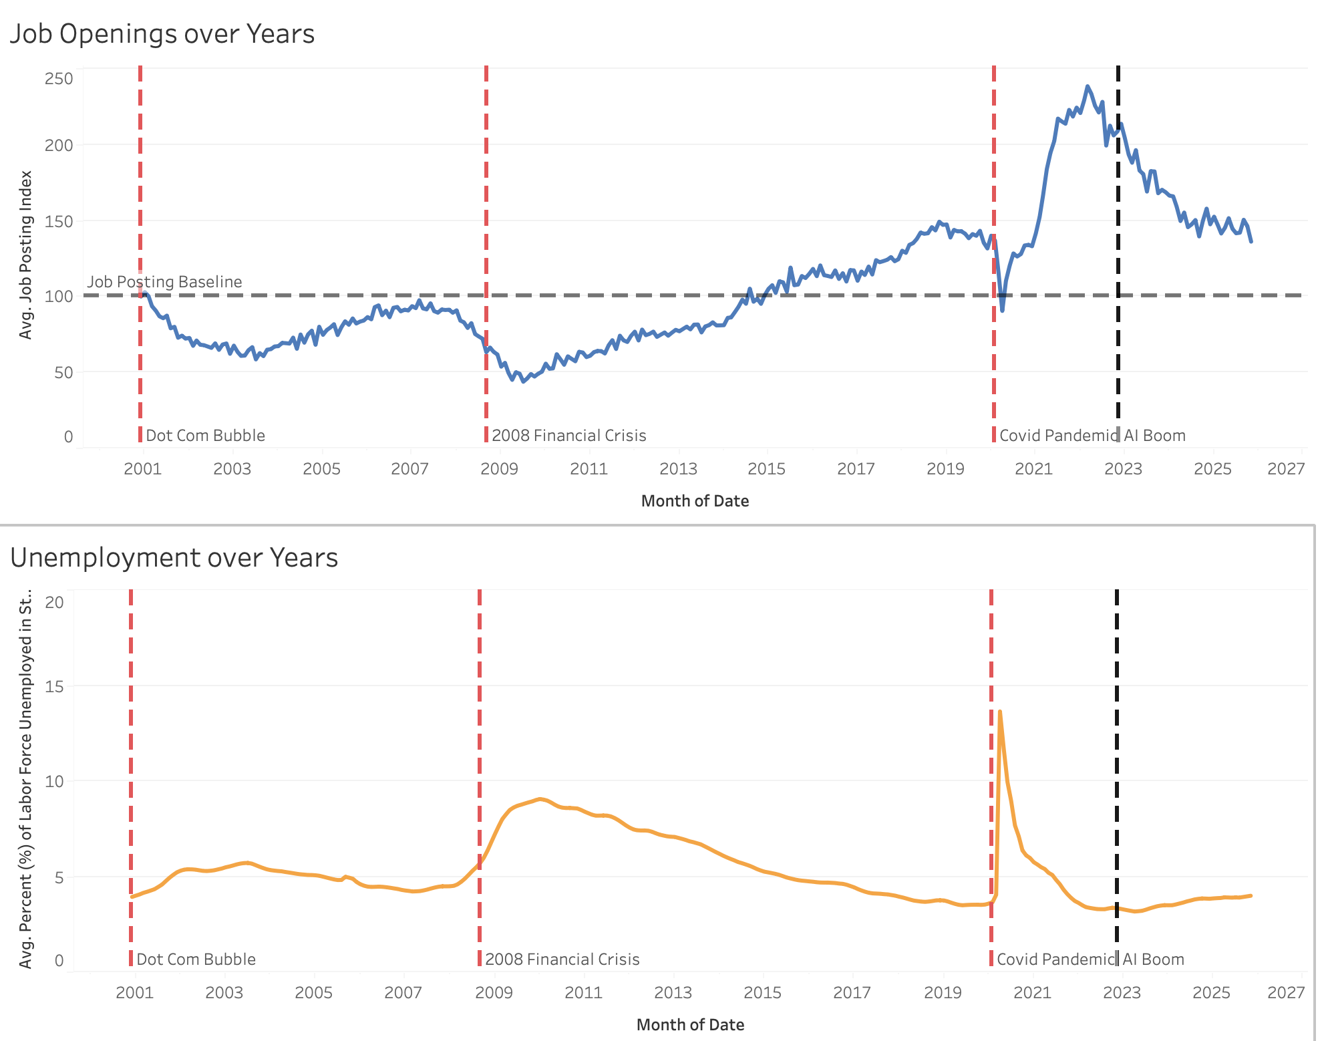
Figure 5: Job Posting Index vs Unemployment

Figure 5 displays unemployment rates and the job posting index as line charts stacked on top of each other in order to highlight their relationship over time. Due to differences in the y-axis scales, separate graphs were used, but they share the same x-axis to allow for direct comparison. Stacking these line charts enables easy comparison of their movements and helps identify patterns between these two indicators. As expected, the visualization suggests an inverse relationship between unemployment and job postings. At the key historical events, this relationship is clearly observed.
Following each economic downturn within our time range, the job posting index decreases while unemployment rises. However, one important observation is that the COVID-19 pandemic had a different effect compared to the other historical events. Specifically, it caused a much more sudden and dramatic shift in both unemployment and job postings, followed by a relatively rapid recovery. This difference may be attributed to the nature of the event, as the pandemic was an unusual and short-term global disruption compared to more prolonged economic crises. While not a conclusive takeaway, this observation could bring about the hypothesis that when looking at economic trends, rapid changes are less likely to sustain than gradual changes.

Discussion and Analysis
Looking back at research questions one and two, we sought to understand how the current job market compares to previous years. To analyze this, 2019 serves as our starting point, as it represents the most recent period prior to the COVID-19 pandemic. At this point just before the start of the pandemic the job posting index was approximately 150. As the pandemic began, job postings sharply declined while unemployment increased, indicating a period of layoffs and reduced hiring. Importantly, this trend did not persist for long. As the economy began to reopen, unemployment declined and job postings rose rapidly, with the job posting index reaching an all time high of approximately 240 between 2020 and the end of 2022.
Just before the release of ChatGPT, referred to as the AI Boom, job postings began to decrease and continued to do so until they plateaued at approximately 150. Therefore, when comparing 2019 to 2025 directly, the job posting index begins and ends at nearly the same level.
This raises the question of how this pattern should be interpreted. One explanation is that during the initial stages of the pandemic, companies had to adjust rapidly, leading to layoffs and a temporary decline in job openings. As the economy began to reopen, companies increased hiring quickly to meet demand, resulting in a sharp rise in job postings. As shown in Figures 4 and 5, however, the job posting index reached an all time high of approximately 240, which may not have been sustainable for the labor market. This could explain the decline in job postings following the post-pandemic surge.
This observation relates to research question three, which examines whether the AI Boom corresponds with a negative shift in the job market. When referencing Figure 4, it is important to acknowledge that while there is a decrease in job postings around this reference point, the job posting index had already been declining prior to the release of ChatGPT. Additionally, the decline plateaued at the pre-COVID job posting level. Therefore, a simple comparison of job postings before and after this event does not provide sufficient evidence to conclude that the AI Boom represents a clear inflection point in the labor market.
However, it is important to note that over the course of the documented timeline, the job posting index increased, as it needed to grow alongside the population of the United States in order to remain healthy. Therefore, the fact that the net change of the job posting index did not improve from 2019 to 2025 indicates that the job market did not fully recover to its previous healthy state, and we cannot rule out that the AI Boom is a potential contributing factor.
That said, a simple comparison of net job opening index may not be an ideal indicator, as it is important to consider long-term expectations for labor market growth. Over time, job postings are expected to increase alongside population growth and economic expansion. From this perspective, the limited improvement in the job posting index between 2019 and 2025 may suggest that the labor market has not fully returned to its previous trajectory. While this analysis cannot establish a causal relationship, it leaves open the possibility that the AI Boom may be one of several contributing factors influencing recent hiring trends.
Finally, we examine research question four, which asks whether certain states or regions are more susceptible to unemployment during economic downturns. The analysis suggests that this is indeed the case. In particular, California and Nevada appear to be the states most affected by economic downturns. Several factors may contribute to this pattern, including the types of industries concentrated in these states, housing market dynamics, and local economic conditions.

Conclusion
Our analysis of unemployment and job openings indicates that the health of the United States labor market has weakened relative to the period prior to the COVID-19 pandemic. As of 2025, the job posting index has not shown a sustained increase beyond the levels observed before the pandemic began. While definitive conclusions cannot be drawn from our analysis, the AI Boom could be a factor contributing to the lack of job index growth over an extended period.

References
Oh, J. (n.d.). Unemployment in America, per U.S. state [Data set]. Kaggle. https://www.kaggle.com/datasets/justin2028/unemployment-in-america-per-us-state

Federal Reserve Bank of St. Louis. (n.d.). FRED: Federal Reserve Economic Data. https://fred.stlouisfed.org/

U.S. Bureau of Labor Statistics. (n.d.). Job openings and labor turnover survey (JOLTS). https://www.bls.gov/jlt/

