DATS 6450 BigData & Cloud Computing
Project: Team 1 - Torque Diagnostics (A Virtual Industrial Technician)
Initial EDA results and updated questions
This note records the first look at the ABB collection and the two sample answers we have already checked by hand. The counts below come from ABB_100GB_Download_List.csv. The answers come from paragraph text. Ruled-table text and figure text are outside this EDA, for the reasons in the extraction section, and the question list at the end follows that limit.

What the collection contains
The download list has 28,666 English PDFs, and every document id appears once. The file sizes add up to 101.84 GB. A title that names a series goes in that series folder. ACS880-11 and ACS860 are examples. A file with no series in the title, including catalogues, articles, and brochures, goes in library. That rule produces 139 folders: 138 named equipment folders and library.
Group | PDFs | Size
All files | 28,666 | 101.84 GB
library | 25,873 (90.3%) | 78.67 GB (77.2%)
Named equipment folders | 2,793 (9.7%) | 23.17 GB (22.8%)
ACS880, across 41 folders | 288 | 2.83 GB
ACS880-11 | 8 | 74.2 MB
ACS860 | 9 | 137.2 MB

Table 1. File counts after the equipment-folder rule. Each document id is in one folder.
Library holds most of the collection. A question that names a drive can search one small folder. The flange-mount question names ACS880-11, which is 8 PDFs. The automatic-reset question names ACS860, which is 9 PDFs. A question that names no series searches library.
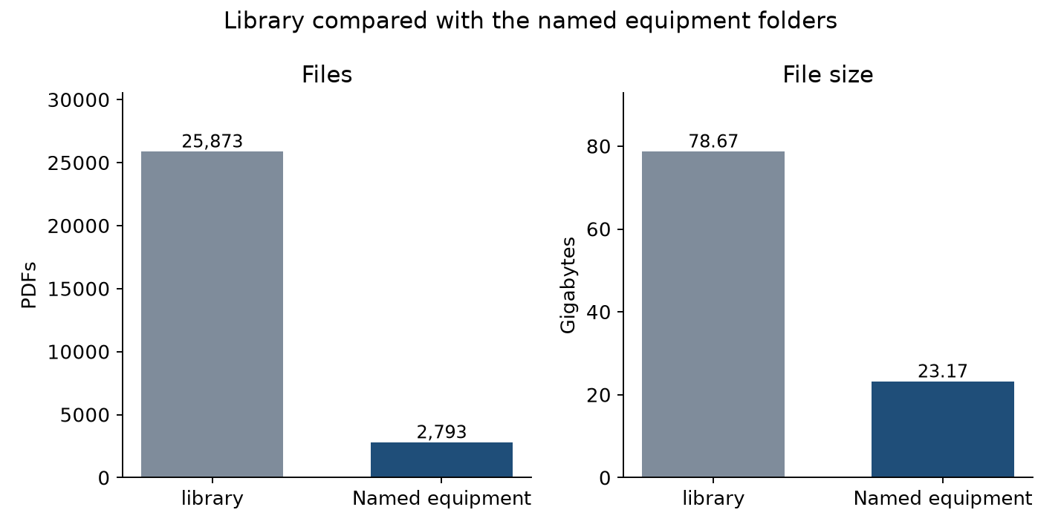
Figure 1. Library and the named equipment folders, with files and size on separate scales.

Document kinds
File count and file size describe different parts of the collection. Data sheets are the largest group by count and a small group by size. Manuals are fewer files and the largest group by size, so the long procedure text sits in the manuals. Articles and catalogues are smaller by count and still account for 15.00 GB and 11.72 GB. Those kinds land in library when the title does not name a series.
Document kind | PDFs | Size
Data sheet | 10,491 | 6.35 GB
Manual | 6,754 | 34.17 GB
Instruction | 4,434 | 9.40 GB
Information | 2,491 | 1.59 GB
Application note | 1,146 | 1.57 GB
Technical description | 885 | 0.90 GB
Technical publication | 663 | 1.32 GB
Brochure | 404 | 8.32 GB
Catalogue | 391 | 11.72 GB
Article | 376 | 15.00 GB
All other kinds | 631 | 11.50 GB

Table 2. The ten largest document kinds by file count. Article is included because it is small by count and large by size. The last row is every remaining kind.
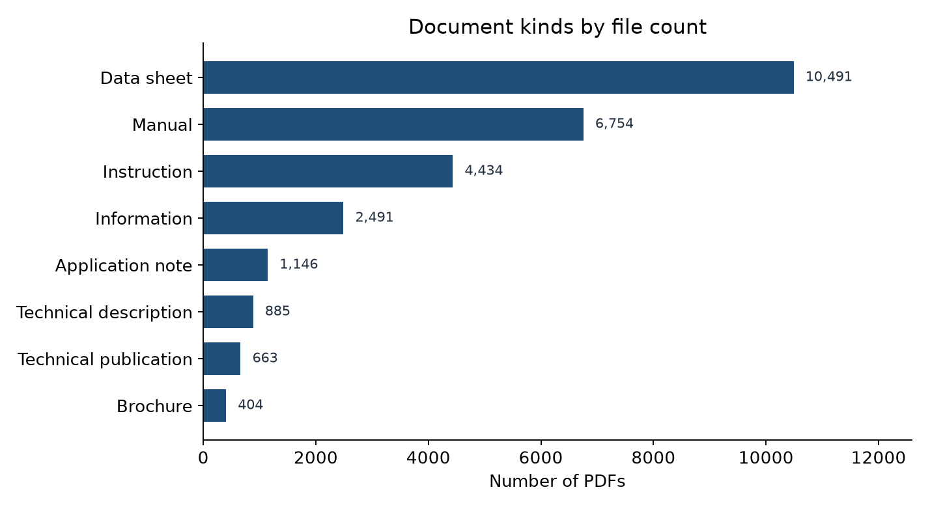
Figure 2. The eight document kinds with the most PDFs. Data sheets lead the count.
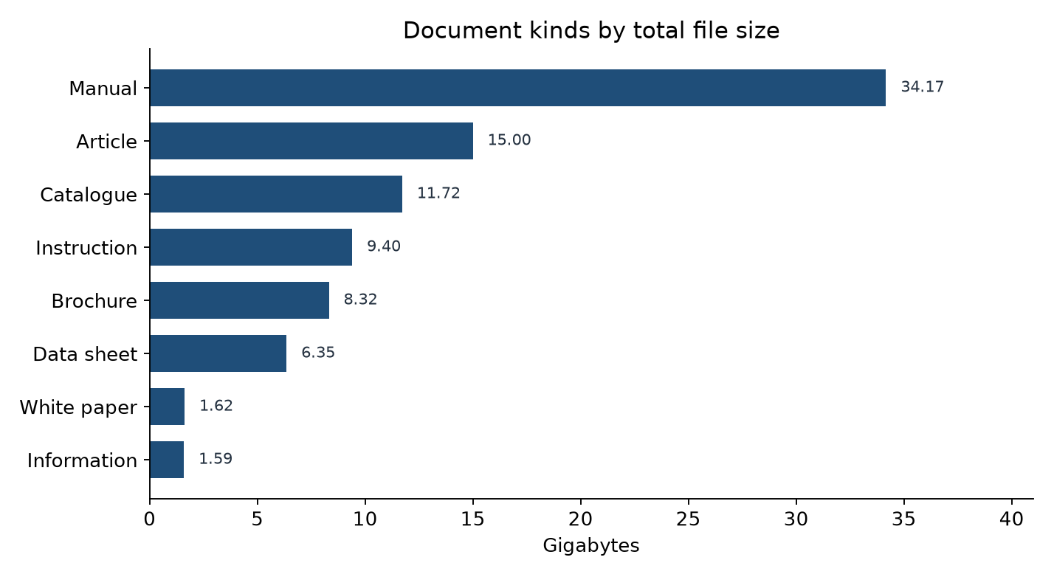
Figure 3. The eight document kinds with the most gigabytes. Manuals lead the size, then articles and catalogues.
Most files are small. 18,391 PDFs are under 1 MB, 7,706 are from 1 to 10 MB, 2,262 are from 10 to 50 MB, and 307 are 50 MB or larger. The largest file is the System pro E power TBBS manual 2019, document 1STM604200R0002, at 920.73 MB. A large file can be a catalogue with little technician procedure in its paragraph text.
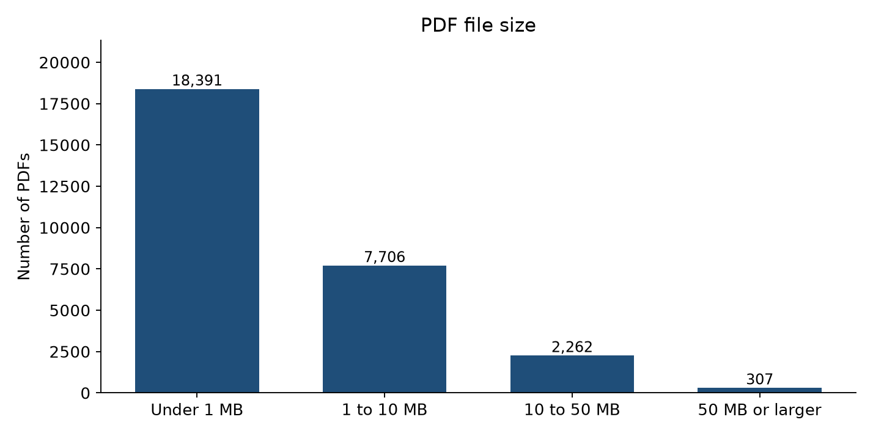
Figure 4. PDFs by file size. Most of the list is under 1 MB.

Named equipment folders
Outside library, the folders are small. IRB has 276 PDFs, Emax 175, System-800xA 140, and the plain ACS880 folder 121. ACS880 text is split across 41 folders and 288 PDFs, 2.83 GB in total. The reply searches the folder named in the question, so an ACS880-11 question stays with those 8 files and does not scan the 78.67 GB in library.
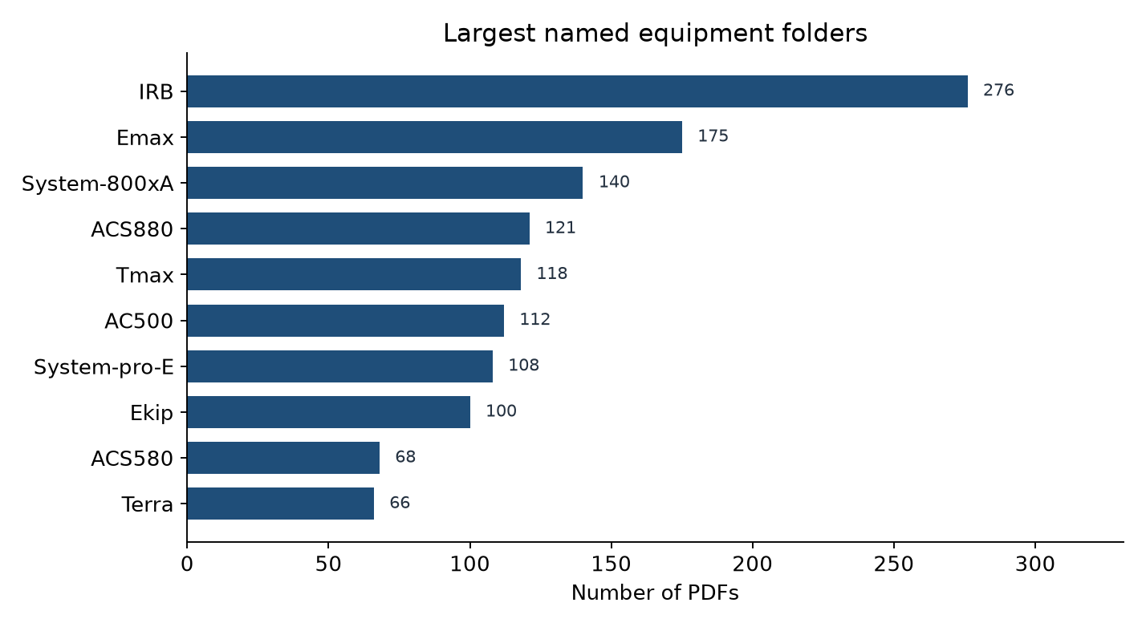
Figure 5. The ten named folders with the most PDFs. Library is left off this chart so the equipment folders stay visible.

Paragraph text, tables, and figures
The text pass stored paragraph passages for 28,665 of the 28,666 PDFs. Those files hold 831,185 passages, and a passage stays on one page. The token files, the BM25 index, and the BAAI/bge-base-en-v1.5 embedding index were built from that paragraph text. The two sample answers below were retrieved from those indexes.
Table text is not in this EDA and is not in the index. pdfplumber turns every line and curve on a page into Python objects. On the ACS880-11 quick installation and start-up guide, document 3AXD50001419028, a 25.33 MB file of 356 pages, that pass was killed by Linux after the process passed the 16 GB of memory on the instance. The drawing pages are what drive the memory up. A full pass over the remaining manuals would repeat that spike on every dense drawing, so we stopped the table extraction and left the search index on paragraph text.
Figure text is not in this EDA and is not in the index. Tesseract does not carry these technical drawings: the pages are dense vector art, and a full optical-character pass overloads the same 16 GB instance without producing reliable procedure text. Gemini can read a figure, and each image spends paid tokens. We did not send the collection to Gemini.
A technician question whose answer is written in a paragraph can be cited from the index we have. A value that exists only inside a ruled table or a figure has no passage to cite, and the reply withholds the step.

Sample answers and the confidence label
We asked two questions whose correct pages we had checked in the manuals. The reply retrieved 15 passages, Qwen2.5-7B-Instruct drafted an answer from those passages, and the program attached the document and page. Each kept sentence was then labeled. The label is copied-sentence when the kept line is already a sentence on the retrieved page. The label is deberta when only part of the claim is on the page and DeBERTa v3 has to decide. The label is withheld when the retrieved pages do not state the claim. On both sample answers the label was copied-sentence, and DeBERTa was called zero times.
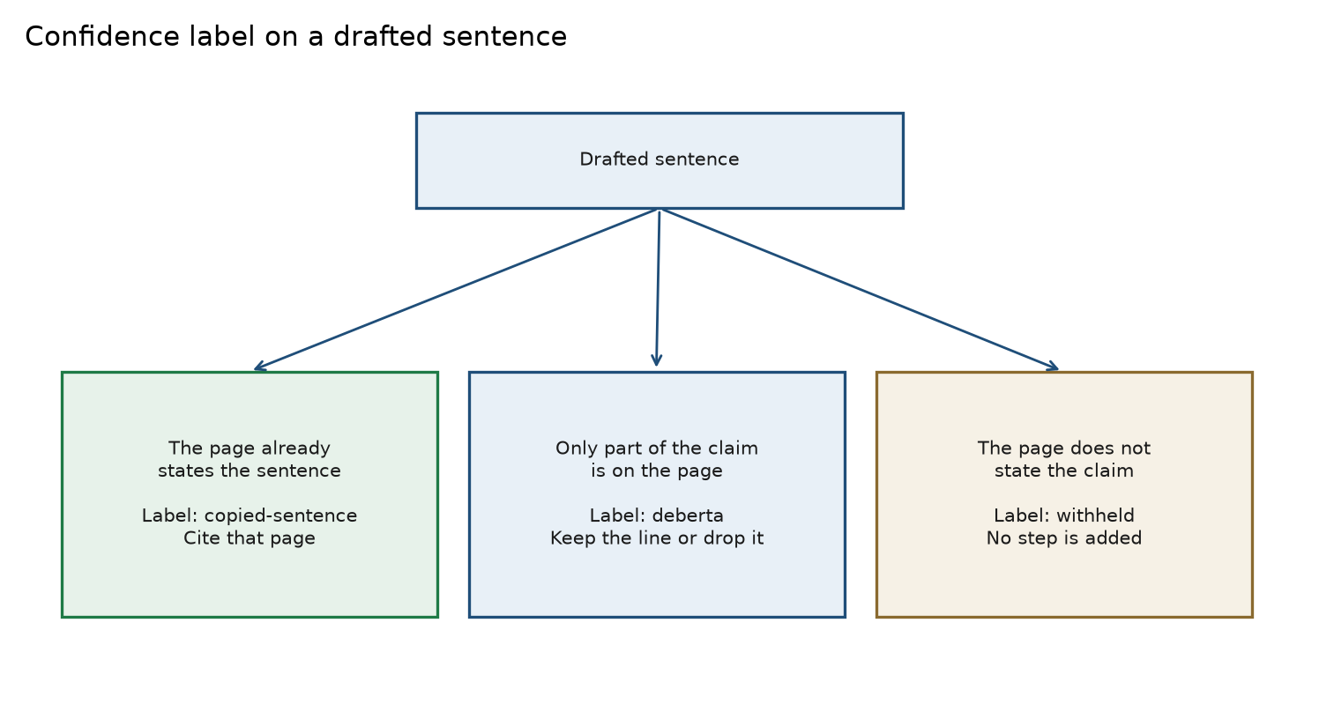
Figure 6. The confidence label is chosen from the drafted sentence and the retrieved page. DeBERTa runs only for a partial paraphrase.
Question | Hand-checked pages | Pages cited in the answer | Confidence
What tools are needed to flange-mount an ACS880-11? | 3AXD50000349838, page 17 | 3AXD50000349838, page 17 | copied-sentence; DeBERTa calls = 0
Which faults can the ACS860 reset automatically? | 3AXD50000034052, page 68; 3ABD00069490, page 27 | 3AXD50000034052, page 68; 3AXD50000034052, page 213 | copied-sentence; DeBERTa calls = 0

Table 3. The two hand-checked questions. Both answers copied a sentence from a retrieved page.
The flange-mount answer cites the checked page and lists the drill, screwdriver set, torque wrench, socket set, and hex key set from that page. The ACS860 answer cites page 68, the checked sentence on overcurrent, overvoltage, undervoltage, and external faults. It also cites page 213 of the same document for the drive-interlock exception. That sentence was copied from a retrieved page, and page 213 is not in the hand-checked set. Page 27 of 3ABD00069490 is in the hand-checked set and was retrieved, and the answer does not cite it.
Precision, recall, F1, and mean reciprocal rank are reported on the pages the answer cites, and the confidence label is reported with them. A cited page is correct when its document id and page number are in the hand-checked set. Precision is the share of cited pages that are checked pages. Recall is the share of checked pages that the answer cites. F1 is their harmonic mean. MRR is 1 divided by the position of the first correct citation. The 15-passage list has its own F1, and that number stays low whenever 15 pages are retrieved and only one or two are marked, even when the citation itself is right.
Question | 15-passage F1 | Citation precision | Citation recall | Citation F1 | Citation MRR | Confidence
Flange-mount tools | 0.125 | 1.00 | 1.00 | 1.00 | 1.00 | copied-sentence
ACS860 automatic reset | 0.235 | 0.50 | 0.50 | 0.50 | 1.00 | copied-sentence
Mean of the two | 0.180 | 0.75 | 0.75 | 0.75 | 1.00 | copied-sentence

Table 4. The 15-passage F1 describes the retrieved list. The citation columns describe the pages named in the answer, with the confidence label beside them. DeBERTa calls were 0 on both answers.
On the flange-mount question the answer cites only the checked page, so citation precision, recall, and F1 are 1, and the confidence label is copied-sentence. On the ACS860 question one of the two citations is a checked page and one of the two checked pages is cited, so citation precision, recall, and F1 are 0.50. The first citation is page 68, so citation MRR is 1. The confidence label is still copied-sentence, because both cited sentences were copied from retrieved pages, including the page-213 sentence that is outside the hand-checked set.

Updated questions
These twelve questions replace the list in the proposal. They follow the file counts above, the paragraph-text index, and the confidence label on the cited pages. Question 10 asks for citation precision, recall, F1, and MRR together with that confidence label. Question 12 asks what the reply does when the requested fact is only in a table or a figure.

Exploratory data analysis
1. Library holds 25,873 PDFs and 78.67 GB. When a question names no drive, what share of the retrieved paragraph pages comes from library catalogues and articles?
2. Data sheets are 10,491 files and 6.35 GB, while manuals are 6,754 files and 34.17 GB. Does the paragraph text of a data sheet state a procedure, or ratings and ordering facts?
3. ACS880 text is split across 41 folders and 288 files. When the question says ACS880-11, does the search stay inside those 8 PDFs?
4. 18,391 PDFs are under 1 MB and 307 are 50 MB or larger. Are the largest files manuals and catalogues, and does their paragraph text stay on one page after the page split?
5. Paragraph text is indexed for 28,665 PDFs. Table text is out because pdfplumber passed 16 GB on a 356-page guide, and figure text is out because Tesseract overloads the instance and Gemini spends paid tokens on each image. Which technician questions can be answered from paragraphs alone?

Natural language processing
6. For the flange-mount question and the ACS860 automatic-reset question, which document and page does the reply cite, and is that page in the hand-checked set?
7. The ACS860 answer cites page 68 and page 213 of 3AXD50000034052. Is the page-213 sentence copied from a retrieved page, and why is page 27 of 3ABD00069490, which was retrieved and hand-checked, left uncited?
8. When the confidence label is copied-sentence, which document and page are cited, and which drafted words are dropped?
9. When the retrieved paragraphs do not state the requested step, does the reply use the withheld label instead of adding a step from a nearby page?

Statistics and machine learning
10. On questions where we can name the correct document and page, what precision, recall, F1, and mean reciprocal rank do the pages cited in the answer get, and what confidence label is attached to that answer? A cited page is correct only when the document id and page number match. The label is copied-sentence, deberta, or withheld. The 15-passage F1 is recorded beside that citation score so the retrieved list and the final answer stay separate.
11. Across the hand-checked set, how often is the confidence label copied-sentence, how often is it deberta, and how often is the answer withheld? On the two sample questions the label was copied-sentence and DeBERTa was called zero times.
12. For a question whose answer is written only in a ruled table or a figure, what citation precision, recall, and confidence label does the paragraph-text reply get? The result we expect is the withheld label, because that text is not in the index.

