**PART 1:MYSQL OUTPUTS**

**THE TABLE:**

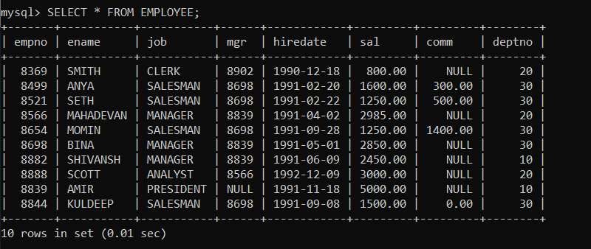

Question1:

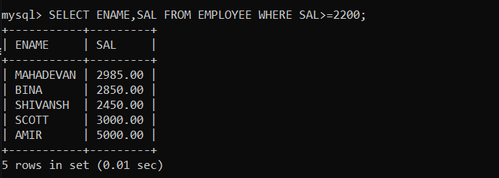

Question 2:

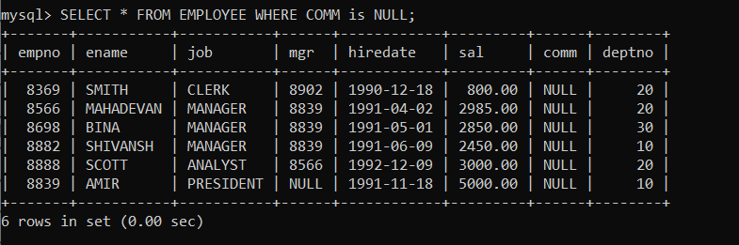

Question 3:

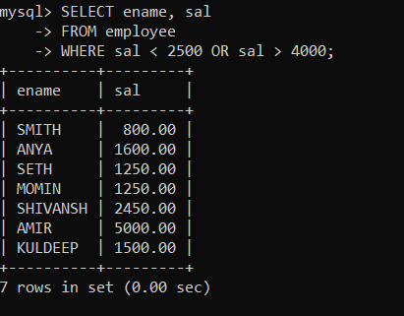

Question 4:

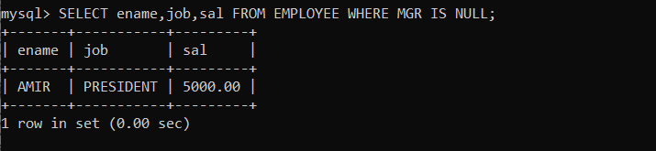

Question 5:

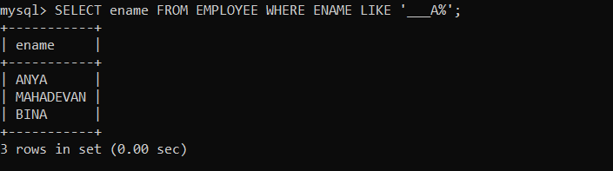

Question 6:

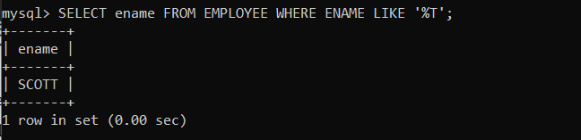

**PART 2: JDBC CONNECTION OUTPUT:**

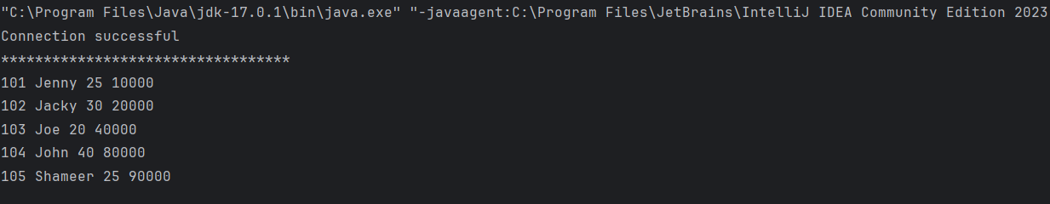

**CODE:**

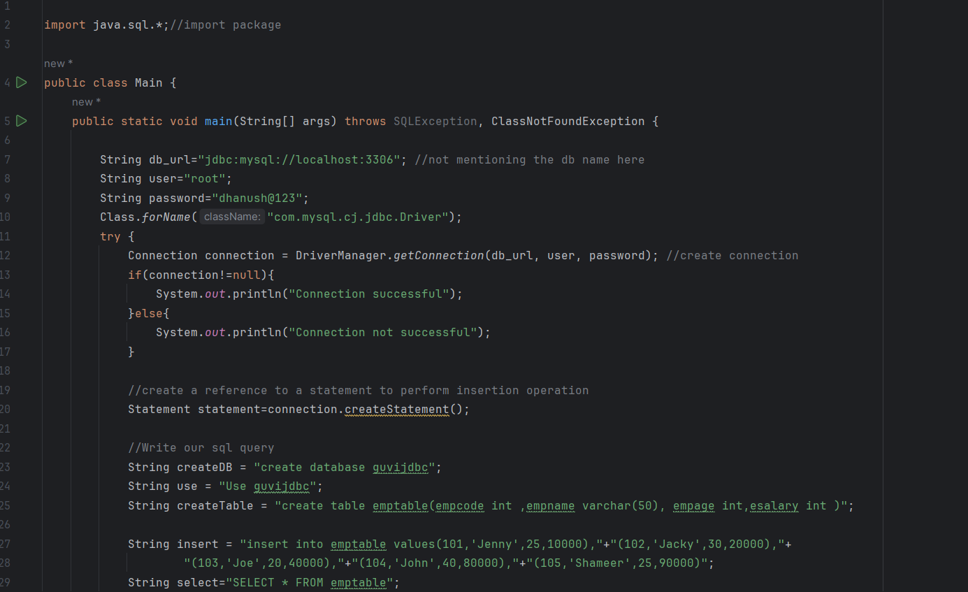

**CODE CONTINUED:**

