**Question 1:**

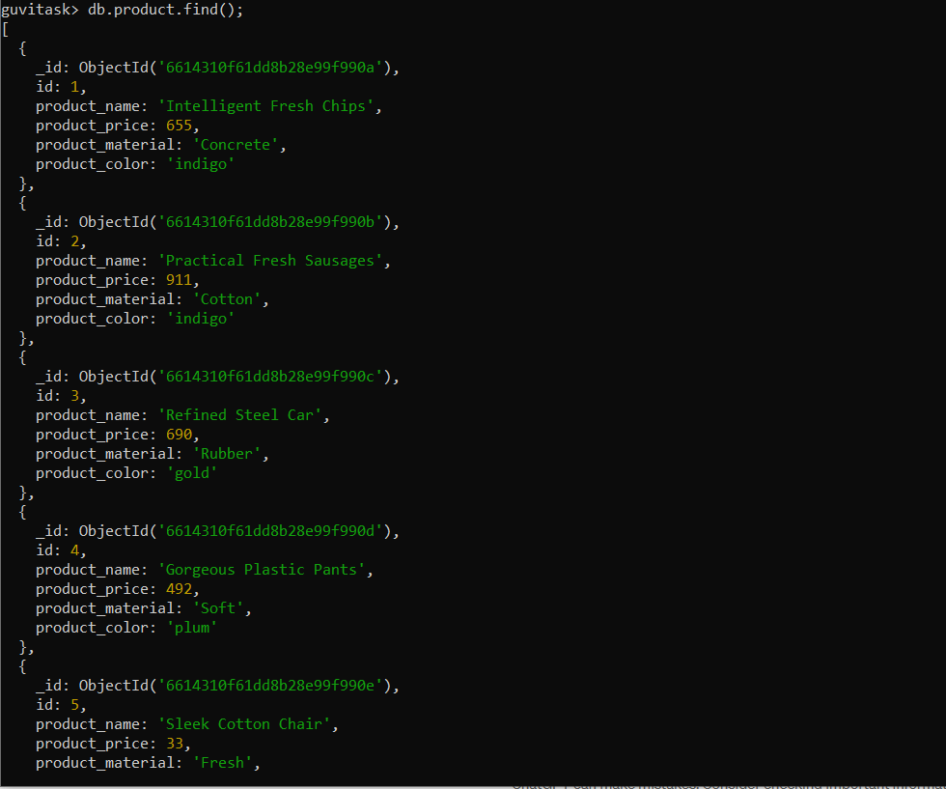

**Question 2:**

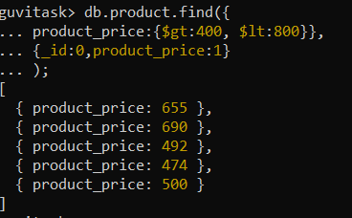

**Question 3:**

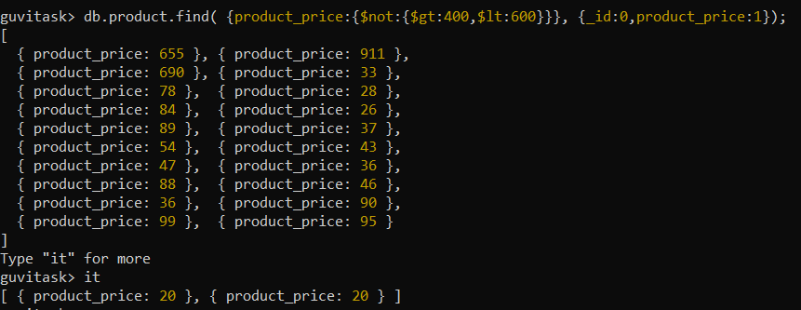

**Question 4:**

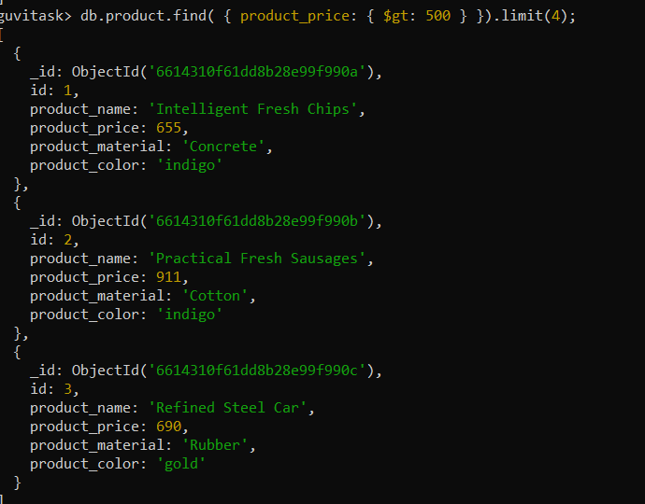

**Question 5:**

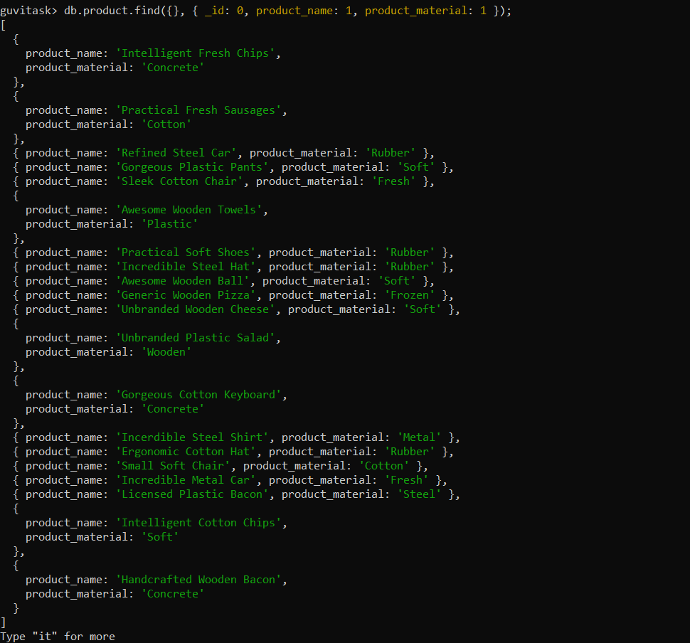 **There is more data but when we type “it”.**

**Question 6:**

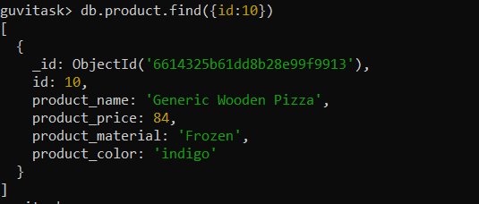

**Question 7:**

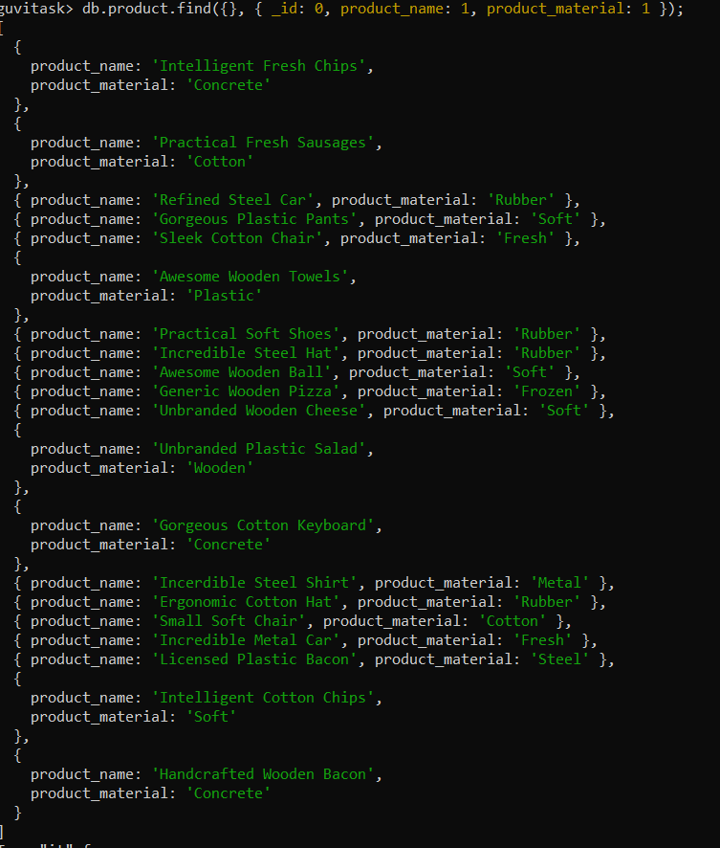

**Question 8:**

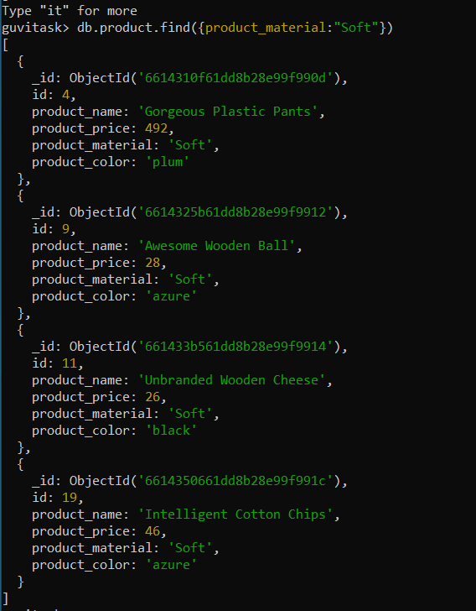

**Question 9:**



**Since there are no documents with color indigo and price 492.00 we didn’t retrieve any documents.**

**Question 10:**

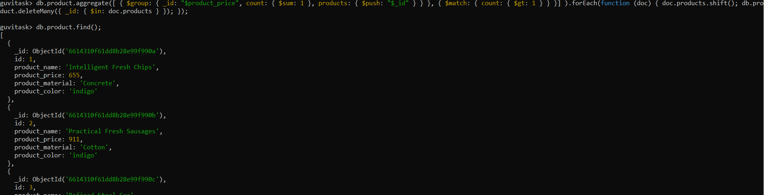

**We have got 24 records instead of 25 which means that the duplicate document has been deleted:**