To display all books:

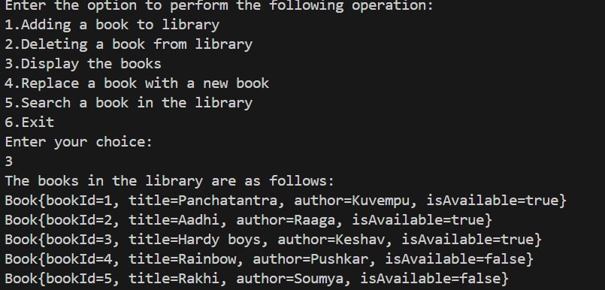

To search particular book:

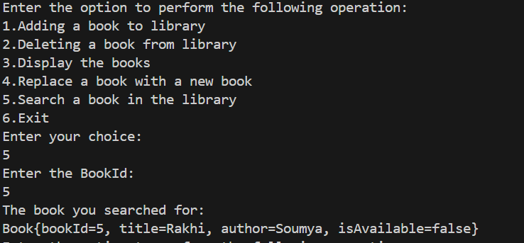

To replace a book:

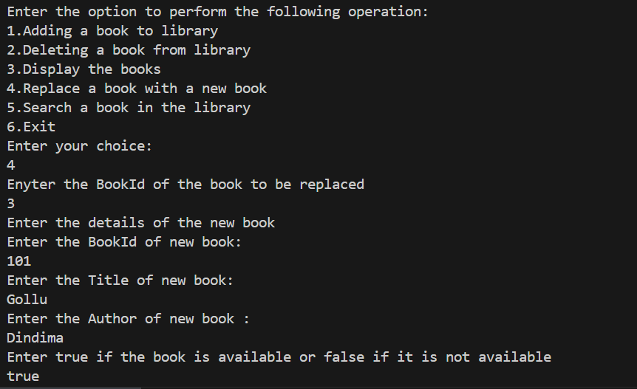

Continued:

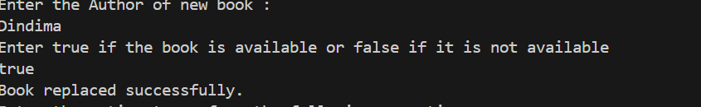

Now if we display all the books we get:

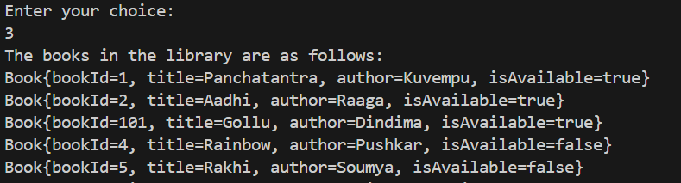

The book is successfully replaced.

To delete a book:

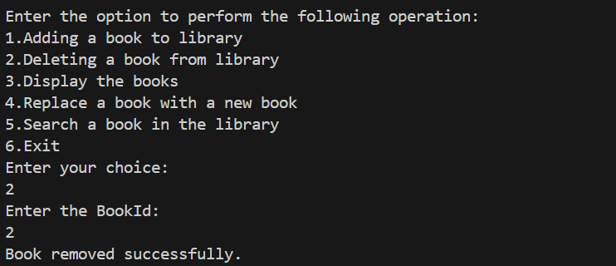

Now if all the books are displayed:

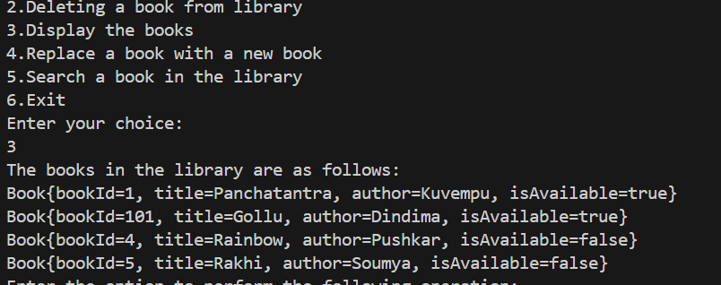

The book of id 2 is deleted.

Corner case 1:

What if the array or the stack is full, we get:

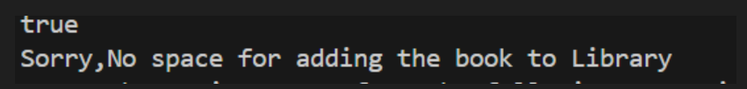

Corner case 2:

What if we try to delete the book when no book is present:

