TO WHOMSOEVER IT MAY CONCERN

Declaration and Authorization

I hereby authorize **E2open Software India Pvt Ltd** and its authorized representatives to verify information’s provided in my resume and application of employment, and to conduct enquires as may be necessary, at the company's discretion. I authorize all persons who may have information relevant to this enquiry to disclose it to **E2open Software India Pvt Ltd** or its representative. I release all persons from liability on account of such disclosure.

I hereby authorize concerned authorities to dispatch my confidential information to **E2open Software India Pvt Ltd** or its authorized representative.

Signed: 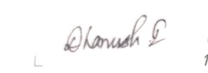

Name: DHANUSH.I

Date:16/04/2024