1. Download and install Java 1.8 and above
   1. Set path environment variable to the location where you installed jdk under that bin directory
      1. Example: C:\Program Files\Java\jdk1.8.0_251\bin
   2. Set JAVA_HOME environment variable to the location where you installed JDK
      1. Example: C:\Program Files\Java\jdk1.8.0_251
2. Download maven using below link:
   1. <http://mirror.cc.columbia.edu/pub/software/apache/maven/maven-3/3.6.3/binaries/apache-maven-3.6.3-bin.zip>
3. Unzip the maven download from step# 2 to some location in your local drive.
4. Create environment variables and set value to the patch where you unzipped Maven
   1. M2_HOME
   2. MAVE_HOME
   3. 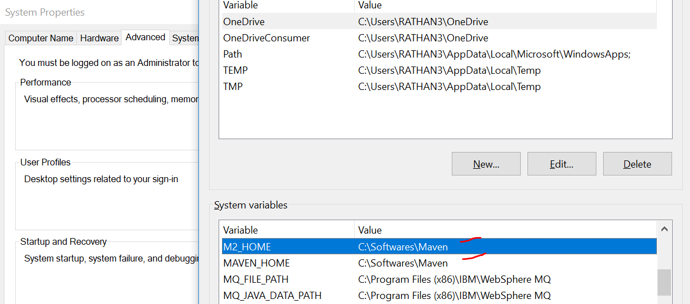
   4. Update path variable by adding Maven install directory \bin
      1. Example: C:\Softwares\Maven\bin
5. If you want to run application via eclipse you can download or copy the eclipse file from the shared driver from step# 2 (**this step is optional**)
6. Open the command prompt and run below command
   1. mvn -version
      1. you should see something similar to below:
         1. 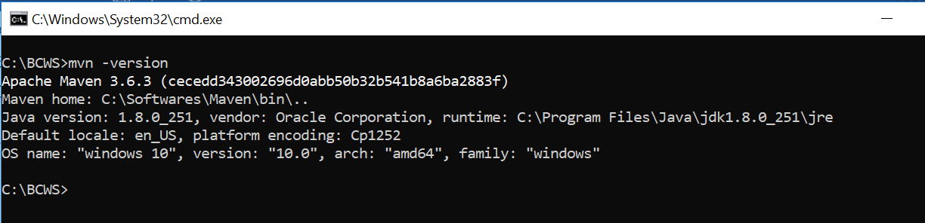
7. Unzip the attached file in C: (this is mandatory to save under C:, failing which you need to change the code).
8. In the command prompt navigate to C:\BCWS and run below command

mvn test

1. The above command will execute the test by opening the browser and display the results in the command prompt something similar to below based on the test status
   1. 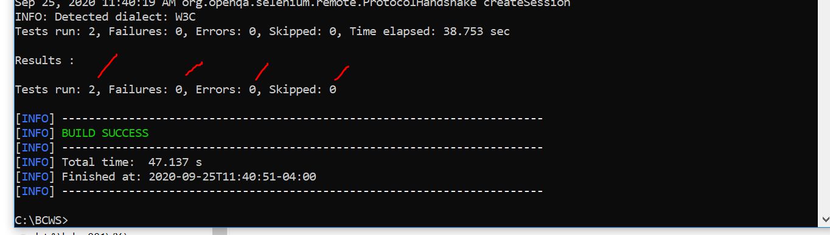
2. For the user-friendly report navigate to below folder and open emailable-report.html
   1. C:\BCWS\target\surefire-reports