ADVANCED SPAM SMS DETECTION USING BAYES THEOREM
M.Tech-Level Explainable NLP Project
Algorithm: Multinomial Naive Bayes with TF-IDF and Explainable AI

Abstract
This project develops an explainable SMS spam detection system using Natural Language Processing (NLP) and the Multinomial Naive Bayes classifier. SMS messages are cleaned, converted into TF-IDF feature vectors, and classified as Ham or Spam. The system also explains its decisions using Bayesian probabilities, entropy, influential-word analysis, and confidence visualizations. The implementation follows the workflow in the submitted Python/Colab project.

Objectives
- Classify SMS messages as Ham or Spam.
- Implement Bayes' Theorem using Multinomial Naive Bayes.
- Convert text into numerical vectors using TF-IDF.
- Explain predictions using posterior probabilities and influential words.
- Visualize confidence using four analytical charts.

Dataset
The project uses the SMS Spam Collection Dataset containing 5,572 SMS messages, with Ham and Spam labels. The code loads the dataset, preprocesses the text, and trains the model on an 80:20 train-test split.
Training workflow and preprocessing are implemented in the submitted code, including TF-IDF vectorization and Multinomial Naive Bayes training.

System Workflow
Input SMS → Text Cleaning → TF-IDF Vectorization → Train-Test Split → Multinomial Naive Bayes → Bayesian Probability Calculation → Prediction → Explainable AI Charts

Theory and Mathematical Concepts

1. Bayes' Theorem
Bayes' Theorem updates the probability of a class after observing evidence.
P(C|X) = [P(X|C) × P(C)] / P(X)
C represents the class (Spam or Ham) and X represents the SMS message.

2. Prior Probability
The prior probability is the probability of a class before seeing a new message.
P(Ham) = Ham Messages / Total Messages
P(Spam) = Spam Messages / Total Messages
The project calculates these values automatically from the dataset.

3. Posterior Probability
The posterior probability is the probability after observing the words in the SMS.
P(Ham|X) and P(Spam|X)
The class with the larger posterior probability becomes the prediction.

4. TF-IDF Vectorization
TF = Frequency of a word / Total words
IDF = log(N / (df + 1))
TF-IDF = TF × IDF
TF-IDF assigns higher importance to informative words while reducing the influence of common words.

5. Multinomial Naive Bayes
The classifier assumes that words contribute independently to the class probability.
P(C|X) ∝ P(C) × Π P(wi|C)
Scikit-learn computes probabilities in logarithmic space for numerical stability.

6. Laplace Smoothing
P(w|C) = (Count(w,C)+1) / (Total Words + Vocabulary Size)
Laplace smoothing prevents zero probabilities for unseen words.

7. Log-Likelihood
log P(C|X) = log P(C) + Σ log P(w|C)
Logarithms avoid numerical underflow when multiplying many small probabilities.

8. Information Entropy
Entropy = −Σ pi log2(pi)
Lower entropy indicates higher prediction confidence.

Project Implementation
1. Load the SMS dataset.
2. Convert text to lowercase and remove punctuation.
3. Generate TF-IDF vectors.
4. Split the dataset into training and testing sets.
5. Train the Multinomial Naive Bayes classifier.
6. Predict Ham/Spam probabilities.
7. Compute posterior probabilities, entropy, confidence, and log-posterior scores.
8. Display four explainable AI charts.

Output Interpretation
The prediction screen displays the original message, Ham/Spam prediction, posterior probabilities, prior probabilities, confidence score, entropy, and log-posterior scores, followed by four analytical charts that explain the model's decision.

Visualization Results
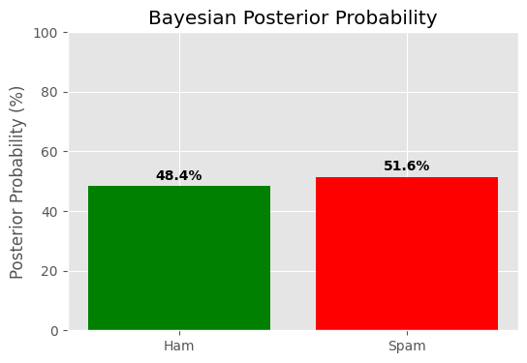
Figure 1: Bayesian Posterior Probability
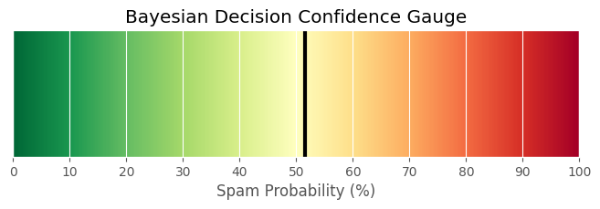
Figure 2: Bayesian Decision Confidence Gauge
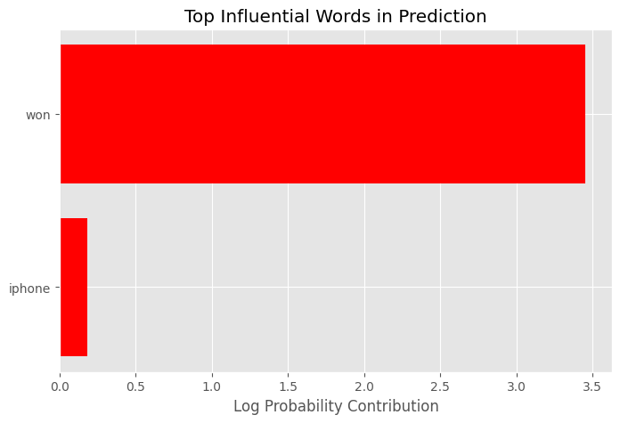
Figure 3: Top Influential Words
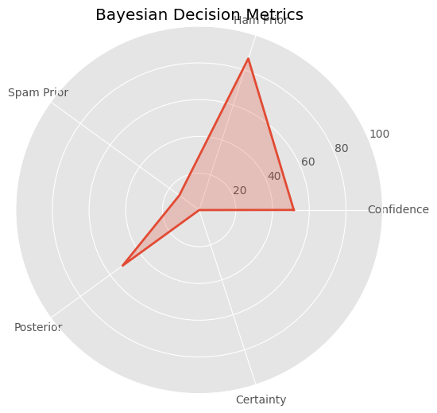
Figure 4: Bayesian Decision Metrics
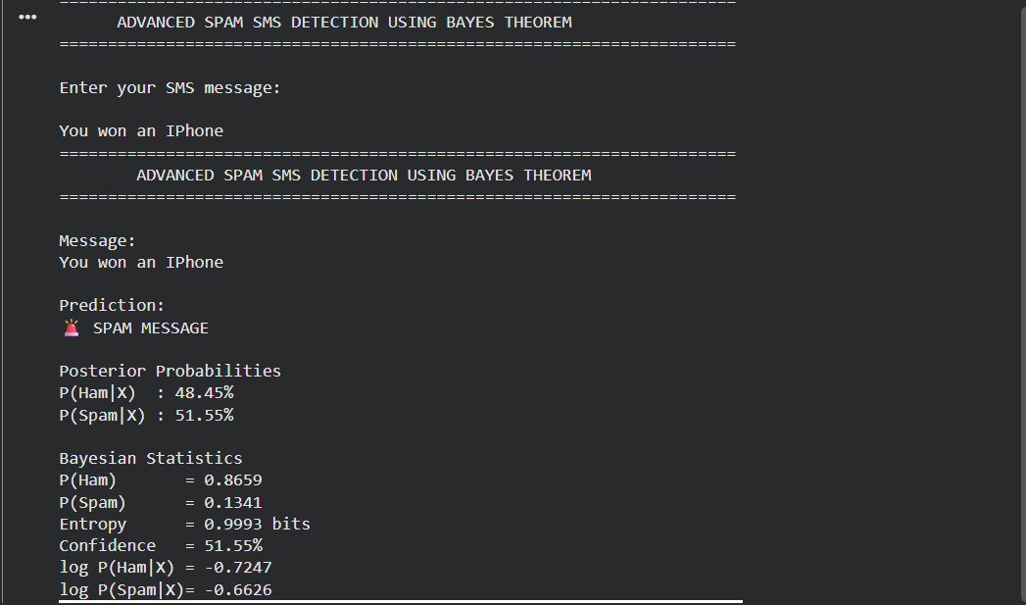
Figure 5: Sample Prediction Output

Explanation of the Four Charts

1. Bayesian Posterior Probability
Displays P(Ham|X) and P(Spam|X). The larger probability determines the final class.

2. Bayesian Confidence Gauge
Shows the spam probability on a 0–100% confidence scale.

3. Top Influential Words
Ranks the words that contributed most to the decision using differences in learned log probabilities.

4. Bayesian Decision Metrics
Combines confidence, priors, posterior strength, and certainty into a single radar chart for quick interpretation.

Advantages
- High accuracy for SMS classification.
- Fast training and prediction.
- Low computational cost.
- Explainable AI visualizations.
- Mathematically interpretable results.

Limitations
- Assumes independent words.
- Limited to the SMS dataset.
- May struggle with modern slang or unseen vocabulary.
- Not intended for multilingual spam detection.

Future Scope
- Deploy as a web application using Flask or Streamlit.
- Support email spam detection.
- Add multilingual NLP models.
- Compare with SVM, Random Forest, and Transformer models.
- Improve explainability using SHAP or LIME.

Conclusion
The project successfully combines TF-IDF vectorization with Multinomial Naive Bayes to classify SMS messages as Ham or Spam while explaining each decision through Bayesian mathematics, entropy, influential-word analysis, and confidence visualizations.

