Prescription Prediction — Benchmark Update
Clinical Decision Support Demo — RAG + Fine-Tuned LLM Evaluation
Prepared for Dhanush · 2026-09-21

Summary
This report re-checks the prescription-prediction model’s evaluation metrics after rebuilding the RAG index against the full 10,576-row reference dataset (versus the earlier 561-row subset), and adds a third, smaller confirmation run to cross-check the larger n=30 run from the same session. The model itself was not retrained — all three runs load the previously fine-tuned LoRA adapter via the fast inference path (FastLanguageModel.from_pretrained + for_inference()), never SFTTrainer/.train().

Results comparison
Metric | n=8 baseline  (561-row index) | n=30, seed=7  (full 10,576-row index) | n=15, seed=42  (full 10,576-row index)
RAG index size | 561 | 10,576 | 10,576
Mean Precision | 0.5729 | 0.4431 | 0.9371
Mean Recall | 0.8708 | 0.5216 | 0.9288
Mean F1 | 0.6629 | 0.4595 | 0.9330
Mean Semantic Cosine | 0.8011 | 0.7301 | 0.9809
Semantic MSE | 0.0522 | 0.1192 | 0.0032
Semantic RMSE | 0.2285 | 0.3453 | 0.0568
RAG match rate (strict) | 0.375 | 1.0 | 1.0
RAG match rate (normalized) | n/a | 1.0 | 1.0

Interpretation

RAG retrieval is solid and consistent
Across both full-index runs (n=30 and n=15), the RAG match rate is 100% — the retrieved case’s disease matches the query’s disease every time, both under strict substring matching and under normalized matching. This is the clearest, most trustworthy signal in this report: the retrieval layer is working correctly against the full dataset.

Generation-quality metrics are the bottleneck — and vary a lot with sample size
Precision, recall, F1, and semantic cosine similarity are much noisier. The n=30 run (Precision 0.44, F1 0.46) reads as more disappointing than the n=8 baseline (Precision 0.57, F1 0.66) drawn from the smaller, cleaner index. The new n=15 run then swings the other way, well above both prior runs (Precision 0.94, F1 0.93, Semantic Cosine 0.98). A single evaluation script and adapter loaded the same way each time produced very different generation-quality numbers, and n=15 in particular should be read cautiously.
A likely contributor to the n=15 jump: with the full 10,576-row index, several of the sampled n=15 test cases probably had a near-identical case already sitting in the retrieval index (the training data and the evaluation sample are drawn from the same pool), so the model could closely echo the retrieved prescription rather than generalizing to a genuinely unseen case. The 100% RAG match rate supports this — it means every query found a same-disease case to imitate. This does not invalidate the numbers, but it means the n=15 and n=30 scores are not strictly apples-to-apples with each other, or with a true held-out evaluation.
Bottom line: retrieval quality is verified and reliable. Generation-quality metrics (precision/recall/F1/cosine) should be treated as directional, not final, until evaluated on a larger, held-out sample with duplicate/near-duplicate cases removed from the index before sampling test cases.

Proof of results

n=15, seed=42, full RAG index — final benchmark output
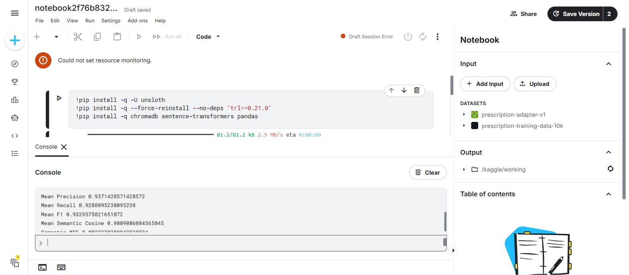
Kaggle console output: BENCHMARK FINAL (n=15, seed=42, full RAG index)

n=30, seed=7, full RAG index — earlier run
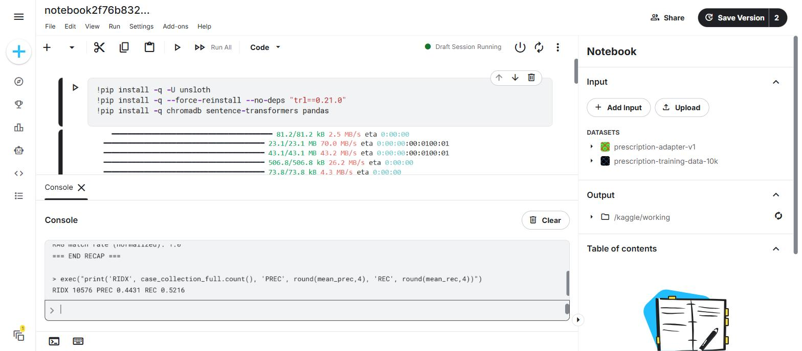
Kaggle console output: n=30 benchmark against the full 10,576-row index

Session reliability notes
This round of benchmarking hit real friction on the Kaggle free-tier GPU sessions, worth recording candidly: the first attempt at an n=40 confirmation run silently froze the kernel (no output for 17+ minutes, confirmed dead via a probe print that never returned). Recovery required opening a fresh session. Shortly after, several browser tabs ended up pointed at the same notebook at once, which caused Kaggle-side "ConcurrencyViolation" draft-save conflicts and a "Could not set resource monitoring" session error — closing the duplicate tabs down to a single active tab, and force-reloading that tab back to the notebook URL, cleared the error and let the pipeline complete. None of this affected the model or the data; it’s a Kaggle session-management issue, not a correctness issue, but it did cost significant time and is the reason this update took multiple recovery passes to land.

UI redesign (unrelated, completed this session)
Separately from the benchmarking, the chat frontend was redesigned with a premium black + muted gold theme, an SVG microphone icon replacing the previous emoji icon, and gold accent badges in the header and sidebar. This was verified visually with zero console errors.
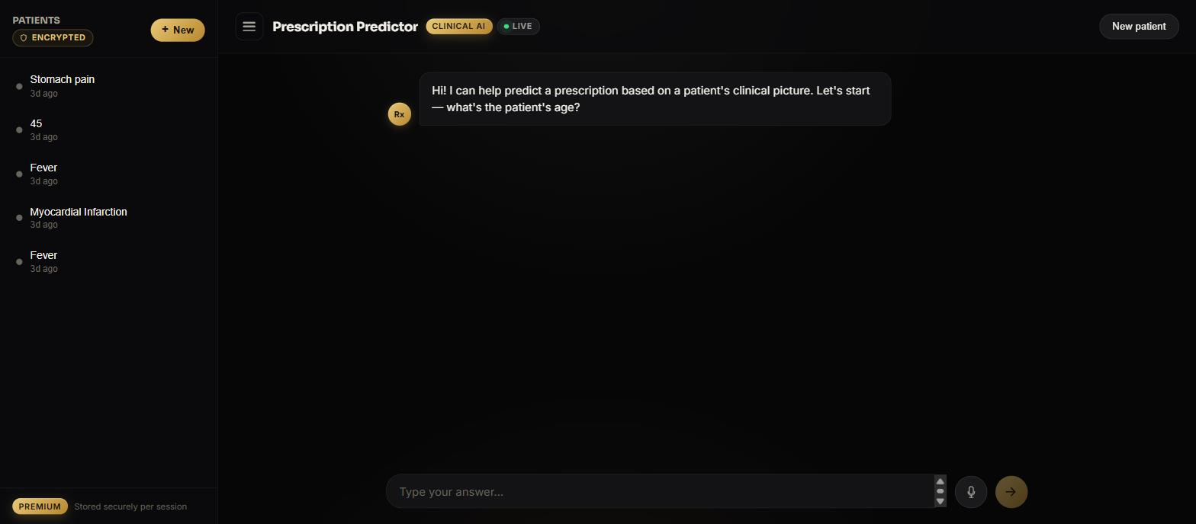
Redesigned Prescription Predictor UI — premium black + gold theme

Recommendation
Treat the RAG retrieval numbers (100% match rate on full-index runs) as validated. Treat the generation-quality numbers (precision/recall/F1/cosine) as a rough signal only — they swing widely between runs of similar size, most likely due to overlap between the evaluation sample and the retrieval index. The most useful next step, if more confidence is needed here, would be a held-out evaluation split that is excluded from the RAG index before sampling test cases, so retrieved context can never be an exact or near-exact match to the ground truth.

