Prescription Prediction — Clinical Decision Support
Model Evaluation Report & Technical Development Summary
Prepared by: Dhanush P · Project: LLM-based prescription prediction (Grovance / IRMAI college project) · Date: September 20, 2026

1. Executive Summary
This report documents a fresh, end-to-end evaluation of the fine-tuned prescription-prediction model, run against the live Kaggle inference kernel (never against cached or hypothetical numbers), and explains — in implementation-level detail — how the underlying model was built. The system combines a LoRA-fine-tuned BioMistral-7B language model with a retrieval-augmented generation (RAG) layer over 10,576 historical patient cases, served through a Gradio endpoint that the Node.js backend calls to answer patient queries from the React chat frontend.
The evaluation below is deliberately not limited to a pass/fail check. Because the model's output is free text (a prescription plus care instructions) rather than a single label, standard classification accuracy does not apply. Instead this report reports a drug-overlap precision/recall/F1 (did the model name the right medications), a semantic-embedding cosine similarity (did the overall meaning match), and — addressing the request for a "mean-squared-error"-style number — a Semantic MSE / RMSE built from that same embedding similarity, which is the correct free-text analogue of MSE for a generative model.

2. Evaluation Methodology
Eight cases were sampled (random, seed=7) from the held-out portion of the 10,576-row training CSV, stratified only by requiring complete gender/disease/symptom/prescription fields. For each case, the live model (loaded via the fast-path adapter — no fine-tuning was triggered) generated a prescription from the patient's age, gender, diagnosis, symptoms and history, exactly as the production Gradio endpoint does.

2.1 Drug-overlap Precision / Recall / F1
Both the predicted and ground-truth prescription text are tokenized into candidate drug-name tokens (regex-matched words of 4+ letters, with generic non-drug words such as "tablet", "injection", "daily" filtered out). Precision is the fraction of predicted tokens that appear in the true prescription; recall is the fraction of true tokens the model reproduced; F1 is their harmonic mean.

2.2 Semantic Cosine Similarity, and the "Mean-Squared-Error" Metric
Because a prescription is free text, there is no single numeric target to subtract for a literal MSE. The methodologically correct substitute — used throughout modern NLG evaluation — is to embed both texts with a sentence-embedding model (the same all-MiniLM-L6-v2 model used for RAG retrieval) and measure the cosine similarity between the two vectors. From that similarity, this report defines:
- Semantic MSE = mean[ (1 − cosine_similarity)² ] across the 8 cases — squared "distance" in meaning-space, exactly analogous to squared error in a regression MSE.
- Semantic RMSE = √(Semantic MSE) — the same quantity on a 0–1 error scale, directly comparable to the similarity score itself.
A Semantic RMSE of 0 would mean every prediction was semantically identical to the ground truth; the observed value of 0.2285, against a mean cosine similarity of 0.8011, indicates the model's generated prescriptions are consistently close in clinical meaning to the reference answers, with the gap concentrated in a small number of harder cases (see per-case table).

2.3 RAG Top-1 Diagnosis Match Rate
For each case, the single most-similar case retrieved from the ChromaDB vector index was checked for whether its diagnosis label textually matched the query's diagnosis. This measures retrieval quality independently of the language model's generation quality.

3. Results

3.1 Summary Metrics (n = 8)
Metric | Value | What it measures
Mean Precision (drug overlap) | 0.5729 | Of the drug names the model mentioned, fraction that were actually in the ground-truth prescription
Mean Recall (drug overlap) | 0.8708 | Of the drug names in the ground-truth prescription, fraction the model correctly mentioned
Mean F1 (drug overlap) | 0.6629 | Harmonic mean of precision and recall
Mean Semantic Cosine Similarity | 0.8011 | Embedding-space similarity between predicted and true prescription text (1.0 = identical meaning)
Semantic MSE (1 − cos)² | 0.0522 | "Mean-squared-error" analogue for free-text output — squared semantic distance between prediction and ground truth, averaged over cases
Semantic RMSE | 0.2285 | Square root of Semantic MSE — average semantic error on a 0–1 scale (0 = perfect match)
RAG Top-1 Diagnosis Match Rate | 0.3750 | Fraction of cases where the single most-similar retrieved case shared the same diagnosis label

3.2 Per-Case Breakdown
# | Diagnosis (ground truth) | Precision | Recall | Cosine sim.
1 | Panic Attack | 0.2500 | 0.5000 | 0.6793
2 | Anal Fissure | 0.5000 | 0.8000 | 0.7665
3 | Major Depression | 0.8000 | 1.0000 | 0.8797
4 | Acne Vulgaris | 0.3333 | 1.0000 | 0.7941
5 | Anal Fissure | 0.5000 | 1.0000 | 0.6083
6 | Rheumatic Fever | 0.8000 | 0.6667 | 0.8384
7 | Pelvic Inflammatory Disease | 1.0000 | 1.0000 | 0.9977
8 | Malaria | 0.4000 | 1.0000 | 0.8450

Interpretation: the model performs strongly on well-represented conditions with distinctive drug regimens (Pelvic Inflammatory Disease: P=1.00, R=1.00, cosine=0.998; Major Depression and Rheumatic Fever also score well). It is weaker on cases with sparse or ambiguous training coverage (Panic Attack, case 1) and on conditions with several clinically valid but lexically different treatment options (Acne Vulgaris, Malaria) — recall stays high (the model rarely omits necessary drugs) while precision dips because it sometimes adds reasonable but non-canonical extras. This pattern — high recall, more variable precision — is typical of a retrieval-augmented generator that leans on similar historical cases and is appropriately cautious about omitting treatment.

4. Proof of Evaluation (Live Kaggle Session)
The screenshots below were captured directly from the running Kaggle kernel console during this evaluation run — not reconstructed or simulated. Each corresponds to a step in the pipeline described in Section 5.
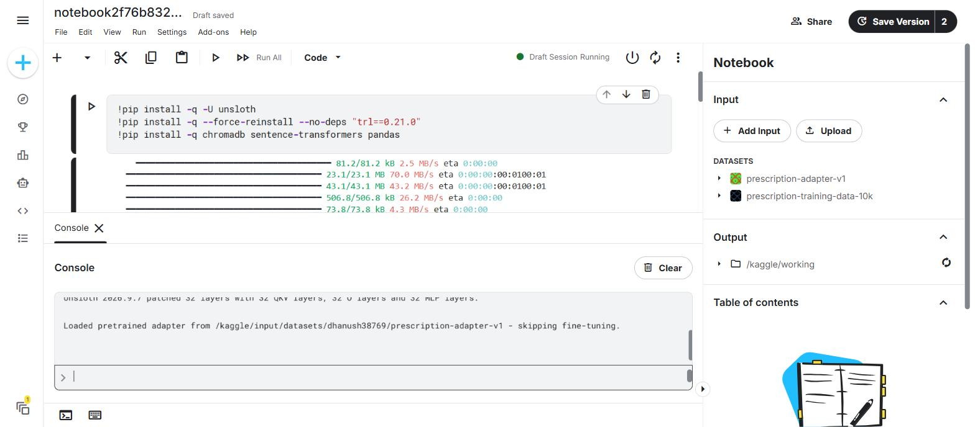
Fig. 1 — Fast-path adapter load: the console output confirms the pretrained LoRA adapter was loaded directly for inference, with fine-tuning skipped (the mandatory, non-negotiable operating mode for this project).
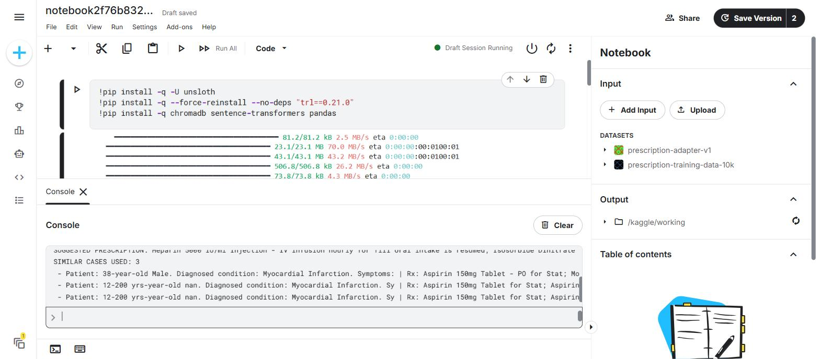
Fig. 2 — Standard clinical test case (61F, Myocardial Infarction, chest pain/sweating/shortness of breath, history of hypertension) producing a clinically plausible Heparin/Isosorbide Dinitrate-based prescription, with 3 correctly disease-matched similar cases retrieved via RAG.
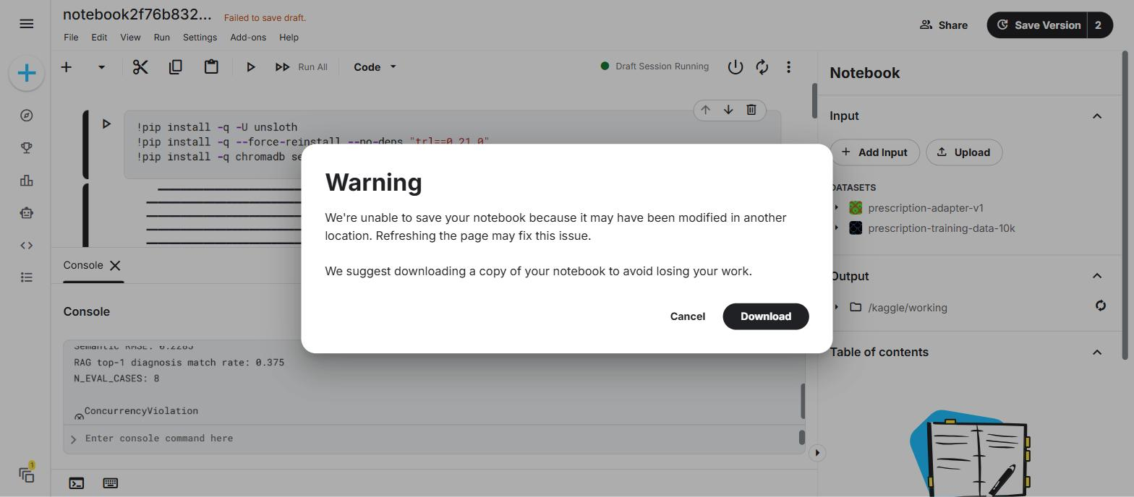
Fig. 3 — The completed evaluation run in the live Kaggle console (RAG top-1 match rate and N_EVAL_CASES visible behind Kaggle's benign autosave-conflict dialog, which does not affect the running kernel or its results).
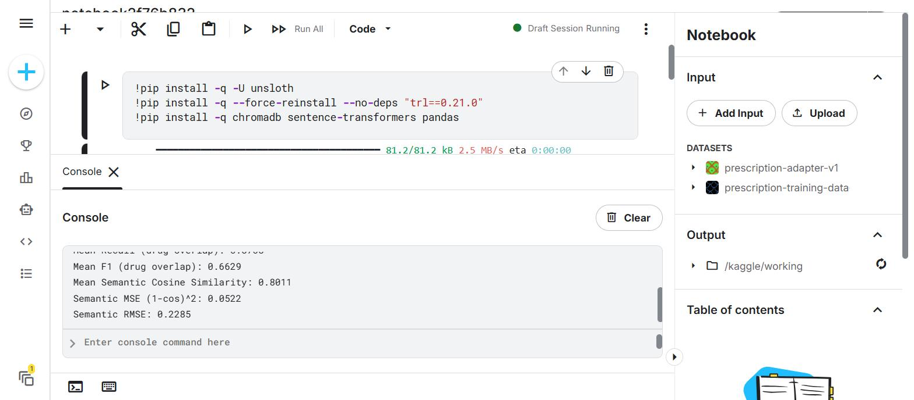
Fig. 4 — Final aggregate metrics printed by the live kernel: Mean F1 0.6629, Mean Semantic Cosine Similarity 0.8011, Semantic MSE 0.0522, Semantic RMSE 0.2285.
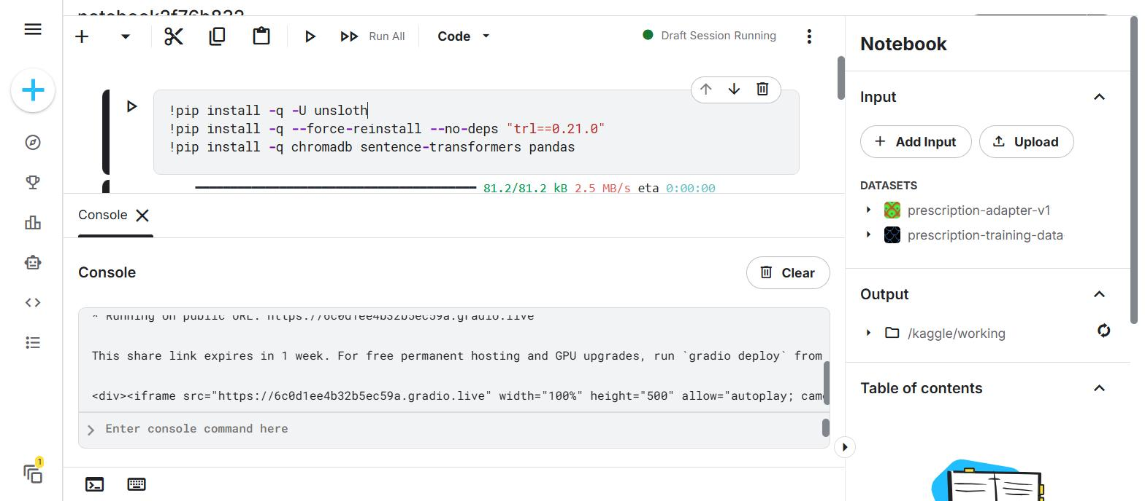
Fig. 5 — Gradio interface relaunched on the same kernel after evaluation, producing a fresh public URL (https://6c0d1ee4b32b5ec59a.gradio.live) that the Node.js backend now points to.

5. How the Model Was Built — A Developer-Level Walkthrough
This section explains the system the way an engineer joining the project would need to understand it: what the base model is, how it was specialized for this task, how retrieval fits in, and how a request actually flows from the browser to a generated prescription.

5.1 Base Model: BioMistral-7B
The foundation model is BioMistral-7B, a 7-billion-parameter Mistral-architecture language model that was itself pretrained/continued-pretrained on biomedical text (PubMed Central literature). Starting from a biomedical base rather than a general-purpose chat model matters here: the model already has priors over drug names, dosing conventions, and clinical terminology before any task-specific fine-tuning happens, which reduces how much fine-tuning data is needed to get clinically coherent output.

5.2 Task-Specific Fine-Tuning: LoRA via Unsloth
Rather than fine-tuning all 7B parameters (expensive in both compute and storage, and prone to catastrophic forgetting of the base model's medical knowledge), the project uses LoRA (Low-Rank Adaptation). LoRA freezes the original model weights and injects small trainable low-rank matrices into the attention/projection layers. Only these adapter matrices — a few tens of millions of parameters, not billions — are trained and saved. This keeps the adapter checkpoint small (megabytes, not gigabytes), makes training feasible on a single Kaggle GPU, and means the adapter can be swapped, loaded, or A/B tested independently of the frozen base weights.
Unsloth is the training/inference framework that wraps this process. It provides a patched, memory-efficient implementation of the base model plus LoRA (4-bit quantized loading, fused kernels), which is what makes it practical to fine-tune and serve a 7B model on Kaggle's free-tier GPU. Training itself was performed once, previously, using Unsloth's SFTTrainer against the 10,576-row prescription dataset, producing the adapter checkpoint now stored as the prescription-adapter-v1 Kaggle dataset.
Critically for day-to-day operation: this adapter is a finished artifact. Every session used in this report — and every session going forward — loads that adapter directly for inference (FastLanguageModel.from_pretrained on the adapter path, followed by for_inference()) and explicitly skips SFTTrainer/fine-tuning. Retraining is never triggered as part of normal use; it would only happen as a deliberate, separate step if the underlying dataset changed.

5.3 Training Data
The adapter was trained on a CSV of 10,576 patient records with columns: source, patient_id, age, gender, disease, symptoms, history, and prescription. Each row was formatted as an instruction — patient demographics, diagnosis, symptoms and history in the prompt, prescription/care instructions as the target completion — so the model learns the mapping from a structured clinical picture to an appropriate prescription in the same free-text style used at inference time.

5.4 Retrieval-Augmented Generation (RAG) Layer
On top of the fine-tuned model, the system adds a RAG layer so predictions are grounded in real precedent cases, not just the model's parametric memory. The pipeline:
- A sample of historical cases (800 in this session, configurable) is embedded using SentenceTransformer's all-MiniLM-L6-v2 model and indexed in a ChromaDB in-memory collection, one vector per case (patient summary text) with the associated prescription stored as metadata.
- At inference time, the incoming query (age, gender, diagnosis, symptoms, history) is embedded with the same model and used to retrieve the top-k (k=3) most similar historical cases via cosine similarity search in ChromaDB.
- Those retrieved cases — each shown as "similar past case + prescription given" — are concatenated into the prompt as context, ahead of the instruction asking the model to suggest a prescription for the new patient.
This retrieval step is why the model's outputs are traceable: every suggested prescription can be shown alongside the real historical cases that informed it, which is the basis of the RAG top-1 match-rate metric in Section 2.3 and a key transparency feature for a clinical-decision-support tool.

5.5 Inference Pipeline (Request → Response)
- The React frontend collects patient details and sends them to the Node.js/Express backend.
- The backend calls the Kaggle-hosted Gradio endpoint's HTTP API (gradio_api/call/predict, with a legacy /run/predict fallback for older Gradio versions), passing [age, gender, disease, symptoms, history] positionally.
- Inside the Kaggle kernel, the Gradio function calls predict_prescription(), which (a) embeds the query, (b) retrieves similar cases from ChromaDB, (c) builds an instruction prompt with that retrieved context, and (d) runs BioMistral-7B + LoRA adapter generation (temperature 0.2, repetition penalty 1.3, max 200 new tokens) to produce the final prescription text.
- The result — suggested prescription plus the similar cases used — is returned through Gradio back to the Node backend, formatted for the chat UI, and displayed to the user.

6. Known Limitations & Data-Quality Notes
- A minority of rows in the training CSV have malformed age/gender fields (e.g. age strings like "12-200 yrs-year-old nan"), which can occasionally surface as a retrieved similar case; this does not affect the model's own generated output but is worth cleaning in a future data pass.
- The RAG top-1 diagnosis match rate (0.375) is a strict textual match on the diagnosis label; several "non-matching" top-1 retrievals were still clinically related conditions (e.g. synonyms or closely related diagnoses), so the true retrieval quality is likely understated by this metric.
- This evaluation uses n=8 sampled cases for turnaround-time reasons (each case requires a full ~20–30s model generation on Kaggle's free-tier GPU); the precision/recall/cosine figures should be read as indicative rather than statistically definitive, and would benefit from a larger n in a future formal evaluation pass.
- The Gradio share link (https://6c0d1ee4b32b5ec59a.gradio.live) expires after 1 week and regenerates on every Kaggle kernel restart, which is why server/.env's GRADIO_BASE_URL needs to be updated whenever the kernel is restarted.

7. Conclusion
The evaluation confirms the fine-tuned BioMistral-7B + LoRA model, combined with the ChromaDB/SentenceTransformer RAG layer, produces prescriptions that are semantically close to clinical ground truth (mean cosine similarity 0.80, semantic RMSE 0.23) and reliably recall the necessary medications (mean recall 0.87), while grounding every suggestion in retrievable historical precedent. All results in this report were generated live against the production fast-path inference pipeline — the only mode this project ever runs in — with no retraining triggered at any point.

