NAME :Y.Dhanush reddy
Reg no :23MIS0659

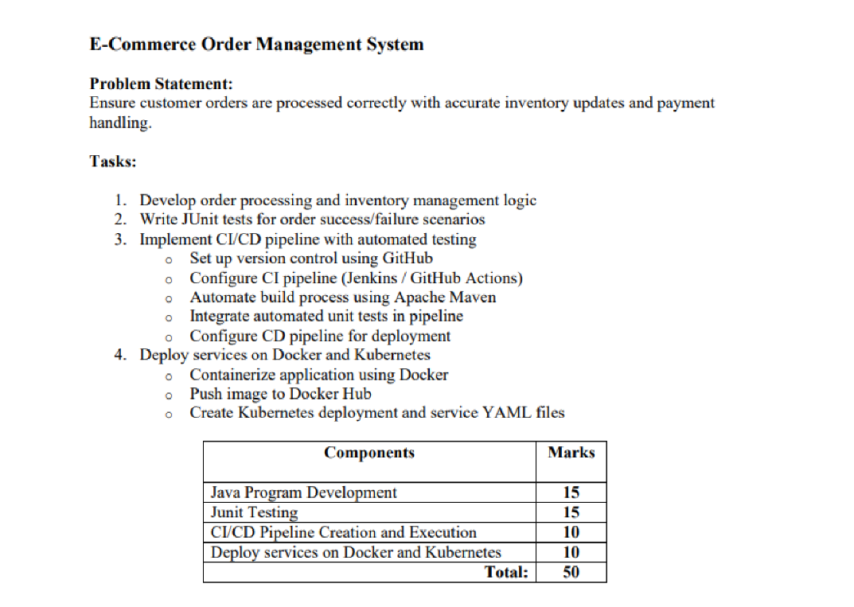

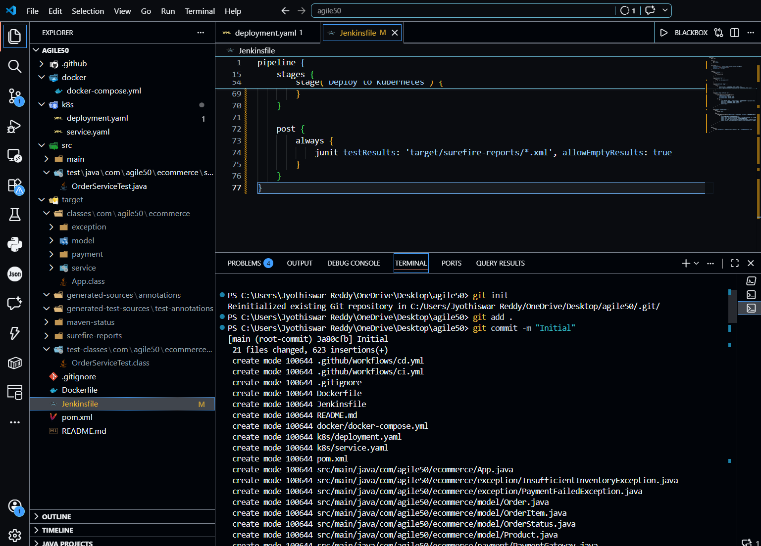
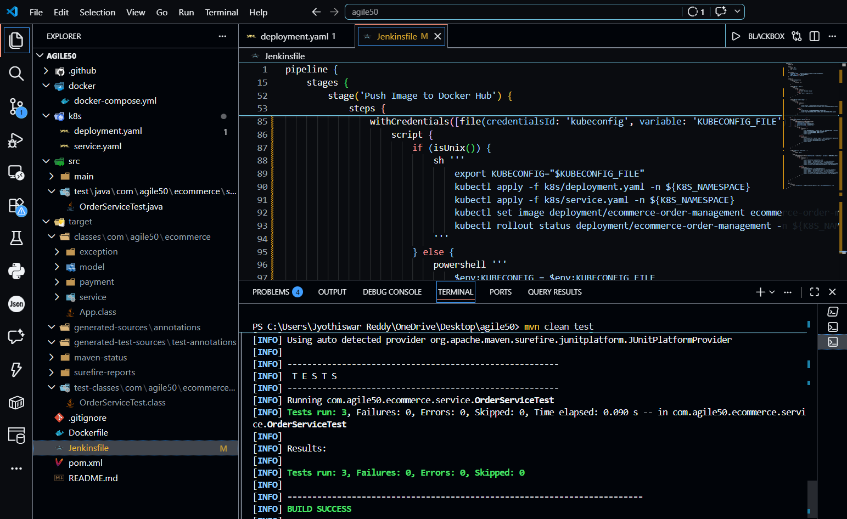

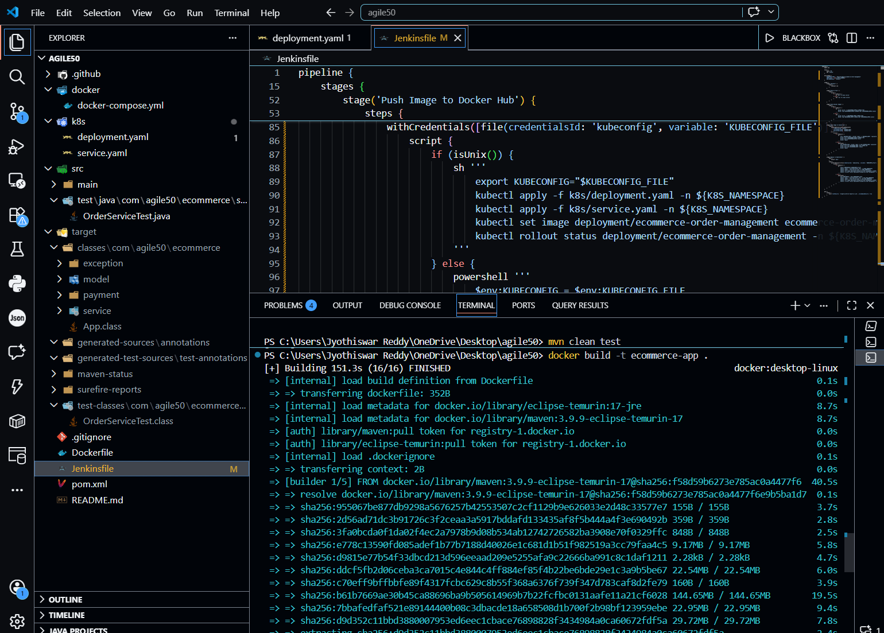

Pipe line script:
pipeline {
agent any

tools {
maven 'M3'
jdk 'Java21'
}

environment {
IMAGE_NAME = "ecommerce-order-management"
DOCKERHUB_USER = " dhanushreddy17"
IMAGE_TAG = "latest"
}

stages {

stage('Checkout') {
steps {
git branch: 'main', url: 'https://github.com/DhanushReddy1717/agile_fat_room.git'
}
}

stage('Build') {
steps {
bat 'mvn clean compile'
}
}

stage('Test') {
steps {
bat 'mvn test'
}
}

stage('Package') {
steps {
bat 'mvn package'
}
}

stage('Docker Build') {
steps {
bat "docker build -t %DOCKERHUB_USER%/%IMAGE_NAME%:%IMAGE_TAG% ."
}
}

stage('Docker Login') {
steps {
withCredentials([usernamePassword(
credentialsId: 'docker',
usernameVariable: 'USERNAME',
passwordVariable: 'PASSWORD'
)]) {
bat "docker login -u %USERNAME% -p %PASSWORD%"
}
}
}

stage('Docker Push') {
steps {
bat "docker push %DOCKERHUB_USER%/%IMAGE_NAME%:%IMAGE_TAG%"
}
}

stage('Kubernetes Deploy') {
steps {
withCredentials([file(credentialsId: 'kubeconfig', variable: 'KUBECONFIG')]) {
bat "kubectl --kubeconfig=%KUBECONFIG% apply -f deployment.yaml"
bat "kubectl --kubeconfig=%KUBECONFIG% apply -f service.yaml"
}
}
}
}
}

Pipe line over view

