NeuralFabric: A Controlled Evaluation of Forecast-Driven and Model-Free Capacity-Guarded Rerouting in Datacenter Fabrics
Divyank Seervi, Krish, Choppa Madhu Dhanush Teja, Srishti Agarwal, Ganesh Khekare*
School of Computer Science and Engineering,
Vellore Institute of Technology, Vellore, Tamil Nadu, India
divyank.seervi2024@vitstudent.ac.in, krish.2024@vitstudent.ac.in, choppa.madhu2024@vitstudent.ac.in, srishti.agarwal2024@vitstudent.ac.in, ganesh.khekare@vit.ac.in*

Abstract—In datacenter fabrics, hash-based multipath routing ignores load, and reactive rerouting acts only after queues have built up. This paper asks whether forecasting link congestion milliseconds ahead improves rerouting. A packet-level simulator of a k=4 Fat-Tree with 1-ms ticks generates telemetry for six synthetic workload families, and a graph convolutional network combined with an LSTM (GCN-LSTM) predicts the congestion of each link five ticks ahead. The same capacity-guarded controller is driven by forecasts or model-free signals. The forecasters rank future congestion better than persistence (AP 0.947 against 0.880), but the graph layers add nothing and onsets remain hard to predict. Guarded rerouting raises delivered packets per tick by 2.9–3.4% over ECMP, lowers delay and reorders fewer packets than aggressive rerouting, yet reduces pooled total drops by only 4.9–5.7%: fabric-link drops fall by 20–25%, but host-link drops rise by 1.8–2.8%. Routing on forecasts does not outperform the current congestion score, on unseen traffic or with up to five ticks of delay. Ablations show that the admission rules are largely redundant with one another, and with model-free signals they give up more than half of the attainable drop reduction for 62–74 times fewer route changes. With the rules in place, a random risk signal does as well as the current score on drops, with 3.5 times the route changes, and a perfect passive five-tick congestion label adds nothing: the gain comes from the capacity check that decides where flows may move, not from congestion information in the signal that decides which flows move, and with a demand estimate from the flows’ sending rates and paths alone, without queue or arrival measurements, the check loses no detectable part of it; without the rules, the signal matters. The controller exceeds the 1-ms tick.

Index Terms—Datacenter networks, predictive routing, congestion forecasting, admission control, in-band network telemetry, graph neural networks, load balancing, Fat-Tree topology

I. Introduction

A. Background
Datacenter networks interconnect thousands of servers which run distributed storage, analytics and Machine Learning (ML) workloads. Measurement studies of production datacenters show that traffic is application-dependent and spiky rather than a smooth aggregate stream [1]. To provide high bisection bandwidth with commodity switches, modern fabrics are built as multi-rooted trees such as the Fat-Tree [2], and related designs like PortLand, VL2, BCube and Jellyfish show that topology and path diversity determine how much routing freedom a controller has [3]–[6].
The standard way to use this path diversity is Equal-Cost Multi-Path (ECMP) forwarding, which hashes every flow onto one of the shortest paths [7]. ECMP is simple and stable, but it is insensitive to load: two large flows can be hashed onto the same link while parallel links remain idle.

B. Motivation
When a link becomes congested, its queue grows, packets are dropped or delayed and transport protocols back off. Every millisecond of queue build-up therefore translates into lost throughput and higher tail latency for the applications sharing that link. If congestion on a link can be anticipated a few milliseconds before it materialises, flows could be moved to another equal-cost path in advance. This idea, called predictive or proactive routing, has become more feasible with the availability of fine-grained In-band Network Telemetry (INT) and fast learning-based predictors.

C. Existing Approaches and Their Limitations
Dynamic flow scheduling systems such as Hedera and DevoFlow move large flows using global visibility of the network state [8], [9], and centralised optimisers such as ElasticTree adapt the active fabric to demand [10]. Distributed congestion-aware load balancers such as CONGA, HULA, DRILL, Presto and LetFlow react to measured path or queue conditions at flow, flowlet or packet granularity [11]–[15]. These systems are effective, but they are reactive by construction: they respond after congestion has already been observed.
In parallel, ML models for networking have advanced quickly. Graph Neural Networks (GNNs) such as RouteNet model the relationship between topology, routing and performance [16], and spatio-temporal graph models forecast traffic in transportation and communication networks [17]–[19]. However, an accurate forecast does not automatically yield a good routing policy. When a forecast flags a link as risky, a controller without admission rules can move many affected flows at once, which generates excessive route churn and can overload the alternative paths.

D. Research Gap
Two questions are frequently conflated in prediction-driven networking: whether a model can forecast congestion, and whether acting on that forecast improves system-level behaviour. Existing studies seldom evaluate the second question against strong, model-free baselines that use the same action mechanism, and they rarely report whether a spatial graph component adds value over purely temporal modelling. Without such ablations, routing gains may be attributed to the predictor when they are in fact produced by the action policy.

E. Proposed Solution and Novelty
This paper presents NeuralFabric, an experimental framework for a controlled evaluation of forecast-driven rerouting. A telemetry-driven congestion forecaster and several model-free signals drive one and the same capacity-guarded rerouting controller, which admits a route change only when the candidate path lowers the signalled risk, keeps path stretch bounded, respects a per-flow cooldown and a per-tick change budget, and passes a capacity check in which accepted moves sequentially reserve headroom. None of these admission rules is new on its own: sequential reservation follows the Global First Fit heuristic of Hedera [8], and the cooldown and conditional moves resemble the damping of FlowBender [20] and the cautious rerouting of Hermes [21]. The contribution of this paper is therefore not a new controller but (i) an evaluation design that keeps the action mechanism fixed while the signal changes, removes each admission rule in turn and repeats the comparison under telemetry and actuation delays, and (ii) the empirical finding this design produces: in the tested setting, the learned forecaster ranks future congestion better than persistence, yet routing on its forecasts brings no measurable benefit over routing on the current congestion score, and, with the admission rules in place, the rules rather than the signal determine the routing outcome: the guarded controller acts as a demand-aware reshuffler in the manner of Hedera: its benefit comes from the capacity check that gates where flows may move, not from congestion information in the signal that selects which flows move, and a check whose demand estimate uses only the flows’ sending rates and paths, without the queue and arrival measurements, gives a drop reduction that is not detectably different (Section V-E).

F. Contributions
The main contributions of this paper include:
- A full-duplex, causal, packet-conserving simulator of a k=4 Fat-Tree fabric with hash-based ECMP, explicit per-direction queues, attribution of packet drops to host links and fabric links, configurable telemetry and actuation delays and an optional closed-loop transport model for flow completion times.
- A spatio-temporal Graph Convolutional Network (GCN) and Long Short-Term Memory (LSTM) forecaster of per-link congestion, evaluated against persistence, an LSTM-only model and logistic regression, with temperature-scaled probabilities, a calibration check, validation-tuned thresholds and onset-only metrics.
- A capacity-guarded rerouting controller that combines known admission rules (sequential capacity reservation, per-flow cooldown, per-tick change budget, path-stretch bound and minimum risk improvement) and can be driven by any per-link risk signal.
- A controlled evaluation methodology, comprising guard-only baselines that share the action mechanism, leave-one-rule-out ablations and parameter sweeps on unseen traffic, a telemetry- and actuation-delay sweep, equivalence tests, family-clustered bootstrap intervals and flow-level metrics, which separates forecast quality from routing benefit.

G. Paper Organisation
Section II critically reviews related work and establishes the research gap. Section III describes the simulator, dataset, forecasting models and guarded controller with their mathematical formulation. Section IV reports the experimental setup, the evaluation metrics and the additional robustness experiments. Section V presents the results, ablations, sensitivity and delay analyses and the discussion. Section VI concludes the paper and outlines future scope.

II. Literature Review

A. Datacenter Topologies and Multipath Routing
The Fat-Tree architecture showed that commodity switches arranged as a multi-rooted tree can deliver full bisection bandwidth [2]. PortLand added a scalable, fault-tolerant layer-2 fabric, VL2 exposed uniform high capacity through Valiant load balancing over a Clos network, BCube proposed a server-centric modular design and Jellyfish studied random regular graphs as an alternative to hierarchical layouts [3]–[6]. These works establish that path multiplicity is the resource a load balancer exploits. ECMP remains the default way of using it because it is stateless and deterministic [7], but hash collisions between long-lived flows are a well-known weakness that motivates load-aware alternatives.

B. Flow Scheduling and Congestion-Aware Load Balancing
Hedera schedules large flows centrally to improve aggregate throughput over ECMP, and DevoFlow analyses the control-plane cost of obtaining the flow visibility that such scheduling requires [8], [9]. Hedera’s Global First Fit heuristic already reserves the demand of each placed flow along its path, so that later placements see only the remaining capacity [8]; the sequential capacity reservation used in this paper follows the same principle. ElasticTree demonstrates demand-driven reconfiguration of the active network [10]. Among distributed schemes, CONGA uses in-network congestion feedback with flowlet switching [11], HULA implements telemetry-driven path selection in programmable data planes [12], DRILL performs micro load balancing using local queue information [13], Presto balances load at the network edge while handling packet reordering [14], LetFlow exploits flowlets for resilience under asymmetry [15], and Clove shifts flowlets between paths from the hypervisor virtual switch using ECN feedback [22]. FlowBender moves a flow to a new ECMP path only after its fraction of ECN-marked acknowledgements has stayed above a threshold for consecutive round trips, a damping rule that plays the same role as the cooldown in our controller [20]. Hermes senses path conditions with round-trip times and ECN and reroutes cautiously: a flow is moved only when it has already sent enough data, is sending below a rate cap and a clearly better path exists [21]. ConWeave makes mid-flow rerouting of RDMA traffic safe by masking packet reordering inside the network [23]. Centralised arbitration in Fastpass and priority-based transport in pFabric show that path selection, scheduling and transport interact strongly [24], [25]. These mechanisms act on observed state at sub-millisecond to millisecond time scales. The admission rules used in this paper (capacity reservation, damping and conditional moves) therefore have clear precedents, and the open question is not whether such rules work but whether a forecast adds value when they are in place.

C. Congestion Control and In-Band Telemetry
Data Center TCP (DCTCP), a datacenter variant of the Transmission Control Protocol (TCP), uses Explicit Congestion Notification (ECN) to keep queues short [26]. DCQCN extends ECN-based control to Remote Direct Memory Access (RDMA) deployments [27], TIMELY uses round-trip time as a congestion signal [28], and HPCC uses precise in-band telemetry to obtain link load information for rate control [29]. PINT reduces the overhead of in-band telemetry while preserving its usefulness for congestion control and path tracing [30]. These works motivate per-hop queue and utilisation measurements as forecasting inputs, but they act on sending rates rather than on path admission.

D. Graph and Temporal Learning for Network Prediction
Graph convolutional networks propagate information along graph edges [31], LSTM networks capture temporal dependence in sequences [32], and surveys categorise convolutional, recurrent and spatio-temporal graph models as distinct families [33]. In traffic forecasting, DCRNN combines diffusion convolution with recurrent units [17], STGCN combines graph and temporal convolutions [18], Graph WaveNet learns adaptive spatial dependencies [34] and T-GCN couples graph convolution with gated recurrent units [19]. A recent survey reviews deep learning specifically for network traffic prediction and highlights the difficulty of generalising across traffic conditions [35]. In network modelling, RouteNet and RouteNet-Fermi predict delay, jitter and loss from topology, routing and traffic [16], [36], and RouteNet-TGNN extends this line to temporal forecasting in dynamic networks [37]. These models establish that graph-temporal forecasting is feasible, but they mainly report prediction accuracy rather than the consequences of acting on predictions in an online control loop.

E. Learning-Based Routing and Control
Learning to Route studies deep reinforcement learning for traffic engineering and highlights how difficult it is to replace algorithmic routing logic with learned policies [38]. AuTO scales deep reinforcement learning to datacenter traffic optimisation by taking fast local decisions for short flows at the end hosts and central decisions for long flows [39]. A hybrid Generative Adversarial Network (GAN) and Recurrent Neural Network (RNN) model has been integrated with Software-Defined Networking (SDN) for access control and traffic engineering, with the GAN generating synthetic traffic [40]. This work relates to ours in two ways, through its reliance on synthetic traffic and through its coupling of a learned temporal model with SDN control, but its evaluation compares learned models with one another rather than with a model-free controller that takes the same actions, which is the comparison the present study adds. GraphCC combines graph learning with multi-agent reinforcement learning to tune ECN parameters in datacenters [41], and NTP-INT uses traffic prediction to plan telemetry paths on high-load switches [42]. For Artificial Intelligence (AI) clusters, Hopper performs congestion-aware path selection for RDMA traffic [43], and FLB shows that fine-grained load balancing interacts non-trivially with lossless flow control [44]. Acting on forecasts is also established in traffic engineering. MicroTE exploits the short-term, partial predictability of datacenter traffic matrices to route the predictable part of the traffic [45], COPE optimises routing for the traffic matrices predicted from history while bounding the penalty for unpredicted ones [46], LSTM-based traffic-matrix predictors have been proposed for SDN [47], and DOTE shows that learning traffic-engineering decisions directly from historical demands can outperform the classic predict-then-optimise pipeline in wide-area networks [48]. These systems act on traffic matrices at time scales of a second or longer; the present study asks the analogous question at the millisecond scale of per-link queue build-up, where the current state is a strong signal.

F. Comparative Summary
Table I compares representative studies in terms of method, data or setting, key finding, strength and limitation with respect to forecast-driven rerouting.

TABLE I
Critical comparison of representative related work with respect to forecast-driven rerouting.
Study | Method | Data / setting | Key finding | Strength | Limitation (for this problem)
ECMP [7] | Per-flow hashing over equal-cost paths | Analytical / standard practice | Simple, stable multipath forwarding | Stateless, deployable everywhere | Load-oblivious; hash collisions persist
Hedera [8] | Central scheduling of large flows | Fat-Tree testbed and simulation | Higher aggregate throughput than static hashing | Global view of large flows | Reactive; control-loop cost
CONGA [11] | Congestion feedback with flowlet switching | Hardware testbed | Better load balance than ECMP under asymmetry | In-network, line rate | Reacts to measured state only
HULA [12] | Telemetry probes in programmable data planes | Programmable-switch implementation | Scalable congestion-aware path choice | Uses telemetry, distributed | No forecasting or admission guard
HPCC [29] | Rate control from in-band telemetry | Testbed and simulation | Precise link-load feedback for transport | Fine-grained telemetry | Acts on rates, not paths
RouteNet [16] | GNN performance model | Simulated topologies | Models network performance for optimisation use cases | Topology-aware learning | Does not evaluate online, capacity-guarded rerouting
T-GCN [19] | Graph convolution with recurrent units | Road-traffic datasets | Spatio-temporal forecasting gains | Joint spatial-temporal model | Not network congestion; no control
GraphCC [41] | Graph learning with multi-agent reinforcement learning | Datacenter simulation | Learned ECN tuning | Learning in the control loop | Controls ECN, not path admission
NTP-INT [42] | Traffic prediction for telemetry planning | High-load switches | Prediction-driven telemetry paths | Prediction feeds control | Different control variable
Hopper [43] | Congestion-aware path selection | AI-cluster RDMA simulation and testbed | Path switching for RDMA traffic | Addresses AI workloads | Not a forecast-vs-guard study
FlowBender [20] | ECN-triggered flow rehashing | Testbed and simulation | Lower latency than ECMP with simple end-host changes | Damps reroutes over consecutive RTTs | Reacts to measured state only
Hermes [21] | Cautious, sensing-based rerouting | Testbed and simulation | Resilient load balancing under uncertainty | Conditional, damped moves | No forecasting; rules not compared with forecasts
MicroTE [45] | Traffic engineering on predictable traffic | Datacenter traces and simulation | Short-term predictability can be exploited | Acts on predictions | Second-scale traffic matrices, not per-link queues
DOTE [48] | Direct optimisation from demand history | WAN topologies and traces | Can outperform predict-then-optimise | Questions explicit forecasting | WAN, minute-scale

G. Review Analysis and Research Gap
Three observations emerge from the review. First, deployed load balancers are predominantly reactive and act at sub-millisecond to millisecond time scales, whereas the systems that act on predictions operate on traffic matrices at time scales of seconds or more. Second, learning-based network models are mostly evaluated on prediction metrics, so it remains unclear whether millisecond-scale forecasts improve routing once acted upon. Third, the admission rules that make rerouting safe are well established, but when learned forecasts drive rerouting, the results are seldom compared with model-free signals that drive the same rules, the contribution of each rule is seldom isolated, and the value of the spatial graph component is seldom measured. Consequently, the following questions remain open: (i) does a telemetry-driven forecaster rank future link congestion better than persistence on unseen workloads; (ii) does the spatial graph component add value over temporal modelling; (iii) does forecast-driven rerouting outperform the same capacity-guarded controller driven by model-free signals; and (iv) which admission rules produce the routing benefit, and does the answer survive telemetry and actuation delays? NeuralFabric is designed to answer these questions under a controlled, reproducible setting.

III. Methodology

A. System Overview
Fig. 1 shows the end-to-end framework. Traffic generators produce flows on a Fat-Tree fabric; the simulator advances packets causally; a telemetry collector converts each tick into switch and link features; a forecaster or a model-free baseline produces per-link risk signals; and the capacity-guarded controller decides whether any flow should change path. Route changes affect future traffic, closing the loop.
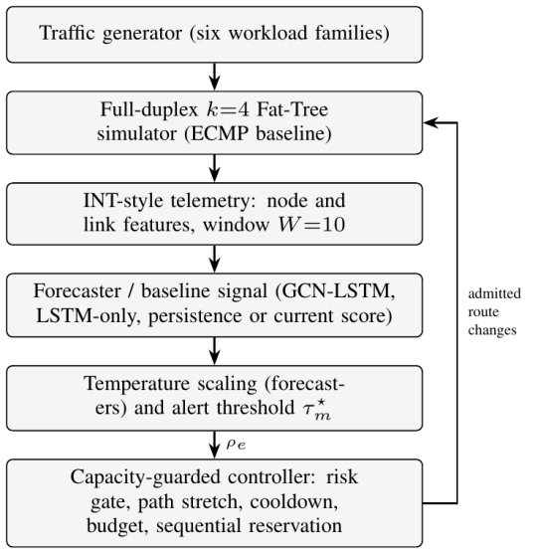
Fig. 1. NeuralFabric framework. Telemetry from the simulator feeds a per-link congestion forecaster or a model-free baseline signal; the resulting strategy-specific link-risk signals $ρ_{e}$ drive a capacity-guarded rerouting controller, and admitted route changes influence subsequent traffic.

B. Network and Simulator Model
The fabric is modelled as a graph $G=\left(V,ℰ\right)$ with switches and hosts as vertices and physical links as edges. A k=4 Fat-Tree, i.e. one built from 4-port switches, contains 4 core, 8 aggregation and 8 edge switches, 16 hosts and 48 physical links, of which 32 interconnect switches [2]. Each physical link $\{u,v\}$ is full-duplex and is represented by two directed links $\left(u,v\right)$ and $\left(v,u\right)$, each with capacity $C$ packets per tick and buffer $B$ packets. Time advances in ticks of 1 ms.
The tick is the unit of time of the simulator and is taken to be 1 ms: with 1,500-byte packets, $C=500$ packets per tick corresponds to 6 Gb/s. Propagation delay (0.5 µs) and serialisation delay (about 1.2 µs per packet at 10 Gb/s) are three orders of magnitude shorter than a tick and are not modelled separately; a packet advances one hop per tick. All delays and horizons in this paper are therefore counted in ticks of 1 ms. The buffer of $B$ = 2,000 packets (3 MB at 1,500 bytes) holds four ticks of line-rate service, so that queue build-up remains visible over several ticks of the forecast horizon before packets are dropped. This is deeper than the per-port share of typical shallow-buffered datacenter switches; smaller buffers would turn queue build-up into drops sooner and shorten the warning time available to any forecaster.
For a directed link $l$ at tick $t$, let $a_{l}\left(t\right)$ be arriving packets and $q_{l}\left(t\right)$ the queue occupancy. Accepted packets, drops, served packets and the queue update are
$${\hat{a}}_{l}\left(t\right)=min\{a_{l}\left(t\right), B−q_{l}\left(t\right)\}, d_{l}\left(t\right)=a_{l}\left(t\right)−{\hat{a}}_{l}\left(t\right),$$ | (1)

$$s_{l}\left(t\right)=min\{q_{l}\left(t\right)+{\hat{a}}_{l}\left(t\right), C\},$$ | (2)

$$q_{l}\left(t+1\right)=q_{l}\left(t\right)+{\hat{a}}_{l}\left(t\right)−s_{l}\left(t\right).$$ | (3)
Packets advance at most one link per tick, so forwarding is causal. Over a run, the simulator asserts packet conservation,
$$P_{\text{offered}}=P_{\text{dropped}}+P_{\text{delivered}}+P_{\text{outstanding}},$$ | (4)
and attributes every drop to a host link (a link with a host endpoint), a fabric link (switch-to-switch) or an unroutable flow, so that $D_{\text{total}}=D_{\text{host}}+D_{\text{fabric}}+D_{\text{unroutable}}$.
Baseline forwarding uses ECMP. For a flow $f$ from $s$ to $d$ with equal-cost shortest-path set $Π_{sd}$, the path index is computed with the 256-bit Secure Hash Algorithm (SHA256) as
$$i_{f}=SHA256\left(s ∥ d ∥ {id}_{f}\right) mod \left|Π_{sd}\right|,$$ | (5)
which spreads flows across all core switches while keeping each flow on a single path.

C. Dataset Generation
No public dataset provides per-link, per-millisecond telemetry for a datacenter fabric together with the ability to replay routing decisions. A synthetic dataset was therefore generated with six traffic families, summarised in Table II. Each scenario lasts $T=150$ ticks. Thirty scenarios (five per family, distinct random seeds) form the forecasting dataset, and a separate set of traffic seeds is used for routing evaluation.
TABLE II
Synthetic traffic families used for data generation.
Family | Description
Uniform | Background flows between random host pairs at moderate rates
Hotspot | Incast: several sources send at high rate to one destination, plus background
Elephant/mice | Mixture of long, high-rate flows and short, low-rate flows
Stride | Pod-to-pod permutation that stresses the core layer
LLM-training | Large Language Model (LLM) training-inspired collective bursts (ring and all-to-all phases); not a trace replay
Mixed | Superposition of the above generators
With a window of $W=10$ ticks and horizon $H=5$ ticks, each scenario yields $T−W−H+1=136$ windows, each containing all 32 fabric links. The stratified split assigns three scenarios per family to training, one to validation and one to testing (18/6/6 scenarios, i.e. 2,448/816/816 windows). Splitting by whole scenarios prevents overlapping windows from crossing partitions.
The stride and LLM-training generators place flows on the same host pairs in every seed (stride: the same sixteen flows; LLM-training: the same ring and pod-leader pairs), so their test scenarios are structurally close to their training scenarios. Section V-B quantifies this overlap and reports results without these two families.

D. Preprocessing and Feature Representation
For each switch $v$, the node feature vector is
$$x_{v}\left(t\right)=\left[\frac{{\overset{‾}{q}}_{v}}{B}, \frac{∑s}{Cdegv}, min​\left(1,\frac{∑d}{C}\right), \frac{∑q}{∑B}\right],$$ | (6)
computed over the egress links of $v$ (average queue, throughput, drops and buffer usage). For each physical fabric link $e=\{u,v\}$, directional quantities are merged by taking the maximum over both directions, and the edge feature vector is
$$x_{e}\left(t\right)=\left[min\left(1,a/C\right), q/B, min\left(1,d/C\right), s/C\right],$$ | (7)
i.e. offered utilisation, normalised queue, normalised drops and served utilisation. All features lie in $\left[0,1\right]$. The features emulate per-hop in-band telemetry but are read directly from the simulator state.
The congestion score of link $e$ combines served load and queue build-up,
$$c_{e}\left(t\right)={clip}_{\left[0,1\right]}​\left(max​\{\frac{s_{e}\left(t\right)}{C}, τ_{c}\frac{q_{e}\left(t\right)}{ϕB}\}\right),$$ | (8)
with $τ_{c}=0.85$ and $ϕ=0.1$, and the binary label is $y_{e}\left(t\right)=1\left[c_{e}\left(t\right)>τ_{c}\right]$. A link is therefore labelled congested when it serves more than 85% of capacity or holds more than 10% of its buffer. The learning target for a window ending at tick $t$ is $y_{e}\left(t+H\right)$.
An onset is a link-window for which $y_{e}\left(t\right)=0$ but $y_{e}\left(t+H\right)=1$; onsets are the cases where forecasting can add information beyond the current state.

E. Forecasting Models
1) GCN-LSTM: At each tick in the window, a two-layer GCN encodes node features [31]:
$$H^{\left(l+1\right)}=ReLU​\left(LN({\hat{D}}^{−1/2}\hat{A}{\hat{D}}^{−1/2}H^{\left(l\right)}W^{\left(l\right)})\right),$$ | (9)
where $\hat{A}$ is the switch adjacency matrix with self-loops, $\hat{D}$ its degree matrix, $LN$ layer normalisation, $ReLU$ the rectified linear unit and $H^{\left(0\right)}=X\left(t\right)$. For link $e=\{u,v\}$ the per-tick input to the temporal model is
$$m_{e}\left(t\right)=W_{p}\left[h_{u}\left(t\right) ∥ h_{v}\left(t\right) ∥ x_{e}\left(t\right)\right]+b_{p}.$$ | (10)
An LSTM [32] processes the sequence $m_{e}\left(t−W+1\right),…,m_{e}\left(t\right)$:
$$\left[i_{t};f_{t};o_{t}\right]=σ\left(Wm_{t}+Uh_{t−1}+b\right),$$ | (11)

$$g_{t}=tanh\left(W_{g}m_{t}+U_{g}h_{t−1}+b_{g}\right),$$ | (12)

$$μ_{t}=f_{t}⊙μ_{t−1}+i_{t}⊙g_{t}, h_{t}=o_{t}⊙tanh\left(μ_{t}\right).$$ | (13)
Here $g_{t}$ is the candidate memory and $μ_{t}$ the memory (cell) state; they are written differently from the congestion score $c_{e}\left(t\right)$ of (8) to avoid ambiguity. A two-layer perceptron maps the final hidden state to a logit $z_{e}$, and the temperature-scaled probability is
$$p_{e}=σ​\left(z_{e}/T_{s}\right),$$ | (14)
where $T_{s}$ is a temperature fitted on validation data [49]. The GCN-LSTM has 17,985 trainable parameters.
2) Baselines: Four baselines use the same inputs and split. Binary persistence predicts ${\hat{y}}_{e}\left(t+H\right)=y_{e}\left(t\right)$. Continuous persistence uses the current score $c_{e}\left(t\right)$ of (8) as the prediction score. LSTM-only removes the GCN and feeds the edge features $x_{e}$ directly into the same LSTM and output head, which isolates the contribution of the spatial component. Logistic regression fits one model per link on the flattened $W×4$ window.

F. Training and Calibration
Models are trained with weighted binary cross-entropy,
ℒ=−1Nn​w+ ynlogpn+1−ynlog1−pn, | (15)
with positive-class weight $w_{\text{+}}=3$ to counter class imbalance. After training, the temperature is obtained by minimising the negative log-likelihood over the validation windows $S_{val}$,
Ts⋆=argminTs>0 −n∈Sval​logPyn∣σzn/Ts, | (16)
and the decision threshold is selected on validation data as the value that maximises the F1 score defined in (23):
$$τ^{⋆}=arg\max_{τ} F1\left(\{1\left[p_{n}>τ\right]\}_{n∈S_{val}}\right).$$ | (17)
Temperature scaling is monotonic, so ranking metrics are unchanged; it rescales the confidence of the probabilities but cannot remove a constant shift such as the one introduced by the positive-class weight. Section V-A therefore measures the remaining miscalibration directly.

G. Capacity-Guarded Rerouting Controller
Let $ρ_{e}$ be the link-risk signal of the chosen strategy; for forecaster-driven strategies, $ρ_{e}$ is the temperature-scaled probability $p_{e}$ of (14). The risk of a path $π$ is
$$r\left(π\right)=\max_{e∈π}ρ_{e}.$$ | (18)
An active flow $f$ on path $π_{f}$ is considered only if $r\left(π_{f}\right)>τ_{m}^{⋆}$, where $τ_{m}^{⋆}$ is the alert threshold of strategy $m$. Every threshold is set on validation data: for each forecaster it is the threshold of (17) (0.75–0.85 for the GCN-LSTM and 0.74–0.78 for the LSTM-only model across training seeds); for the continuous score it is the threshold that maximises the validation F1 score of $c_{e}\left(t\right)$ as a predictor of $y_{e}\left(t+H\right)$, which gives $τ^{⋆}=0.851$ and thus essentially the label threshold $τ_{c}=0.85$; and for the binary label it is 0.5. Up to three candidate paths are generated as weighted simple paths with link cost $1+10 ρ_{e}$. A candidate $π^{'}$ is admissible only if all of the following hold:
$$r\left(π_{f}\right)−r\left(π'\right)≥δ,$$ | (19)

$$\left|π'\right|≤\left|π_{f}\right|+2,$$ | (20)

$$D\left(e\right)+r_{f}+\frac{Q\left(e\right)}{Δt}≤α C\left(e\right) ∀e∈π^{'}∖π_{f},$$ | (21)
where $r_{f}$ is the flow rate, $D\left(e\right)$ the estimated demand on directed link $e$ (the larger of the summed active-flow rates and the observed arrivals), $Q\left(e\right)$ its queue and $α$ the headroom factor. All terms of (21) are in packets per tick: $D\left(e\right)$, $r_{f}$ and $C\left(e\right)$ are rates, and the queue enters as the rate $Q\left(e\right)/Δt$ needed to drain it within one control interval $Δt=1$ tick, so the check asks whether the link could carry the moved flow and clear its backlog in the next tick. Section V-E removes the queue term and the observed arrivals from (21) to test which of its terms matter. In addition, a flow may not be moved within $κ$ ticks of its previous move, at most $M$ moves are admitted per tick, and predictions older than one tick are rejected. Once a move is accepted, demand is reserved immediately:
$$\begin{matrix}D\left(e\right)←D\left(e\right)−r_{f} ∀e∈π_{f}, \\ D\left(e\right)←D\left(e\right)+r_{f} ∀e∈π',\end{matrix}$$ | (22)
so later decisions in the same tick cannot claim the same headroom; this is the reservation principle of Hedera’s Global First Fit [8], and the cooldown is a damping rule in the spirit of FlowBender [20]. Flows are processed in decreasing order of current-path risk. Algorithm 1 summarises the procedure. The default parameters are $δ=0.15$, $α=0.90$, $κ=5$ and $M=4$. They were set by hand when the controller was first implemented, before any of the experiments reported here, and were not tuned on the benchmark traffic (seeds 3000–3009); Section V-E varies each of them on unseen traffic.
Algorithm 1 Capacity-guarded rerouting (one tick)
Require: strategy-specific link-risk signals $ρ$, threshold $τ_{m}^{⋆}$, active flows $F$, link states
1: Initialise demand $D\left(e\right)$ for every directed link; $n←0$
2: for $f∈F$ sorted by decreasing $r\left(π_{f}\right)$ do
3: if $n≥M$ then
4: break
5: end if
6: if $r\left(π_{f}\right)≤τ_{m}^{⋆}$ or $f$ in cooldown then
7: continue
8: end if
9: for $π'$ in up to 3 weighted simple paths of $f$ do
10: if (19), (20) and (21) hold then
11: Reserve demand by (22); $π_{f}←π'$; $n←n+1$
12: Start cooldown of $f$; break
13: end if
14: end for
15: end for
The same controller is driven by different signals $ρ_{e}$ to form the routing strategies: forecaster probabilities (guarded GNN, guarded LSTM), the binary persistence label (guarded persistence) and the continuous score $c_{e}$ (guarded score). For the binary label, path risks are 0 or 1, so (19) holds for any $0<δ≤1$ exactly when the current path contains a congested link and the candidate contains none; $δ$ has no effect on guarded persistence, which is therefore an all-or-nothing version of the same rule. Reactive rerouting moves every flow whose current path crosses a fabric link with utilisation above 0.9 to the shortest path in which each such link costs 100 and every other link 1; it has no per-tick budget or capacity check, and a flow is not moved again within five ticks. Unguarded GNN rerouting moves flows away from links whose predicted probability exceeds a fixed alert threshold of 0.7 and chooses the shortest path under the same risk-weighted link costs plus a penalty on flagged links; it keeps the five-tick per-flow cooldown but has no capacity check, per-tick budget, path-stretch bound or minimum-improvement condition. Because the guarded and unguarded GNN strategies differ in several respects at once, the contribution of each rule is isolated separately by the leave-one-rule-out ablation of Section V-E. Score, no rules (Tables V and IX) denotes the score-driven guarded controller with every admission rule except the alert threshold removed.

H. Evaluation Protocol
Forecasting is evaluated on the held-out test scenarios only. Routing strategies are compared on identical traffic: for each family and traffic seed, every strategy receives exactly the same flows, which yields paired comparisons. Differences are summarised with paired bootstrap confidence intervals over (family, seed) pairs for routing and over test scenarios for forecasting. Because seeds within a family are not independent (all stride seeds share the same sixteen flows), routing intervals are also computed with a two-stage bootstrap that resamples families and then seeds within each family. A claim of “no difference” between two strategies is tested as equivalence with two one-sided tests (TOST) [50] at a margin of ±1% of the mean ECMP total drops, i.e. one fifth of the effect of the guard itself: equivalence is declared when the 90% confidence interval of the difference lies inside the margin. This margin is wide, since the whole spread among the guarded strategies (0.86 points) fits inside it, so the one-sided bounds on the difference are the main evidence; and because a percentile bootstrap over only six (or four) families undercovers, per-family differences are also reported (Table VII). All ablations, sweeps and delay experiments use the unseen traffic seeds 4000–4009, which were used neither for training nor for the main benchmark.

IV. Experimental Setup

A. Environment
The experiments were performed on a notebook computer HP 14s-dq2xxx (CPU only without GPU; an 11th generation Intel Core i5-1135G7 2.40 GHz, 4 core 8 threads CPU with integrated Intel Iris Xe Graphics) with 8 GB of RAM running Windows 11 Home (build 26200). The software environment includes Python 3.14.3, PyTorch 2.14.1 (CPU build), PyTorch Geometric 2.8.0, NetworkX 3.7, NumPy 2.5.3 and scikit-learn 1.9.1. The PyTorch and Python versions are specified according to what is recorded by the benchmarking scripts’ results file, and other package versions correspond to the project’s requirements.txt (frozen). Inference time was measured with two CPU threads. Calibration and overlap analyses and experiments on out-of-scope traffic, admission policies, delays, impact on flow level and computational performance (sections V-A-V-H) were conducted on a cloud virtual machine (CPU Intel Xeon, 2.8 GHz, 2 virtual CPUs with Python 3.13 and the same PyTorch version) using the checkpoints trained on the notebook. Prior to that 156 runs of the routing benchmark across all strategies on this machine perfectly reproduced stored values. Hence, the outputs from Table IV (except its ECE column), Figure 2, the pilot experiment from Section V-B, the main benchmark (Tables V and VII; seed-benchmark rows of Table VI; Figures 4, 5, and 7), and the rows from Table VIII corresponding to “change-budget” along with the time spent on inference in Figure 9 were computed from the notebook. On the other hand, the ECEs, Figure 3, the overlap analysis from Section V-B, the “unseen-seed” rows from Table VI, Figures 6 and 8, the rest of the rows of Table VIII, the “Score, no rules” rows from Tables V and IX, Table IX, and the outcomes discussed in Sections V-E to V-H were computed from the cloud machine.

B. Hyperparameters and Training Procedure
The Table III below gives the parameters and configuration used in the experiments. The Adam optimizer is applied with a learning rate of 0.001, weight decay of 0.0001, batch size of 32, and gradient clipping threshold of 1.0. Training is carried out over a maximum of 50 epochs, with early stopping being activated in case of no increase in the validation AP in 10 successive epochs. Besides, the learning rate is reduced by half whenever there is no improvement in the validation AP in 5 successive epochs. The GCN-LSTM and LSTM-only models are trained on three different random seeds. In the routing scenario, the performance measures are obtained by averaging the output of the three variants of the trained models.
TABLE III
Hyperparameters and experimental settings.
Setting | Value
Topology | k=4 Fat-Tree, 32 fabric links
Link capacity / buffer | 500 packets/tick / 2000 packets
Tick, scenario length | 1 ms, 150 ticks
Window $W$ / horizon $H$ | 10 / 5 ticks
GCN layers / hidden size | 2 / 64
LSTM layers / hidden size | 1 / 32
Dropout | 0.3
Optimiser | Adam
Learning rate / weight decay | ${10}^{−3}$ / ${10}^{−4}$
Batch size / max epochs | 32 / 50 (early stop, patience 10)
Positive-class weight $w_{\text{+}}$ | 3
Training seeds | 3
Guard: $δ$, $α$, $κ$, $M$ | 0.15, 0.90, 5 ticks, 4 moves/tick
Routing traffic seeds | 10 per family (3000–3009)
Ablation, sweep and delay seeds | 10 per family (4000–4009)
Equivalence margin (TOST) | ±1% of mean ECMP total drops
Control-loop delays | telemetry or actuation: 2 or 5 ticks; both: 5 ticks
Forecast interval | 1 (default), 2 or 5 ticks
Closed-loop transport | AIMD: ×0.5 per RTT on loss, +5% of nominal rate per tick; 600-tick limit

C. Evaluation Metrics
Congestion is a minority class (positive rate 0.233 overall and 0.035 among onset candidates), so accuracy alone would be misleading. Precision is $P=\frac{TP}{TP+FP}$ and recall is $R=\frac{TP}{TP+FN}$, where True Positives (TP), False Positives (FP) and False Negatives (FN) are counted at the decision threshold. The F1 score, Average Precision (AP) and Brier score are computed as
$$F1=\frac{2PR}{P+R},$$ | (23)

AP=k​Rk−Rk−1 Pk, | (24)

Brier=1Nn​pn−yn2. | (25)
The main criterion for ranking the models is AP, which evaluates the precision–recall curve independently of the decision threshold. The area under the Receiver Operating Characteristic (ROC) curve (AUC) is also reported, and the Brier score evaluates the accuracy of the predicted probabilities. The forecasting metrics are calculated over all test windows and over onset windows only. Routing performance is measured by the number of dropped packets (total, fabric-link and host-link), packets delivered per tick, mean and 99th-percentile delivery delay, and route changes per run. The relative change in packet drops with respect to ECMP is calculated as
$$Δ_{\%}=100⋅\frac{D_{\text{strategy}}−D_{\text{ECMP}}}{D_{\text{ECMP}}},$$ | (26)
The 95% confidence intervals (CIs) are obtained from 2000 paired bootstrap resamples, and calibration is measured with the expected calibration error (ECE) over ten equal-width probability bins,
$$ECE=\sum_{b=1}^{10}{\frac{n_{b}}{N}}\left|{\overset{‾}{p}}_{b}−{\overset{‾}{y}}_{b}\right|,$$ | (27)
where n_{b} is the number of link-windows in bin b while p̂_{b} and ȳ_{b} represent the average predicted probability and fraction of positive cases. Besides packet counts, two flow-level metrics are used: packet reordering (a delivered batch counts as reordered if a later-injected batch of the same flow was already delivered) and, in the closed-loop variant of Section IV-D, the flow completion time (FCT) and its slowdown relative to an idle network.

D. Supplementary Experiments
The following eight supplementary experiments are conducted to address the threats to validity. Unless noted otherwise, traffic seeds 4000-4009 are used for the unseen data, and in the case of model-based methods, all three training seeds are used.
1) Rule ablation and sweep parameters: The rule ablation process proceeds sequentially (capacity check, sequential reservation, change budget, stretch bound, minimum improvement, cooldown, and substituting the validation-tuned threshold with a fixed 0.7 value for unguarded rerouting). Afterward, all the rules are removed together to measure guarded score, guarded persistence, and guarded GNNs. In addition, parameters α, δ, and κ are swept to measure guarded score. The individual rules are also added one at a time to the controller without rules.
2) Control loop delay: The controller and the forecaster see telemetry with staleness of d_{T} = 5 ticks, or the route change becomes effective with a delay of d_{A} = 5 ticks, or both delays are five ticks; the flow rates and control decisions are not delayed.
3) Forecast interval: The forecaster is called each I = 5 ticks, and each forecast becomes actionable I ticks after being called, i.e., inference is given I ticks to complete; the controller takes decisions each tick based on the latest forecast (for model-based strategies, the first training seed is used initially).
4) Reordering: For benchmark seeds 3000-3009, all the strategies are rerun with per-flow instrumentation that counts out-of-order deliveries (for model-based strategies, the first training seed is used); packet dynamics stay untouched.
5) Closed-loop transport: The amount of data for each flow is fixed and equals the amount of packets offered in the open-loop scenario. A dropped packet is detected one round trip later (two times the path length in ticks), and a retransmission is started. The source rate is halved at most once each round trip after packet loss, or is increased by 5% of the nominal rate each tick in the absence of packet loss (additive increase/multiplicative decrease). The experiment ends when all flows complete (at most 600 ticks). This transport does not use ECN or delay-based congestion control and thus represents a very rough approximation of transport feedback but does not represent any protocol in particular; it is performed on benchmark seeds using the first training seed for the GNN-based strategies.
6) Offered load: Every flow rate of the unseen traffic is multiplied by a load factor of 0.1, 0.125, 0.15, 0.2, 0.25, 0.5, 0.75 or 1.0, and ECMP, guarded score, guarded GNN (three training seeds), score without rules and the random risk signal are rerun.
7) Control signals: The default controller is driven by a random risk drawn independently and uniformly from [0, 1] for every fabric link and tick, by a static random risk drawn once per run, by a passive oracle that reads the true score or label of every fabric link five ticks ahead with routing frozen, and by a constant risk (signal-free guard: every flow eligible, minimum improvement 0). The random and static signals and the score oracle use the score threshold 0.851, and the label oracle uses 0.5. The capacity check is also run with noisy, rate-blind and telemetry-estimated flow rates.
8) FlowBender-style baseline: ECN marking at 10% of the buffer and rehashing after two consecutive marked ticks (also 5% and one tick), on the benchmark seeds in the open loop and on seeds 3000–3004 in the closed loop; the closed-loop runs of all strategies are also repeated with a reordering penalty (Section V-G).

V. Results and Discussion

A. Forecast Quality
Table IV and Fig. 2 show the forecaster test results. Temporal models perform better than persistence in predicting future congestion. Persistence only repeats its current state. If we compare the AP scores for both GCN-LSTM and continuous persistence, the AP of GCN-LSTM is 0.947 ± 0.003, whereas the AP of continuous persistence is 0.880, which means GCN-LSTM has improved by +0.067 (95% CI [+0.040, +0.131]). This headline is a pooled AP, computed over all test windows of the six scenarios together (with the interval from a bootstrap over scenarios), not a mean of per-scenario APs; because AP is not additive, the pooled gain exceeds the mean of the six per-scenario gains (+0.048; Table A1). The pooled gain and its upper bound are driven mainly by the LLM-training scenario, whose AP is low for every model (0.092 for the GCN-LSTM against 0.036 for continuous persistence): without it the pooled gain is +0.052, and the bootstrap draws at or above the upper bound contain on average 3.2 copies of this scenario out of six, against one expected. Based on each test case scenario, the GCN-LSTM, on average, across three training seeds, has higher mean AP compared to the continuous persistence for all the six cases with improvements ranging from +0.023 for the elephant/mice scenario to +0.072 for the hotspot scenario (Table A1), and this also holds for the LSTM approach. The performance of the GCN-LSTM, however, is inferior to that of continuous persistence for onset event in the elephant/mice case scenario (0.107 vs. 0.137). Performance-wise, logistic regression comes very close to that of both methods; the AP for the logistic regression model is 0.938 (vs. 0.947) while its onset AP is 0.180 (vs. 0.184); logistic regression is also the better calibrated model, with a much lower ECE value of 0.011 (vs. 0.052), so most of the gain over persistence is already available from a linear model. The effect of temperature scaling is negligible as the fitted temperatures are in the interval 0.79 to 0.98 and the validation score difference due to temperature scaling is no more than 0.0016 while it is roughly 0.001 on the test set. However, the outputs are still poorly calibrated (Fig. 3): because the positive-class weight increases the prediction and temperature scaling just rescales the predictions, the mean prediction of the GCN-LSTM is higher than the positive rate (0.28–0.29 vs 0.233) leading to an expected calibration error (ECE) of 0.046–0.057 (only LSTM: 0.026–0.031). Applying affine (Platt) recalibration [51] to the same validation set helps eliminate the shift resulting in an ECE of 0.009–0.012. Therefore, we call the forecaster outputs "temperature scaled" and not probabilities; see Section V-E.
TABLE IV
Forecast quality on test scenarios. Values for the GCN-LSTM and LSTM-only models are means over three training seeds; the ± value is the standard deviation of the GCN-LSTM AP across seeds. ECE: expected calibration error over ten bins. Brier score and ECE are not reported for continuous persistence, whose score is not a probability (—).
Predictor | F1 | AP | AUC | Brier | ECE | Onset AP
GCN-LSTM | 0.893 | 0.947±0.003 | 0.976 | 0.049 | 0.052 | 0.184
LSTM-only | 0.900 | 0.946 | 0.972 | 0.041 | 0.028 | 0.192
Logistic regression | 0.865 | 0.938 | 0.968 | 0.046 | 0.011 | 0.180
Persistence (cont.) | 0.887 | 0.880 | 0.961 | — | — | 0.163
Persistence (binary) | 0.887 | 0.813 | 0.926 | 0.053 | 0.053 | 0.035
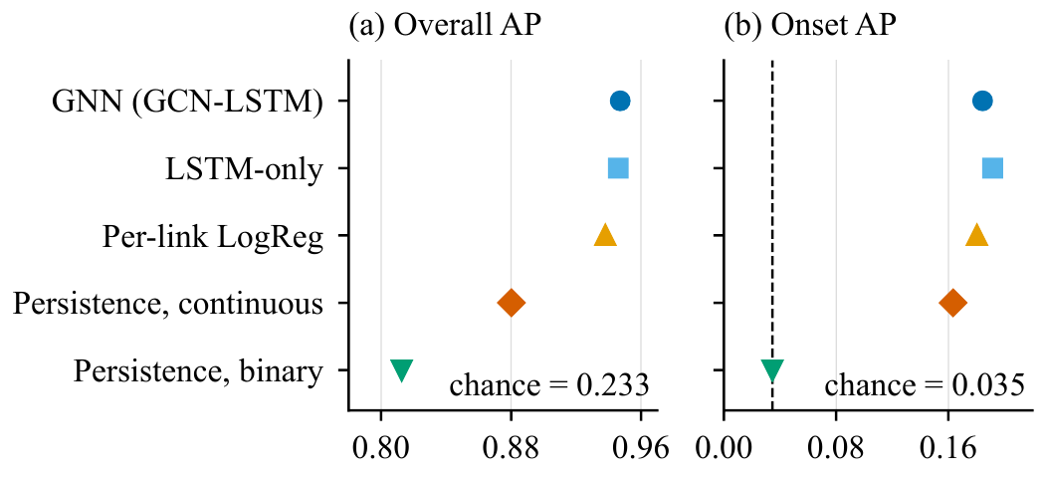
Fig. 2. Average precision overall (a) and on congestion onsets (b). The AP of a random predictor equals the positive rate: 0.233 overall (below the axis range of (a)) and 0.035 for onsets (dashed line in (b)). Error bars show the standard deviation over three training seeds and are hidden where they are smaller than the markers. LogReg: logistic regression.
Prediction of the occurrence of the new congestion is a difficult task. Trained model achieves only an onset AP of 0.18–0.19, and the edge between the GCN-LSTM and continuity is +0.021, with the confidence interval slightly more than zero. It is clear that the majority of predictive power comes from the ability to predict whether congestion will increase or decrease, but not the new congestion.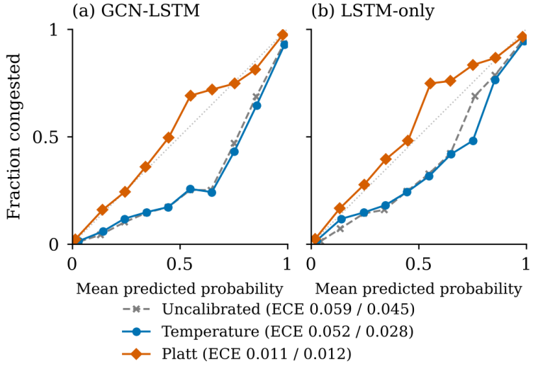
Fig. 3. Reliability diagrams on the test scenarios for (a) the GCN-LSTM and (b) the LSTM-only forecaster, pooled over three training seeds (ten equal-width bins). Points below the diagonal indicate over-prediction. The ECE values in the legend are given as GCN-LSTM / LSTM-only.

B. Generalisation to Unseen Workload Families
To check whether the models learn congestion patterns instead of the traffic generator, a pilot experiment trained the models on five families and tested them on the sixth, rotating through all six. In every rotation, the learned forecaster achieved a higher AP than continuous persistence, with a confidence interval above zero, and the LSTM-only model came within 0.009 AP of the GCN-LSTM. However, the pilot ran for only 20 epochs with a single training seed, so it gives only a first, qualitative indication that the models generalise.
Structural similarity between scenarios. Since stride generator provides the same sixteen host pairs (and consequently the same ECMP paths) in every seed, the stride test scenario contains exactly the same flows and ECMP paths as three stride training scenarios — there is 0.73-0.82 correlation in per-link congestion rate and 91%-94% matching link-tick labels. Similarly, LLM-training family shows the matching (label similarity 95%-97%). On the contrary, none of the other four families have more than 42% shared hosts between test and training scenarios and show no correlation in per-link congestion rate. Excluding two mentioned families from test scenarios does not alter the results: on the remaining four scenarios GCN-LSTM model beats continuous persistence by +0.052 AP (95% CI [+0.033, +0.065], an interval that is fragile with only four test scenarios), whereas its advantage in the number of onset ticks is indistinguishable from 0 (+0.013, [−0.015, +0.033]). The same is true in the holdout pilot experiment where any stride scenario is not available during training: learned forecaster again outperforms continuous persistence in predicting stride traffic (0.957 vs 0.937). This problem of structural similarity is relevant to routing experiment — all ten stride seeds use exactly the same set of flows due to the structure of stride benchmark.

C. Ablation Study
Two ablation studies were conducted to measure the contribution of the spatial component and of the forecaster.
Without spatial information. The proposed approach employs both GCN and LSTM modules; this ablation uses only the latter to test if including the graph component helps, by comparing the full GCN-LSTM forecaster with the purely sequential LSTM forecaster. Employing only the LSTM results in performance almost equal to that of GCN-LSTM with an increase in AP by +0.001 (difference between GCN-LSTM and LSTM, 95% CI [−0.003, +0.014]). The latter approach has even a little better F1 score (0.900 vs 0.893) and Brier score (0.041 vs 0.049). The result holds for k=4 and h=5. It may be due to the fact that the short-term behavior of the link depends primarily on the flows that are using it now, and their presence is already accounted for by the link features. However, it should be noted that the forecaster has only aggregated statistics of per-link features, while the controller has access to per-flow flow counts. If flow counts or other measures of demand were available for the forecasting part, the difference could be more pronounced, and this needs to be explored further.
Without a forecaster. To estimate the advantage of a forecaster with respect to the current state, it is necessary to run the experiment without a forecaster, i.e. to rely on model-free signals. As it can be seen from Table V, guarded score (based on the current congestion score) is the most effective in terms of drops reduction (drops 5.72%), followed by guarded LSTM (drops 5.37%), guarded GNN (drops 5.27%) and guarded persistence (drops 4.86%). Is there a real difference? Table VI examines this question: there is virtually no difference between guarded GNN and guarded LSTM with respect to the ±1% margin (90% CI [−0.28%, +0.47%] of ECMP drops on the benchmark seeds, Table VI). In addition, guarded GNN is not equivalent to guarded score within ±1% on benchmark seeds, since the 90% confidence interval goes up to 1.03% (paired) and 1.17% (family-clustered) of ECMP drops (Table VI). The meaningful result here is a one-tailed constraint: The forecaster has a maximum edge of 0.10% of ECMP drops over the current score (one-sided 95% bound), while the current score may have an edge up to approximately 1% better. For unseen seeds, the difference is even smaller — 0.18% of ECMP drops; this value is equivalent to zero within ±1%, but only for the paired bootstrap method. It is still possible to say that guarding by the forecaster does not beat guarding by the current congestion score. From the data on family-level (Table VII), the guarded score is seen to have fewer total drops than the guarded GNN in the four families where they differ, by 0.3 to 2.0 points of the family’s ECMP drops.
TABLE V
Routing outcomes per strategy over 6 families × 10 traffic seeds (model-based strategies averaged over three training seeds). p99: 99th percentile. Score, no rules: the score-driven controller without admission rules; FlowBender-style: Section V-I. These two rows were run on the cloud machine, which reproduced the other rows exactly (Section IV-A).
Strategy | Total drops vs ECMP | Fabric drops vs ECMP | Host drops per run | Delivered pkt/tick | Mean delay (ms) | p99 delay (ms) | Reroutes per run
ECMP | 0 (reference) | 0 (reference) | 150,969 | 2,508.2 | 7.70 | 15.47 | 0
Reactive | −4.15% | −17.05% | 153,414 | 2,561.9 | 7.95 | 17.60 | 547.5
Unguarded GNN | −5.51% | −26.46% | 156,800 | 2,587.8 | 7.95 | 17.17 | 585.6
Score, no rules | −10.30% | −53.50% | 164,621 | 2,662.9 | 7.56 | 15.15 | 2,546.5
FlowBender-style | −10.62% | −55.99% | 165,597 | 2,670.5 | 7.21 | 13.58 | 1,039.4
Guarded GNN | −5.27% | −22.98% | 154,990 | 2,587.6 | 7.29 | 14.04 | 58.9
Guarded LSTM | −5.37% | −23.52% | 155,128 | 2,589.7 | 7.30 | 14.28 | 47.8
Guarded persistence | −4.86% | −19.79% | 153,718 | 2,582.0 | 7.28 | 14.20 | 47.8
Guarded score | −5.72% | −24.85% | 155,259 | 2,594.7 | 7.26 | 14.12 | 37.9

TABLE VI
Equivalence tests for total drops per run, guarded GNN minus alternative, on the benchmark seeds and on the unseen seeds. Mean difference and 95% CI are in packets per run (paired bootstrap over (family, seed) pairs); 90% CIs are in percent of mean ECMP total drops, from the paired and the family-clustered bootstrap. Equivalence (TOST) is declared when the 90% CI lies within ±1%.
Alternative | Mean diff. | 95% CI | 90% CI (pairs) | 90% CI (clustered) | Equivalent at ±1% (pairs / clustered)
Guarded persistence (seeds 3000–3009) | −889 | [−2,863, +878] | [−1.15%, +0.26%] | [−1.30%, +0.26%] | No / No
Guarded score (seeds 3000–3009) | +990 | [−463, +2,500] | [−0.10%, +1.03%] | [−0.04%, +1.17%] | No / No
Guarded LSTM (seeds 3000–3009) | +224 | [−751, +1,205] | [−0.28%, +0.47%] | [−0.34%, +0.64%] | Yes / Yes
Guarded persistence (seeds 4000–4009) | −1,086 | [−2,584, +386] | [−1.07%, +0.05%] | [−1.11%, +0.05%] | No / No
Guarded score (seeds 4000–4009) | +402 | [−1,191, +2,042] | [−0.41%, +0.81%] | [−0.78%, +1.30%] | Yes / No
Guarded LSTM (seeds 4000–4009) | +418 | [−492, +1,414] | [−0.14%, +0.58%] | [−0.18%, +0.67%] | Yes / Yes

TABLE VII
Absolute ECMP drops per run by traffic family and changes relative to ECMP for guarded score and guarded GNN (benchmark seeds 3000–3009). Loss: share of offered packets dropped. —: no fabric drops.
Family | ECMP total | ECMP fabric | ECMP host | Loss | Score: total | Score: fabric | Score: host | Score: delivered | GNN: total | GNN: fabric | GNN: host | GNN: delivered
Uniform | 33,890 | 20,697 | 13,192 | 7.6% | −34.7% | −76.7% | +31.3% | +3.0% | −32.7% | −77.3% | +37.2% | +2.8%
Hotspot | 278,899 | 128,176 | 150,724 | 39.3% | −6.1% | −18.4% | +4.4% | +4.2% | −5.4% | −15.8% | +3.3% | +3.8%
Elephant/mice | 76,963 | 39,262 | 37,700 | 21.1% | −28.5% | −69.7% | +14.5% | +7.9% | −27.8% | −71.9% | +18.1% | +7.7%
Stride | 8,916 | 8,916 | 0 | 2.8% | −100.0% | −100.0% | — | +2.9% | −100.0% | −100.0% | — | +2.9%
LLM-training | 24,684 | 0 | 24,684 | 16.2% | 0.0% | — | 0.0% | 0.0% | 0.0% | — | 0.0% | 0.0%
Mixed | 887,949 | 208,435 | 679,514 | 54.1% | −1.7% | −12.0% | +1.4% | +2.4% | −1.4% | −9.5% | +1.1% | +1.9%
All families | 218,550 | 67,581 | 150,969 | 36.1% | −5.7% | −24.8% | +2.8% | +3.4% | −5.3% | −23.0% | +2.7% | +3.2%

D. Routing Outcomes
Fig. 4 breaks down the drops into fabric-link drops and host-link drops. Each guarded scheme removes about 20–25% of the fabric-link drops, with few route changes, but every rerouting strategy also increases host-link drops, by 1.6–3.9% (9.0% score without the rules): traffic that is no longer dropped inside the fabric now reaches the destination host link and is dropped there, because the receiver is the bottleneck and no other path exists. Total drops therefore fall by only 4.9–5.7%, and the fabric-drop reduction should not be read as the headline effect. This average is primarily determined by the contribution of the Mixed family, making up 68% of ECMP drops (Table VII), and of the Hotspot case (21%), for which guarded score removes only 1.7% and 6.1%, respectively. If we consider an average with equal weights from all six cases, then guarded score filters out 28.5% of all drops, and guarded GNN 27.9%. However, this average depends significantly on the case of the single-stride collision (–100%), and, without that, the respective values decrease to 14.2% and 13.5%. The ECMP case sees 36% loss of offered packets, being thus highly overloaded; lighter loads are examined in Section V-F.
Table V also shows the cost of aggressive rerouting. Unguarded GNN rerouting leads to a total drop reduction of 5.51%, outperforming three of the four guarded variants (the only one beating it is guarded score, at 5.72%) as well as reactive rerouting (4.15%), yet both aggressive techniques use over 540 route changes per run and increase delivery delay compared to ECMP (99th percentile: 17.17 ms and 17.60 ms compared to 15.47 ms). In contrast, the guarded schemes offer comparable drop reductions with 38–59 route changes per run and display the lowest delivery delay among all methods (mean: 7.26–7.30 ms compared to 7.70 ms; 99th percentile: 14.04–14.28 ms). With the same controller driven by the existing score in the absence of any admission rule (Score, no rules), the largest number of drops is removed, reaching 10.30%, or close to double compared to the drop removal by guarded score (the difference between paired means is −4.58 points of ECMP drops, 95% CI [−7.62, −2.08]). But this method involves a total of 2,546.5 routes changed in each run and 19.5% of the packets reordered (Section V-G). It also delivers 6.2% more packets per tick than ECMP (2,662.9 against 2,508.2), the most of all strategies, and has a lower mean delay than ECMP (7.56 against 7.70 ms), so in the open-loop model it is the best strategy on drops and throughput.
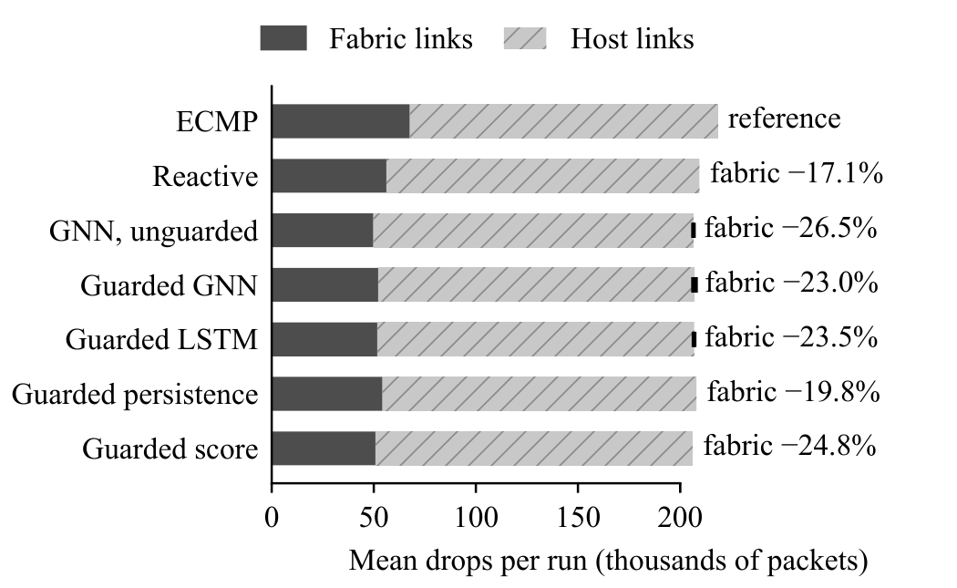
Fig. 4. Mean drops per run split into fabric-link and host-link drops for each routing strategy; annotations give the fabric-drop change relative to ECMP.
Fig. 5 shows the fabric-drop reduction of the guarded variants per traffic family. The highest drop reduction relative to ECMP is achieved for stride traffic, where ECMP hashes multiple flows between pods onto the same core links. All ten stride traffic seeds produce the same set of sixteen flows (only rates and timing differ); the stride result therefore represents a single collision scenario and should not be interpreted as ten independent confirmations. No drops on fabric links occur for the LLM-training family under any strategy, because its bursts overflow the links of the host nodes. For the elephant/mice family, there are fewer drops for the reactive and unguarded GNN rerouting strategies than for any guarded variant (these two strategies are not shown in Fig. 5). In the mixed family too, unguarded GNN rerouting produces fewer drops. In both families, this comes at the cost of far more route changes (roughly 7–10 times as many in elephant/mice and 44–67 times as many in mixed).
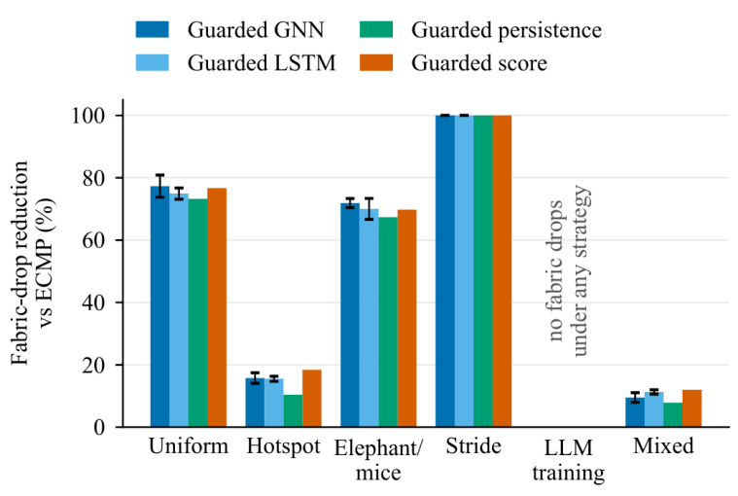
Fig. 5. Fabric-drop reduction relative to ECMP per traffic family for the guarded variants. The LLM-training family has no fabric drops under any strategy.

E. Admission-Rule Ablation and Sensitivity
Fig. 6 evaluates the effect of disabling one admission rule at a time on traffic seeds 4000-4009 for guarded score, guarded persistence and guarded GNN. With all the rules active, the three algorithms decrease drops by 4.28%, 3.60% and 4.10%, respectively, using 34-55 route changes per run. Only the capacity check rule, when disabled, results in a meaningful change: the drop reduction shrinks by 1.2-1.4 percentage points (about a third), the number of route changes grows to 172-204 per run, and the 99th percentile delay becomes higher than in ECMP (15.7-16.4 ms vs 15.1 ms). Disabling the minimum improvement rule lowers total drops only slightly further, by 0.4-0.6 points (this range includes zero), while increasing the number of route changes 1.5-2.1 times, and disabling sequential reservation increases route changes 38-66% while leaving the drop reduction unchanged. Disabling change budget, stretch bound, cooldown, and changing the alert threshold from validation optimized score (0.851 for score and 0.75–0.85 for the GNN) to 0.7, changes the drop reduction by at most 0.22 points. In every case of single-rule ablation, the difference between guarded GNN and guarded score means differs by 0.05-0.63 points and not statistically significant. The leave-one-out results show only that the other rules overlap with one another, not that they are unimportant.
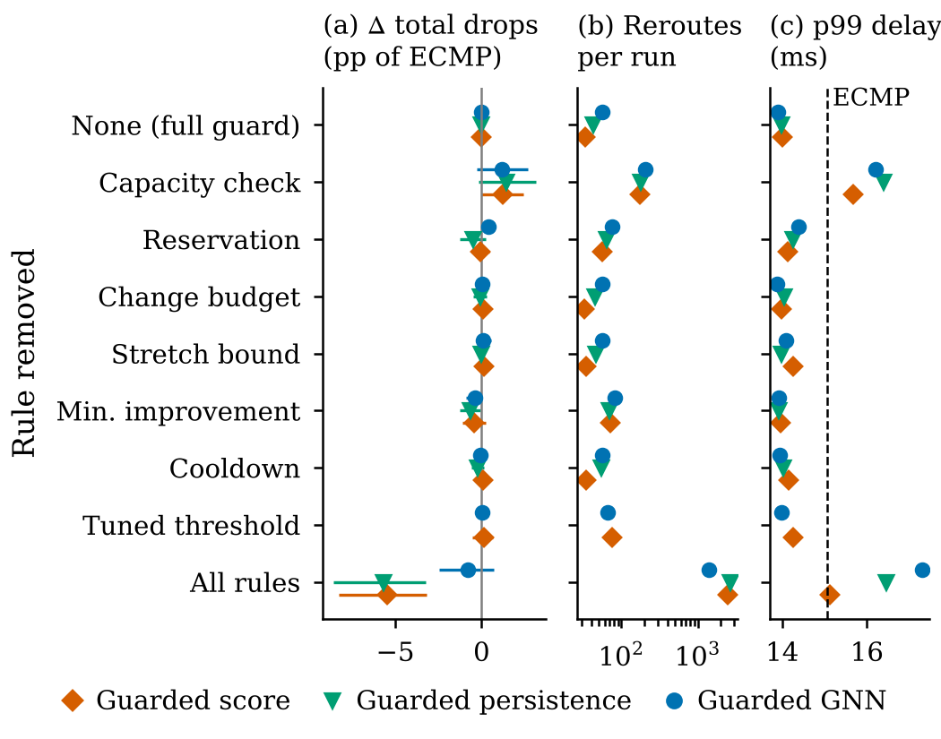
Fig. 6. Leave-one-rule-out ablation on unseen traffic seeds 4000-4009 (60 runs per variant; guarded GNN averaged over three training seeds). (a) Change of total number of drops from the full guarding in % of mean ECMP total drops, with 95% bootstrap intervals (negative: fewer drops). (b) Number of route changes per run (log scale). (c) Mean 99th-percentile delivery delay; the dashed line corresponds to ECMP. Variant ‘tuned-threshold’ replaces the validation threshold by 0.7 and is not applicable for binary signaling.
The absence of rules makes visible what the price of rules is and what they accomplish. Re-routing according to the model-free signals eliminates 9.8% (score) and 9.3% (persistence) of the total drops – more than twice as many as the guarded controller does – but it involves 2,492 to 2,678 route changes per run – about 62 to 74 times as many – and lacks the delay advantage over ECMP in the 99th-percentile delay of 15.1 ms (score) and 16.5 ms (persistence), compared with 15.1 ms for ECMP. Re-routing according to the GNN forecasts that don't have the rules involved (with the validation-tuned alert threshold, unlike the unguarded GNN of Table V, which uses a fixed 0.7) is certainly worse: it removes only 4.9% of the total drops, which is 4.9 points less than score signal with the same conditions (95% CI [+3.1, +6.9]), with the highest 99th-percentile delay of all versions (17.3 ms). As the forecast triggers all the re-routes when there are no admission rules, forecast error leads directly to route change error. So admission rules don't maximize drop elimination. Rather, they set another operating point and accept some potential drop reduction for an extremely smaller number of route changes and lower delay. With it, they take little concern of the type of the signal. The gradual increase in rules in the score-based controller without rules shows how much each rule reduces the route changes (Table A2). In particular, the capacity constraint, together with the reservation in a sequential manner, change budget, minimum improvement condition, and cooldown individually bring down the number of route changes from 2,492 to between 134-583 route changes per run, while the stretch bound does not seem to affect the route changes. Out of all of those, the capacity check rule alone keeps a drop reduction of 4.64% with 134 route changes, and the minimum improvement condition alone keeps only a 1.61% drop reduction while increasing the 99th percentile delay to 16.8ms, surpassing ECMP at 15.1 ms.
In Table VIII α, δ, κ, and M are varied one by one for guarded score on the same unseen seeds. Increasing the capacity threshold from α=0.6 to α=1.2 brings increase of both drop reduction (2.67% to 4.69%) and route changes (10 to 121 per run), but 99th-percentile delay remains below ECMP during the whole range. Complete removing of the check brings drop reduction to 3.06% with 172 route changes and increases the delay over ECMP. Decreasing δ usually causes increasing route changes for a higher drop reduction (δ=0: 4.73% with 72 changes; δ=0.5: 2.50% with 10). The cooldown has no effect until the default of five ticks, then it begins to decrease the moves and benefit of the strategy. Change budget becomes relevant only below the default: with M=2 is 0.58 points worse than with M=4, whereas M=8 and M=16 are equal (all in 0.09 points of M=4), no family differing more than 0.51 points. The current parameters lie in the middle of the trade-off of fewer drops and more route changes, not at the optimum point. None of the examined sets of the parameters nulls the benefit of ECMP, while default improves the value by -4.28% (paired 95% CI of per run difference[-12838,-6085] packet)
Terms of the capacity check. To test whether the check works through demand or through the current queue and arrival measurements in (21), the default guard was rerun on the unseen seeds with these terms removed (Table A7): without the queue term (B), with the demand taken as the summed sending rates of the flows on the link, i.e. without the observed arrivals (C′), without both (D, a check on flow-rate demand alone), and with the rate-blind estimate of Section V-F, in which every flow is assumed to send the mean active rate, also without queue and arrivals (E; the mean is computed from the sending rates, so this check is not rate-free). With the score signal, removing the queue term changes no run, and removing the arrivals as well changes total drops by +0.15 points of the ECMP drops (95% CI [−0.20, +0.53], family-clustered [−0.25, +0.64]; −4.13% against −4.28% for the full check), with 35 instead of 34 route changes per run. With the random signal, the check on flow-rate demand alone gives −4.33% against −4.59% (+0.26 points, [−0.36, +0.93]) with 132 instead of 120 route changes, and the rate-blind check gives −4.66% (−4.39% with the score). None of these intervals excludes zero, so the removed terms have no detectable effect on drops; they are not shown to be equivalent. Re-evaluating every capacity test of the full check under the reduced checks shows why the effect is small: with the score signal, no candidate path that reaches the check contains a queued link, because a link with a queue is near full utilisation and therefore has a high score, which the link costs and the minimum-improvement rule already avoid, and the observed arrivals decide about 1% of the tests; with the random signal, 46% of the tested candidates contain a queued link, but on such links the summed rates or arrivals already exceed the headroom, so the queue term alone decides fewer than 0.1% of the tests and the arrivals about 2%. The check on flow-rate demand alone still removes 1.07 (score; 95% CI [−0.13, +2.29]) and 2.75 points (random; [+1.43, +4.26]) more drops than no capacity check (−3.06% and −1.57%), with 35 against 172 and 132 against 294 route changes per run. In this simulator, the effect of the capacity check is therefore carried by the demand that the flows’ sending rates place on each link, and, since the rate-blind check also works, mainly by where the flows are rather than by their exact rates; the queue and arrival measurements add no detectable benefit. Current congestion still enters the score-driven guard through its signal, which steers candidate paths away from loaded links, but the random signal, which carries no congestion information, reaches a drop reduction that is not detectably different with the same demand-only check. A deployed controller would have to estimate this demand from measurements, so the separation may be less clean in practice.
TABLE VIII
Guarded score sensitivity to headroom parameter α, minimal improvement δ, cooldown κ, and change budget M on the unseen traffic seeds 4000–4009 (varying one parameter at a time). Changes are relative to ECMP.
Parameter | Value | Total drops vs ECMP | Delivered vs ECMP | Reroutes per run | p99 delay (ms)
Headroom α | 0.60 | −2.67% | +1.54% | 10.5 | 14.27
 | 0.75 | −3.36% | +1.94% | 15.1 | 14.22
 | 0.90 (default) | −4.28% | +2.51% | 33.9 | 14.00
 | 1.00 | −4.62% | +2.70% | 66.5 | 13.88
 | 1.20 | −4.69% | +2.73% | 120.6 | 14.15
 | no check | −3.06% | +1.70% | 172.2 | 15.67
Min. improvement δ | 0.00 | −4.73% | +2.81% | 72.0 | 13.97
 | 0.05 | −4.05% | +2.40% | 38.2 | 14.07
 | 0.15 (default) | −4.28% | +2.51% | 33.9 | 14.00
 | 0.30 | −3.79% | +2.22% | 23.7 | 14.18
 | 0.50 | −2.50% | +1.46% | 9.6 | 14.23
Cooldown κ (ticks) | 0 | −4.21% | +2.49% | 34.0 | 14.15
 | 2 | −4.23% | +2.50% | 34.4 | 14.13
 | 5 (default) | −4.28% | +2.51% | 33.9 | 14.00
 | 10 | −3.74% | +2.20% | 23.4 | 13.93
 | 20 | −3.69% | +2.17% | 21.0 | 14.02
Budget M (moves/tick) | 2 | −3.70% | +2.17% | 34.6 | 14.08
 | 4 (default) | −4.28% | +2.51% | 33.9 | 14.00
 | 8 | −4.19% | +2.46% | 32.9 | 13.98
 | 16 | −4.19% | +2.46% | 32.9 | 13.98
Calibration and routing. Replacing the temperature-scaled GNN probabilities by Platt-recalibrated ones, with the alert threshold re-tuned on validation data, changes the total-drop reduction of guarded GNN on the unseen seeds from 4.10% to 4.06% (paired difference +0.04 points, 95% CI [−0.34, +0.44]), with 57 instead of 55 route changes per run. The routing conclusions therefore do not depend on the miscalibration reported in Section V-A.
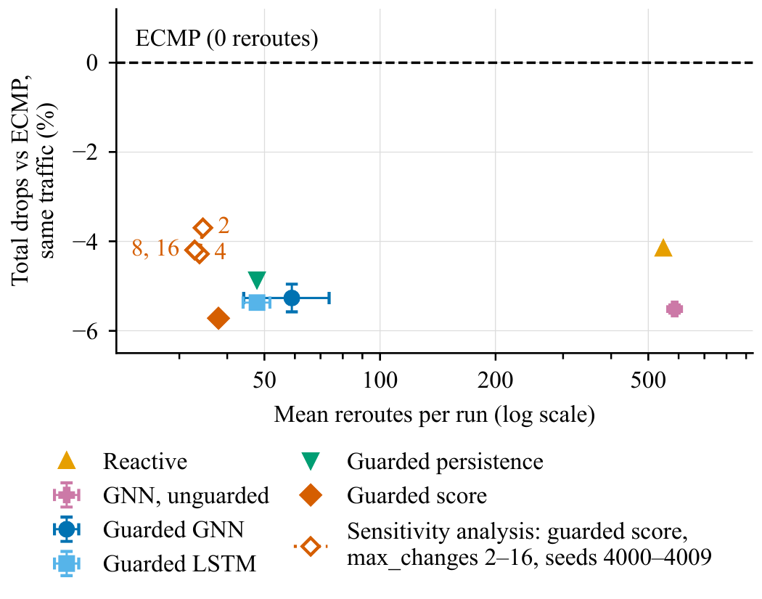
Fig. 7. Change in total drops relative to ECMP versus route changes per run (log scale). The curve shows the sensitivity analysis of guarded score over $M∈\{2,4,8,16\}$ on unseen traffic seeds. In the legend, max_changes denotes $M$.

F. Delay, Control Signals and Offered Load
The simulator provides the controller with perfect and instantaneous information: telemetry arrives at the same tick as described, and the route change applies at the subsequent tick. In real-world system, delays will occur due to export, computation, and rule installation. This is precisely the role of the forecaster to be played. Fig. 8 reproduces the guarded score and guarded GNN comparison on the test seeds and with telemetry delays of two and five ticks and actuation delays of two and five ticks; in the case of d_T = 5, five-tick forecast means the current tick, while the score is five ticks behind.
Up to five ticks of delay does not significantly alter the drop reduction provided by both approaches (less than one percentage point and not monotonically, Fig. 8a). With telemetry delay of two ticks the score achieves 4.82% drops and with five-tick telemetry delay, it is 4.45%; similarly, for actuation delays of two and five ticks the score delivers 4.16% and 4.18% drops. The guarded GNN approach provides 4.49%, 4.65%, 3.97% and 3.46% drops respectively. Difference between GNN forecasting and score is indicative of marginal gain only under a five-tick delay between telemetry and forecast—that is, when GNN forecasts coincide with the current time step (GNN minus score: -0.20 points, 95% CI [-0.55; +0.12]) where the confidence interval encompasses zero. Under five-tick delay between actuation and forecast, when forecast is thought to be the most beneficial for performance, the GNN lags behind the score by 0.72 points ([-0.01; +1.51]), and when both actuation and telemetry delays are taken into account, GNN underperforms by 0.20 points ([-0.25; +0.67]). No indication of benefit from forecasting is provided by the sweep under both telemetry and actuation delay settings, and actuation delay setting runs counter to forecast expectations; the reason has not been explored.
Control signals. The existence of stale telemetry does not affect the observed reduction of the guarded score (4.82% and 4.45% for telemetry delays of two and five ticks, respectively, versus 4.28% without any delay). For that reason, the default controller was also tested on unseen seeds with two control signals and an oracle. If the risk for each link is randomly selected independently for each tick, then the overall number of drops is reduced by 4.59% using 120 route changes per run (difference between guarded score: -0.31 points, 95% confidence interval [-1.18, +0.53]). Reductions per family are similar to those of the guarded score. The two signals are not equivalent on churn, however: the random signal needs 3.5 times as many route changes as the score (120 against 34 per run; paired difference +86, 95% CI [+69, +105]), reorders 0.67% of the delivered packets in 23.6% of the flows against 0.22% in 7.4%, and has a 0.43 ms higher 99th-percentile delay (95% CI [+0.02, +0.83]). The GNN needs 1.6 times as many route changes as the score (55 per run; +21, [+11, +34]) and reorders 0.27% of the packets in 8.8% of the flows (Table A3). At equal drops, the signal therefore still controls churn, and on this measure the forecaster is worse than the current score. The static random risk per run moves almost no flows (6 route changes per run) and shows no effect. A passive oracle, computed at every tick by copying the simulator state, advancing the copy five ticks with all routes frozen (no further controller moves) and reading the true future score or label of every fabric link, reduces the number of drops by 3.57% and 3.68%, i.e. 0.71 and 0.60 points less than the current score (95% CIs [−0.24, +1.72] and [−0.42, +1.79]), with 22 and 29 route changes per run, fewer than the score, and 0.18% and 0.21% of the packets reordered. Because it knows only what will be congested if no flow is moved, and not what happens after a move, this oracle is not an upper bound on the value of forecasting; it shows only that a perfect passive five-tick congestion label adds nothing to the guarded controller. The drop reduction, based on the standard rule set, is therefore independent of any information about congestion in the risk signal; it comes from changing traffic flows from their current ECMP allocation, as a function of the capacity test performed at each link on the demand placed on it by the flows (Section V-E). Under the admission rules, the controller therefore acts as a demand-aware reshuffler in the manner of Hedera rather than as a congestion-driven controller, and comparisons of GNN and score under the guard cannot reveal the value of forecasting, because every signal reaches the same floor of drop reduction. The signal matters only without the rules, and there the forecaster removes far fewer drops than the score (4.9% against 9.8%).
Rate knowledge and a signal-free guard. The capacity check (21) uses the flow rates and the demand on each link, which the simulator knows exactly (the demand is the larger of the summed flow rates and the observed arrivals). The variants below change only the flow-rate estimates and keep the queue and arrival terms; Section V-E removes those terms. To test whether the benefit depends on this idealisation, the default controller was rerun on the unseen seeds with rate estimates carrying multiplicative log-normal noise (σ = 0.25, 0.5 and 1.0, mean-preserving, drawn afresh every tick), with a rate-blind check that assumes every active flow sends the mean active rate, and with telemetry-estimated rates, i.e. the mean number of packets each flow delivered per tick over the last five ticks (Table A4). The drop reduction does not shrink: guarded score reduces total drops by 5.06%, 4.81% and 4.36% with noisy rates, by 4.38% when rate-blind and by 5.72% with telemetry estimates, against 4.28% with exact rates, but its route changes rise from 34 to 44–103 per run. Delivered rates are lower than sending rates whenever packets are dropped, so telemetry estimates loosen the check; with them, the random risk signal removes 7.57% of the total drops, 1.85 points more than the score (95% CI of the difference [+0.46, +3.49]). A signal-free guard, in which every flow is eligible, candidates are plain shortest paths and the capacity check alone decides, reduces total drops by 3.49% with exact rates (0.79 points less than guarded score, 95% CI [−0.24, +1.87]) and by 6.80% with telemetry estimates, with 178 and 209 route changes per run. In this model, the capacity check therefore does not need exact per-flow rates and provides most of the drop reduction without any risk signal, and the signal mainly affects how many route changes are made. Real demand estimators may err in ways that independent noise does not capture.
Offered load. To cover light to heavy load, every flow rate of the unseen traffic was multiplied by a load factor from 0.1 to 1.0, where 1.0 is the traffic used elsewhere (Table A5). This lowers the share of offered packets that ECMP drops from 35.5% at the default load to 26.2%, 15.4%, 4.6%, 1.8%, 0.32%, 0.14% and 0% at load factors 0.75, 0.5, 0.25, 0.2, 0.15, 0.125 and 0.1. At load factors of 0.5 and above, guarded score removes 4.3–5.6% of the total drops. At 0.25 and below it removes none: it has 2.97% more drops than ECMP at 0.25 and 1.56% more at 0.2, and is within 0.4% of ECMP at 0.15 and 0.125, with 0–24 route changes per run and a 99th-percentile delay at or below that of ECMP. The forecaster does not outperform the score at any load: guarded GNN minus guarded score lies between 0.00 and +0.62 points of the ECMP drops, every 95% interval includes zero, and near the congestion knee (load factors 0.15, 0.2 and 0.25) the differences are +0.62, +0.05 and +0.31 points. The random risk signal stays within 1.7 points of the score at every load, again with intervals that include zero, but it moves about 290 flows per run even at light load, which raises its 99th-percentile delay 0.9–1.7 ms above that of ECMP at load factors up to 0.25. Separately, the score-driven controller without admission rules removes 2.2–11.3 points more drops than guarded score at every load with drops, with 12–2,492 route changes per run. Within this range of loads, the sweep gives no indication of a load region in which forecasting helps; the GNN was trained at the default load only.
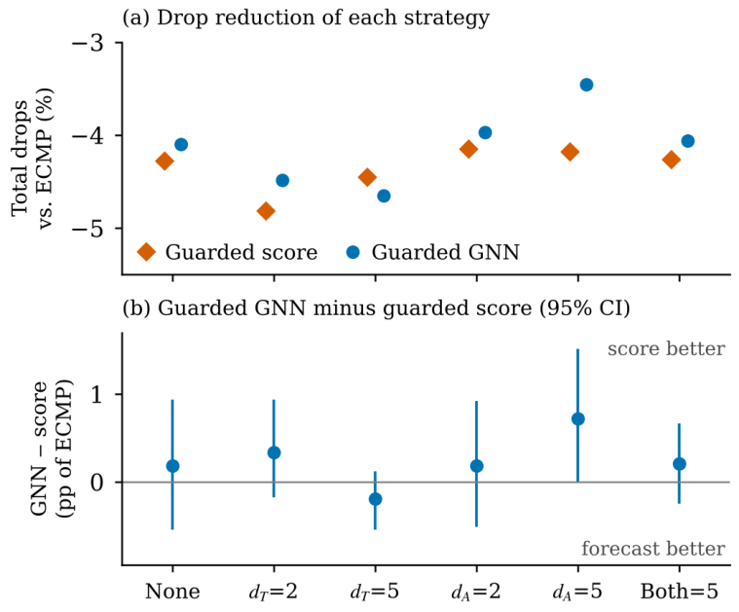
Fig. 8. Control-loop delay on the unseen traffic seeds 4000–4009: (a) change in total drops relative to ECMP and (b) paired difference between guarded GNN and guarded score, in percentage points of the mean ECMP total drops, with 95% paired-bootstrap intervals; $d_{T}$: telemetry delay, $d_{A}$: actuation delay (ticks); guarded GNN averaged over three training seeds.

G. Flow-Level Effects
Reordering. Route change may reorder packets if packets on the new route pass by packets yet waiting on the old one. For the test seed sequences, the aggressive policies reorder 15.7-18.2% of the packets, while 53-64% of the flows incur reordering (score, no rules: 19.5% and 68%); the guarded policies reorder 0.26-0.38% of the packets in 9-14% of the flows, while ECMP does not reorder any packets at all. Thus, the guard decreases reordering by a factor of 41-71. It is significant because reordering is the primary expense incurred by mid-path rerouting for loss-sensitive transports, which treat reordering as loss.
Closed-loop flow transport and flow completion time. Table IX shows the closed-loop version of the experiment described in Sec. IV-D, where lost packets are retried, and senders back off. All guarded approaches yield shorter flow completion times than ECMP, as the mean FCT drops to 120.3-120.6 ticks, while the median slow-down decreases from 1.37 to 1.26-1.29, the mean run-wise slowdown by 0.06-0.07 (95% CI for paired difference in guarded GNN slow-down: [-0.136, -0.009]). Aggressive rerouting leads to the opposite effect – both reactive and unguarded GNN rerouting increase the mean FCT up to 137.5 ticks and 131.9 ticks correspondingly with on average around 1500 route changes per run, since this strategy incurs additional packet losses and retries (in 49% and 42% of the packets are retransmitted, whereas only 39% are for ECMP). The rule-less, score-based controller, which removes the most drops in the open-loop test, executes 6,304 route changes per run and has a mean FCT 1.3% longer than ECMP (counting unfinished flows as censored; paired-cell bootstrap 95% CI [−1.1%, +4.1%]) but a p99 FCT 7.0% shorter ([−9.3%, +1.2%]); neither difference is significant, so against this strategy the FCT evidence is mixed. The benefit of the guard is especially pronounced in the case of elephant/mice family (mean slow-down 1.66 for ECMP compared to 1.33-1.39); in the incast-dominated hotspot family, where the receiver’s link is the bottleneck, guarded rerouting slightly increases the mean slow-down (from 2.71 to 2.75-2.79), the LLM-training family is not impacted. Guarded GNN and guarded score are indistinguishable at the mean (average FCT of 120.3 and 120.4 ticks), but their p99 FCTs are different (444 and 456 ticks). Hence, the open-loop experimental results are confirmed by the coarse closed-loop model as well; indeed, admission control transforms reactive and unguarded GNN rerouting from being detrimental to beneficial for the flow completion, while forecaster has no effect here; against the score-driven controller without rules, the base model cannot separate the two. The base model includes no penalty for reordering, so its FCTs omit the main cost of rerouting; the variant below adds one. Between 6 and 9 out of 1,928 flows per approach had not completed in 600 ticks and hence excluded from the FCT computation. Counting the censored connections in the end (at 600 ticks) contributes to increasing the average FCT of all strategies by 1.4–2.0 ticks and the p99 FCT by 13–32 ticks, without changing the overall ranking (ECMP: 126.6 and 502 ticks; guarded strategies: 121.7-122.0 and 457-475 ticks).
Reordering penalty. The closed-loop runs were repeated with a conservative reordering penalty: every out-of-order delivery is treated by the sender as a loss signalled by duplicate acknowledgements, so half a round trip later the reordered packets are retransmitted spuriously (they consume capacity but add no progress) and the rate is halved, at most once per round trip together with real losses (Table A6). The guarded strategies are barely affected: their spurious retransmissions are 0.3% of the offered packets, and the mean FCT of guarded score stays 3.5% below that of ECMP (95% CI [−5.1%, −2.1%]; p99 4.4% below, [−8.0%, −0.4%]). Without admission rules, spurious retransmissions reach about 16% of the offered packets, and the mean FCT of the score-driven controller rises to 18.8% above ECMP ([+15.6%, +21.8%]; p99 +6.1%, [+1.7%, +14.2%]), while reactive and unguarded GNN rerouting reach 26.6% and 22.9% above ECMP. Because this penalty treats every reordered batch as a loss, whereas real transports tolerate some reordering (duplicate-ACK thresholds, time-based loss detection), the two models bracket the realistic case: the guard is clearly preferable when reordering costs as much as loss, and indistinguishable from the score-driven controller without rules when reordering is free. Which applies depends on the transport and cannot be settled in this model.
TABLE IX
Closed-loop transport variant (loss recovery and AIMD rate control) on the benchmark seeds 3000–3004 of every family. FCT: flow completion time in ticks; slowdown: FCT divided by the FCT on an idle network; Retx.: share of packets retransmitted; Reroutes: route changes per run. Model-based strategies use the first training seed. Score, no rules: score-driven controller without admission rules. FCT and slowdown are over completed flows; censored values are given in the text.

Strategy | Mean FCT | p99 FCT | Mean slowdown | p99 slowdown | Retx. (%) | Reroutes
ECMP | 125.2 | 483 | 3.410 | 35.89 | 39.4 | 0.0
Reactive | 137.5 | 462 | 4.000 | 50.18 | 49.5 | 1495.9
Unguarded GNN | 131.9 | 468 | 3.714 | 45.95 | 41.9 | 1474.9
Score, no rules | 126.6 | 451 | 3.705 | 42.88 | 37.9 | 6304.0
Guarded GNN | 120.3 | 444 | 3.347 | 37.12 | 38.1 | 102.5
Guarded persistence | 120.6 | 444 | 3.329 | 34.97 | 37.7 | 78.7
Guarded score | 120.4 | 456 | 3.343 | 35.77 | 38.0 | 61.0

H. Computation Time and Control Interval
Figure 9 shows inference time per tick for the laptop. Inference time of the GCN-LSTM is 2.0 ms (median) and 4.1 ms (99th percentile), while the inference time of the LSTM-only model is 1.5 ms (99th percentile). In the routing experiments, the forecaster is called at every 1-millisecond tick, but the simulator does not wait for the forecaster to finish. Hence, the GCN-LSTM model is slower than the simulated clock on this CPU because the median inference time exceeds the duration of one tick. It is the tick and not the horizon that is the right basis of comparison here.
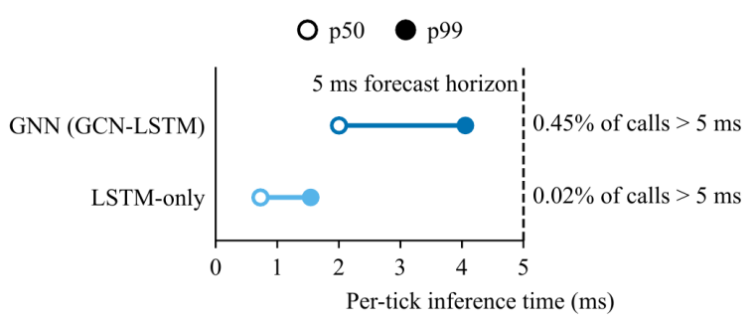
Fig. 9. Median (p50) and 99th-percentile (p99) inference time per tick for the GCN-LSTM and LSTM-only forecasters relative to the 5 ms forecast horizon (laptop CPU, two threads).
Inference is also not the limiting factor here. As measured on the cloud machine using the original controller, one tick of the guarded controller requires 3.4 ms in median and 69 ms in 99% percentile when driven by the score, and 2.7 ms in median and 82 ms in 99% percentile when driven by the GCN-LSTM, while the GCN-LSTM takes 2.9 ms on average in median on the same cloud machine; in the case of the mixed family, one tick takes 44–51 ms in median. A breakdown of the costs of running the guarded controller with GCN-LSTM on the mixed network revealed that almost all the costs are due to computing weighted shortest paths in NetworkX. The controller, therefore, is the bottleneck of the control loop and a deployment solution requires either the computation of paths off-line or some hardware support.
To see whether coarser-grained forecasting maintains the routing result, guarded GNN was tested again, but in this run, the forecaster is called only every two or five ticks and its prediction is usable only after its interval, thus, allowing 2 or 5 ms per invocation for the GCN-LSTM to perform inference. This changes the reduction in total drops of the controlled runs on unseen seeds from 4.14% (in the case of the original guarded controller, calling the GCN-LSTM every tick and with the same training seed) to 4.33% and 4.48%, with the number of route changes going down to 53 and 36 compared with 68. Thus, when predicting the future every five ticks, which even allows time enough for the 99% percentile GCN-LSTM inference on the laptop computer (taking 4.1 ms), the routing result stays preserved, and in this coarseness the GCN-LSTM inference stays in line with the simulated clock. Still, the complete duration of the controller tick (2.7–3.4 ms at the median, 44–51 ms within the mixed family) is out of reach.

I. Comparison with the State of the Art
Load-balancing solutions relying on switches (CONGA, HULA, and Clove) and those implemented on the hosts (FlowBender, Hermes) are not reproduced in the simulation because flowlets, ECN marking, and transport protocol behaviors are lacking; a FlowBender-style emulation with ECN marking at a queue threshold and rehashing after consecutive congested ticks is evaluated below. Thus, the quantitative part of this comparison will be based on baseline schemes capturing major design ideas: static hashing (ECMP), reactive threshold rerouting, unguarded forecast-driven rerouting, and model-free guarded rerouting. The model-free guarded controller follows the reservation rule set by Hedera and also demonstrates the dampened and conditional movements associated with FlowBender and Hermes; however, it is not a replacement of those systems in terms of its functioning process.
FlowBender-style baseline. Since the required state exists in the simulator, a FlowBender-style baseline [20] was implemented: a link marks ECN when its queue exceeds 10% of its buffer, and a flow whose path contains a marking link for two consecutive ticks is rehashed to a randomly chosen different equal-cost path; there is no capacity check, budget or risk signal. On the benchmark seeds (Table V) it reduces total drops by 10.62%, 4.90 points more than guarded score (95% CI of the difference [+2.25, +8.09]), and has the lowest delivery delay of all strategies (mean 7.21 ms, 99th percentile 13.58 ms), but it makes 1,039 route changes per run and reorders 9.4% of the delivered packets in 42% of the flows; a more aggressive setting (5% threshold, one tick) gives 10.79% with 2,159 route changes. In the closed-loop model its mean FCT is 3.4% longer than that of guarded score without a reordering penalty ([+1.8%, +5.3%]) and 12.4% longer with it ([+9.8%, +14.5%]; Table A6). FlowBender-style rehashing therefore behaves like the score-driven controller without rules: it removes more drops and lowers open-loop delay than the guard, at the cost of much more churn and reordering, which lengthens flow completion in the closed-loop model.
NeuralFabric is distinct from reactive approaches of Table I in its ability to rely on forecasts and is different from learning solutions like RouteNet and T-GCN that are assessed through their ability to predict or optimize routes rather than perform online rerouting. Our results show that, under the conditions of a millisecond time scale, the guarded controller does not show any loss in performance using the current score instead of predictions; whether the same holds for CONGA, FlowBender, and Hermes was not tested.

J. Discussion
Key results. Temporal neural networks were shown to predict the future state of link congestions better than persistence in overall AP in all the settings used, including a pilot experiment evaluating workload families not seen in the training set and without any structural repeating cases of stride and LLM-training. There is no gain from use of Graph Convolutional Network (GCN). Prediction of new congestion appears to be hard and predictions suffer from the upward bias of temperature-scaled probabilities. Forecast-driven rerouting does not beat current congestion-dependent rerouting with identical admission rules in all single-rule ablation experiments and in presence of delays of up to five telemetry or actuation steps. All guarded schemes deliver a 2.9–3.4% gain in the number of packets delivered per tick, reduce delay and drop totals by 4.9–5.7% while making less reordering actions than aggressive rerouting, despite the fact that most of total drops are incurred on the host links and are beyond control by any rerouting mechanism. They are also shown to decrease flow completion time in our closed loop model setting, unlike reactive and unguarded GNN rerouting, which increases completion times; against the score-driven controller without rules, the guard shortens completion times only when reordering is penalised.
Interpretation. The guarded rerouting procedure is not the best policy for drop avoidance: removing all admission rules from the model-free controller doubles its drop reduction, but this policy changes 62–74 times as many routes and loses most of the guard’s delay advantage over ECMP. Thus, the admission rules define the tradeoff point between drops, churn, and delay; the removal of capacity check alone becomes the major alteration in this respect; nevertheless, gradual integration of the rules reveals their redundancy with each other (Section V-E). Considering that the five-tick horizon is small relative to the lifetime of the flows and primary control loop lacks of delay, the contribution of the risk signal becomes marginal in case of adoption of the capacity check, since stochastic risk signal works as well as the existing one on drops, though with 3.5 times as many route changes, and a perfect passive five-tick congestion label brings no improvement over it (V-F). The congestion measurements inside the check itself also add no detectable benefit: a check on the demand placed on each link by the flows’ sending rates and paths, without queue and arrival terms, gives a drop reduction that is not detectably different (Section V-E). What matters in this setting is information about where the flows are and what they send, rather than measured queues or arrivals, used as a gate on where they may move; congestion information used as a trigger for which flows move does not change drops. On the other hand, without admission rules, risk signal gains importance and increases in forecast error is the factor increasing the number of moves. Under such circumstances, forecast-based routing becomes 4.9 percentage points worse than score-based routing.
Implications. With respect to a millisecond-scale control loop equipped with an admission control policy, the priority should lie in improving the admission control policy rather than on improving the forecaster itself. Forecast-driven routing should be compared with a model-free signal that drives the same action, and each admission rule should be ablated. Improvements in prediction may otherwise be incorrectly identified as an improvement in admission control policies. These considerations depend on the particular experimental setting, and thus generalization of these findings is not possible to control loops where delays are longer with respect to the forecasted horizon, to wider fabrics, or to traffic with a longer lifespan. The delay sweep does not indicate any benefit of forecasting at delays of up to five ticks; with five ticks of actuation delay, the forecaster did worse by 0.72 points.
Limitations. Packets-batches simulator operates with 1 ms tick rate and does not consider ECN, PFC, and RDMA. The closed-loop configuration used in simulations for flow completion times is a coarser, loss-based model as opposed to the real transport protocol. The telemetry in question is the ideal case in the main set of experiments; the span of the delay sweep consists of constant delays up to five ticks. Traffic is synthetic; the traffic stride and LLM training families have repeated host pairs' usage within each seed while the former is based on the pattern of collective communication rather than on traces replication. Only one topology (k = 4) and one forecast horizon (five ticks) were investigated; the forecasting data set consists of six cases, holdout experiments were performed using one seed only, and the forecaster employs only per-link aggregated features. Some additional experiments use a single seed of GNN training. The capacity check is given exact flow rates in the main experiments; noisy, rate-blind and telemetry-estimated rates were tested (Section V-F), but not a deployed demand estimator; the finding that the queue and arrival terms add nothing (Section V-E) rests on exact knowledge of each flow’s path and sending rate.
Recommendations. Larger fabric spatial graph models (for instance, k = 8) should be validated on longer forecasting horizons with per-flow demand and interlink congestion propagation where neighboring information has more relevance. In order to produce forecasts valuable beyond state information, onset-oriented training objectives and adjusted probabilities would become necessary. Forecast-based control could be reconsidered with real transport protocols, where control loop delays would be estimated on hardware with forecasting horizons matching the delays.

VI. Conclusion and Future Scope
NeuralFabric examines forecast-driven rerouting in a controlled setting in which a telemetry-driven congestion forecaster and model-free signals drive the same capacity-guarded controller in a full-duplex Fat-Tree simulation. The learned forecasters ranked future congestion better than persistence in overall AP in every test scenario (on average over training seeds), though not in onset AP, but a per-link logistic regression obtained most of this gain, the spatial graph component gave no measurable advantage, onsets remained hard to predict and the probabilities were biased upwards. Forecast-driven guarded routing performed no better than the same controller driven by the current congestion score, on the benchmark and on unseen traffic, under every single-rule ablation and with up to five ticks of telemetry or actuation delay or at lighter offered loads. All guarded approaches increased delivered packets per tick by 2.9–3.4% and reduced pooled total drops by 4.9–5.7% (fabric-link drops by 20–25%), with about ten times fewer route changes and 41–71 times less packet reordering than aggressive rerouting, with lower delay than ECMP and, in a closed-loop transport model, with about 4% shorter mean flow completion times; against the score-driven controller without rules, which removes the most drops, this advantage appears only when reordering is penalised. The ablations show that removing the capacity check alone changes the outcome most, that the rules are largely redundant with one another, and that the rules as a whole trade part of the attainable drop reduction for far fewer route changes and lower delay. The main point is that, in this idealised millisecond-scale setting, with the admission rules in place, the guarded controller acts as a demand-aware reshuffler whose benefit comes from the capacity check that gates where flows may move rather than from congestion information in the signal that selects which flows move; removing the queue and arrival measurements from the check changed total drops by at most 0.26 points of the ECMP drops on average, with no detectable effect, so the check works through the demand that the flows place on each link: a random risk signal did as well as the current score on drops, though with 3.5 times as many route changes, and a perfect passive five-tick congestion label added nothing, whereas without the rules the signal matters; whether forecasting pays off in slower control loops, at longer horizons or in larger fabrics remains open.
Future work will test larger topologies (k=8) and longer forecast horizons matched to measured control-loop delays, use realistic flow sizes and transport protocols with lossless flow control, give the forecaster per-flow demand inputs, design training objectives for congestion onsets, and implement the controller with precomputed candidate paths on programmable data planes.

Data and Code Availability
The simulator, training and evaluation code, checkpoints of the trained models, the raw results of every run (including the additional experiments), and the scripts that generate the figures and tables are available from the authors upon reasonable request. All datasets and traffic are generated with fixed random seeds and can be regenerated exactly with the generation scripts; the simulator is deterministic.

Appendix: Supplementary Tables
TABLE A1
Per-scenario forecast quality on the six test scenarios (one per family; GCN-LSTM averaged over three training seeds). Columns 3–6: overall AP; Onset: AP on onset windows only; Persist.: continuous persistence; Pos.: positive link-windows; Δ: GCN-LSTM minus continuous persistence. The pooled row ranks all test windows together and is not the mean of the rows above.
Scenario | Pos. | GCN-LSTM | LogReg | Persist. | Δ | Onset GCN-LSTM | Onset persist.
Uniform | 675 | 0.980 | 0.979 | 0.934 | +0.047 | 0.157 | 0.138
Hotspot | 1,577 | 0.939 | 0.941 | 0.867 | +0.071 | 0.281 | 0.260
Elephant/mice | 774 | 0.965 | 0.964 | 0.942 | +0.023 | 0.107 | 0.137
Stride | 611 | 0.958 | 0.935 | 0.917 | +0.041 | 0.073 | 0.017
LLM-training | 109 | 0.092 | 0.076 | 0.036 | +0.056 | 0.056 | 0.023
Mixed | 2,348 | 0.962 | 0.956 | 0.914 | +0.048 | 0.254 | 0.252
Pooled (all six) | 6,094 | 0.947 | 0.938 | 0.880 | +0.067 | 0.184 | 0.163

TABLE A2
Add-one-in rule ablation for the score-driven controller (unseen seeds 4000–4009, 60 runs per row): each rule added alone to the controller without rules. ECMP p99 delay: 15.07 ms.
Rules | Total drops vs ECMP | Route changes per run | p99 delay (ms)
No rules | −9.76% | 2492 | 15.13
+ capacity check (with reservation) | −4.64% | 134 | 14.50
+ change budget | −3.27% | 390 | 15.18
+ stretch bound | −9.79% | 2474 | 14.72
+ minimum improvement | −1.61% | 309 | 16.77
+ cooldown | −6.65% | 583 | 15.60
All rules (default guard) | −4.28% | 34 | 14.00

TABLE A3
Default guard driven by different risk signals (exact flow rates, unseen seeds 4000–4009, 60 runs per row; GNN averaged over three training seeds). Route chg.: route changes per run; Reord.: share of delivered packets reordered and of flows with reordering; p99: 99th-percentile delay. Δ vs score: paired difference in total drops, in points of mean ECMP total drops, with 95% bootstrap CI (positive: more drops). ECMP p99 delay: 15.07 ms. Passive oracle: true congestion five ticks ahead with routing frozen.
Signal | Drops vs ECMP | Δ vs score [95% CI] | Route chg. | Reord. pkts | Reord. flows | p99 (ms)
Score | −4.28% | — | 33.9 | 0.22% | 7.4% | 14.00
GNN | −4.10% | +0.18 [−0.55, +0.93] | 55.3 | 0.27% | 8.8% | 13.90
Random | −4.59% | −0.31 [−1.18, +0.53] | 120.2 | 0.67% | 23.6% | 14.43
Static random | +0.01% | +4.29 [+2.79, +5.78] | 6.0 | 0.03% | 0.8% | 14.95
Passive oracle (future score) | −3.57% | +0.71 [−0.24, +1.72] | 22.0 | 0.18% | 4.2% | 13.93
Passive oracle (future label) | −3.68% | +0.60 [−0.42, +1.79] | 28.5 | 0.21% | 5.4% | 14.08
Signal-free | −3.49% | +0.79 [−0.24, +1.87] | 178.0 | 0.24% | 7.5% | 13.82

TABLE A4
Default guard with exact, noisy, rate-blind or telemetry-estimated flow rates in the capacity check (unseen seeds 4000–4009, 60 runs per cell; GNN averaged over three training seeds). Entries: total-drop change relative to ECMP / route changes per run. Telemetry estimate: mean packets delivered per tick by the flow over the last five ticks. Signal-free: every flow eligible, capacity check alone decides.
Rate estimate | Score | GNN | Random | Signal-free
Exact | −4.28% / 34 | −4.10% / 55 | −4.59% / 120 | −3.49% / 178
Noise σ = 0.25 | −5.06% / 47 | −4.63% / 71 | −5.14% / 123 | —
Noise σ = 0.5 | −4.81% / 65 | −4.86% / 95 | −5.86% / 129 | −5.08% / 206
Noise σ = 1.0 | −4.36% / 103 | −4.44% / 129 | −6.05% / 146 | —
Rate-blind | −4.38% / 44 | −4.07% / 64 | −4.47% / 109 | −3.59% / 163
Telemetry estimate | −5.72% / 44 | −5.19% / 71 | −7.57% / 151 | −6.80% / 209

TABLE A5
Offered-load sweep: every flow rate of the unseen traffic (seeds 4000–4009, 60 runs per cell) multiplied by the load factor; GNN averaged over three training seeds. Entries: total-drop change relative to ECMP / route changes per run; GNN − score in points of mean ECMP drops with 95% bootstrap CI.
Load | ECMP loss | Guarded score | GNN − score [95% CI] | Random | Score, no rules
0.1 | 0.00% | — / 0 | 0 (no drops) | — / 294 | — / 0
0.125 | 0.14% | +0.0% / 2 | +0.00 [+0.00, +0.00] | −1.70% / 294 | −11.27% / 12
0.15 | 0.32% | +0.34% / 4 | +0.62 [+0.00, +1.86] | −0.76% / 294 | −7.90% / 93
0.2 | 1.8% | +1.56% / 15 | +0.05 [−2.14, +2.35] | +0.33% / 293 | −3.64% / 370
0.25 | 4.6% | +2.97% / 24 | +0.31 [−0.85, +2.10] | +2.23% / 290 | −2.31% / 674
0.5 | 15.4% | −5.57% / 33 | +0.09 [−0.57, +0.82] | −5.03% / 239 | −7.76% / 1536
0.75 | 26.2% | −4.44% / 29 | +0.58 [−0.11, +1.27] | −4.98% / 173 | −9.02% / 2089
1.0 | 35.5% | −4.28% / 34 | +0.18 [−0.55, +0.93] | −4.59% / 120 | −9.76% / 2492

TABLE A6
Closed-loop transport without and with the reordering penalty (benchmark seeds 3000–3004 of every family; model-based strategies use the first training seed). FCT in ticks over all flows, unfinished flows censored at the end of the run; Δ: mean FCT relative to ECMP; Spur.: spurious retransmissions as a share of offered packets.
Strategy | Mean FCT | p99 FCT | Δ mean | Mean FCT (pen.) | p99 FCT (pen.) | Δ mean (pen.) | Spur.
ECMP | 126.6 | 502 | — | 126.6 | 502 | — | 0.0%
Reactive | 139.5 | 494 | +10.2% | 160.2 | 560 | +26.6% | 15.6%
Unguarded GNN | 133.9 | 492 | +5.8% | 155.6 | 553 | +22.9% | 16.2%
Score, no rules | 128.2 | 467 | +1.3% | 150.4 | 533 | +18.8% | 16.1%
FlowBender-style | 125.9 | 459 | −0.6% | 137.3 | 487 | +8.5% | 7.9%
Guarded GNN | 121.9 | 475 | −3.7% | 122.6 | 486 | −3.1% | 0.3%
Guarded persistence | 122.0 | 457 | −3.6% | 122.8 | 475 | −3.0% | 0.3%
Guarded score | 121.7 | 471 | −3.8% | 122.1 | 480 | −3.5% | 0.3%

TABLE A7
Terms of the capacity check (21) of the default guard (unseen seeds 4000–4009, 60 runs per row; S: score, R: random risk signal, random seeds as in Table A3). A: demand max(summed flow rates, observed arrivals) plus queue term; B: without the queue term; C′: demand = summed sending rates of the flows on the link, with queue term; D: summed sending rates only, no queue term; E: as D with every flow assumed to send the mean active rate (rate-blind; the mean uses the sending rates); No check: capacity check removed. Total: total-drop change relative to ECMP; Δ vs A: paired difference from A with the same signal, in points of mean ECMP total drops, with 95% bootstrap CI (positive: more drops); Fabric / host: drop change on fabric and host links relative to ECMP; Deliv./tick: delivered packets per tick; Mean / p99: delivery delay; Route chg.: route changes per run.
Capacity check | Sig. | Total (%) | Δ vs A [95% CI] | Fabric / host (%) | Deliv./ tick | Mean / p99 (ms) | Route chg.
A: full check | S | −4.28 | — | −19.5 / +1.5 | 2644.3 | 7.09 / 14.00 | 33.9
 | R | −4.59 | — | −22.6 / +2.3 | 2648.4 | 7.14 / 14.43 | 120.2
B: no queue | S | −4.28 | +0.00 [+0.00, +0.00] | −19.5 / +1.5 | 2644.3 | 7.09 / 14.00 | 33.9
 | R | −4.57 | +0.02 [−0.02, +0.07] | −22.6 / +2.3 | 2648.7 | 7.14 / 14.47 | 120.4
C′: no arrivals | S | −4.13 | +0.15 [−0.20, +0.53] | −19.4 / +1.7 | 2642.0 | 7.08 / 13.93 | 35.5
 | R | −4.46 | +0.13 [−0.44, +0.66] | −23.3 / +2.7 | 2647.6 | 7.12 / 14.27 | 129.4
D: rates only | S | −4.13 | +0.15 [−0.20, +0.53] | −19.4 / +1.7 | 2642.0 | 7.08 / 13.93 | 35.5
 | R | −4.33 | +0.26 [−0.36, +0.93] | −22.8 / +2.7 | 2645.6 | 7.13 / 14.32 | 131.9
E: rate-blind | S | −4.39 | −0.12 [−1.19, +0.93] | −20.0 / +1.6 | 2644.5 | 7.14 / 14.33 | 55.2
 | R | −4.66 | −0.08 [−0.97, +0.71] | −22.7 / +2.2 | 2650.3 | 7.20 / 14.60 | 129.7
No check | S | −3.06 | +1.22 [−0.01, +2.45] | −14.4 / +1.3 | 2623.4 | 7.48 / 15.67 | 172.2
 | R | −1.57 | +3.01 [+1.56, +4.64] | −6.9 / +0.5 | 2603.6 | 7.61 / 15.98 | 294.1
ECMP | — | 0.00 | — | — | 2579.6 | 7.41 / 15.07 | 0

References
[1] T. Benson, A. Akella, and D. A. Maltz, “Network traffic characteristics of data centers in the wild,” in Proc. 10th ACM Internet Measurement Conf. (IMC), 2010, pp. 267–280.
[2] M. Al-Fares, A. Loukissas, and A. Vahdat, “A scalable, commodity data center network architecture,” in Proc. ACM SIGCOMM, 2008, pp. 63–74, doi: 10.1145/1402958.1402967.
[3] R. N. Mysore, A. Pamboris, N. Farrington, N. Huang, P. Miri, S. Radhakrishnan, V. Subramanya, and A. Vahdat, “PortLand: A scalable fault-tolerant layer 2 data center network fabric,” in Proc. ACM SIGCOMM, 2009, pp. 39–50, doi: 10.1145/1594977.1592575.
[4] A. Greenberg et al., “VL2: A scalable and flexible data center network,” in Proc. ACM SIGCOMM, 2009, pp. 51–62, doi: 10.1145/1594977.1592576.
[5] C. Guo et al., “BCube: A high performance, server-centric network architecture for modular data centers,” in Proc. ACM SIGCOMM, 2009, pp. 63–74, doi: 10.1145/1594977.1592577.
[6] A. Singla, C.-Y. Hong, L. Popa, and P. B. Godfrey, “Jellyfish: Networking data centers randomly,” in Proc. 9th USENIX Symp. Networked Systems Design and Implementation (NSDI), 2012, pp. 225–238.
[7] C. Hopps, “Analysis of an equal-cost multi-path algorithm,” RFC 2992, IETF, Nov. 2000.
[8] M. Al-Fares, S. Radhakrishnan, B. Raghavan, N. Huang, and A. Vahdat, “Hedera: Dynamic flow scheduling for data center networks,” in Proc. 7th USENIX NSDI, 2010, pp. 281–296.
[9] A. R. Curtis, J. C. Mogul, J. Tourrilhes, P. Yalagandula, P. Sharma, and S. Banerjee, “DevoFlow: Scaling flow management for high-performance networks,” in Proc. ACM SIGCOMM, 2011, pp. 254–265.
[10] B. Heller, S. Seetharaman, P. Mahadevan, Y. Yiakoumis, P. Sharma, S. Banerjee, and N. McKeown, “ElasticTree: Saving energy in data center networks,” in Proc. 7th USENIX NSDI, 2010.
[11] M. Alizadeh et al., “CONGA: Distributed congestion-aware load balancing for datacenters,” in Proc. ACM SIGCOMM, 2014, pp. 503–514, doi: 10.1145/2619239.2626316.
[12] N. Katta, M. Hira, C. Kompella, A. Vahdat, and J. Rexford, “HULA: Scalable load balancing using programmable data planes,” in Proc. ACM Symp. SDN Research (SOSR), 2016, doi: 10.1145/2890955.2890968.
[13] S. Ghorbani, B. Godfrey, Y. Ganjali, and A. Firoozshahian, “Micro load balancing in data centers with DRILL,” in Proc. 14th ACM Workshop on Hot Topics in Networks (HotNets), 2015, doi: 10.1145/2834050.2834107.
[14] K. He, E. Rozner, K. Agarwal, W. Felter, J. Carter, and A. Akella, “Presto: Edge-based load balancing for fast datacenter networks,” in Proc. ACM SIGCOMM, 2015.
[15] E. Vanini, R. Pan, M. Alizadeh, P. Taheri, and T. Edsall, “Let it flow: Resilient asymmetric load balancing with flowlet switching,” in Proc. 14th USENIX NSDI, 2017, pp. 407–420.
[16] K. Rusek, J. Suárez-Varela, P. Almasan, P. Barlet-Ros, and A. Cabellos-Aparicio, “RouteNet: Leveraging graph neural networks for network modeling and optimization in software-defined networks,” IEEE J. Sel. Areas Commun., vol. 38, no. 10, pp. 2260–2270, 2020.
[17] Y. Li, R. Yu, C. Shahabi, and Y. Liu, “Diffusion convolutional recurrent neural network: Data-driven traffic forecasting,” in Proc. Int. Conf. Learning Representations (ICLR), 2018.
[18] B. Yu, H. Yin, and Z. Zhu, “Spatio-temporal graph convolutional networks: A deep learning framework for traffic forecasting,” in Proc. 27th Int. Joint Conf. Artificial Intelligence (IJCAI), 2018, pp. 3634–3640, doi: 10.24963/ijcai.2018/505.
[19] L. Zhao, Y. Song, C. Zhang, Y. Liu, P. Wang, T. Lin, M. Deng, and H. Li, “T-GCN: A temporal graph convolutional network for traffic prediction,” IEEE Trans. Intell. Transp. Syst., vol. 21, no. 9, pp. 3848–3858, 2020, doi: 10.1109/TITS.2019.2935152.
[20] A. Kabbani, B. Vamanan, J. Hasan, and F. Duchene, “FlowBender: Flow-level adaptive routing for improved latency and throughput in datacenter networks,” in Proc. 10th ACM Int. Conf. Emerging Networking Experiments and Technologies (CoNEXT), 2014, pp. 149–159, doi: 10.1145/2674005.2674985.
[21] H. Zhang, J. Zhang, W. Bai, K. Chen, and M. Chowdhury, “Resilient datacenter load balancing in the wild,” in Proc. ACM SIGCOMM, 2017, pp. 253–266, doi: 10.1145/3098822.3098841.
[22] N. Katta, A. Ghag, M. Hira, I. Keslassy, A. Bergman, C. Kim, and J. Rexford, “Clove: Congestion-aware load balancing at the virtual edge,” in Proc. 13th Int. Conf. Emerging Networking Experiments and Technologies (CoNEXT), 2017, doi: 10.1145/3143361.3143401.
[23] C. H. Song, X. Z. Khooi, R. Joshi, I. Choi, J. Li, and M. C. Chan, “Network load balancing with in-network reordering support for RDMA,” in Proc. ACM SIGCOMM, 2023, pp. 816–831, doi: 10.1145/3603269.3604849.
[24] J. Perry, A. Ousterhout, H. Balakrishnan, D. Shah, and H. Fugal, “Fastpass: A centralized zero-queue datacenter network,” in Proc. ACM SIGCOMM, 2014, pp. 307–318, doi: 10.1145/2619239.2626309.
[25] M. Alizadeh et al., “pFabric: Minimal near-optimal datacenter transport,” in Proc. ACM SIGCOMM, 2013, pp. 435–446, doi: 10.1145/2486001.2486031.
[26] M. Alizadeh, A. Greenberg, D. A. Maltz, J. Padhye, P. Patel, B. Prabhakar, S. Sengupta, and M. Sridharan, “Data center TCP (DCTCP),” ACM SIGCOMM Comput. Commun. Rev., vol. 40, no. 4, pp. 63–74, 2010, doi: 10.1145/1851182.1851192.
[27] Y. Zhu et al., “Congestion control for large-scale RDMA deployments,” in Proc. ACM SIGCOMM, 2015, pp. 523–536, doi: 10.1145/2785956.2787484.
[28] R. Mittal et al., “TIMELY: RTT-based congestion control for the datacenter,” in Proc. ACM SIGCOMM, 2015, pp. 537–550, doi: 10.1145/2829988.2787510.
[29] Y. Li et al., “HPCC: High precision congestion control,” in Proc. ACM SIGCOMM, 2019, pp. 44–58, doi: 10.1145/3341302.3342085.
[30] R. Ben Basat, S. Ramanathan, Y. Li, G. Antichi, M. Yu, and M. Mitzenmacher, “PINT: Probabilistic in-band network telemetry,” in Proc. ACM SIGCOMM, 2020.
[31] T. N. Kipf and M. Welling, “Semi-supervised classification with graph convolutional networks,” in Proc. Int. Conf. Learning Representations (ICLR), 2017.
[32] S. Hochreiter and J. Schmidhuber, “Long short-term memory,” Neural Computation, vol. 9, no. 8, pp. 1735–1780, 1997, doi: 10.1162/neco.1997.9.8.1735.
[33] Z. Wu, S. Pan, F. Chen, G. Long, C. Zhang, and P. S. Yu, “A comprehensive survey on graph neural networks,” IEEE Trans. Neural Netw. Learn. Syst., vol. 32, no. 1, pp. 4–24, 2021, doi: 10.1109/TNNLS.2020.2978386.
[34] Z. Wu, S. Pan, G. Long, J. Jiang, and C. Zhang, “Graph WaveNet for deep spatial-temporal graph modeling,” in Proc. 28th IJCAI, 2019, pp. 1907–1913, doi: 10.24963/ijcai.2019/264.
[35] O. Aouedi, V. A. Le, K. Piamrat, and Y. Ji, “Deep learning on network traffic prediction: Recent advances, analysis, and future directions,” ACM Comput. Surv., vol. 57, no. 6, pp. 1–37, 2025, doi: 10.1145/3703447.
[36] M. Ferriol-Galmés et al., “RouteNet-Fermi: Network modeling with graph neural networks,” IEEE/ACM Trans. Netw., vol. 31, no. 6, pp. 3080–3095, 2023, doi: 10.1109/TNET.2023.3269983.
[37] S. Ahmad, G. S. Rao, H. A. M. Abdeljaber, E. S. N. Joshua, F. A. Abdalla, and H. Gadi, “RouteNet-TGNN: A temporal graph neural network for delay and loss forecasting in dynamic communication networks,” J. Commun., vol. 21, no. 2, pp. 211–225, 2026, doi: 10.12720/jcm.21.2.211-225.
[38] A. Valadarsky, M. Schapira, D. Shahaf, and A. Tamar, “Learning to route,” in Proc. 16th ACM Workshop on Hot Topics in Networks (HotNets), 2017, pp. 185–191, doi: 10.1145/3152434.3152441.
[39] L. Chen, J. Lingys, K. Chen, and F. Liu, “AuTO: Scaling deep reinforcement learning for datacenter-scale automatic traffic optimization,” in Proc. ACM SIGCOMM, 2018, pp. 191–205, doi: 10.1145/3230543.3230551.
[40] G. Khekare, K. P. Kumar, K. N. Prasanthi, S. R. Godla, V. Rachapudi, M. S. A. Ansari, and Y. A. B. El-Ebiary, “Optimizing network security and performance through the integration of hybrid GAN-RNN models in SDN-based access control and traffic engineering,” Int. J. Adv. Comput. Sci. Appl. (IJACSA), vol. 14, no. 12, 2023, doi: 10.14569/IJACSA.2023.0141262.
[41] G. Bernárdez, J. Suárez-Varela, X. Shi, S. Xiao, X. Cheng, P. Barlet-Ros, and A. Cabellos-Aparicio, “GraphCC: A practical graph learning-based approach to congestion control in datacenters,” Comput. Netw., vol. 257, art. 110981, 2025, doi: 10.1016/j.comnet.2024.110981.
[42] P. Zhang, H. Zhang, Y. Dai, C. Zeng, J. Wang, and J. Liao, “NTP-INT: Network traffic prediction-driven in-band network telemetry for high-load switches,” J. Netw. Comput. Appl., vol. 242, art. 104265, 2025, doi: 10.1016/j.jnca.2025.104265.
[43] E. Nosrati and M. Ghaderi, “Congestion-aware path selection for load balancing in AI clusters,” arXiv:2506.08132, 2025.
[44] J. Hu, W. Li, X. Liu, J. Wang, B. Liu, P. Yin, J. Wang, J. Huang, and K. Chen, “FLB: Fine-grained load balancing for lossless datacenter networks,” in Proc. USENIX Annu. Tech. Conf. (ATC), 2025.
[45] T. Benson, A. Anand, A. Akella, and M. Zhang, “MicroTE: Fine grained traffic engineering for data centers,” in Proc. 7th ACM Int. Conf. Emerging Networking Experiments and Technologies (CoNEXT), 2011, pp. 1–12, doi: 10.1145/2079296.2079304.
[46] H. Wang, H. Xie, L. Qiu, Y. R. Yang, Y. Zhang, and A. Greenberg, “COPE: Traffic engineering in dynamic networks,” in Proc. ACM SIGCOMM, 2006, pp. 99–110, doi: 10.1145/1159913.1159926.
[47] A. Azzouni and G. Pujolle, “NeuTM: A neural network-based framework for traffic matrix prediction in SDN,” arXiv:1710.06799, 2017.
[48] Y. Perry, F. V. Frujeri, C. Hoch, S. Kandula, I. Menache, M. Schapira, and A. Tamar, “DOTE: Rethinking (predictive) WAN traffic engineering,” in Proc. 20th USENIX Symp. Networked Systems Design and Implementation (NSDI), 2023, pp. 1557–1581.
[49] C. Guo, G. Pleiss, Y. Sun, and K. Q. Weinberger, “On calibration of modern neural networks,” in Proc. 34th Int. Conf. Machine Learning (ICML), PMLR vol. 70, 2017, pp. 1321–1330.
[50] D. J. Schuirmann, “A comparison of the two one-sided tests procedure and the power approach for assessing the equivalence of average bioavailability,” J. Pharmacokinet. Biopharm., vol. 15, no. 6, pp. 657–680, 1987, doi: 10.1007/BF01068419.
[51] J. C. Platt, “Probabilistic outputs for support vector machines and comparisons to regularized likelihood methods,” in Advances in Large Margin Classifiers, A. J. Smola, P. Bartlett, B. Schölkopf, and D. Schuurmans, Eds. Cambridge, MA, USA: MIT Press, 1999, pp. 61–74.

