






Audio Amplifier

Dhanush H S 4SU24EC018

Dhanush R 4SU24EC019

Mohan Reddy 4SU24EC044

Table of Contents

Pg no
Table of Contents ii
List of figure iii

Chapter 1 Introduction

  - Background of the project. 1

  - Importance and applications. 2

  - Problem statement. 3

Chapter 2 Circuit Design

2.1 Circuit diagram with proper labelling 4

2.2 simulation setup and parameters. 5

2.3 Simulation results. 6

Chapter 3 Hardware Implementation

3.1 Circuit diagram for hardware. 7

3.2 Components lists. 8

3.3 Steps followed for hardware implementation. 8

3.4 Photographs of the hardware setup. 9

Chapter 4 Results and Discussions

4.1 Compare LTspice simulation results with 9
hardware results.

Chapter 5 Conclusion

5.1 Summary. 10

Reference 12

List of Figure

Figure  No. | Description | Page no
2.1 | Ltspice simulation | 04
2.3 | Input-output waveform | 05
3.1 | Hardware schematic | 07
3.4 | Hardware setup | 09

Chapter 1
Introduction

  - Background
The field of audio electronics has evolved significantly over the last century, transitioning from the bulky, heat-generating vacuum tubes of the early 1900s to the highly efficient, miniature solid-state components we use today. Audio amplification the process of increasing the amplitude of electrical signals to drive loudspeakers remains a fundamental pillar of modern technology.Whether in sophisticated home theater systems, public address systems, or personal mobile devices, the core requirement remains the same: taking a weak electrical signal and boosting its power to a level that can physically move a speaker cone to produce audible sound waves.
In the current era of mobile computing, smartphones, laptops, and tablets have become the primary sources of media consumption. While these devices excel in digital processing and storage, they face significant physical limitations regarding audio output. Due to the drive for thinner and lighter devices, the built-in speakers in modern electronics are often small and lack the power to produce rich, room-filling sound. This signal, usually less than 1 volt in amplitude with very low current capability, is designed to drive high-impedance headphones, not low-impedance loudspeakers.
This creates a technological gap: we have high-quality audio sources in our pockets, but we lack the immediate means to play that audio loudly for a group of people without bulky external equipment. To bridge this gap, a dedicated Audio Power Amplifier is required. This acts as the interface between the weak signal source and the speaker, providing both voltage gain and current gain.

This project focuses on the implementation of such a system using the LM386 integrated circuit. Introduced in the 1970s, the LM386 became the industry standard for low-power audio applications and remains widely used today in intercoms, portable radios, and hobbyist electronics. Unlike complex "Class A" or "Class AB" amplifiers built from discrete transistors, which require careful biasing and thermal management, the LM386 integrates the pre-amplifier, power amplifier, and internal biasing circuitry into a single 8-pin package., this project aims to demonstrate how classic analog circuitry can be used to solve the modern problem of weak audio output in portable devices.

1.2 Importance and Applications
The ability to process and amplify audio signals is a cornerstone of modern electronics, bridging the gap between digital processing and human perception. While signal generation has become increasingly miniaturized and digital, the physical act of producing sound still requires analog power amplification. The importance of this project lies in its practical demonstration of how low-voltage, single-supply circuitry can drive substantial loads, a critical requirement for battery-operated portable devices.

By utilizing the LM386 integrated circuit, this project highlights the efficiency and simplicity required in consumer electronics. Unlike bulky high-fidelity systems that demand complex dual-rail power supplies and large heat sinks, the LM386 allows for compact, lightweight designs that are essential for mobile technology. This balance of size, power consumption, and output capability makes the study of such amplifiers fundamental for understanding embedded audio systems.

Applications:
- Portable Consumer Electronics: This circuit topology is the basis for portable Bluetooth speakers, pocket radios, and handheld gaming consoles where battery life and space are premium constraints.

- Communication Systems: Similar low-power amplification is used in intercom stations, walkie-talkies, and landline telephone speakerphones to drive small loudspeakers.

- Diagnostic Tools: In electronics repair, small, portable amplifiers (often called "signal tracers") are used to audibly detect signals at various points in a faulty circuit.

1.3 Problem Statement or Motivation
Most mobile devices (smartphones, laptops) output audio signals suitable only for high-impedance headphones. These signals are too weak (typically <1V) to drive external loudspeakers directly. The motivation for this project is to build a low-cost, portable amplifier that bridges this gap, allowing weak audio sources to drive 20Ω speakers with sufficient volume.

Chapter 2
Circuit Design

2.1 Circuit Diagram
The circuit is designed and modelled in LTspice software. The design consists of an AC voltage source (representing the audio input), the amplifier stage, and a resistive load (representing the speaker).

Fig 2.1
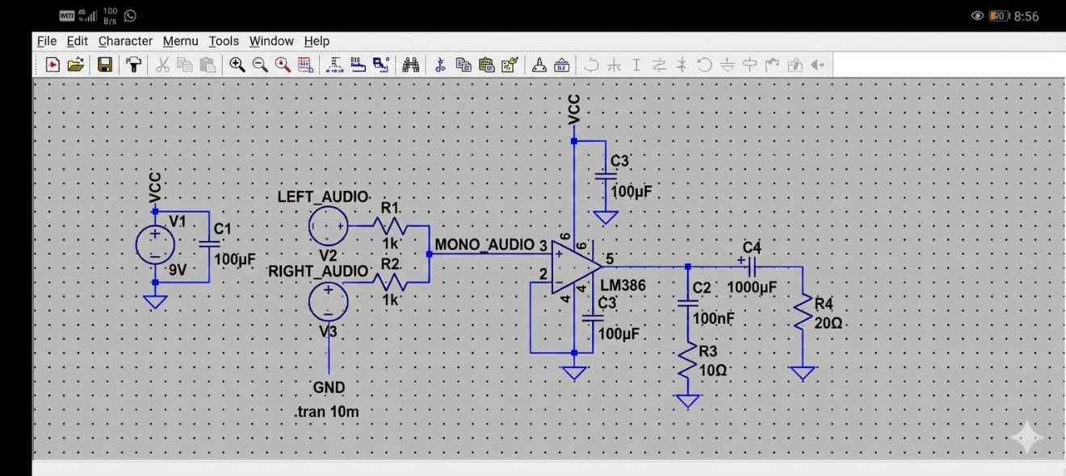

- Input Source: Sine Wave.

- Amplifier Model: LM386 operational model.

- Load: 20Ω resistor.

2.2 Simulation Setup and Parameters
- Software Used: LTspice XVII.

- Input Signal: A sine wave with a frequency of 1kHz.

- Supply Voltage: 9V DC.

- Simulation Command: .tran to observe voltage vs. time.

.tran 10m

2.3 Simulation Results (Waveforms)
The simulation input and output waveform is shown in

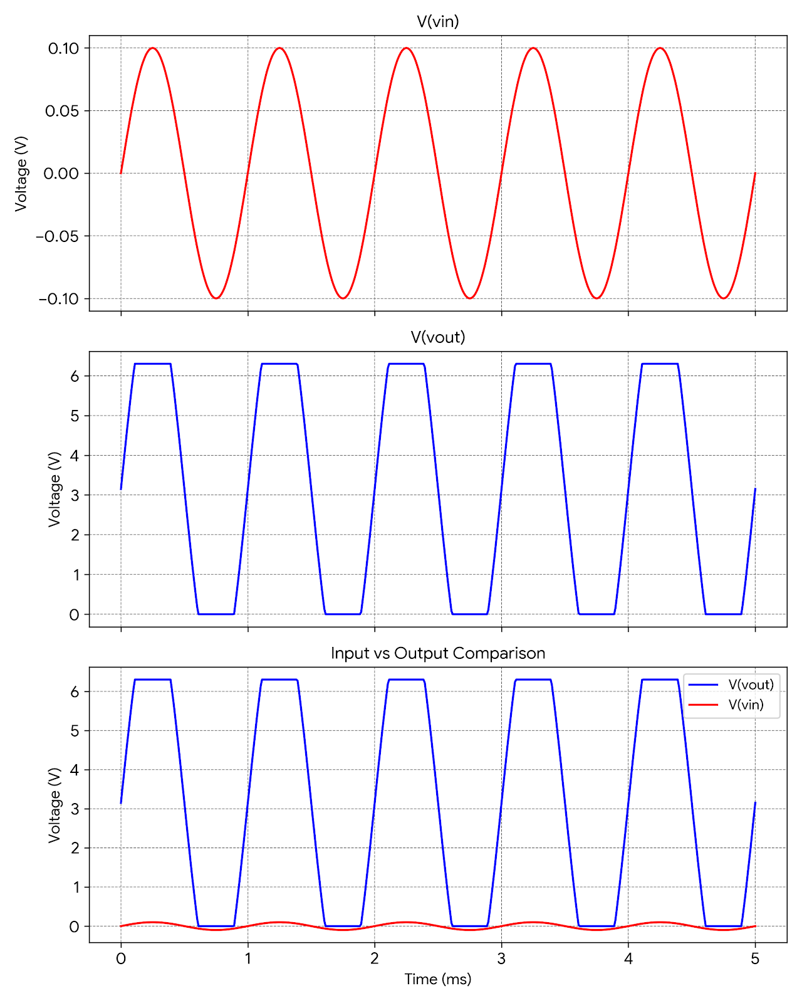
Figure 2.3

Observations from Waveforms:
- Input Voltage (Red Trace, Top Graph): The input V(vin) is a clean sine wave.
- Output Voltage (Blue Trace, Middle Graph): The output V(vout) shows the amplified signal.

  - Observation of Clipping: The output waveform in the simulation shows "clipping" (flat tops and bottoms). The voltage swings from approximately 0V to 6.3V. This indicates that the input signal amplitude was high enough to drive the amplifier into saturation. The amplifier is outputting the maximum possible voltage allowed by the 9V power supply (limited by the internal transistors).

- Comparison (Bottom Graph): Overlaying the input and output clearly shows the gain and the phase relationship. The output is significantly larger than the input, demonstrating successful amplification.

Chapter 3
Hardware Implementation

3.1 Circuit Diagram for Hardware
The hardware was assembled according to the schematic shown in Figure 3.1.

Figure 3.1: Hardware Schematic
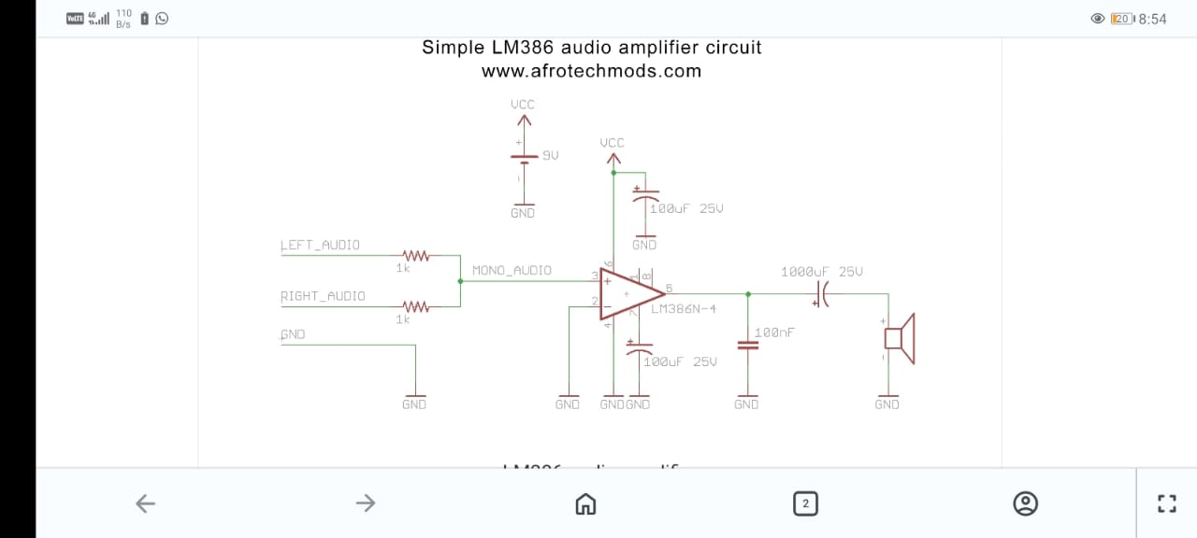

Components List:
- Integrated Circuit (IC1): LM386N-4 (1) - Audio Amplifier IC

- Resistors: 1kΩ (2) - Input Mixing

- Capacitors: 100μF, 25V ( 2) - Power Decoupling & Bypass

- Capacitor: 1000μF, 25V (1) - Output Coupling

- Capacitor: 100nF (0.1μF) (1) - Noise Filter

- Speaker: 4Ω or 8Ω, 1 Watt (1) - Output Load

- Power Source: 9V supply(1) - Power Supply

- Connector: 3.5mm Aux Jack (1) - Input Connector

3.3 Steps Followed for Hardware Implementation
- Breadboard Assembly: The circuit was first assembled on a breadboard to verify connections. The LM386 was placed across the central ridge.

- Power Rails: The 9V battery clip was connected to the power rails. A 100μF capacitor was added across VCC and GND.

- Input Wiring: The Aux cable wires (Left, Right, Ground) were identified. Resistors were used to mix Left and Right channels into Pin 3.

- Gain and Bypass: The 100μF bypass capacitor was connected to Pin 7.

- Output Stage: The negative leg of the 1000μF capacitor was connected to the speaker, and the positive leg to Pin 5.

- Testing: An audio source was connected, and the sound output was verified.

3.4 Photographs of the Hardware Setup

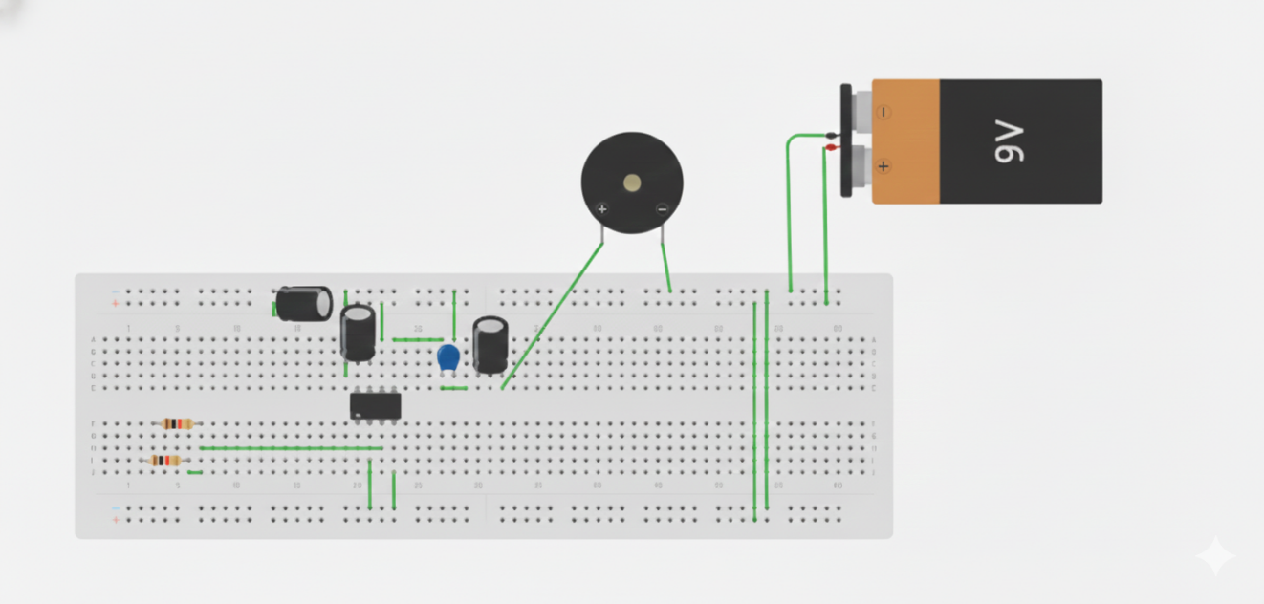

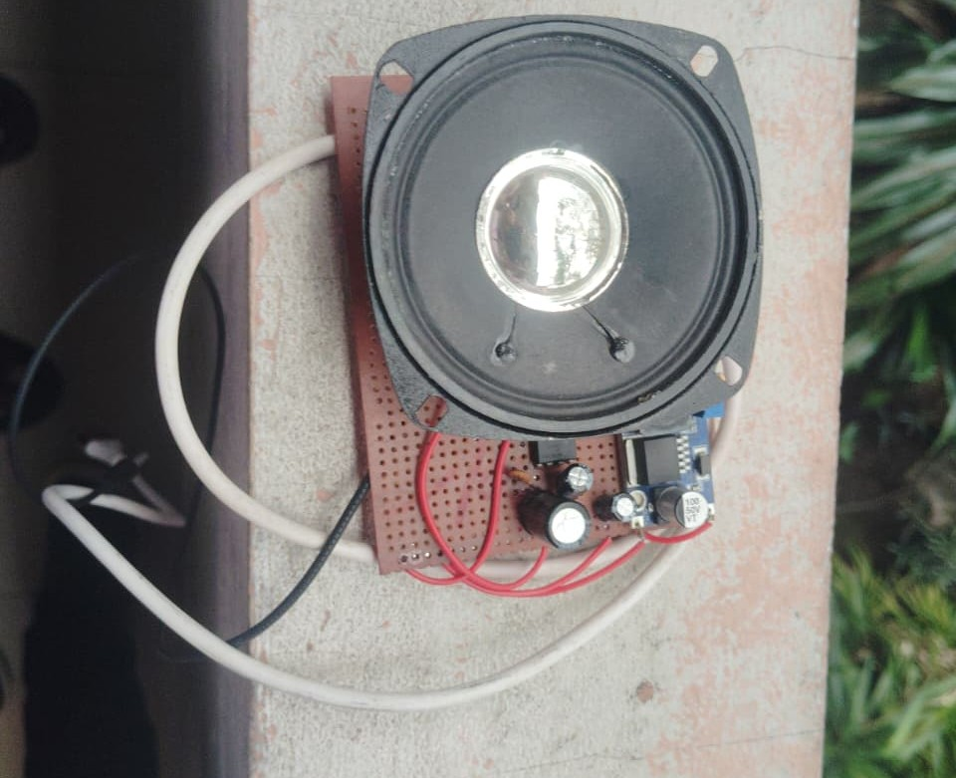

Chapter 4
Results and Discussion

An important thing we saw in the simulation was "clipping." The tops and bottoms of the output wave were flat. The voltage only went from about 0V to 6.3V. This happened because the amplifier's gain was set to the maximum of 200 using the 10μF capacitor. The input signal was too strong, causing the amplifier to reach its power limit and distort the output.

The real hardware circuit worked just like the simulation. It successfully amplified audio from a phone to play through a speaker. When the phone volume was medium, the sound was clear. But when we turned the phone volume up to the maximum, we could hear distortion. This distortion in real life matched the clipping we saw in the simulation graphs.
This comparison shows our simulation was accurate. It also proves that it is important to control the input volume to prevent distortion for clear sound. which confirms how the LM386 gain setting works.

Chapter 5
Conclusion
5.1 Summary of the Work Done
This project successfully designed, simulated, and built a portable audio amplifier using the LM386 IC.

- Simulation: Verified the amplification logic and highlighted the limits (clipping) of the system.

- Implementation: The circuit was built using standard components and a 9V power supply.

- Performance: The amplifier successfully drove a speaker with sufficient volume for personal use, converting a weak Aux signal into audible sound. The project demonstrated the effectiveness of the LM386 for low-power audio applications.

References

- [1] Texas Instruments, "LM386 Low Voltage Audio Power Amplifier Datasheet (Rev. D)," Texas Instruments, Dallas, TX, USA, Aug. 2023. [Online]. Available: https://www.ti.com/lit/ds/symlink/lm386.pdf

- [2] Afrotechmods, "Simple LM386 audio amplifier circuit," Afrotechmods.com. [Online]. Available: http://www.afrotechmods.com/groovy/amplifier/amplifier.htm. [Accessed: Dec. 15, 2025].

