Enron Email Analysis
A Big Data Analysis using Hadoop, MapReduce, Hive, Spark and Google BigQuery
Dhanush Mahesala Chandrashekar (1020938)
Under the Guidance of:
Prof. Jeongkyu Lee
Department of Computer Science
University of Bridgeport
dhchandr@my.bridgeport.edu

Abstract—This paper describes the analysis of Enron Corporation’s emails using the big data technologies, Hadoop-MapReduce, Hive, Spark and Google’s BigQuery. The data set taken for this paper has folders of every employee with all the emails sent or received by the employee of Enron corporation. Enron corporation filed bankruptcy in 2001. Enron share price were an all-time up of $90.56 and ended-up with a closing stock of $0.26 within 4 months. It was later revealed that its financial condition of high stock price was a planned fraud. This I am trying to find out reason behind the fraud and the information leak. To start with I have consider the sent emails and inbox emails of all the employees in the dataset because it will be interesting know which employee communicated the most the corporation and who the most famous employees who received most of the emails. The most challenging part the dataset was to clean it and organise it to make it usable for the analysis. This paper includes the understand and implementation of the above-mentioned technologies. By the end of the paper we will see how queries were performed on the big data tools. We will also see on how much time does each bigdata tools take to perform certain task and to give an output.
- Introduction
The narrative of Enron Corp. is the narrative of an organization that achieved dramatic statures, just to confront a confounding fall. Its crumple influenced a huge number of representatives and shook Wall Street to its centre. At Enron's pinnacle, its offers were worth $90.75; when it defaulted on some loans on December 2, 2001, they were exchanging at $0.26. Right up 'til today, numerous think about how such an intense business, at the time one of the biggest organizations in the U.S, deteriorated overnight and how it figured out how to trick the controllers with counterfeit property and off-the-books accounting so long.
Before filing the bankruptcy in 2001, Enron Corporation was one of the biggest coordinated flammable gas and power organizations on the planet. It promoted flammable gas fluids worldwide and worked one of the biggest gaseous petrol transmission frameworks on the planet, totalling in excess of 36,000 miles. It was additionally one of the biggest free designers and makers of power on the planet, serving both modern and developing markets. Enron was likewise a noteworthy provider of sun based and wind sustainable power source around the world, dealt with the biggest arrangement of gaseous petrol related hazard administration contracts on the planet, and was one of the world's greatest free oil and gas investigation organizations.
In North America, Enron was the biggest discount advertiser of gaseous petrol and power. Enron spearheaded inventive exchanging items, for example, gas fates and climate fates, altogether modernizing the utilities business. After a surge of development in the mid-1990s, the organization kept running into troubles. The size of Enron's misfortunes was avoided investors. The organization collapsed after a fizzled merger manage Dynegy Inc. in 2001 uncovered monstrous money related finagling. The organization had positioned number seven on the Fortune 500, and its disappointment was the greatest liquidation in American history.

At the time of bankruptcy “The New York Times” ran an article titled, “Market Watch: A self-inflicted wound aggravates angst over Enron”. This was a leak to the press from the company. Hence my analysis involved in knowing which employee from the corporation were the most famous people who exchanged most of the emails. That allows me to focus on the sent and the inbox emails from the Enron dataset.
- DATASET
Enron Data can be download from the Kaggle website:
https://www.kaggle.com/wcukierski/enron-email-dataset/data
This dataset is unique and is one of the only publicly available mass collections of real emails available for study. It consists of approximately 500,000 emails. All the emails are generated by 150 employees of the Enron Corporation, mostly senior management of Enron organized into folders. The dataset was obtained by Federal Energy Regulatory Commission during its investigation of Enron’s collapse. These email datasets involve a lot of conversations happened between employees giving me a way to analysis the behavioural patterns over e-mail. The dataset has helped in understanding the thoughts of the management with respect to the false accounting.
The dataset consists of two fields; files and messages. Since the dataset is in form of folders the files column tells the folder in which the data is, and the messages shows the content of the emails, from which many attributes like, ‘To’, ‘From’, ‘Subject’, ‘Content’, ‘Timestamp’ can be extracted. This extraction of the attribute can be done using python. Also, I have used a mapper and a reducer to filter the data and converted into table format which can be used for the other big data tools, Hive, Spark and Google’s BigQuery.

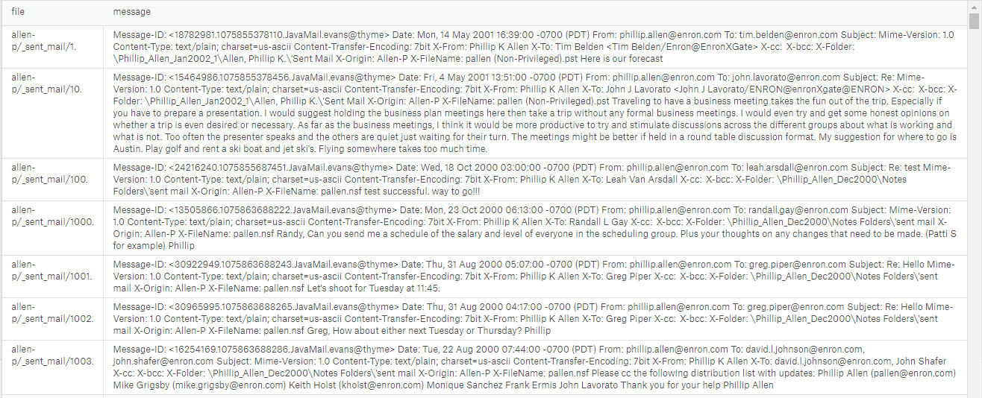
Fig 1. Sample Dataset
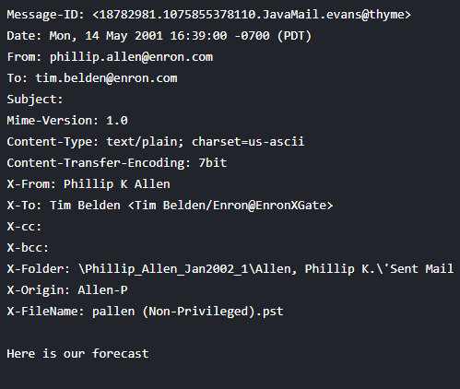
Fig 2. Sample raw email format

As can be seen from the raw email format that it contains a lot of information which is suitable for the analysis. Ideally, we can ignore the content in the email and the collect the data like Date, To, From and Subject. It is easy to extract the required data from each email because of the structured nature of the emails. Regex expressions in python were used to filter out the header information.
- HADOOP- MAPREDUCE
MapReduce is a framework which is used to build the applications that can process huge amount of data parallelly on a large clusters of commodity hardware. Its is also know for its distributed computing based on java, python or any other streaming languages. In the whole MapReduce program has two main functions, mapper and reducers. The data is divided into chunks of blocks that sent to mapper. Mapper then converts the collected data into another set of data, where individual elements are broken into tuples (key and values). This broken data is then sent to reducer [2]. Reducer takes this data as input and combines them into smaller set of tuples.
Generally, the input data is in the form of files or directory that is stored on HDFS (Hadoop Distributed File System). The files are then passed to mapper line by line and mapper processes the data creating many chucks of data. Reducer stage is combination of shuffler and reducer stage. Reducer processes the output of the mapper and produces new sets of output, that will be stored in the HDFS.
In this project, I have used two mappers and two reducer programs to do different jobs. The mapper1 and reducer1 is used to get the total number of emails sent by the employees of the Enron corporation. Out of the dataset all the sent emails and the inbox emails were filtered and loaded on to HDFS as email-sent and email-inox. To upload the data in HDFS follow the commands in Appendix.

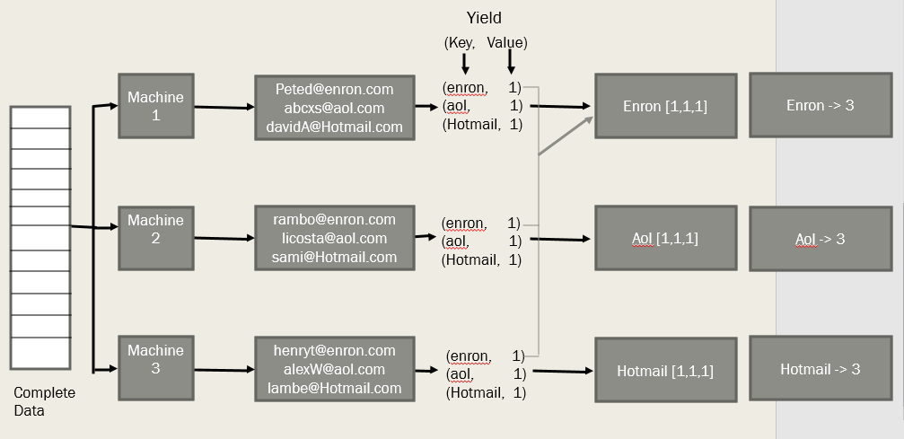
Fig 3. MapReduce programming model

First by using the mapper1 and reducer 1, my focus was to read the data and to know the how many emails were sent out by each employee of the corporation. Mapper1 runs where regex function was used to collect sender name, origin (folder from where the emails was taken) and the email ID of the receiver. Output of the mapper1 would be like:
Rank<tab>Sender<tab>Origin<tab>receivers email id
Example:
89889 symes, kate ksymes@enron.com assemblek@world.com
Reducer1 will then take this as an input and processes it by knowing how many receivers had received the emails form the Enron employees. The output format of the reducer1 is:
Sender<Tab>Number of receivers
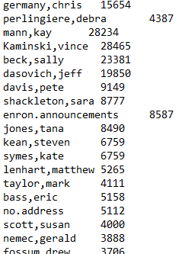
Fig 4. Output after Mapper1 and Reducer1
Since the data is in folder and unstructured it is important for me to filter the data and get an out in the form that I could convert it into a table for the remaining big data tools to be implemented. In order to do this an additional mapper2 and reducer2 was written, that would help me in extracting the required data and converting them into a table format.
The data form email-sent and email-inbox in the HDFS was sent to mapper2. The output of the mapper2 and reducer2 is in the format:
Data<tab>Sender<tab>Receivers<tab>subject<tab>ID
Now we can see that the output of mapper2 and reducer2 is more readable and separated with <TAB> which helps in reading the data and imprinting the data format into the tables with <TAB> as a delimiter. This mapreduce2 helped me in structuring the data.

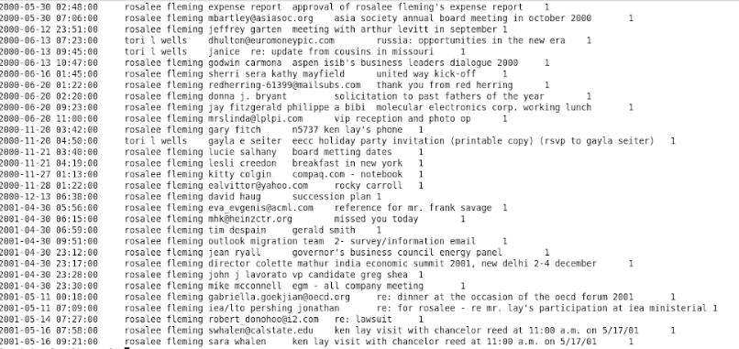
Fig 5. Output of MapReduce2
- Hive

Hive is data ware house software built on top of Hadoop for providing data summarization, query and analysis. Its provides an SQL based interface for querying the data stored in various databases. It supports the analysis of huge datasets stored on the Hadoop cluster or HDFS [3]. The SQL like query provided is known as HiveQL with schema to read and load the data and then converts the data into MapReduce.
In my project implementation, the output of MapReduce2 is save in a folder “result_mr”. This will be the location for the Hive to pick up the data and format it into a table with <TAB> as a delimiter.
Table name where the data was loaded to is enron_emails.
Execution of Hive can be tracked in Hue and user interpreter for Hive that runs on a localhost.

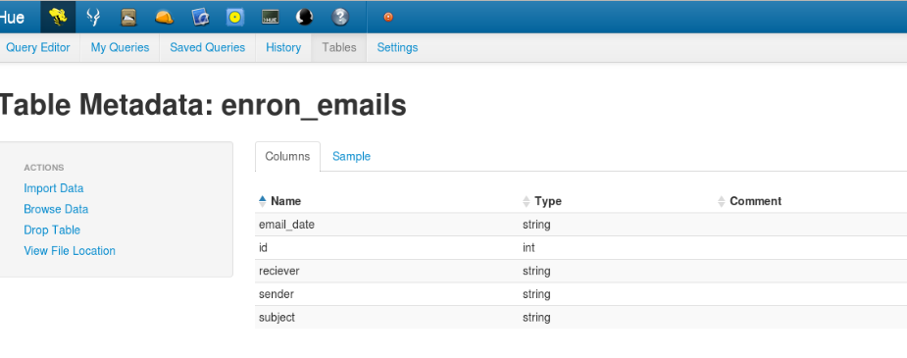
Fig 6. Enron_emails table on HUE.

One HUE, the queries can be executed by writing the query in the query editor and clicking on Run Query.

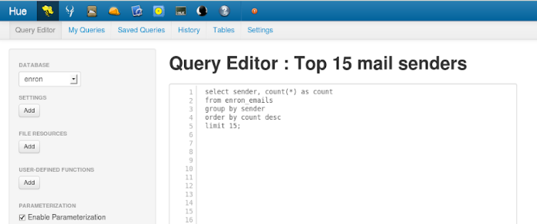
Fig 7. Query Editor

Time taken to run each query and produce an output was about 10 -15secs.
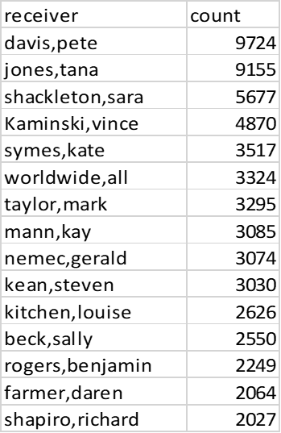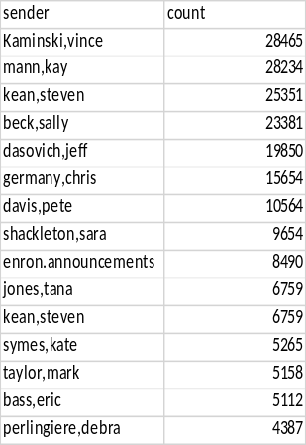
Fig 8. Top 15 receivers Fig 9. Top 15 senders

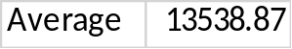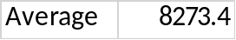
Fig 10. Avg. email sent by Fig 11. Avg. email
Top 20 employees received by top20 employees
- Spark
Thought Hive and MapReduce were well executed and showed the required output, its slow. This is because when ever I execute a query it would run a new instance of the MapReduce program upon the data-set stored with HDFS. To fasten this, Spark can be used. Main advantage of Spark is the velocity that is met by mainly keeping and interacting with data within the memory [4]. This makes spark very powerful in caching hence increasing the performance. Spark supports a variety of scripting languages like Python, Scala, R and Java. In my project, I have used spark version 2.3.0. As I executed each of the queries, the time to generate the output was significantly faster compared to MapReduce and Hive, about 2-3 seconds.

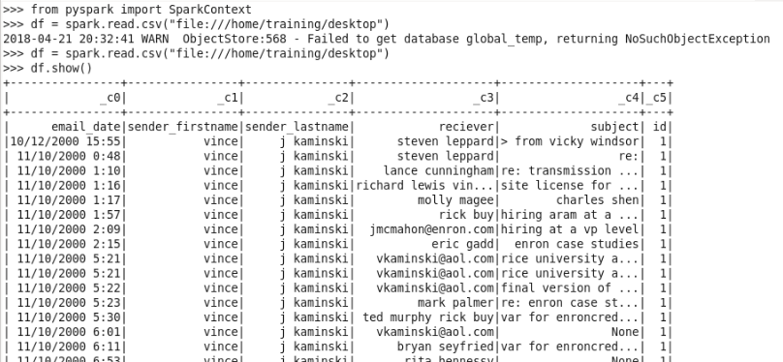
Fig 12. Data frame in table format in Spark
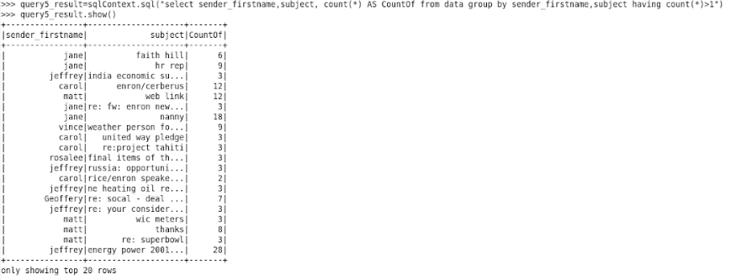
Fig 13. Query run on pyspark
- BigQuery
BigQuery [5] is a Google’s web service that enables interactive analysis of massively large datasets working in conjunction with Google storage. To access BigQuery, Google cloud platform billing should be active.
In my project, the table was uploaded to database Enron and named it as email_enron. In order to test the performance of the BigQuery, more amount of data was added and duplicated to check the capacity of the query execution.
The queries executed on BigQuery was to find the top 15 receivers and senders in the company, average emails sent by the top 20 sends and number of senders with the same subject line. It was very interesting to see that BigQuery was the fastest amount all the big data programming tools. It took at-most 1 to 1.50 seconds to complete and get an output of any of the query.

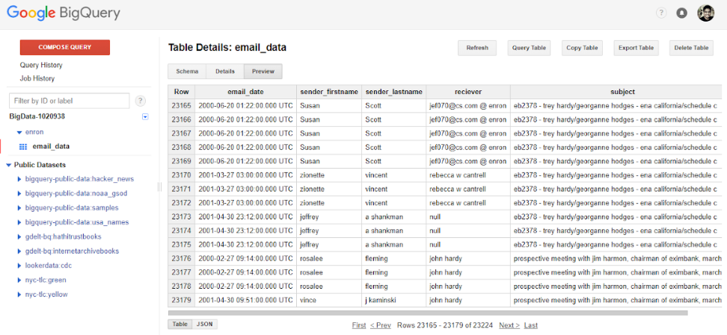
Fig 14. BigQuery table
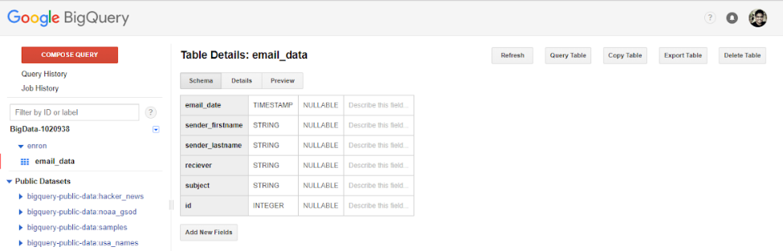
Fig 15. Table Schema

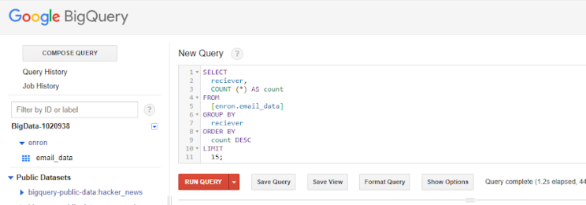
Fig 16 Query Execution in BigQuery

- Conclusion
It’s being very interesting to see how the big data tools like MapReduce, hive, spark and BigQuery make it easy to work on Big size that is impossible to be analysed otherwise. In the Enron email dataset, the most challenging part was to clean up the data and understand the dataset. Understand of the dataset is very important to know who to solve the problems statements. It was interesting to see how an unstructured data with full of data can be converted into readable data with a sensible analysis. The analysis talks about the top 20 top management people were involved in maximum email conversation happened at the time the fall of Enron started. It is very clear from the query output is that most of the top management people were involved in the fraud if considered sent and received emails. Average email sent by these employees was 13,538 and average emails received by these employees was 8,273.
This analysis also talks about the execution speed of the different big data tools. Google Big Query and Spark seems be more powerful in term of performance and the scalability.

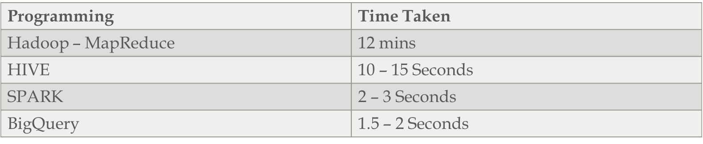

- References
- Enron email dataset:
https://www.kaggle.com/wcukierski/enron-email-dataset/data
- MapReduce: https://hadoop.apache.org/docs/r1.2.1/mapred_tutorial.html
- Hive learning:
https://hive.apache.org/
- Spark learning: https://spark.apache.org/
- BigQuery learning:
https://cloud.google.com/bigquery/what-is-bigquery

