**Create an Elastic Beanstalk environment :-**

1. Navigate to AWS console and open Elastic Beanstalk.

2. Create a webserver environment.

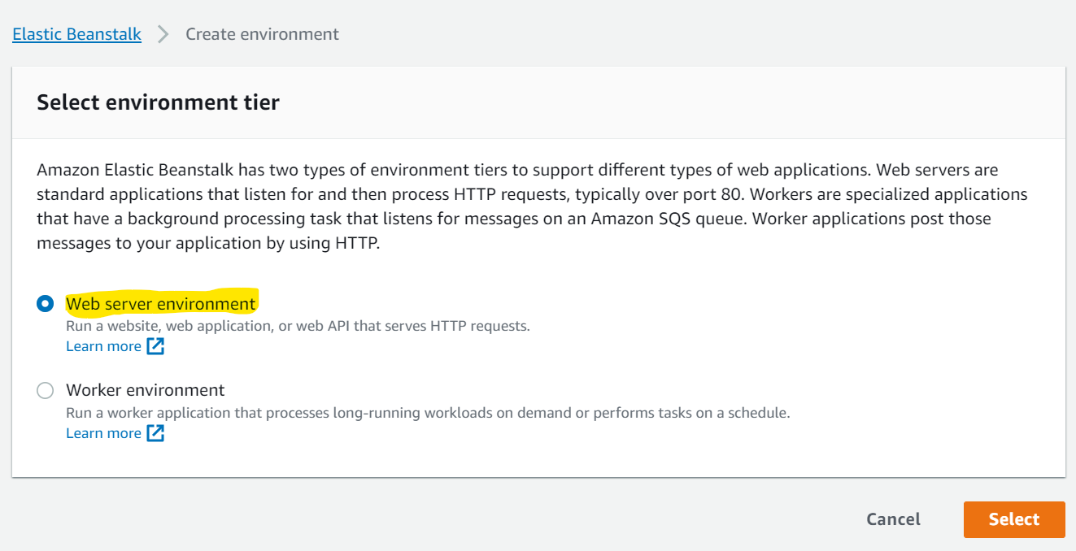

3. Provide unique Application and environment name.

4. Choose Managed platform as ‘NodeJS’ and application code as ‘sample’.

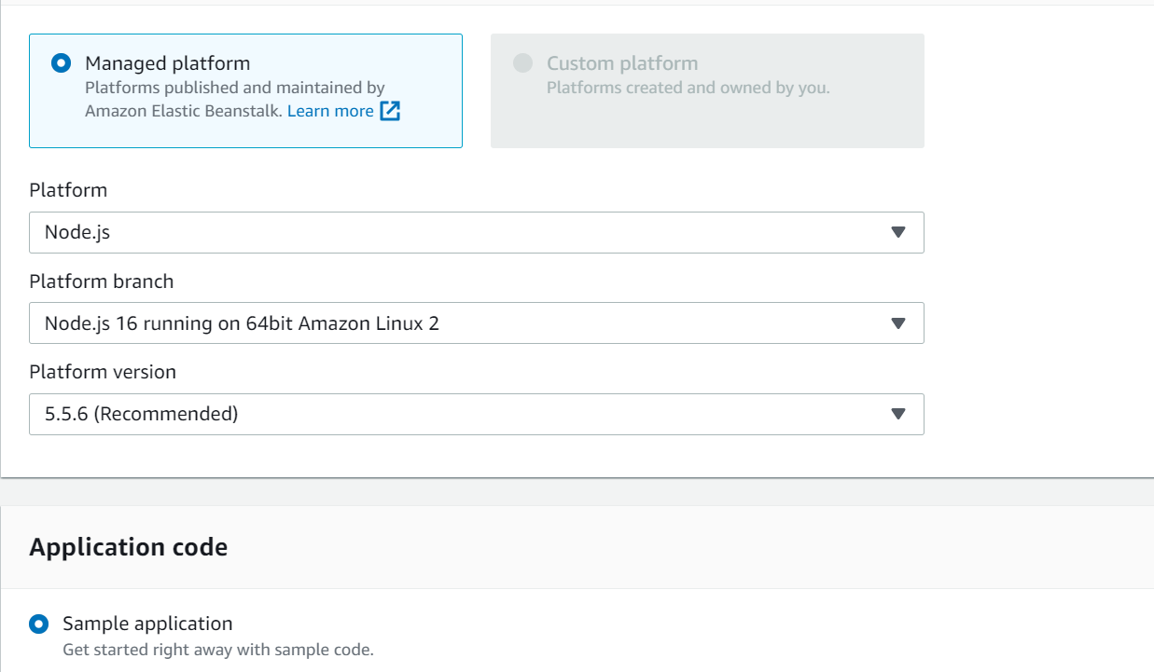

5. Launch the elastic beanstalk environment. (Note: The launch will take a few minutes.)

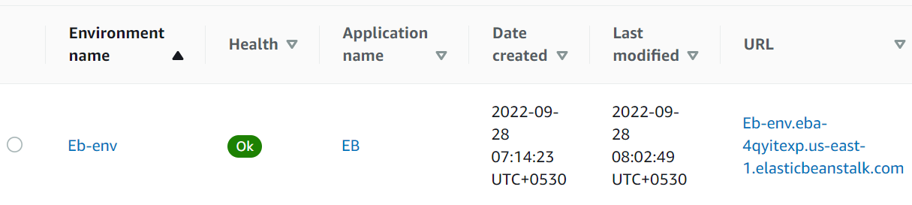

6. Once the environment is launched, use the URL to access the NodeJS webpage.

