**44-542 Object Oriented Programming**

**Lab09: Interfaces and Abstract Classes Lab Activity**

**Objective:** Covers the creation and usage of **Interfaces and Abstract classes.**

**NOTE:**

* Do not hard code any values.
* Check the sample output to know how the results need to be printed.
* Read every instruction carefully and follow them strictly.
* Do not change the name of the attributes and methods given.
* @author notation should contain your full name.
* Use the Javadoc given to you to know the instance variables, classes, interfaces, abstract classes.
* Follow the Javadoc carefully to know the dependencies and method descriptions.
* Ensure your code is indented properly.
* Generate Javadoc before uploading your project.

**How to View Javadoc**:

* Go to “Javadoc” -> “index.html” to access the javadocs.

**Overview:**

* This lab lets you create a phone bill for given service based on call log data.
* You must create all the classes given in UML diagram. The input text file is provided to you. You must define the relationships from the below given UML diagram. Generate Javadoc for your project which must include appropriate comments, @param, @return annotations for all constructors and methods.

**Steps for the Program:**

* Create a New Project and name it as **Lastname_Lab09InterfacesAndAbstractClasses** where **Lastname** is your last name.
* Create all the enums, interfaces and classes given in the Javadoc.
* Go through each interface and class to know the list of instance variables and methods.
* Go through the method descriptions given in Javadoc to know the required functionality.

**UML Diagram for the program:**

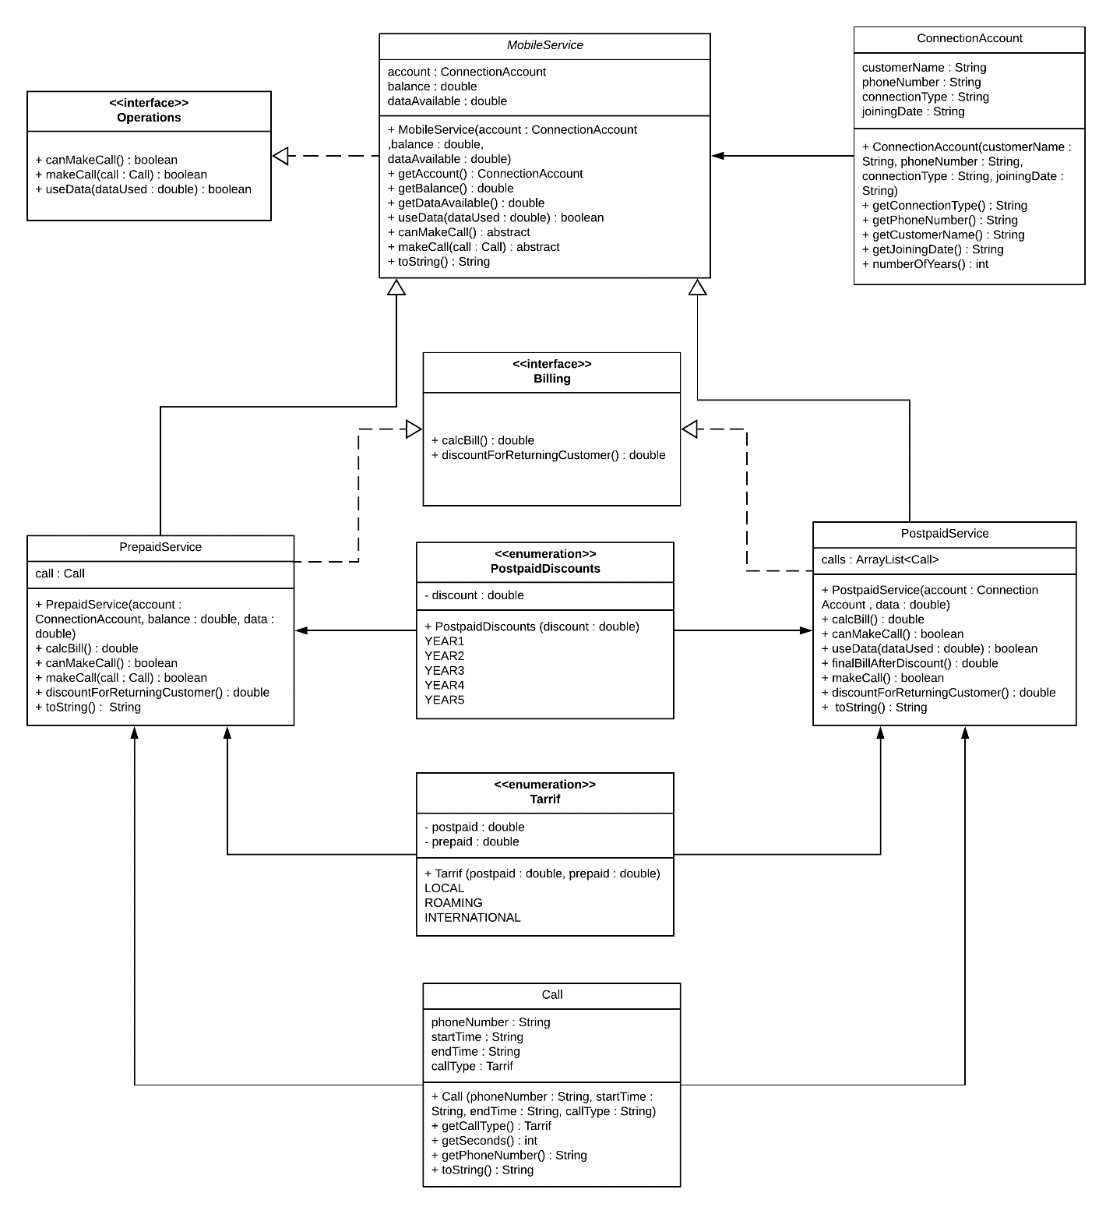

1. **Additional Notes for Tarrif enum:**
2. You need to create the constructor for enum.
3. And you no need to create the below methods

public static Tarrif[] values()

public static Tarrif valueOf(double postpaid, double prepaid)

When you generate the **Javadoc** the above methods will be produced by default.

1. **Additional Notes for PostpaidDiscounts enum:**
2. You need to create the constructor for enum.
3. And you no need to create the below methods

public static PostpaidDiscounts [] values()

public static PostpaidDiscounts valueOf(double discount)

When you generate the **Javadoc** the above methods will be produced by default.

1. **TelecommDriver class:**
2. Please find driver class specifications in “**TelecommDriver.java”** provided with Lab document.
3. To view given tabs and spaces in input file, click on ¶ in Paragraph section of MS Word (Tabs are shown as arrow and space as dot).

**Sample Output:**

|  |
| --- |
| ************************Postpaid customers invoice***************************  -----------------------------------------------------------------------------  Customer Name :Aegon Targaryen  Phone Number :(+2)565-665-5789  Connection Type :postpaid Connection Date :19-Mar-2015  -----------------------------------------------------------------------------  Phone number Call Type From To  +35232456789 LOCAL 2020-10-02 08:42:02 2020-10-02 09:53:31  +14587091246 LOCAL 2020-02-12 18:22:13 2020-02-12 19:23:31  +24567890345 ROAMING 2020-03-18 16:11:37 2020-03-18 16:19:59  +81651498126 INTERNATIONAL 2020-04-12 08:42:02 2020-04-12 09:21:49  +75716801328 LOCAL 2020-01-02 14:41:42 2020-01-02 16:13:51  +215714713376 ROAMING 2020-01-15 23:31:52 2020-01-16 00:56:22  +915660431347 INTERNATIONAL 2020-03-19 22:38:51 2020-03-20 01:02:03  +881309255692 ROAMING 2020-07-27 19:03:59 2020-07-27 20:21:51  -----------------------------------------------------------------------------  Additional mobile data used :0.00MB  Bill Amount :$218.51  Returning Customer Discount(20.0%) :$43.70  Final Bill Amount :$174.81  -----------------------------------------------------------------------------  -----------------------------------------------------------------------------  Customer Name :Ramsay Bolton  Phone Number :(+1)657-489-6361  Connection Type :postpaid Connection Date :04-Mar-2011  -----------------------------------------------------------------------------  Phone number Call Type From To  +13626628267 ROAMING 2020-02-22 01:05:12 2020-02-22 02:01:31  +29804473875 INTERNATIONAL 2020-04-11 11:05:31 2020-04-11 12:12:21  +29804473875 INTERNATIONAL 2020-09-25 09:05:12 2020-09-25 09:32:43  +14677371686 ROAMING 2020-10-26 11:32:11 2020-10-26 11:51:59  +13626628267 ROAMING 2020-02-23 07:02:23 2020-02-23 07:31:30  +13626628267 ROAMING 2020-03-01 10:01:45 2020-03-01 11:05:25  +17787597520 LOCAL 2020-07-25 12:00:00 2020-07-25 12:12:12  +29804473875 INTERNATIONAL 2020-09-25 19:25:12 2020-09-25 19:32:43  +88153212612 LOCAL 2020-10-26 12:02:01 2020-10-26 12:03:09  -----------------------------------------------------------------------------  Additional mobile data used :0.00MB  Bill Amount :$121.80  Returning Customer Discount(20.0%) :$24.36  Final Bill Amount :$97.44  -----------------------------------------------------------------------------  *************************Prepaid customers invoice***************************  -----------------------------------------------------------------------------  Customer Name :Tyrion Lannister  Phone Number :(+2)560-978-3759  Connection Type :prepaid  -----------------------------------------------------------------------------  Last Call Details:  Phone number Call Type From To  +912689559871 INTERNATIONAL 2020-07-26 08:08:07 2020-07-26 08:12:10  -----------------------------------------------------------------------------  Available mobile data :95.71MB  Balance :$66.33  Last Call Amount :$2.84  -----------------------------------------------------------------------------  -----------------------------------------------------------------------------  Customer Name :Eddard Stark  Phone Number :(+1)573-898-0767  Connection Type :prepaid  -----------------------------------------------------------------------------  Last Call Details:  Phone number Call Type From To  +88153212612 LOCAL 2020-10-26 12:02:01 2020-10-26 12:03:09  -----------------------------------------------------------------------------  Available mobile data :221.81MB  Balance :$82.87  Last Call Amount :$0.23  -----------------------------------------------------------------------------  **********************Invoking useData() of customer*************************  -----------------------------------------------------------------------------  Customer Name :Aegon Targaryen  Phone Number :(+2)565-665-5789  Connection Type :postpaid Connection Date :19-Mar-2015  -----------------------------------------------------------------------------  Phone number Call Type From To  +35232456789 LOCAL 2020-10-02 08:42:02 2020-10-02 09:53:31  +14587091246 LOCAL 2020-02-12 18:22:13 2020-02-12 19:23:31  +24567890345 ROAMING 2020-03-18 16:11:37 2020-03-18 16:19:59  +81651498126 INTERNATIONAL 2020-04-12 08:42:02 2020-04-12 09:21:49  +75716801328 LOCAL 2020-01-02 14:41:42 2020-01-02 16:13:51  +215714713376 ROAMING 2020-01-15 23:31:52 2020-01-16 00:56:22  +915660431347 INTERNATIONAL 2020-03-19 22:38:51 2020-03-20 01:02:03  +881309255692 ROAMING 2020-07-27 19:03:59 2020-07-27 20:21:51  -----------------------------------------------------------------------------  Additional mobile data used :17.40MB  Bill Amount :$219.38  Returning Customer Discount(20.0%) :$43.88  Final Bill Amount :$175.50  -----------------------------------------------------------------------------  -----------------------------------------------------------------------------  Customer Name :Tyrion Lannister  Phone Number :(+2)560-978-3759  Connection Type :prepaid  -----------------------------------------------------------------------------  Last Call Details:  Phone number Call Type From To  +912689559871 INTERNATIONAL 2020-07-26 08:08:07 2020-07-26 08:12:10  -----------------------------------------------------------------------------  Available mobile data :82.51MB  Balance :$66.33  Last Call Amount :$2.84  -----------------------------------------------------------------------------  -----------------------------------------------------------------------------  Customer Name :Eddard Stark  Phone Number :(+1)573-898-0767  Connection Type :prepaid  -----------------------------------------------------------------------------  Last Call Details:  Phone number Call Type From To  +88153212612 LOCAL 2020-10-26 12:02:01 2020-10-26 12:03:09  -----------------------------------------------------------------------------  Available mobile data :119.83MB  Balance :$82.87  Last Call Amount :$0.23  -----------------------------------------------------------------------------  *************************Best postpaid customer******************************  -----------------------------------------------------------------------------  Best Customer Details:  Customer Name: Aegon Targaryen  Bill amount :$175.50 |

**Submit your solution by following the steps below:**

* Save your files in **NetBeans**.
* Zip your entire Project. (It should be called ***Lastname*_Lab09InterfacesAndAbstractClasses.zip** where **Last name** is your last name.)
* Submit the Zip file to the **Lab09InterfacesAndAbstractClasses** on canvas.
* Download the Zip file you have submitted.
* Look in the Zip file and verify the class files in the Zip folder are correct. If not resave your project in **NetBeans** and resubmit.